WEEK 3 TECHNICAL REPORT: DRONE METADATA AND GIS INTEROPERABILITY

1. Photographic and Orientation Metadata (EXIF & XMP)
Photogrammetric reconstruction and orthomosaicing rely on the exact reconstruction of the camera’s position and orientation at the millisecond the sensor shutter is released. This spatial positioning is recorded in two distinct metadata blocks embedded directly within the header of raw drone images:
Exchangeable Image File Format (EXIF):
EXIF is a standard industry format that stores basic device parameters and positioning metadata. The primary tags required for GIS georeferencing include GPSLatitude and GPSLongitude (stores horizontal coordinates in Degrees-Minutes-Seconds which are converted to decimal degrees), GPSAltitude (ellipsoidal height of the drone), and FocalLength (critical for calculating ground coverage).
Extensible Metadata Platform (XMP):
XMP is an XML-based metadata standard that allows drone manufacturers (like DJI) to write custom properties. For drone photogrammetry, the custom DJI namespace contains flight orientation angles: GimbalPitchDegree (camera vertical tilt), GimbalYawDegree (heading relative to North), GimbalRollDegree (horizontal stabilization angle), and RelativeAltitude (flight height relative to the takeoff location, which is preferred over absolute altitude for ground footprint math).

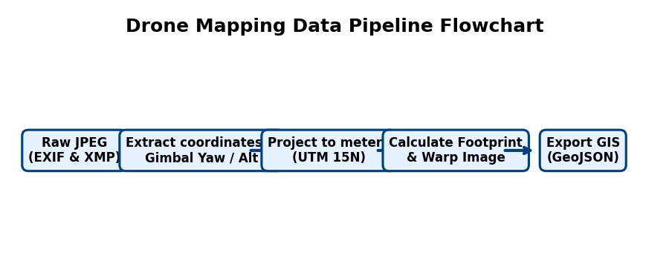
Figure 1: Telemetry data extraction and coordinate projection pipeline.
2. High-Precision Positioning (RTK/PPK) and Telemetry Logs
Standard GNSS receivers provide an accuracy of 2 to 5 meters, which is insufficient for engineering-grade mapping. Precision mapping uses base stations to correct satellite signal errors:
Real-Time Kinematic (RTK):
A ground base station streams real-time corrections via cell connection or radio to the drone during flight. The drone corrects its position instantly and geotags the images with centimeter-level precision (1 to 2 cm).
Post-Processed Kinematic (PPK):
The drone and base station record satellite measurements independently in RINEX files. After the flight, a processing script merges the files and calculates corrected tracks, which are written back to the photos.
3. Coordinate Reference Systems (CRS) & Hands-on Mismatch Case Study
A major challenge in drone mapping is coordinate system alignment. Drone coordinates start as geographic degrees (WGS84 GPS), but point clouds and digital surface models must be projected onto a flat 2D grid in meters (Projected CRS like UTM) to perform linear measurements.
Case Study (Brighton Beach Hands-on):
During our hands-on mapping implementation, we encountered a classic multi-system projection mismatch:
1. The point cloud (model.laz) was projected in UTM Zone 15N (EPSG:32615) for Duluth, MN.
2. The elevation model (dsm.tif) was projected in UTM Zone 10N (EPSG:32610) for California.
3. The raw drone images were recorded in geographic WGS84 Lat/Lon coordinates.
To overlay the photos and query the heights correctly in our visualizer, we integrated GDAL OGR coordinate transformers (poCT_to_GPS and poCT_to_UTM10) to dynamically convert and align coordinates, preventing a mapping offset of thousands of kilometers.
4. Sensor Geometry and Footprint Calculations (Formula Explanation)
To project a flat drone image onto its correct ground location, we compute the camera Field of View (FOV) and footprint dimensions using the following formulas. Here is what they physically mean:
Formula 1 (Horizontal FOV Angle):
FOV_h = 2 * arctan( Sw / (2 * f) )
Physical Meaning: This formula calculates the horizontal viewing angle of the camera lens. Sw is the physical width of the camera sensor (e.g. 6.17 mm), and f is the focal length of the lens (e.g. 3.61 mm). Dividing the sensor width by twice the focal length calculates the ratio of the triangle's base to its height. The arctan function converts this ratio into an angle, and multiplying by 2 gives the full left-to-right viewing cone (approx. 81.2° for a DJI Phantom 3).
Formula 2 (Vertical FOV Angle):
FOV_v = 2 * arctan( Sh / (2 * f) )
Physical Meaning: Identical to the horizontal FOV formula, but using the vertical sensor height (Sh = 4.55 mm) to calculate the top-to-bottom viewing cone (approx. 65.5°).

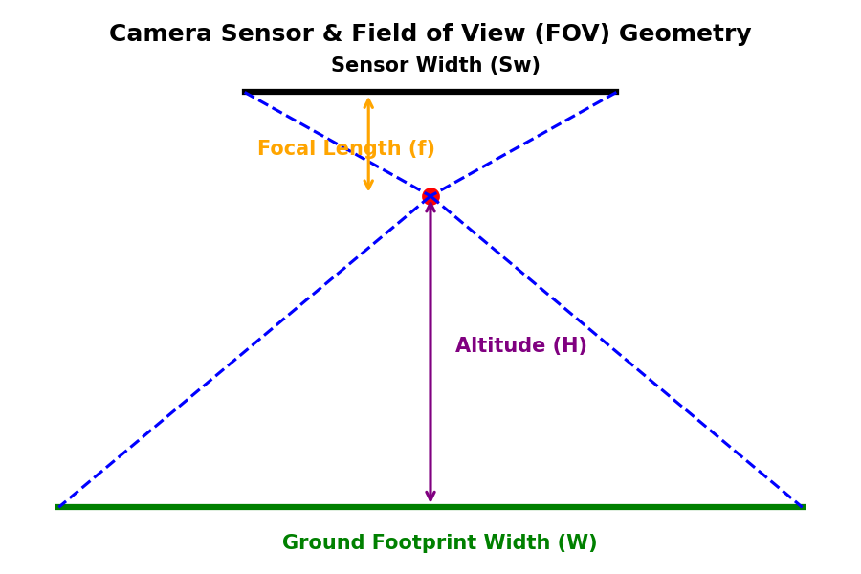
Figure 2: Geometric projection of camera sensor onto ground footprints.
Formula 3 & 4 (Physical Ground Bounding Dimensions):
W_ground = 2 * H * tan( FOV_h / 2 )
H_ground = 2 * H * tan( FOV_v / 2 )
Physical Meaning: These formulas estimate the physical length and width of the ground area captured in a single photograph (when looking straight down). H is the relative altitude of the drone above the ground (height). By taking the tangent of the half-viewing angle (tan(FOV/2)) and multiplying it by the altitude H, we find the distance from the center point to the outer edge of the photo. Multiplying by 2 gives the total ground width (approx. 1.71 * H) and height (approx. 1.28 * H).
5. Data Lineage, Quality Metrics & GIS Export
Data lineage is the document history of how the files were prepared. In our hands-on task, we downsampled the point cloud from 940k points down to 47k points to ensure smooth, real-time rendering in our visualizer. This represents a controlled quality trade-off: we reduce data density to achieve high frame rates (over 60 FPS) while keeping the spatial lineage intact.
Furthermore, our custom visualizer acts as an active GIS pipeline. When clicking 'Export GIS GeoJSON', the app projects the rotated ground corners of each image footprint back into WGS84 GPS (Lat/Lon) coordinates and exports them as a standard GeoJSON file. This output allows professional surveyors to import the drone footprints directly into standard tools like QGIS or ArcGIS for overlays and mapping reports.

