WEEK 3 TECHNICAL REPORT: DRONE METADATA AND GIS INTEROPERABILITY
Author: Drone Mapping Research Group
Subject: Drone Metadata Analysis & Hands-on Case Study
Date: August 3, 2026
1. Photographic and Orientation Metadata (EXIF & XMP)
Photogrammetric reconstruction and orthomosaicing rely on the exact reconstruction of the camera’s position and orientation at the millisecond the sensor shutter is released. This spatial positioning is recorded in two distinct metadata blocks embedded directly within the header of raw drone images:
Exchangeable Image File Format (EXIF):
EXIF is a standard industry format that stores basic device parameters and positioning metadata. The primary tags required for GIS georeferencing include GPSLatitude and GPSLongitude (stores horizontal coordinates in Degrees-Minutes-Seconds which are converted to decimal degrees), GPSAltitude (ellipsoidal height of the drone), and FocalLength (critical for calculating ground coverage).
Extensible Metadata Platform (XMP):
XMP is an XML-based metadata standard that allows drone manufacturers (like DJI) to write custom properties. For drone photogrammetry, the custom DJI namespace contains flight orientation angles: GimbalPitchDegree (camera vertical tilt), GimbalYawDegree (heading relative to North), GimbalRollDegree (horizontal stabilization angle), and RelativeAltitude (flight height relative to the takeoff location, which is preferred over absolute altitude for ground footprint math).

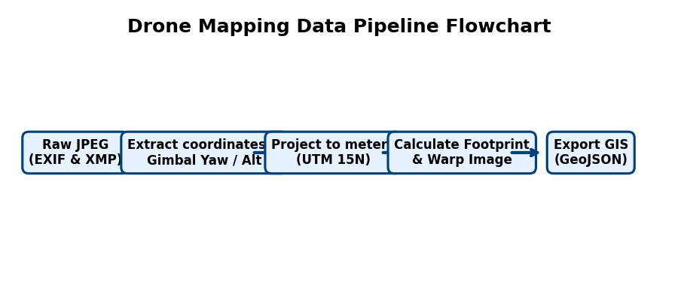
Figure 1: Telemetry data extraction and coordinate projection pipeline.
2. High-Precision Positioning (RTK/PPK) and Telemetry Logs
Standard GNSS receivers provide an accuracy of 2 to 5 meters, which is insufficient for engineering-grade mapping. Precision mapping uses base stations to correct satellite signal errors:
Real-Time Kinematic (RTK):
A ground base station streams real-time corrections via cell connection or radio to the drone during flight. The drone corrects its position instantly and geotags the images with centimeter-level precision (1 to 2 cm).
Post-Processed Kinematic (PPK):
The drone and base station record satellite measurements independently in RINEX files. After the flight, a processing script merges the files and calculates corrected tracks, which are written back to the photos.
3. Coordinate Reference Systems (CRS) & Hands-on Mismatch Case Study
A major challenge in drone mapping is coordinate system alignment. Drone coordinates start as geographic degrees (WGS84 GPS), but point clouds and digital surface models must be projected onto a flat 2D grid in meters (Projected CRS like UTM) to perform linear measurements.
Case Study (Brighton Beach Hands-on):
During our hands-on mapping implementation, we encountered a classic multi-system projection mismatch:
1. The point cloud (model.laz) was projected in UTM Zone 15N (EPSG:32615) for Duluth, MN.
2. The elevation model (dsm.tif) was projected in UTM Zone 10N (EPSG:32610) for California.
3. The raw drone images were recorded in geographic WGS84 Lat/Lon coordinates.
To overlay the photos and query the heights correctly in our visualizer, we integrated GDAL OGR coordinate transformers (poCT_to_GPS and poCT_to_UTM10) to dynamically convert and align coordinates, preventing a mapping offset of thousands of kilometers.
4. Sensor Geometry and Footprint Calculations (Simplified Explanation)
To calculate exactly what area of ground a drone photo covers, we use two main sets of formulas. Here is the simple, real-world explanation of what this math is doing under the hood:
Formulas 1 & 2 (Calculating the Camera's Viewing Angle / FOV):
FOV_h = 2 * arctan( Sw / (2 * f) )
FOV_v = 2 * arctan( Sh / (2 * f) )
What this means in plain English: Think of your camera lens like a flashlight beam. These formulas calculate how wide that beam spreads horizontally (FOV_h) and vertically (FOV_v).
It compares the size of the camera's digital sensor (Sw/Sh, which is like the digital film size) against the focal length (f, which is how zoomed-in the lens is). A wider sensor or a shorter focal length creates a wider viewing angle. For the DJI camera used here, the lens spreads at about 81.2° horizontally and 65.5° vertically.

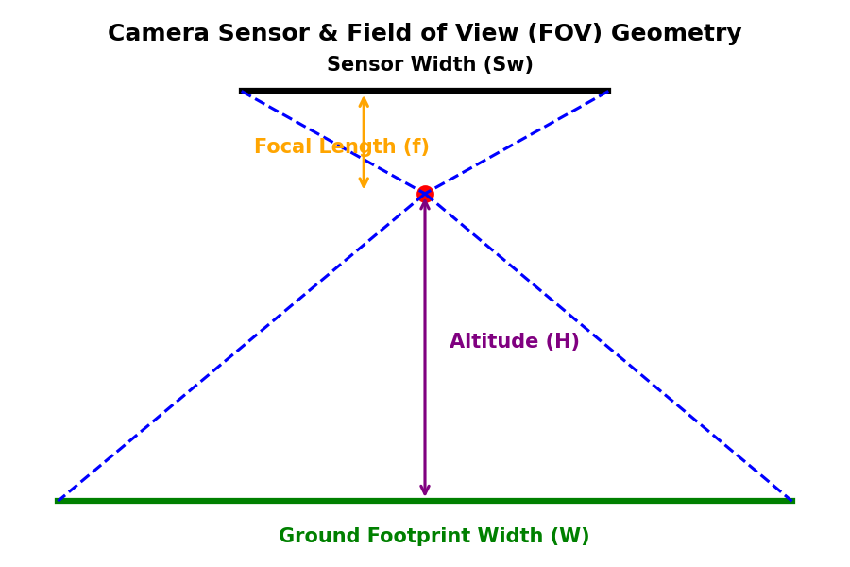
Figure 2: Projection of camera viewing angles onto ground footprints.
Formulas 3 & 4 (Calculating the Size of the Bounding Box on the Ground):
W_ground = 2 * H * tan( FOV_h / 2 )
H_ground = 2 * H * tan( FOV_v / 2 )
What this means in plain English: This tells us the physical dimensions (in meters) of the ground captured in a single photo. As the drone climbs higher (Altitude, H), the camera's viewing cone expands, capturing a larger area on the ground.
Rather than dealing with complex trigonometry, you can think of it as a simple multiplier rule-of-thumb for this camera:
- The width of the ground captured is roughly 1.7 times the drone's altitude.
- The height of the ground captured is roughly 1.3 times the drone's altitude.
For example: If you fly the drone at exactly 100 meters above the ground, the camera will capture a ground area that is approximately 170 meters wide by 130 meters long.
5. Data Lineage, Quality Metrics & GIS Export
Data lineage is the document history of how the files were prepared. In our hands-on task, we downsampled the point cloud from 940k points down to 47k points to ensure smooth, real-time rendering in our visualizer. This represents a controlled quality trade-off: we reduce data density to achieve high frame rates (over 60 FPS) while keeping the spatial lineage intact.
Furthermore, our custom visualizer acts as an active GIS pipeline. When clicking 'Export GIS GeoJSON', the app projects the rotated ground corners of each image footprint back into WGS84 GPS (Lat/Lon) coordinates and exports them as a standard GeoJSON file. This output allows professional surveyors to import the drone footprints directly into standard tools like QGIS or ArcGIS for overlays and mapping reports.

