**PIZZA SALES SQL QUERIES**

**A. KPI’s**

**1. Total Revenue:**

select sum(quantity) as total_pizza_sold, sum(price) as total_revenue from order_details

join pizzas using (pizza_id);



**2. Average Order Value**

select sum(price) / count(distinct(order_id)) as avg_order_value from pizzas

join order_details using (pizza_id);



**3. Total Pizzas Sold**

select sum(quantity) as pizza_sold from order_details;



**4. Total Orders**

select count(distinct(order_id)) as total_orders from orders;



**5. Average Pizzas Per Order**

SELECT CAST(CAST(SUM(quantity) AS DECIMAL(10,2)) /

CAST(COUNT(DISTINCT order_id) AS DECIMAL(10,2)) AS DECIMAL(10,2))

AS Avg_Pizzas_per_order

FROM orders

join order_details using (order_id);



**B. Daily Trend for Total Orders**select dayname(date) as Order_day,

count(distinct(order_id)) as Total_Orders

from order_details

join orders using (order_id)

group by dayname(date);

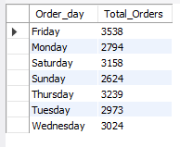

**C. Monthly Trend for Orders**

select monthname(date) as Month_Name,

count(distinct(order_id)) as Total_Orders

from order_details

join orders using (order_id)

group by monthname(date);

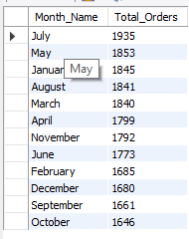

**D. Hourly Trend for Total Pizzas Sold**

SELECT hour(order_time) as order_hours, SUM(quantity) as total_pizzas_sold

from pizza_sales

group by order_hours

order by order_hours;

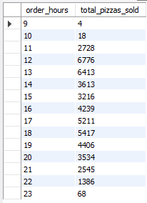

**E. % of Sales by Pizza Category**

select category,cast(sum(price) as decimal(10,2)) as Total_Revenue

from order_details

join pizzas using (pizza_id)

join pizza_types using (pizza_type_id)

group by category;

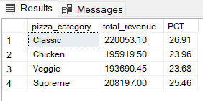

**F. % of Sales by Pizza Size**

SELECT pizza_size, CAST(SUM(total_price) AS DECIMAL(10,2)) as total_revenue,

CAST(SUM(total_price) * 100 / (SELECT SUM(total_price) from pizza_sales) AS DECIMAL(10,2)) AS PCT

FROM pizza_sales

GROUP BY pizza_size

ORDER BY pizza_size

***Output***

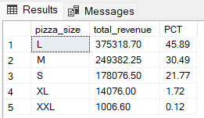

**G. Total Pizzas Sold by Pizza Category**

SELECT category as Pizza_Category, SUM(quantity) as Total_Quantity_Sold

FROM order_details

join pizzas using (pizza_id)

join pizza_types using (pizza_type_id)

GROUP BY category­

ORDER BY Total_Quantity_Sold DESC;

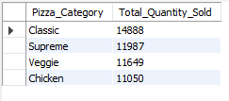

**H. Top 5 Pizzas by Revenue**

select name as Pizza_Name ,cast(sum(price) as decimal(10,2)) as Total_Revenue

from order_details

join pizzas using (pizza_id)

join pizza_types using (pizza_type_id)

group by name

order by total_revenue desc limit 5;

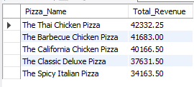

**I. Bottom 5 Pizzas by Revenue**

select name Pizza_Name,cast(sum(price) as decimal(10,2)) as Total_Revenue

from order_details

join pizzas using (pizza_id)

join pizza_types using (pizza_type_id)

group by name

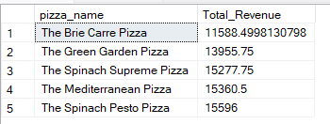order by total_revenue asc limit 5;

**J. Top 5 Pizzas by Quantity**

select name as Pizza_Name, sum(quantity) as Pizza_sold

from order_details

join pizzas using (pizza_id)

join pizza_types using (pizza_type_id)

group by name

order by Pizza_sold desc limit 5;

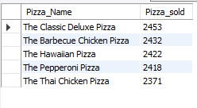

**K. Bottom 5 Pizzas by Quantity**

select name as Pizza_Name, sum(quantity) as Pizza_sold

from order_details

join pizzas using (pizza_id)

join pizza_types using (pizza_type_id)

group by name

order by Pizza_sold asc limit 5;

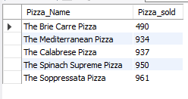

**L. Top 5 Pizzas by Total Orders**

select name as Pizza_Name, count(distinct(order_id)) as Total_orders

from order_details

join pizzas using (pizza_id)

join pizza_types using (pizza_type_id)

group by name

order by total_orders desc limit 5;

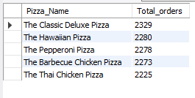

**M. Borrom 5 Pizzas by Total Orders**

select name as Pizza_Name, count(distinct(order_id)) as Total_orders

from order_details

join pizzas using (pizza_id)

join pizza_types using (pizza_type_id)

group by name

order by total_orders ASC limit 5;

