Andrey Kashirin
Agile Manager
Moscow, Russia
kashirinas@rambler.ru
+7 926 014 2327
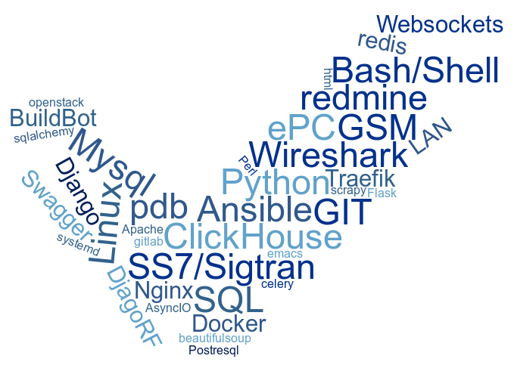
Tech i've been touched more than 1 month

Summary
I’ve started my career as a telecom engineer, meanwhile having high passion to software development. Both of these fields are joined in my position as a leader of the team, developing software for telco.
I do like learning: during daily trip to work I read some technical books or watch courses.
I’ve been working in startups where we had very limited resources at the beginning and I’ve had to try different roles, therefore I’ve got practical understanding of daily tasks and the needs of participants of software company’s team; later when team grew I took more management functions.
My team and I both had high attitude and motivation regardless nature of task or problem therefore there were no failed technical tasks, where we took part. Of course that implies work under high pressure and in agile environment.
I can abstract from problem to be able to look on to in from different angles, which may speed up its solving. As a good side effect of this, quite frequently, I see both points of view of arguing parties, so I help them to reach understanding.

I assume that it's more natural to read from the top to the bottom, thus I placed my experience in reversed order:

Education
- 2001 - 2006, Mordovia State University named after N.P. Ogarev (MSU), Bachelor, of mathematics, applied mathematics and information science.
I've got bachelor degree of applied math in the university where we studied a number of languages and math that could be applied to algorithms. Graduation work – “Development of CAD software for control cnc machines.”. An application which allows to import from AutoCAD and alter; or create from scratch 3D drawing and export it into machine’s native format to create a product.

Employment history
- June 2005 - June 2009 , ZTE ; then Huawei, Technical Support Engineer, . Moscow, Russia
B2B; Telco circuit switching core
In both companies I had similar duties: providing full-cycle deployment of 2/3G telecom CS core equipment. I've got valuable experience working in customer-facing environment; under high pressure and of course good knowledge of telecom standards plus business processes (huawei borrowed processes from IBM) and corporate culture.
- September 2009 - July 2014 (4 years 11 months), Oracle, Professional service engineer, remote, Mulhouse, France
B2B; Telco probed passive monitoring equipment, service assurance.
Here I continued dive into telecom. I worked with network monitoring system. I've deepen understanding how networks work (literally down to the bits) and written few apps which were included into the distribution image. Here I've got experience working in multicultural (although mainly western) environment having colleagues form the Europe and the US.
- April 2013 – February 2019. Rivasense; then renamed to SysQual, Development Lead. Moscow, Russia
B2B; Development of Telco probed passive monitoring equipment.
This is my long-play. Considering negative experience with the system in Oracle we decided to develop our own from the scratch. Here I shared many roles as this startup grew up before my eyes. I started as business analyst, then added architecture, then database design and architecture and python backend development and finally devops). As company got larger I passed some of
these roles to my new colleagues, but quite frequently I had to recall my duties to assist in difficult case. Management of the team of 23 members (12 developers), including 75% remote members. Each domain has its own language and technologies, but I list major: clickhouse, mysql, linux, nginx, ansible, systemd, openstack, vmware, ansi c, php, js, python, sql. I had to know each at basic level, because sometimes in case of rush I helped to make some patches. Product won a quite demanding tender in Tier I telco operator. Finally product was bought by large swiss competitor and buried(
- April 2019 – present. HyperQuant, BE Team Lead. Moscow, Russia
B2C; Fin-tech.
I manage development and delivery of several cryptocurrency trading products. Team consists of both office and remote developers. As far as it’s startup with limited budged – I have hands on experience with development. BackEnd is a bunch of services (not exposed to public) and API endpoints for web gui. All backend is written on python: django, django-rest. DBs are: ClickHouse and Postgres. We use CI/CD with: gitlab, github, docker and almost ready to jump into AWS. Of course this is relatively new industry for me and I had to learn a lot of things, but I like learning.

Hobby
- Skiing
- Bike

