from machine import Pin

from time import sleep

# Define the PIR sensor, LED

PIR sensor Pin(28, Pin.IN)

RedLED = Pin(27, Pin.OUT)

try:

while True:

# PIR sensor detects motion

if PIR sensor.value() == 1: print("\033c") # Clear Terminal

RedLED.high() sleep(7)

print("Motion Detected!")

else:

RedLED.low()

sleep(1)

except keyboardInterrupt: Pin.cleanup()

print("Exiting')

print("Cleaning up!")

display.clear()

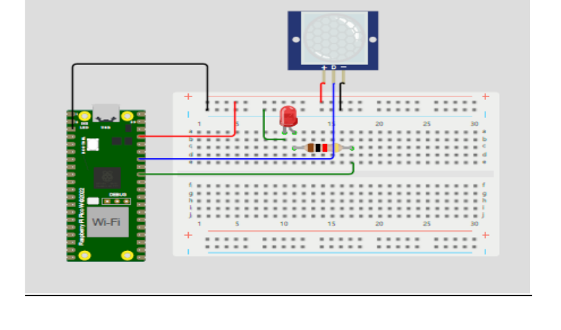

—---------------------------------------------------------------------------------------------

import sqlite3

conn = sqlite3.connect('my_database.db')

print("OPENED DATABASE SUCCESSFULLY")

conn.execute("CREATE TABLE IF NOT EXISTS PERSON (NAME TEXT, AGE INT, SALARY REAL)")

print("TABLE CREATED SUCCESSFULLY")

conn.execute("INSERT INTO PERSON (NAME, AGE, SALARY) VALUES ('RAKESH', 90, 200)")

conn.execute("INSERT INTO PERSON (NAME, AGE, SALARY) VALUES ('VAIBHAV', 21, 20000)")

conn.execute("INSERT INTO PERSON (NAME, AGE, SALARY) VALUES ('GIRISH', 66, 20000)")

conn.commit()

print("INSERT DONE SUCCESSFULLY")

cursor = conn.execute("SELECT NAME, AGE, SALARY FROM PERSON")

for row in cursor:

print(f"NAME={row[0]} AGE={row[1]} SALARY={row[2}")

conn.execute("UPDATE PERSON SET SALARY = 25000.00 WHERE NAME = 'GIRISH'")

conn.commit()

print("UPDATE DONE SUCCESSFULLY")

conn.close()