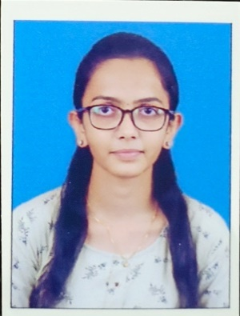**Sakshi Atul Kandage**

**Address:** Near Market Yard Chakan, Tel-Khed,

Dist- Pune, Pin no- 410501

**Email :** [kandagesakshi55@gamil.com](mailto:kandagesakshi55@gamil.com)

**Mobile :** 8605947621

**CAREER OBJECTIVES:**

Currently seeking a challenging work placement opportunity within a dynamic firm, which will offer early responsibilities and the opportunity to develop practical skills.

**ACADEMIC QUALIFICATION:**

|  |  |  |  |  |
| --- | --- | --- | --- | --- |
| Education | Institution | University | Year | Grade |
| FY(MSC)-CS | MIT Arts, Commerce & Science College, Alandi | Savitribai Phule Pune University | 2023-2024 | Appearing |
| BSC-(CS) | MIT Arts, Commerce & Science College, Alandi | Savitribai Phule Pune University | 2021-2023 | 76.45% |
| 12th (HSC) | Mahatma Gandhi Vidyalaya & Jr.College, Rajgurunagar | Maharashtra State Board | 2020 | 60.00% |
| 10th (SSC) | ST.Xavier’s High School, Panchgani | Maharashtra State Board | 2018 | 73.60% |

**COMPUTER AND OTHER CERTIFICATION COURSES:**

* Certification for Completion of C Programming Training
* Certification for Completion of HTML Training

**SKILLS:**

* C
* HTML & CSS
* Java Beginner
* Python Beginner
* Honesty and Hardworking

**STRENGTHS:**

* Quick Learner
* Teamwork
* Ability to adopt challenging situations

**EXTRA-CURRICULAR ACTIVITIES:**

* Participated in District Level VolleyBall & BasketBall Match

**HOBBIES:**

* Drawing
* Travelling
* Listening Music
* Learning New Things

**PERSONAL DETAILS:**

* Name : Sakshi Atul Kandage
* Gender : Female
* Date of Birth : 20th April 2002
* Marital Status : UnMarried
* Nationality : Indian
* Language Known : Hindi, Marathi, English

**DECLARATION:**

I do declare that all information and particulars furnished here by me are true and correct to the best of my knowledge.

DATE:

PLACE: Chakan, Pune Sakshi Atul Kandage