Q1. Create a function to reverse a list in Python. Use an AI tool to suggest alternative
implementations. Test and compare the performance of each version.
(Each question carries 5 marks)

Prompt:write a python code to create a function to reverse a list in python and suggest alternative implementations and test and compare the performance of each version and display the reversed list.

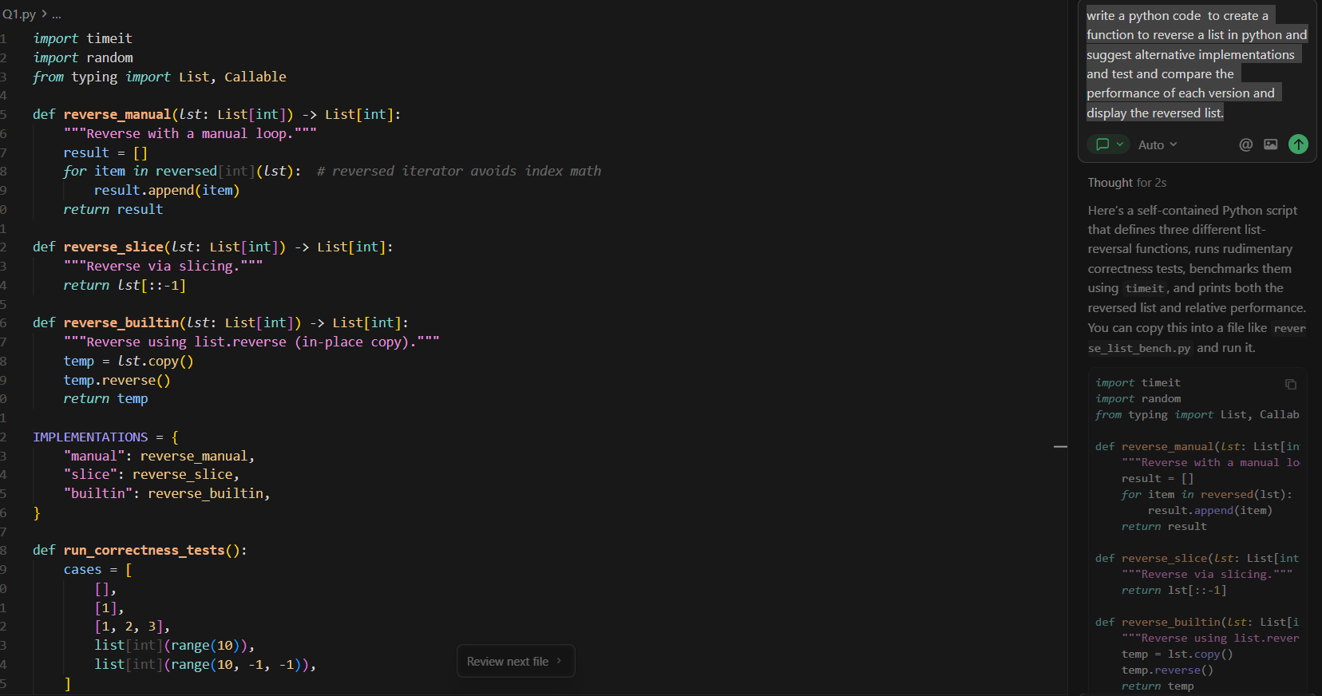

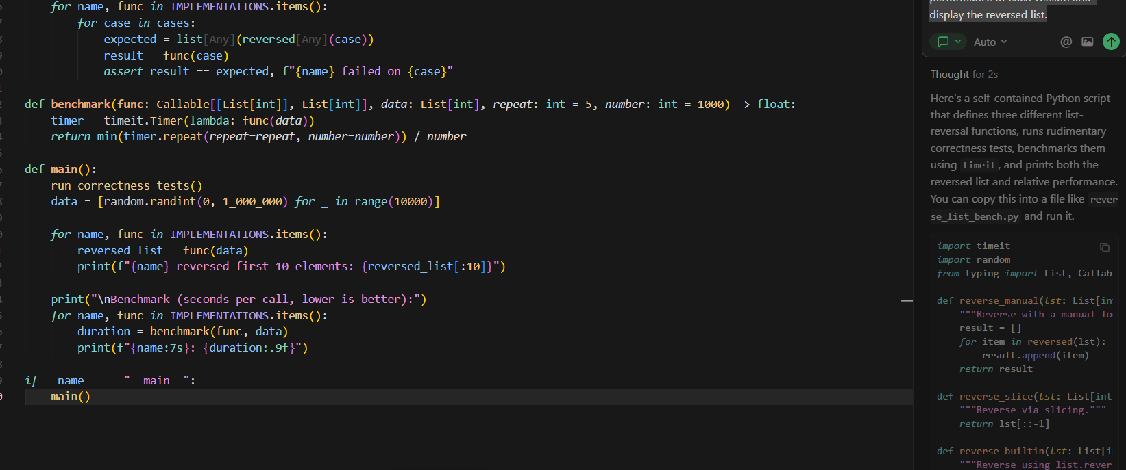

Output:
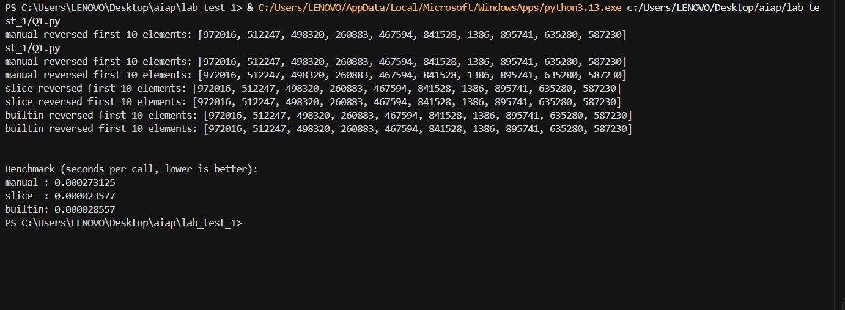

Q2. Design a few-shot prompt to guide an AI tool in writing code for a basic linked list
with methods for insert and delete. Analyze the resulting code for correctness and
completeness.
(Each question carries 5 marks)

Prompt:
write a user input python code for a basic linked list with methods for insert and delete
examples:
Input:
Insert the numbers: 1, 2, 3, 4, 5
Output:
Linked list becomes:
1 → 2 → 3 → 4 → 5
Input:
Delete the number: 3
(Current list: 1 → 2 → 3 → 4 → 5)
Output:
Linked list becomes:
1 → 2 → 4 → 5
Input:
Insert the numbers: 10, 20
(Current list: 1 → 2 → 4 → 5)
Output:
Linked list becomes:
1 → 2 → 4 → 5 → 10 → 20

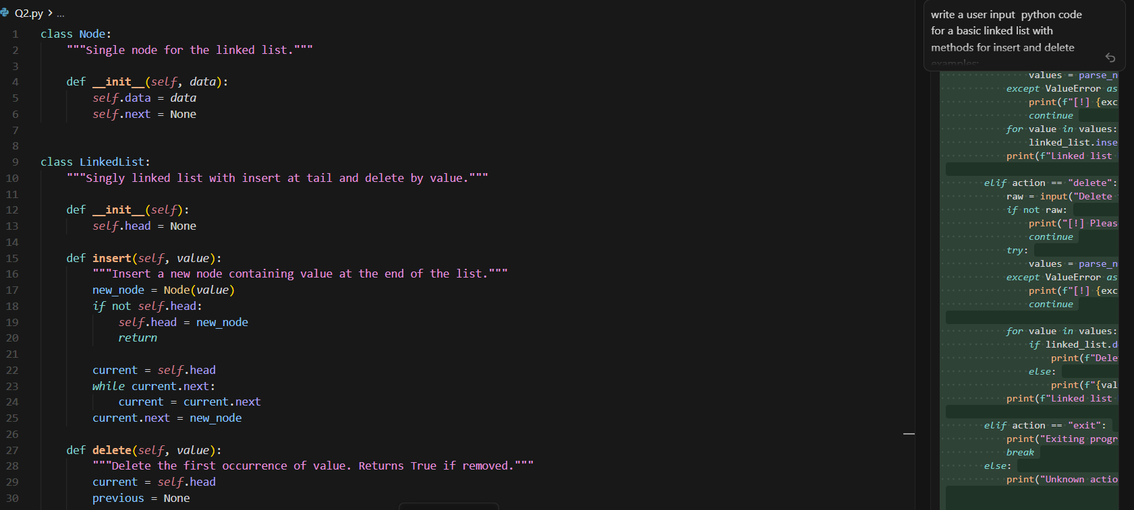

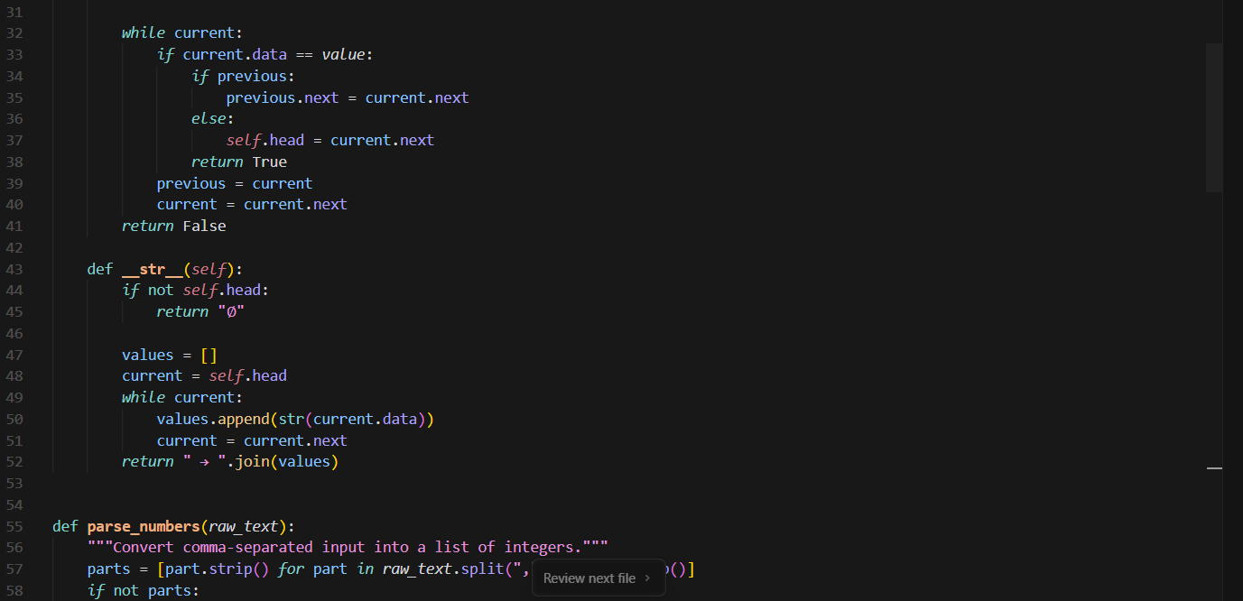

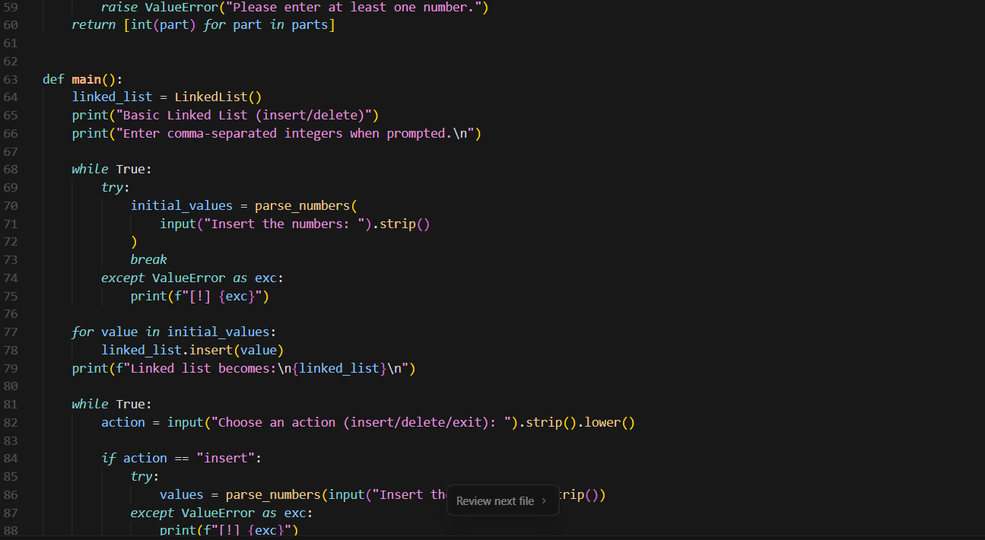

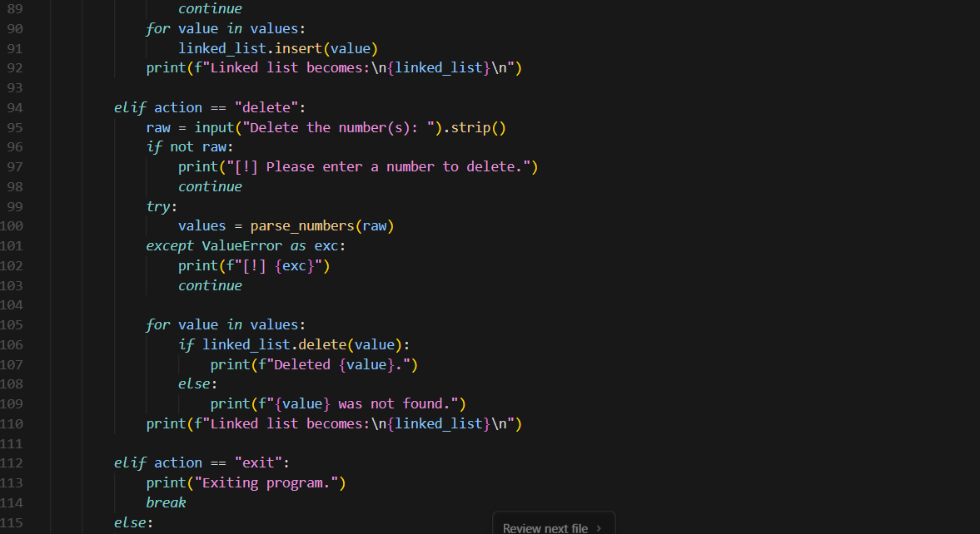

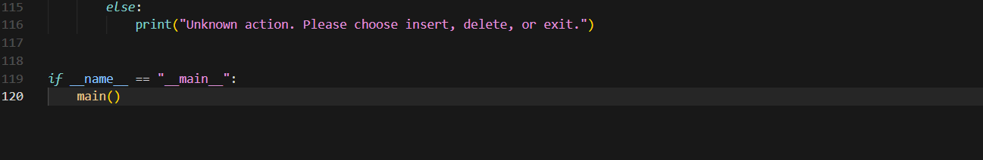

Output:

