1.43bn  Sum of DUTY PAID_INR |  | 22.35M  Sum of QUANTITY |  | 53.77M  Sum of TOTAL VALUE_USD |  | 100.00%  %GT Sum of TOTAL  VALUE_USD
Year, Quarter, Month, Day   2017   2018   2019   2020   2021   2022 | 
100.00%
%GT Sum of DUTY PAID_INR
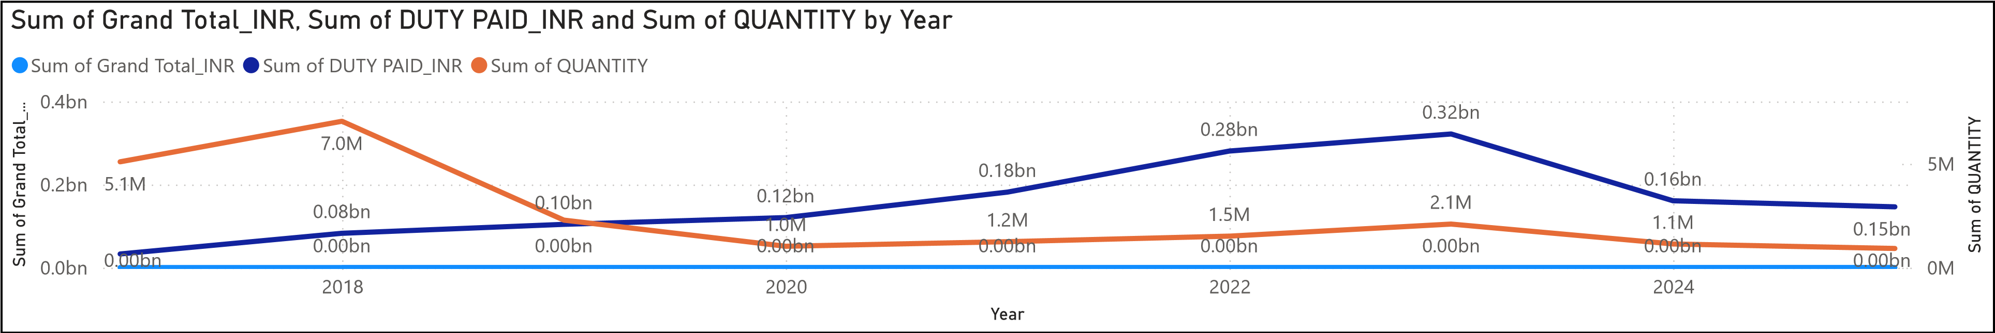
SIDHARTH ASSOCIATES

Sum of TOTAL VALUE_INR, Sum of Grand Total_INR and First Model Name by Sub Category |  | Sum of Grand Total_INR by Sub Category  100%  Other  Lunch Box  Cloth Stand  Tea Strainer  Scrubber48.05K  Hanger 17.01K Basket 14.54K  Holder 9.28K  Sprinkler 6.90K  1.3%
  Other | Lunch Box | Cloth Stand
  Sum of TOTAL VALUE_INR | Sum of TOTAL VALUE_INR | Sum of TOTAL V…
  Sum of TOTAL VALUE_INR | Scrubber  Sum of TOTAL VALUE_INR |  | Hanger  Sum of TOTA…
  Sum of TOTAL VALUE_INR | Tea Strainer  Sum of TOTAL VALUE_INR
  Sum of TOTAL VALUE_INR | Tea Strainer  Sum of TOTAL VALUE_INR |  | Sprinkler
  Sum of TOTAL VALUE_INR | Tea Strainer  Sum of TOTAL VALUE_INR |  | Basket
  542.59K
  85.89K
  59.88K
  56.23K
Sum of Capacity and Avg Landed Cost Per Unit
