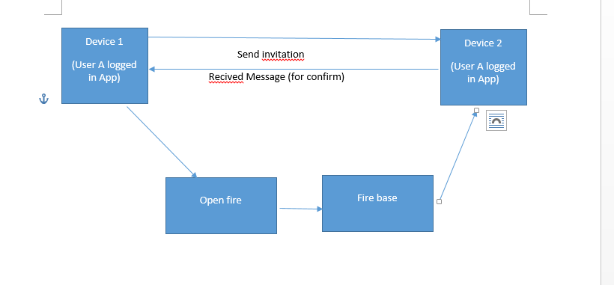

1) When user is logged in app, message can be send by openfire.

2) When user is logout in app, message cannot be sended anywhere.

3) When user is offline without lost xmpp socket connect by no WIFI , no battery, no Internet and also app is sleeping mod, message can be sended as FCM message by using openfire plugin.

And

1. Web service put SSL, Openfire Put ssl
2. Groupchatting is v2