
FACULTY: FACULTY OF ICT

PROGRAMME: PROGRAM

YEAR: 2

LECTURER: Ms. MARY KADWA

FROM: Priscilla Kandaya

COURSE: OOP

COURSE CODE: BSCICT 2203

DUE DATE: 2nd APRIL 2026

Code 1:
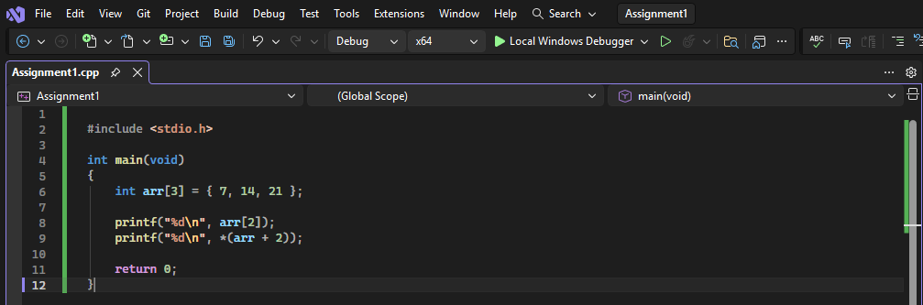
Output:
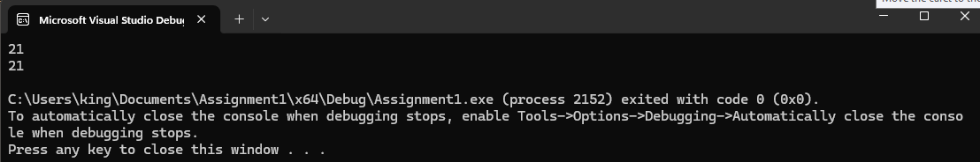
This program demonstrates how arrays and pointers are related in C. The array arr contains three values: 7, 14, and 21. The expression arr[2] accesses the third element of the array directly, while *(arr + 2) uses pointer arithmetic to access the same element. Both methods produce the same result, showing that array indexing and pointer arithmetic are interchangeable in C.
Code 2:
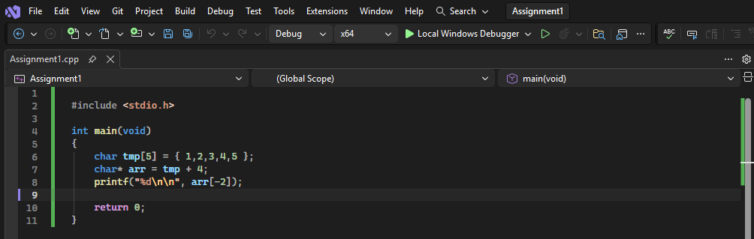
Output:
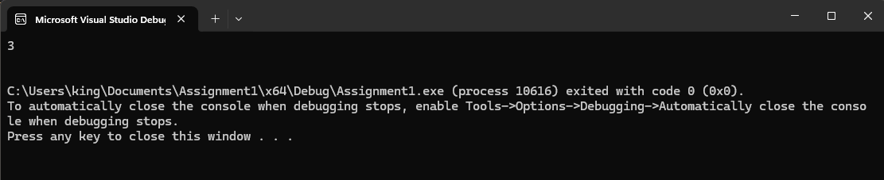
In this program, we declare an array tmp with five elements and then create a pointer arr that points to the last element of the array. Using arr[-2] in the printf statement allows us to access the value two positions before the pointer, which in this case is the number 3. This demonstrates how pointers in C can be used not only to traverse arrays forward but also to move backward, giving more flexible control over memory access.

Code 3:
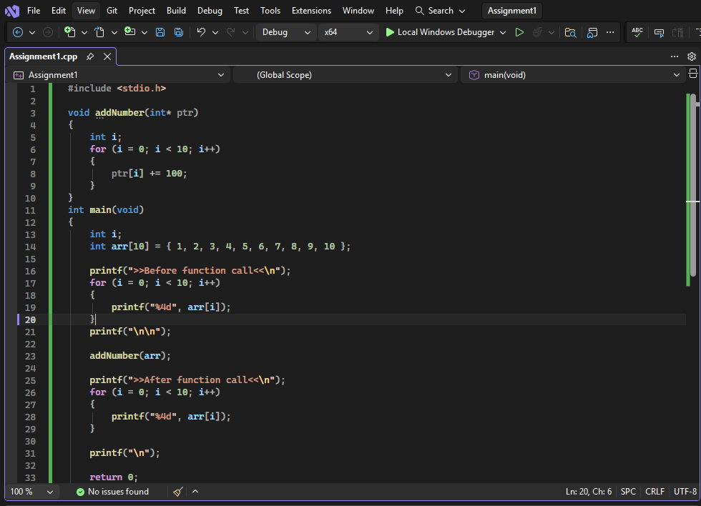
Output:
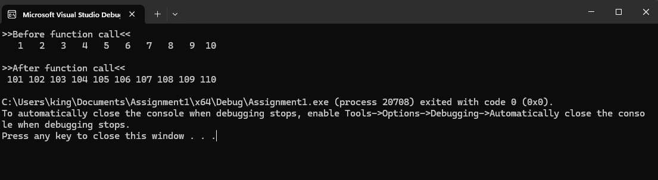
This program demonstrates how a function can modify an array using pointers. The array is passed to the function addNumber() as a pointer, allowing direct access to its elements. Inside the function, a loop adds 100 to each element. Since arrays are passed by reference in C, the changes affect the original array. The output before and after the function call confirms that all values were successfully updated.After the function call, the modified array is printed again. The output shows that all values have increased by 100, proving that arrays are passed to functions by reference (using pointers), meaning changes inside the function affect the original array.
Code 4:
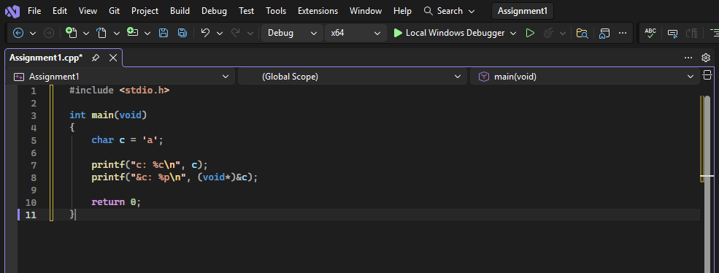
Output:
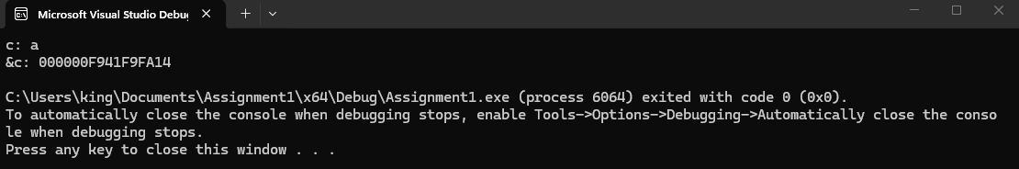
This program demonstrates how to display both the value and the memory address of a variable in C. It declares a character variable c and initializes it with the value 'a'. The printf function is then used twice: the first call prints the value of c using the %c format specifier, while the second call prints the address of c by casting it to (void*) and using the %p format specifier.

Code 1:
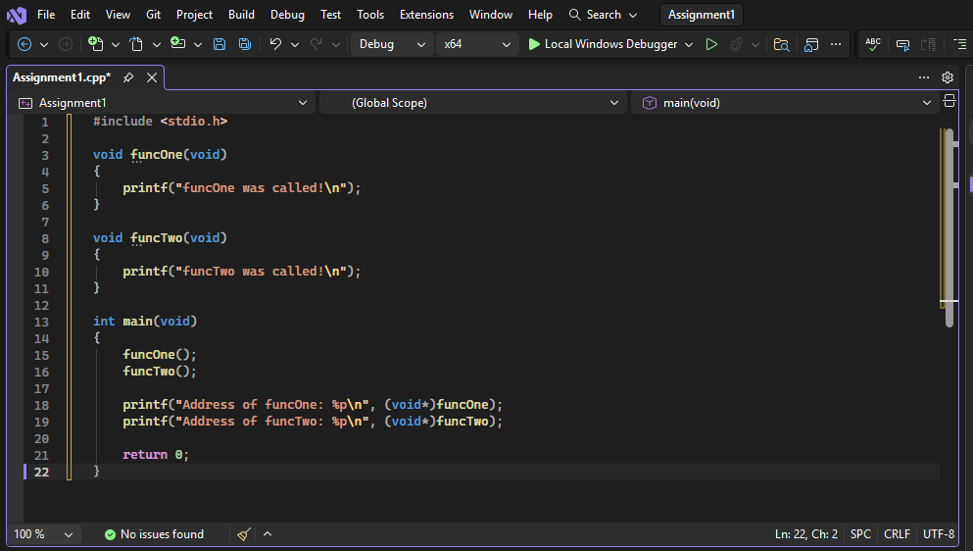
Output:
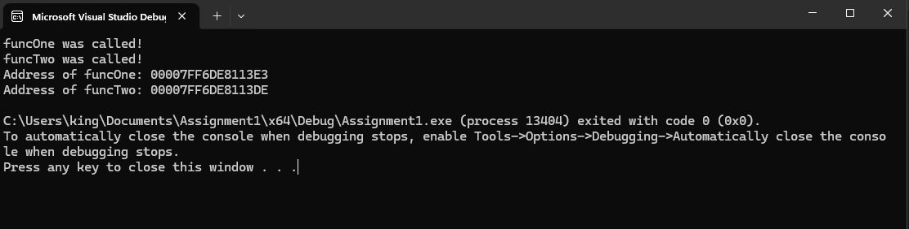
This program demonstrates functions and function addresses in C. Two functions, funcOne and funcTwo, are defined and called in the main() function. Each function prints a message when executed. The program also prints the memory addresses of both functions using %p. In C, function names represent the starting address of the function in memory, meaning they can be treated like pointers.
Code 2:
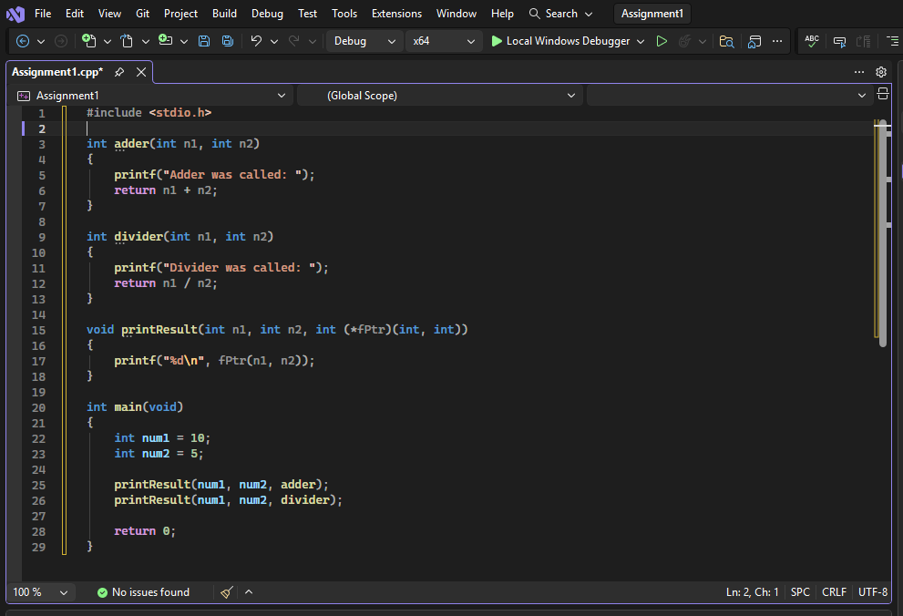
Output:
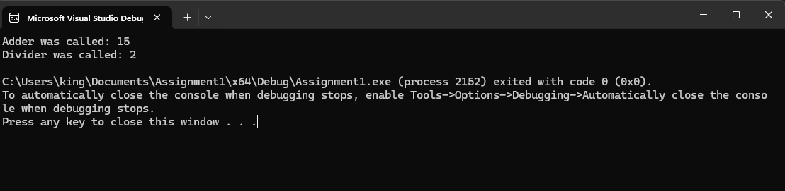
This program demonstrates the use of function pointers in C. Two functions, adder() and divider(), perform addition and division respectively. The function printResult() accepts a function pointer as a parameter, allowing it to call different functions dynamically. In main(), the same function printResult() is used with both adder and divider, showing how function pointers enable flexible and reusable code by selecting functions at runtime. Overall, the program shows how function pointers enable flexible and reusable code, where functions can be passed as arguments and selected at runtime instead of being hardcoded.
Code 3:
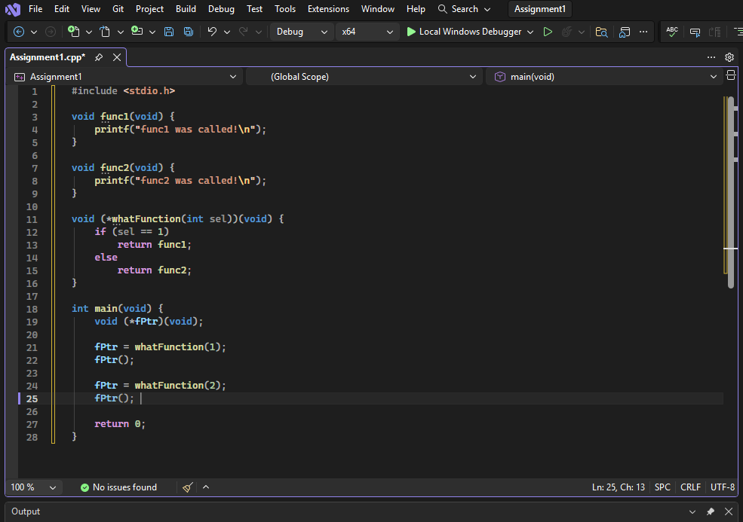
Output:
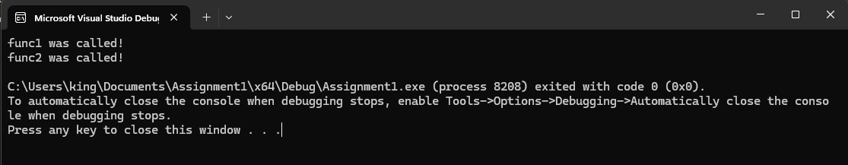
This code defines two simple functions, func1 and func2, which just print messages when called. It also has a function called whatFunction that takes a number as input and returns a pointer to one of these functions, if you pass 1, it returns func1; otherwise, it returns func2. In main, a function pointer fPtr is used to store whichever function whatFunction returns, and calling fPtr() actually runs that function. Essentially, the program demonstrates how you can choose at runtime which function to execute, making the behavior flexible instead of fixed.

Code 4:
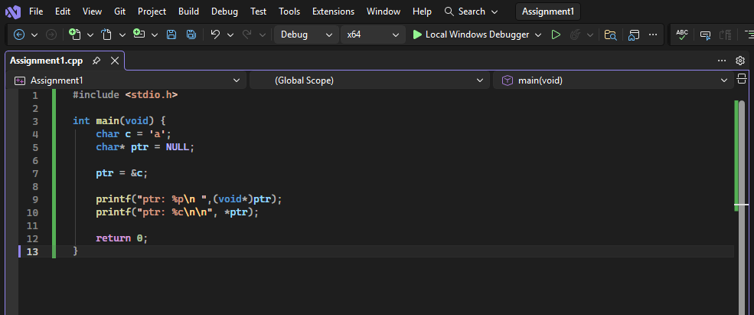

Output:
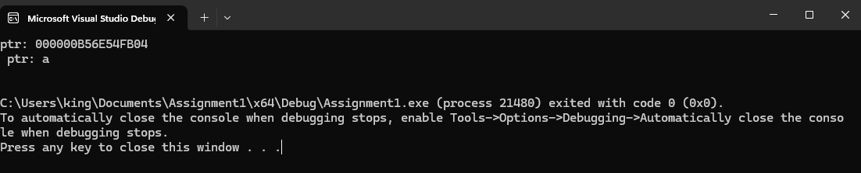
This C program shows how pointers work. It creates a character variable c and sets it to 'a'. Then it declares a pointer ptr and sets it to NULL. After that, ptr is made to point to c’s address. The program prints the value of c using the pointer and also prints the address of c stored in the pointer. Finally, it ends with return 0;. This demonstrates how to use a pointer to access a variable’s value and address.

