

**Arab Academy for Science, Technology & Maritime Transport College of Computing and Information Technology**

**Course:** Object-Oriented Programming

**Lecturer:** Dr.Fahima Maghraby**,** Dr. Wael Zakaria

**Teaching Assistant:** Eng. Maiada, Eng. Hagar, Eng. Ahmed, Eng. Karim

**Sheet:** Lab 1 Revision

Book reference: if and loop statements (Chapter 3, 5), String processing (Chapter 4)

**1.12 (Average speed in kilometers)** Assume that a runner runs 24 miles in 1 hour, 40 minutes, and 35 seconds. Write a program that displays the average speed in kilometers per hour.

(Note 1 mile is equal to 1.6 kilometers.)

**2.14 (Health application: computing BMI)** Body Mass Index (BMI) is a measure of health on weight. It can be calculated by taking your weight in kilograms and dividing, by the square of your height in meters.

Write a program that prompts the user to enter a weight in pounds and height in inches and displays the BMI.

Note one pound is 0.45359237 kilograms and one inch is 0.0254 meters.

Here is a sample run:

Enter weight in pounds: 95.5

Enter height in inches: 50

BMI is 26.8573

**\*Update your code to continue reading inputs and printing outputs until the user decides to end the program**

**3.32 (Geometry: point position)** Given a directed line from point p0(x0, y0) to p1(x1,y1), you can use the following condition to decide whether a point p2(x2, y2) is on the left of the line, on the right, or on the same line (see Figure 3.11):

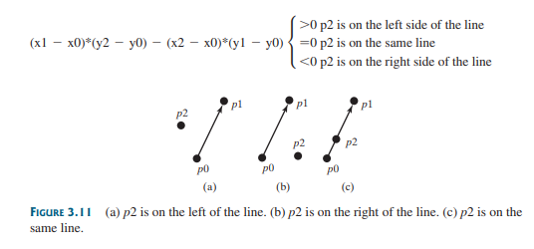

**5.49 (Count Vowels and consonants)** Assume that the letters A, E, O, U, and I are vowels.

Write a program that prompts the user to enter a string, and displays the number of vowels and consonants in the string.

Enter a string: Programming is fun

The number of vowels is 5

The number of consonants is 11