

**Arab Academy for Science, Technology & Maritime College of Computing, and Information Technology**

**Course:** CCS2401- CS212 Data Structures and algorithms min-**projects** for 12th Week

**Lecturer:** Dr. Wael Zakaria

**Teacher Assistant:** Eng.Nada Mahmoud

**Class:** CS5 & CS8

**Project Name:** yym566

**Team:**

Yassin Osama 221005138,

Youssef Ahmed Mostafa 221006460,

Mariam yasser 221006617

## Q1: Using ADT list: Consider two lists G and H. G contains the student grades in courses, and H contains the total number of credit hours in the corresponding courses. implement a function that calculates the GPA of student.

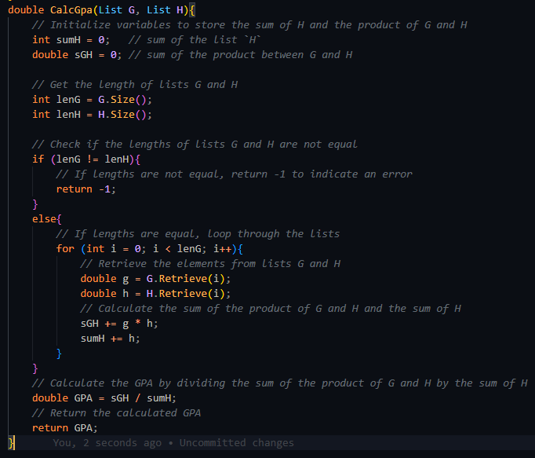

}Q2: Write a complete implementation for finding the minimum element in a binary search tree, print all the numbers that divisible by 3. You may write either a recursive or iterative implementation.A computer screen shot of text
