EX1:
Original state:
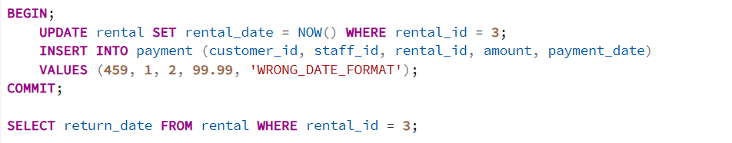
After run query:
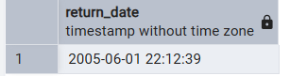
return_date didn’t update because the payment_date’s update format is wrong.
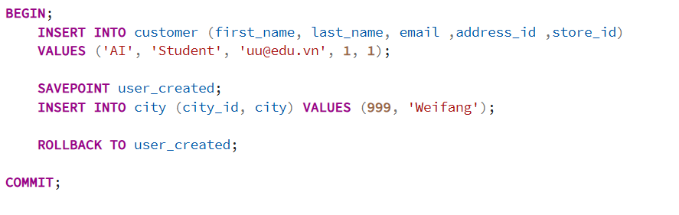
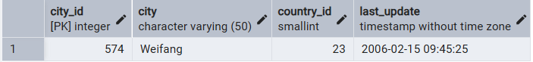

EX2:
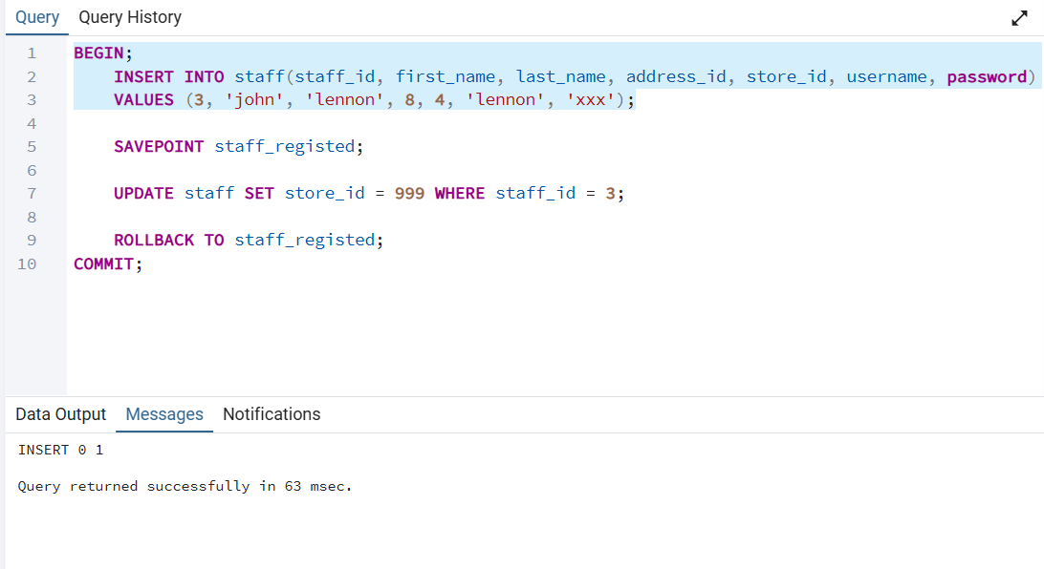
Register completed.
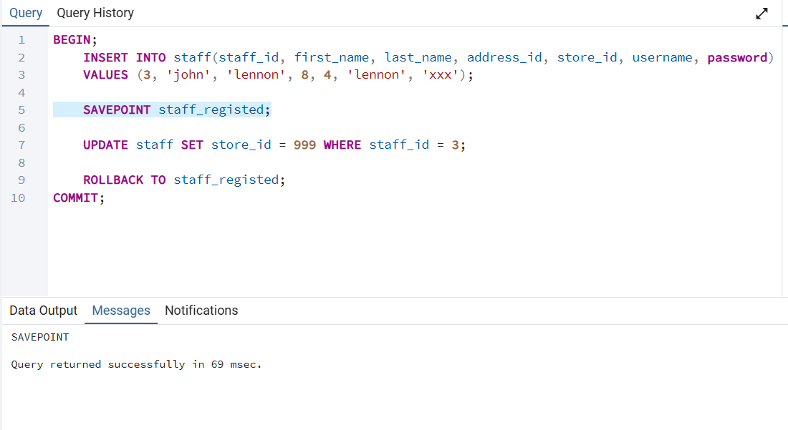
Savepoint created.
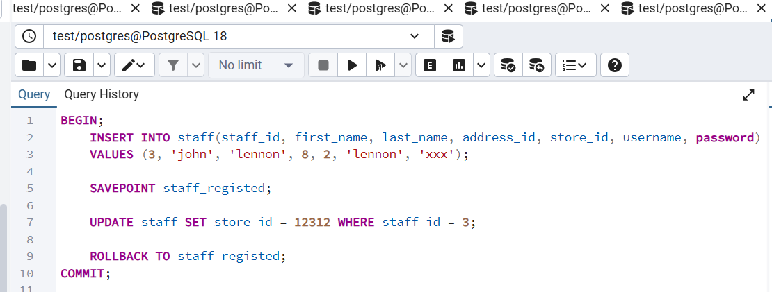somehow the code still update because store_id is not a foreign key.
1

