PS3 Action client-action server

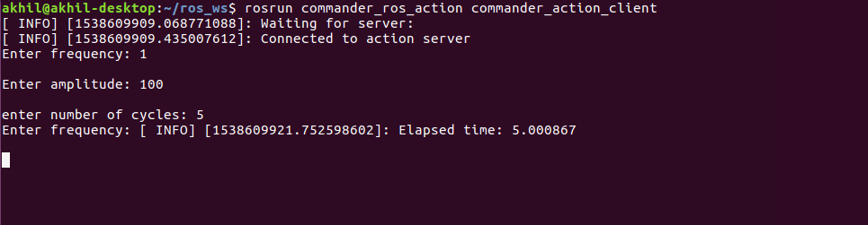Client side, asking for goals. The time at the end for 5 cycles with a frequency of 1 shows the time elapsed is 5 seconds.

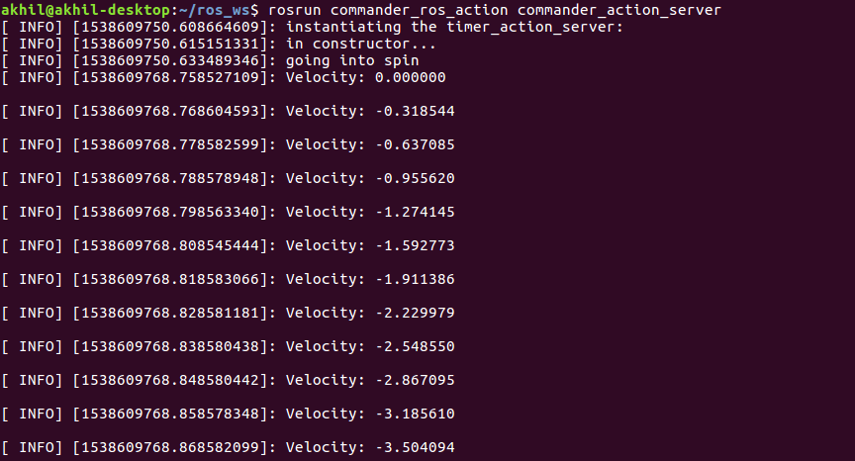Server returning commanded velocity based on given goals.