Assignment 1

1. Snapshot of using rqt_plot with minimal_simulator and minimal_controller:

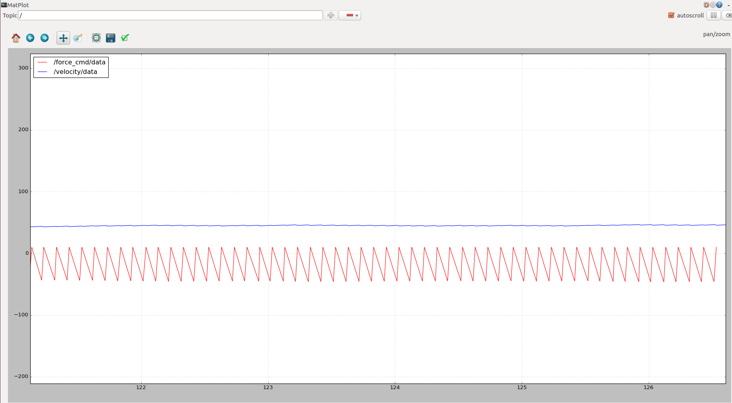
rostopic pub -r 10 force_cmd std_msgs/Float64 10

The above syntax was used to add a force to the simulator and add error to the velocity which was set at 0.

New commander node was added. Amplitude entered: 100, frequency: 10.
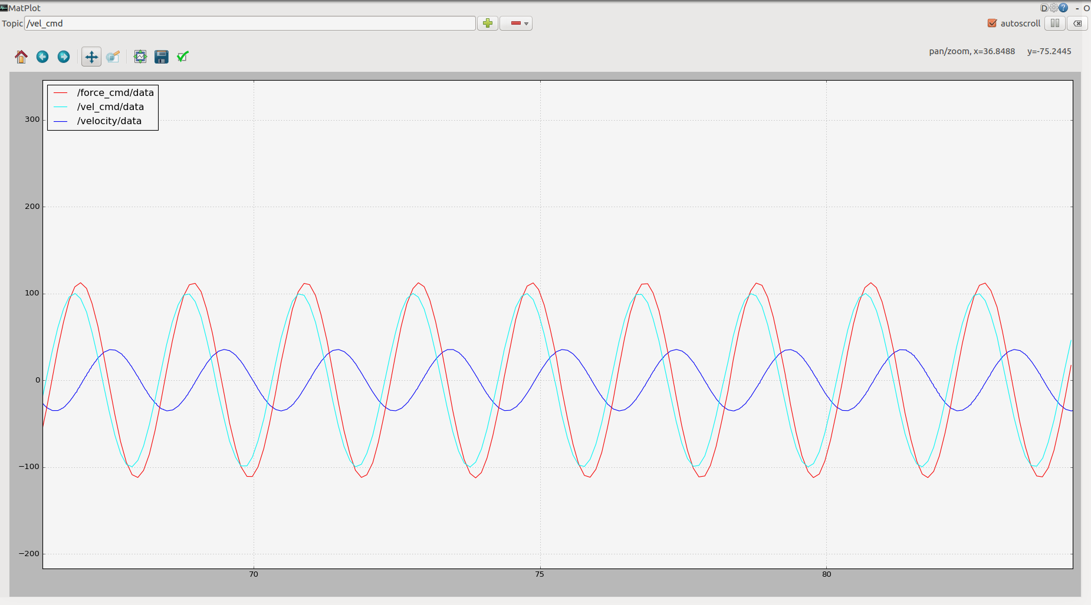
Kv = 1, dt = 0.1
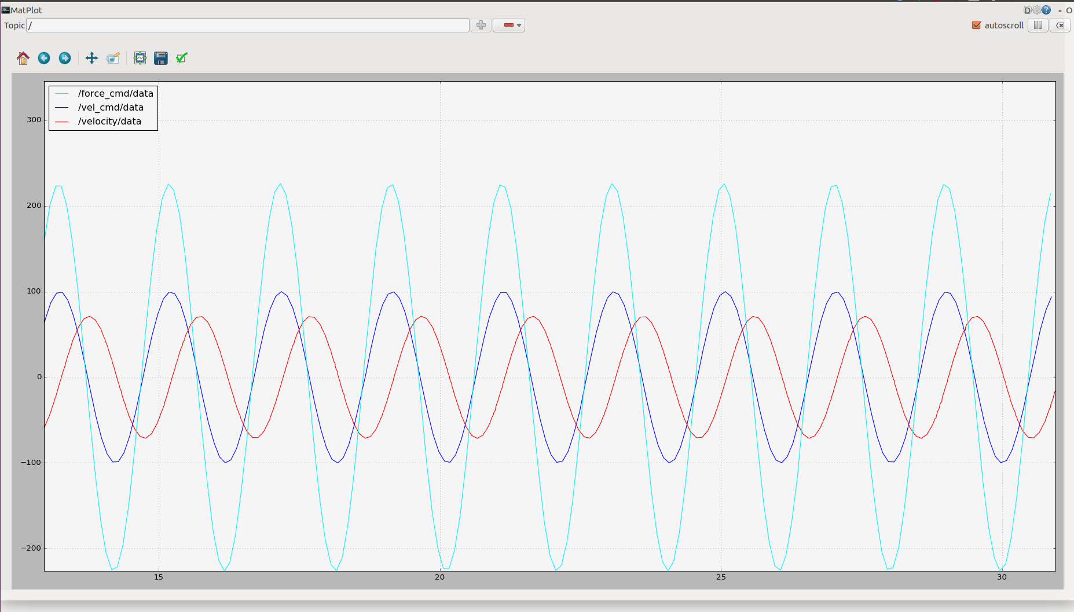
Kv = 2, dt = 0.1
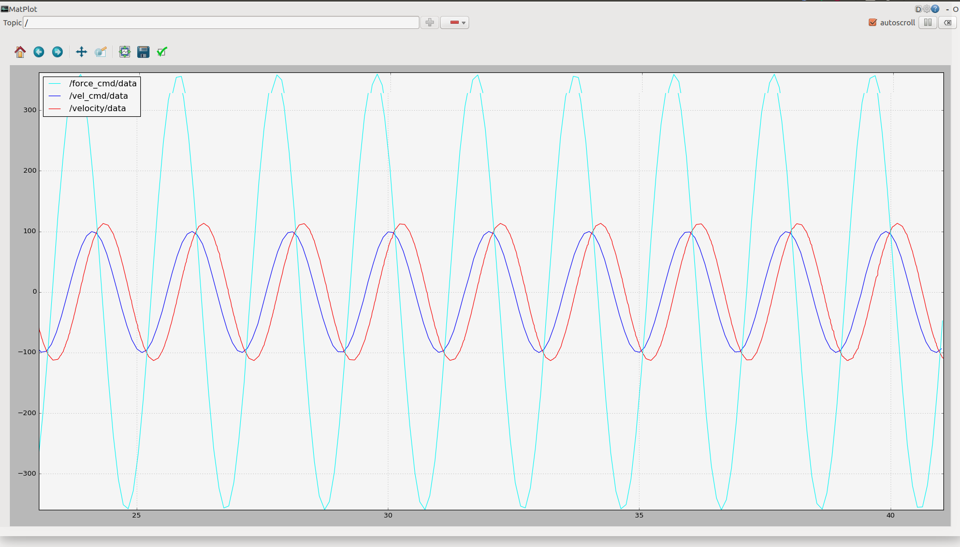
Kv = 5, dt = 0.1
As Kv keeps on increasing the performance becomes better as seen in the snapshots, however after reaching a maxima the performance becomes worse as a lot of overshoot and unwanted behavior is noticed.
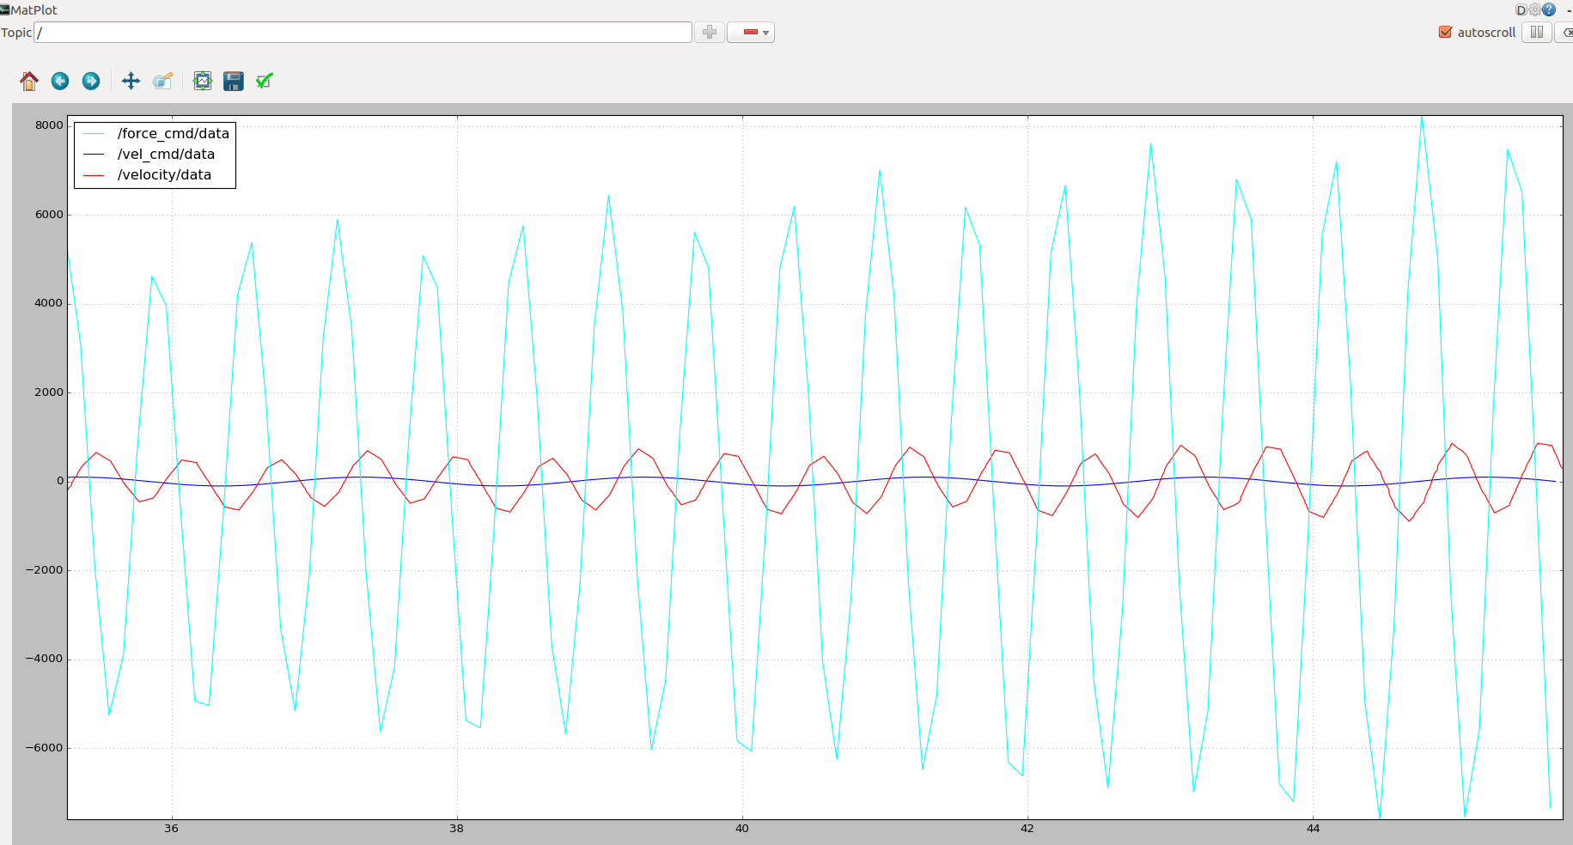
Kv = 10, dt = 0.1

On decreasing the sampling rate (0.01) the velocity and velocity command are completely out of sync and the velocity is overshoots the desired velocity by a large amount.

If the sampling rate is higher (1.0) the force_cmd imparts large forces (>1MN) to allow the velocity to catch up.

Code attached.

