Shell Scripting main Command for day-to-day activities:

--- >> **awk '{print $2}' -- All lines**

Key Differences: If we use this this will show All lines present in that “**Column = 2 “**

Eg:

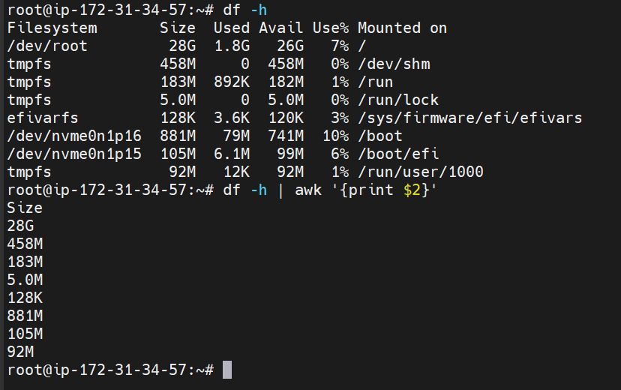

--- >> **awk 'NR==2{print $5}'** -- Only the 5th line which means **“ROW = 2 and Column = 5”**

--- >> **cut** command

This was used to cut down the values: eg :

O/P: 453% if we need only 453 then we need to use

**echo “453%” | cut -d “%” -f1 O/P : 453**

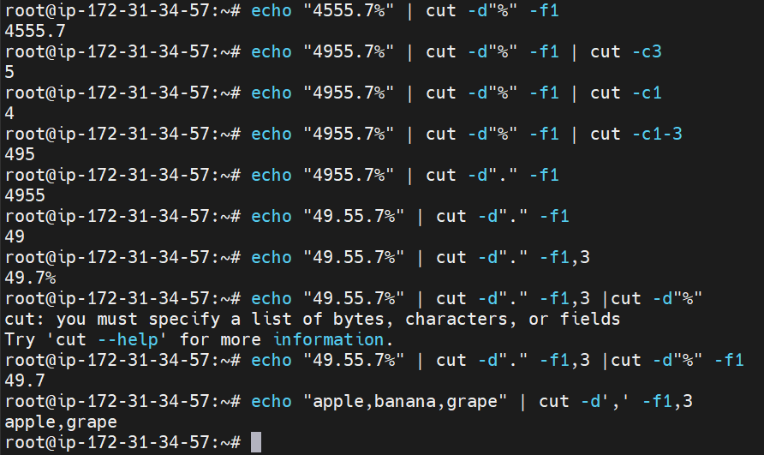

>> echo “4555.7” | cut -c1-3 --- O/P is 433 first 3 numbers