***CHAPTER - 4***

***MODELING***

*This chapter gives the unified modeling language diagrams.*

## 4. MODELING

### 4.1 Design

Requirements gathering followed by careful analysis leads to a systematic Object Oriented Design (OOAD). Various activities have been identified and are represented using Unified Modeling Language (UML) diagrams. UML is used to specify, visualize, modify, construct and document the artifacts of an object-oriented software-intensive system under development.

**4.1.1. Use Case Diagram**

In the Unified Modeling Language (UML), the use case diagram is a type of behavioral diagram defined by and created from a use-case analysis. It represents a graphical over view of the functionality of the system in terms of actors, which are persons, organizations or external system that plays a role in one or more interaction with the system. These are drawn as stick figures. The goals of these actors are represented as use cases, which describe a sequence of actions that provide something of measurable value to an actor and any dependencies between those use cases.

In this application there is only actor – soldier and below is the use case diagram of this application.



**Figure 4-1 Use Case Diagram for System**

**4.1.2 Sequence Diagram**

UML sequence diagrams are used to show how objects interact in a given situation. An important characteristic of a sequence diagram is that time passes from top to bottom: the interaction starts near the top of the diagram and ends at the bottom (i.e. Lower equals later).

A popular use for them is to document the dynamics in an object-oriented system. For each key, collaboration diagrams are created that show how objects interact in various representative scenarios for that collaboration.

Sequence diagram is the most common kind of interaction diagram, which focuses on the message interchange between a numbers of lifelines.

The following nodes and edges are typically drawn in a UML sequence diagram: lifeline, execution specification, message, combined fragment, interaction use, state invariant, continuation, destruction occurrence.



**Figure 4-4 Sequence Diagram for User**



**Figure 4-5 Sequence Diagram for Admin**

**4.1.3 Activity Diagram**

Activity diagram is another important diagram in UML to describe dynamic aspects of the system. Activity diagram is basically a flow chart to represent the flow form one activity to another activity. The activity can be described as an operation of the system.So the control flow is drawn from one operation to another. This flow can be sequential, branched or concurrent. Activity diagrams deals with all type of flow control by using different elements like fork, join etc.Activity is a particular operation of the system.



**Fig 4-6 Activity Diagram for user**



**4.1.4 Class Diagram**

In software engineering, a class diagram in the Unified Modeling Language (UML) is a type of static structure diagram that describes the structure of a system by showing the system’s classes, their attributes, operations (or methods), and the relationships among the classes.

The class diagram is the main building block of object oriented odeling. It is used both for general conceptual odeling of the odelingc of the application, and for detailed odeling translating the models into programming code. Class diagrams can also be used for data modeling. The classes in a class diagram represent both the main objects, interactions in the application and the classes to be programmed.



**Figure 4-8 Class Diagram**

**4.1.5 Deployment Diagram**

Deployment diagram shows execution architecture of systems that represent the assignment (deployment) of software artifacts to deployment targets (usually nodes).

Nodes represent either hardware devices or software execution environments. They could be connected through communication paths to create network systems of arbitrary complexity. Artifacts represent concrete elements in the physical world that are the result of a development process and are deployed on nodes.

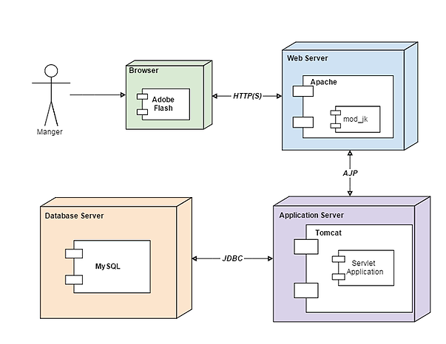

**Figure 4-9 Deployment Diagram of the system**