Set Up Environment in Azure Via Terraform

Pre-Requiesites :
    - Azure Subscription
    - Download Terraform
    - Write Terraform files to create Environmnet in Azure . Environment consist of Vnet,Subnets,Instances(public subnet – VM, Private Subnet – SQL database).

Azure DevOps CI/CD Pipelines :-

CI Pipeline :
    - Repositiory name to retrieve files (Azure Repo,Git)
    - Tasks List for Artifact creation
    - Dotnet Core Application consists following tasks
i. Restore
ii Build
iii. Publish
iv. Copy Files of Terraform to Artifact
v. PublishBuildArtifacts

CD Pipeline :
1. Define Artifact
2. Stages :
Environment Creation Stage : (Agent Pool – Hosted Agent)
        - Create Storage accont and container to store Terraform State file (Azure CLI)
        - Get Storage account key by using Powershell commands.
$key=(Get-AzureRmStorageAccountKey -ResourceGroupName
$(terraformstoragerg) -AccountName $(terraformstorageaccount)).Value[0]
Write-Host "Power shell Output"
Write-Host "##vso[task.setvariable variable=storagekey;]$key"

        - Replace Tokens to replace variable values .
        - Terraform Installer
        - Terraform init
        - Terraform plan
        - Terraform validate and apply
Note : Once Environment creation completed, we have to create Self-Hosted Agent for Copy files task in next stage. Pre-Apprval Condition need to implement before Application Deployment stage.
Application Deployment into VM stage : (Agent Pool – Self-Hosted Agent)
i. Copy files Task

Git Hub Repository :
https://github.com/kandisridhar/Azure-Terraform-Dotnet-POC.git

Screen Shots for Reference :
  - CI Pipeline (azure-pipeline.yml):
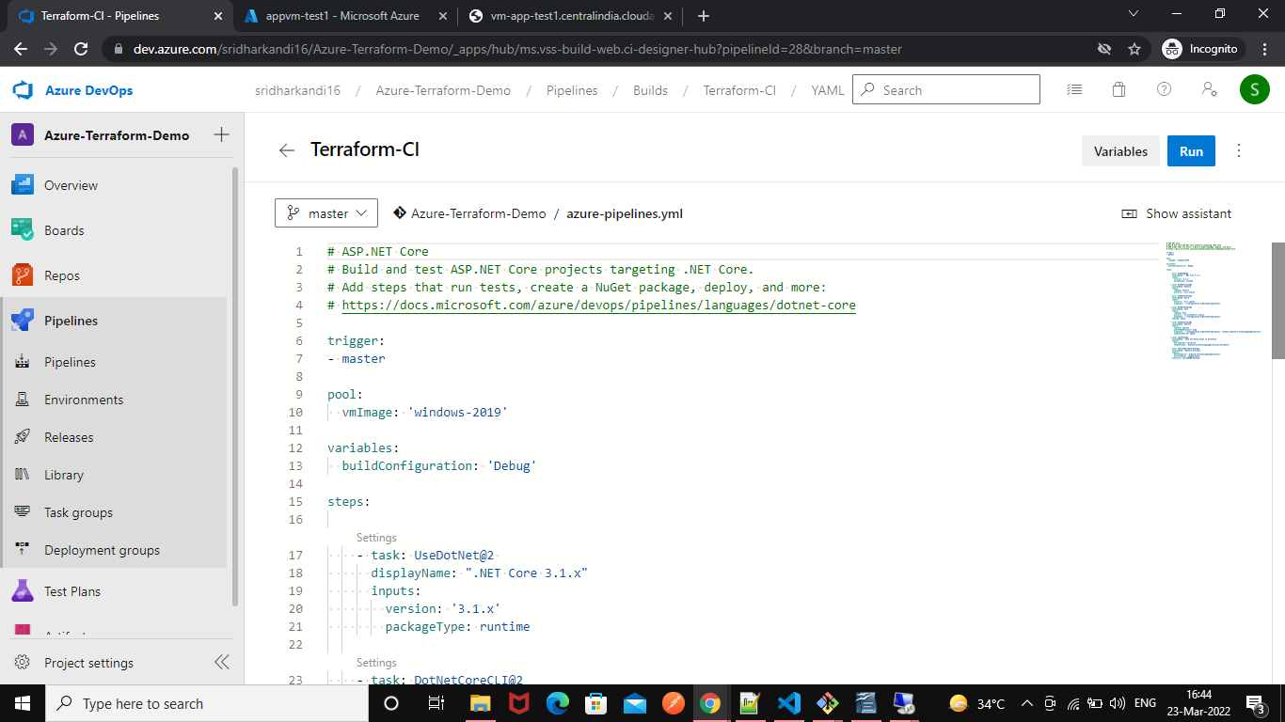
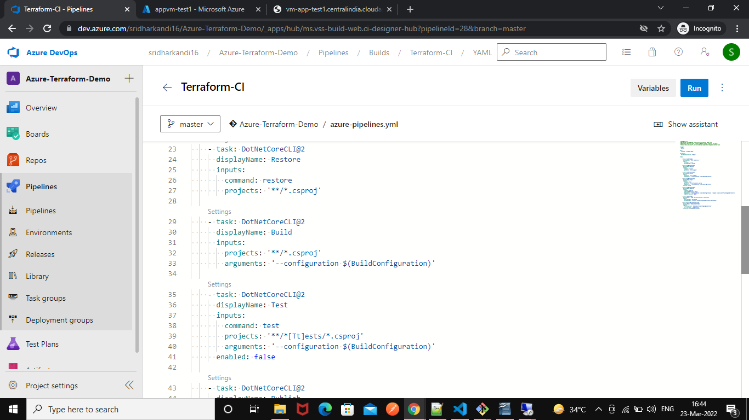
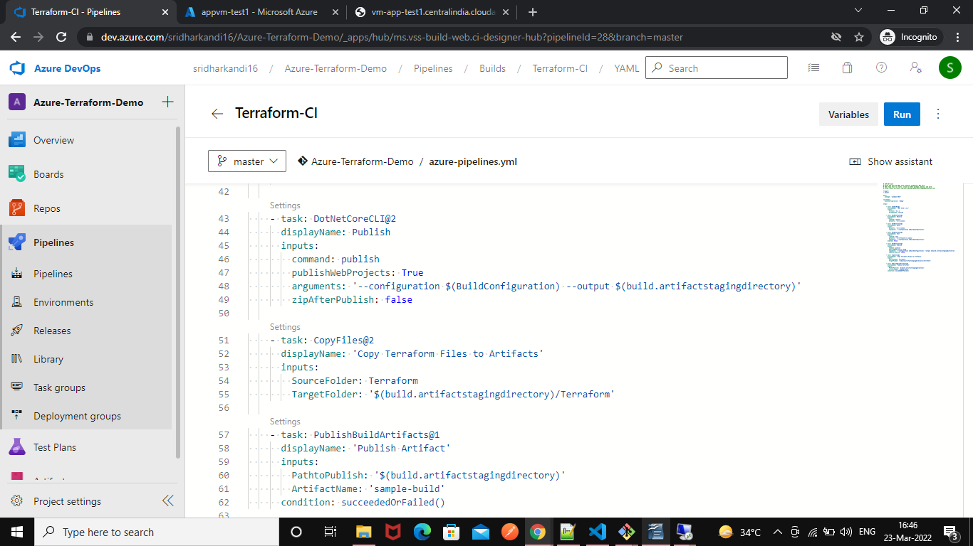
2. CD Pipeline :
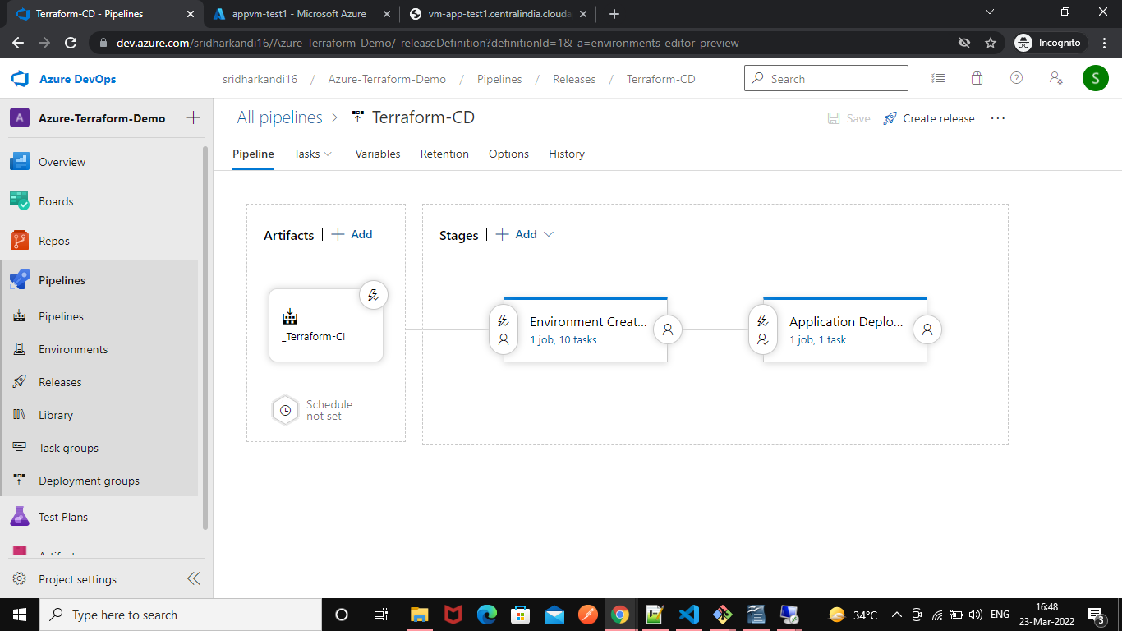

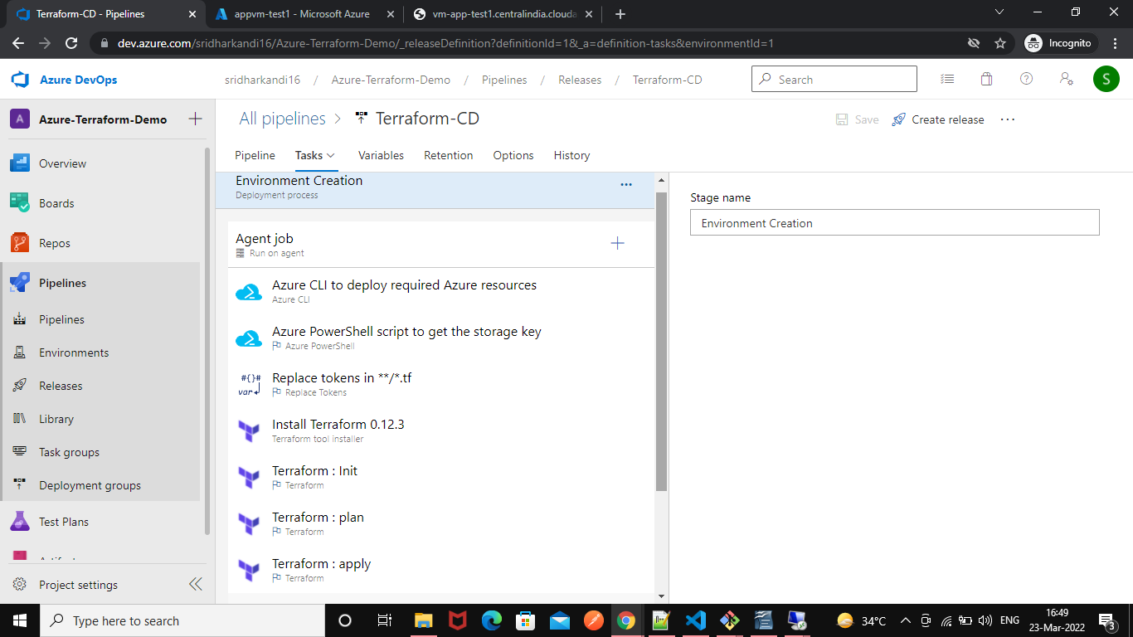

3. Create Self-Hosted Agent

