Camera System LLD:

UML Diagram: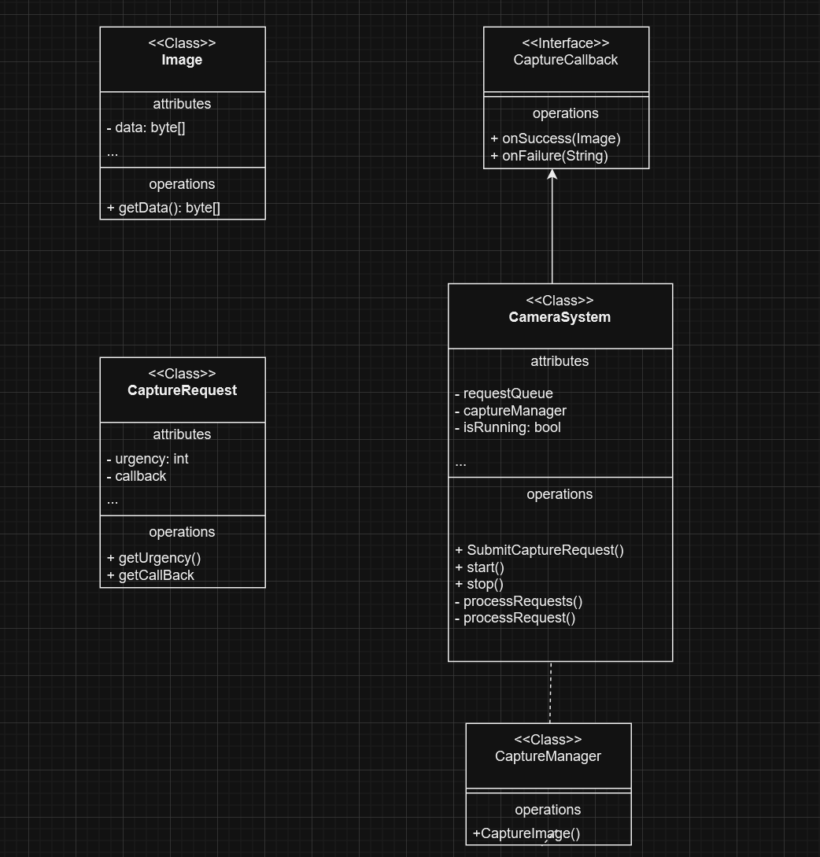

Java implementation will include following components:

**Note: The Implementation of classes and components for Camera System can be found in ``Camera_System_LLD.java`` file in the same folder.**

This Java implementation includes the following components:

1. Image: Represents a captured image.
2. CaptureCallback: Interface for capture result callbacks.
3. CaptureRequest: Encapsulates a capture request with its urgency and callback.
4. CaptureManager: Simulates the actual image capture process.
5. CameraSystem: The main class that manages the capture requests and processing.

Key points of this implementation:

1. It uses a PriorityBlockingQueue to manage capture requests based on their urgency.
2. The CaptureManager simulates asynchronous image capture using CompletableFuture.
3. The CameraSystem processes requests in a separate thread, allowing for concurrent operations.
4. Callbacks are used to handle capture results asynchronously.
5. The system can be started and stopped, allowing for proper resource management.

This implementation provides a foundation that can be extended with more features such as:

* Adding more sophisticated error handling and logging.
* Implementing a more realistic image capture process.
* Adding configuration management for system parameters.
* Implementing a more comprehensive client interface, possibly using REST APIs or WebSockets for real-time communication.