**Screenshot showing the analytics graph in Kanban tool:**

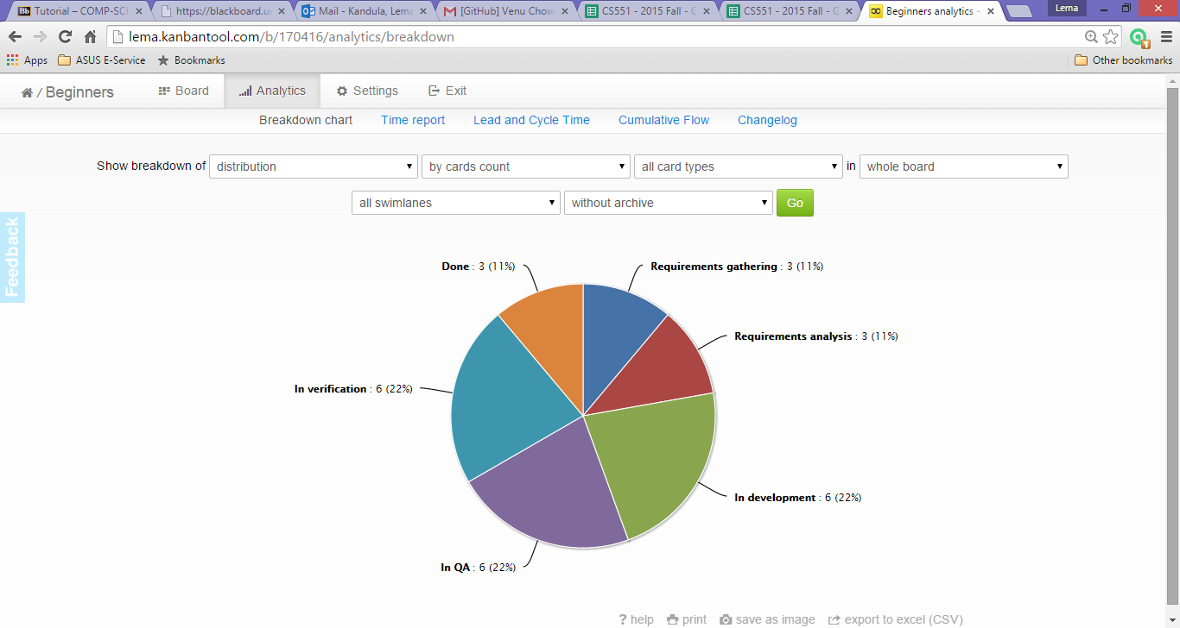

**Screenshot displaying Board of work share done in Kanban tool:**

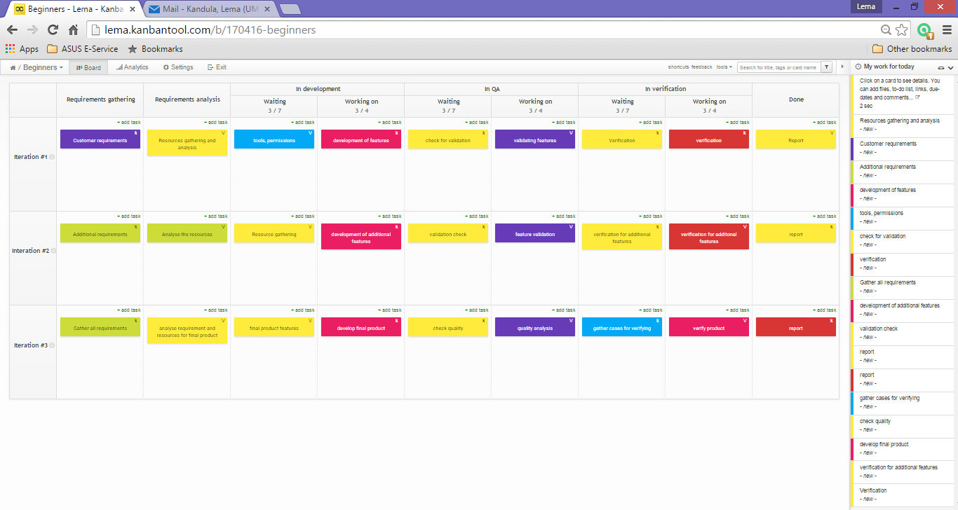

**Screenshot of Class Diagram for chat application:**

