# FORM in IIQ

**Forms**

Forms are used to present items to users for input in several components of IdentityIQ. They are used with:

l Application and role provisioning policies

l Identity provisioning policy (only applicable for installations using Lifecycle Manager)

l Data entry and approvals in workflow steps

l Present simplified views for process variable and step argument editing in workflows

l Report filter specification

**Form Types**

1. Application Provisioning Policy Form.
2. Role Provisioning Policy Form.
3. WorkFlow Form

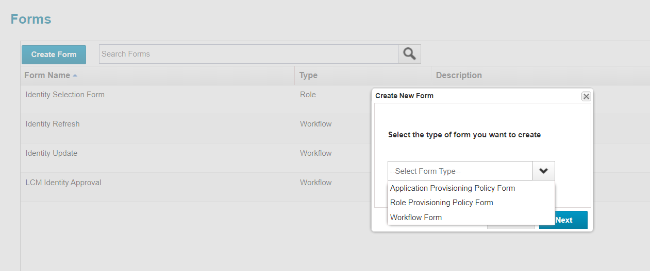

**Buttons**

Buttons enable the user to indicate which action to take next and how to process the data on the form. Buttons only apply to workflow forms. Buttons can be specified on identity provisioning policy forms, but the window does not support any action on them other than next (submit). Since **Submit** and **Cancel** buttons already exist on the window and

perform the appropriate functions for the window, additional buttons are unnecessary. They cannot be specified in aComponents of a Form Definition

role or application provisioning policy form, and they are not used by the report executor when it combines the specific report's form with the Report Form Skeleton.

Buttons require two attributes, a label and an action. The label determines the text displayed on the button. The action determines what the system does in response to clicking that button. There are four available actions:

l **next**: save (and validate fields with validation scripts where specified) any entered form data and set the work item status to approved. This can then be used in the Transition logic to advance the workflow to the next step (OK/Save/Approve/Submit functionality).

l **back**: save entered form data (no validation is performed) and set the work item status to rejected. This can then be used in the Transition logic to return to a previous step or any other appropriate action for a rejection. Saved value is redisplayed on this form if the workflow logic process back through this step again.

l **cancel**: close the form, suspend the workflow and return to previous page in user interface, this leaves work item active. awaiting a different action choice by the user.

l **refresh**: save the entered form data and regenerate the form; not a state transition - just a redisplay of the form (rarely used).

These are examples of button elements.

<Button label='Submit' action='next'/>

<Button label="Cancel" action="cancel"/>

<Button action="back" label="Back"/>

<Button action="refresh" label="Refresh"/>

**Sections**

Sections divide a form into logical groupings that are visually marked on the window with boxes around the fields in each section.

Sections contain nested field elements and might contain nested sections when sub-groupings are needed.