Rapporto tecnico

Report information
Created | 2026-10-26
Intervention from | 2026-10-24
Intervention to | 2026-10-26
Customer | Azienda Fittizia
Site | Stabilimento di test
Machine | Macchina campione
Machine serial | SYN-0042
Personnel | Tecnico Uno, Tecnico Due
Intervention types | Supervision, Extraordinary maintenance, Other
Other intervention details | Prova funzionale sintetica

Summary
1 Verifica linea ?
1.1 Controllo interno ?
2 Prova ?
Conclusioni ?

1 Verifica linea
Verifica avviata

1.1 Controllo interno
Test headings, lists and typography
Inspection sequence:
- Check mounting points
- Check motor alignment
- Record measured clearance
After the numbered list, confirm no interference.
Multilingual sample text: Italiano — Deutsche Prüfung — 日本語テスト.
Pressione stabile
Seconda riga
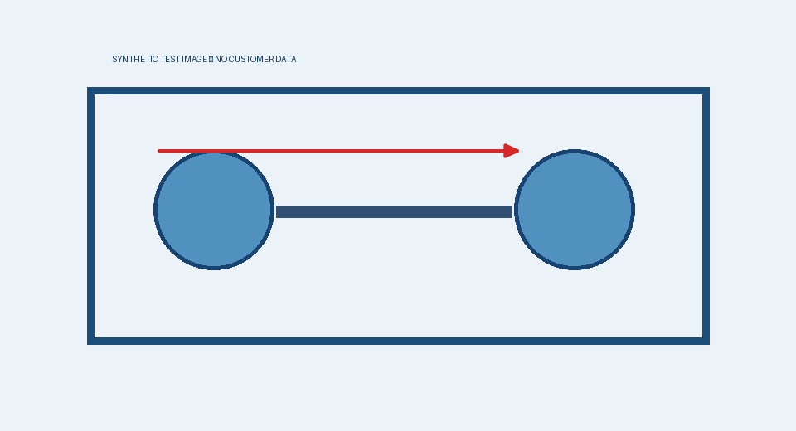
Foto dimostrativa
Parametro | Valore
Velocità | 45

Dettagli
Nota dopo il sottomodulo

2 Prova
Controllo completato
Item | Zone | Target | Observed | Result
ST-01 | Section 2 | 12.50 mm | 12.20 mm | PASS
ST-02 | Section 3 | 12.50 mm | 12.30 mm | PASS
ST-03 | Section 4 | 12.50 mm | 12.40 mm | PASS
ST-04 | Section 1 | 12.50 mm | 12.50 mm | PASS
ST-05 | Section 2 | 12.50 mm | 12.10 mm | PASS
ST-06 | Section 3 | 12.50 mm | 12.20 mm | PASS
ST-07 | Section 4 | 12.50 mm | 12.30 mm | PASS
ST-08 | Section 1 | 12.50 mm | 12.40 mm | PASS
ST-09 | Section 2 | 12.50 mm | 12.50 mm | PASS
ST-10 | Section 3 | 12.50 mm | 12.10 mm | PASS
ST-11 | Section 4 | 12.50 mm | 12.20 mm | PASS
ST-12 | Section 1 | 12.50 mm | 12.30 mm | PASS
ST-13 | Section 2 | 12.50 mm | 12.40 mm | PASS
ST-14 | Section 3 | 12.50 mm | 12.50 mm | PASS
ST-15 | Section 4 | 12.50 mm | 12.10 mm | PASS
ST-16 | Section 1 | 12.50 mm | 12.20 mm | PASS
Validation notes: the synthetic information above is intentionally fictional. Verify editable table cell widths, heading styles, photo positioning, numbered lists, automatic summary page references and the final conclusions section in Microsoft Word.

Conclusioni
Esito positivo

