 

INSTITUTE FOR ADVANCED COMPUTING AND

SOFTWARE DEVELOPMENT AKURDI, PUNE

Documentation On

**“JamDb (Japanese Animated Media Database)”**

PG-DAC SEPT 2022

**Submitted By:**

Group No: 34

**Roll No. Name:**

**229037 Kandarp Singh**

**229081 Shivam Sakore**

**Mr. Rohit Puranik** **Mrs. Gauri Kadam**

**Center Coordinator**  **Project Guide**

**ABSTRACT**

This project is a platform that allows users to easily search and access information about various forms of Japanese media, including anime, manga, films, TV shows, video games, and music..

The portal allows users to below mentioned features

**Search functionality**: Users could search for specific titles or browse by genre, release date, rating, and other categories.

**Information and reviews**: The website could provide detailed information about each title, including synopses, cast and crew information, reviews, and ratings.

**User ratings and reviews**: Users could rate and review titles, as well as share their own recommendations and opinions.

**Recommendations**: The website could provide personalized recommendations based on a user's viewing or playing history, as well as similar titles that other users have enjoyed.

**Community features**: The website could include forums, chat rooms, and social media integrations to allow users to connect and discuss their favorite titles with others.

Overall, the website would provide a comprehensive and user-friendly resource for anyone interested in Japanese media, from casual fans to hardcore enthusiasts.

**ACKNOWLEDGEMENT**

I take this occasion to thank God, almighty for blessing us with his grace and taking our endeavor to a successful culmination. I extend my sincere and heartfelt thanks to our esteemed guide, **Mrs. Gauri Kadam** for providing me with the right guidance and advice at the crucial juncture sand for showing me the right way. I extend my sincere thanks to our respected **Centre Co-Ordinator Mr. Rohit Puranik**, for allowing us to use the facilities available. I would like to thank the other faculty members also, at this occasion. Last but not the least, I would like to thank my friends and family for the support and encouragement they have given me during the course of our work.

**Kandarp Sing (229037)**

**Shivam Sakore (229081)**

**Table of Contents**

**ABSTRACT...................................................................................................................................2**

**ACKNOWLEDGEMENT............................................................................................................3**

1. **INTRODUCTION....................................................................................................................7**

**1.1 Project Objective...............................................................................................................8**

**1.2 Project Overview...............................................................................................................8**

**1.3 Project Scope ....................................................................................................................8**

**1.4 Study of the System .........................................................................................................9**

**1.4.1 Modules....................................................................................................................9**

**2. SYSTEM ANALYSIS.............................................................................................................15**

**2.1 Existing System ..............................................................................................................15**

**2.2 Proposed System ............................................................................................................15**

**2.3 System Requirement Specification................................................................................16**

**2.3.1 General Description...............................................................................................16**

**2.3.2 Problem Statement………………………………………………………………16**

**2.3.3 System Objectives .................................................................................................17**

**2.3.4 System Requirements............................................................................................17**

**3. SYSTEM DESIGN.................................................................................................................20**

**3.1 INPUT AND OUTPUT DESIGN ..................................................................................20**

**3.1.1 Input Design ...........................................................................................................20**

**3.1.2 Output Design ........................................................................................................21**

**3.2 DATABASE DESIGN ....................................................................................................21**

**3.2.1 Database.................................................................................................................21**

**3.2.2 System Tools ........................................................................................................21**

**3.3. SYSTEM TOOLS……………………………………………………………………....22**

**3.3.1 Front End.................................................................................................................22 3.3.2 Back End .................................................................................................................22**

**4. SYSTEM DIAGRAMS**

**4.1.1 1 Level DFD for Admin .........................................................................................23**

**4.1.2 1 Level DFD for Faculty.........................................................................................24**

**4.1.3 1 Level DFD for Student .......................................................................................25**

**4.1.4 E-R Diagram……...................................................................................................26**

**4.1.5 E-R Diagram System Generated…………………………………………….…..27**

**4.1.6 Class Diagram.........................................................................................................28**

**4.1.7 UseCase Diagram……………………………………………………………........29**

**5. TABLE STRUCTURE ....................................................................................................30**

**6. PROJECT DIAGRAMS..................................................................................................33**

**7. CONCLUSION ................................................................................................................**

**8. REFERENCES................................................................................................................**

**LIST OF FIGURES**

**FIGURE 1: ADMIN ACTIVITY DIAGRAM -------------------------------------------------------10**

**FIGURE 2: FACULTY ACTIVITY DIAGRAM----------------------------------------------------12**

**FIGURE 3: STUDENT ACTIVITY DIAGRAM ---------------------------------------------------14**

**FIGURE 4: 1 LEVEL DFD FOR ADMIN------------------------------------------------------------23**

**FIGURE 5: 1 LEVEL DFD FOR FACULTY--------------------------------------------------------24**

**FIGURE 6: 1 LEVEL DFD FOR STUDENT--------------------------------------------------------25**

**FIGURE 7: E-R DIAGRAM-----------------------------------------------------------------------------26**

**FIGURE 8: E-R DIAGRAM SYSTEM GENERATED--------------------------------------------27**

**FIGURE 9: CLASS DIAGRAM ------------------------------------------------------------------------28**

**FIGURE 10: USECASE DIAGRAM-------------------------------------------------------------------29**

**FIGURE 10: TABLE STRUCTURE ------------------------------------------------------------------30**

**FIGURE 11: PROJECT DIAGRAMS ----------------------------------------------------------------33**

1. **INTRODUCTION**

Japanese media, including anime, manga, films, TV shows, video games, and music, has a huge following all over the world. With the increasing popularity of these forms of entertainment, it can be challenging for fans to keep up with the latest releases or find information about their favorite titles.

A Japanese media database website could be an ideal platform to address this challenge, providing a one-stop-shop for fans to access information about various forms of Japanese media. This platform would be an online repository of information and resources about Japanese media, including anime, manga, films, TV shows, video games, and music.

The website would be designed to be user-friendly, allowing users to easily search for specific titles or browse by genre, release date, rating, and other categories. The website would also provide detailed information about each title, including synopses, cast and crew information, reviews, and ratings, making it easier for users to decide which titles to watch or play.

Additionally, the website could provide personalized recommendations based on a user's viewing or playing history, as well as similar titles that other users have enjoyed. This feature would be especially useful for users who are new to Japanese media or want to explore different genres or titles.

User ratings and reviews would also be an essential feature of the website, allowing users to rate and review titles, as well as share their own recommendations and opinions. This feature would enable users to engage with other fans and create a community around their favorite titles.

Community features such as forums, chat rooms, and social media integrations would further enhance the user experience, allowing fans to connect and discuss their favorite titles with others. Users could also create profiles, follow other users, and share their favorite titles with their followers.

**Features:-**

1. User **registration and login** for user and admin.
2. **Search functionality:** Users could search for specific titles or browse by genre, release date, rating, and other categories.
3. **Information and reviews:** The website could provide detailed information about each title, including synopses, cast and crew information, reviews, and ratings.
4. **User Profiles:** Allow users to create profiles to keep track of their viewing and reading history, as well as their favorite titles and reviews.
5. **User ratings and reviews:** Users could rate and review titles, as well as share their own recommendations and opinions.
6. **Recommendations:** The website could provide personalized recommendations based on a user's viewing or playing history, as well as similar titles that other users have enjoyed.
7. **Community features:** The website could include forums, chat rooms, and social media integrations to allow users to connect and discuss their favorite titles with others.
8. **Integration with streaming services:** The website could provide links to legal streaming services where users can watch or listen to titles, making it easy to find and access content.
9. **News and updates:** The website could feature news and updates about upcoming titles, events, and industry developments.
10. User- friendly and **secure design**
11. **Compatibility** with different browsers and devices
12. **Deployment on a web server** and accessible via a URL
    1. **PROJECT OBJECTIVE**

The objective of the Japanese Media Database website is to create a comprehensive platform that allows users to easily search and access information about various forms of Japanese media, including anime, manga, films, TV shows, video games, and music. The website aims to improve the user experience by providing personalized recommendations, community features, and user ratings and reviews. The goal is to create a one-stop-shop for Japanese media enthusiasts who want to easily find and discover new titles, connect with others who share their interests, and stay up-to-date with the latest news and updates in the industry.

* 1. **PROJECT OVERVIEW**

The Japanese Media Database website is a comprehensive platform that aims to provide a one-stop-shop for Japanese media enthusiasts. The website includes features such as search functionality, information and reviews, user ratings and reviews, recommendations, and community features. Users can search for specific titles or browse by genre, release date, rating, and other categories. The website provides detailed information about each title, including synopses, cast and crew information, reviews, and ratings. Users can rate and review titles, as well as share their own recommendations and opinions. The website provides personalized recommendations based on a user's viewing or playing history, as well as similar titles that other users have enjoyed. The website includes forums, chat rooms, and social media integrations to allow users to connect and discuss their favorite titles with others. The website also provides news and updates about the Japanese media industry, creator profiles. The website is designed to improve the user experience and make it easy for users to find and discover new Japanese media titles, connect with others who share their interests, and stay up-to-date with the latest news and updates in the industry.

* 1. **PROJECT SCOPE**

The Japanese Media Database website is intended to be a comprehensive platform that provides information, ratings, reviews, recommendations, and community features related to Japanese media. The website aims to be a one-stop-shop for Japanese media enthusiasts who want to easily find and discover new titles, connect with others who share their interests, and stay up-to-date with the latest news and updates in the industry.

The website will cover various forms of Japanese media, including anime, manga, films, TV shows, video games, and music. It will provide detailed information about each title, including synopses, cast and crew information, reviews, and ratings. Users will be able to rate and review titles, as well as share their own recommendations and opinions. The website will provide personalized recommendations based on a user's viewing or playing history, as well as similar titles that other users have enjoyed.

In addition to providing information and recommendations, the website will also include community features, such as forums, chat rooms, and social media integrations, to allow users to connect and discuss their favorite titles with others. The website will provide news and updates about the Japanese media industry, including upcoming releases, industry events, and interviews with creators.

The project scope is limited to creating a platform that provides information, ratings, reviews, recommendations, and community features related to Japanese media. The website will not host any illegal or copyrighted material, and will only provide links to official sources for streaming or purchasing Japanese media titles.

**1.4 STUDY OF THE SYSTEM**

1. **MODULES:**

The system after careful analysis has been identified to be presented with the following modules and roles.

The modules involved are:

➢ Admin

➢ User

* + - 1. Admin:

Admin should be able to review all the users which have been created in the system and manage them.

Admin will have the access to whether to keep the groups or faculty profiles which have been created in the system or to remove them.

Admin will also be able to see the project details and faculty details.



**Fig. 1 Admin Activity Diagram**

* + - 1. Faculty:

Faculty should be able to register and login to the system using their personal email and password.

Faculty should be able to review the projects submitted by the students and provide ratings and feedback on the projects.

Faculty should be able to view the details of the project such as the title, description, file, student details.



**Faculty**

**Fig. 2 Faculty Activity Diagram**

* + - 1. Student:

Students should be able to register and login to the system using their personal email and password.

Students should be able to submit their project data including the title, description, and file (pdf, ppt, docx).

Students should be able to edit and update their project details before final submission.

**Fig. 3 Student Activity Diagram**



Student

1. **SYSTEM ANALYSIS**

System analysis is the process of gathering and interpreting facts, diagnosing problems, and using the information to recommend improvements on the system. System analysis is a problem-solving activity that requires intensive communication between the system users and system developers.

System analysis or study is an important phase of any system development process. The system is viewed as a whole, the inputs are identified, and the system is subjected to close study to identify the problem areas. The solutions are given as a proposal. The proposal is reviewed on user request and suitable changes are made. This loop ends as soon as the user is satisfied with the proposal.

**2.1 EXISTING SYSTEM**

The existing system for evaluating projects in educational institutions often involves physical submission of the project in a printed form, along with relevant documents and other materials. These physical copies are then manually reviewed by the faculty, who provide feedback and grades to the students. This process can be time-consuming and inefficient, particularly if there are a large number of projects to be evaluated.

Additionally, the physical copies of projects can be misplaced or lost, which can cause problems for both students and faculty. It may also be difficult for students to access their graded projects after the evaluation process is complete, as they may need to visit the faculty in person or wait for physical copies to be returned to them.

By creating an online portal for storing and organizing projects, our system aims to address these challenges and streamline the submission and evaluation process.

**2.2 PROPOSED SYSTEM**

The proposed system is an online portal for storing and organizing projects submitted to a college or educational institution. The portal allows students to upload and access their projects, and provides a centralized location for faculty to review and grade the projects.

**2.3 SYSTEM REQUIREMENT SPECIFICATION**

**2.3.1 GENERAL DESCRIPTION**

**Product Description:**

The online portal project is a web-based application that provides a platform for students to submit their project data and personal information, and for faculty to review and rate the projects.

The main goal of the project is to streamline the process of project submission and evaluation, making it more efficient and user-friendly.

The target users of the product are students, faculty and administrator.

The system will be designed to be secure, easy to use, and accessible from any device with a web browser.

The system will be developed using a modern web development framework and technologies such as HTML, CSS, JavaScript, and a relational database.

The system will be tested for compatibility with different browsers and devices to ensure a consistent user experience.

The system will be deployed on a web server and will be accessible via a URL.

**2.3.2 Problem Statement:**

Design and develop an online portal that provides a centralized platform for students to submit their project data and personal information, and for faculty to review and rate the projects. The portal should be easy to use, secure, and accessible from any device with a web browser. The system should also include features for tracking project information and providing feedback to students.

**2.3.3 SYSTEM OBJECTIVES**

➢ To Provide a Web application for online Submission of Students Projects.

➢ To provide a Web application for faculty to evaluate the projects submitted by students.

**2.3.4 SYSTEM REQUIREMENTS**

**2.3.4.1 NON-FUNCTIONAL REQUIREMENTS**

* 1. **PERFORMANCE REQUIREMENTS:**

Specify any performance requirements for the online portal, such as response time, throughput, or capacity constraints.

* 1. **SAFETY REQUIREMENTS**:

Identify any safety requirements for the online portal, such as requirements for handling hazardous materials or preventing accidents.

* 1. **SECURITY REQUIREMENTS:**

Specify any security requirements for the online portal, such as requirements for protecting sensitive data or preventing unauthorized access.

* 1. **SOFTWARE QUALITY ATTRIBUTES:**

Identify any software quality attributes that are important for the online portal, such as usability, reliability, or maintainability, and specify any requirements or goals related to these attributes.

* 1. **BUSINESS RULES:**

Identify any business rules or policies that the online portal will need to enforce, such as rules for handling data or rules for managing user access.

**2.3.4.2 FUNCTIONAL REQUIREMENTS**

**F1. User registration and login:** Users should be able to register and login to the system using their email and password.

**F2. User Profile Management:** Users should be able to view and edit their profile information, such as name, email, and contact number.

**F3. Project Submission:** Students should be able to submit their projects, including the title, description, and files. They should also be able to view and edit their submitted project data before the deadline.

**F4. Project Review:** Faculty should be able to review and rate the projects submitted by the students. They should also be able to provide feedback on the projects and view the submitted project data.

**F5. Permission Management:** Admin should be able to assign permissions to the faculty.

**F6. File Management:** Users should be able to upload files, such as project documents, in different formats, such as PDF, PowerPoint, etc.

**F7. Search and Filter:** Users should be able to search and filter the projects based on different criteria such as project title, group number, faculty name and ratings given by faculties.

**F8. Reports and Analytics:** Admin should be able to view different reports and analytics such as total number of registered users, total number of submitted projects, etc.

**F9. Security:** The system should have a secure login system and use SSL(Secure Sockets Layer)/TLS(Transport Layer Security) encryption to protect user data.

**MODERATOR**

**Description of features**

A moderator is considered as a staff who can manage faculty/students for the time being. As a future update moderator may give facility to delete and manage his institute projects. Admin works as moderator.

Here are roles and responsibilities that a moderator/admin may have:

1. Manage user accounts: A moderator/admin may have the ability to create, delete, and manage user accounts on the platform.
2. Monitor user activity: A moderator/admin may be responsible for monitoring user activity on the platform to ensure that all users are following the rules and guidelines.
3. Enforce platform rules: A moderator/admin may have the authority to enforce platform rules and guidelines and take action against users who violate them.
4. Respond to user inquiries: A moderator/admin may be responsible for responding to user inquiries and providing support as needed.
5. Manage content: A moderator/admin may be responsible for managing content on the platform, such as approving or removing user-generated content.
6. Resolve disputes: A moderator/admin may be responsible for resolving disputes between users on the platform.
7. Improve platform functionality: A moderator/admin may work with developers to improve platform functionality and user experience.
8. **SYSTEM DESIGN**

System design is the solution for the creation of a new system. This phase focuses on the detailed implementation of the feasible system. Its emphasis on translating design. Specifications to performance specification. System design has two phases of development.

➢ Logical Design

➢ Physical Design

During logical design phase the analyst describes inputs (sources), outputs(destinations), databases (data sores) and procedures (data flows) all in a format that meets the user requirements. The analyst also specifies the needs of the user at a level that virtually determines the information flow in and out of the system and the data resources. Here the logical design is done through data flow diagrams and database design. The physical design is followed by physical design or coding. Physical design produces the working system by defining the design specifications, which specify exactly what the candidate system must do. The programmers write the necessary programs that accept input from the user, perform necessary processing on accepted data and produce the required report on a hard copy or display it on the screen.

**3.1 INPUT AND OUTPUT DESIGN**

**3.1.1 INPUT DESIGN:**

Input design is the link that ties the information system into the world of its users. The input design involves determining the inputs, validating the data, minimizing the data entry and provides a multi-user facility. Inaccurate inputs are the most common cause of errors in data processing. Errors entered by the data entry operators can be controlled by input design. The user-originated inputs are converted to a computer-based format in the input design. Input data are collected and organized into groups of similar data. Once identified, the appropriate input media are selected for processing. All the input data are validated and if any data violates any conditions, the user is warned by a message. If the data satisfies all the conditions, it is transferred to the appropriate tables in the database. In this project the student details are to be entered at the time of registration. A page is designed for this purpose which is user friendly and easy to use. The design is done such that users get appropriate messages when exceptions occur.

**3.1.2 OUTPUT DESIGN:**

Computer output is the most important and direct source of information to the user. Output design IACSD 26 is a very important phase since the output needs to be in an efficient manner. Efficient and intelligible output design improves the system relationship with the user and helps in decision making. Allowing the user to view the sample screen is important because the user is the ultimate judge of the quality of output. The output module of this system is the selected notifications.

**3.2** **DATABASE DESIGN**

**3.2 DATABASE**

Databases are the storehouses of data used in the software systems. The data is stored in tables inside the database. Several tables are created for the manipulation of the data for the system. Two essential settings for a database are

▪ Primary key - the field that is unique for all the record occurrences

▪ Foreign key - the field used to set relation between tables

Normalization is a technique to avoid redundancy in the tables.

**3.3 SYSTEM TOOLS**

The various system tools that have been used in developing both the front end and the back end

**3.3.1 FRONT END:**

React is a library which is developed by Facebook is utilized to implement the frontend. React (also known as React.js or ReactJS) is a free and open-source front-end JavaScript library for building user interfaces or UI components. It is maintained by Facebook and a community of individual developers and companies. React can be used as a base in the development of single page or mobile applications. However, React is only concerned with state management and rendering that state to the DOM, so creating React applications usually requires the use of additional libraries for routing, as well as certain client-side functionality.

**3.3.2 BACKEND:**

The back end is implemented using MySQL which is used to design databases.

**MySQL:**

MySQL is the world's second most widely used open-source relational database management system (RDBMS). The SQL phrase stands for Structured Query Language. An application software called Navicert was used to design the tables in MySQL.

**Spring-Boot:**

This is used to connect MYSQL and fetch data from database and store the data in database. The Spring Framework is an application framework and inversion of control container for the Java platform. The framework's core features can be used by any Java application, but there are extensions for building web applications on top of the Java EE (Enterprise Edition) platform. Although the framework does not impose any specific programming model, it has become popular in the Java community as an addition to the Enterprise JavaBeans (EJB) model. The Spring Framework is Open-source Framework.

**4.1.1 1 Level DFD for ADMIN**

Admin

Faculty Table

Login Table

Student Table

User - Credential

ID & Password

Rejected if not matched

Data for Verification

Verified Data

Send OTP

Forgot Password

Forgot Password

**Fig. 4 1 Level DFD Admin**

**4.1.2 1 Level DFD for FACULTY**

Student Table

User-Credential

Faculty Table

ID & Password

Rejected if not matched & not verified

Data for Verification

Verified Data

Send OTP

Forgot Password

Forgot Password

**Fig. 5 1 Level DFD for Faculty**

Project Info Table

Auto Increment Faculty ID

Message for students Successful/ Changes required

For Fetching Particular Student Project Information

Faculty

**4.1.3 1 level DFD for Student**

Project_Info_Table

User-Credential

Student Table

ID & Password

Rejected if not matched

Data for Verification

Verified Data

OTP

Forgot Password

**Fig. 6 1 Level DFD for Student**

Faculty

Project_Info_Table

srs/ppt/Report

**4.1.4 E-R Diagram**

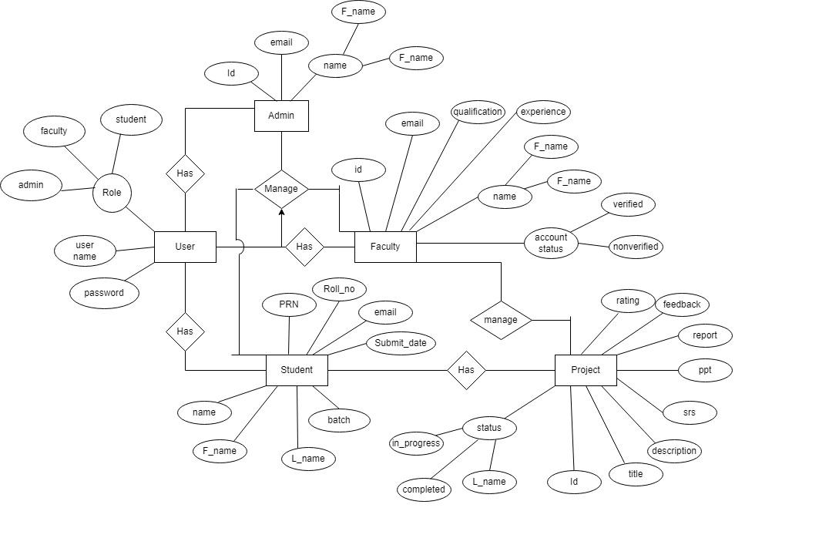

**Fig.7 ER Diagram**

**4.1.5 ER Diagram System Generated**

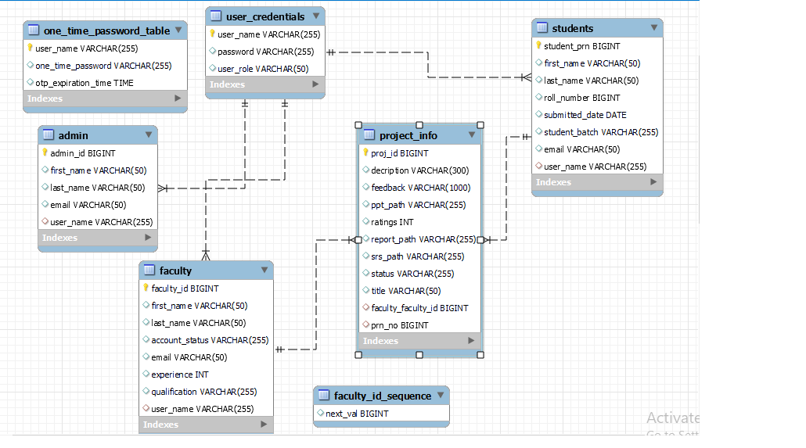

**Fig. 8 System Generated E-R Diagram**

**4.1.6 Class Diagram**

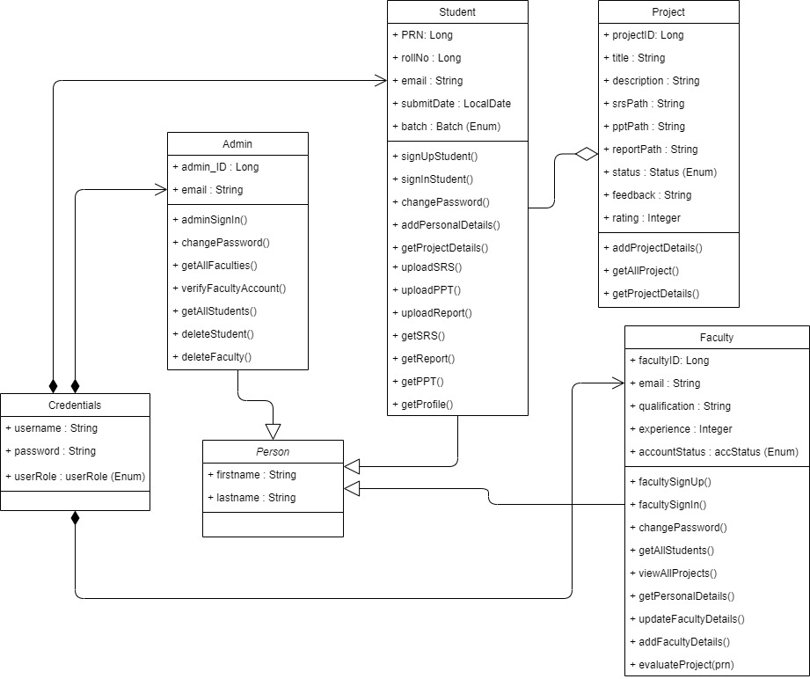

**Fig.9 Class Diagram**

**4.1.7 UseCase Diagram**

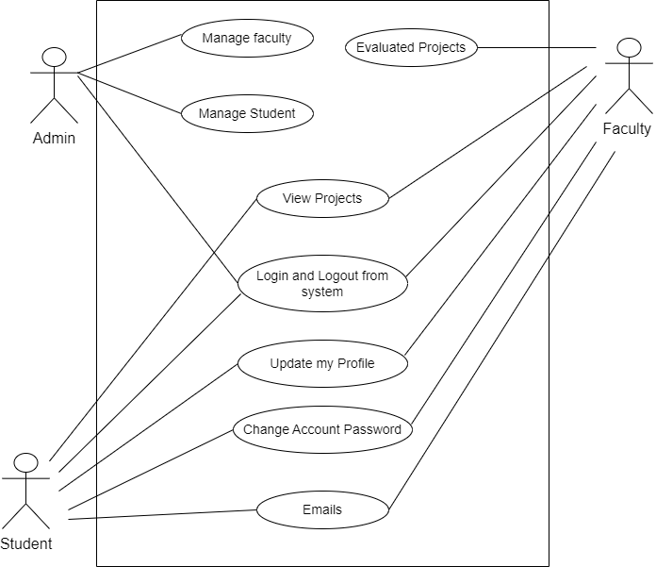

**Fig.10 UseCase Diagram**

**5. TABLE STRUCTURE**

**Tables:**



**Admin:**



**Faculty:**



**Project Info:**



**Faculty ID Sequence:**

**Students: **

**User Credentials:**



1. **PROJECT DIAGRAMS SCREENSHOT**
2. **CONCLUSION**

The project entitled “Project-Diary” was completed successfully.

The system has been developed with much care and free of errors and at the same time it is efficient and less time consuming. The purpose of this project was to develop a web application and for online managing and evaluating Students Projects. This project helped us in gaining valuable information and practical knowledge on several topics like designing web pages using React.js, usage of responsive templates, , and management of database using MySQL. The entire system is secured. Also, the project helped us understanding about the development phases of a project and software development life cycle. We learned how to test different features of a project. There is a scope for further development in our project to a great extent. A number of features can be added to this system in future like providing admin more control over projects, faculty and students so that Institute get more control over students projects and tring to experiments new things related to digital World. These features could have implemented unless the time did not limit us.

In conclusion, a Japanese media database website would be an ideal platform for fans of Japanese media. By providing a one-stop-shop for information and resources, this website would make it easier for fans to access and discover new titles. With features such as personalized recommendations and user ratings and reviews, the website would enable users to engage with other fans and create a community around their favorite titles.

`

1. **REFERENCES**

[1] JavaScript Enlightenment, Cody Lindley-First Edition, based on JavaScript 1.5, ECMA-262, Edition

[2] Mc Graw Hill’s, Java: The complete reference 7thEdition, HerbertScheldt

[3] Complete CSS Guide, Maxine Sherrin and John Allsopp-O'ReillyMedia; September 2012

**ONLINE REFERENCE**

[1] [www.Google.com](http://www.Google.com)

[2] [www.w3school.com](http://www.w3school.com)

[3] www.javatpoint.com