11430495
How does spending on CCTV security equipment vary across marketing segments in India?
Word count - 1477
Abstract
This report analyses the variation in CCTV equipment spending among different market segments. The report uses Indian household expenditure survey data (2016) for its analysis. This was carried out through the use of a K-means cluster on key variables such as, CCTV expenditure, rurality, household size, MPCE, sex, religion and age. The cluster analysis showed that urbanisation was the main driving force behind CCTV expenditure. However increased household size was associated with limited CCTV expenditure. Whereas age, religion and sex had limited influence. Therefore, my hypothesis that large wealthy urban families being the primary demographics behind CCTV expenditure was only partially correct. These findings alongside limitations of this report lead me to call for further research into this topic using a newer data set for regional analysis providing niche and unique insights.
Introduction
This report will answer the question, “How does spending on CCTV security equipment vary across marketing segments in India?”. I will answer this question by carrying out a K-means cluster analysis on 2016 Indian household expenditure survey data. My chosen variables for this analysis are CCTV expenditure, mean per capita expenditure (MPCE), household size, rurality, sex, religion and age. I have chosen these variables as I believe they will provide a broad insight into the driving factors of CCTV expenditure. For example, Anand (2023) finds that there are large wealth disparities between India’s demographic groups particularly between urban and rural demographics. Yet 12% of the world’s population resides in the Indian rural market (Parida and Sahney 2017) emphasising the broad scope and importance of this demographic for marketing research. Furthermore Baber (2019) outlines the important role religion plays in consumer behaviour influencing behavioural responses to advertisement and consumer satisfaction. Mean per capita expenditure and household size may also play an important role influencing CCTV expenditure as the increased size of a household may increase the need for CCTV itself while MPCE can show a household’s capability to spend on CCTV at all. Therefore, I hypothesise that large wealthy urban families will be the primary customer demographics for CCTV expenditure. This report will begin with a preliminary data analysis describing the key variables and measuring their correlation to one another. It will then progress into the cluster analysis and discussion of the results. I will conclude this paper with a discussion of its limitations.
Preliminary data analysis
Table 1
 | n | mean | sd | min | max | range | se
CCTV | 158165 | 16.88 | 441.16 | 0 | 38000 | 38000 | 1.1093
rural | 158165 | 1.45 | 0.5 | 1 | 2 | 1 | 0.0013
sex | 158165 | 1.49 | 0.5 | 1 | 2 | 1 | 0.0013
relig | 158165 | 1.24 | 0.43 | 1 | 2 | 1 | 0.0011
age | 158165 | 38.60 | 14.9 | 18 | 120 | 102 | 0.0375
HHsize | 158165 | 5.85 | 2.91 | 1 | 40 | 39 | 0.0073
mpce | 158165 | 2354.44 | 3055.73 | 0 | 306666.7 | 306666.7 | 7.6835
National sample survey office (2016)
Table 1 displays a descriptive statistics table for my chosen variables highlighting key information about each variable. Each variable Is made up off 158165 observations with the mean, SD, min, max, range and SE displayed. While each variable is numerical rural, sex and religion are binary with means of 1.45, 1.49 and 1.24 respectively. CCTV, age, household size and MPCE are continuous with means of 16.88, 38.6, 5.85 and 2354.44.
The binary variable religion was recoded grouping categories into Hinduism (1) and other (2). This was done as other religions combined only make up 24% of the total population. by combining them they have become a more substantial category. This may allow for an improved comparison between Hindus and other religious groups identifying whether significant differences in market preferences exist between Hindus and non-Hindus.
A key statistic highlighted by the table is the standard deviation of MPCE being 3055.73 being substantially higher than the mean. This implies that there is a large variation and gap between households in their per person expenditure. This further supports Annand’s (2003) findings of large wealth disparities in India.

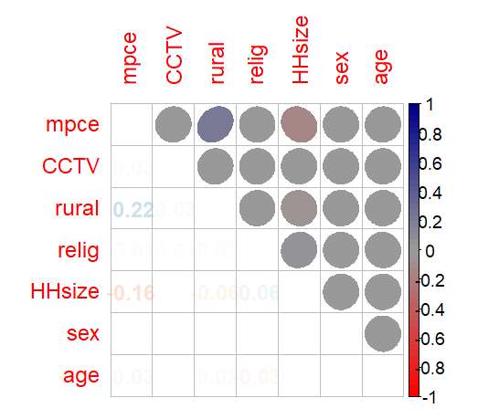
Figure 1

National sample survey office (2016)
Figure 1 displays a correlation heat map between each of my chosen variables. Most variables display little to no correlation with one another. However, the variables MPCE and Household size do display weak correlations. For example, MPCE is shown to have a weak positive correlation with urban households displaying a Pearson's r coefficient of 0.22. This further suggests significant disparities between urban and rural populations. Another weak correlation associated with MPCE is between household size which displays a negative correlation of 0.16. This suggests that the more members of a household the less disposable income they have, to spend. However, this does not necessarily mean that larger families are more likely to be poor. Rather MPCE is a measure of average household spending per person therefore families with multiple children will have their average brought down more than childless couples. Overall preliminary correlation analysis has revealed only weak relationships between the key variables. However, some associations do still remain, and cluster analysis may be able to form grouping based on these.
Cluster analysis
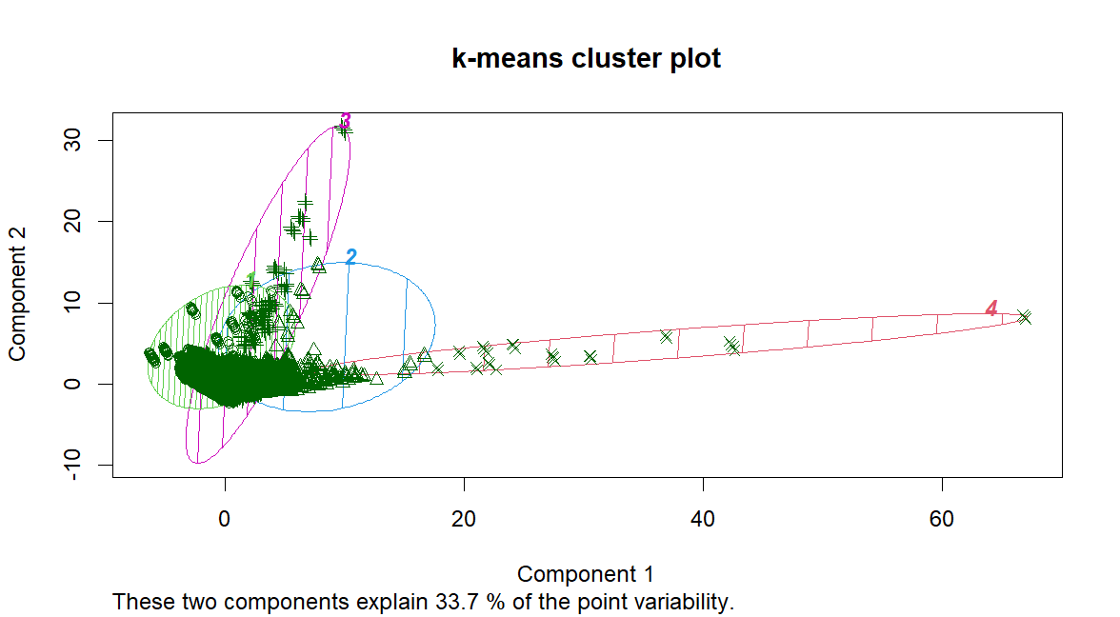
figure 2

National sample survey office (2016)
Figure 2 displays the K-means cluster plot of my chosen variables. According to Chapman and Feit (2019) this is an unsupervised model which attempts to find clusters and groupings from the structure of the data itself. K-means is a distance method of clustering which models data in centroid clusters. This attempts to maximize the distance between groups and minimise the distance within the group itself creating distinct entities with unique attributes (Chapman and Feit 2019).
Figure 2 is heavily dense with many observations between 0 and 10 on the x axis and 0 and 5 on the y axis. However, it does also display a large amount of variance and outliers with some observations reaching 30 on the y axis and 70 on the x axis. I have then grouped these observations into 4 distinct clusters with some minor overlapping in the densest part of the graphs.

Group.1 | CCTV | rural | sex | relig | age | HHsize | mpce
1 | 8.55 | 1.35 | 1.488 | 1.25 | 38.22 | 6.21 | 1609.40
2 | 102.62 | 1.86 | 1.484 | 1.21 | 41.00 | 3.86 | 14706.61
3 | 42.70 | 1.78 | 1.487 | 1.22 | 39.89 | 4.62 | 4238.98
4 | 0.00 | 1.62 | 1.437 | 1.34 | 38.71 | 4.18 | 143316.20
Table 2
National sample survey office (2016)
Table 2 displays the mean for each variable within each of the four clusters. Due to the number of binary variables used in this analysis I have chosen mean instead of median as this shows the proportion of each binary more clearly than the median (Chapman and Feit 2019). Our key variable CCTV expenditure varies substantially between each group with group 2 displaying the highest expenditure at 102.62 and lowest being group 4 with 0.00 expenditure on CCTV.
Group 2 the highest spending group is characterised as having the most urban population at 1.86 (86%) the smallest household size of just 3.86 on average and having the second highest income. This partly proved my hypothesis as living in urban areas does increase the rate of CCTV expenditure which could be due to a perceived risk of crime victimisation. This is coupled with having a high income allowing for such expenditures. However, this disproves my hypothesis that increased household size would drive CCTV expenditure.
Group 4 is the lowest spending group and is characterized by having a 22% lower urban population than group 2 this further supports the claim that security spending and rurality are linked. However, this group does display extremely high income at 143316.20 the highest of all the groups. The lack of CCTV expenditure can be explained for a multitude of reasons. For one CCTV is not a product which individual households would buy regularly therefore it can be assumed that wealthy households already own CCTV systems and have not seen the need to purchase a new one. Furthermore, with such high levels of income they may live in safer neighbourhoods and be less exposed to crime than their urban counterparts, reducing the need for CCTV systems.
This cluster analysis has shown valuable trends within CCTV expenditure data. It has supported my hypothesis that urban households drive CCTV expenditure however it has also disproven my hypothesis that large household size will increase expenditure. Furthermore, it confirmed that some factors have little association with CCTV expenditure such as age and gender.
Limitations
However, this report is not without its limitations. One being that the data was gathered in 2016 meaning the findings in this report may not be relevant to companies wishing to market their CCTV products in India. This is especially relevant as both the CCTV tech industry and India as a whole is developing rapidly leading to substantial changes in demographics. Another limitation with this paper is that it takes a broad approach covering the entirety of India. Whereas by focusing on a single state or region unique trends can be observed allowing for the application of niche marketing strategies for specific consumers.
Conclusion
To conclude this report has analysed Indian household survey data to examine how CCTV expenditure varied across Indian market segments using K-mean clustering. This analysis showed that urbanization is the driving factor for CCTV spending whereas spending is driven down by household family size disproving my initial hypothesis that household size would be associated with higher levels of spending. Therefore, businesses would want to target wealthy consumers who live in urban environments with small families in order to increase CCTV sales. However, this report was limited by its scope and the age of data being analysed. Future studies can overcome these limitations by narrowing their research to specific localities while analysing contemporary household survey data leading to unique marketing opportunities for businesses.
Bibliography
Anand, I., Thampi, A., Vakulabharanam, V. (2023). ‘Wealth inequality: the Indian case’, Canadian Journal of Development Studies, DOI: 10.1080/02255189.2023.2212898
Baber, H. (2019). Influence of Religiosity on the Behavior of Buying Sports Apparel: A Study of the Muslim Market Segment in India. Organizations and Markets in Emerging Economies, 10(2), pp.212–226. doi:https://doi.org/10.15388/omee.2019.10.11.
Chapman, C. and Elea Mcdonnell Feit (2015). R for marketing research and analytics. Cham ; New York: Springer International Publishing.
National Sample Survey Office, MOSPI, Government of India, (2016). ‘Household expenditure on Services and Durable goods’. Available at: India - Household expenditure on Services and Durable goods - JULY 2014 - JUNE 2015, 72 round
Parida, R. R., Sahney, S., (2017). ‘Exploration of Indian rural markets and marketing’, Asia Pacific Journal of Marketing and Logistics, 30 (2), pp. 297-308. DOI 10.1108/APJML-12-2016-0241

