Introduction To
Machine Learning
1

“On your mark, set, go...”



- The Action Plan | - Step 6 - Model Building
- Step 1 - Project Overview | - Step 7 - Model Evaluation
- Step 2 - Data Ingestion | - A Journey from Data to Decisions
- Step 3 - Data Preprocessing | - Looking Ahead
- Step 4 - Exploratory Data Analysis | - Exercises
- Step 5 - Feature Engineering


What is Machine Learning?
- Imagine you're asked to calculate your Body Mass Index (BMI) given your weight and height. This is straightforward—you use a formula:
BMI = Weight in kg / (Height in m )²
- Similarly, if you want to determine the speed of your bike when you've covered 50 km in 2 hours, you simply apply the formula:
Speed = Distance / Time
- In these cases, the relationships between the variables are clear and can be precisely described using mathematical formulas. If you know the formula, you can easily compute the answer.
- However, not all relationships in the world are this straightforward. Consider the following questions:
I have 10 years of job experience; what should be my expected salary?
I have studied 50 hours this semester; how many marks am I likely to score in the examination?
- These questions involve variables that are interconnected in complex ways. Factors such as industry demand, economic conditions, individual performance and IQ, and more can influence salary or examination scores. There's no simple formula that can capture all these nuances.
- So, how do we answer such questions? Well, by using Machine Learning.
Machine Learning Definition
- Machine Learning (ML) is a field of Artificial Intelligence (AI) that enables computers to learn from data and make predictions or decisions without being explicitly programmed for every specific task.
- Instead of relying on predefined equations or rules, ML algorithms analyze data to discover patterns and relationships, building models that can generalize to new unseen situations.
- Figure 1.1 shows the difference between traditional programming and machine learning.
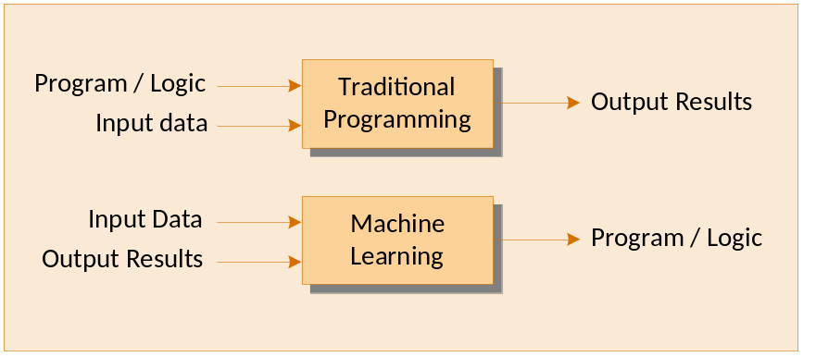Figure 1.1
- In traditional programming we manually write program logic that takes input and generates the desired output. For example, to calculate BMI, we provide the exact formula, and the system simply calculates output for a given input. This method works well when the relationship between inputs and outputs is straightforward and known.
- In Machine Learning instead of explicitly programming the logic, we give the system input data and expected outcomes. The machine then learns the relationship that maps the input to the output, effectively generating the "program" or predictive model on its own.
- This paradigm shift in ML allows us to tackle problems like image recognition, personalized recommendations or language processing that would be too complicated for traditional programming methods.
Understanding ML Through an Example
- Let's revisit the question "I have 10 years of job experience; what should be my expected salary?"
- Suppose we have historical data from different companies that include employees' years of experience and their corresponding salaries. The data might look as shown in Figure 1.2.
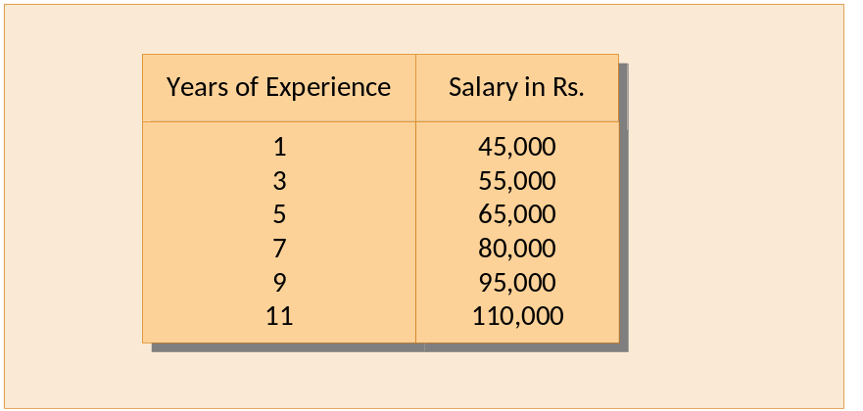 Figure 1.2
- We can use this data to train a machine learning model. The model analyzes the data to find a relationship between years of experience and salary.
- After training, the model might predict that someone with 10 years of experience should expect a salary of approximately Rs. 100,000. Thus, the model has learned the pattern from the data and can generalize it to new inputs.
- In Chapter 2, we will learn the intricacies of how a machine learning model is trained on a dataset and how it makes predictions. This will help you get a deeper understanding of the underlying processes involved.
AI Versus ML
- AI is the science and engineering of creating intelligent systems capable of performing tasks that require human intelligence, such as reasoning, problem-solving, learning and understanding natural language.
- ML is a subset of AI that focuses specifically on enabling systems to learn patterns from data.
- Apart from ML, AI has other subsets as shown in Figure 1.3.
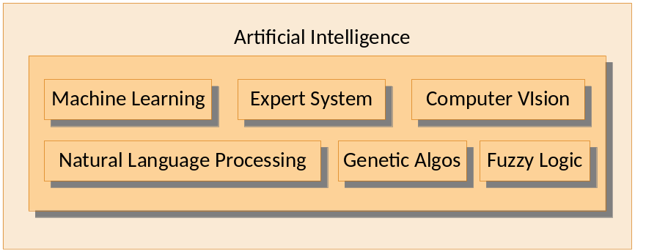 Figure 1.3
Let us discuss these subsets one by one.
Expert Systems
- Expert Systems are AI programs that emulate the decision-making ability of a human expert in a specific domain. They use a knowledge base of facts and rules to analyse information and provide conclusions or recommendations.
- The key characteristics of an Expert System are as follows:
- Rule-Based Reasoning: An expert system operates using "if-then" rules derived from human expertise.
- Knowledge Base: An expert system contains a comprehensive repository of domain-specific information.
- Inference Engine: An expert system Processes the rules to draw conclusions from the provided data.
- Example: A Medical Diagnosis Expert System that is designed to assist doctors in diagnosing illnesses.
Input: For this expert system patient symptoms like fever, cough, shortness of breath are inputs.
Processing: The expert system uses its knowledge base, which includes rules like—If fever, cough and shortness of breath, then consider pneumonia. Or if high fever and rash, then consider measles.
Output: The system suggests that the patient might have pneumonia and advises further medical tests.

Natural Language Processing (NLP)
- Natural Language Processing is a field of AI that focuses on enabling computers to understand, interpret, and generate human language in a way that is both meaningful and useful.
- The key characteristics of NLP are as follows:
- Language Understanding: NLP Comprehends the intent and context behind words and sentences.
- Language Generation: NLP produces human-like text or speech responses.
- Bridging Communication: NLP facilitates interaction between humans and machines using natural language.
- Example: Virtual Personal Assistants like Apple's Siri.
Input: Voice command like "Hey Siri, what's the weather like today?"
Processing: Siri uses NLP to recognize speech and convert it into text and to understand that you're asking about the weather for today.
Output: Siri retrieves the weather information and replies, "It's currently sunny and 75 degrees."
Computer Vision (CV)
- Computer Vision is a field of AI that enables machines to interpret and understand visual information from the world, such as images and videos.
- The key characteristics of Computer Vision are as follows:
- Image Recognition: It identifies objects, people, or patterns in images.
- Image Processing: It enhances or manipulates visual data for analysis.
- Understanding Context: It interprets the spatial relationships and context within visual inputs.
- Example: Autonomous Vehicles like self-driving cars use computer vision to navigate roads safely.
Input: Cameras capture real-time images of the car's surroundings.
Processing: The system identifies lane markings to stay within lanes, traffic signs and signals to obey speed limits and traffic lights, pedestrians and obstacles to avoid collisions.
Output: The car makes driving decisions based on the visual input and processing rules.
Genetic Algorithms
- Genetic Algorithms (GAs) are optimization techniques inspired by the process of natural selection and genetics. They evolve solutions to problems by iteratively selecting and modifying candidate solutions.
- The key characteristics of GAs are as follows:
- Evolutionary Process: GAs mimic biological evolution mechanisms—selection, crossover, and mutation.
- Population-Based Search: GAs work with a pool of potential solutions.
- Fitness Function: GAs evaluate how close a given solution is to the optimal solution.
- Example: Optimizing Delivery Route - A logistics company wants to find the most efficient (shortest) delivery route for its fleet that cover all delivery points. This is a complex problem known as the Traveling Salesman Problem.
- Genetic Algorithm approach to solve this problem includes following steps:
- Initialization: Generate a population of random route plans.
- Evaluation: Use a fitness function to assess the total distance of each route.
- Selection: Choose the best-performing routes.
- Crossover and Mutation: Combine parts of selected routes and introduce minor changes to create new routes.
- Iteration: Repeat the process over several generations.
The outcome is that the algorithm evolves increasingly efficient routes over time.
Fuzzy Logic
- Fuzzy Logic is a form of logic that allows reasoning with approximate values and uncertainties. Unlike traditional binary logic (true or false), fuzzy logic variables may have a truth value that ranges between 0 and 1.
- The key characteristics of Fuzzy Logic based systems are as follows:
- Handling Uncertainty: Fuzzy logic deals with concepts that are not black and white.
- Linguistic Variables: Fuzzy logic uses descriptive terms like "hot", "warm" or "cold" rather than precise numerical values.
- Rule-Based System: Fuzzy logic applies rules that can handle degrees of truth.
- Example: Climate Control System - An intelligent air conditioning system that adjusts temperature based on fuzzy logic.
Input: Temperature measured in number but interpreted as "cool", "comfortable" or "warm", humidity interpreted as "dry", "normal" or "humid."
Processing: The system uses fuzzy rules like:
- If temperature is "warm" and humidity is "humid," then set cooling level to "high".
- If the temperature is "comfortable" then maintain current settings.
Output: The system adjusts the cooling level smoothly rather than switching abruptly between settings.
- These subsets of AI—Machine Learning, Expert Systems, Natural Language Processing, Computer Vision, Genetic Algorithms, and Fuzzy Logic demonstrate the diversity within the field of AI. Each subfield addresses different aspects of intelligence and offers unique tools for solving complex problems.
Types of Machine Learning
- Machine Learning systems can be grouped based on how much guidance or "supervision" they get during training. There are three main types of ML systems:
- Supervised Learning
- Unsupervised Learning
- Reinforcement Learning
- Figure 1.4 shows different types of ML systems along with their sub-categories.
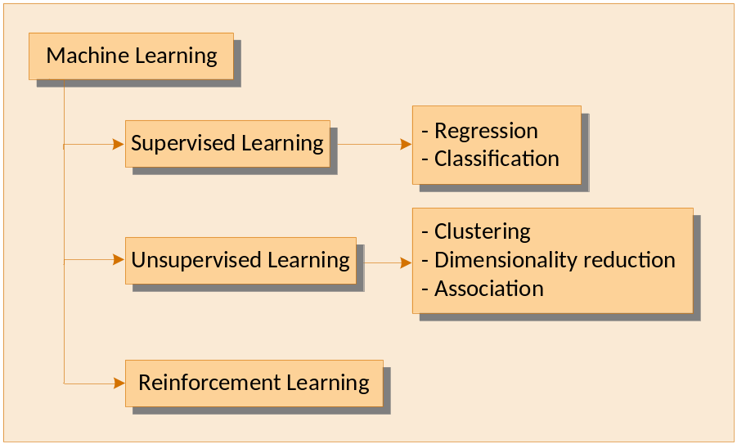 Figure 1.4
Supervised Learning
- Imagine you’re learning to solve math problems, and your teacher gives you a workbook. Each problem in the workbook comes with a question and the correct answer. As you work through each problem, you could compare your solution with the correct answer to see if you got it right. If not, you learn from your mistake and try again.
- Supervised Learning works in a similar way. In this type of learning, the machine is given a bunch of examples that include both the input (the question) and the correct output (the answer). The goal is for the machine to learn the relationship between these inputs and outputs so that, when given a new question, it can predict the answer correctly.
How Supervised Learning Works?
- Training Data: Supervised learning uses a labeled dataset. For example, suppose you want to teach a machine to recognize pictures of cats and dogs. You provide it with thousands of images, where each image is labeled as either "Cat" or "Dog". The machine is trained using this data.
- Learning Phase: The machine analyzes the labeled data and looks for patterns. For example, it learns that cats tend to have pointy ears, and dogs usually have a different body shape. This way, it builds a "model" in its memory, which helps it understand the difference between cats and dogs.
- Prediction Phase: Once trained, you can show the model a new picture it has never seen before, and it will try to guess whether it is a cat, or a dog based on what it has learned.
- Some of the key supervised learning algorithms are as follows:
- Linear Regression
- Logistic Regression
- Support Vector Machines
- K-Nearest Neighbors
- Decision Trees and more
- There are two main types of problems that supervised learning can tackle, depending on what kind of answers (or outputs) we are trying to predict. These are Regression and Classification.
Regression
- Regression involves predicting a continuous numeric value.
- Real-World examples of Regression:
- Predicting house prices based on features like size and location.
- Estimating sales numbers based on advertising spend.
- Forecasting temperature for the next day based on historical weather data.
- Predicting price of a stock based on economic environment.
Classification
- Classification involves predicting a category rather than a number.
- Real-World examples of Classification:
- Spam detection: Classifying emails as "spam" or "not spam."
- Image classification: Determine whether an image contains a cat or a dog.
- Medical diagnosis: Predicting whether a patient has a disease (positive) or not (negative) based on symptoms.
- Student Placement: Predicting whether a student will get placed in a company or not based on factors like grades, internships, and interview performance.

Unsupervised Learning
- Suppose you are given jigsaw puzzle pieces, and you are required to assemble them into a coherent picture. The catch is you are not given the picture of how the completed puzzle looks like. Since you don't know the final solution, you start by grouping similar pieces together—like all the blue pieces for sky, green ones for grass, etc. Over time you will start noticing patterns that help you fit the pieces together.
- Unsupervised Learning works in a similar way. In this type of learning, the machine is fed a lot of data, but no correct answer. The goal is for the machine to find hidden patterns or group similar items together on its own. It might discover clusters or groups in the data, even without knowing exactly what each group means.
- For example, if you give an unsupervised learning algorithm a bunch of pictures of animals, it might group all the cats together, all the dogs together, and so on, without being told which animal is which. It just finds the similarities and organizes them accordingly.
- It is called Unsupervised Learning because, during the learning process, the machine isn’t provided with the correct answers or labels. There’s no "teacher" guiding it. Instead, the machine must figure things out on its own by exploring the data, identifying patterns, and grouping similar items together.
- Unsupervised learning tackles three main types of problems: Clustering, Dimensionality Reduction, and Association. Each of these involves organizing, simplifying, or discovering relationships within data, but they approach it in different ways.
Clustering
- Think of a party where people break off into smaller groups based on what interests them. No one is telling them where to go, they just gravitate towards each other. Some might head to the snack table, others might start talking about music, while a few get into discussions about sports. As the party progresses, these groups become more defined, and the common interests start to shine through.
- Clustering works in much the same way. In this type of learning, the machine doesn’t receive specific instructions on how to group the data. Instead, it scans the data, looking for similarities, and groups items together based on shared features. Just like people at the party naturally form groups around common interests, the machine creates clusters based on patterns it detects.
- Suppose you provide data on customer shopping habits to a clustering algorithm. From the data the algorithm may discover that one group of customers tends to buy tech gadgets, while another prefers to stock up groceries. The algorithm doesn’t know in advance what these groups will be—it simply identifies the patterns hidden within the data and forms clusters accordingly.
- There are several powerful algorithms used to identify clusters in data. Here are a few of the most popular ones:
- K-Means Clustering
- Hierarchical Clustering
- DBSCAN
Dimensionality Reduction
- Let’s say you’re preparing for an exam, and you have a huge pile of notes in front of you. As you go through them, you notice that much of the information is either repetitive or not particularly relevant. So, you start trimming down the material, focusing only on the key points that matter. In the end, your notes are much shorter, but they still capture all the essential concepts you need to know for the exam.
- Dimensionality Reduction works similarly. When dealing with large datasets that have many features or variables, some of that information may be redundant or irrelevant. The goal is to simplify the data by reducing the number of features while keeping the important patterns intact.
- For example, suppose you’re analyzing house prices, and your dataset includes dozens of features like square footage, number of bedrooms, neighborhood, age of the house, etc. Some of these features might be closely related, such as the number of bedrooms and the size of the house. Dimensionality reduction can help by condensing similar or less useful features, leaving you with a simpler dataset that still preserves the key factors that impact house prices.
- There are several algorithms used to reduce the number of features in a dataset while retaining its most important information. The more commonly used ones are:
- Principal Component Analysis (PCA)
- t-Distributed Stochastic Neighbor Embedding (t-SNE)
- Linear Discriminant Analysis (LDA)
Association
- Association is based on finding patterns like these within large datasets. The goal is to identify relationships between different items or events that frequently occur together. Rather than predicting outcomes, it focuses on discovering how items are linked.
- If a store has data on customers’ shopping habits, an association algorithm might find that people who buy pasta often buy tomato sauce as well. This insight allows the store to recommend items or bundle them together. In e-commerce, such recommendation systems are used to suggest products based on what you’ve already added to your shopping cart.
- Similarly, a grocery store notices that every time you buy bread, you also pick up some butter. Over time, the store may realize this happens regularly, not just for you, but for many other shoppers. The store could use this pattern and place bread and butter near each other on the shelves.
Reinforcement Learning
- Picture this: You’re learning to ride a bike, but there’s no one around to teach you. So, you hop on and try different things, which is the only way to improve. When you lose your balance, you adjust your posture. If you pedal too slowly and the bike stops, next time you pedal faster. Each action gives you feedback—whether it's a near fall or smooth riding—and over time, you figure out how to keep going.
- Reinforcement Learning works on the same principle. It’s all about learning from feedback. An agent (like a computer program or robot) interacts with its environment, makes choices, and then gets feedback—either in the form of a reward for doing well or a penalty for making a mistake. The goal is for the agent to maximize rewards by learning the best strategies over time, just as you learned to ride the bike.
- For instance, imagine programming a computer to play a video game. Initially, it will likely make random moves, fail a lot, and lose the game. However, after each win or positive outcome, it receives a reward, while losses provide a penalty. By continuously learning from this feedback, it figures out which moves or strategies work best to win the game.
- Another great example is a self-driving car. The car learns by constantly interacting with its environment. If it stays in its lane, avoids obstacles, and follows traffic rules, it gets positive feedback. If it swerves, hits something, or breaks a rule, it is penalized. Over time, it learns how to make better decisions and improve its driving performance.
Applications of Machine Learning
- From healthcare to entertainment, machine learning is transforming industries and enabling innovative solutions that were once impossible. Let’s explore some fascinating applications where machine learning is making a big impact.

Healthcare
- Early Disease Detection: Imagine a model that can analyze medical scans, such as X-rays or MRIs, and detect diseases like cancer or heart conditions long before a human doctor could. Machine learning models trained on thousands of such scans can identify early signs of tumors, saving lives by providing quicker diagnoses.
- Accelerating Drug Discovery: Developing new drugs traditionally takes years. Machine learning models can analyze complex biological data, predicting which compounds might be effective against specific diseases. This speeds up the research process, bringing new treatments to the market faster.
Finance
- Fraud Detection: Banks use machine learning to monitor transactions for unusual patterns, flagging fraudulent activities immediately. For example, if your card is suddenly used in a foreign country while you're still at home, the system can block the transaction and alert you instantly.
- Algorithmic Trading: Machine learning models are used to analyze stock market data and make split-second trading decisions. These models learn from historical data to predict price movements, helping firms buy or sell stocks at just the right time.
Retail
- Recommendation Engines: Have you ever wondered how Netflix seems to know exactly what you want to watch next, or how Amazon suggests just the right product? That’s machine learning in action. These recommendation systems analyze your browsing and purchasing behavior to suggest movies, products, or songs you're likely to enjoy.
- Customer Sentiment: By analyzing social media and customer reviews, machine learning can gauge how customers feel about a brand or product. This helps companies understand their audience and improve their services or products accordingly.
Transportation
- Navigating the Roads: Self-driving cars use ML to "see" the world around them. By processing data from cameras, radar, and lidar, these vehicles can recognize objects like pedestrians, traffic lights, and other vehicles. They make split-second decisions, such as when to stop, accelerate, or change lanes.
- Route Optimization: Machine learning models in ride-sharing apps like Uber or Ola predict traffic patterns and find the quickest routes, improving fuel efficiency and reducing waiting times for passengers.
Agriculture
- Crop Monitoring: Drones equipped with machine learning models can fly over fields and monitor crop health, soil quality, and detect pests. By analyzing this data, farmers can optimize water usage, fertilizer application, and pesticide distribution, leading to healthier crops and higher yields.
- Predicting Harvest: Machine learning models can predict the best time to harvest crops by analyzing weather patterns, soil moisture, and plant growth. This helps farmers maximize the quality and quantity of their harvest.

Education
- Personalized Learning Paths: Educational platforms use machine learning to analyze students' learning habits and progress, providing personalized content and exercises. This helps each student learn at their own pace and focus on areas where they need improvement.
- Virtual Tutors: AI-powered tutors can assist students by answering questions, explaining difficult concepts, and providing practice problems, helping to supplement traditional classroom learning.
Challenges in Machine Learning
- Developing and deploying machine learning models comes with significant challenges. While these models can be incredibly powerful, building them requires overcoming obstacles related to data, model behavior, and technical resources.
- Lack of Data: A machine learning model trained on a limited amount of data won’t have enough information to learn all the patterns to make accurate predictions. Without enough data, even the best algorithms can’t perform well.
- Inconsistent or Noisy Data: At times the data used by a machine learning model is full of errors, missing values, or irrelevant information. Cleaning and organizing this data becomes a time-consuming process that requires careful attention to detail to ensure the model can learn effectively.
- Overfitting: Overfitting is like memorizing answers to past exams without understanding the concepts. An overfitted model learns every detail, including noise, performing well on training data but struggling to generalize to new, unseen data, leading to poor real-world performance.
- Bias: Bias occurs when a model is trained on skewed data, much like someone who grows up seeing only traditional gender roles (men as breadwinners and women as homemakers) may believe they are the norm everywhere. The model learns a narrow, biased view of reality.
- Model Interpretability: This refers to understanding how a machine learning model makes decisions. For instance, if a loan application is rejected without explanation, it can be frustrating. Simple models, like decision trees, provide clear decision paths, while complex models, like neural networks, often act as "black boxes," making it harder to explain decisions in critical areas like finance, healthcare or law enforcement where decisions have significant real-world impacts.
- Hardware Constraints: Training large-scale models like GPT requires thousands of high-performance GPUs running for weeks. Complex tasks like natural language processing and image recognition demand significant computational resources. Without this infrastructure, training can take days or weeks. Real-time applications, such as self-driving cars, also need fast, reliable hardware to make split-second decisions.
- Financial Cost: Setting up and maintaining a high-performance computing infrastructure is expensive, and cloud-based solutions, while scalable, can still become costly for long-term projects. This creates a barrier for smaller companies or independent researchers who may not have the budget to access top-tier computational power.
- While the challenge mentioned above may seem daunting, the field of machine learning is evolving rapidly, and new solutions are emerging every day. Researchers and practitioners are continually innovating, developing tools and techniques to address these issues head-on.
____________________________________________________________________


- Answer the following questions:

- What do the prompts C:\>, $ and >>> signify?
- In which two modes can IDLE be used?
- What is the purpose of the two programming modes offered by IDLE?
- How can third party libraries be used in a Python program?

- Match the following pairs:

a. pip | 1. Advanced mathematical operations
b. Jupyter | 2. Scientific computing
c. Spyder | 3. Manipulate numerical tables
d. PyPI | 4. Visualization
e. NumPy | 5. Computer vision
f. SciPy | 6. Package installation tool
g. Pandas | 7. Build and document applications
h. MatPlotLib | 8. Scientific library
i. OpenCV | 9. Python package index

- State whether the following statements are True or False:

- Python is a specification that can be implemented through languages like Python, C#, Java, etc.
- CPython is implementation of Python specification, written in C.
- Python program is first compiled into byte code, which is then interpreted.
- Most Linux distributions already contain Python.
- The Windows system does not contain Python and it needs to be separately installed.
- Python programs can be built using IDLE, NetBeans, PyCharm and Visual Studio Code.
- Third-party Python packages are distributed using PyPI.

