End-to-End ML
Project
2

“On your mark, set, go...”



- The Action Plan | - Step 6 - Model Building
- Step 1 - Project Overview | - Step 7 - Model Evaluation
- Step 2 - Data Ingestion | - A Journey from Data to Decisions
- Step 3 - Data Preprocessing | - Looking Ahead
- Step 4 - Exploratory Data Analysis | - Exercises
- Step 5 - Feature Engineering


The Action Plan
- Machine Learning is a complex field with many interconnected parts—data ingestion, preprocessing, analysis, modeling, evaluation, and more. If we were to study each part in isolation without seeing how they fit together, it could feel overwhelming and abstract.
- Hence, we wish to learn how to build an end-to-end Machine Learning project. This will give you a bird's eye view of the entire ML process. It will then become easier to understand and connect the dots as we delve deeper into specific topics in chapters to follow.
- We intend to build the ML project in the following steps:
- Project Overview: Introducing the problem that we'll solve and why it's important.
- Data Ingestion: Learning how to load and understand the data we'll work with.
- Data Preprocessing: Cleaning and preparing the data to ensure accurate analysis.
- Exploratory Data Analysis (EDA): Exploring the data to uncover patterns and insights.
- Feature Engineering: Enhancing the data to improve model performance.
- Model Building: Selecting and training a suitable Machine Learning model.
- Model Evaluation: Assessing the model's performance and interpreting the results.
Step 1 - Project Overview
- The goal of the project is to build an ML solution for the Training and Placement Cell of a University that wishes to identify which students are likely to secure job placements after graduation.
- This information can help in providing targeted support to students who might need additional assistance in enhancing their employability.
- By analyzing Cumulative Grade Point Average (CGPA) and Intelligence Quotient (IQ) scores of university students, we can build a model that predicts a student's placement status.
- This project falls under the category of supervised learning. As we know, in supervised learning the model learns from a labeled dataset—in this case, data where the placement status (placed or not placed) is already known.
- We will perform classification, which involves predicting a discrete label (such as "placed" or "not placed") rather than a continuous value.
- By the end of this project, we'll have a model that can input a student's CGPA and IQ scores and output a prediction of their placement status.
The Dataset
- To build our ML model we will use a toy dataset that includes:
CGPA: The student's cumulative grade point average on a scale of 0 to 10.
IQ Score: An assessment of the student's intelligence quotient.
Placement Status: A label indicating whether the student was placed ("Yes") or not placed ("No").
Here's a snapshot of what the data looks like:

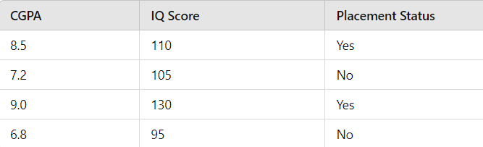
Figure 2.1
Project Tools
- It is expected that you are familiar with Python and following Python libraries:
NumPy: For numerical computations and array handling.
Pandas: For data manipulation and analysis.
Matplotlib: For data visualization.

- For this project, we'll be using Google Colab (short for Colaboratory) tool. It is a free, cloud-based Jupyter notebook environment provided by Google. It allows us to write and execute Python code through our web browser.
- Google Colab tool offers several advantages. These are as follows:
- Since everything runs on cloud, we don't need to install Python or any libraries on our local machine.
- We can run code cells in a notebook independently and see the output instantly. This makes it ideal for interactive computing, testing, and debugging.
- Notebook lets us run code in a step-by-step manner, which helps in understanding and refining algorithms as we progress.
- We can share your notebooks with others, allowing for seamless collaboration.
- We can access our notebooks from any device with an internet connection.
Getting Started with Google Colab
- To begin working on the project, follow the steps mentioned below:
- Navigate to the link https://colab.research.google.com/ in your web browser.
- In the popup dialog on the Colab homepage, click on the "New notebook" button. A new notebook will open which is now ready for you to start coding.
- Click on the notebook title "Untitled.ipynb" at the top. Rename it to "Student_Placement_Prediction.ipynb". The notebook is automatically saved to our Google Drive.
- We can type Python code in the code window and use Ctrl-Enter to run the code.

Step 2 - Data Ingestion
- Data ingestion is the process of loading the dataset into our working environment so that we can begin analyzing and modeling it.
- The following program loads the csv file from the given url and obtains some basic information about the dataset.

import pandas as pd
url = "sdfsdfdsf"
df = pd.read_csv(url) # loads csv file into DataFrame

print("\nFirst 5 rows of DataFrame")
print(df.head( ))

print ("\nNo. of rows, columns in dataset:")
print(df.shape)

print("\nSummary of DataFrame:")
print(df.info( ))

print("\nNo. of duplicate rows:")
print(df.duplicated( ).sum( ))

- Here is the output of the program…

First 5 rows of DataFrame
cgpa iq placement
0 6,8 123.0 Yes
1 5,9 106.0 No
2 5,3 121.0 No
3 7,4 132.0 Yes
4 5,8 142.0 No

No. of rows, columns in dataset:
(100, 3)

Summary of DataFrame:
<class 'pandas.core.frame.DataFrame'>
RangeIndex: 100 entries, 0 to 99
Data columns (total 3 columns):
# Column Non-Null Count Dtype
--- ------ -------------- -----
0 cgpa 95 non-null object
1 iq 100 non-null float64
2 placement 100 non-null object
dtypes: float64(1), object(2)
memory usage: 2.5+ KB
None

No. of duplicate rows:
0

- Given below are some observations about the output:
- The head( ) function displays the contents of the first five rows of the DataFrame.

- The dataset has three columns: cgpa, iq, and placement.

- Float values contain comma instead of decimal point.

- The dataset contains 100 rows and 3 columns.

- The info( ) function provides a concise summary of the DataFrame, including the data types of each column and the number of non-null values.

- The cgpa column has 95 non-null values, indicaties that there are 5 missing values.

- The cgpa and placement columns are of type object (string).

- The iq column is of type float64.

- Duplicate entries can affect the quality of our analysis. We can check for duplicates using the duplicated( ) function and then summing the results.

- df.duplicated( ) returns a Series of boolean values indicating whether each row is a duplicate of a previous row.

- sum( ) adds up the True values (where True counts as 1), giving the total number of duplicate rows. The result is 0, indicating that there are no duplicate rows in the dataset.
Step 3 - Data Preprocessing
- In this section, we will preprocess our dataset to prepare it for analysis and modeling. Data preprocessing is an essential step in any ML project, as it ensures that the data is clean and in the correct format for further processing.
- We will perform the following operations:
- Replace commas with dots in the cgpa column
- Convert the cgpa column data type from object to float
- Convert the placement column values from 'Yes' and 'No' to 1 and 0
- This can be done adding the following statements to the above program:

df['cgpa'] = df['cgpa'].str.replace(',', '.')
df['cgpa'] = df['cgpa'].astype(float)
df['placement'] = df['placement'].map({'Yes':1, 'No': 0})

print(df.head( ))
print("Type of cgpa = ", df['cgpa'].dtype)
print("Type of placement = ", df['placement'].dtype)

- The output of this portion of the code is given below:

cgpa iq placement
0 6.8 123.0 Yes
1 5.9 106.0 No
2 5.3 121.0 No
3 7.4 132.0 Yes
4 5.8 142.0 No
Type of cgpa = float64
Type of placement = int64

- Given below are some comments about the operations carried out in this program:
- The replace( ) function replaces comma with a decimal point in each element of cgpa column. The converted string is assigned back to df['cgpa'], thereby updating the column with the modified values.
- After replacing commas with dots, the cgpa column values are still of type object (string). To be able to perform numerical operations, on cgpa we have converted this column to a numerical data type (float) using the astype( ) function. The result is assigned back to df['cgpa'], thereby updating the column with the converted data type.
- The placement column contains categorical values 'Yes' and 'No'. ML algorithms don’t understand English words. So, we need to convert these values to numerical format. This has been achieved using the map( ) function.
- map( ) function replaces every 'Yes' with 1 and every 'No' with 0. The result is assigned back to df['placement'], updating the column with the mapped numerical values.
- We have verified the data type of the cgpa and placement column using the dtype property of DataFrame object.
- By completing the data preprocessing steps on our dataset, we have ensured that our data is now in the correct format for further analysis.
Step 4 - Exploratory Data Analysis
- Before we can build a reliable machine learning model, it's essential to thoroughly understand the data we're working with. This is where Exploratory Data Analysis (EDA) comes into play.
- EDA helps us to:
- Understand the underlying structure of the data
- Identify anomalies or outliers that may affect our analysis
- Discover relationships between variables
- Formulate hypotheses and guide the modeling process
- Without EDA, we risk making incorrect assumptions or overlooking critical information that could compromise our model's effectiveness.
Descriptive Statistics
- Using the describe( ) function we can obtain descriptive statistics like central tendency, dispersion, and shape of the dataset's distribution.
- This includes metrics like count, mean, standard deviation (std), minimum, maximum, and quartiles (25%, 50%, 75%).

import pandas as pd
url = "sdfsdfdsf"
df = pd.read_csv(url)
print(df.describe)

- On execution, we get the following output:

cgpa iq placement
count 95.000000 100.000000 100.000000
mean 5.988421 123.580000 0.470000
std 1.157112 39.944198 0.502519
min 3.300000 37.000000 0.000000
25% 5.000000 101.500000 0.000000
50% 6.000000 127.500000 0.500000
75% 6.900000 149.000000 1.000000
max 8.500000 233.000000 1.000000
- We can observe that the standard deviation of cgpa is approximately 1.15, indicating moderate variability in CGPA scores. Likewise, standard deviation of 39.94 in iq indicates significant variability in IQ scores. A mean of 0.47 suggests that approximately 47% of students were placed.
Univariate Analysis of All Features
- Univariate analysis involves examining each variable individually to understand its distribution and identify any patterns.
- Histogram gives us an idea of the distribution of data and boxplot shows potential outlier in data. So, we will draw histograms and boxplots for cgpa and iq.
- For the categorical column placement we can draw a count plot showing the frequency distribution of the categories.
- We will draw these plots using libraries Matplotlib and Seaborn libraries.
- Matplotlib is used for creating static, animated, and interactive visualizations. Seaborn is a data visualization library based on matplotlib, providing a high-level interface for drawing attractive statistical graphics.

import matplotlib.pyplot as plt
import seaborn as sns

# plots for cgpa
sns.histplot(data=df, x='cgpa', bins=10, kde=True)
plt.show( )
sns.boxplot(x='cgpa', data=df)
plt.show( )

# plots for iq
sns.histplot(data=df, x='iq', bins=10, kde=True)
plt.show( )
sns.boxplot(x='iq', data=df)
plt.show( )

# plot for placement
sns.countplot(data=df, x='placement')
plt.show( )

- Here is the output of the program…
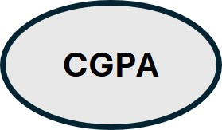  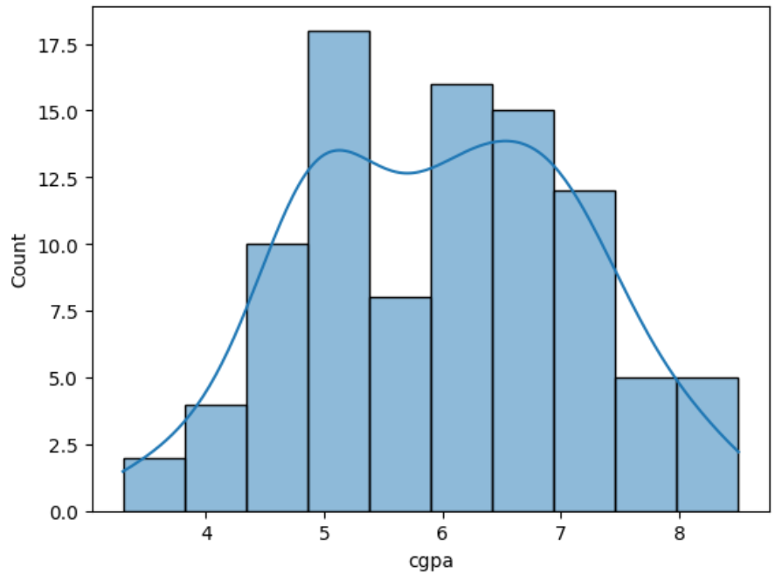 | 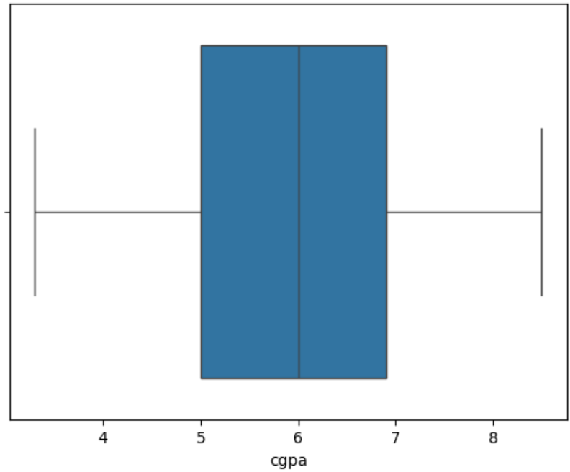
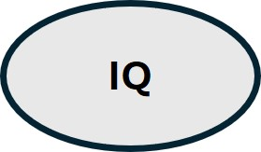  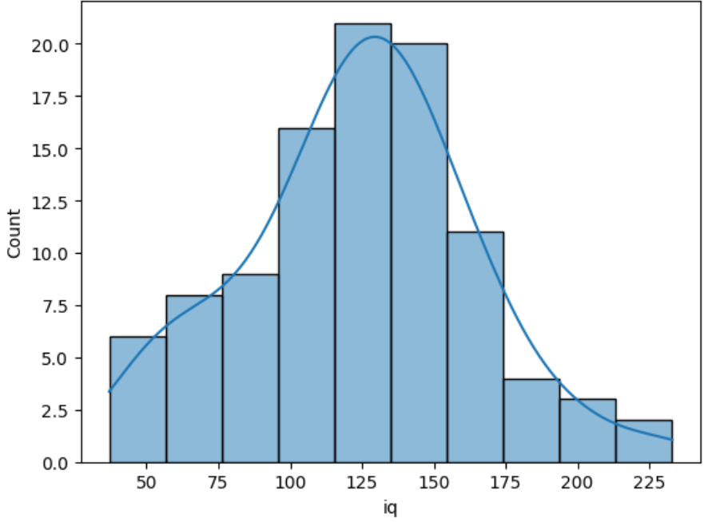 | 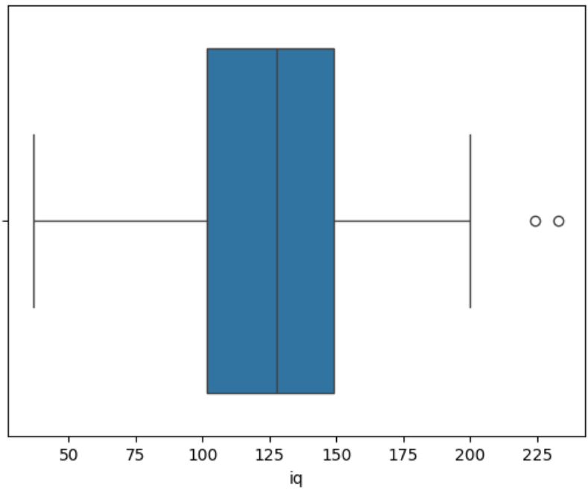

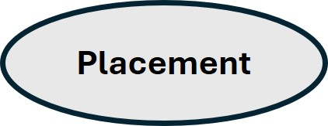
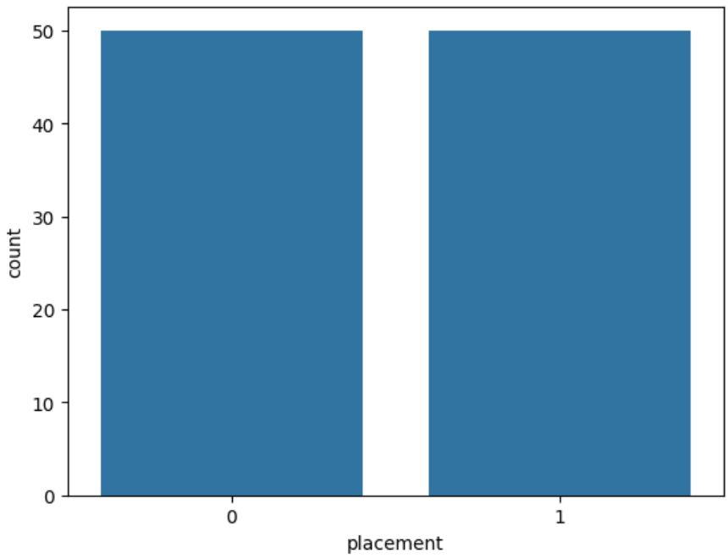
Figure 2.2
- Histograms are created using the histplot( ) function. While calling this function data=df specifies the DataFrame, x='cgpa' specifies the column to plot, bins=10 specifies the number of bins in the histogram and kde=True adds a Kernel Density Estimate line to show the distribution shape.
- We can make the following observations from these plots:
- The CGPA distribution appears to be approximately normal as most students have a CGPA between 5.0 and 7.0. The CGPA box plot shows no potential outliers (good news!). The median CGPA is around 6.0.
- The IQ scores are widely spread, ranging from 37 to 233. The distribution is almost normal. There are multiple outliers with exceptionally high IQ scores. The median IQ score is roughly around 125.
- The frequency distribution of all classes is perfectly balanced, which is great news. As you'll learn in Chapter 14, class imbalance can pose significant challenges for machine learning models.
Bivariate Analysis of Input Features
- Bivariate analysis examines the relationship between two variables and can be illustrated using a scatterplot and correlation coefficient as shown in the following program:

import matplotlib.pyplot as plt
import seaborn as sns

# relationship between cgpa and iq
sns.scatterplot(data=df, x='cgpa', y='iq')
plt.show( )
corelation = df[['cgpa', 'iq']].corr( )
print(corelation)

- On execution the program produces the following output:
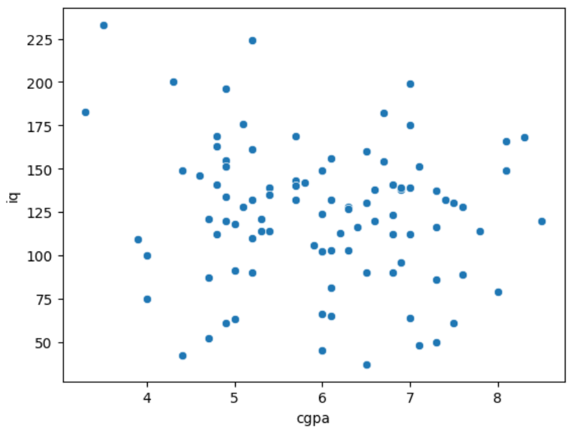

cgpa iq
cgpa 1.000000 -0.128172
iq -0.128172 1.000000

- The scatter plot shows a slight negative correlation between CGPA and IQ (higher IQ correlates to low CGPA scores).
- Correlation coefficient measures the strength and direction of the linear relationship between two variables. It ranges from -1 to +1.
- A value of +1 indicates a perfect positive linear relationship, a value of -1 indicates a perfect negative linear relationship and a value close to 0 suggests little or no linear relationship between the variables.
- df[['cgpa', 'iq']].corr( ) calculates the correlation matrix between cgpa and iq.
- The correlation coefficient between cgpa and iq is approximately -0.12, indicating a moderate negative correlation.
Multivariate Analysis with Target Variable
- Multivariate analysis involves examining more than two variables simultaneously. In our case we can use it to examine the relationship between cgpa, iq, and placement.
- We will do this by drawing a scatterplot in the following program:

import pandas as pd
import matplotlib.pyplot as plt
import seaborn as sns
url = "sdfsdfsdf"
df = pd.read_csv(url)
# relationship between cgpa, iq and placement
sns.scatterplot(data=df, x='cgpa', y='iq', hue='placement')
plt.show( )

On execution, the program produces the output shown in Figure 2.3.
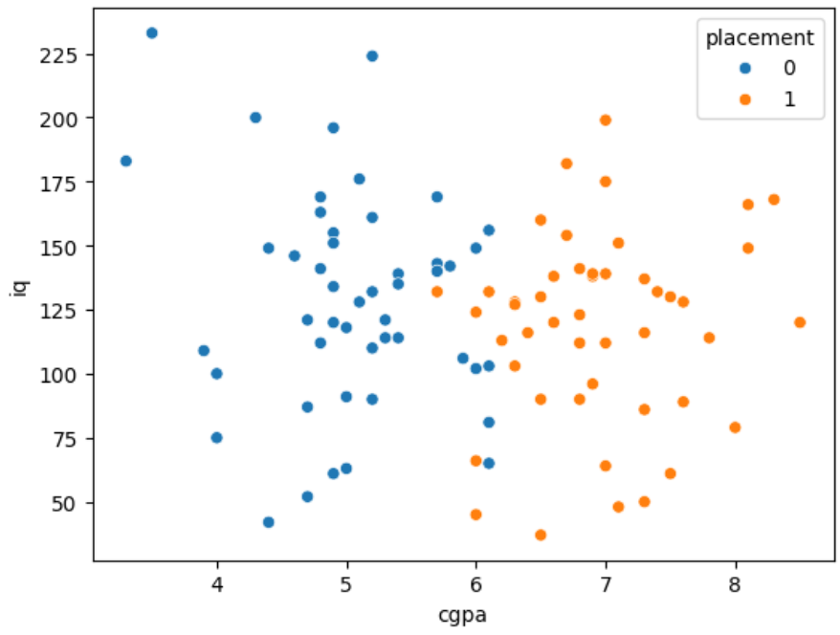
Figure 2.3

- hue='placement' colors the data points based on the placement status. The legend indicates which color corresponds to each placement status.
- From Figure 2.3 we can observe that students who are placed (placement = 1) tend to have higher CGPA scores.
- It also appears that the two classes (placement 1 and 0) are linearly separable, meaning we can distinguish them by drawing a straight line that separates the two classes (this information will be useful during the modeling stage).
Step 5 - Feature Engineering
- Feature engineering is the process of using domain knowledge to extract features from raw data that make machine learning algorithms work better. It involves creating, transforming, and selecting features to improve the performance of predictive models. It's about making the data more informative and suitable for the machine learning algorithm we're using.
- Many feature engineering techniques are available for improving the quality of the data. Despite the simplicity of our dataset, feature engineering is still essential to enhance our model's predictive capabilities.
- We will use feature engineering techniques for:
- Handling missing values in cgpa
- Outlier detection and treatment in iq
- Feature scaling
Let us now deal with these one by one.
Handling Missing cgpa Values
- During data exploration, we noticed that the cgpa column contains missing values. Missing data can lead to biased results and reduce the reduce the accuracy of our model if not properly addressed.
- The simplest approach to deal with missing values is to remove those rows. This comes at the cost of losing potentially valuable data, which may reduce the overall dataset size and affect model performance.
- Instead of discarding data, we can replace missing values with estimates. Common imputation methods include filling in the mean or median of the column or employing a predictive model to estimate the missing values based on other features in the data.
- Each method has its trade-offs, and the choice depends on the dataset and the importance of the missing information.
- For this project we use mean imputation, i.e. we will replace the missing values in the cgpa column with the column's mean. This method is not only simple to implement but also appropriate in this case because the cgpa data roughly follows a normal distribution.
- In a normally distributed dataset, the mean is a reliable central value that effectively represents the overall data. This makes mean imputation a reasonable choice, as it minimizes distortion and helps retain the integrity of the dataset.
- Let’s now apply mean imputation to our cgpa column through a program.

import pandas as pd
url = "sdfsdf "
df = pd.read_csv(url)
df.info( ) # reports 95 cgpa values, 5 missing

df['cgpa'] = df['cgpa'].str.replace(',', '.')
df['cgpa'] = df['cgpa'].astype(float)
mean_cgpa = df['cgpa'].mean( )
df['cgpa'].fillna(mean_cgpa, inplace=True)
df.info( ) # reports 100 cgpa values

- Once the mean of cgpa values is calculated using mean( ) function, the missing values are replaced with mean value using the fillna( ) function. The parameter inplace=True modifies the original DataFrame.
Handling Outlier iq Values
- Outliers are data points that significantly deviate from other observations in the dataset. They can occur due to measurement errors, data entry errors, or they may be valid but extreme observations.
- Outliers can distort statistical measures and adversely affect the performance of machine learning models.
- We can detect outliers using statistical methods like Interquartile Range (IQR) or Z-score.
- Once identified, we ca treat outliers by either removing them, or capping them to some threshold value, or applying mathematical functions (like log) to reduce the effect of outliers.
- During our EDA, we plotted a box plot for the iq column and observed potential outliers on the higher side. We can identify these outliers using a simple conditional statement.
- Once identified, we'll cap the outliers by setting it to a defined upper bound. Since most IQ scores are below 200, we'll cap any IQ score above 200 to 200. Here is how we do this:

import pandas as pd
import numpy as np
url = "ssdfsdf"
df = pd.read_csv(url)
print("Old df with outliers:")
print(df[df['iq'] > 200])
df['iq'] = np.where(df['iq'] > 200, 200, df['iq'])
print("New df with no outliers:")
print(df[df['iq'] > 200])

- The expression df[df['iq'] > 200] filters the DataFrame to include only rows where the iq value is greater than 200.
- The where( ) function checks if the value in the iq column is greater than 200. If the condition is true, it replaces the value with 200. If the condition is false, it keeps the original value df['iq'].
- Here is the output of the program…

Old df with outliers:
cgpa iq placement
16 5,2 224.0 No
50 3,5 233.0 No
New df with no outliers:
Empty DataFrame
Columns: [cgpa, iq, placement]
Index: [ ]

- If you plot the boxplot again, it will not show any outliers. Thus, by carefully handling outliers, we've improved the quality of our dataset, which will contribute to building a more robust and accurate machine learning model.
Feature Scaling
- Feature scaling is the process of adjusting the scales of features so that they contribute equally to the learning process of a machine learning model. In other words, it's about bringing all the features to a similar scale without distorting differences in the ranges of values.
- Our features, cgpa and iq are on different scales. cgpa ranges approximately from 3.3 to 8.5, whereas iq ranges from 37 to 233.
- If we don't scale these features, the machine learning model might interpret iq as being more important than cgpa simply because it has larger numerical values. This can lead to biased models where features with larger scales dominate the learning process.
- We will use Standardization (Z-score Normalization) for scaling our features because it centers the data and is less sensitive to outliers compared to normalization. The following program shows how this can be done.

from sklearn.preprocessing import StandardScaler
df['cgpa'] = df['cgpa'].str.replace(',', '.')
df['cgpa'] = df['cgpa'].astype(float)
ss = StandardScaler( )
df[['cgpa', 'iq']] = ss.fit_transform(df[['cgpa', 'iq']])
print(df.head( ))

- After importing the StandardScaler class from the ML library scikitlearn, we have created an instance of this class.
- The fit_transform( ) method of this class first fits the scaler to the data (computes the mean and standard deviation for each feature) and then transforms the data according to these computed parameters. The scaling is done separately for each feature. The output of the program is given below.

cgpa iq placement
0 0.705104 -0.000260 Yes
1 -0.076821 -0.442829 No
2 -0.598104 -0.052327 No
3 1.226388 0.234041 Yes
4 -0.163701 0.494375 No

- The cgpa and iq columns now contain scaled values. These values represent the number of standard deviations each original value is from the mean of its feature. We will study the inner working of StandardScaler class in detail in Chapter 5.
Step 6 - Model Building
- With our data cleaned and prepared, we're now ready for the exciting part: building and evaluating our machine learning models! This is where all the hard work pays off, as we put our data to the test and unlock its potential to make powerful predictions.
- We'll create a model that can predict whether a student will be placed or not based on his/her CGPA and IQ scores. This involves the following steps:
- Defining features and target variable
- Splitting data into training and testing sets
- Choosing an appropriate machine learning algorithm
- Training our model on the training data
Defining Features and Target Variable
- First, we need to separate our dataset into features and target variable. Features (x) stand for the input variables that will help us make predictions, whereas target variable (y) is the output variable that we wish to predict.
- For our dataset we can define the features and target variable through the statements given below.

# Features: CGPA and IQ
x = df[['cgpa', 'iq']]
# Target Variable: Placement Status
y = df['placement']

Here x contains cgpa and iq columns. These are the characteristics of each student that we believe influence their placement status. Likewise, y contains the placement column, which indicates whether a student was placed (1) or not placed (0).
By defining X and y, we're telling our model what inputs to consider and what output to predict.
Splitting the Data
- To assess how well our model performs on new, unseen data, we'll split our dataset into two parts:
Training Set: Used to train the model
Testing Set: Used to evaluate the model's performance
- For this we will use an 80/20 split, meaning 80% of the data will be used for training and 20% for testing. This can be done as shown below.

from sklearn.model_selection import train_test_split
# Splitting the dataset (80% training, 20% testing)
X_train, X_test, y_train, y_test = train_test_split(x, y, test_size=0.20,
random_state=42)

- The train_test_split( ) function from scikit-learn shuffles and splits the data into training and testing sets. The parameter test_size=0.20 specifies that 20% of the data should be reserved for testing. The parameter random_state=42 sets a seed for the random number generator, ensuring that we get the same split every time we run the code. This makes our results reproducible.
- By doing this, we can train our model on one portion of the data and test it on a separate portion, giving us a good indication of how it might perform in the real world.
Choosing the Right ML Model
- Since we're dealing with a classification problem (predicting whether a student is placed or not), we need an algorithm that's suitable for binary classification.
- One of the most popular and straightforward algorithms for binary classification is Logistic Regression. Despite its name, it is used for classification tasks.
- The Logistic Regression algorithm is easy to understand and interpret. It is computationally less intensive, making it quick to train. Also, it works well when the relationship between the features and the target is linear, which seems to be the case based on our exploratory data analysis.
Creating and Training the Model
- Now, let's create an instance of the Logistic Regression model and train it using our training data.

from sklearn.linear_model import LogisticRegression
# create an instance of the Logistic Regression model
model = LogisticRegression( )
# training the model on the training data
model.fit(X_train, y_train)

- The sklearn.linear_model module contains various linear models. From it we have imported LogisticRegression class and created an instance of it. This creates a new logistic regression model with default parameters.
- model.fit(X_train, y_train) fits the model to our training data, allowing it to learn the relationship between the features (cgpa and iq) and the target variable (placement).
- By executing this code, we've successfully trained our logistic regression model. It has now learnt from the data and is ready to make predictions.
- Note that we won't delve into the mathematical details of how Logistic Regression works here. We will explore it thoroughly in Chapter 7, where we'll break down the inner workings and intuitions behind this powerful algorithm.
Step 7 - Model Evaluation
- Congratulations! We've trained our logistic regression model to predict student placements based on CGPA and IQ scores. But how good is our model in predicting student placements? For this we will put our model to the test and see how well it performs.
- For this we will focus on two key aspects:
- Calculating the Accuracy: Measuring how often our model makes the correct prediction.
- Plotting the Decision Boundary: Visualizing how our model separates the two classes (placed vs. not placed) based on the input features.
Calculating the Accuracy
- Accuracy gives us a straightforward way to assess our model's performance. It tells us the proportion of correct predictions out of all predictions made. An accuracy of 100% means our model predicts every outcome correctly—a rare but delightful scenario!
- First, we'll use our trained model to make predictions on the test data that the model hasn't seen before. This is done in the following code snippet.

# make predictions on the test set
y_pred = model.predict(X_test)

model.predict(X_test) uses the logistic regression model to predict the placement status for each student in the test set.
- Now, we'll calculate the accuracy of our model's predictions.

from sklearn.metrics import accuracy_score
# Calculating the accuracy
accuracy = accuracy_score(y_test, y_pred)
print(f"Model Accuracy: {accuracy * 100:.2f}%")

The function accuracy_score(y_test, y_pred) compares the true placement statuses (y_test) with our model's predictions (y_pred) and calculates the accuracy.
{accuracy * 100:.2f}% formats the accuracy value as a percentage with two decimal places.
- On execution it reports the model accuracy as 95%. This means that out of all the students in our test set, our model correctly predicted the placement status for 95% of them.
- But remember, accuracy is just one metric. Depending on the context and the data, accuracy alone might not tell the whole story. However, since our dataset is balanced (roughly equal numbers of placed and not placed students), accuracy is a suitable metric for evaluation.
Plotting the Decision Boundary
- A decision boundary is a line (or surface in higher dimensions) that separates the feature space into regions corresponding to different classes. In our case, it helps us visualize how the model distinguishes between students who are placed and those who are not based on their CGPA and IQ scores.
- Instead of writing code from scratch to plot the decision boundary, we'll use a library called mlxtend (Machine Learning Extensions). It provides useful tools for data science tasks, including the plot_decision_regions( ) function, which makes plotting decision boundaries a breeze!
- You can install mlxtend using the following command:

!pip install mlxtend

The exclamation mark ! is used to run shell commands within Jupyter notebooks or Google Colab.
- Let's create a plot that shows the data points (students), colored by their actual placement status and the decision boundary learned by our logistic regression model.

import matplotlib.pyplot as plt
from mlxtend.plotting import plot_decision_regions

# combine training and test data for plotting
X_combined = pd.concat([X_train, X_test])
y_combined = pd.concat([y_train, y_test])

# plot the decision boundary
plt.figure(figsize=(10, 6))
plot_decision_regions(X_combined.values, y_combined.values,
clf=model, legend=2)

# adding axis labels and title
plt.xlabel('CGPA')
plt.ylabel('IQ Score')
plt.title('Decision Boundary of Logistic Regression Model')
plt.show( )

We have combined X_train and X_test (and similarly for y) because plot_decision_regions( ) requires the full dataset.
plot_decision_regions( ) takes the feature matrix, target array, and the trained classifier (clf=model) to plot the decision regions. legend=2 positions the legend on the plot.
- The plot drawn by our program is shown in Figure 2.4.

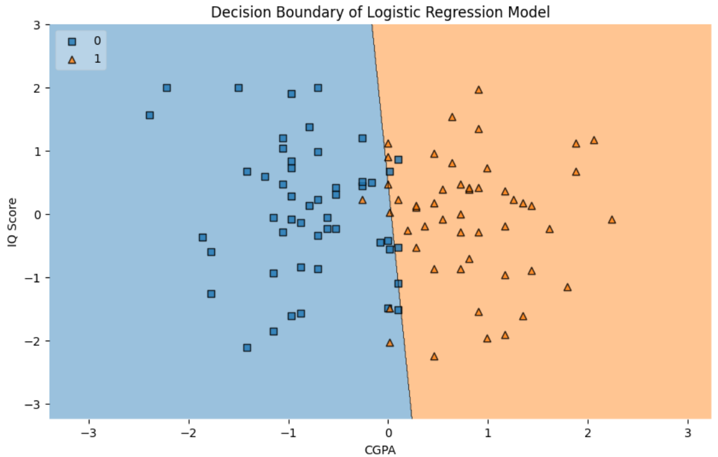
Figure 2.4
The plot shows different regions corresponding to the predicted classes. Region 0 corresponds to students predicted as not placed and Region 1 corresponds to students predicted as placed.
The data points represent individual students, plotted based on their CGPA and IQ scores. The colors of the points correspond to their actual placement status.
The line separating the regions is the decision boundary learned by our model.
- Our logistic regression model has learned a linear decision boundary that effectively separates the two classes.
- Students with higher CGPA tend to fall into the "placed" region.
- The model captures the underlying patterns in the data, and the visualization confirms its effectiveness.
A Journey from Data to Decisions
- Congratulations! 🌟 We have taken a significant step forward in our machine learning journey by completing the first end-to-end ML project.
- By working through an entire project, we have gained valuable insights into how each component fits into the grand scheme of building a ML model.
- Throughout this chapter we engaged with the data, made decisions, and saw firsthand how ML models are built and evaluated. We transformed raw data into actionable insights, which is the essence of ML.
Looking Ahead
- While our model performs well, there's always room for improvement! In chapters to follow, we will zoom in on each step we have touched upon while building this project.
- We will also do cross-validation to ensure that our model generalizes well with new data. We will also explore other ML algorithms to see if we can achieve even better results.
- Keep up your enthusiasm and curiosity and get ready to dive even deeper into the exciting world of machine learning!
____________________________________________________________________


- Match the following pairs:

a. Data Ingestion | 1. | Replacing missing values with the average value of the feature
b. EDA | 2. | Visualizing data to uncover patterns and relationships
c. Feature Engineering | 3. | Scaling features to have zero mean and unit variance
d. Mean Imputation | 4. | A linear model used for classification tasks
e. StandardScaler | 5. | Loading data into the working environment for analysis
f. Logistic Regression | 6. | Modifying features to improve model performance
g. Outlier Treatment | 7. | Adjusting or removing data points that deviate significantly from others
h. Decision Boundary | 8. | The line or surface that separates different classes in a model
- State whether the following statements are True or False:

- Google Colab allows us to run Python code without needing to install Python or any libraries on our local machine.
- Feature scaling is important to prevent features with larger scales from dominating the learning process.
- Outliers in the iq column were handled by removing the rows containing these outlier values.
- Mean imputation is suitable for replacing missing values in the cgpa column when the data is normally distributed.
- A correlation coefficient close to zero indicates a strong linear relationship between two variables.
- Replacing missing values with the mean is always the best strategy for handling missing data.
- The placement column had to be converted to numerical values because machine learning algorithms cannot directly handle categorical string values.

- Build an end-to-end ML project for the problem described below.

A university wishes to build a Machine Learning Solution for its Admissions Office to predict student dropout risk. With this solution the university wishes to identify students at risk of dropping out before graduation. With early intervention, the university can provide targeted academic support and resources to help students stay on track and complete their degrees. This will increase retention rates, enhance student success, and improve the institution's overall reputation.
You are required to describe the actions that you will take in each of the following steps while building this project end-to-end.
Step 1 - Project Overview – Objective, Why it is important
Step 2 - Data Ingestion – Goal, Data Collection Sources – Student demographics, Academic performance data, Financial data, External factors
Step 3 - Data Preprocessing – Goal, Tasks – Handling missing data, Encoding categorical variables, Normalizing/Scaling data, Removing outliers
Step 4 - Exploratory Data Analysis – Goal, Tasks – Data visualization, Statistical analysis, Target variable distribution
Step 5 - Feature Engineering – Goal, Tasks – Create new features, Interaction terms, Binning or bucketing
Step 6 - Model Building – Goal, Model selection, Train-Test split
Step 7 - Model Evaluation – Goal, Tasks – Performance metrics, Confusion matrix, ROC curve, Cross-validation

