Lee Wei Kang

Software Engineer

**Email**: leeweikang1220@gmail.com

**Phone**: (60) 169519266

**Github**: github.com/kang120

**LinkedIn**:linkedin.com/in/weikang120

**Personal Website**: lwk20.com

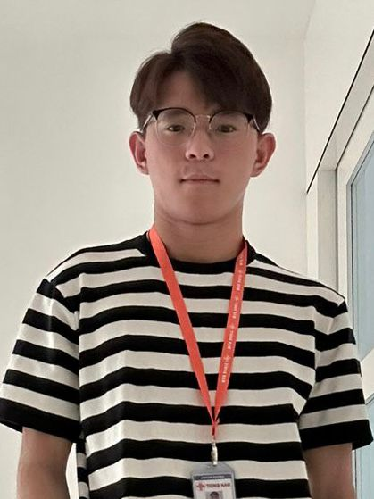

**Languages**: Chinese, English, Malay

A Software Engineer with 1 year of experience in high-performance web application development. Proficient in frontend with React and Angular, backend with Restful API and MySQL. Experienced in leading projects, migrating technologies, and implementing modern UI designs. Seeking to leverage skills in a dynamic environment to contribute to cutting-edge projects.

**Educations**

**Apr 2019 – June 2023 Bachelor in Computer Science Hons Artificial Intelligence**

*Multimedia University, Malacca, Malaysia*

CGPA: 3.89/4.00

**Experiences**

**Oct 2023 - Present Software Engineer ˑ Full-time**

*Tiong Nam Logistics Holdings Berhad, Johor, Malaysia*

*Leaving Reason: Company job is repetitive. Seeking new opportunity that aligns with my career goals and grows.*

* Design, build, and deploy high-performance web applications and APIs, ensuring optimal functionality and user experience
* Develop web applications to track real-time live locations of trucks, enabling efficient logistics management
* Implement modern and visually appealing UI designs to enhance the overall look and feel of web applications
* Evaluate new solutions and make recommendations for the continuous improvement

**May 2022 - May 2023 Software Engineer ˑ Part-time ˑ Sep 2022 - May 2023**

*Ounch Sdn Bhd, Kuala Lumpur, Malaysia*

* Maintain and update software to meet the latest client requirements
* Render new 3D maps as per client specifications
* Troubleshoot, debug, and enhance existing software and plugins to improve overall performance and user experience
* Provide timely and effective technical support to address client issues

**Software Engineer Intern ˑ Internship ˑ May 2022 - Aug 2023**

*Ounch Sdn Bhd, Kuala Lumpur, Malaysia*

* Conduct research and development on emerging technologies to identify opportunities for replacing traditional solutions with more advanced alternatives
* Develop prototypes that reflect the availability and functionality of proposed solutions, showcasing their potential benefits
* Analyze user behaviors on digital signage with machine learning and build a dashboard to visualize the analysis result

**Nov 2021 - Dec 2021 Voluntary Research Assistant ˑ Voluntary**

*Multimedia University, Malacca, Malaysia*

* implement new user interface on web app
* Prepare test cases and run through all the scenarios in each module
* Migrate the old system to updated CodeIgniter framework

**Skills**

**Programming Languages**: JavaScript, HTML/CSS, PHP, Python, Java, C++, C#

**Frameworks & Library**: React, Angular, Bootstrap, Sass, Restful API, GraphQL, ASP.NET, Spring Boot, CodeIgniter, Django, Flask

**Database**: MySQL, Oracle, MSSQL

**Tools:** Git, Node

**Certificates**

**First Class Honor ˑ awarded by the faculty for achieving excellent performance in CGPA**

**Huawei Certification – AI ˑ awarded by Huawei for successfully completing the AI exam**

**Hobbies & Interests**

**Hobbies**: Basketball, Badminton, Body Building, Chess, Programming

**Interests**: Software, Finance, Investment, Forex, Logistics