

MECS 0033 Artificial Intelligence
Title: TransitAI UTM – A Web-Based Chatbot for Campus
Transport Information

Course Code | MECS 0033
Course Name | Artificial Intelligence
Section | 52
Lecturer’s Name | Dr. Shafaatunnur binti Hasan
Session/Semester
Assignment Title | TransitAI UTM – A Web-Based Chatbot for Campus Transport Information
Group | 5
Member Details | Mohd Faiz Bin Min  Teoh Jia Kang  Ahmad Umar Bin Mohammad Yusof

TABLE OF CONTENTS
1.0 Objectives 2
2.0 Problem Statement 2
2.1 Introduction 2
2.2 Problem Background 3
2.3 Significance of the problem 3
2.4 Needs of an AI Solution 3
3.0 Empathy Map 4
1. What does stakeholder see? 6
2. What does stakeholder hear? 6
3. What does stakeholder say and do? 6
4. What does stakeholder think and feel? 6
4.0 Architecture 8
4.1 Front-End User Interface (UI) 9
4.3 Notification API 11
4.4 Knowledge Repository Interaction 12
5.0 Features and Design 13
5.1 Survey Report 13
5.2 Stakeholder Interview Summary 19
5.3 User Interface Storyboard 20
5.4 User Interface Navigation Flow 23
5.5 Knowledge Base Predicate Logic 24
5.6 CNF Conversion 25
5.7 Resolution Refutation Example 26
6.0 Intelligent Agent 28
6.1 PEAS Model Overview 28
6.2 PEAS Model Diagram 30
6.3 Relationship Between PEAS Model and User Interface 30
7.0 Appendix (Survey Form and Responses) 31

1.0 Objectives
- To design and develop an AI-based chatbot capable of understanding user queries related to UTM shuttle bus services.
- To implement an intent recognition mechanism that can classify user inputs (e.g., schedule inquiry, route request, operational information) and generate appropriate responses.
- To develop a knowledge-based system that integrates shuttle schedule and route data for intelligent information retrieval.
- To evaluate the chatbot’s performance in terms of response accuracy, relevance, and user interaction effectiveness.

2.0 Problem Statement
At UTM, transport-related information such as shuttle schedules and routes is typically provided through static formats such as websites and documents. These sources are not interactive and require users to manually search for relevant information, which can be time-consuming and inefficient.
Furthermore, existing systems do not incorporate intelligent mechanisms to interpret user queries or provide personalized responses. Artificial intelligence system may help to interpret user queries, extract relevant meaning, and provide accurate responses in real time. An AI-based chatbot can address these challenges deliver appropriate transport information efficiently.

2.1 Introduction
A chatbot is a computer program designed to simulate conversation with users through text or voice. Modern chatbots use Artificial Intelligence (AI) technologies such as Natural Language Processing (NLP), intent recognition, and response generation to provide useful and intelligent responses.
At Universiti Teknologi Malaysia (UTM), shuttle bus services are important for students, staff, and visitors to travel between colleges, faculties, libraries, cafeterias, and other campus facilities. However, accessing accurate transport information can be inconvenient when users need immediate answers.
This proposal focuses on developing TransitAI UTM, an AI-based campus transport chatbot that helps users obtain transport information efficiently through a web-based platform.

2.2 Problem Background
UTM is a large campus with many faculties, residential colleges, and facilities located across different areas. Students often depend on shuttle buses to move around campus.
Currently, transport information is usually obtained through:
- Static schedules on notice boards
- Websites or social media pages
- Waiting at bus stops without certainty
These methods are not interactive and may not provide instant or updated information.
Common issues faced by users include:
- Not knowing next shuttle arrival time
- Confusion about routes and destinations
- Lack of delay notifications

2.3 Significance of the problem
Transport inefficiency affects student punctuality, daily productivity, and campus mobility. Students may be late for classes, miss appointments, or waste time waiting for transport. For transport staff, repetitive enquiries regarding schedules and routes increase workload and reduce efficiency. Therefore, an intelligent chatbot system can significantly improve information delivery and service quality.

2.4 Needs of an AI Solution
An AI solution is needed because traditional static information systems cannot understand user questions or provide personalized responses.
The proposed chatbot can:
- Identify user intent
- Extract important locations or timing requests
- Provide instant accurate responses
- Reduce repetitive manual enquiries
This makes AI more effective than static websites or posters.

3.0 Empathy Map
Empathy Map from the Stakeholders’ Perspectives:

Stakeholder 1: Students/User
1. What does stakeholder see?
- Long waiting times at bus stops
- Static shuttle schedules on notices board or websites
- Crowded buses during peak hours
- Different students asking the same transport questions
- Limited real-time updates about delays or route change
2. What does stakeholder hear?
- Complaints about unreliable shuttle timing.
- Announcements about service changes.
- Suggestions to walk or use alternative transport.
- Lecturers reminding students not to be late.
3. What does stakeholder say and do?
- “When is the next bus?”
- “Which shuttle goes to my faculty?”
- Check schedules online or on posters.
- Ask friends or staff for transport information.
- Wait early at bus stops to avoid missing the shuttle.
4. What does stakeholder think and feel?
- Worried about being late for class.
- Frustrated when schedules are unclear.
- Confused about routes or stops.
- Stressed during peak hours.
- Relieved when receiving accurate information quickly.
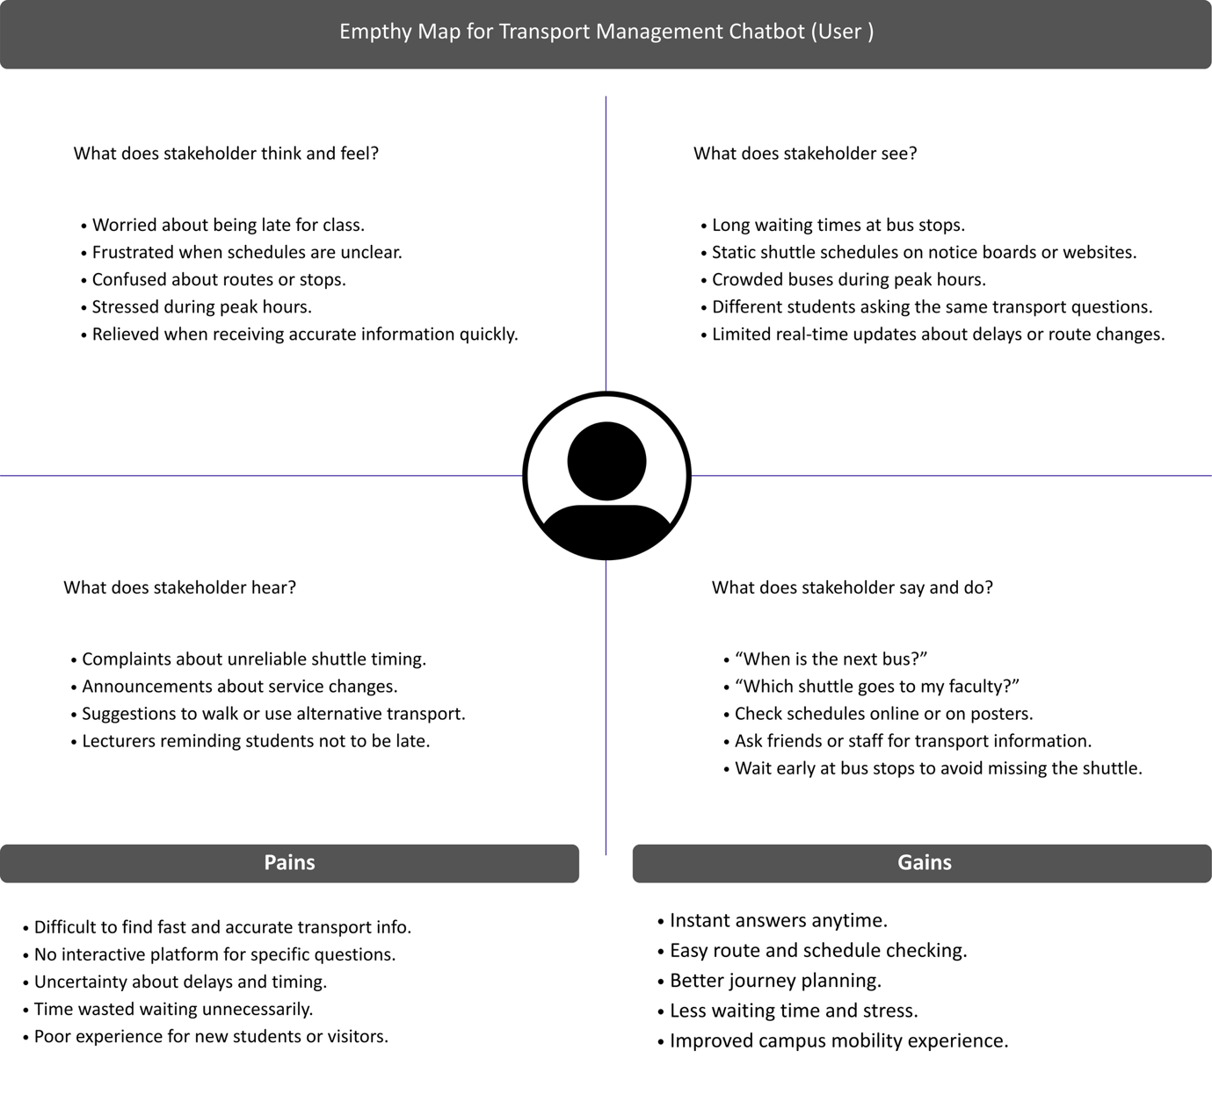
Figure 1 Empathy Map: User
Mind mapping link: https://canva.link/e13hccubouqhj9j

Stakeholder 2: Transport Management / Service Provider

1. What does stakeholder see?
- High volume of repetitive student enquiries.
- Congestion at popular bus stops.
- Complaints regarding delays or unclear schedules.
- Manual processes for schedule updates.
- Difficulty communicating changes quickly.

2. What does stakeholder hear?
- Students complaining about late buses.
- Requests for more frequent service.
- Feedback from university management.
- Driver reports about traffic or operational issues.
- Pressure to improve service quality.

3. What does stakeholder say and do?
- Answer schedule questions through calls
- Update routes and timetables manually.
- Manage shuttle operations daily.
- Handle complaints and feedback.
- Coordinate drivers and service announcements

4. What does stakeholder think and feel?
- Overwhelmed by repetitive enquiries.
- Concerned about maintaining service efficiency.
- Responsible for user satisfaction.
- Stressed when disruptions happen.
- Interested in smarter systems to reduce workload.
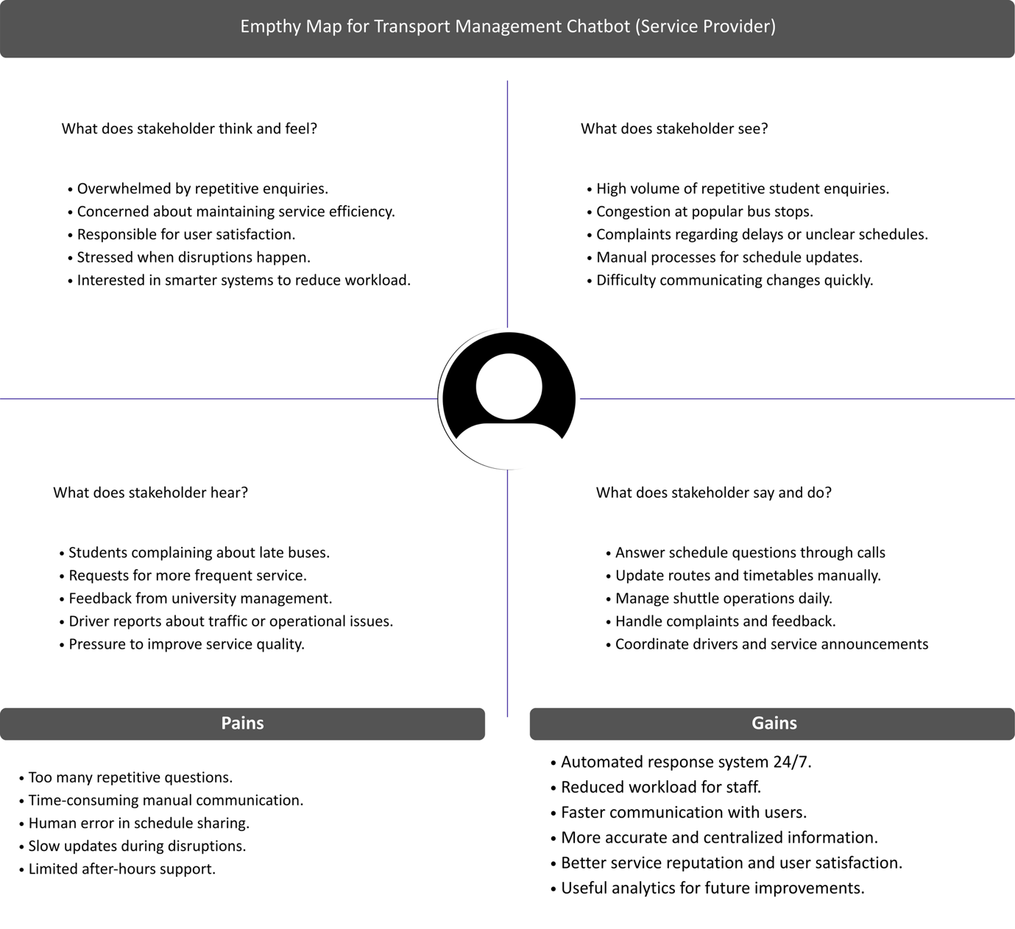
Figure 2 Empathy Map: Services Provider
Mind mapping link: https://canva.link/e13hccubouqhj9j

4.0 Architecture
The UTM Campus Assistance Chatbot Hostel Management is built to offer staff,
students, and hostel administration a seamless, engaging, and effective service. The solution can be implemented as a mobile or web application, in order to process user requests and deliver pertinent responses.

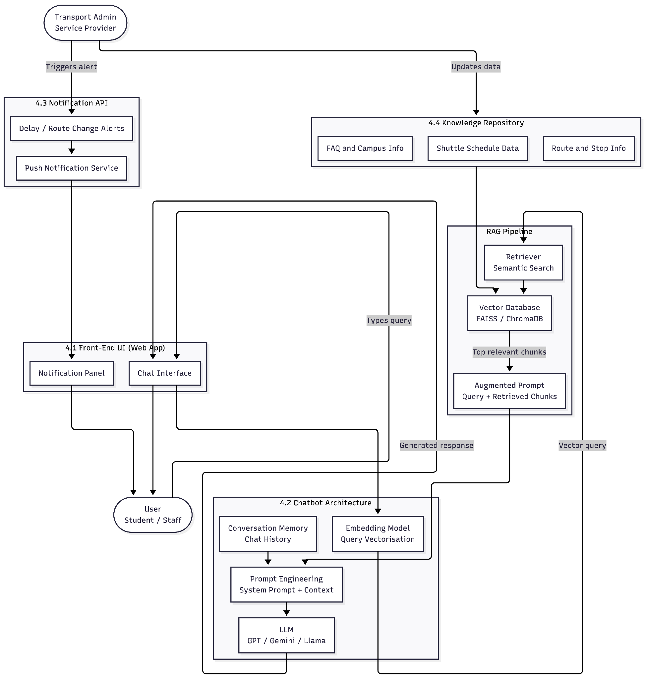
Figure 3 TransitAI UTM Chatbot Architecture

4.1 Front-End User Interface (UI)
The Front-End User Interface (UI) serves as the primary interaction layer between user and the TransitAI UTM system. It is designed as a web-based chat interface that allows students and staff to type queries and receive instant responses. The UI is built to be simple, accessible, and responsive, ensuring a smooth experience across different devices including laptops and smartphones.
Key features of the Front-End UI include:
· A chat window where users can type and receive responses in real time.
· A notification panel to display alerts on shuttle delays or route changes.
· A clean and minimal layout that is easy to navigate without prior technical knowledge.

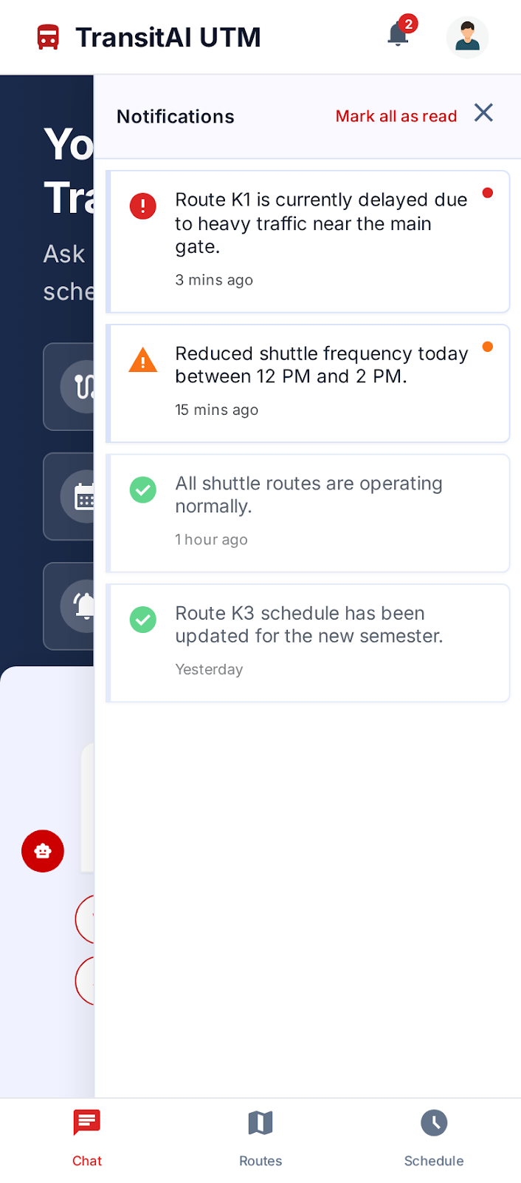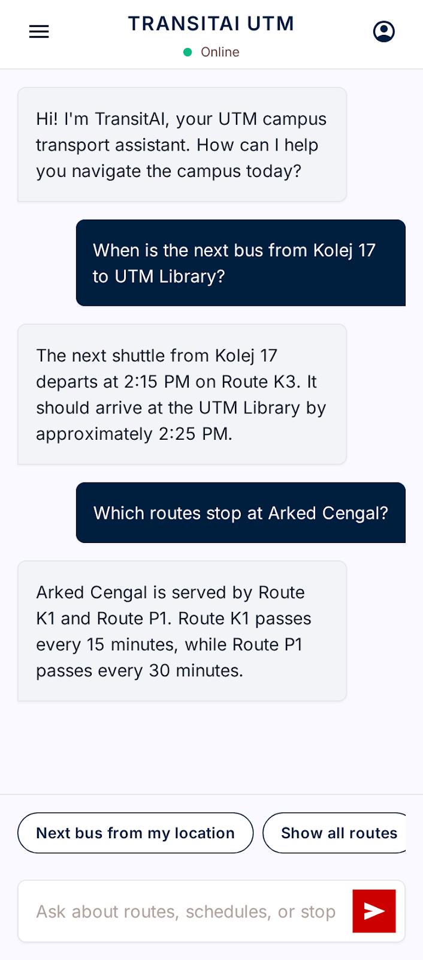
Figure 4 Front-End User Interface

4.2 Chatbot Architecture
The chatbot architecture is the core processing layer for TransitAI UTM. It is responsible for understanding user queries and generating accurate, contextually relevant responses. Unlike traditional rule-based systems that rely on fixed commands, TransitAI UTM uses Large Language Model (LLM) combined with a Retrieval-Augmented Generation (RAG) pipeline to handle a wide range of natural language inputs effectively.
The process flow of the chatbot architecture is as follows:
· User Query Input: The user submits a question through the chat interface, such as asking about the next shuttle departure time or available routes.
· Embedding Model: The user query is converted into a numerical vector representation using an embedding model. This allows the system to perform semantic search rather than simple keyword matching.
· Retriever: The vectorised query is matched against the vector database using semantic similarity search to retrieve the most relevant chunks of information from the knowledge repository.
· Prompt Engineering: The retrieved information chunks are combined with the original user query and a system prompt to form an augmented input for the LLM.
· Large Language Model (LLM): The augmented prompt is processed by an LLM such as GPT or Gemini, which generates a natural language response based on the retrieved context.
· Conversation Memory: The system retains previous exchanges within a session, allowing the chatbot to handle multi-turn conversations and follow-up questions coherently.
This architecture ensures that responses are grounded in verified campus transport data rather than relying solely on the LLM's general training knowledge, which reduces the risk of inaccurate or outdated information being delivered to the user.

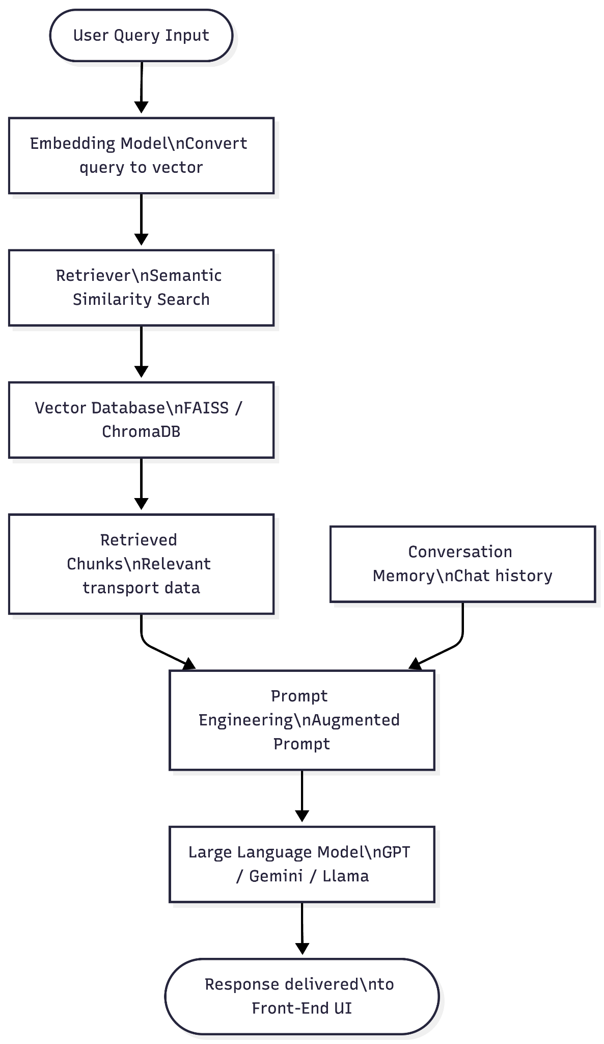
Figure 4.3 Chatbot Architecture Flow

4.3 Notification API
The Notification API serves as the alert delivery layer for the TransitAI UTM system. It enables the system to proactively push important updates to users without requiring them to actively query the chatbot. This is particularly useful for time-sensitive information such as shuttle delays, service cancellations, or route changes.
The Notification API operates through the following process:
· Transport administrators trigger alerts manually when there are service disruptions or schedule changes.
· The Notification API receives the alert and broadcasts it as a push notification to users who are currently accessing the web application.
· The notification is displayed on the user's Notification Panel within the Front-End UI, ensuring that users are informed immediately.
By integrating a dedicated Notification API, the system addresses one of the key problems identified in the problem background, which is the lack of real-time delay notifications. This reduces the need for users to repeatedly query the chatbot about service status and improves the overall reliability of the information service.

4.4 Knowledge Repository Interaction
The Knowledge Repository is the data layer of TransitAI UTM system. It stores all transport-related information that the chatbot references when generating responses. Rather than relying on the LLM's built-in training data, which may be outdated or inaccurate for campus-specific information, the system maintains a dedicated repository of verified UTM shuttle data.
The knowledge repository contains the following categories of information:
· Shuttle Schedule Data: Departure times, frequency, and operating hours for all shuttle routes on campus.
· Route and Stop Information: Details of shuttle routes including all designated stops, destinations, and connections between faculties, colleges, and campus facilities.
· Frequently Asked Questions (FAQ): Common transport-related questions and their answers, such as fare information and service availability during public holidays.
To enable semantic search, all documents and data in the knowledge repository are converted into vector embeddings and stored in a vector database such as FAISS, ChromaDB and Pgvector. When user submits a query, the RAG pipeline retrieves the most relevant data chunks from this vector store and passes them to the LLM for response generation. Transport administrators are responsible for keeping the repository up to date by uploading revised schedules or route information when changes occur.

5.0 Features and Design
This section presents the proposed features and user interface design for TransitAI UTM. The design is based on student-user survey feedback and stakeholder needs gathered during the Define phase of the Design Thinking process. The outcome is presented as a storyboard, a user interface navigation flow, a knowledge base representation, and a logical proof example.

5.1 Survey Report
The survey collected 15 responses from UTM users. The responses indicate that transport information is needed most for daily campus movement, especially by students who stay on campus and depend on shuttle services for class and hostel travel.
Table 5.1 Respondent profile and transport usage
Survey item | Main result | Interpretation for TransitAI UTM
Respondent status | Undergraduate students: 10/15 (66.7%); postgraduate students: 4/15 (26.7%); staff: 1/15 (6.7%). | The primary user group is students, but the system should also support staff and visitors who need campus transport information.
Residence | On-campus hostel: 12/15 (80.0%); off-campus residence: 3/15 (20.0%). | On-campus users are likely to ask about nearby stops, hostel-to-faculty routes, and morning shuttle timing.
Shuttle usage frequency | Regular users: 9/15 (60.0%); never/rarely: 6/15 (40.0%). | The chatbot should support both frequent users who need quick updates and occasional users who need route guidance.
Common usage time | Morning only: 8/15 (53.3%); morning and afternoon: 7/15 (46.7%). | The interface should prioritise morning schedule checking, next-bus arrival, and class-time travel support.

Table 5.2 Survey feedback and desired features
User feedback area | Survey evidence | Desired feature / design response
Difficulty with schedule information | Difficulty obtaining schedule information: Yes 6/15 (40.0%), No 9/15 (60.0%). | Provide schedule checking through natural-language chat and quick-action buttons.
Arrival uncertainty | Unsure about arrival times sometimes/often/very often: 14/15 (93.3%). | Prioritise real-time bus arrival updates and show the last updated time or fallback source.
Transport problems | No latest announcement 11/15 (73.3%); bus delay 8/15 (53.3%); missed bus 7/15 (46.7%). | Add alert cards, delay notifications, and next available bus suggestions after a missed bus.
Current system satisfaction | Neutral 12/15 (80.0%); satisfied 2/15 (13.3%); unsatisfied 1/15 (6.7%). | A neutral result suggests the existing information system is usable but not strong enough for instant, personalised answers.
Lateness caused by transport | Late due to transport issues: Yes 4/15 (26.7%), No 11/15 (73.3%). | The chatbot should reduce avoidable lateness by giving next-bus and alternative-route responses quickly.
Acceptance of chatbot | Would use chatbot: Yes 14/15 (93.3%), Maybe 1/15 (6.7%). | The chatbot is acceptable as the main interaction channel for transport information.

Table 5.3 Feature priority from survey responses
Rank | Requested feature | Survey count | UI implication
1 | Real-time bus arrival updates | 14/15 (93.3%) | Display estimated arrival and last updated time in the chat result.
2 | Bus schedule checking | 9/15 (60.0%) | Provide a Schedule quick action and natural-language schedule intent.
3 | Delay notifications | 8/15 (53.3%) | Provide alert panel and route subscription for delay messages.
4 | Bus stop locations | 6/15 (40.0%) | Show stop details, landmarks, and nearby facilities.
5 | Route guidance | 5/15 (33.3%) | Ask for origin and destination, then recommend route and stop sequence.
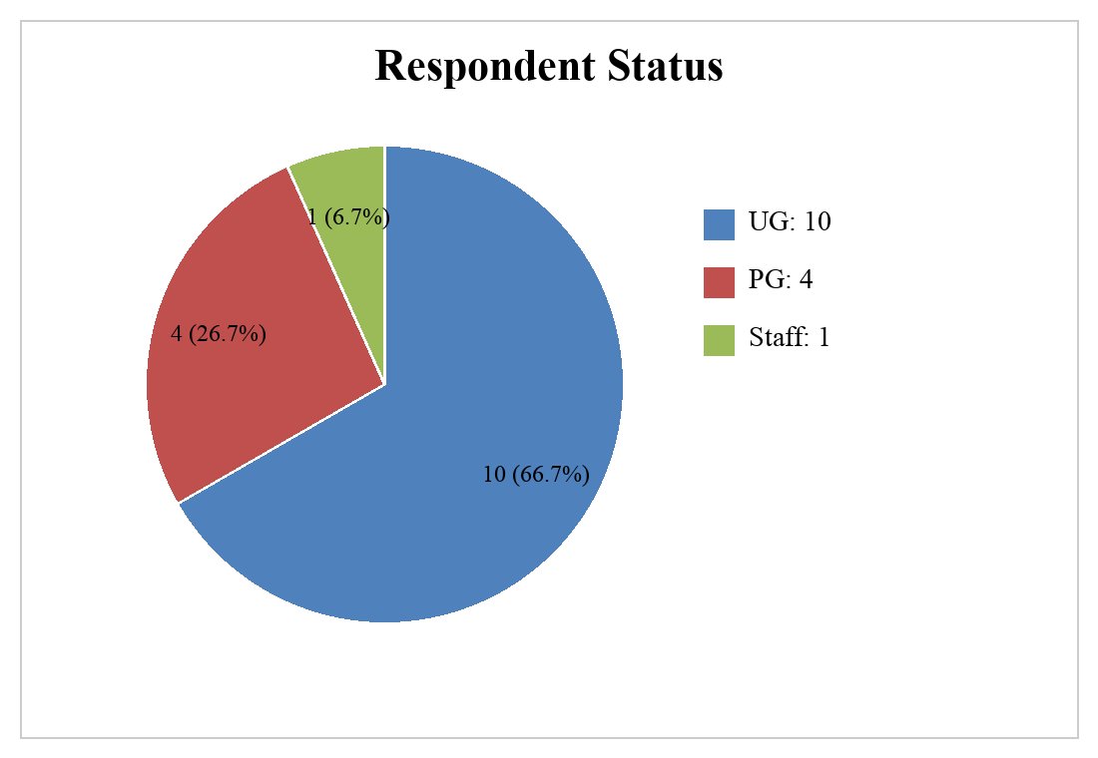
Figure 5.1 Respondent status — Undergraduate (66.7%), Postgraduate (26.7%), Staff (6.7%)
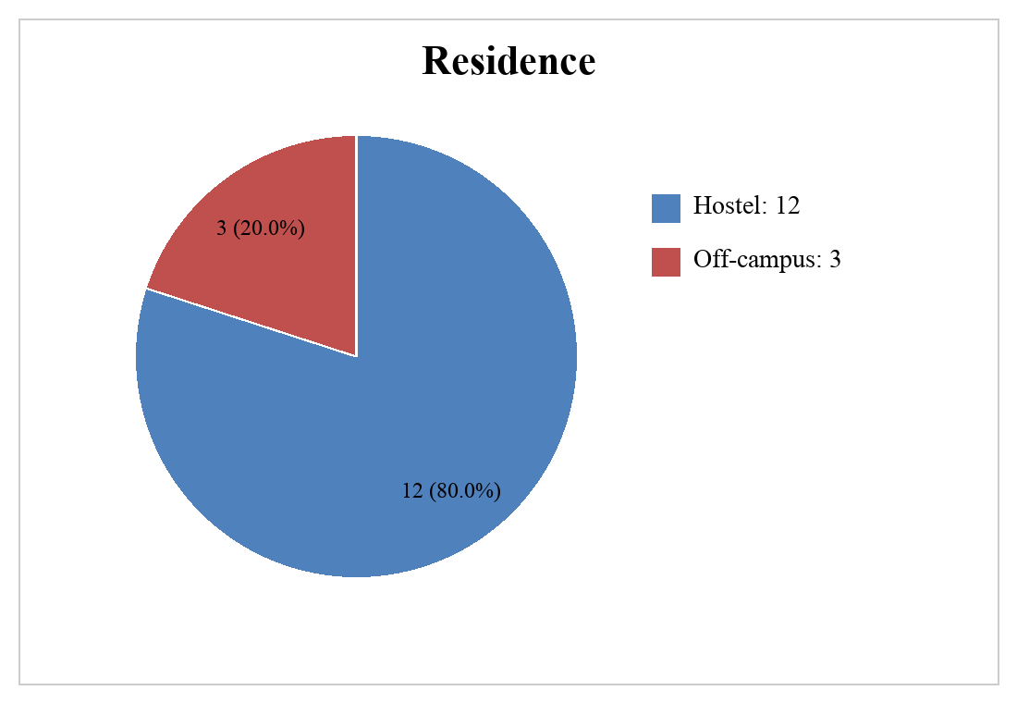
Figure 5.2 Residence — Hostel (80.0%) dominates over off-campus (20.0%)
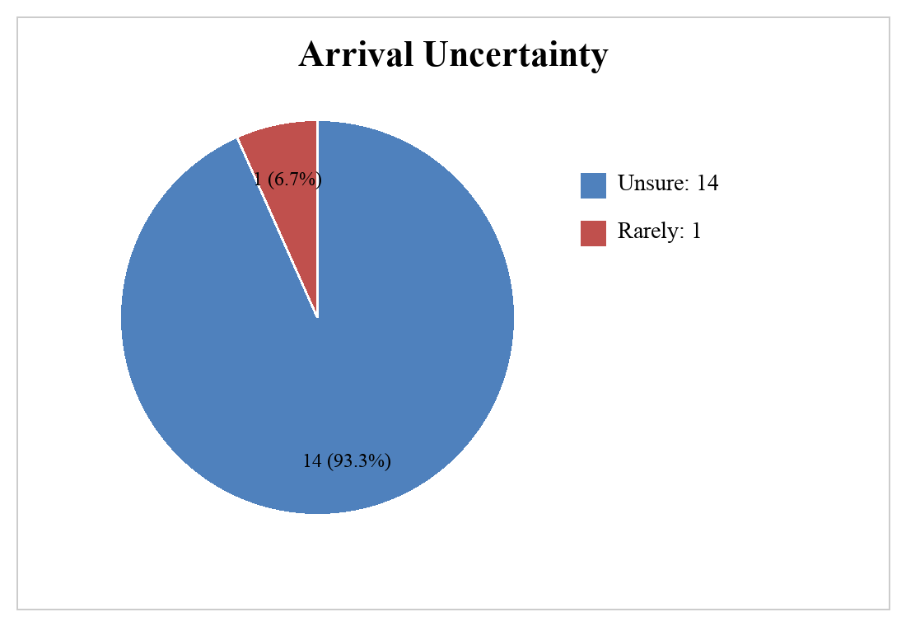
Figure 5.3 Arrival uncertainty — 93.3% of respondents are unsure about bus arrival times
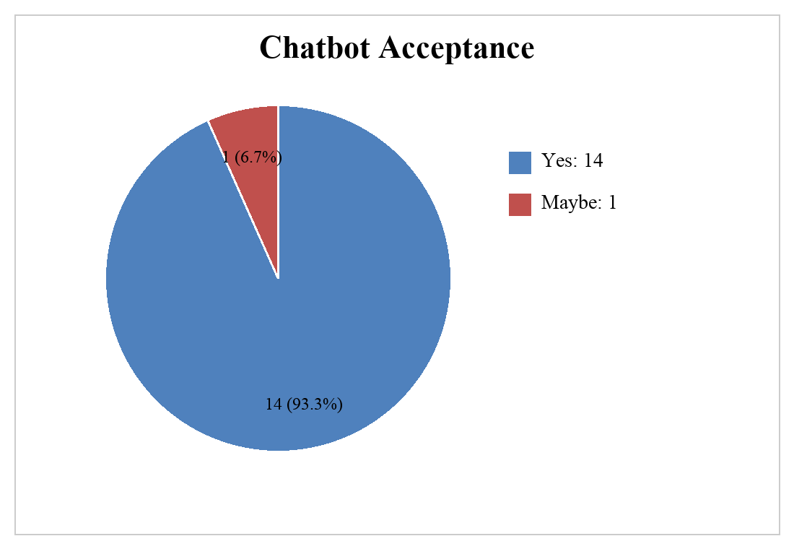
Figure 5.4 Chatbot acceptance — 93.3% would use a transport chatbot
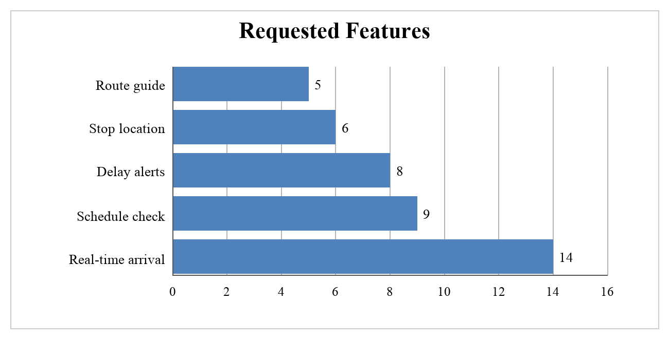
Figure 5.5 Requested features by survey count (n=15)
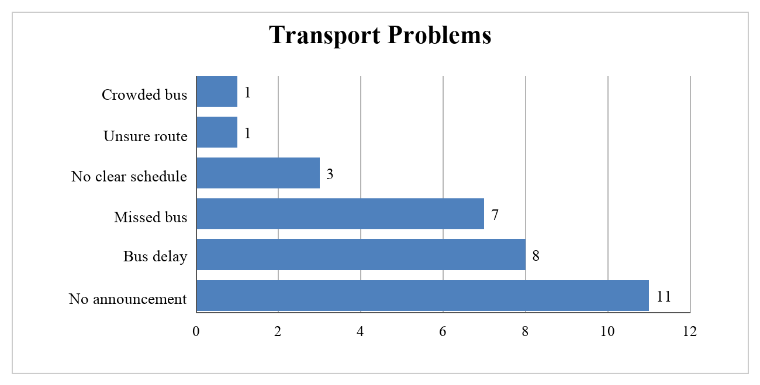
Figure 5.6 Transport problems faced by users (n=15)
Survey limitation: the survey provides enough direction for the storyboard and feature design, but it is a small sample with mostly closed-ended questions. The design would be stronger with more respondents, open-ended comments, and a confirmed stakeholder interview transcript.

5.2 Stakeholder Interview Summary
Interviewee name:LIM WEI YIN. Role: Student commuter / UTM shuttle bus user. Date: 10 MAY 2026.
The interview was conducted with a student who regularly uses the UTM shuttle service. The discussion focused on the student's experience when checking bus schedules, waiting at stops, and deciding what to do when a bus is delayed or missed. The student explained that the most common problem is not knowing whether the bus is still coming, already passed, or delayed.
The student also highlighted that the most useful system would answer timetable and route questions quickly, show the correct bus stop, and send clear delay announcements. Therefore, TransitAI UTM should include a knowledge base for schedule and route facts, latest-update responses, route guidance, delay notifications, and a simple feedback flow when the chatbot cannot answer confidently.
Table 5.4 Interview findings and design response
Interview finding | Design response
Student repeatedly checks similar questions about schedule, stops, route direction, and next bus timing. | Use chatbot intent recognition for schedule inquiry, route guidance, bus stop location, and arrival-time questions.
Delay or route-change announcements are not always noticed quickly by students while waiting or walking to stops. | Add an Alerts screen and delay-notification subscription for selected routes.
Student may not know which shuttle route or stop is best from hostel or faculty locations. | Provide route guidance that asks for origin and destination, then recommends a route and stop sequence.
Student may ask questions in informal language or with incomplete location details. | Add a fallback rule: ask a clarification question or record feedback for staff follow-up.

5.3 User Interface Storyboard
Table 5.5 User interface storyboard for TransitAI UTM
Screen | User action | System response
Home / Welcome | The user opens TransitAI UTM and chooses a quick action or types a transport question. | The system displays chatbot input, Schedule, Route, Arrival, Alerts, and Bus Stop options.
Chat Query | The user asks a question such as 'What bus goes to my faculty?' | The system classifies the intent and asks for missing origin, destination, route, or time information if needed.
Schedule Result | The user asks for timetable or next departure information. | The system returns route name, stop, next bus time, operating window, and data source note.
Route Guidance | The user enters current location and destination. | The system recommends a route, stop sequence, and link to bus stop detail.
Real-Time Arrival | The user asks when the next bus will arrive. | The system displays estimated arrival time, last updated time, and fallback schedule if live data is unavailable.
Alerts | The user checks latest announcements or subscribes to a route. | The system displays delay notices, route changes, and notification options.
Bus Stop Detail | The user selects a stop from a route result. | The system displays nearby landmark, facilities, and walking direction guidance.
Feedback / Escalate | The user reports wrong information or an unresolved question. | The system records the issue for transport staff and returns the user to the chat flow.

Figure 5.7 shows storyboard mockups for the four most-used screens (Home, Chat Query, Schedule Result, and Alerts), derived from the screen flow in Table 5.5.

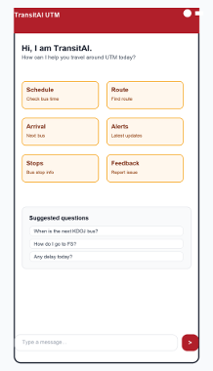
Figure 5.7 (a) Home / Welcome screen — quick-action buttons and chat input
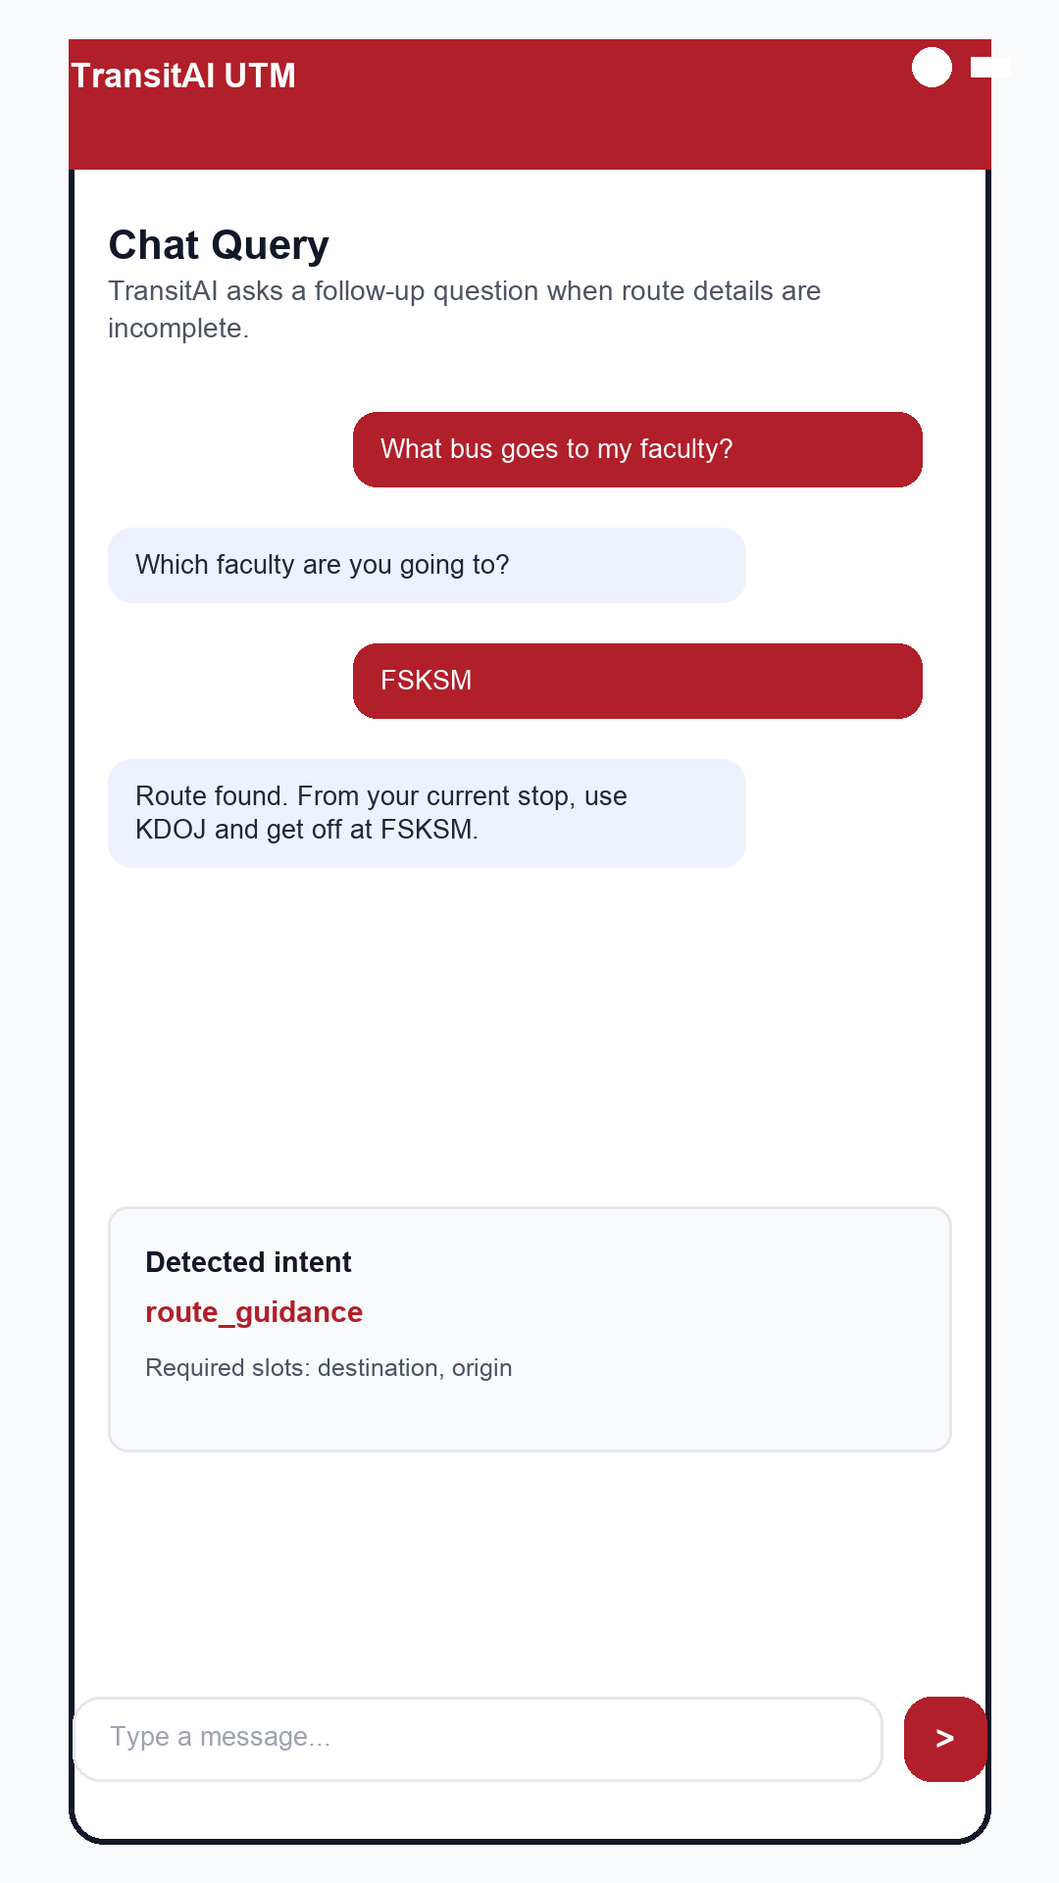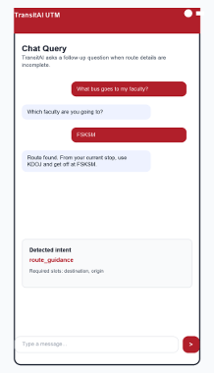
Figure 5.7 (b) Chat Query screen — intent classification with follow-up question
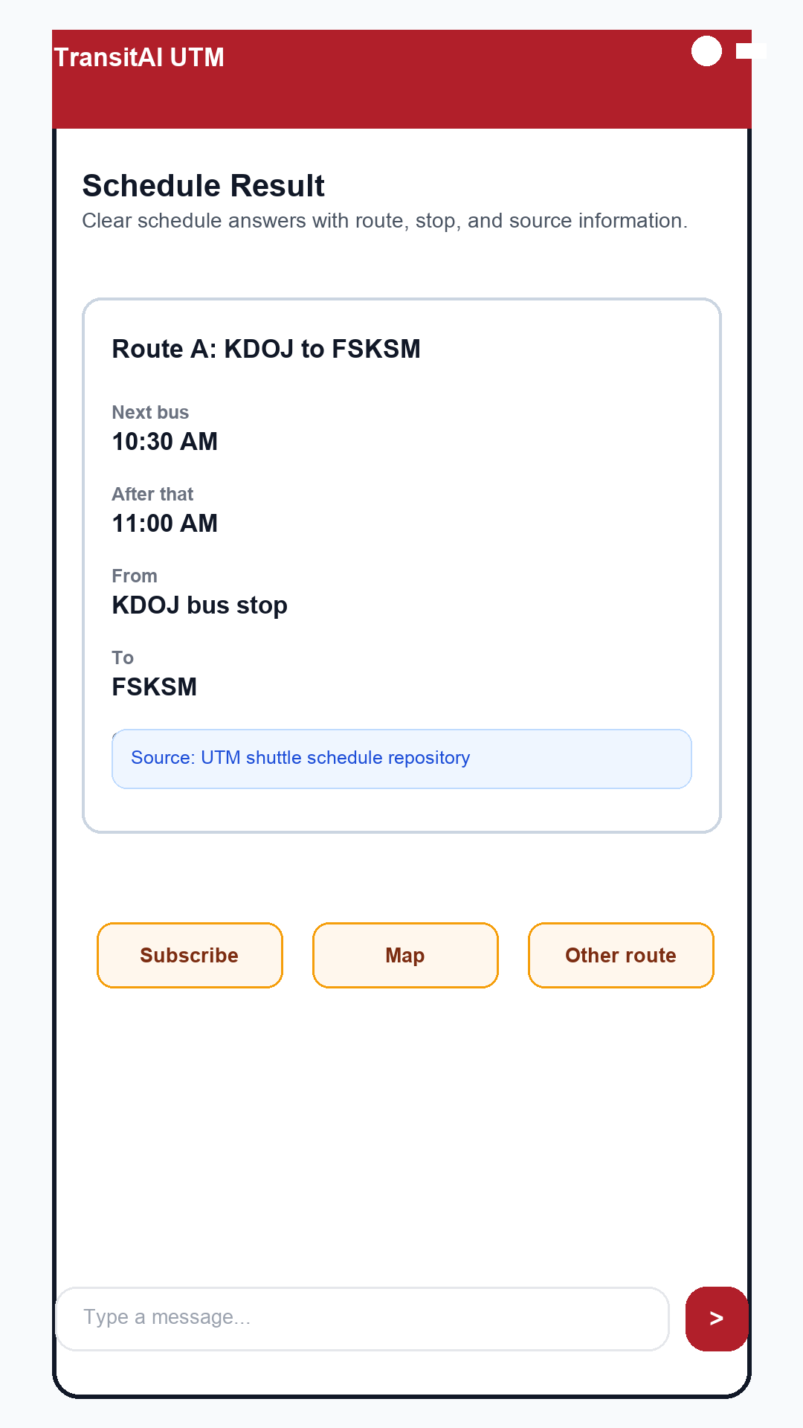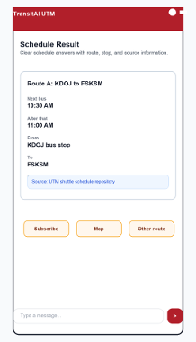
Figure 5.7 (c) Schedule Result screen — next bus, operating hours, stop sequence
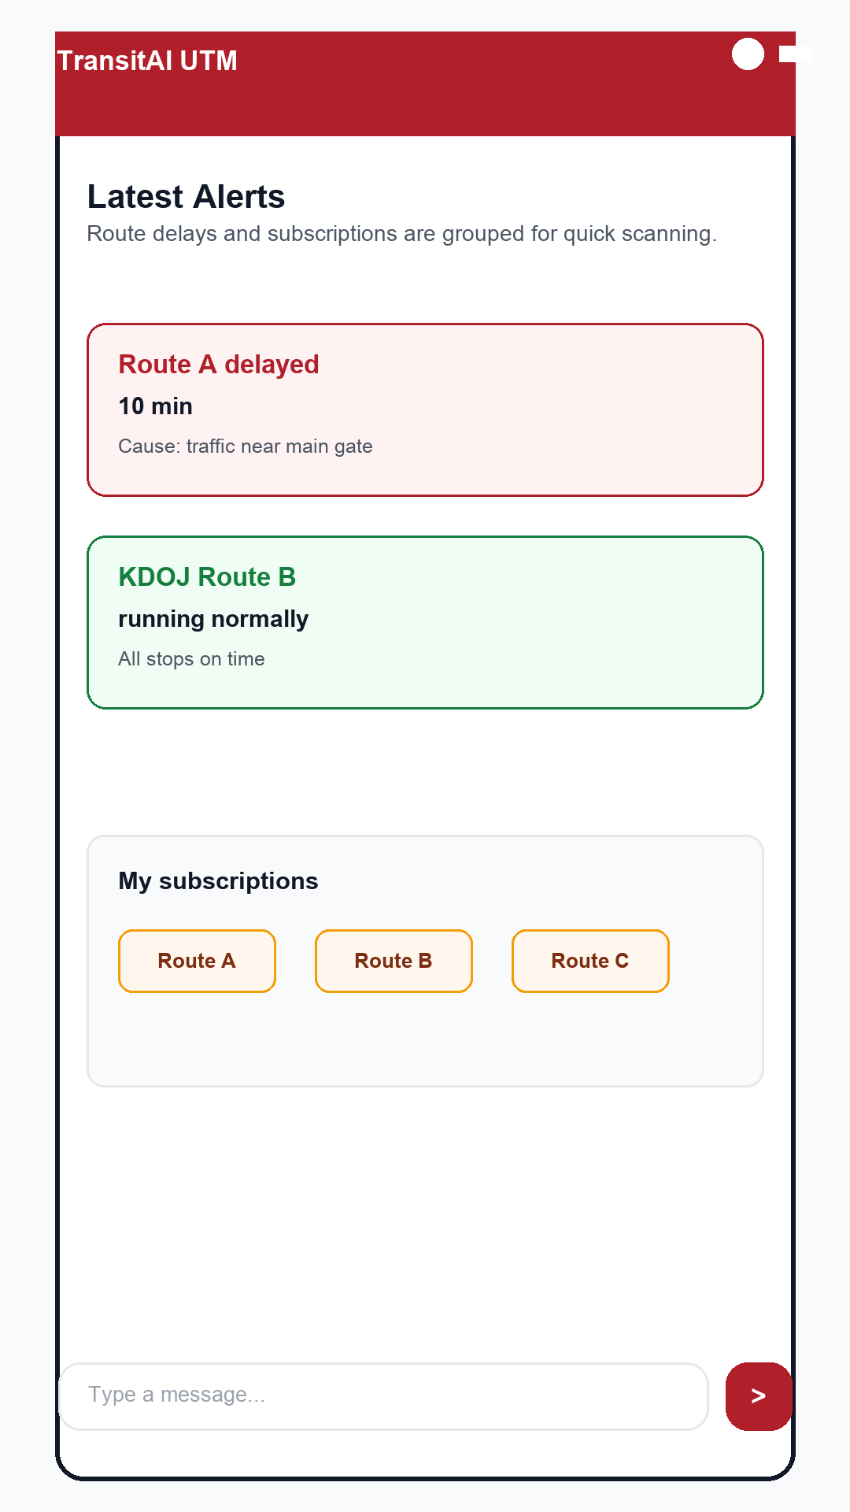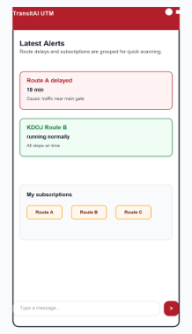
Figure 5.7 (d) Alerts / Notifications screen — delay alerts and route subscriptions

5.4 User Interface Navigation Flow
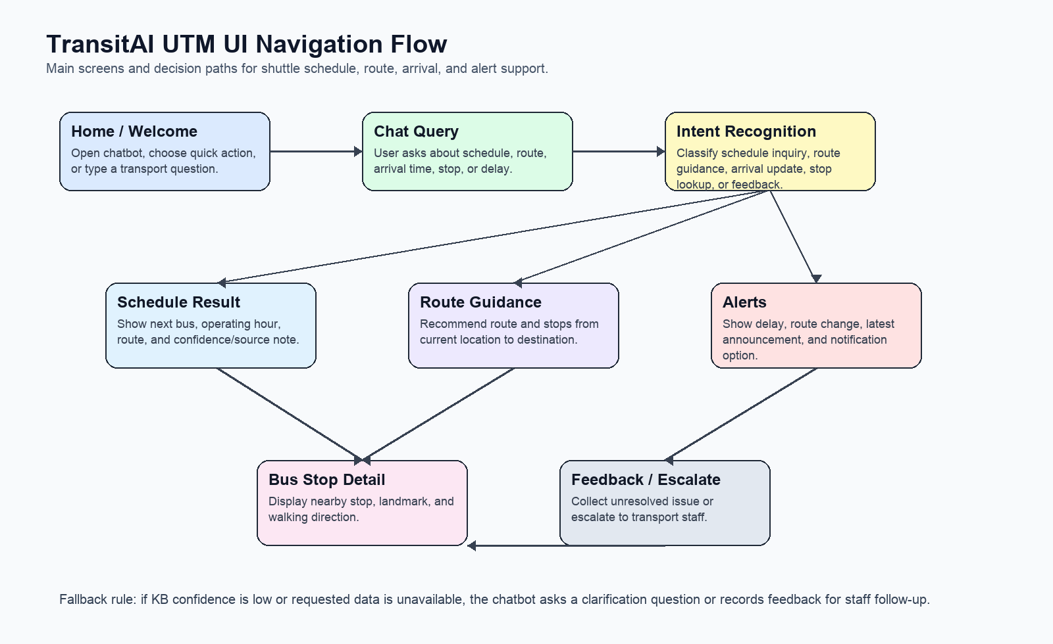
Figure 5.1 User interface navigation flow for TransitAI UTM.
The navigation flow demonstrates how TransitAI UTM handles user interaction from initial query. Users either choose a quick action or submit a free-text question. The system routes user requests through intent recognition before directing users to the appropriate module such as schedule inquiry, route guidance, arrival information or alerts. Low-confidence answers trigger clarification or feedback capture.

5.5 Knowledge Base Predicate Logic
Predicate definitions used in the TransitAI UTM knowledge base:
- Route(r): r is a shuttle route.
- Stop(s): s is a bus stop.
- Serves(r,s): route r serves stop s.
- CanTravel(r,s,d): route r can take a user from stop s to destination d.
- UserAt(u,s): user u is currently at stop or location s.
- WantsDestination(u,d): user u wants to go to destination d.
- NextBus(r,s,t): the next bus for route r at stop s arrives at time t.
- Delayed(r): route r is delayed.
- Intent(q,i): query q is classified as intent i.
- NotifyUser(u,r,m): user u should receive message m about route r.
Possible knowledge representations:
1. forall r,s: Serves(r,s) -> Route(r) and Stop(s).
2. forall r,s,d: Serves(r,s) and Serves(r,d) and s != d -> CanTravel(r,s,d).
3. forall u,s,d,r: UserAt(u,s) and WantsDestination(u,d) and CanTravel(r,s,d) -> RecommendedRoute(u,r).
4. forall r,s,t: NextBus(r,s,t) -> ArrivalInfoAvailable(r,s,t).
5. forall r: Delayed(r) -> NeedDelayNotification(r).
6. forall u,r: WantsRouteAlert(u,r) and NeedDelayNotification(r) -> NotifyUser(u,r,delay).
7. forall q,r: AsksSchedule(q) and MentionsRoute(q,r) -> Intent(q,schedule_inquiry).
8. forall q,d: AsksRoute(q) and MentionsDestination(q,d) -> Intent(q,route_guidance).
9. forall q,l: AsksStop(q) and MentionsLocation(q,l) -> Intent(q,bus_stop_location).
10. forall q,s: Intent(q,schedule_inquiry) and MentionsStop(q,s) -> RetrieveSchedule(q,s).

5.6 CNF Conversion
Before performing resolution refutation, the First-Order Logic (FOL) rules in the knowledge base are converted into Clause Normal Form (CNF). CNF conversion transforms implication rules into disjunction clauses that can be used for automated logical reasoning and theorem proving. The resulting CNF clauses are then used in the proving process to infer knowledge within the TransitAI UTM chatbot system.
Table 5.6 CNF Conversion table
First-Order Logic (FOL) | CNF Form
Delayed (r) → NeedDelayNotification (r) | ¬Delayed(r) ∨ NeedDelayNotification(r)
WantsRouteAlert (u,r) ^ NeedDelayNotification (r) → NotifyUser (u, r, delay) | ¬WantsRouteAlert(u,r) ∨ ¬NeedDelayNotification(r) ∨ NotifyUser(u,r,delay)

The CNF clauses above are used in the resolution refutation process presented in the next section to prove that the system should notify a user when a subscribed shuttle route experiences delays.

5.7 Resolution Refutation Example
Scenario: a user named ali has subscribed to alerts for route_a. The system receives knowledge that route_a is delayed. The new knowledge to prove is NotifyUser(ali, route_a, delay).
Table 5.6 Clauses used in the resolution proof
Clause | Meaning
P1: WantsRouteAlert(ali, route_a) | Ali wants route alerts for route_a.
P2: Delayed(route_a) | route_a is delayed.
P3: not Delayed(r) or NeedDelayNotification(r) | If a route is delayed, a delay notification is needed.
P4: not WantsRouteAlert(u,r) or not NeedDelayNotification(r) or NotifyUser(u,r,delay) | If a user subscribes to a route and notification is needed, notify the user.
Negated goal: not NotifyUser(ali, route_a, delay) | Resolution refutation assumes the opposite of the goal.
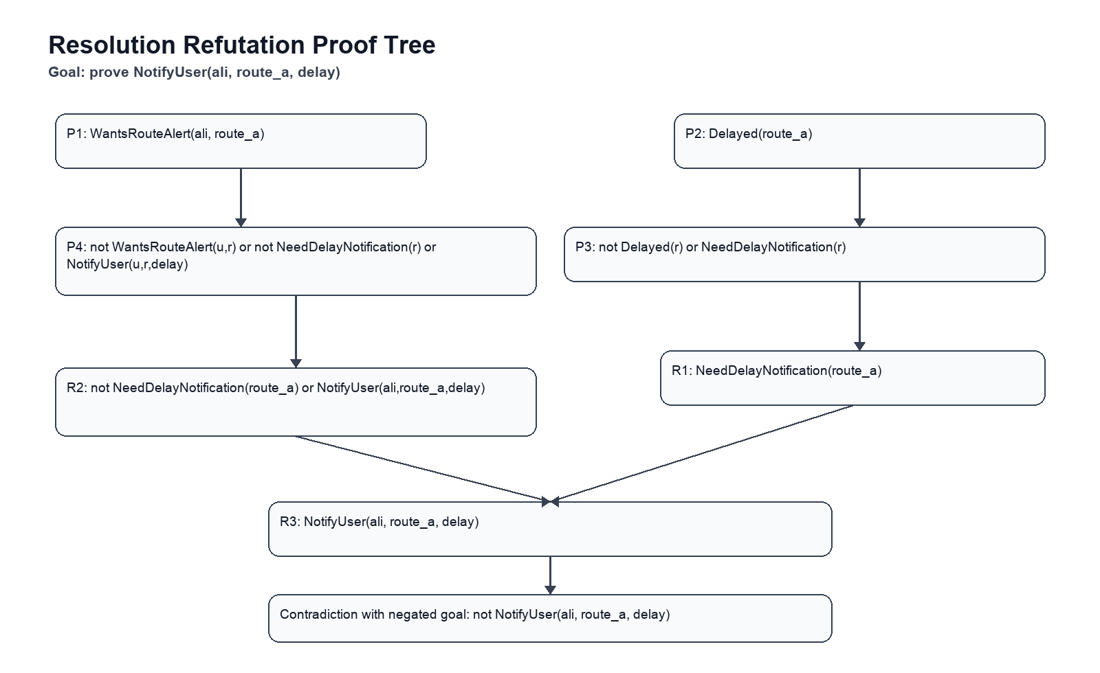
Figure 5.2 Resolution refutation proof tree for a delay notification.
- Resolve P2 with P3 to infer NeedDelayNotification(route_a).
- Resolve P1 with P4 to infer not NeedDelayNotification(route_a) or NotifyUser(ali, route_a, delay).
- Resolve the two inferred clauses to infer NotifyUser(ali, route_a, delay).
- Resolve NotifyUser(ali, route_a, delay) with the negated goal to produce a contradiction. Therefore, the notification knowledge is proven.

6.0 Intelligent Agent

6.1 PEAS Model Overview
The PEAS (Performance Measure, Environment, Actuators, and Sensors) model is used to describe the task environment of the proposed intelligent agent, TransitAI UTM. The model identifies how the chatbot perceives information, interacts with users, operates within the university transport environment, and evaluates its performance.
P: Performance Measure – The performance of TransitAI UTM is evaluated through several measurable criteria. These include the accuracy of the information provided (correct bus schedules, routes, and stop details), the speed of response (fast replies with minimal processing delay), the level of user satisfaction (relevant, clear, and helpful answers), the task completion rate (the proportion of user queries successfully resolved without human intervention), and the reduction of transport uncertainty (fewer missed buses and clearer guidance for users). Together, these measures determine how effectively the agent supports students and staff in navigating the campus transport system.
E: Environment – The environment in which TransitAI UTM operates is the university campus transport ecosystem. This includes the human actors such as students and staff who request transport information, as well as the physical and informational elements such as bus routes, bus stops, and operating schedules. The environment can be characterised as partially observable, since the agent only perceives the information provided through user queries and database records rather than the full real-world traffic conditions. It is also stochastic and dynamic, because bus availability, delays, and demand may change over time, and sequential, as earlier interactions and queries may influence later responses within a conversation.
A: Actuators/Effectors – The actuators are the means through which TransitAI UTM acts upon its environment and delivers output to the user. These include the chat interface used to communicate with users, the generated responses that provide schedule and route information, the alert mechanism that notifies users of updates or delays, and the guidance function that directs users to the correct bus stops or routes. Through these effectors, the agent translates its decisions into useful actions that assist the user in real time.
S: Sensors – The sensors are the channels through which TransitAI UTM perceives information from its environment. These include the user query input, which captures the questions and requests entered by users, the Schedule Database, which supplies up-to-date timetable information, the Route Database, which provides route and stop details, and the feedback channel, which captures user responses and ratings. These sensors allow the agent to gather the data required to understand user needs and generate accurate, relevant responses.

Property | Components | Description
P – Performance Measure | Accuracy, fast reply, user satisfaction, less delay | Measures how effectively the agent serves users: correct schedule/route information, quick response times, high user satisfaction, and reduced delays and transport uncertainty.
E – Environment | Students, staff, routes, bus stops, schedules | The university campus transport ecosystem in which the agent operates. It is partially observable, stochastic, dynamic, and sequential.
A – Actuators/Effectors | Chat, response, alert, guidance | The means by which the agent acts on its environment: communicating via chat, generating responses, sending alerts, and guiding users to the correct routes or stops.
S – Sensors | User query, Schedule DB, Route DB, feedback | The channels through which the agent perceives information: user queries, schedule and route databases, and user feedback.
Table 6.1 Summarises the four properties of the PEAS model for TransitAI UTM.

6.2 PEAS Model Diagram
Environment

Student
Staff
Routes
Bus Stops
Sensor

Schedule DB
Route DB
Feedback
User Query
Actuator

Chat
Response
Alert
Guidance
Performance
Accuracy
Fast Reply
User Satisfaction
Less Delay

6.3 Relationship Between PEAS Model and User Interface
The proposed user interface supports the implementation of the PEAS model. The Chat Query screen functions as the primary sensor input mechanism by capturing user requests. The Schedule Result, Route Guidance, and Alerts screens act as actuators by presenting intelligent responses and notifications. The campus transport ecosystem forms the environment in which TransitAI operates, while user satisfaction, response accuracy, and reduction in transport uncertainty serve as key performance measures for evaluating the effectiveness of the intelligent agent.
The following describes how each property of the PEAS model will be represented in the proof of concept (POC) prototype of TransitAI UTM. The Performance Measure is represented through the system’s response accuracy and speed, where the prototype is evaluated based on whether the chatbot returns correct schedule and route information, responds with minimal delay, and resolves user queries without human intervention; these metrics can be observed directly when a user interacts with the Chat Query screen and receives results. The Environment is represented by the university transport context the prototype simulates, including the student and staff users who key in requests, the bus routes, bus stops, and timetable data stored in the system, which together form the partially observable, dynamic setting the agent reacts to. The Actuators/Effectors are represented by the output screens of the prototype, namely the Schedule Result, Route Guidance, and Alert/Notification screens, which display the agent’s responses, deliver guidance, and push notifications back to the user. The Sensors are represented by the input channels of the prototype, mainly the Chat Query input field that captures user questions, together with the Schedule Database, Route Database, and feedback channel that supply the agent with the data needed to generate accurate responses. In this way, every PEAS property maps directly to a concrete element of the proposed user interface and prototype, demonstrating how the intelligent agent will function in practice.

7.0 Appendix (Survey Form and Responses)
Google Form link: https://docs.google.com/forms/d/e/1FAIpQLSc7msjysrbg9BrY1H0YFlMgASn5deQ1FZWWDtxm_Zb5rIoIGA/viewform?usp=sharing&ouid=104755593441673232150
Responses : https://docs.google.com/spreadsheets/d/1cNvAq4HuSrxGwsOKl4we5BVm82_PYOeobq100imWEiI/edit?gid=1385422250#gid=1385422250
Mind mapping link: https://canva.link/e13hccubouqhj9j
