TransitAI UTM
Administrator Manual
Web-Based Campus Transport Chatbot Prototype
MECS0033-52 Artificial Intelligence, Section 52, Group 5
This Word document is the separate Administrator Manual deliverable. The in-app Staff Demo screen is only a demonstration/control surface; it does not replace this manual.
Manual item | Description
Audience | Lecturer, marker, transport administrator, or maintainer reviewing the prototype.
Prototype path | MECS0033-52/Group5Asg1/prototype/index.html
No-install mode | Open index.html directly, or run python3 -m http.server 8000 from the prototype folder.
Main grading evidence | Interactive screen, problem solving workflow, and a clear administrator process.
Important data boundary | Route labels/sequences are public-list aligned where available; timetable, ETA, headway, live status, and walking notes are prototype simulation.

1. Purpose and Rubric Alignment
The project report proposes TransitAI UTM as an AI-based chatbot for campus transport information. This prototype converts the report into a browser-based proof of concept that a marker can interact with directly.
Rubric criterion | What the prototype shows | Where to verify
Originality / Interactive Screen | A phone-style web app with free-text input, quick actions, intent confidence, RAG-style source notes, demo-time control, alerts, feedback, and a visible AI pipeline panel. | index.html, Chat screen, Staff Demo screen, demo deck
Problem Solving | The app addresses shuttle schedule uncertainty, route confusion, bus-stop lookup, arrival uncertainty, delay notification, and user feedback/escalation. | Chat, Schedule, Route, Arrival, Bus Stop, Alerts, Feedback
Admin Manual | This document explains the architecture, component map, data policy, configuration steps, proof procedure, screenshots, and troubleshooting process. | ADMIN_MANUAL.docx

2. Design Link to the Newest Report
The newest Group5Asg.docx describes the following AI concepts. The prototype intentionally implements each concept in a small, inspectable way suitable for a 10% proof of concept.
Report concept | Prototype implementation
Intent recognition | js/intent.js classifies six intents and displays the selected intent plus confidence score in the UI.
Knowledge repository / RAG | js/kb.js stores route, stop, FAQ, delay, and feedback facts; js/retriever.js retrieves matching knowledge chunks and source notes.
Conversation memory | js/chat.js keeps recent origin/destination context so follow-up questions can reuse session state.
Notification API concept | The Staff Demo delay toggle simulates a staff-issued disruption; the Alerts screen simulates delivery to a subscribed user.
CNF / resolution refutation | js/resolution.js derives NotifyUser(ali, route_a, delay) from P1-P4 plus the negated goal, matching the report's Figure 5.2 example.
PEAS model | The UI acts as sensors and actuators; the knowledge base and proof engine represent the environment/state reasoning used by the agent.

3. Data Source and Accuracy Policy
Do not present all prototype data as official live UTM data. The safe explanation is: public sources are used for route names and stop sequences where available; the POC simulates timing and live status because no verified live feed is connected.
Data shown | Status | Administrator explanation
BAS A/B/C/D/E/F/G/H route labels and stop sequences | Public-list aligned | Visible public UTM/DVC/KDOJ route pages list these route groups and many stop sequences. Some public effective-date fields are historical, so use them only as route/sequence reference, not proof of current operation.
Stop labels such as CP, KP, K9/K10, KTC, KDOJ, KDSE, KTDI, N24, SKT, P19, T02, T08, V01 | Public stop labels | These labels appear in public route listings and are safe to use as prototype stop codes.
FKE query support | Partially verified mapping | The prototype maps FKE to P19 / FKE area because the public BAS G route lists P19. A production system should verify the exact active shelter.
FC query support | Prototype faculty alias | The prototype maps FC to N24 / Cluster Area because N24 appears in public route listings. Exact current FC stop mapping was not found.
PSZ Library | Verified landmark, route stop unverified | The chatbot can identify PSZ as a campus landmark but should not invent a direct shuttle route to PSZ.
Next departure, operating hours, headway, ETA, walking notes | Prototype simulation | These demonstrate the AI workflow and demo-time behavior only. They are not official timetable/live arrival values.
Delay status | Prototype simulation | Staff Demo toggle simulates a transport staff update so the resolution proof and alert workflow can be shown.

Sources checked on 2 July 2026:
- UTM DVC Development shuttle bus schedule page: https://dvcdev.utm.my/announcement/shuttle-bus-schedule/
- KDOJ UTM Bus Schedule route list: https://www.kdoj.com.my/insight/utm-bus-schedule/
- UTM JB 2025 shuttle timetable PDF: https://studentppi.utmspace.edu.my/wp-content/uploads/2024/12/Jadual-Bas-Shuttle-Kampus-UTM-JB-2025-01012025.pdf

4. Component and Function Map
File | Main object | Important functions | Responsibility
js/kb.js | KB, KBUtil | findStop, findStops, routesServing, routesBetween, nextDeparture, setClock, setDelayed, logFeedback | Knowledge repository, entity lookup, directional route matching, deterministic demo schedule, delay/feedback state.
js/intent.js | Intent | classify(query) | Intent scoring for schedule, route guidance, arrival, bus-stop lookup, alerts, feedback, and FAQ.
js/retriever.js | Retriever | retrieve(query, k) | RAG-style keyword/token retrieval over stops, routes, FAQs, alerts, and source notes.
js/resolution.js | Resolution | prove(user, route) | First-order resolution-refutation proof for delay notification.
js/chat.js | Chat | send(text), init() | Conversation controller, response rendering, session memory, AI explanation panel updates.
js/app.js | App | showScreen, showStop, renderAlerts, renderAdmin, runProof | Screen routing, Staff Demo controls, alerts, feedback, stop detail, proof display.

Runtime data flow:
1. The student taps a quick action or types a transport question.
2. Intent.classify() scores the query and selects the strongest intent.
3. Retriever.retrieve() selects relevant knowledge chunks and source notes.
4. The per-intent handler builds a grounded response card.
5. The UI displays the answer, data-source note, time basis, and AI pipeline trace.

5. How to Interact With the Prototype
Use this section during presentation. Each figure is annotated with arrows so the marker can see what to click and what evidence to point out.

5.1 Open the Prototype and Start From Chat
1. Open prototype/index.html, or serve the folder with python3 -m http.server 8000.
2. Confirm the phone status time is visible at the top right.
3. Use quick actions for a predictable demo, or type your own question in the composer.
4. Keep the AI pipeline panel visible because it supports the Originality / Interactive Screen score.
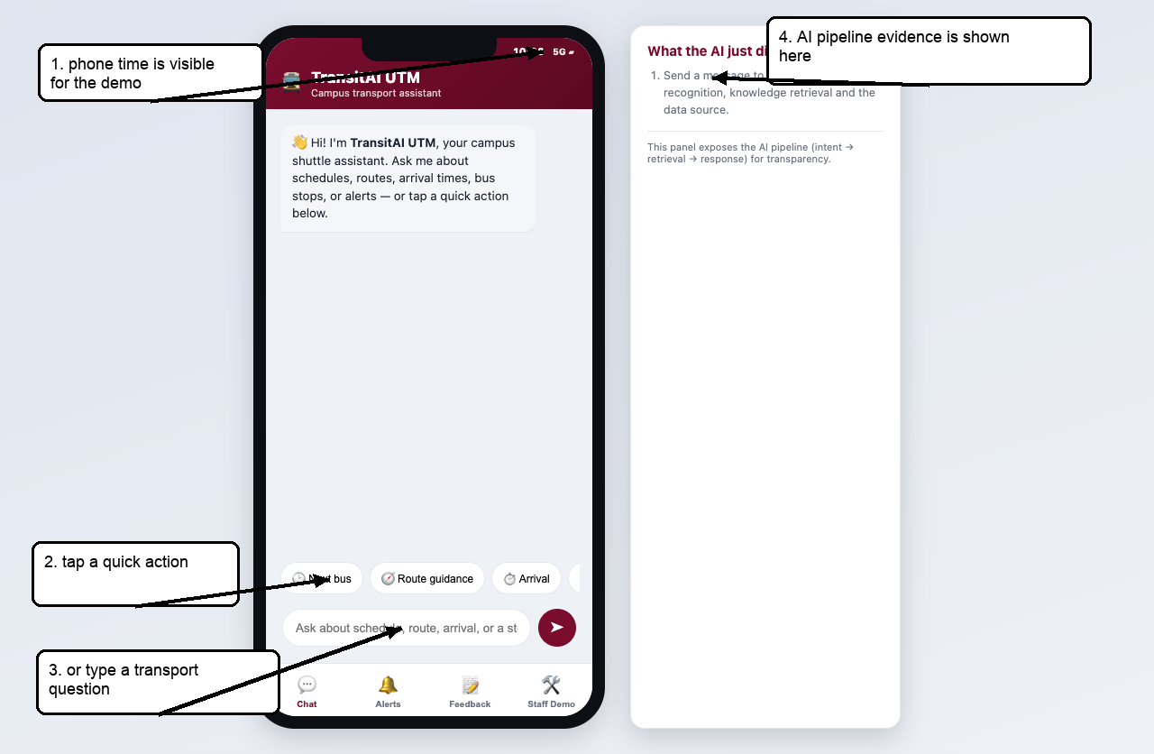
Figure 1. Home/chat screen: visible phone time, quick actions, text input, and AI pipeline panel.

5.2 Schedule Inquiry
1. Tap Next bus or type: When is the next bus to FKE?
2. Point to the intent confidence chip to show AI intent recognition.
3. Point to the Time basis row to show why the demo works even at night.
4. Point to the source note and say: route/sequence data is public-list aligned; timing is simulated.
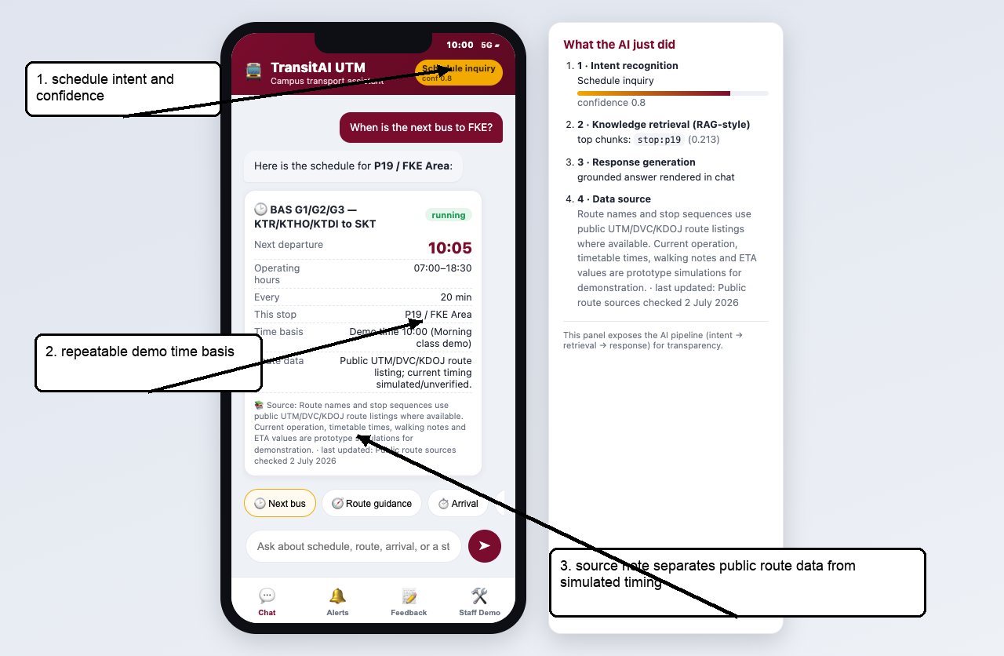
Figure 2. Schedule answer with demo-time basis and truthful source/simulation wording.

5.3 Route Guidance
1. Tap Route guidance or type: How do I get from KTDI to P19 FKE?
2. The chatbot should recommend BAS G1/G2/G3 and display the ordered stop sequence.
3. Explain that routesBetween() checks direction, so the origin must appear before the destination in the route sequence.
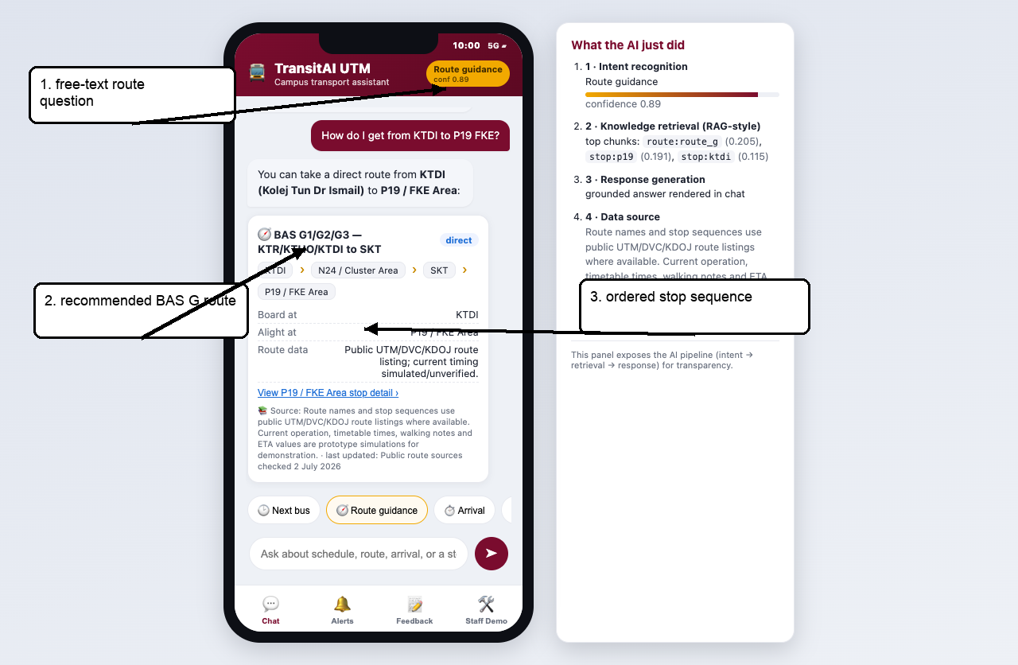
Figure 3. Route guidance screen showing route recommendation and stop sequence.

5.4 Arrival ETA
1. Tap Arrival or type: When will the next bus arrive at CP?
2. Explain that ETA is simulated because the POC has no live GPS feed.
3. Use the Time basis row to prove the app is not stuck on the real current time.
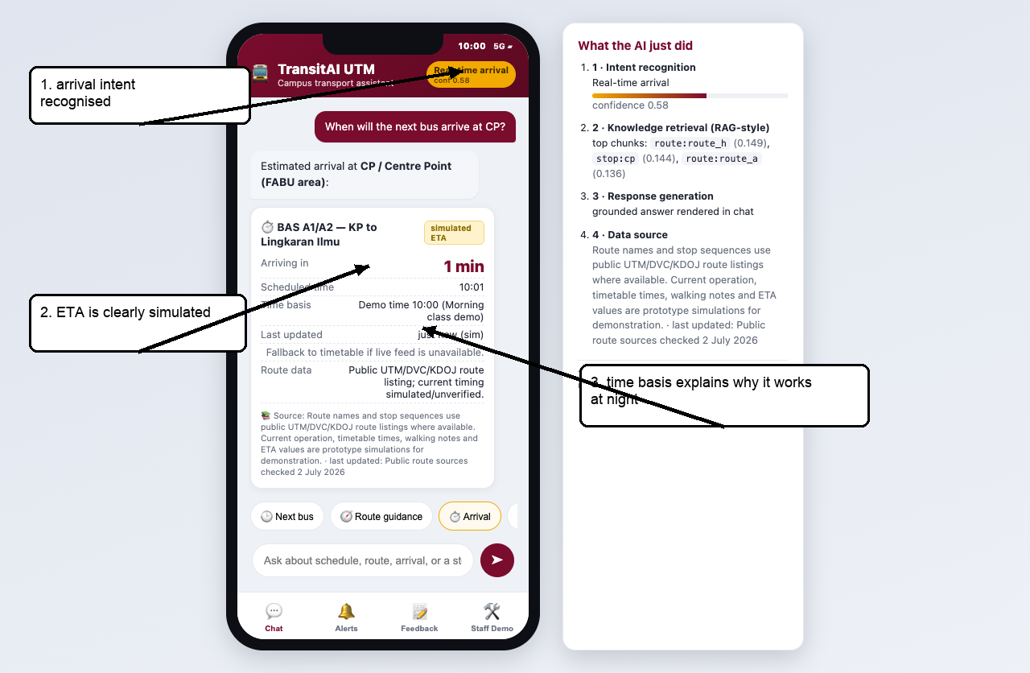
Figure 4. Arrival card clearly labels ETA as simulated and tied to demo time.

5.5 Bus Stop Detail
1. Tap Bus stop or type: Where is the FC bus stop?
2. Point to the data-status wording so the marker sees that uncertain mappings are not overstated.
3. Use this screen to explain how users can find landmarks, facilities, and walking guidance.
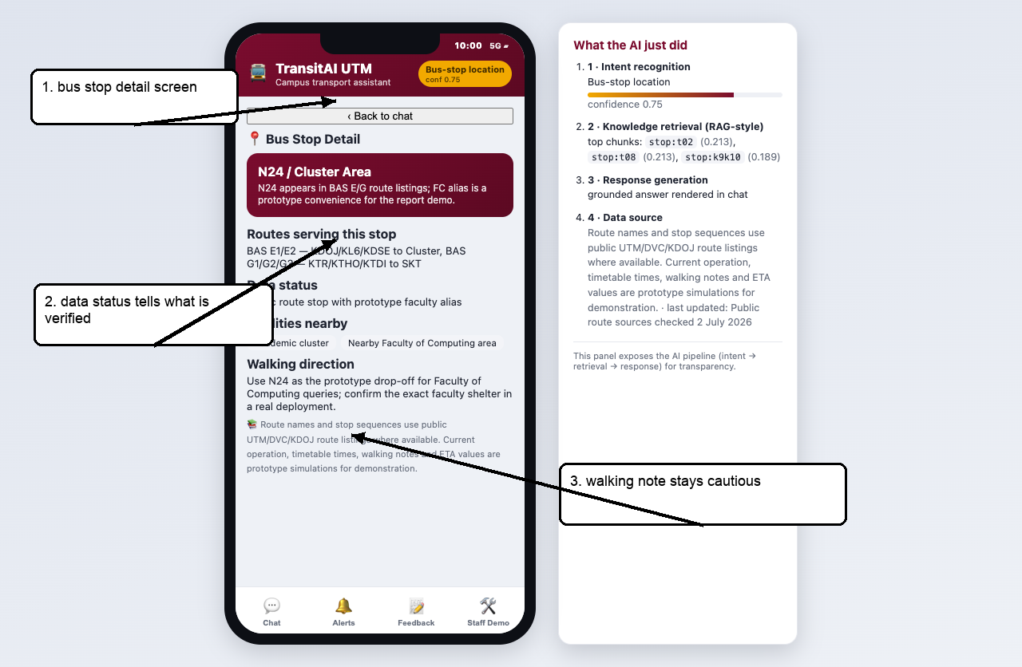
Figure 5. Bus Stop Detail screen with data status and cautious walking note.

6. Staff Demo Operation
The Staff Demo screen is inside the prototype only to make the proof and time scenarios repeatable during marking. The required Administrator Manual remains this separate Word document.

6.1 Demo-Time Control
1. Open Staff Demo.
2. Choose 10:00 Class demo before showing schedule, route, or arrival flows.
3. Return to Chat and run a schedule or arrival query.
4. Use 20:30 Night closed-service only when deliberately showing a closed-service case.
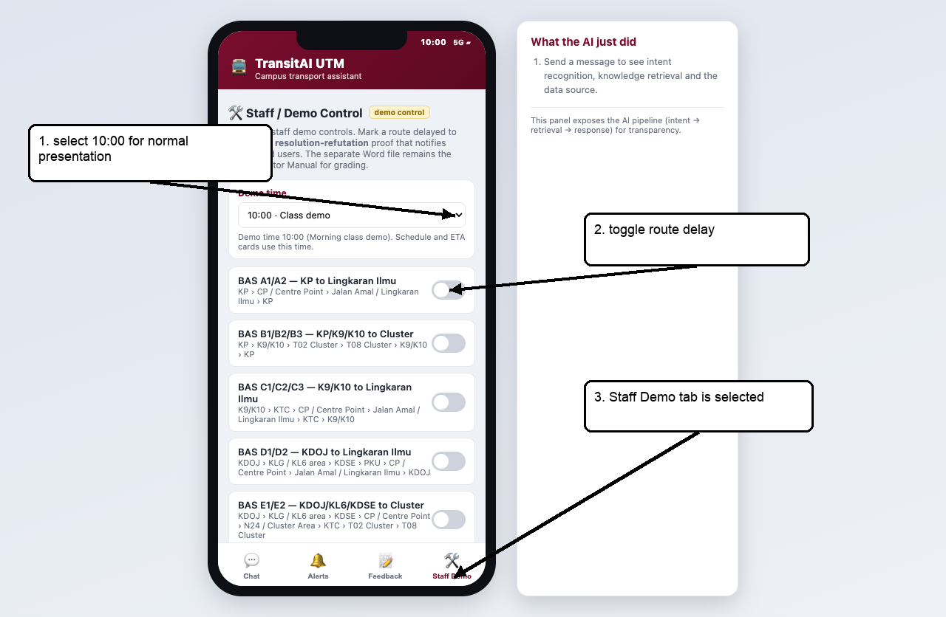
Figure 6. Staff Demo screen: demo-time selector, delay toggles, and proof panel.

6.2 Delay Alert and Resolution-Refutation Proof
This is the originality highlight because it is not only UI. The app computes the logic proof from current app state.
Clause | Meaning
P1 WantsRouteAlert(ali, route_a) | Ali subscribes to route_a alerts.
P2 Delayed(route_a) | route_a is currently delayed.
P3 not Delayed(r) or NeedDelayNotification(r) | If a route is delayed, a notification is needed.
P4 not WantsRouteAlert(u,r) or not NeedDelayNotification(r) or NotifyUser(u,r,delay) | If a subscribed user needs a route notification, notify the user.
Negated goal: not NotifyUser(ali, route_a, delay) | Resolution assumes the opposite and derives a contradiction.

1. Open Staff Demo.
2. Toggle BAS A1/A2 - KP to Lingkaran Ilmu to delayed.
3. The app runs Resolution.prove('ali', 'route_a').
4. The proof panel prints P1, P2, P3, P4, the negated goal, R1, R2, R3, and the empty clause.
5. Open Alerts to show the resulting notification.
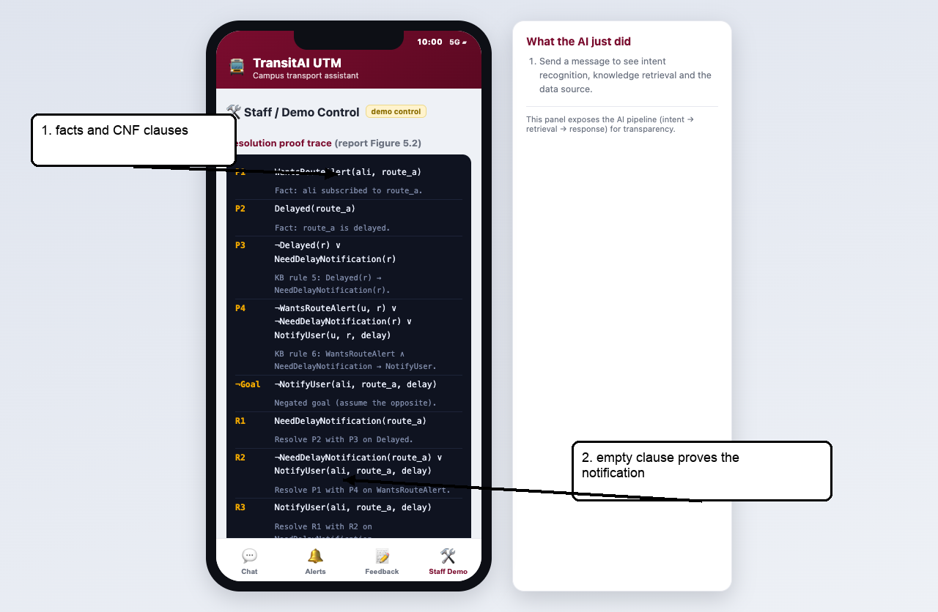
Figure 7. Staff Demo proof view after route_a is marked delayed.
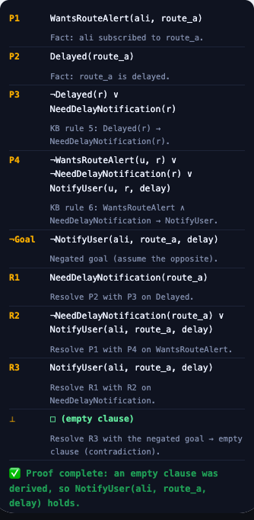
Figure 8. Cropped proof trace: empty clause proves NotifyUser(ali, route_a, delay).

6.3 Alerts and Feedback
1. After the proof succeeds, open Alerts.
2. Confirm a delay notification is visible for the subscribed user.
3. Open Feedback to show how wrong information or missed-bus problems are escalated.
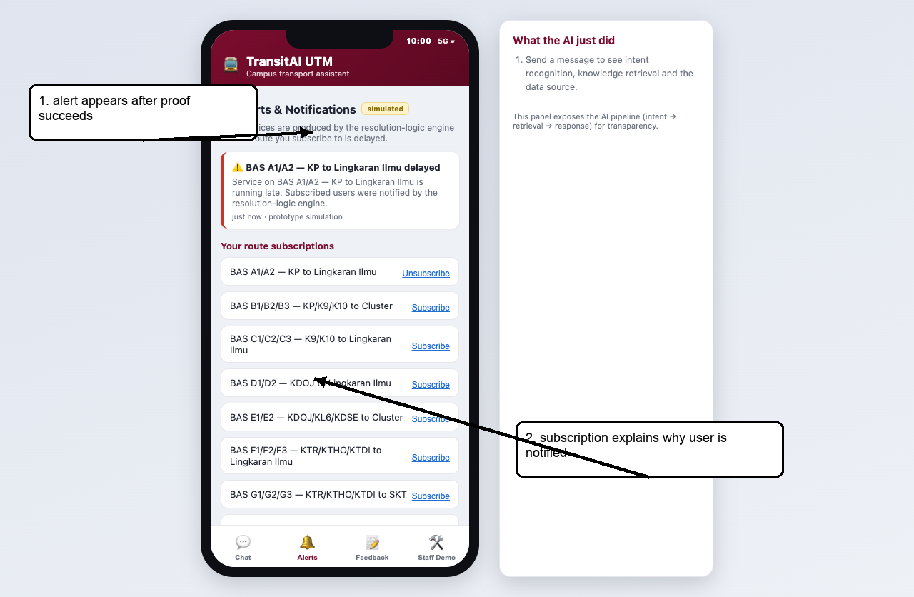
Figure 9. Alerts screen after proof-triggered notification.
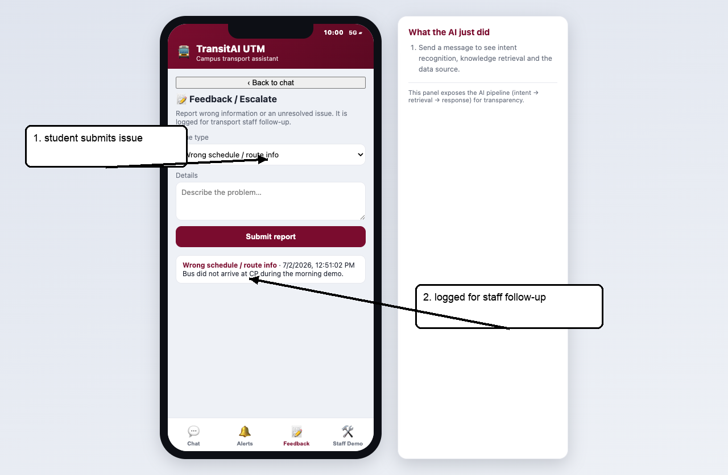
Figure 10. Feedback screen after a sample report is submitted.

7. Configuration Guide

7.1 Add or Edit a Stop
Edit KB.stops in js/kb.js. Always include aliases that users are likely to type and a status field that tells the truth about the data.
{ id: "p19", name: "P19 / FKE Area", aliases: ["p19", "fke", "electrical"], status: "public stop/area label with faculty alias", landmark: "...", facilities: ["Faculty area"], walking: "..." }

7.2 Add or Edit a Route
Edit KB.routes in js/kb.js. Keep public route sequences separate from simulated timing values.
{ id: "route_g", name: "BAS G1/G2/G3 - KTR/KTHO/KTDI to SKT", stops: ["ktr","ktho","ktdi","n24","skt","p19","cp"], operating: { start: "07:00", end: "18:30" }, headway: 20, source: "Public UTM/DVC/KDOJ route listing; current timing simulated/unverified." }

7.3 Tune Intent Recognition
- Edit the CUES object in js/intent.js.
- Strong cues score 2 and weak cues score 1.
- Add real phrases from users, but avoid ultra-common single words as strong cues.
- Retest schedule, route, arrival, bus stop, alerts, feedback, and FAQ queries after edits.

7.4 Change Default Demo Time
Edit KB.clock.demoTime in js/kb.js. The current default is 10:00 because it is a reliable class-time scenario. The Staff Demo selector can override this without editing code.

7.5 Add a New Delay-Proof Scenario
1. Add a subscription fact to KB.subscriptions, for example { user: 'ali', route: 'route_b' }.
2. Make sure the route exists in KB.routes.
3. Toggle that route in Staff Demo.
4. Confirm Resolution.prove(user, route) prints the proof only when the user is subscribed and the route is delayed.

8. Troubleshooting
Symptom | Likely cause | Fix
Blank screen | Script load issue or missing file | Reload; ensure all js/*.js files are present and loaded in index.html order.
Schedule says closed now | Demo/live clock outside operating window | Staff Demo -> Demo time -> 10:00 for normal presentation.
Route missing | No verified route sequence serves origin before destination | Use CP as interchange or add a verified route sequence; do not invent official data.
Wrong intent | Missing or weak cue phrase | Add the phrase to CUES in js/intent.js and retest all six main intents.
Proof does not run | Route is not delayed or user is not subscribed | Toggle delay and ensure KB.subscriptions contains ali for the route.
Edited data not visible | Browser cache | Save the file and hard-refresh the browser.
Marker asks if times are official | POC uses simulated timing | State that no live verified feed is connected; the POC demonstrates workflow and source transparency.

9. Submission and Demo Checklist
- Submit prototype/index.html plus css, js, screenshots, ADMIN_MANUAL.docx, and TransitAI_UTM_Prototype_Demo.pptx.
- Before presenting, open Staff Demo and set Demo time to 10:00.
- Show Chat, Schedule, Route, Arrival, Bus Stop, Alerts, Feedback, and Staff Demo.
- Say clearly: route names/sequences are public-list aligned where available; timing, ETA, delay state, and walking notes are simulated.
- Use Staff Demo -> toggle BAS A delayed -> proof trace -> Alerts as the originality highlight.
- Keep the Word manual ready because it is the separate Admin Manual deliverable required by the rubric.

