# The impact of COVID-19 on citizen science in Japan: a long-term multi-city analysis

## 1 Introduction

# background: how COVID-19 impacts the world

The COVID-19 has complex impact on human society, environment, and biodiversity, especially in cities (Bates et al., 2020).

Studies reported an increase of observations of wildlife in cities, while many revealed a decrease of public engagement in biodiversity citizen science.

# why analyze the relationship between covid and citizen science

Citizen science is designed to enhance public engagement in science research. In biology field, amateur and volunteers are encouraged to collect data of plants and animals. Citizen science has been proved to benefit scientific research since public engagement yield a great number of long-term data across large scale, which is generally difficult to achieve with ‘formal research’ that requires loads of financial input. With the development of information technology, there are currently many online platforms for biological citizen science. This platform allows the participants to upload their record on their own personal computers.

# research gap 1

The impact of COVD-19 on citizen science remains unclear. Many platforms reported a change of engagement during COVID-19. Many gray literature reported an increase in the early stage of COVID-19 or shut down period (“Volunteers Flock To Sign Up As Citizen Scientists,” n.d.; Young, 20:23:49 UTC). However, the change might be dependent on the platform, location, spatial and temporal scales, and biological group. Many related studies show different conclusion. The submission of full protocol list decreased during COVID-19 period compared to the average value of past three years at the same time for African Bird Atlas Project in southern Africa (Rose et al., 2020). The observation and participants decreased on eButterfly and Nature’s Notebook while increased for iNaturalist and eBird in the US during the spring of 2020 (Crimmins et al., 2021). The participants and observation also decreased dramatically during the four-day City Nature Challenge in Tokyo, Japan (Kishimoto and Kobori, 2021). While the research of five European countries for five common bird species sighting detected a different pattern (Roll et al., 2021). Though the interest to the birds’ growth was detected with Google trend data, the submission of observation remains hardly changed in Italy and Germany, and even decreased for Sweden.

# research gap 2

## previous studies didn’t analyze the impact of infection number: citizen science is not just affected by policies (in a “top-down” manner) but also by the number of infections.

## the impact of the COVID-19 on citizen science should be discussed with the methodology of the ananlysis

# research gap 2: no multi-city comparison in Japan

Furthermore, only a few studies focused on citizen science in Asian cities (Kishimoto and Kobori, 2021). A study examined the impact of COVID-19 on the participant, observation, and identify rate in Tokyo based on iNaturalist data (Kishimoto and Kobori, 2021). However, the study only tested the four-day City Nature Challenge period, which can be affected by chance factors comparing to long-term data. And a single-city research cannot reveal the impact of other cities. Even if we expand the scope of the topic to non-COVID-19 period, less research of Asian cities has been published comparing to European and American countries/cities #need ref#. Besides, most of the studies suggested that COVID-19 influence public engagement in citizen science due to lock-down policies. However, people constrain their mobility not only for policies, but also in response to the situation of COVID-19 #need ref#.

# what I have done

In this study, we predicted that citizen science not only affected by shut-down policies but also the number of infections. Since the constraint of mobility, and concern about health, the participation of citizen science will decrease during the shut-down and when the infection of the surrounding area is high, while the identify rate and per participant observation may become higher. We used iNaturalist data and COVID-19 open data to test our hypothesis.

## 2 Methodology

### 2.1 Data preparation

# about iNaturalist: intro; operation; data attributes

iNAturalist is a citizen science online platform that users can upload the data of the organisms they observed, either on smartphone application or computers. The data of an observation record includes user information, photo or audio, time, location, etc. The community users can also engage by identifying the record uploaded.

# search and download data

We access iNaturalist, searched the data of top 11 Japanese cities by population, and downloaded the records from 2015 to 2020. The cities includes Kyoto, Kobe, Sapporo, Saitama, Osaka, Hiroshima, Nagoya, Tokyo, Kawasaki, Yokohama, Fukuoka. The meta data of each record includes number of observations, number of identifications, location of the observations.

### 2.2 Data analysis

# workflow

# data clean

# comparison of observations and users

I compared the number of observations, users, and observations per user in each year for each city, and further analyzed monthly data of those indexes.

# comparison of behavior of users

I compared the behavior of users for every two consecutive years from 2015 to 2020. I compared the behavior of long-term users and other users. Here ‘long-term user’ is defined as uploaded observation data in three years out of the six years. The index compared including the number of observation records uploaded, and how their behavior changed since 2019 to 2020.

### 2.3 Results

#### 2.3.1 Comparison of annual data

Observations and participants had been increasing in most cities before 2019, so had the number of total active days (Figure 1(a)-(c)). Then, as expected, the numbers of participants for most cities decreased in 2020 except for Saitama and Sapporo. However, only 6 and 7 cities out of the 11 cities experienced a decrease of observations and active days from 2019 to 2020.

Furthermore, on the contrast, the number of observations per participant per active day showed a decrease trend from 2016 to 2019, while increased in 2020 (Figure 1(f)). Other than that, most cities also witnessed an increase of observation per participants (Figure 1(d)) and active days per participant (Figure 1(e)) from 2019 to 2020.

The number of identification participants decreased in 7 cities (Figure 1(g)) and the percentage of observations with identification history decreased in 9 cities in 2020 (Figure 1(h)).

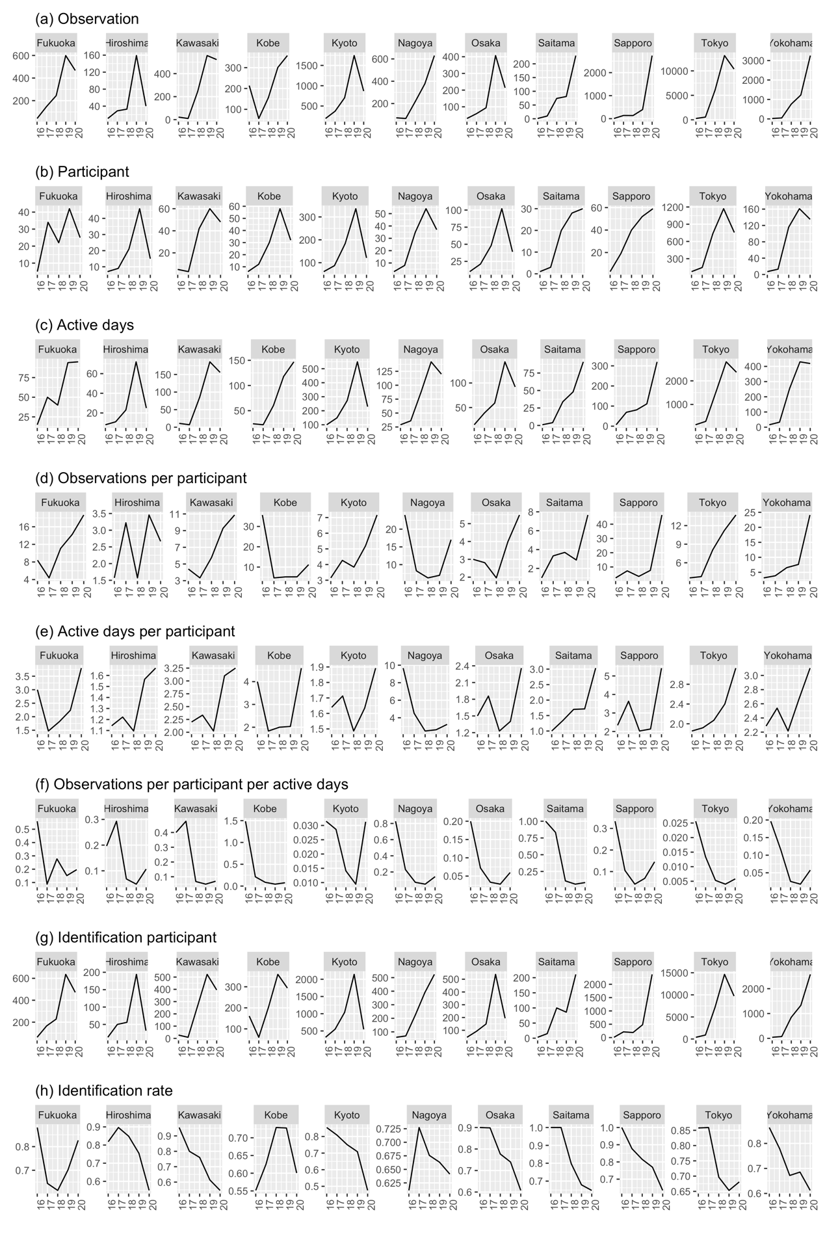

Figure 1 The number of observations, participants, active days, observation per participant, active days per participant, and observation per participant per active day from 2016 to 2020.

#### 2.3.2 Comparison of monthly data

There is no obvious pattern in monthly data comparison (Figure 2).

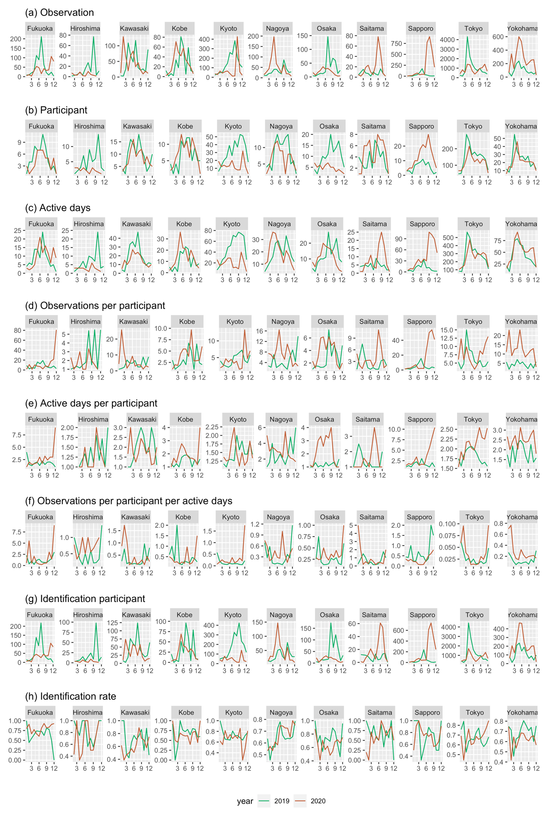

Figure 2 The number of observations, participants, active days, observation per participant, active days per participant, and observation per participant per active day of each month in 2019 and 2020.

#### 2.3.3 Comparison of user groups

As expected, the experienced participants have higher annual observation and annual active days comparing with new participants, while the observation per active day is only significantly different in Nagoya city (Figure 3).

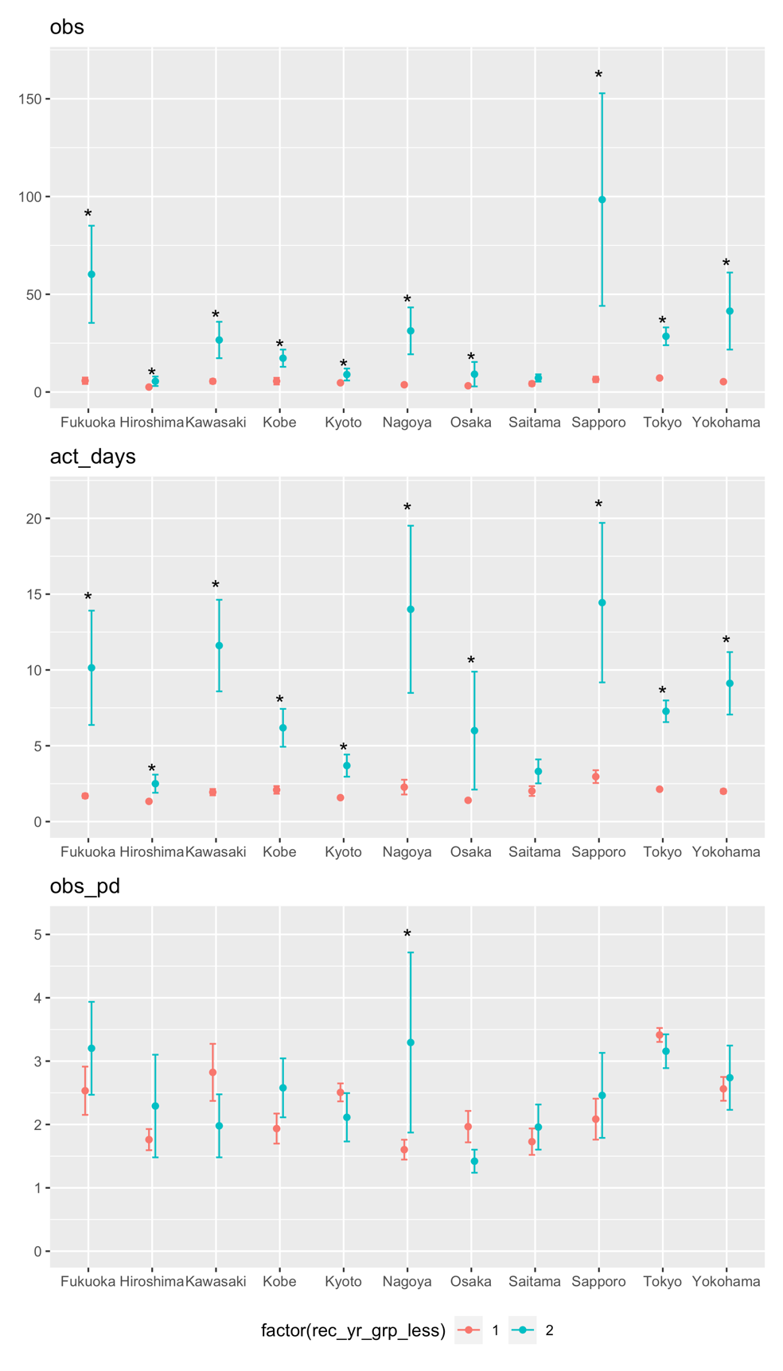

Figure Comparison of annual metrics between new participants and experienced participants (time span: 2016-2020). Group “1” represents new participants, group “2” for experienced participants.

For new participants, the number of observations and observations per active day during COVID-19 differed significantly from those metrics in 2019 in 4 and 5 out of the 11 cities respectively (Figure 4). On contrast, less significant difference was found for experienced participants. In terms of active days, only in two cities was found the significant difference for new participants, while no significant difference was detected for that metrics for experienced participants.

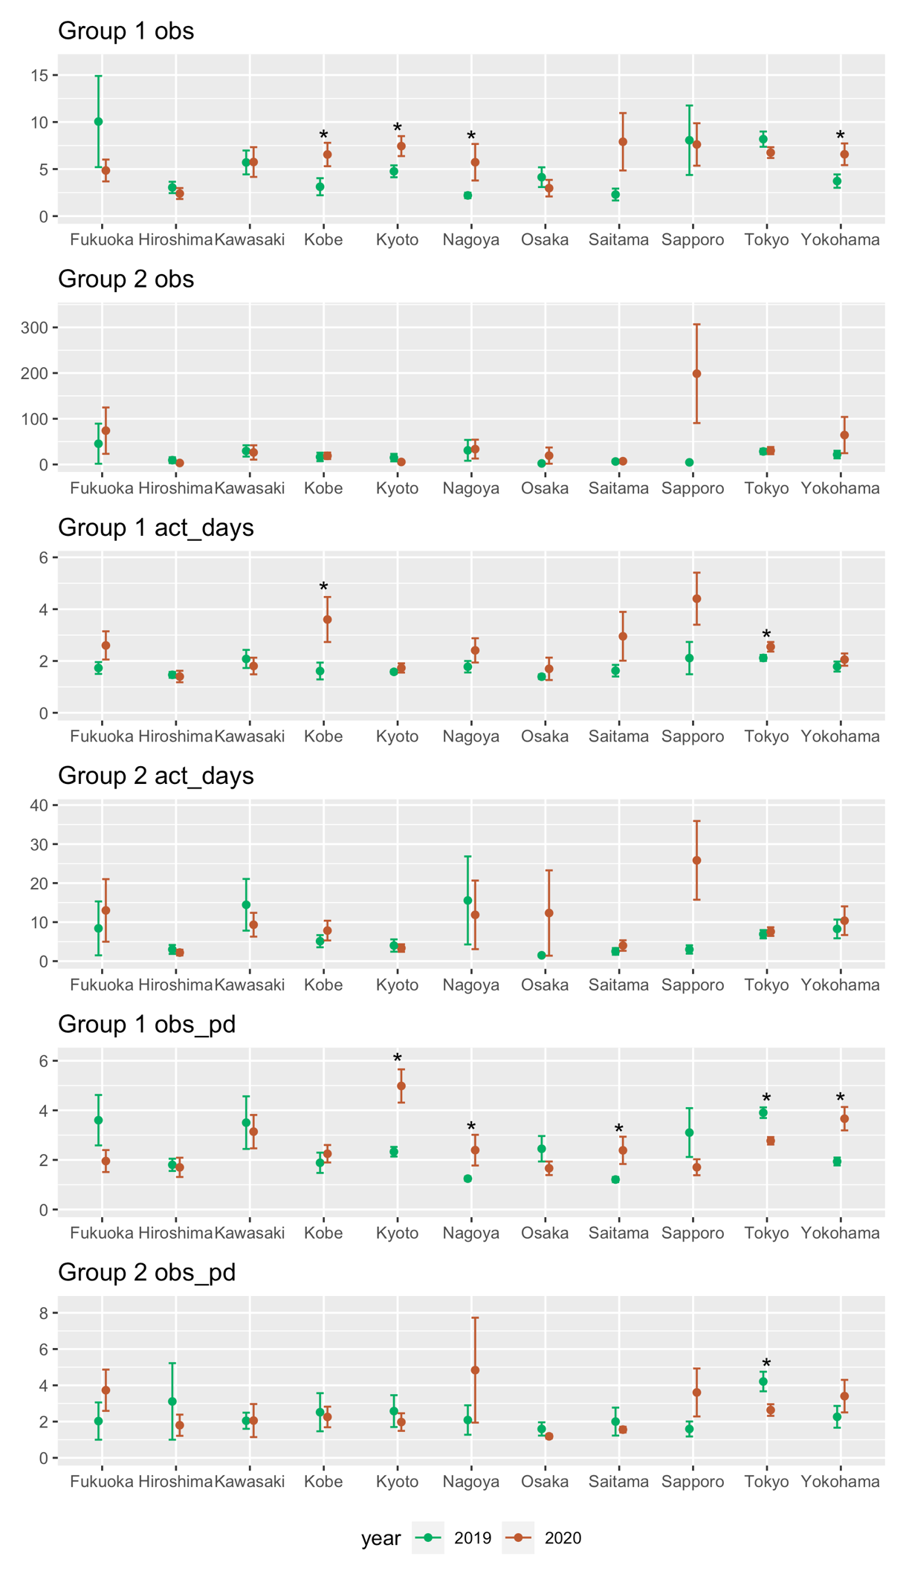

Figure Comparison of metrics of different participant groups between year 2019 and 2020.

## 3 Discussion

### 3.1 Impact of COVID-19 to citizen science

# discussion on the reason of the impacts

# Why the observation goes down: is it because of decreasing observation days or because of the decreasing participants? What is the reason for between-city difference?

Unlike the citizen science programs relying on online operation only, biodiversity programs, requiring outdoor observation, are usually reported to experience a decrease during the COVID-19 #ref#. As expected, we also detected that citizen scientists contribute less during COVID-19. But many studies didn’t look into the details of the reason for the decrease. Our further test indicates that the reason is mainly due to a decrease of participants. On the other hand, surprisingly, though both observation and active days dropped in 2020, active days per participant and observation per participant per day increased in most cities.

The reason for less participants in 2020 is probably …

### 3.2 About research method

# discussion of analysis method

# When analyzing the impact of COVID-19 on citizen science, researchers should consider the ‘early stage growth’ of citizen science in a city, as well as the impact of other policies and number of infections.

# the difference between long term impact and short term impact: short term analysis may lead to bias.

### 3.3 To conservation practice

# what is insight of the results to conservation practice?

And what is the opportunity during COVID?

## Conclusion

## References

Bates, A.E., Primack, R.B., Moraga, P., Duarte, C.M., 2020. COVID-19 pandemic and associated lockdown as a “Global Human Confinement Experiment” to investigate biodiversity conservation. Biological conservation 248, 108665.

Crimmins, T.M., Posthumus, E., Schaffer, S., Prudic, K.L., 2021. COVID-19 impacts on participation in large scale biodiversity-themed community science projects in the United States. Biological Conservation 256, 109017. https://doi.org/10.1016/j.biocon.2021.109017

Kishimoto, K., Kobori, H., 2021. COVID-19 pandemic drives changes in participation in citizen science project “City Nature Challenge” in Tokyo. Biological Conservation 255, 109001. https://doi.org/10.1016/j.biocon.2021.109001

Roll, U., Jarić, I., Jepson, P., da Costa‐Pinto, A.L., Pinheiro, B.R., Correia, R.A., Malhado, A.C., Ladle, R.J., 2021. COVID‐19 lockdowns increase public interest in urban nature. Front Ecol Environ 19, 320–322. https://doi.org/10.1002/fee.2374

Rose, S., Suri, J., Brooks, M., Ryan, P.G., 2020. COVID-19 and citizen science: lessons learned from southern Africa. Ostrich 91, 188–191. https://doi.org/10.2989/00306525.2020.1783589

Volunteers Flock To Sign Up As Citizen Scientists [WWW Document], n.d. URL https://www.wbur.org/hereandnow/2020/04/14/volunteers-citizen-scientists (accessed 10.20.21).

Young A., 20:23:49 UTC. City Nature Challenge RESULTS [WWW Document]. iNaturalist. URL https://www.inaturalist.org/projects/city-nature-challenge-2020/journal/34792-city-nature-challenge-results (accessed 10.20.21).