|  |  |  |  |  |
| --- | --- | --- | --- | --- |
|  | 目录 | 进度 | 未完成内容 | 备注 |
| 主菜单 | 完成 | - |  |
| 盖门测试 | **未完成** | **传感器与按钮之间的关系** | **参考以下表** |
| 料斗测试 | 完成 | - |  |
| 显示屏测试 | 完成 | - |  |
| 音响测试 | **未完成** | **mp3来源文件** | **从以前的RPi拷贝mp3** |
| 二维码测试 | **未完成** | **Event未做** |  |
| 风扇测试 | 完成 | - |  |
| 称重传感器 | | | |
| --第一 | **未完成** | **Event未做** |  |
| --第二 | **未完成** |  |
| --第三 | **未完成** |  |
| --第四 | **未完成** |  |

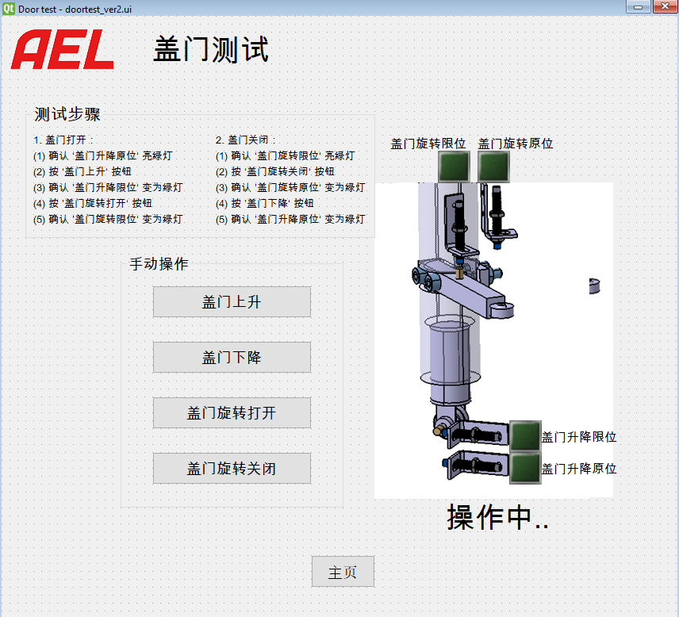

|  |  |  |  |  |  |
| --- | --- | --- | --- | --- | --- |
|  | Doorup_  home | Doorup_  limit | Doorrot_  home | Doorrot_  limit | Event |
| Home pos | o | x | x | X | 1.“盖门上升”激活  2. 其余未激活 |
| Door up status | x | o | o | X | 1.“盖门下降”激活  2.“盖门旋转打开”激活  3. 其余未激活 |
| Door rot opened status | x | o | x | o | 1.“盖门旋转关闭”激活  2. 其余未激活 |

1. Operation : Program(automatic execution after booting of Raspbian)

2. Maintenance : Program(Manual execution after booting of Raspbian, need mouse and small monitor)

1.Maintenance GUI

2.Wiring

3.Purchasing electrical parts

4.Test with maintenance GUI and parts

Zhuhai test

1. Wiring

2. Test with maintenance program

3. Test operation program

Update/program rectification from HK

1. Update/rectification and publishing exe file

2. Sending program to Zhuhai colleague

3. If necessary for update, **Copy it to raspberry pi using USB**