EE-313 Lab Report 1

Bilge Kaan Ateş

February 18, 2024

1. **Introduction:**

Aims of this lab are finding saturation current of a p-n diode and designing a temperature sensor using the temperature-forward voltage relation of a diode.

The requirements as follows:

* When the sensor is at room temperature, the output voltage should be nearly half the supply voltage (Vdd/2 ±0.3V).
* The output voltage should show the temperature difference between the room temperature and the temperature of the sensor diode in degrees with a 10% tolerance. For example, a +1℃ difference should give us a change of +1±0.1 V in the output voltage.
* A red LED should turn on when the sensor's temperature exceeds +3±0.5°C the room temperature.
* The LED should never flicker around the thresholds (it should have a 0.1°C hysteresis).

1. **Experimental Implementation:**
   1. **Measurement method:**

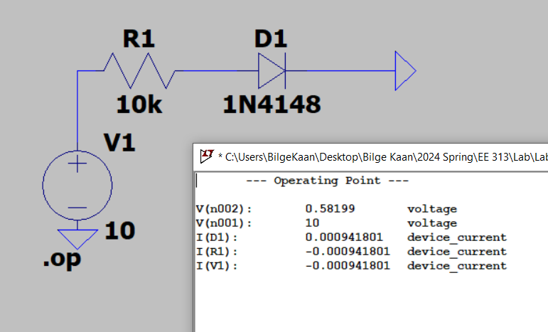

Fig. 1: measurement circuit

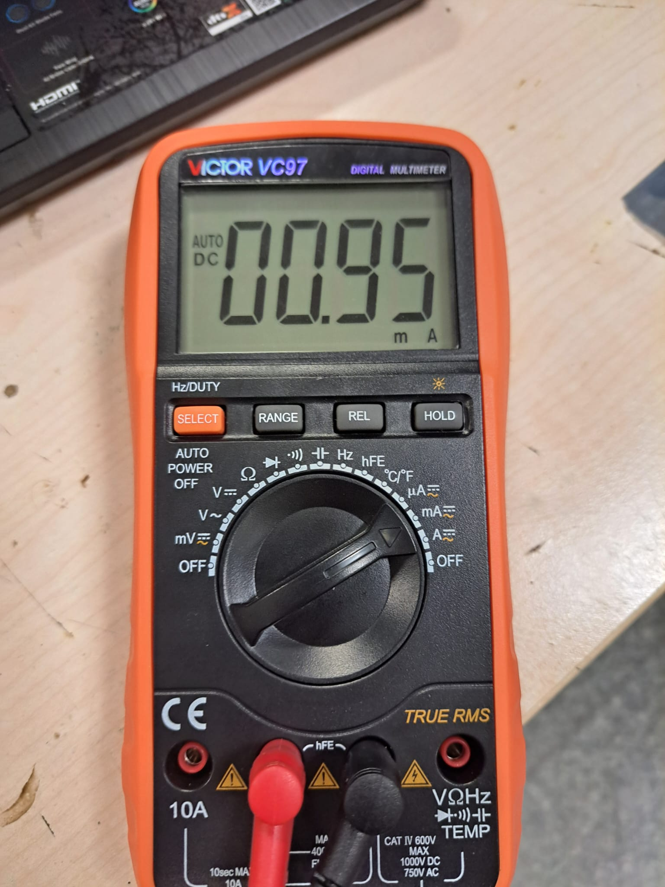

Fig. 2: Measured

I created the simple circuit depicted in Fig. 1 for the first section. In order to prevent excessive current and diode degradation, I put a series resistor. I used the following formula to determine :

(1)

* Total current flows in diode: mA -
* Forward voltage of the diode: ,
* Boltzmann constant:
* Temperature:
* Charge of the electron:
* Ideality factor of the diode:
* We can use:

Therefore, is found as follows:

is nearly equal to LTspice value of shown in Fig. 2. The error rate is is %5.5 which is acceptable.



Fig. 3:

* 1. **Differential Temperature Sensor Design:**

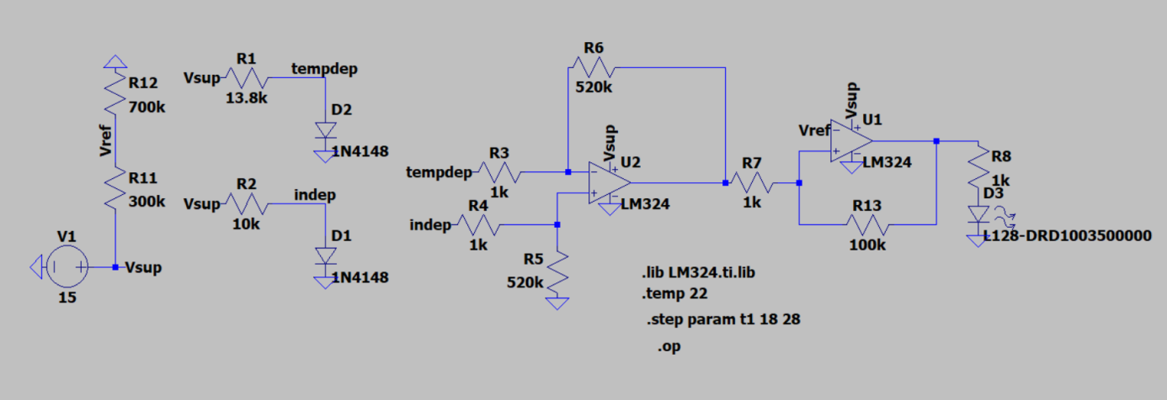

Fig. 4: Whole circuit design

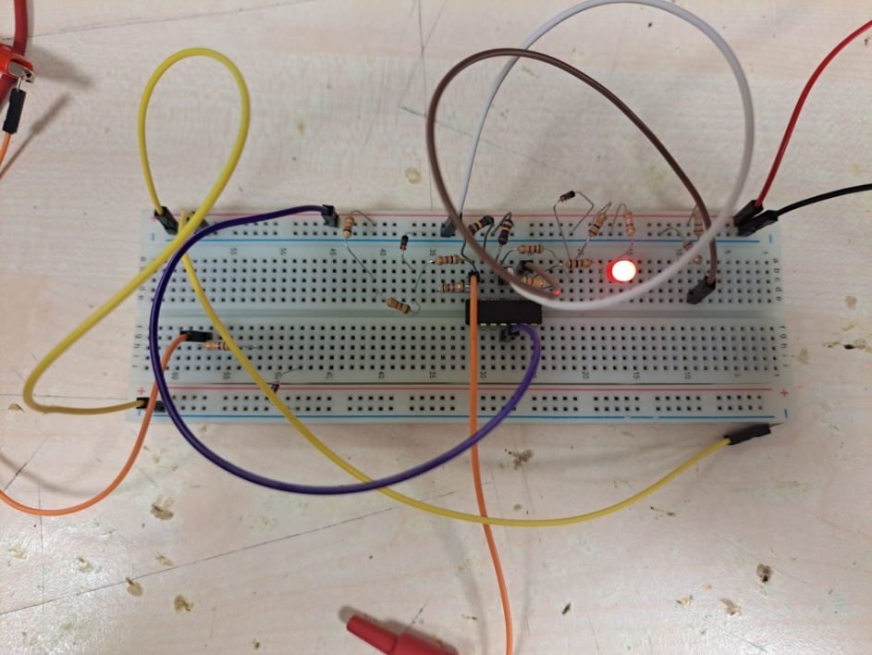

Fig. 5: Implemented Temperature Sensor Circuit

I implemented my designed circuit that measures the temperature and maps it on voltage level with a linear relation. However, I couldn’t observe the linear temperature-output voltage relationship since I wasn’t able to increase diode’s temperature linearly.

Diode-threshold voltage relationship can be observed in formula (1). I obtain after some calculations. In order to designing a temperature sensor with diodes, I used 2 diodes with shunt technique. One of them used for reference point (room temperature) while the other one is used for temperature measurement. After that, I used differential OPAMP for comparing the diodes threshold voltages generate an output voltage as expected. Differential OPAMP’s output voltage formula is as follows:

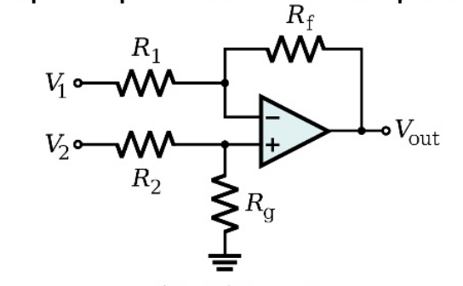

Fig. 6: Differential OPAMP schematic

(2)

If then we have

As a result, I used standard resistor values and obtain the amplification coefficient as 560 since is not exactly -2mV/K. Also this ratio increased for the experiment (520 ratio used in simulation) since observed output is less than the simulation and standard values are limited. Consequently, I nearly satisfied the second requirement even if output voltage doesn’t perfectly map the temperature difference with a desired linear relationship. To achieve output voltage equals to the half of the supply voltage, I used formula (1) and increase the value of series resistor of temperature dependent diode. I connected 10kΩ resistance series to reference diode and 13.9kΩ resistor series to sensor diode. As a result, I decreased the current flows through sensor diode and reduced its voltage about 15mV. Hence, I obtained a bias voltage that shifts the output voltage forward at the room temperature. So, first requirement satisfied with %1.3 error rate. Output voltage at the room temperature is shown in Fig. 7.

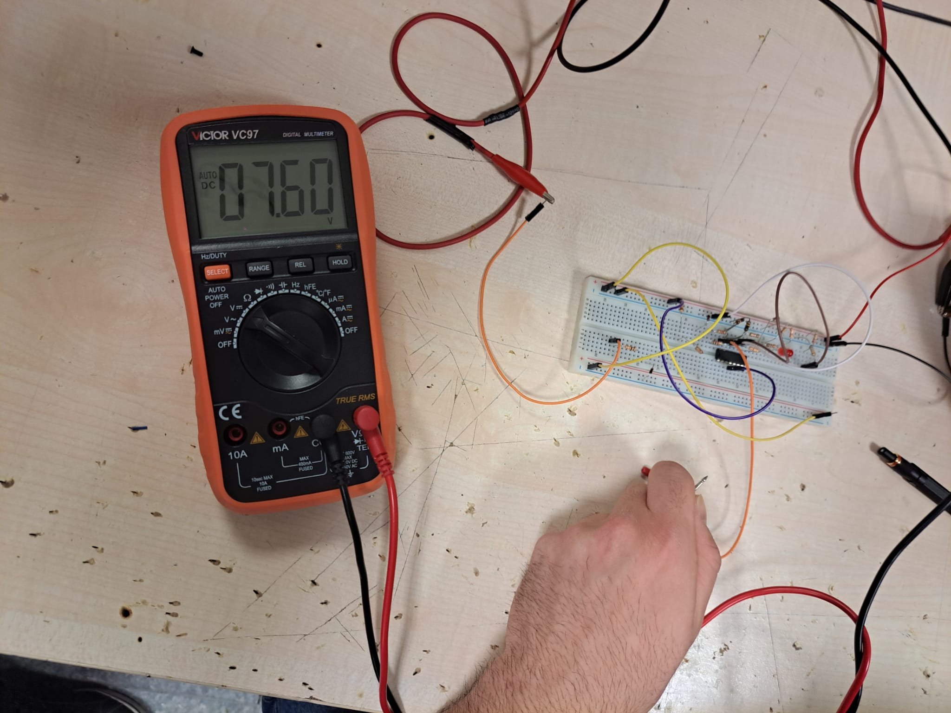

Fig. 7: at room temperature

After I obtained the , I used a comparator OPAMP with to satisfy the third requirement that when temperature sensor exceeds 3C°, light the led. I used voltage divider for this purpose and used 270kΩ and 680kΩ resistors. Thus, comparator OPAMP goes high when the exceeds 10.5 V, 3C° higher than the room temperature. I put 1kΩ series resistor to led limit the current. Finally, I used hysteresis method (positive feedback) to avoid from flicker around the threshold voltages with difference 0.1mV. For the positive feedback resistors formula given as follows:

(3)

Hence, I used standard resistor values 1kΩ/150kΩ ratio for this purpose and obtained 0.9mV difference between high and low threshold voltages. However, my experimental threshold difference comes up, which can be observed in Fig. 8 and Fig. 9.

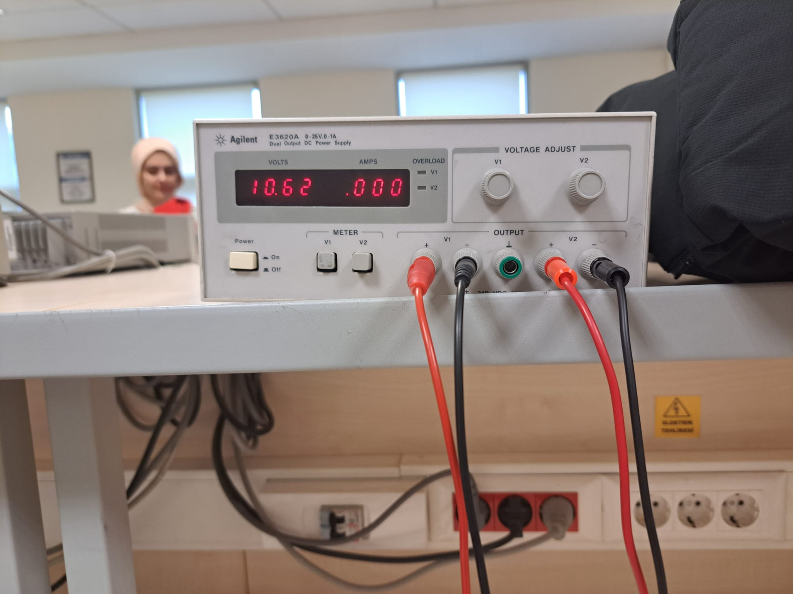

Fig. 8: Lower threshold voltage: for stop lighting

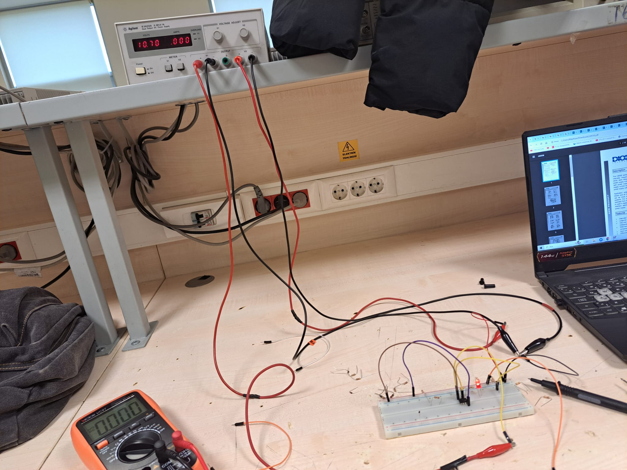

Fig. 9: Higher threshold voltage, for start lighting

I used a red LED, a 1N4148 diode, an LM324 OPAMP, a variety of value resistors, to build this circuit on a breadboard. Corresponding experimental results can be seen in Fig. 10, 11 and 12. As Fig. 10 and 12 represents, if the room temperature is equal or lower than the sensor diode, then output voltage is: . However, Fig. 11 shows that

when sensor diode’s temperature increases (3C° higher than the reference diode). Hence, 3rd and 4th requirements are satisfied as well.

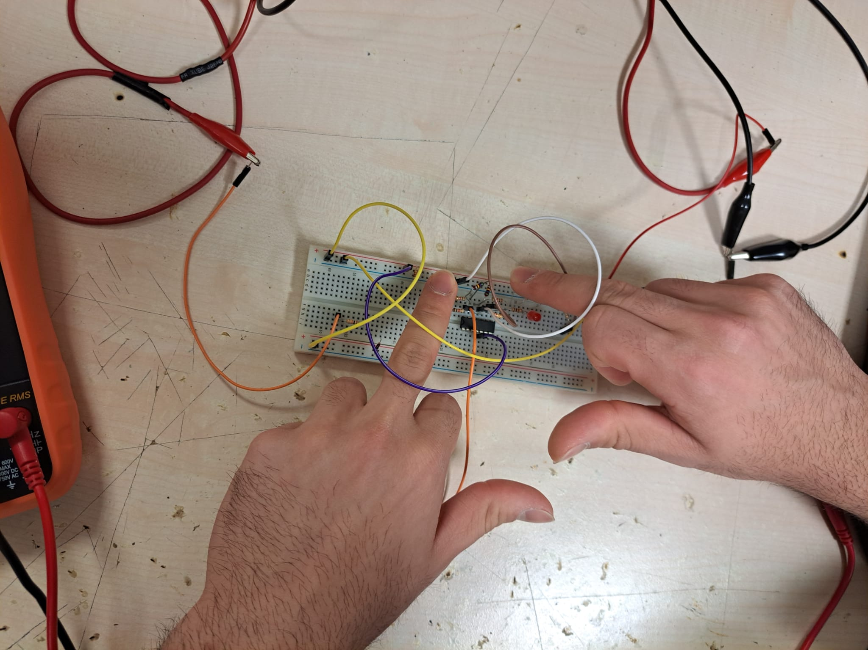

Fig. 10: When two diodes temperature changes same amount

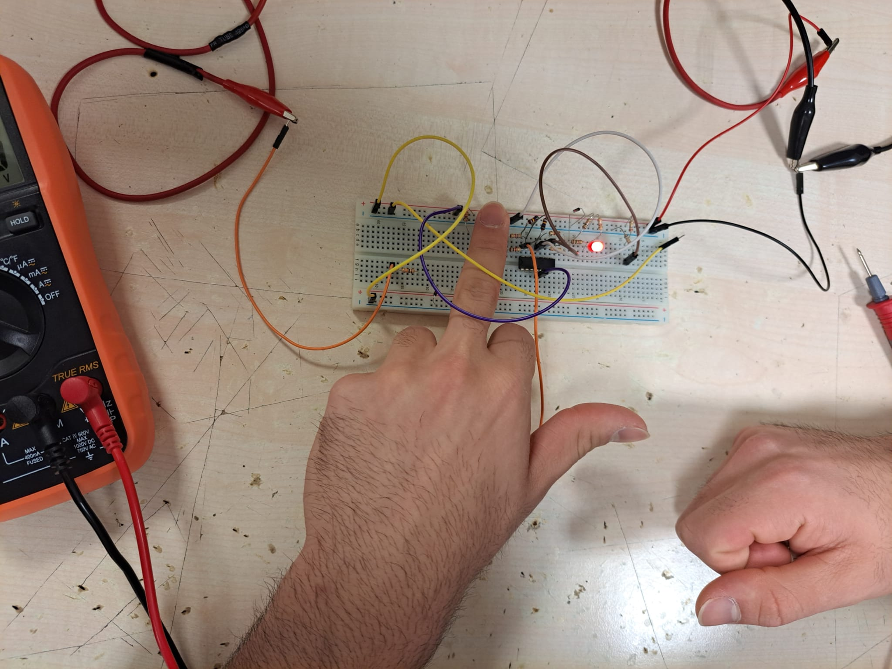

Fig. 11: When sensor diode’s temperature increases

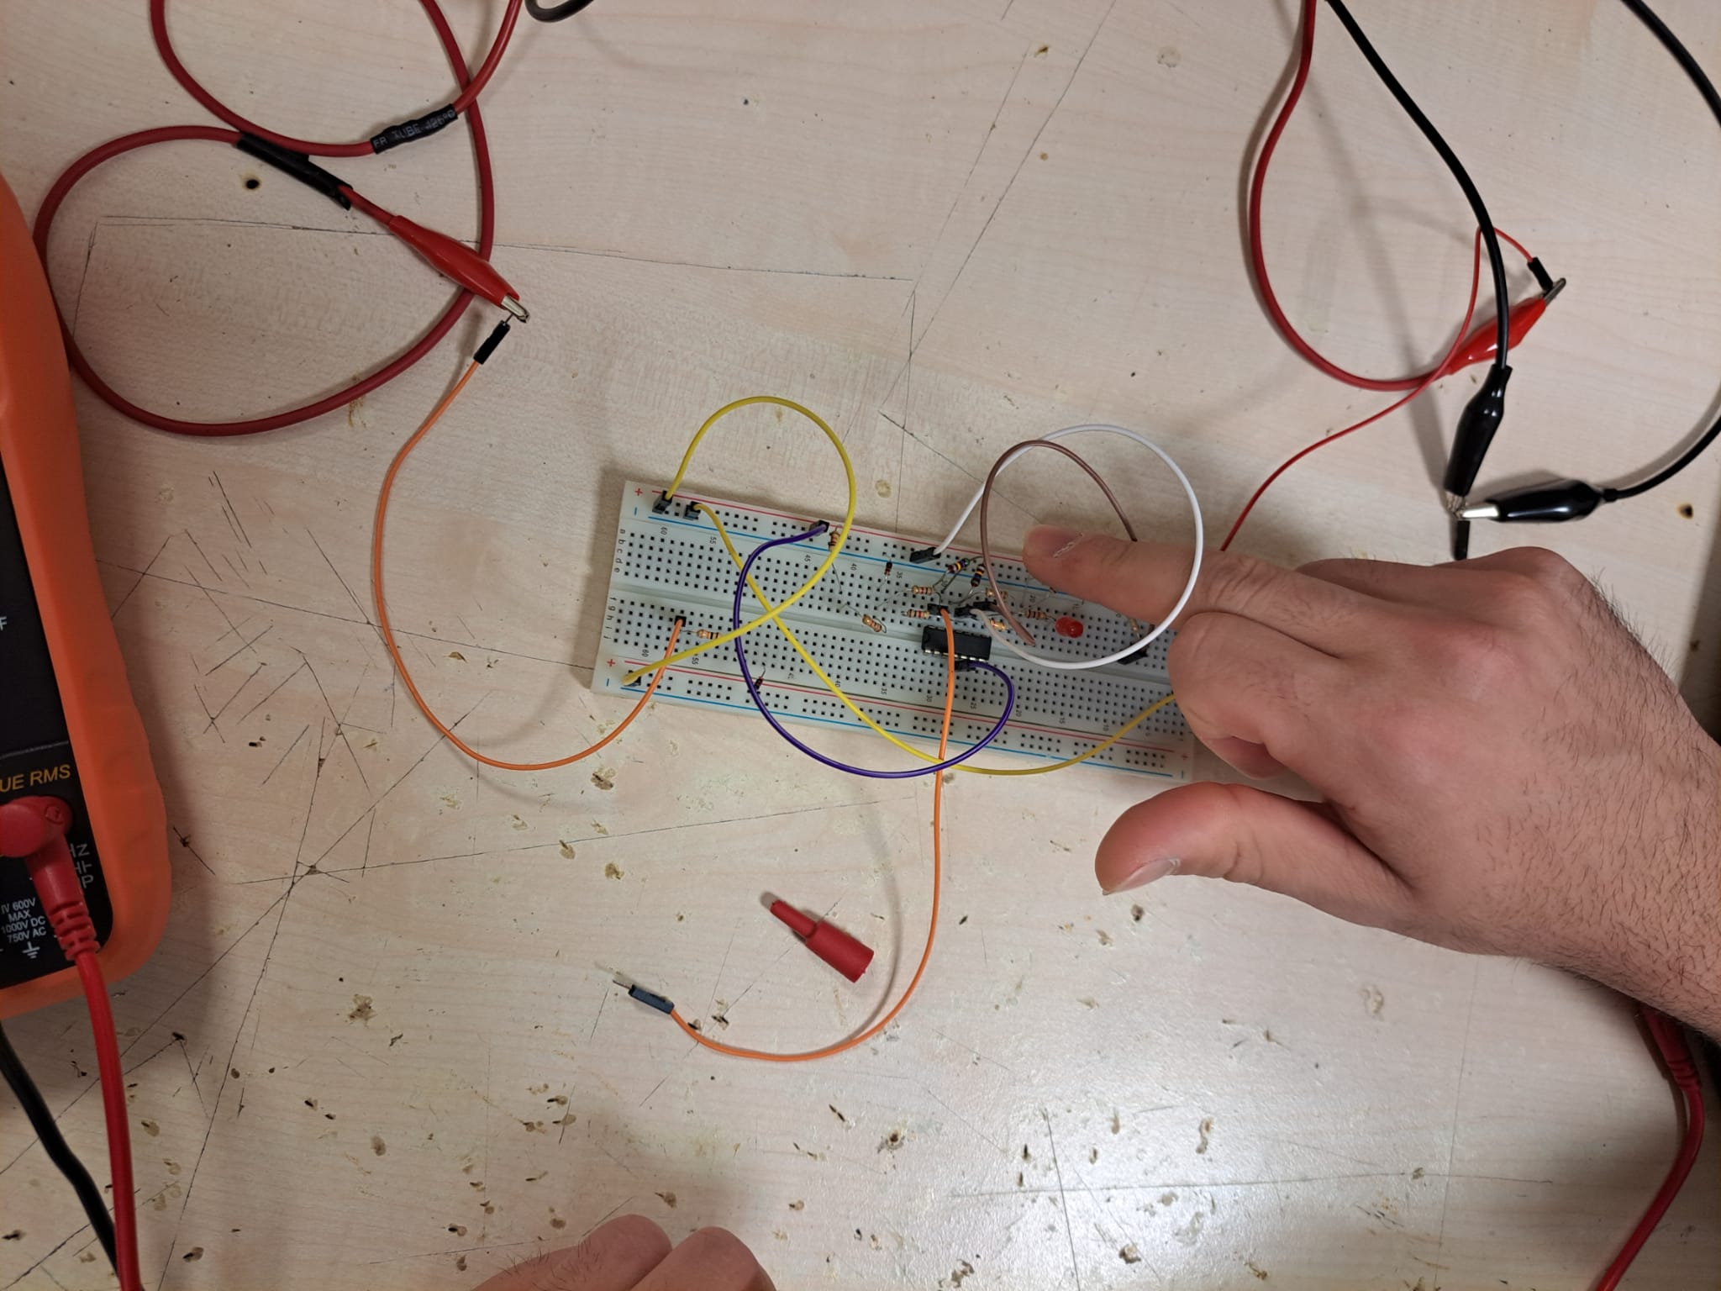

Fig. 12: When reference diode’s temperature increases

* 1. **Diptrace Schematic:**

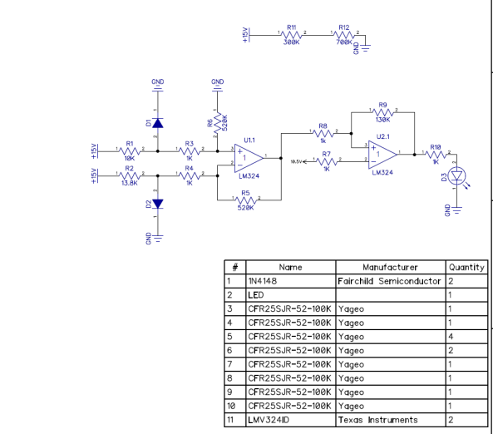

Fig. 8: Diptrace Schematic

1. **Conclusion:**

To sum up, the goal of the lab experiment were firstly determining the current, or the diode's saturation current, with the formula (1) and secondly designing a temperature sensor circuit using the temperature dependency of a diode forward voltage under constant current with the requirements stated in the introduction. To accomplish this, two OPAMP circuits were utilized: the Differential OPAMP and the Comparator OPAMP circuits. In order to turn on the LED, Differential OPAMP maps the linear relation with temperature and output voltage. Thereafter, Comparator OPAMP utilized to give high voltage to the LED when reference voltage beaten by the output voltage.

Nevertheless, for a number of reasons, certain mistakes happened at different points in the process. Among these were possible mistakes in the breadboard and component values, which can cause problems with connectivity. Additionally, the values in the lab experiment differ significantly from those in the simulation since the setup and components are not optimal for getting the right values (using standard values instead of actual ones). Furthermore, a number of the simulation's constituents are not in optimal condition in comparison to those utilized in the experiment. Using less stressed components could help to lessen these problems.

The experiment was successful, and a diode was used to make a differential temperature sensor. Through this experiment, I obtained numerous experiences and intuition in circuit design and test processes.