EE-313 Lab Preliminary Report 1

Bilge Kaan Ateş

February 11, 2024

1. **Introduction:**

Aims of this lab are finding saturation current $I_{s}$ of a p-n diode and designing a temperature sensor using the temperature-forward voltage relation of a diode.

1. **LTspice Implementation:**
   1. $I_{s}$**Measurement method:**

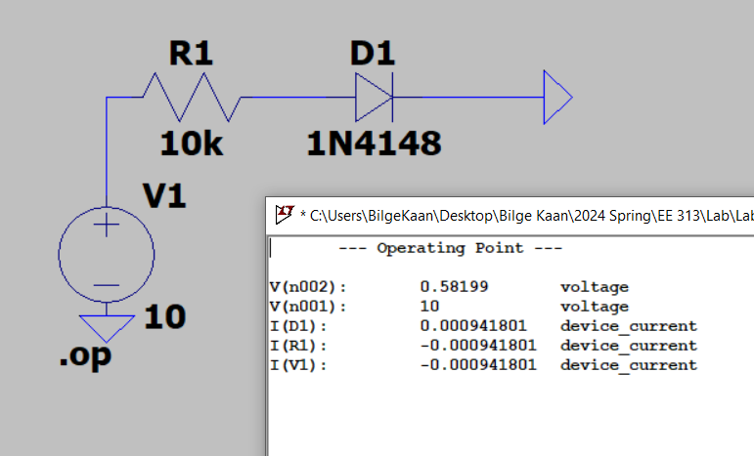

Fig. 1: $I_{s}$ measurement circuit

For the first part, I designed a basic circuit shown in Fig. 1. I put a series resistor for avoiding the high current and impairment of the diode. $I_{s}$ can be calculated with the following formula:

$I_{tot}=I_{s}(e^{\frac{V_{f}*q}{nkT}}-1)$ (1)

* Total current flows in diode: $I_{tot}=0.942$ mA
* Forward voltage of the diode: $V_{f}= 582 mV$
* Boltzmann constant: $k={1.3810}^{-23} J/K$
* Temperature: $T=300K$
* Charge of the electron: $q=1.6*{10}^{-19}C$
* Ideality factor of the diode: $1.752$
* We can use: $V_{T}=\frac{kT}{q}=25.85 mV$

Therefore, $I_{s}$ is found as follows:

$$I_{s}=\frac{I_{tot}}{e^{\frac{V_{f}}{nV_{T}}}-1}=\frac{942x{10}^{-6}}{e^{\frac{582}{1.752*25.85}}-1}=2.53nA≅2.52nA$$

Which is nearly equal to LTspice value of $I_{s}$ shown in Fig. 2.



Fig. 2:

* 1. **Differential Temperature Sensor Design:**

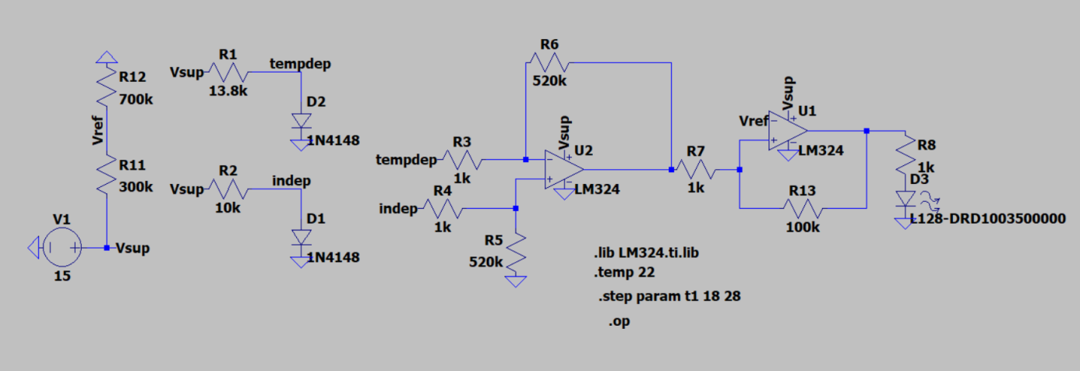

Fig. 2: Whole circuit design

I designed a circuit that measures the temperature and maps it on voltage level with a linear relation. Design requirements are as follows:

1. When the sensor is at room temperature, the output voltage should be nearly half the supply voltage (Vdd/2 ±0.3V).
2. The output voltage should show the temperature difference between the room temperature and the temperature of the sensor diode in degrees with a 10% tolerance. For example, a +1degree difference should give us a change of +1±0.1 V in the output voltage
3. A red LED should turn on when the sensor's temperature exceeds +3±0.5°C the room temperature.
4. The LED should never flicker around the thresholds (it should have a 0.1°C hysteresis).

Diode-threshold voltage relationship can be observed in formula (1). I obtain $\frac{dV_{f}}{dT}≅-2mV/K$ after some calculations. In order to designing a temperature sensor with diodes, I used 2 diodes with shunt technique. One of them used for reference point (room temperature) while the other one is used for temperature measurement. After that, I used differential OPAMP for comparing the diodes threshold voltages generate an output voltage as expected. Differential OPAMP’s output voltage formula is as follows:

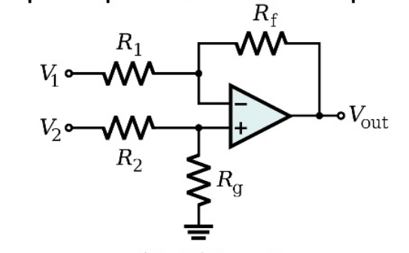

Fig. 3: Differential OPAMP schematic

$V_{out}=\frac{\left(R_{f}+R_{1}\right)R_{g}}{\left(R_{g}+R_{2}\right)R_{1}}V_{2}-\frac{R_{f}}{R_{1}}V_{1}$ (2)

If $R_{f}=R_{g} and R_{1}=R_{2},$ then we have $V_{out}=\frac{R_{f}}{R_{1}}(V_{2}-V_{1})$

As a result, I used $R_{f}=520kΩ, R_{1}=1kΩ$ and obtain the amplification coefficient as 520 since $\frac{dV_{f}}{dT}$ is not exactly -2mV/K. Consequently, I satisfied the second requirement. To achieve output voltage equals to the half of the supply voltage, I used formula (1) and increase the value of series resistor of temperature. Hence, I obtained a bias voltage that shifts the output voltage $\frac{V_{sup}}{2}$ forward at the room temperature. So, first requirement satisfied as well.

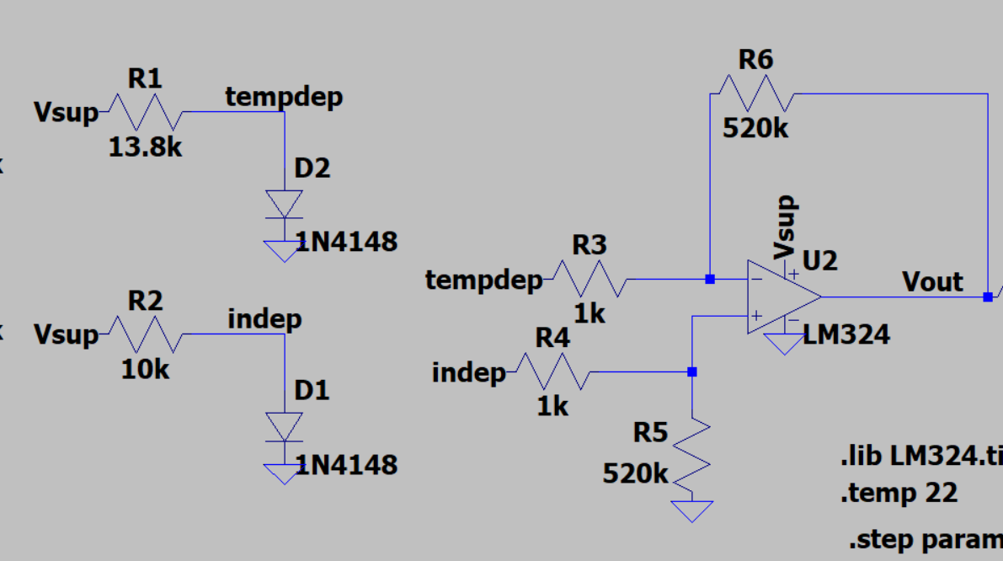

Fig. 4: Corresponding part of the circuit

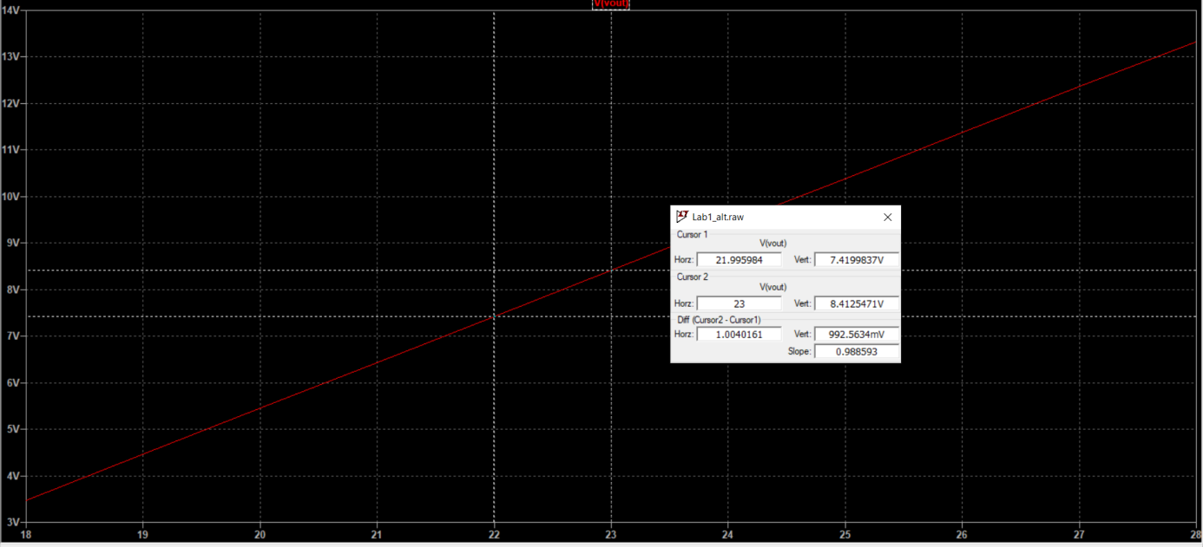

Fig. 5: Accurate voltage-temperature relation.

After I obtained the $V_{out}$, I used a comparator OPAMP with $V_{ref}=\frac{V_{sup}}{2}+3 V$ to satisfy the third requirement that when temperature sensor exceeds 3C°, light the led. I achieved this at 25.1C° (3.1C° higher than the room temperature). Thus, comparator OPAMP goes high when the $V_{out}$ exceeds 10.5 V, 3C° higher than the room temperature. I put 1kΩ series resistor to led limit the current. Finally, I used hysteresis method (positive feedback) to avoid from flicker around the threshold voltages. For the positive feedback resistors formula given as follows:

$∆V=\frac{R_{1}}{R_{2}}\left(V_{sup}-3\right)=0.1$ (3)

Hence, I used 1kΩ/130kΩ ratio for this purpose. Second part of the circuit and its responses can be seen in Fig. 6 and Fig. 7 in detail.

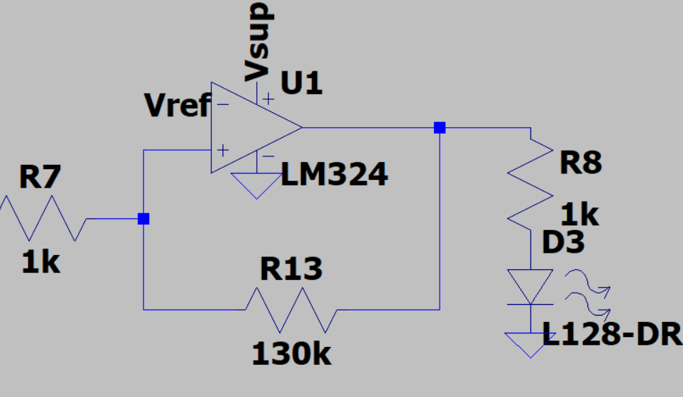

Fig. 6: Comparator OPAMP with hysteresis

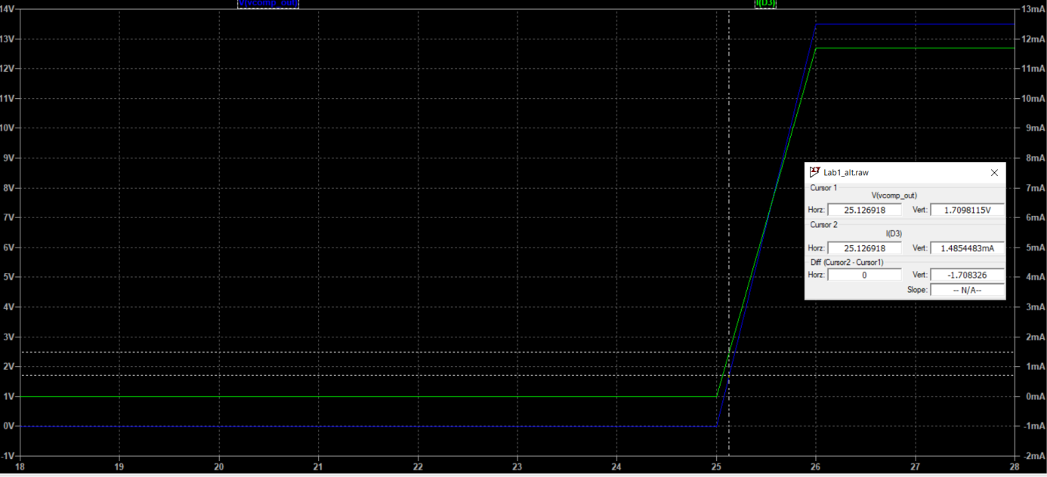

Fig. 7: OPAMP output voltage and current flows through LED

* 1. **Diptrace Schematic:**

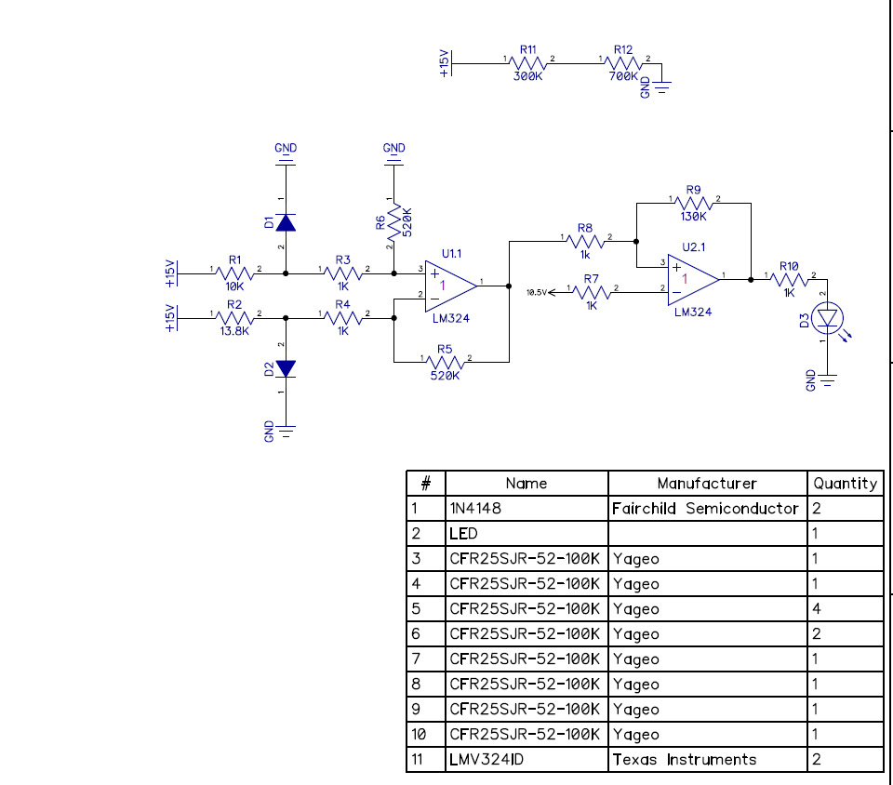

Fig. 8: Diptrace Schematic