EE-313 Lab Report 2

Bilge Kaan Ateş

March 6, 2024

1. **Introduction:**

Aims of this lab are designing a simple circuit to find β value of a pnp-type BJT transistor and designing a low-dropout voltage regulator (LDR) with pnp-type BJT as a regulator, an OPAMP to provide feedback and a Zener diode to obtain a reference voltage with an output current 100mA. We are allowed to choose an output voltage of 7, 8 … ,12V. Specifications are as follows:

1. Line regulation: When is between to , the output voltage, , changes by no more than 10mV when the output current is 20mA,  
    ( ).
2. Load regulation: When , the output voltage, , changes no more than 50mV when the output current changes between 5mA and 100mA ( is varied between to )
3. An output short circuit current of smaller than 250mA when .
4. A green LED should turn on if the regulation is achieved. Otherwise, it should turn off, for example, because the input voltage is too low or the output current is too high.

1. **LTspice Implementation:**
   1. **β Measurement method:**

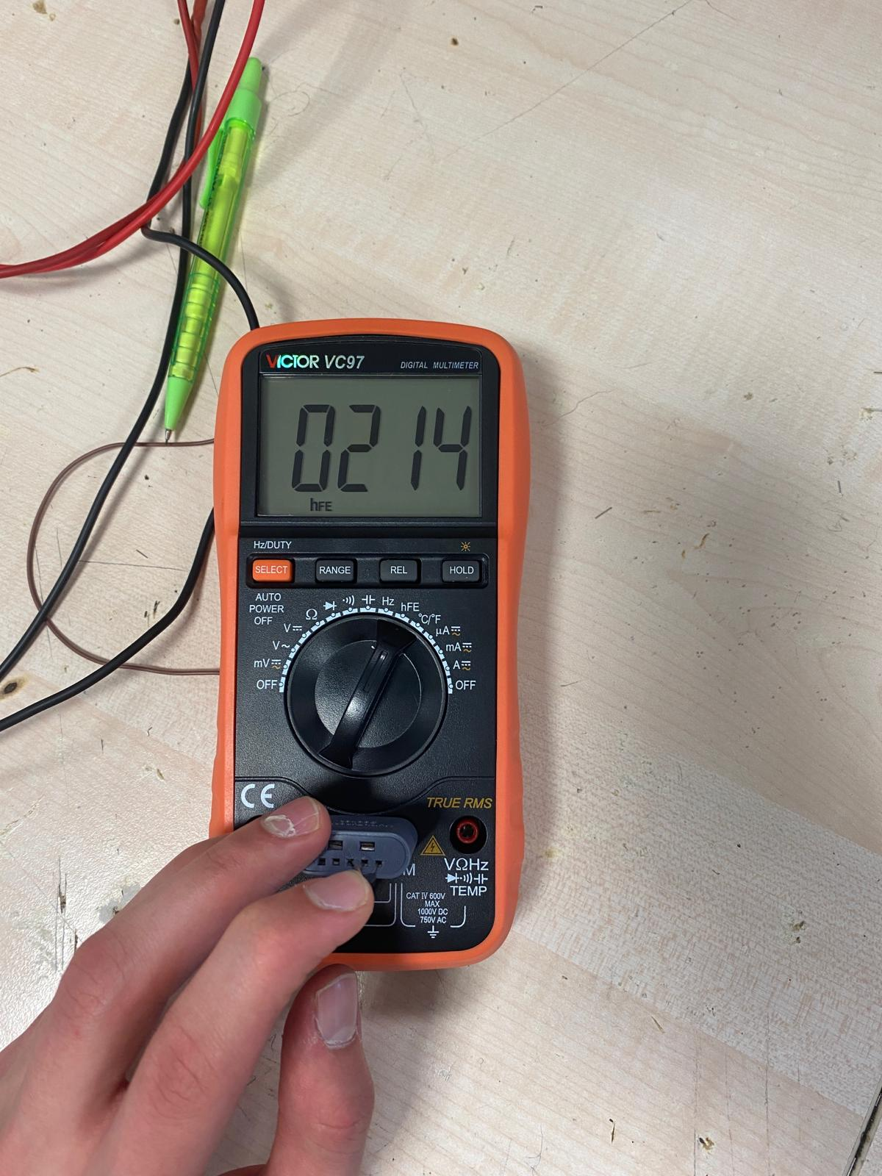

Fig. 1: measurement method

For the first part, I placed the BJT to the multimeter shown in Fig. 1. In order to measure β, I adjust the multimeter in hFE mode. Calculated in LTSpice as below:

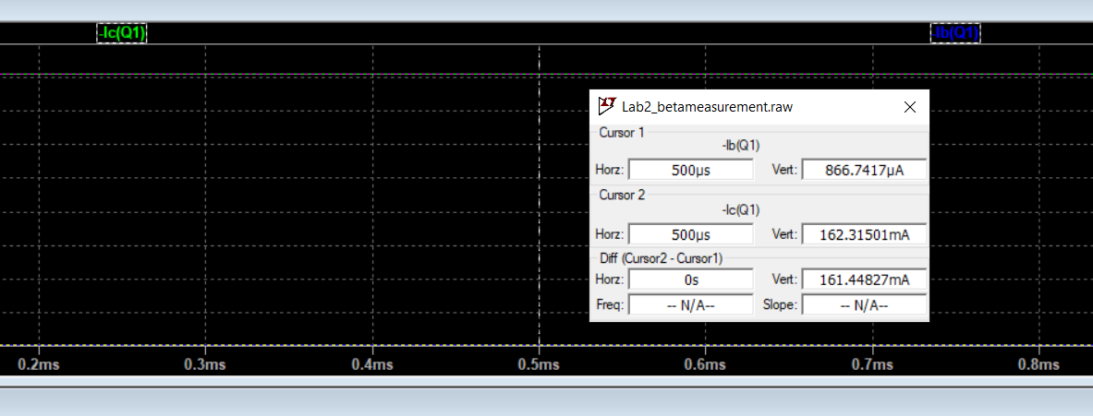

Fig. 2: Collector and base currents of the circuit in Fig. 1

* 1. **Low-Dropout Voltage Regulator Design:**

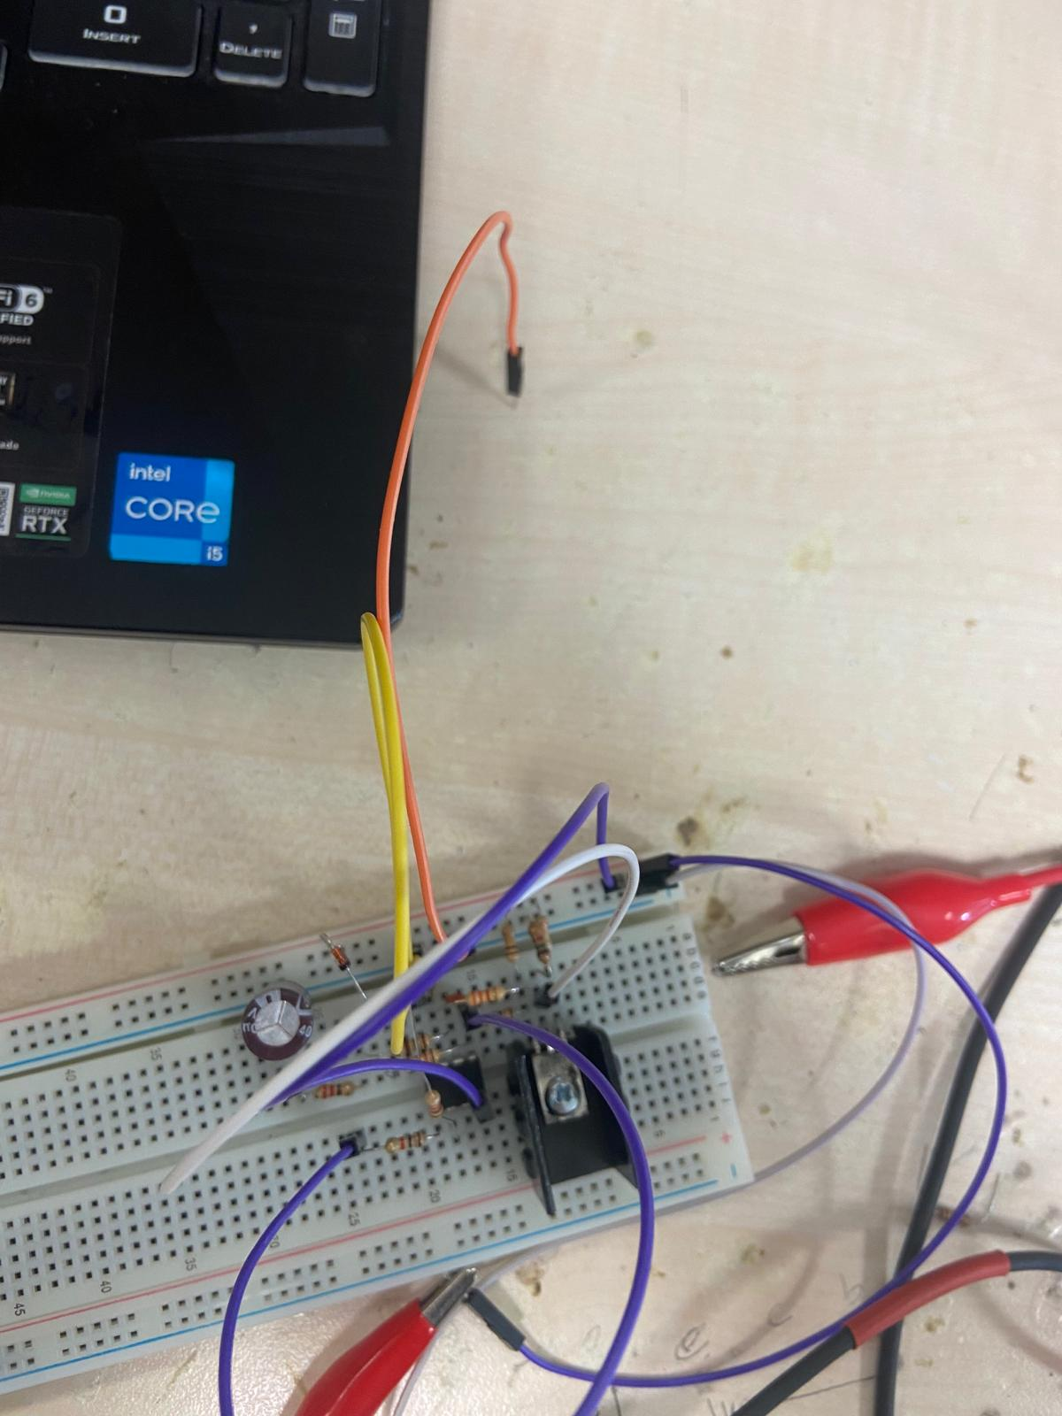

Fig. 3: Whole circuit design

I designed a circuit that regulates the given input voltage and do not gives output voltage more than 8V given in Fig. 3. I used pnp-type BJT transistor to regulate the voltage. Voltage drops out around 0.5V since as seen in formula (1) and 3.3Ω series connected resistor. I connected BJT’s base terminal to a feedback OPAMP circuit. That sub circuit can be observed in Fig. 4.

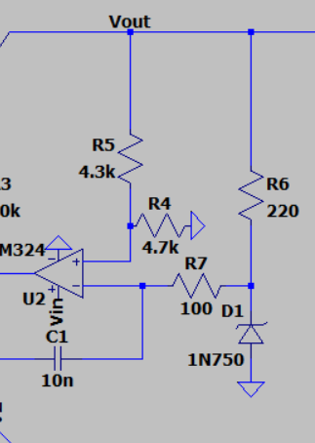

Fig. 4: Feedback circuit

In this feedback circuit, I connect a reverse-biased Zener diode to inverting input of OPAMP since to obtain a reference voltage. 1N750 zener diode has 4.7V breakdown voltages. Increasing the series resistor value (R6) to this Zener diode reduces the breakdown voltage since the current goes through it reduces. I used a voltage divider to connect the non-inverting input of OPAMP to necessary voltage 4.7. I chose 8V output voltage, therefore, I used 3.3k and 4.7kΩ for this purpose (Note that I used 9V and 4.3kΩ resistor in the preliminary. However 4.7kΩ is not available in the lab and hence I used 8V as output voltage). However, in the real-life implementation, I observed 8.5V as output voltage. This is probably occurred by the Zener diode’s breakdown voltage, resistor values are not exactly as their labeled values and tolerances, and OPAMP’s output voltage is some amount. Except those, circuit works properly. Whenever the exceeds the 8.5V, OPAMP goes high and keep voltage difference same. Hence, and remains same as well. I connect non-inverting input to output with a capacitor to avoid instantaneous voltage shifts and hold stability. Same method applied to the output node as well. Regulation starts at 9.07V as shown in Fig. 5.

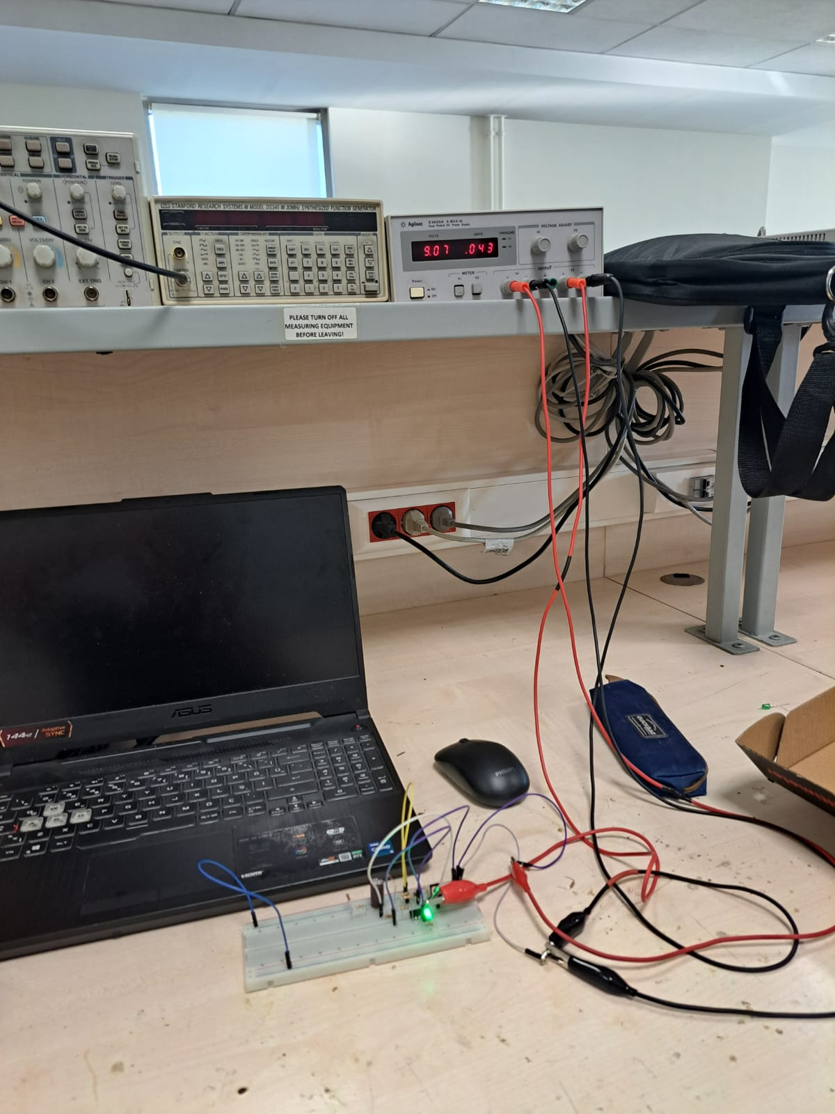

Fig. 5: Regulation starting voltage

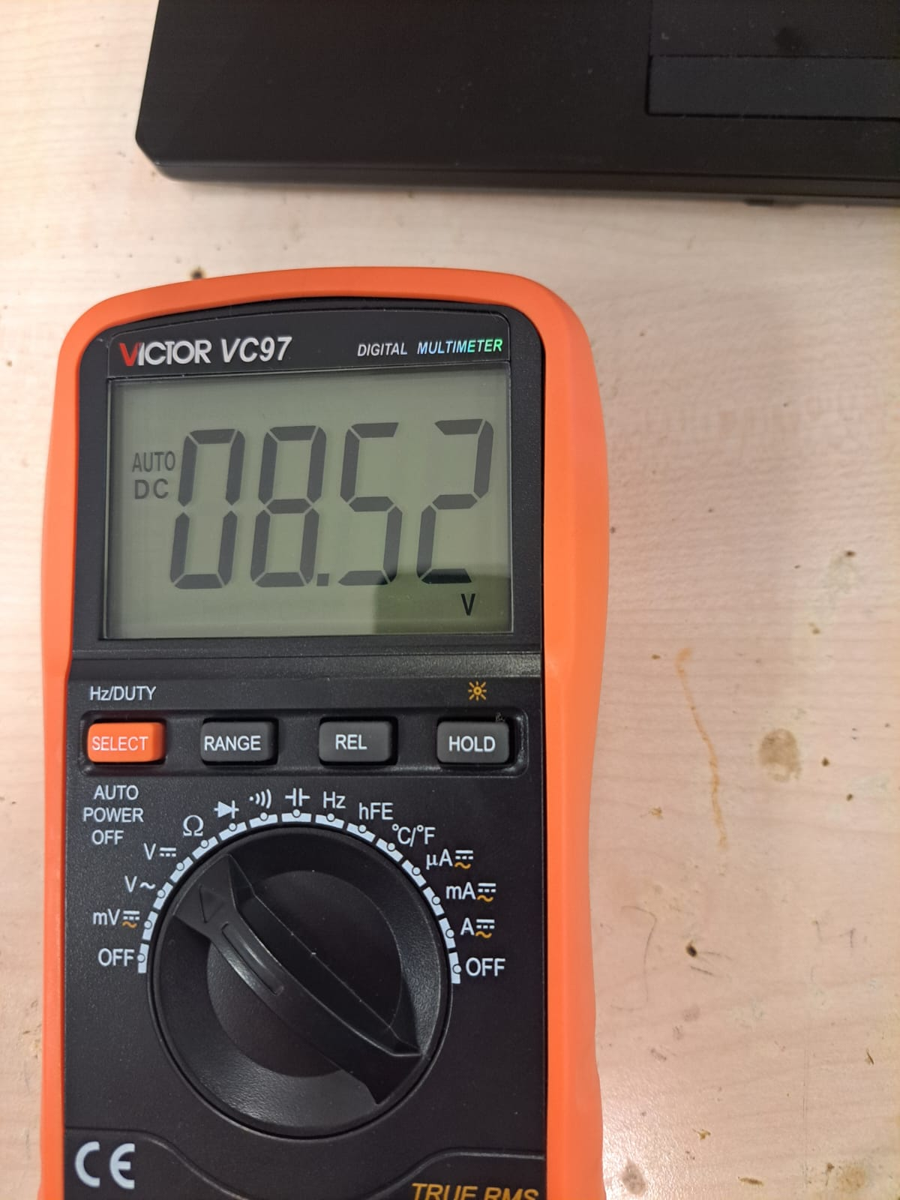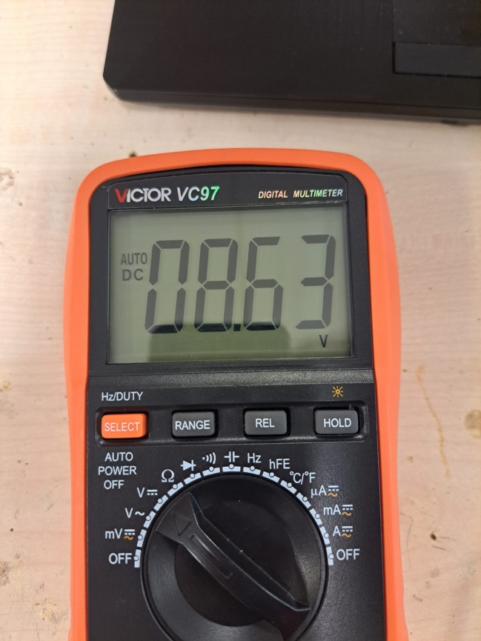

(a) (b)

Fig. 6: Line Regulation condition

For the first requirement, I used and with the corresponding values that are 470Ω and 680Ω respectively to hold approximately 20mA output current. I have obtained maximum 11 mV change with a 20mA output current between boundaries. Hence, line regulation satisfied.

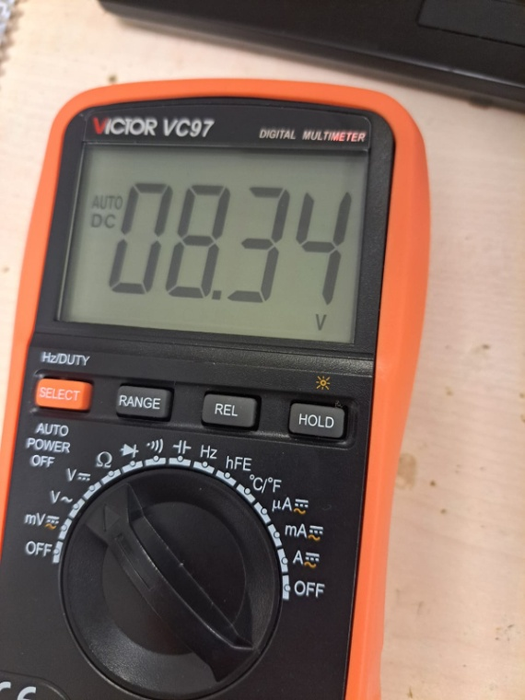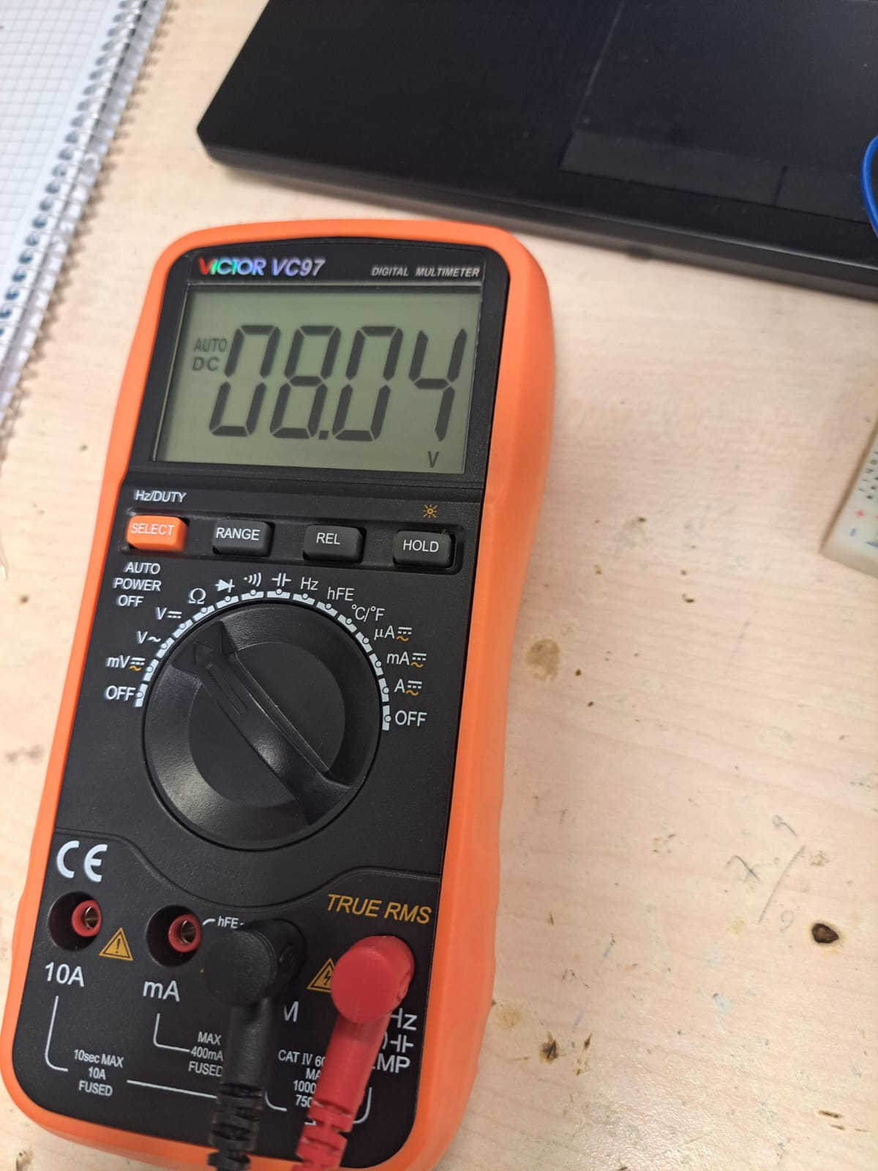

Fig. 7: Load regulation (left one is with and right one is )

As can be seen in Fig. 6, load regulation achieved with no more than 50mV change while output current varying between 5 to 100mA, where . Hence, the circuit works well with loads between 82Ω to 1.5kΩ and output currents 102mA and 5.3 mA respectively. Hence load regulation is satisfied as well.

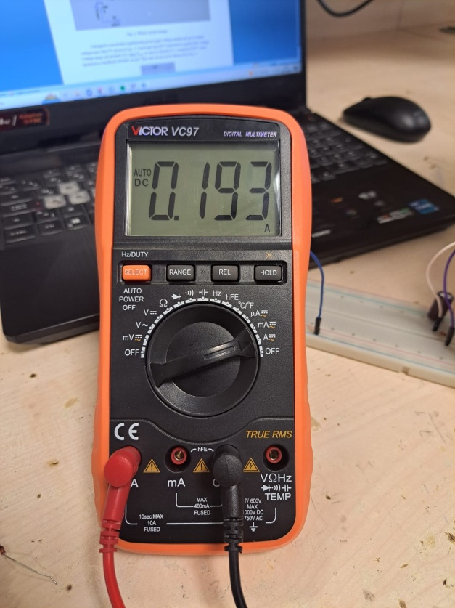

Fig. 8: Output short circuit current

To find short circuit current of the output, I connect multimeter in series between collector terminal of BJT and ground. I observed , which satisfies the third requirement.

As we see in Fig. 4, a green Led turns on when the circuit starts to regulating output voltage. When it is lower than desired value, OPAMP goes low and hence, comparator OPAMP gives low as well. You can see LED turns off when the circuit is out of the regulation stage in Fig. 9. Fourth requirement satisfied in this sense.

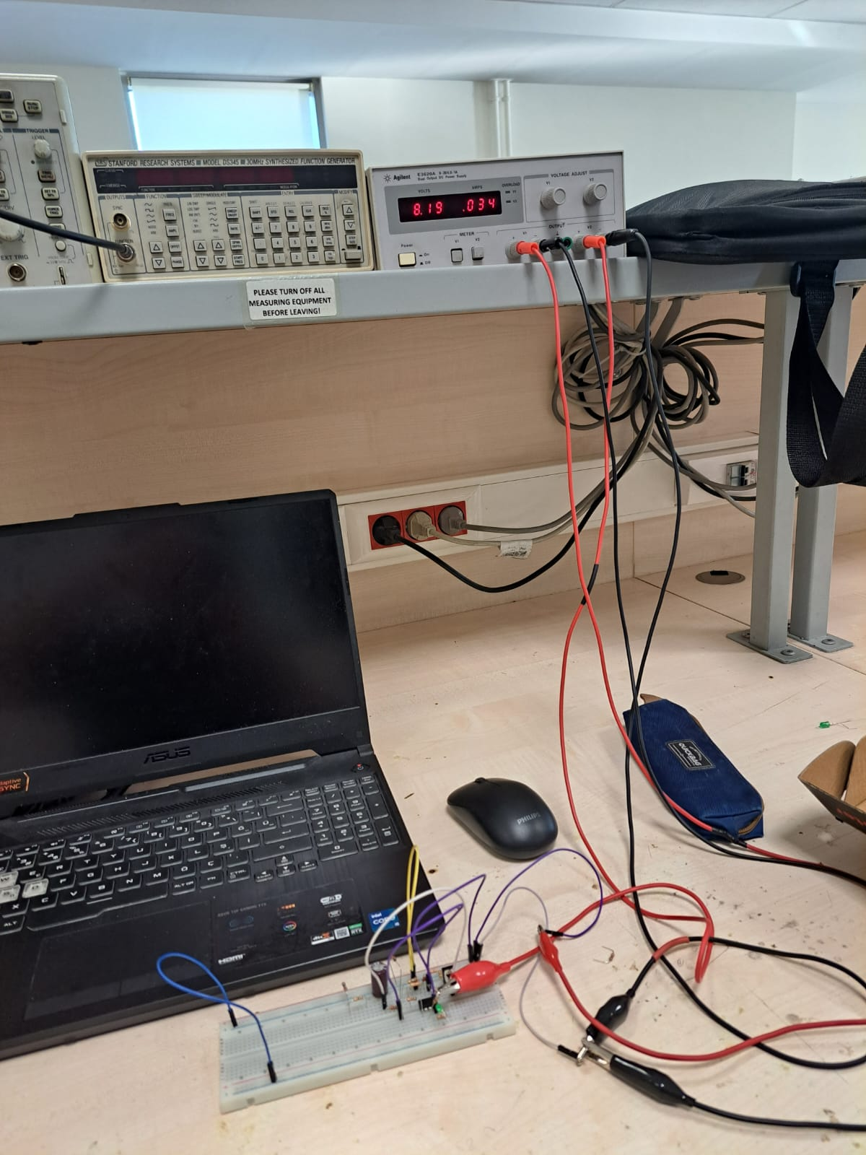

Fig. 9: When

From the datasheet of BD136, I find the junction to ambient thermal resistance , junction to case thermal resistance , and the maximum junction temperature . Formulas for the and are as follows:

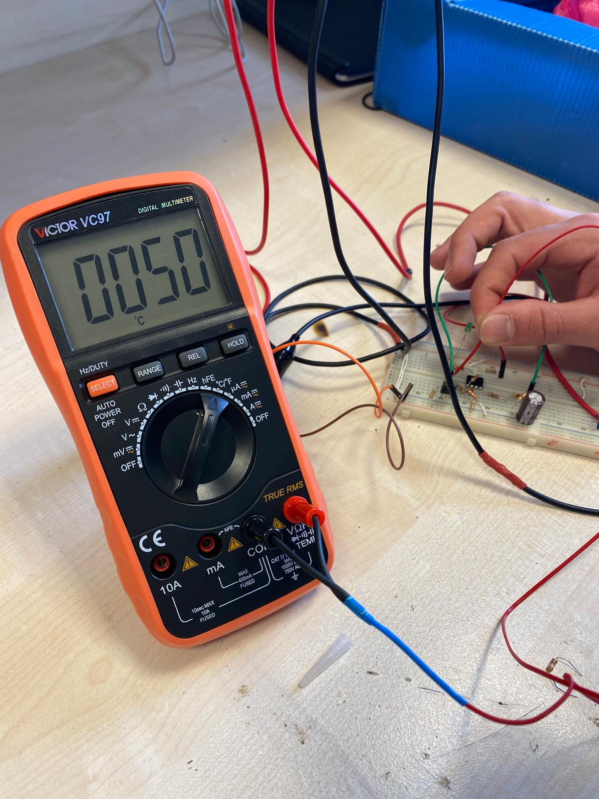

Fig. 10: Circuit without heat sink



Fig. 11: Circuit with heat sink

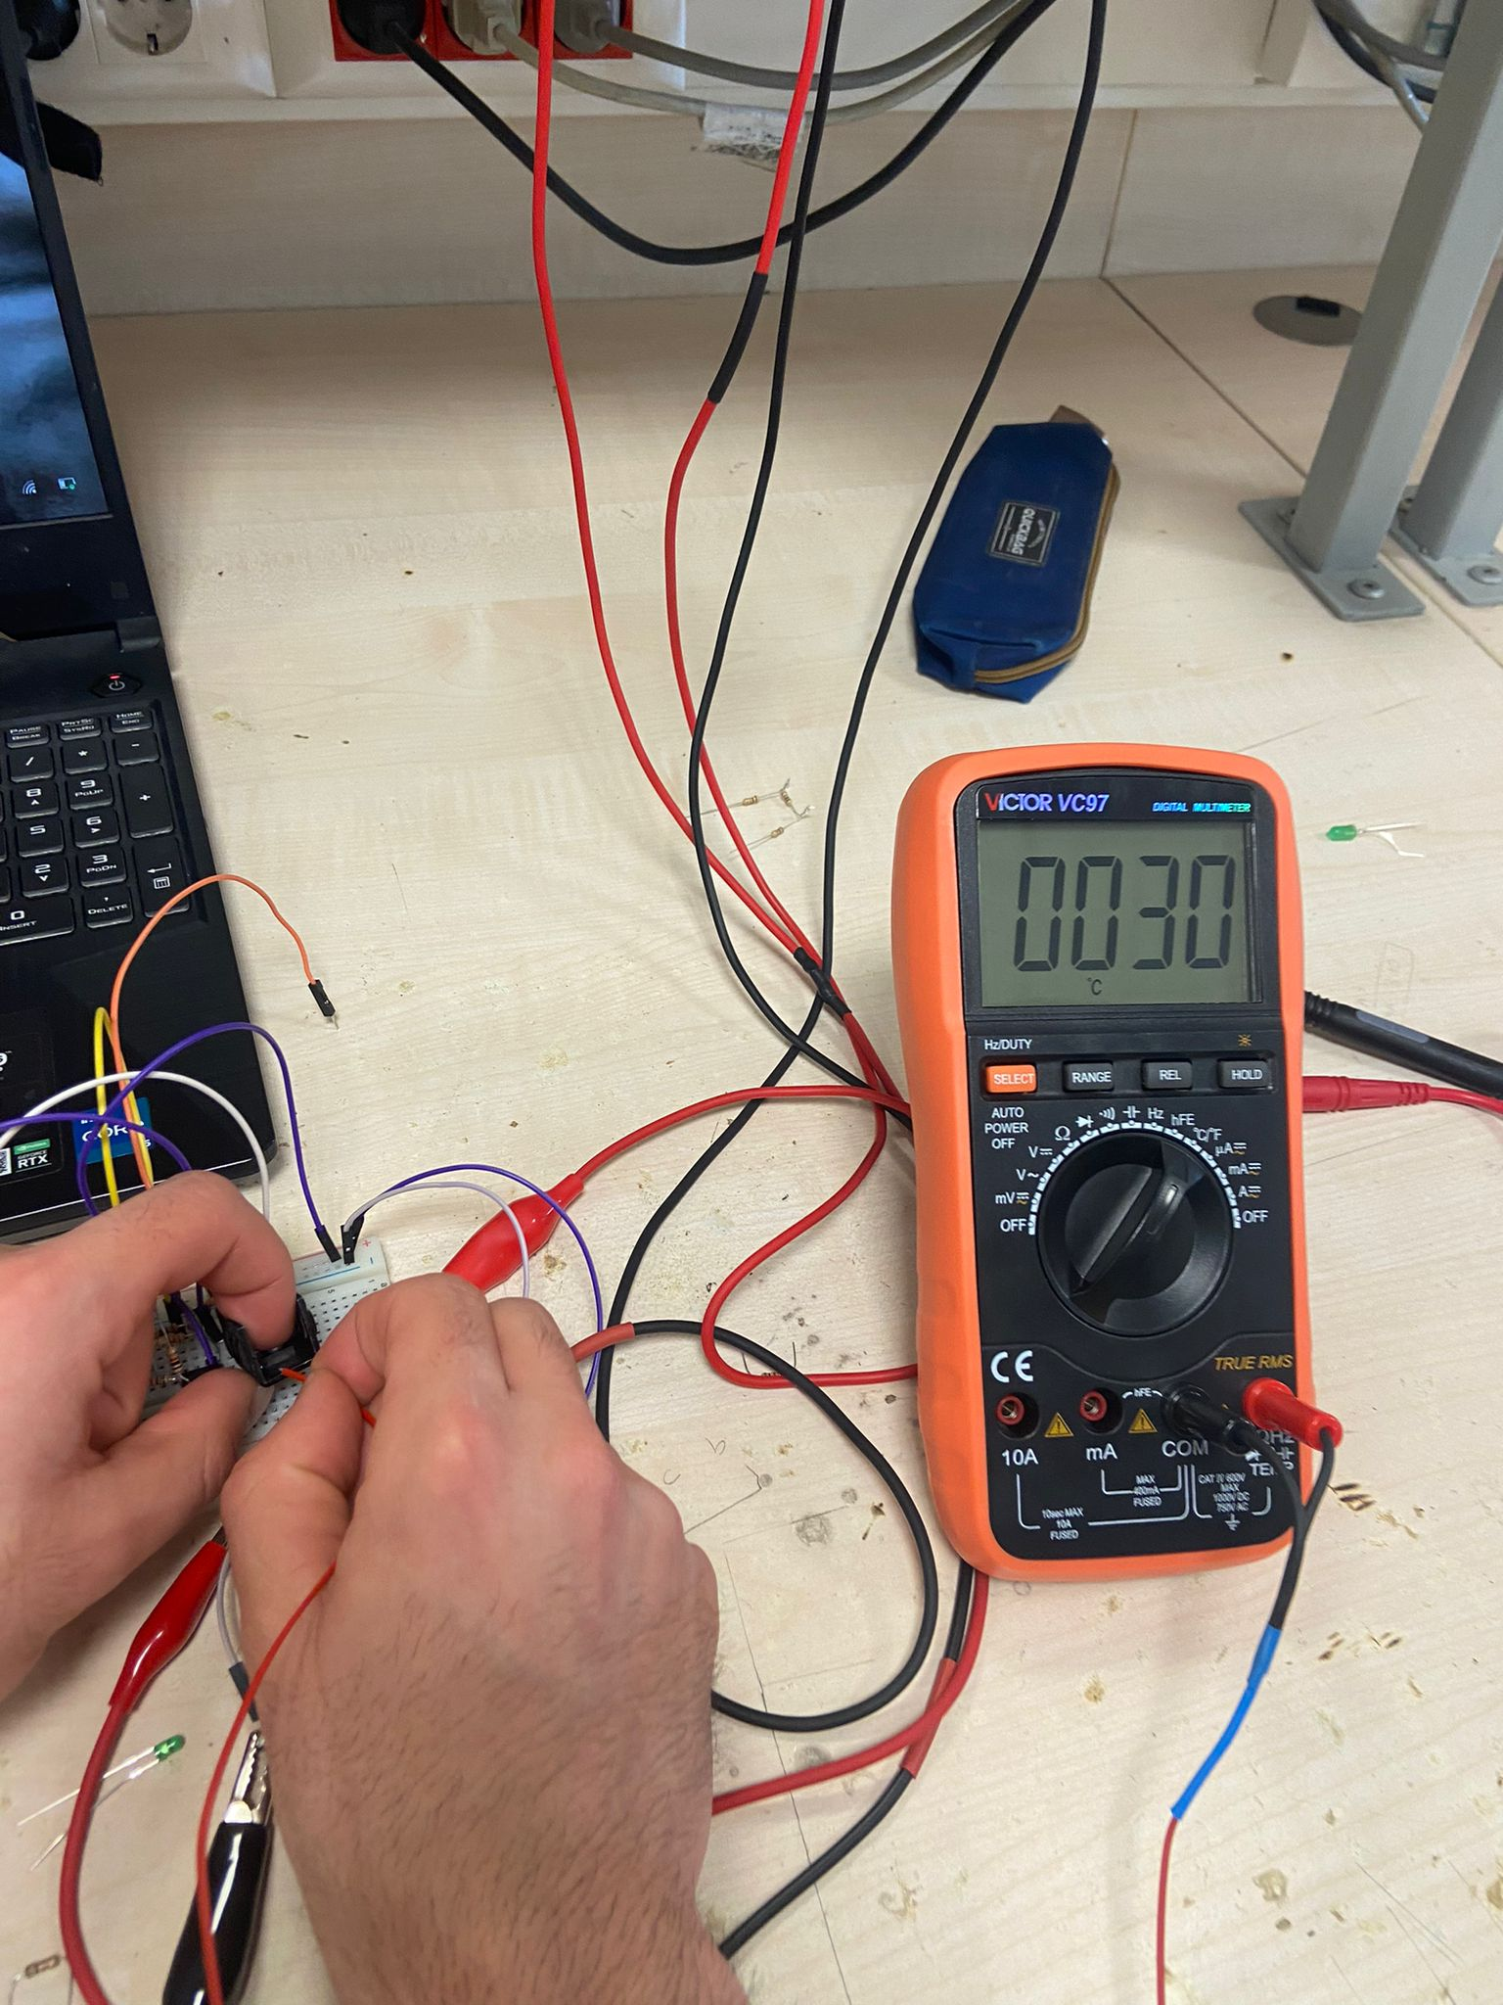

Fig. 12: Measured temperature with 3.3Ω resistor with heat-sink (nearly short-circuit current)

While the circuit draws high amount of current (short-circuit current or similar) BJT gets hotter. As seen in Fig. 10, it has a temperature is 50°C where theoretical calculations expect 51.4°C. To protect BJT from high temperature while low-valued load resistors connected to circuit, I used heat-sink. Heat-sink cools down the BJT with its large surface area and high thermal conductivity. As shown in Fig. 12, BJT’s temperature is 30°C while 3.3Ω load resistor connected.  
 The experiment's goal aim is to build a Low-Dropout Voltage Regulator (LDR) with a Zener diode to supply reference voltage, a pnp-type BJT transistor to provide high stable amount of current and an OPAMP to feed-back to BJT. The main objectives were to analyze thermal performance, provide adequate line and load management, measure the BJT's β, and assess short circuit current which are important for a LDR circuit.

Nonetheless, for a variety of reasons, errors occurred at various stages of the process. Among these were potential errors in the breadboard and component values, which could cause connectivity issues. Furthermore, the values in the lab experiment deviate considerably from those in the simulation since the setup and components are not optimal for obtaining the desired values. Furthermore, several of the simulation's components are not in optimal condition when compared to those used in the experiment.

The developed LDR circuit successfully met the requirements for LED indication, short-circuit current, line and load regulation. With the extra heat-sink implementation, the thermal management kept the BJT operating within safe temperature ranges. This experiment allowed us to better grasp how BJT and Zener diodes work in circuits.