EE-313 Lab Preliminary Report 2

Bilge Kaan Ateş

February 26, 2024

1. **Introduction:**

Aims of this lab are designing a simple circuit to find β value of a pnp-type BJT transistor and designing a low-dropout voltage regulator (LDR) with pnp-type BJT as a regulator, an OPAMP to provide feedback and a Zener diode to obtain a reference voltage with an output current 100mA. We are allowed to choose an output voltage of 7, 8 … ,12V. Specifications are as follows:

1. Line regulation: When $V_{in}$ is between $V_{out}+0.7$ to $V_{out}+ 6$, the output voltage, $V_{out}$, changes by no more than 10mV when the output current is 20mA,  
    ( $R_{L}=\frac{V_{out}}{0.02}$).
2. Load regulation: When $V_{in}=V_{out}+2$, the output voltage, $V_{out}$, changes no more than 50mV when the output current changes between 5mA and 100mA ( $R_{L}$ is varied between $\frac{V_{out}}{0.005}$ to $\frac{V_{out}}{0.1}$)
3. An output short circuit current of smaller than 250mA when $V_{in}=V_{out}+0.7$.
4. A green LED should turn on if the regulation is achieved. Otherwise, it should turn off, for example, because the input voltage is too low or the output current is too high.
5. Zener diode should not dissipate more than 100mW.
6. From the datasheet of BD136, find the junction to ambient thermal resistance ($R_{θJA}$), junction to case thermal resistance ($R_{θJC}$), and the maximum junction temperature ($T_{Jmax}$). Estimate the junction temperature ($T_{J}$) and case temperature ($T_{C}$) of BD136 when $V_{in}$ is 3V greater than $V_{out}$ and when a load resistor is connected at the output, drawing a current of 80mA. Assume that the ambient temperature is $T_{A}=25°C$.

1. **LTspice Implementation:**
   1. **β Measurement method:**

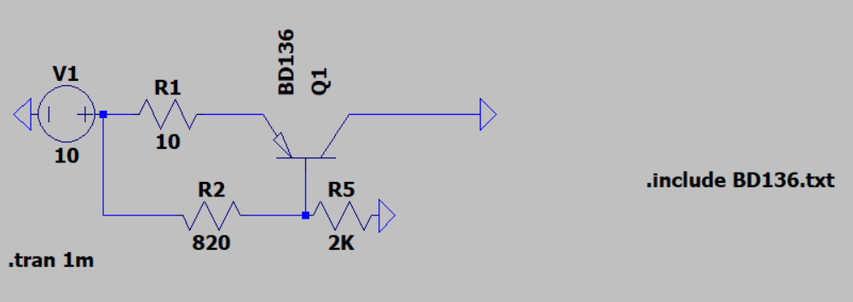

Fig. 1: $β$ measurement circuit

For the first part, I designed a basic circuit shown in Fig. 1. In order to measure β, one should use BJT in active region. For the correct biasing the pnp-type BJT conditions are as follows:

$V_{EB}>V_{th}$, $V_{EC}>V_{sat}$ (1)

Hence, I connect collector to ground and measured the collector current and base current as shown in Fig. 2. I calculated β of BD136 class BJT with the below formula:

$$β=\frac{I_{C}}{I_{B}}=\frac{162.3}{0.867}≈187$$

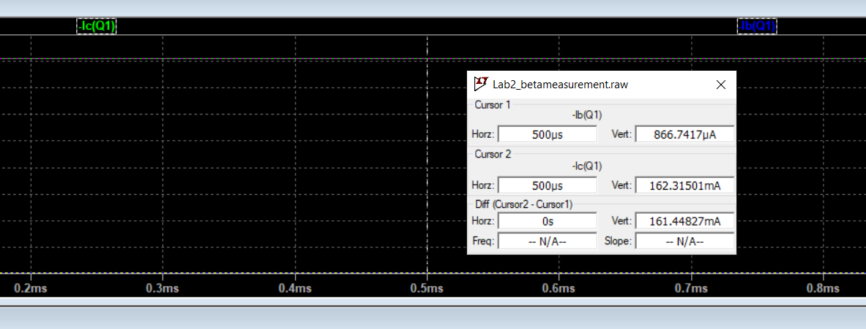

Fig. 2: Collector and base currents of the circuit in Fig. 1

* 1. **Low-Dropout Voltage Regulator Design:**

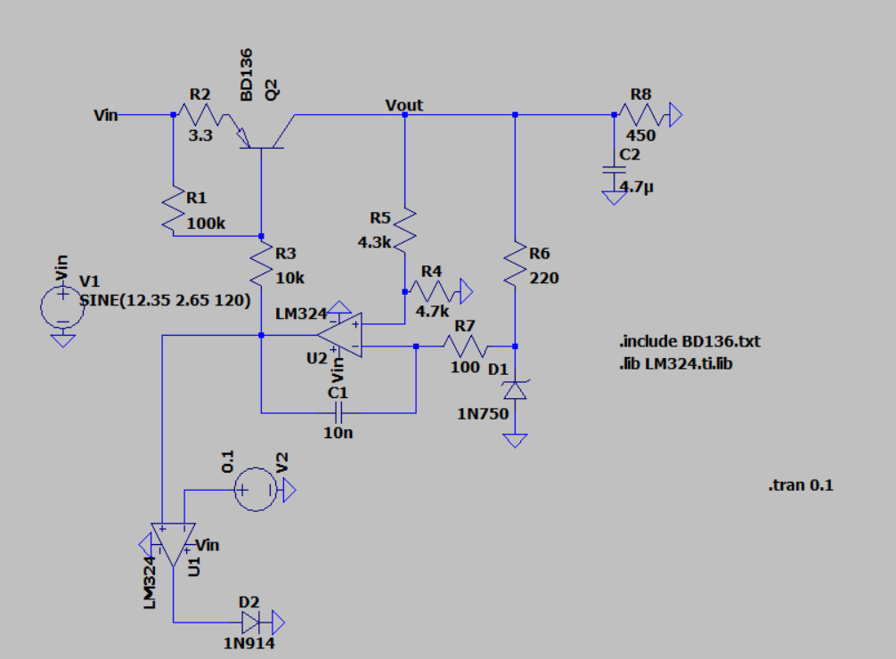

Fig. 3: Whole circuit design

I designed a circuit that regulates the given input voltage and do not gives output voltage more than 9V given in Fig. 3. I used pnp-type BJT transistor to regulate the voltage. Voltage drops out around 0.3V since $V_{sat}$, as seen in formula (1). I connected BJT’s base terminal to a feedback OPAMP circuit. That sub circuit can be observed in Fig. 4.

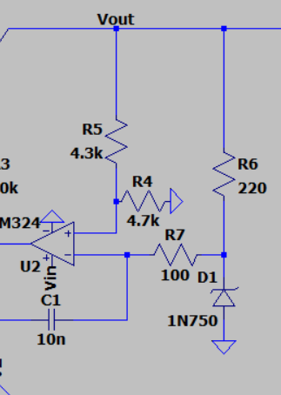

Fig. 4: Feedback circuit

In this feedback circuit, I connect a reverse-biased Zener diode to inverting input of OPAMP since to obtain a reference voltage. 1N750 zener diode has 4.7 breakdown voltages. Increasing the series resistor value (R6) to this Zener diode reduces the breakdown voltage since the current goes through it reduces. I used a voltage divider to connect the non-inverting input of OPAMP to necessary voltage 4.7. I chose 9V output voltage, therefore, I used 4.3k and 4.7kΩ for this purpose. Whenever the $V_{out}$ exceeds the 9V, OPAMP goes high and keep $V_{EB}$ voltage difference same. Hence, $I_{B}$ and $I_{C}$ remains same as well. I connect non-inverting input to output with a capacitor to avoid instantaneous voltage shifts and hold stability. Same method applied to the output node as well.

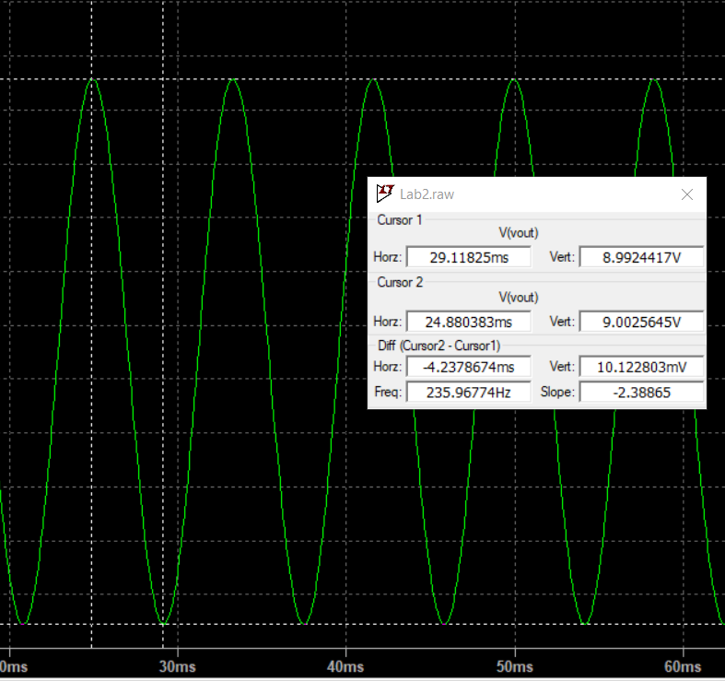 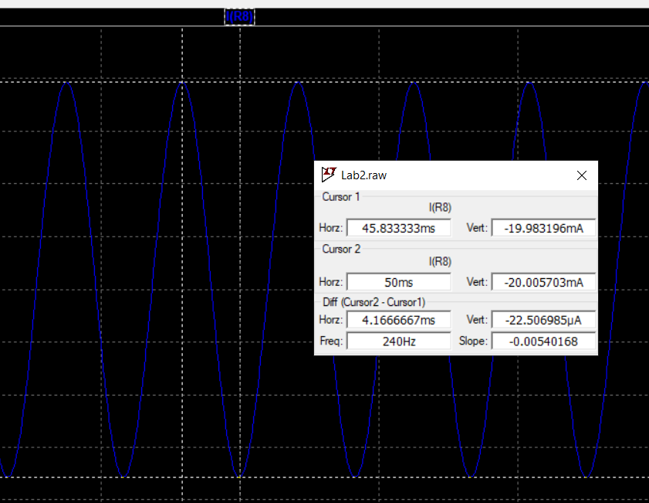

Fig. 5: Line Regulation condition

For the first requirement, I have obtained maximum 10 mV change with 120Hz frequency source with a 20mA output current. This line regulation strongly related with the time constant (τ) of the feedback circuit. Although reducing the time constant of this circuit gives us low voltage difference, it can lead to highly unstable regulator voltage. Therefore, time constant should be chose carefully.

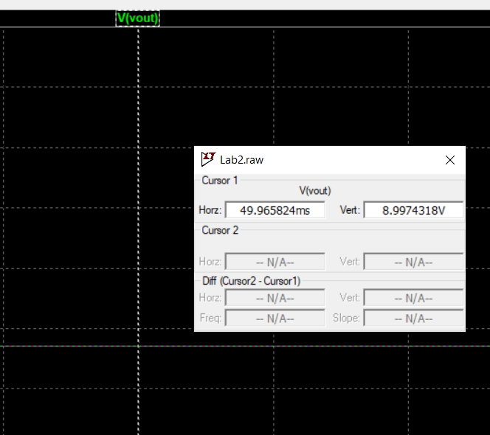 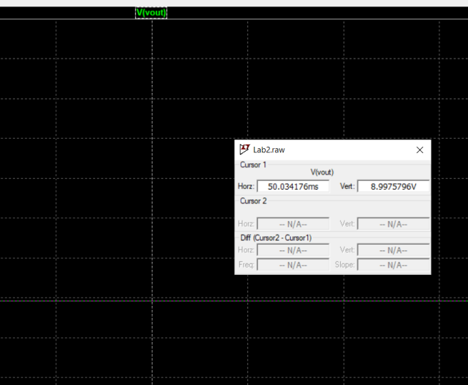

Fig. 6: Load regulation (left one is with $R_{L}=\frac{V_{out}}{0.1}$ and right one is $R_{L}=\frac{V_{out}}{0.005}$)

As can be seen in Fig. 6, load regulation achieved with no more than 50mV change while output current varying between 5 to 100mA, where $V_{in}=V_{out}+2$. Hence, the circuit works well with loads between 90Ω to 1800Ω.

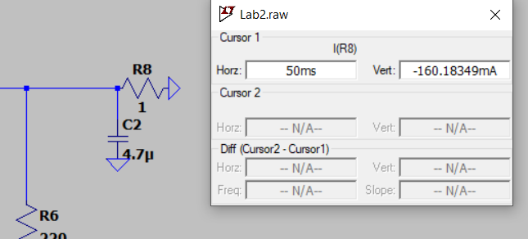

Fig. 7: Output short circuit current

To find short circuit current of the output, I put 1Ω resistor and measured

$I_{out}=160mA<250mA$, which satisfies the third requirement.

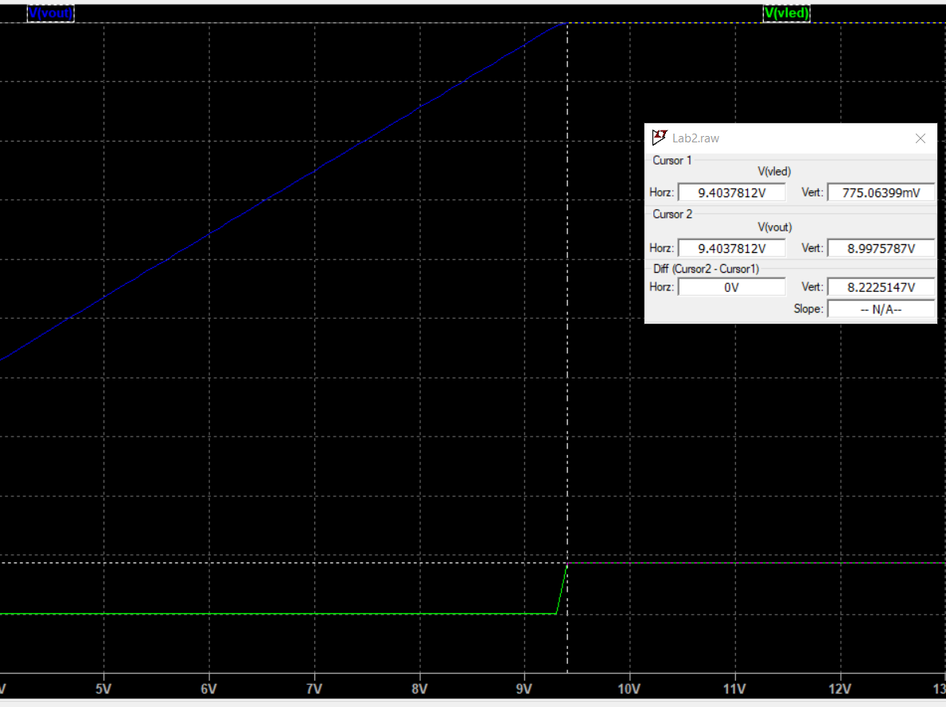

Fig. 8: Led indicator of regulation

As we see in Fig. 8, a green Led turns on when the output voltage reaches to its maximum. When it is lower than desired value, OPAMP goes low and hence, comparator OPAMP gives low as well. Fourth requirement satisfied in this sense. Zener diodes power dissipation is shown in Fig. 9. It is less than 100mW so fifth requirement satisfied as well.

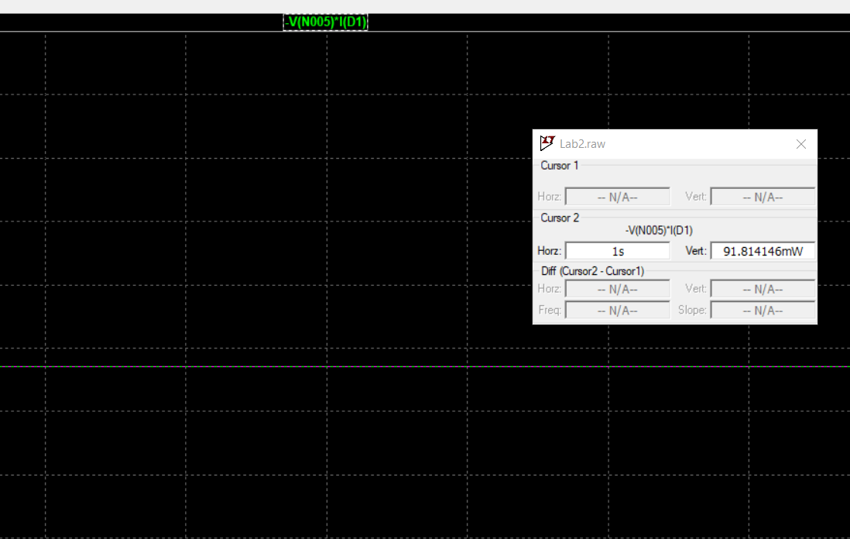

Fig. 9: Power dissipation of Zener diode

From the datasheet of BD136, I find the junction to ambient thermal resistance $R_{θJA}=100C°/W$, junction to case thermal resistance $R_{θJC}=10C°/W$, and the maximum junction temperature $T_{Jmax}=150 C°$. Formulas for the $T_{J}$ and $T_{C}$ are as follows:

* 1. **Diptrace Schematic:**

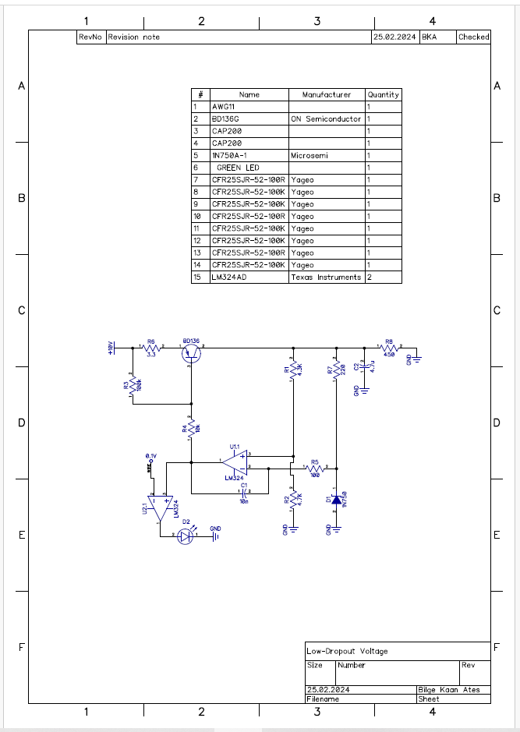

Fig. 10: Diptrace Schematic