EE-313 Lab Experimental Report 3

Bilge Kaan Ateş

March 31, 2024

1. **Introduction:**

Aims of this lab are designing a simple Push-Pull Class B Amplifier which is able to deliver at least 2.25W power to a 8.2Ω resistive load. Up to 9V supply voltages are allowed. We are allowed to choose an gain ratio of from 15dB to 25dB. Specifications are as follows:

1. The amplifier should deliver at least a 2.19W power to an 8.2Ω resistance (12  to an 8.2Ω power resistor) starting from 10Hz to 40KHz at the chosen gain value.
2. The harmonics (the highest is possibly the third harmonic) at the 2.25W output power level should be at least 40 dB lower than the fundamental signal at 1 KHz.
3. The power consumption at quiescent conditions should be less than 500mW. ;
4. The amplifier's overall efficiency (output power/total supply power) should be at  least 45% at max power output at 1KHz.
5. **LTspice Implementation:**
   1. **Implemented Circuit:**

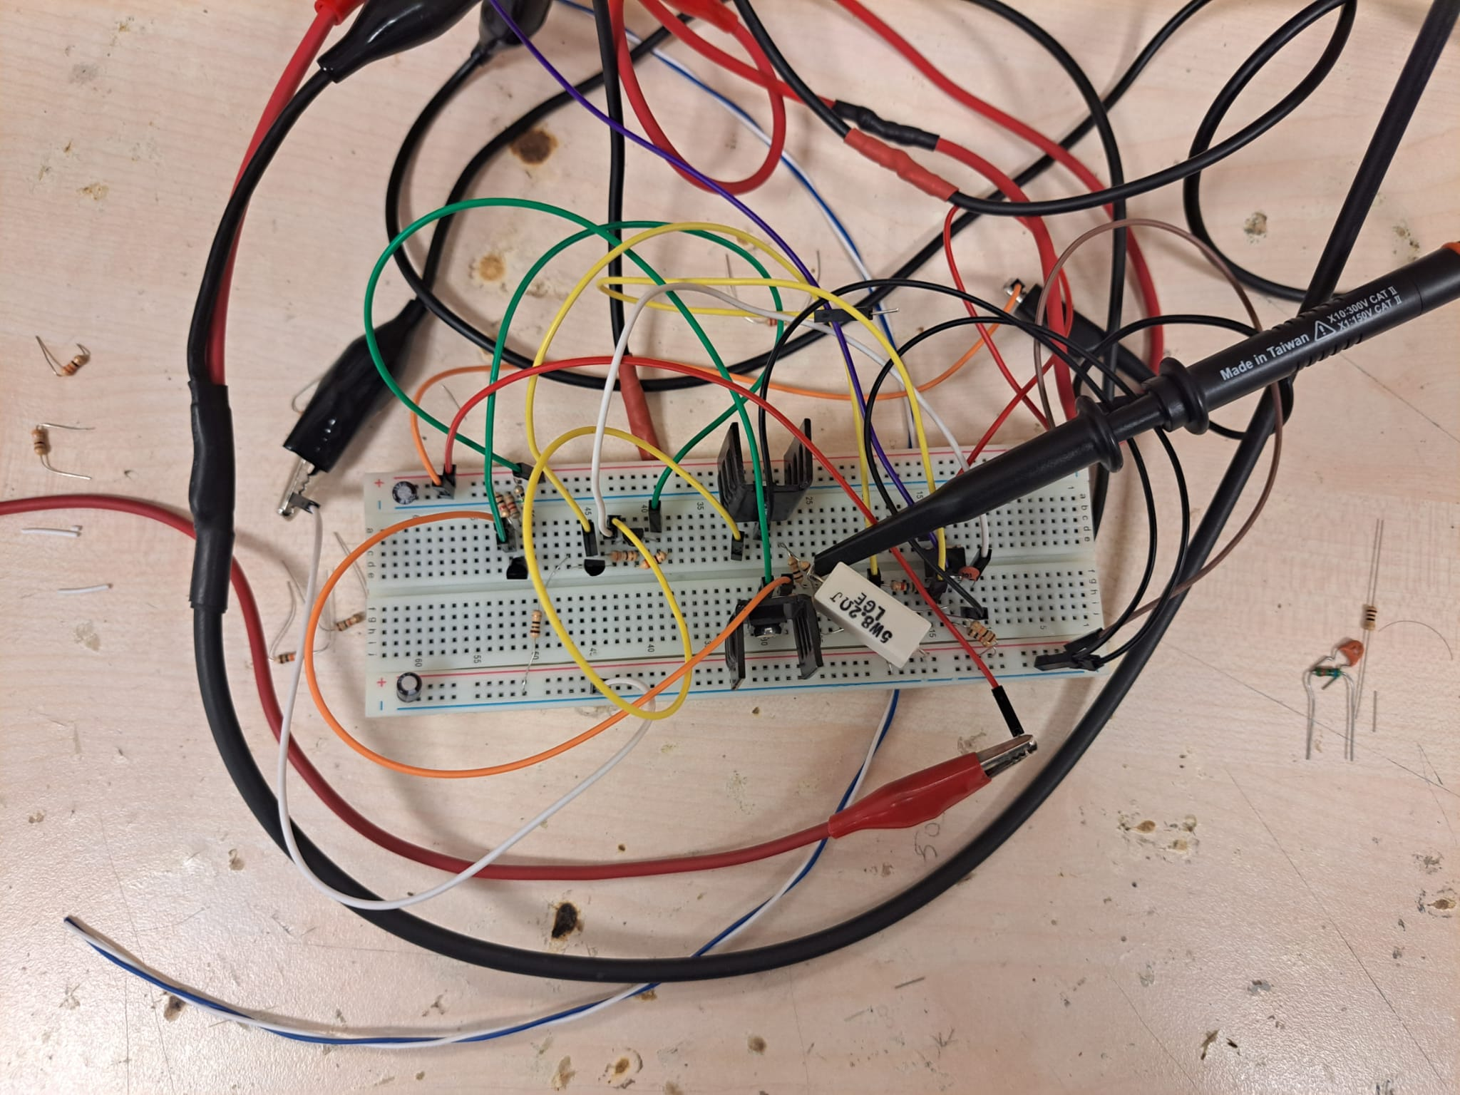

Fig. 1: Implemented Circuit

I used two supply source where one of them provides +9V and the other one provides -9V. I chose this supply range for operating with both push and pull BJT transistor topologies and avoid from necessity of high valued capacitor DC block capacitor between output of the amplifier and load resistor.

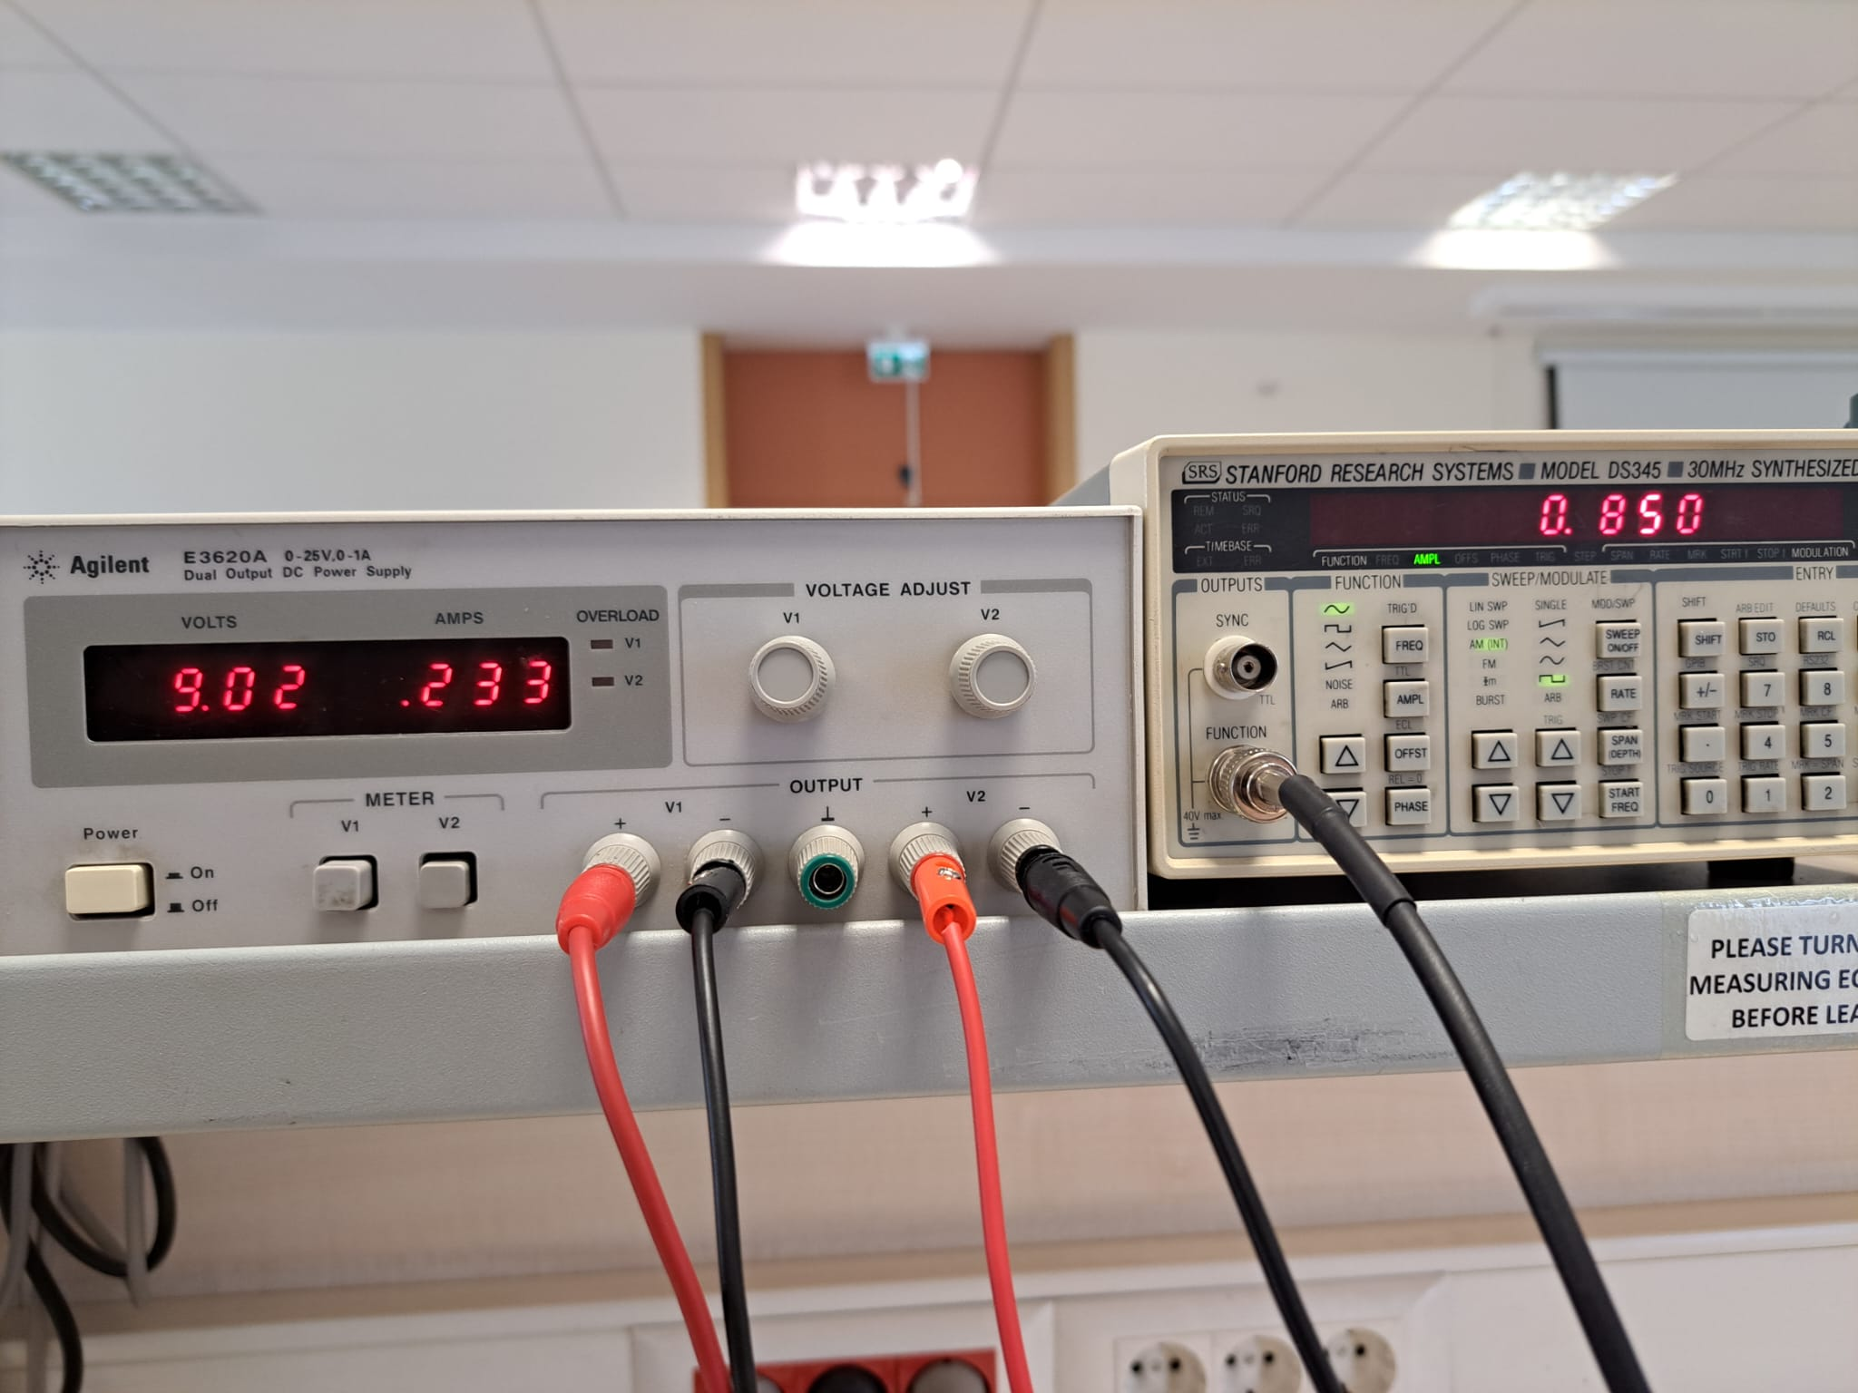

Fig. 2: Currents drawn from power supply

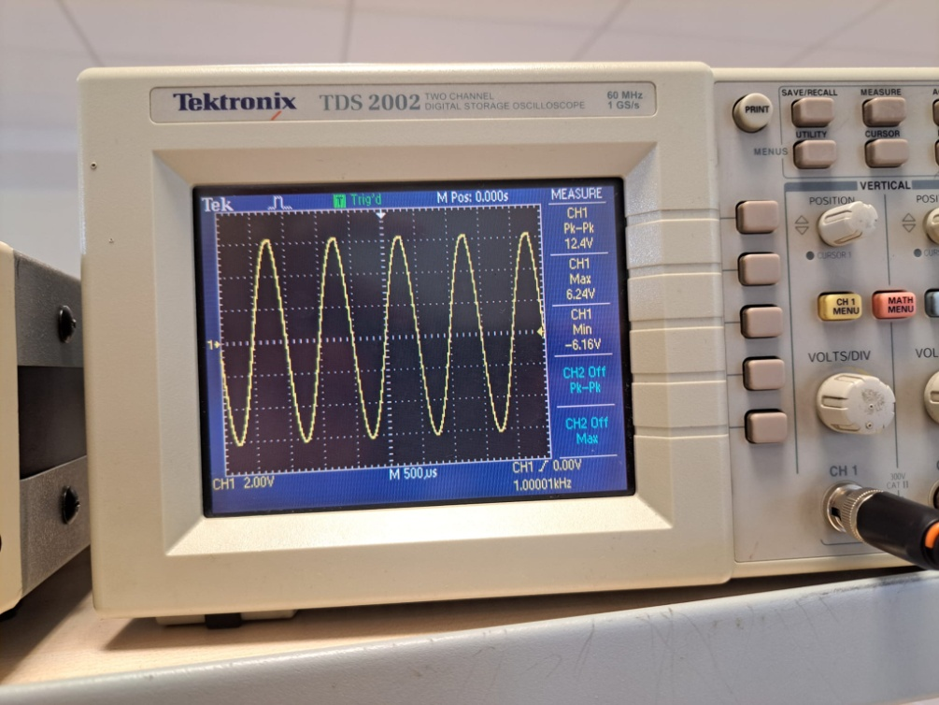

Fig. 3: of the load

As seen in Fig. 2, at high input level, current drawn from the power supply is 233mA and input voltage which is equal to 0.85V. From Fig. 3, we see the output voltage which is 12.4V peak to peak. Gain, source power, output power and the efficiency can be calculated as below:

Source power is multiplied by two since I used two equivalent sources.

Hence, fourth condition is satisfied.

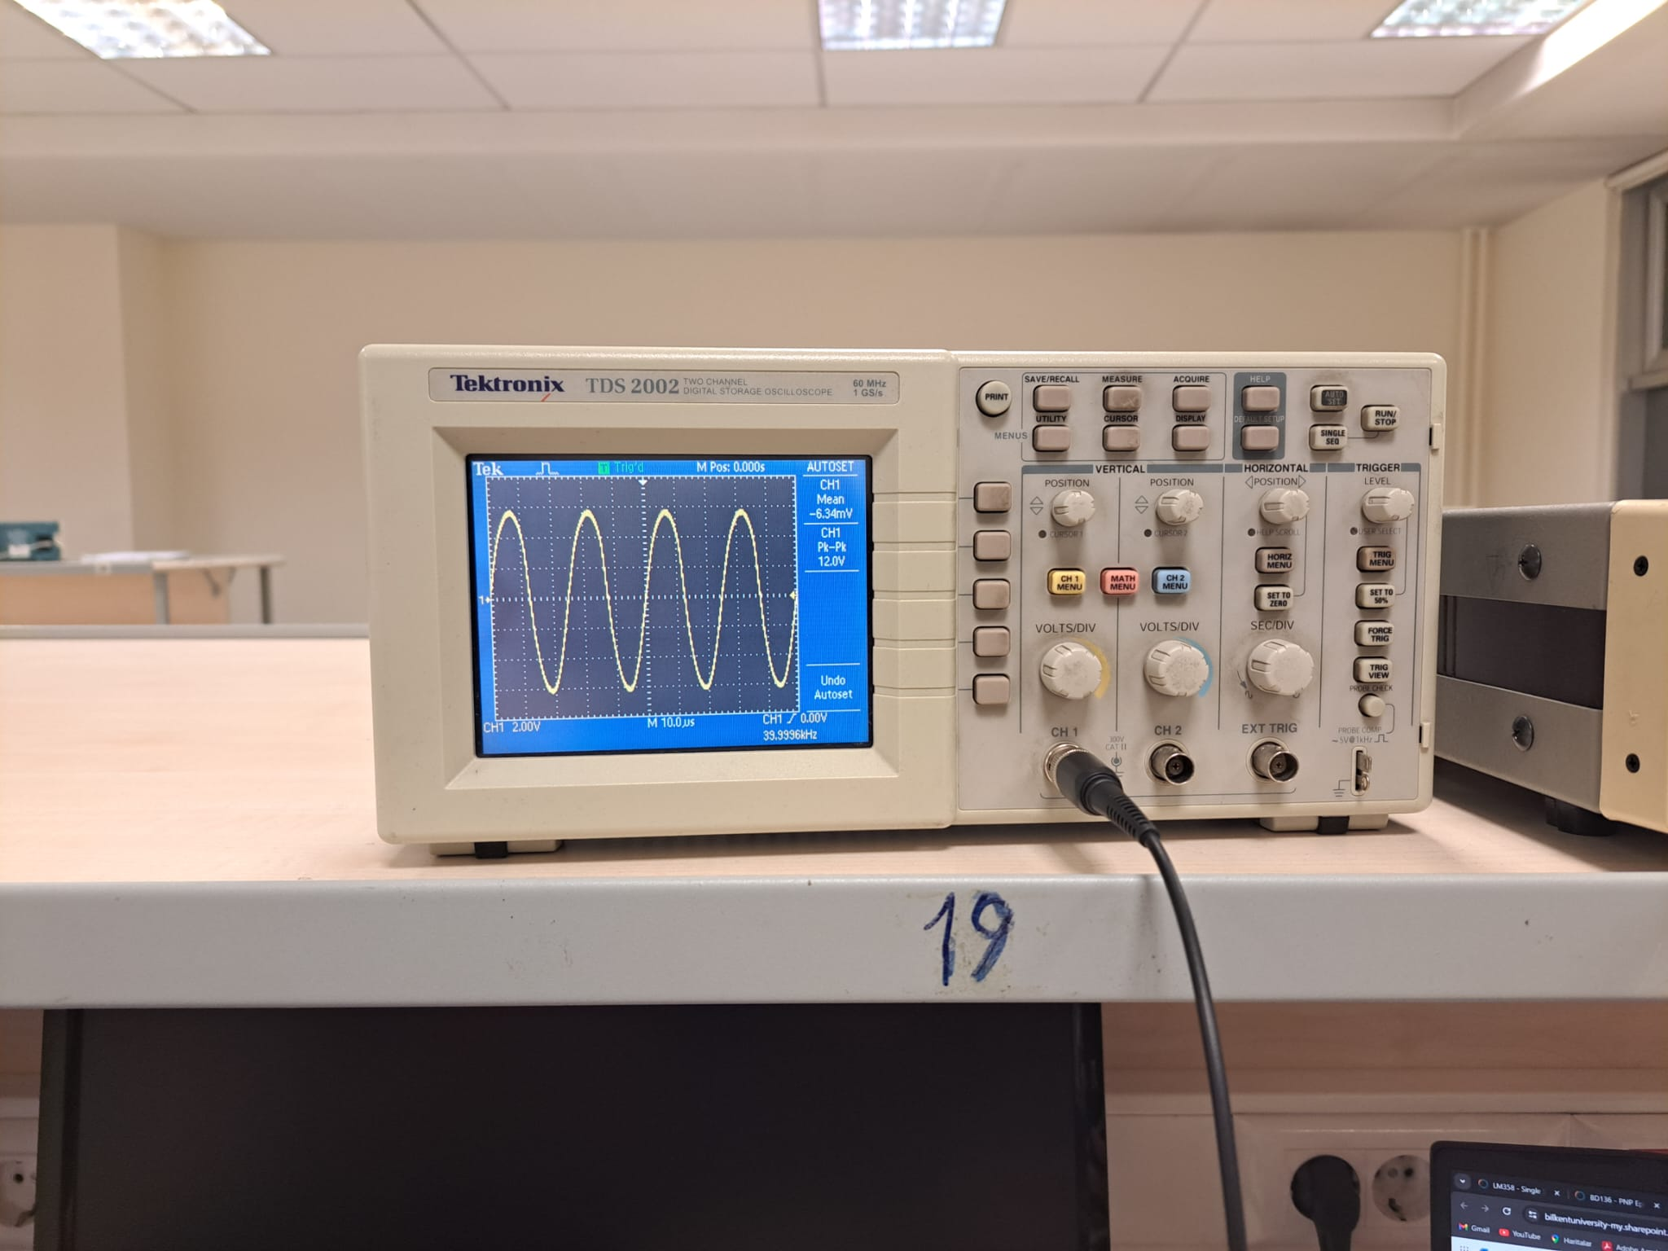

(a)

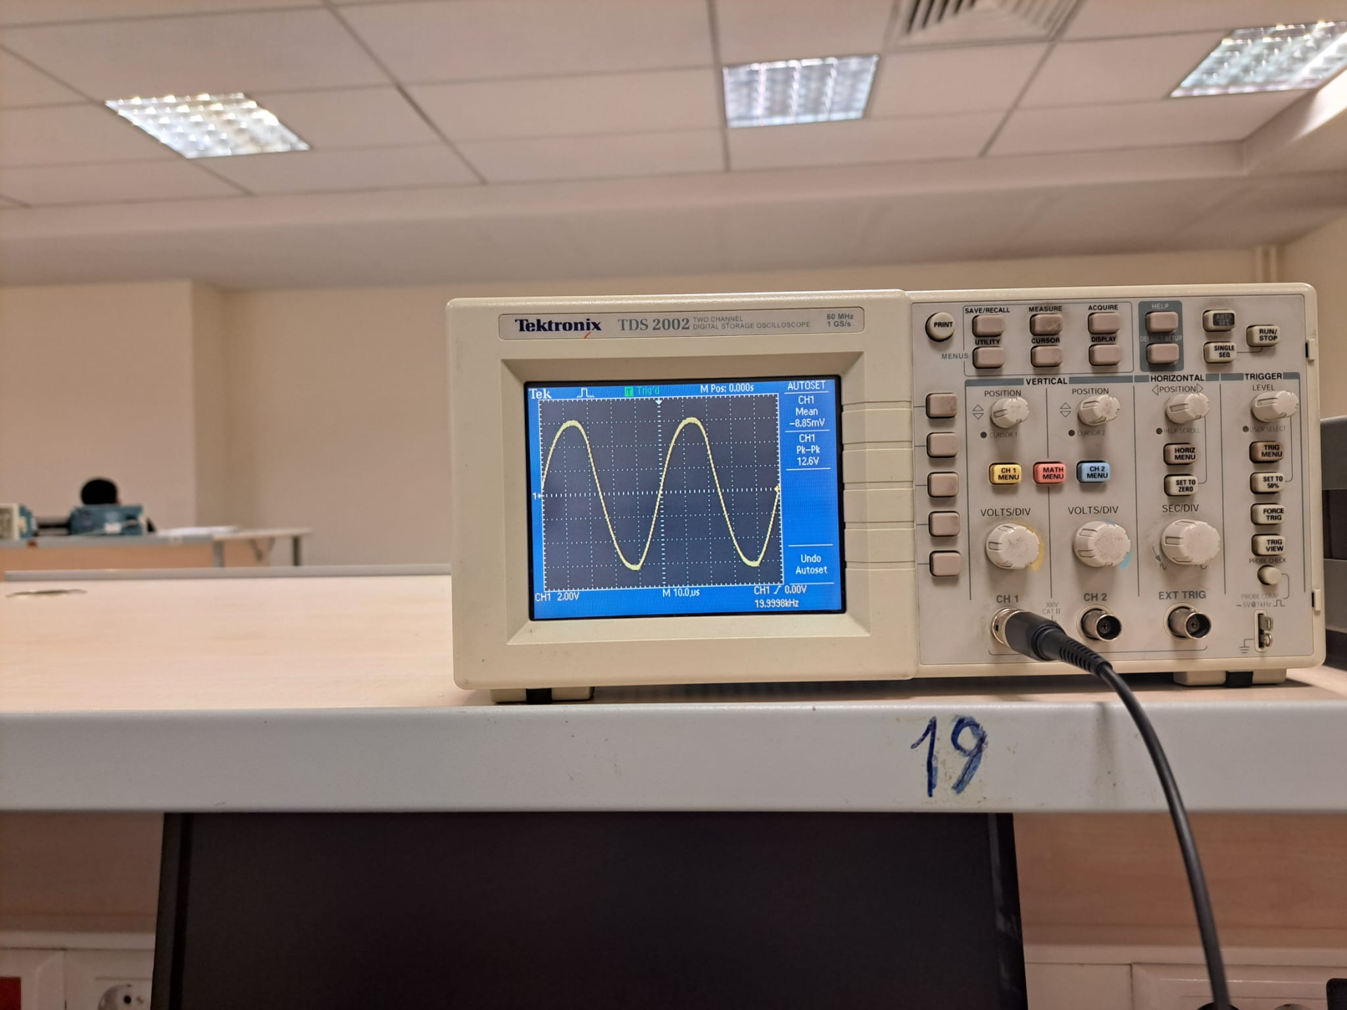

(b)

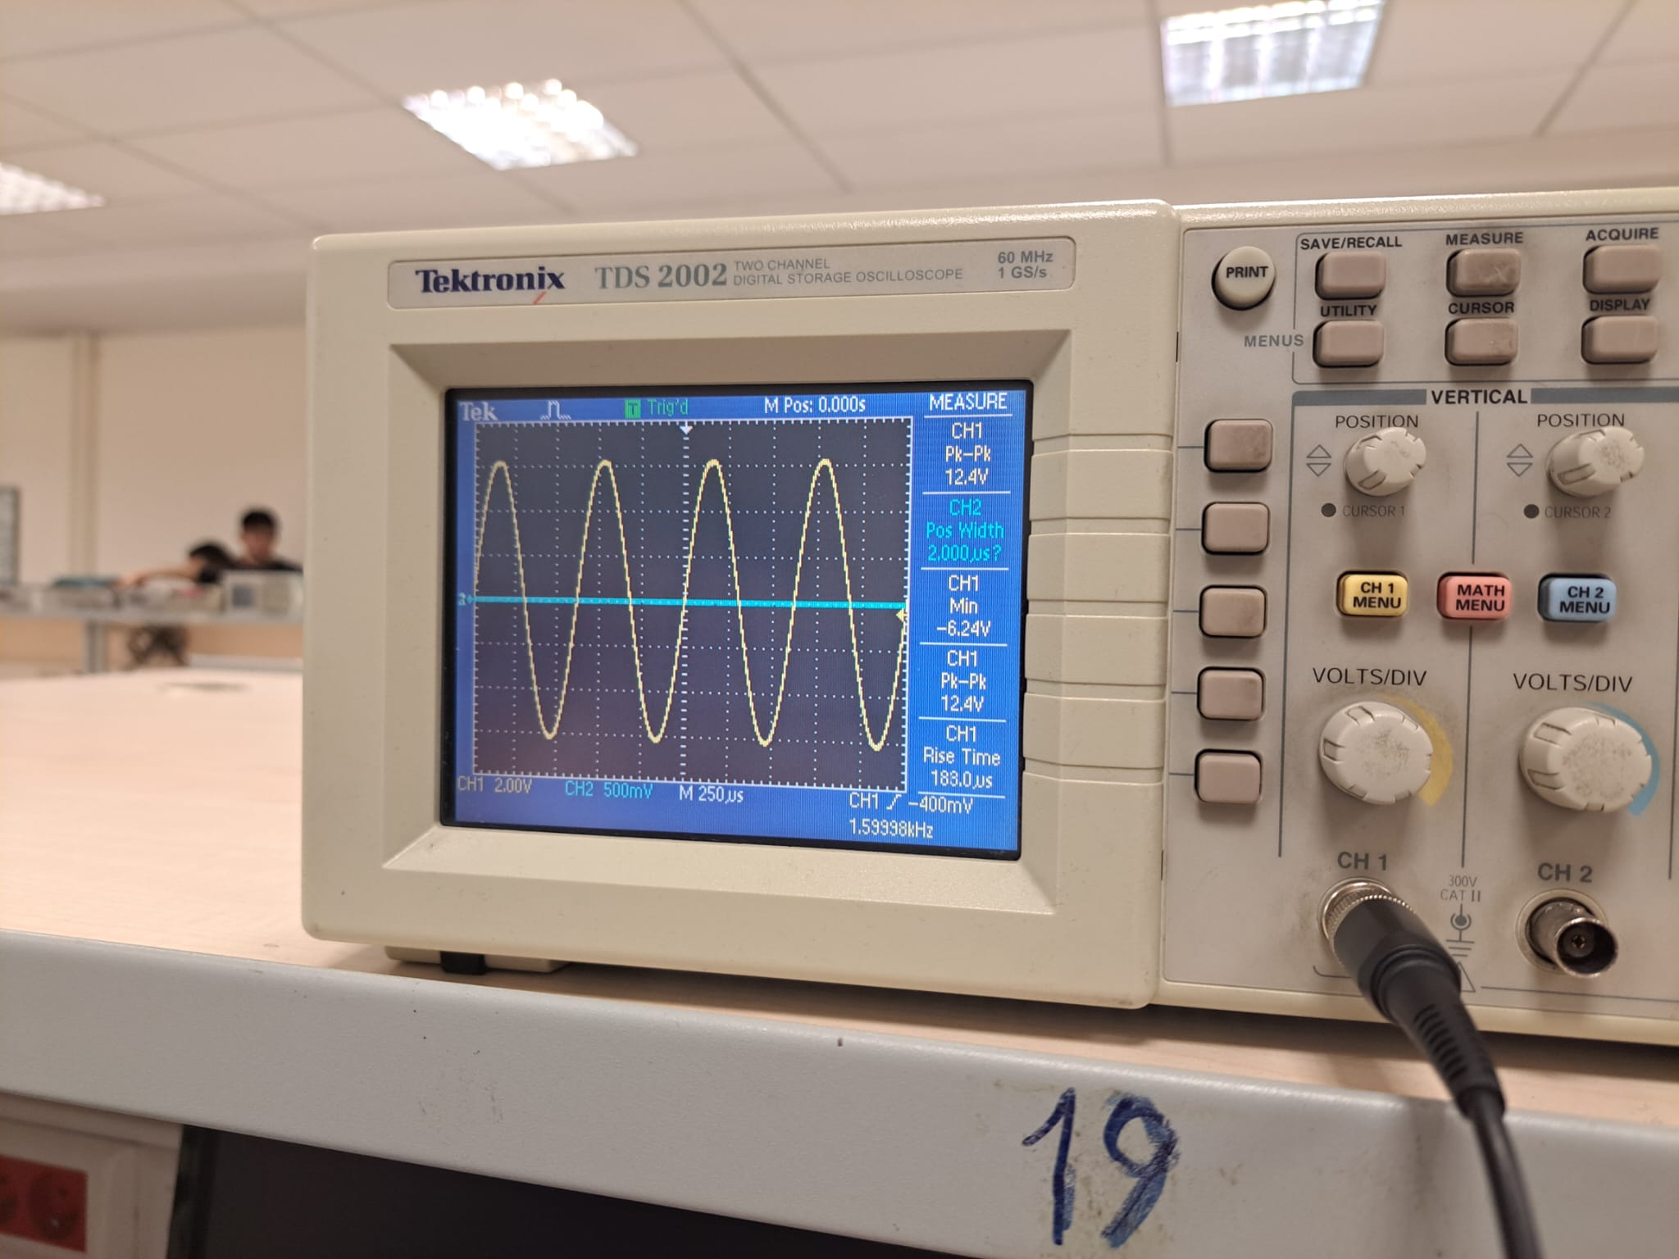

(c)

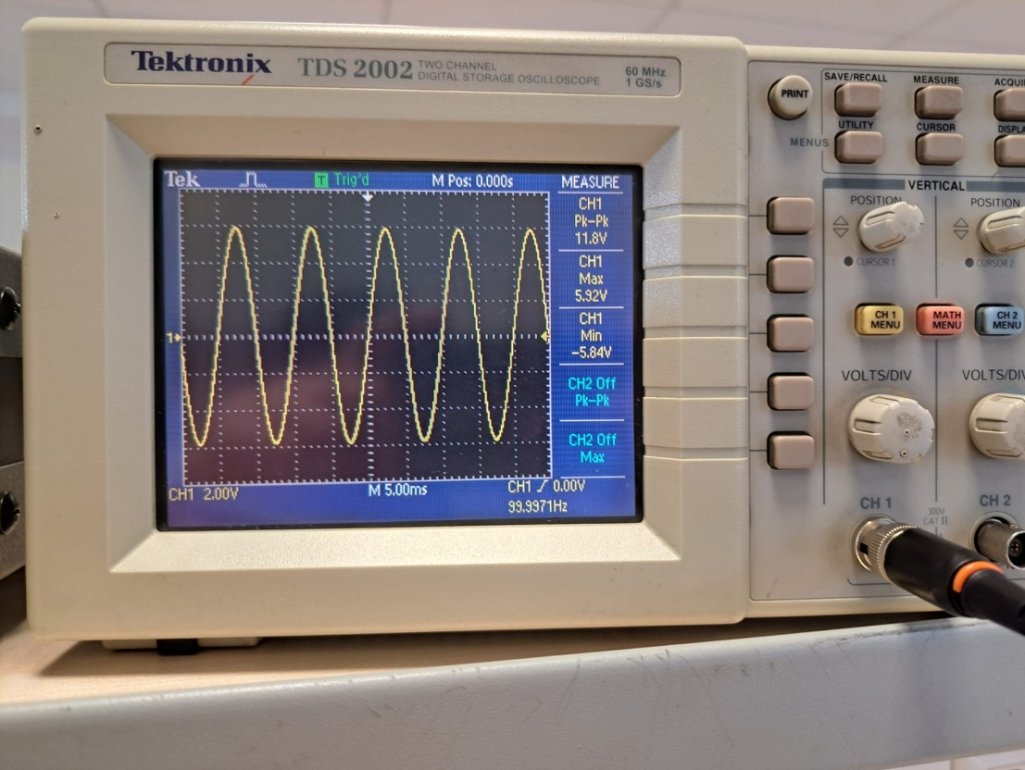

(d)

Fig. 4: Output power for f = 40k, 20k, 1.5k, 100 Hz

As we see in Fig. 4, the output power is greater than 2.19W as desired in the requirements except for f = 10Hz and 100Hz where output power is 2.15W. Thus, there is a slight difference with error rate 1.8%.This condition is achieved for frequencies that range from 10Hz to 40 kHz. I couldn’t see the 1 dB drop in gain. However, I see the gain drop after 20kHz frequency. Probably it occurs after the 40kHz gain. Therefore, first requirement is satisfied as well. Corresponding gain plot can be observed in Fig. 5.

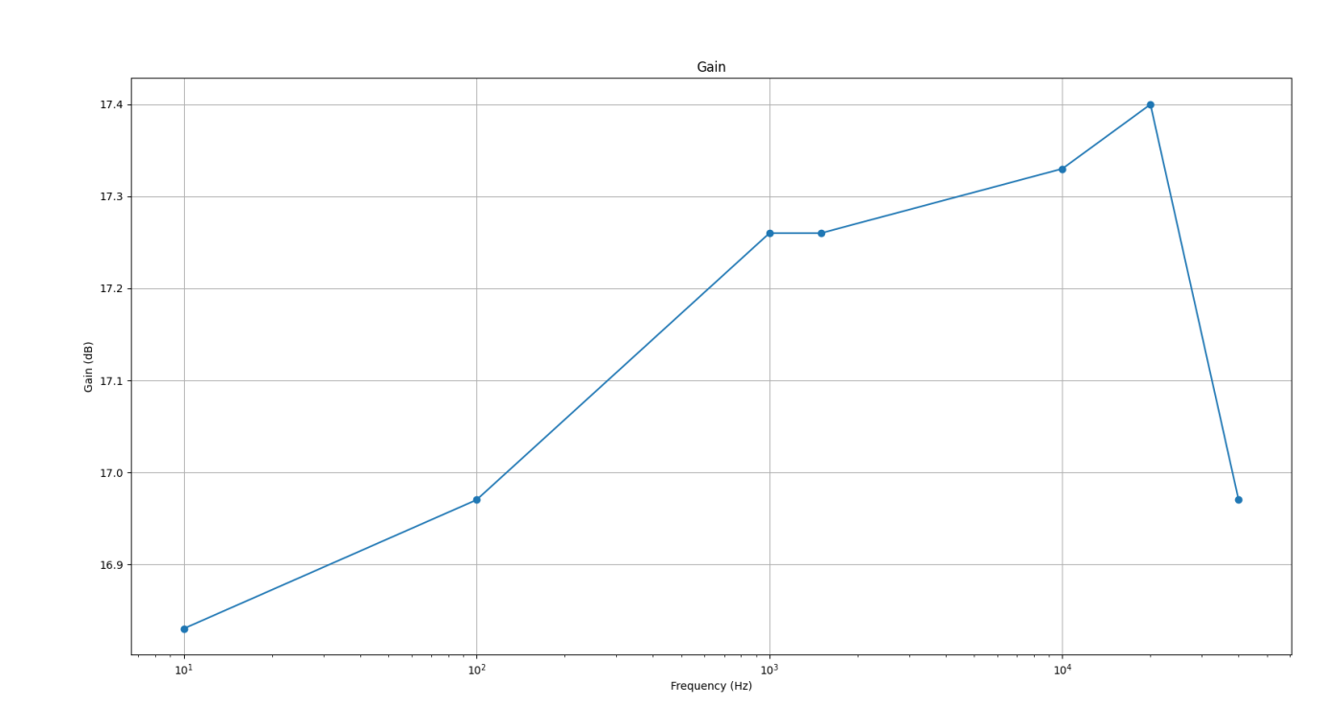

Fig. 5: Gain plot with respect to frequency in a semi-logarithmic plot

Fig. 6 shows the FFT of . As seen in those figures, amplitude-wise difference of harmonics at 1 kHz and 3kHz (the harmonic that has most greater amplitude except the one at 1 kHz frequency) has 44.8 dB ratio which is greater than 40dB. Thus, second requirement satisfied as well.

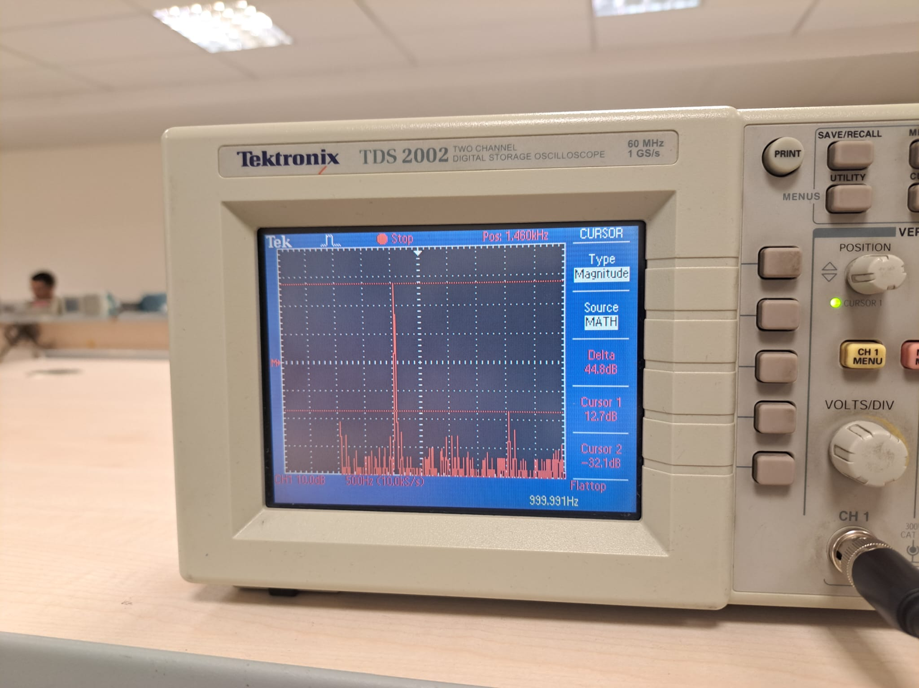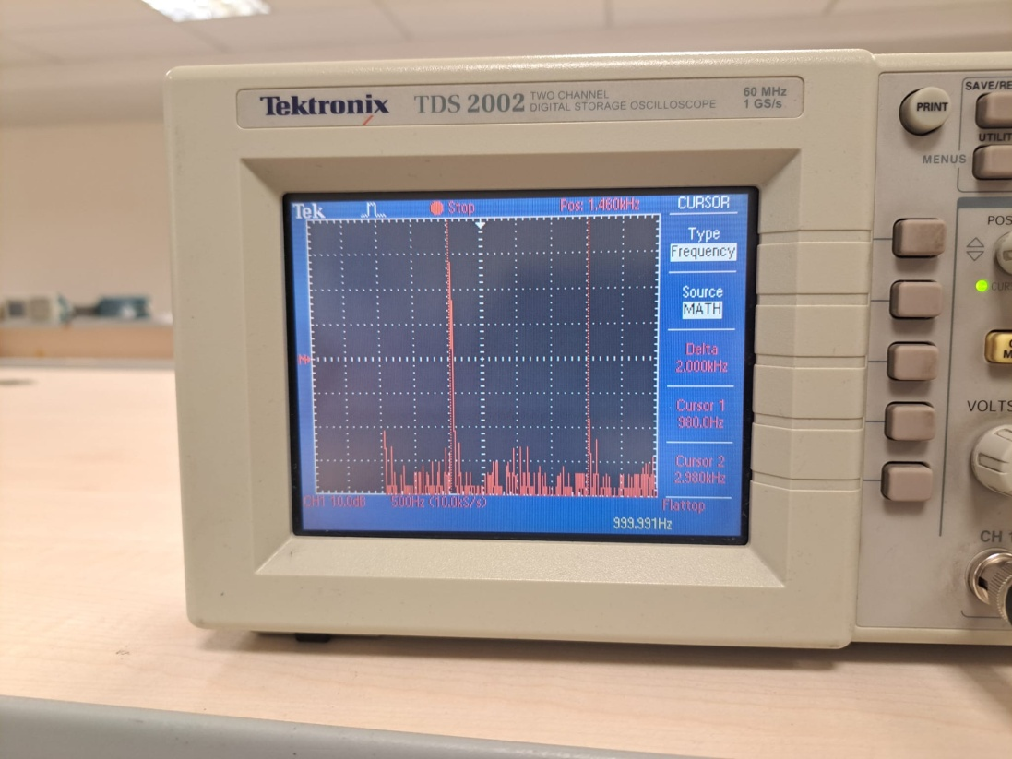

Fig. 6: FFT analysis of the at max power with

For the quiescent condition, I set condition. I obtained the results shown in Fig. 7. I observed the power consumption in this state is approximately 0.487 W which is less than 0.5W as stated in the third requirement. Therefore, that condition satisfied as well.

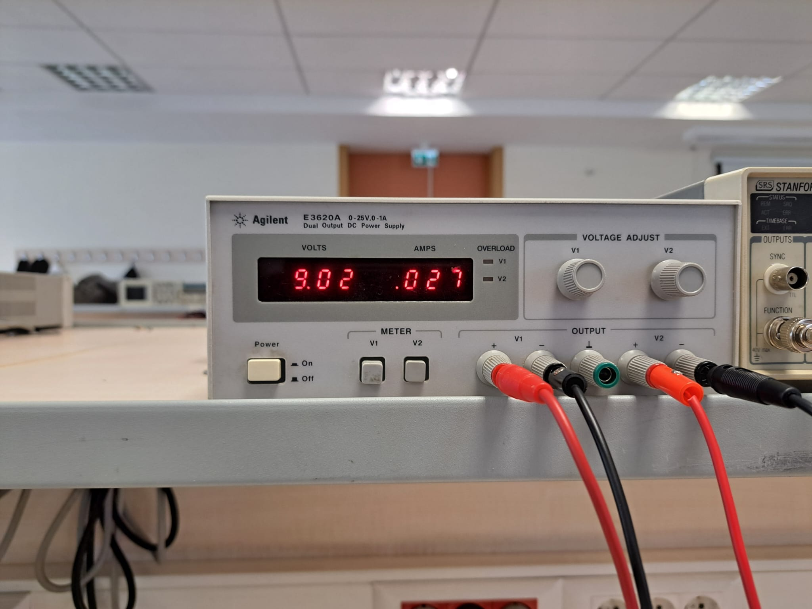

Fig. 7: Current drawn from supply at quiescent condition

In, Fig. 8, one can observe the efficiency plot with respect to given input voltage. With some errors, I observed the quadratic efficiency increase.

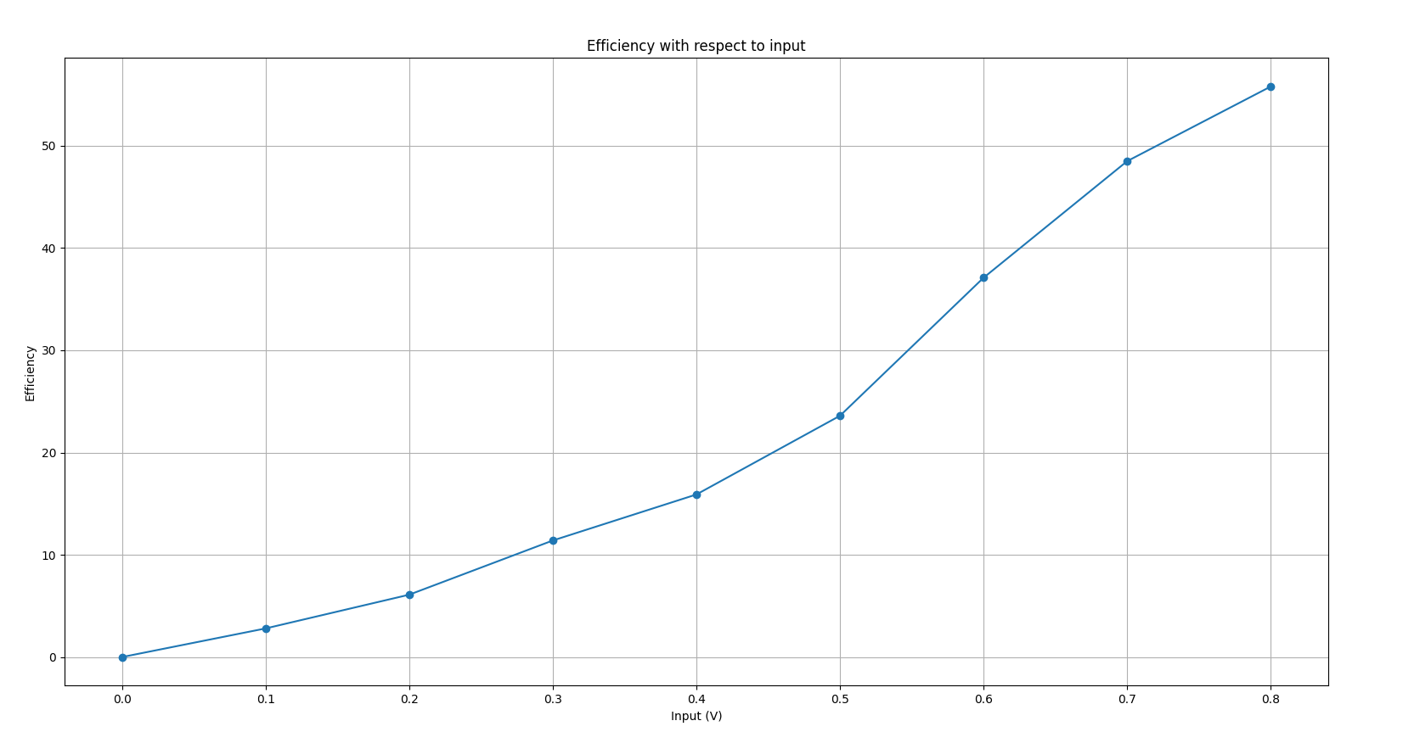

Fig. 8: Efficiency Plot

1. **Conclusion:**

The lab focused to develop a push-pull Class-B power amplifier that meets the needed Class-B efficiency andpower consumption and harmonic distortion requirements. It can produce output power greater than 2.14W to an 8.2Ω load over a frequency range of 10Hz to 40kHz. In practice, the required conditions were met successfully. The design consistently produced at least 2.14W over the frequency range, peaking at 2.344W at 1 kHz. Third harmonic suppression was -32.1dB, which is 44.8 dB lower than the 1 kHz fundamental signal. I measured 487mW of quiescent power consumption, which is less than 500mW. By reaching 55.8% efficiency at maximum power output and 1 kHz, I was able to exceed the needed 45% efficiency. Comparisons with LTspice simulations revealed low error rates, confirming reliability. Ultimately, the implemented push-pull Class-B power amplifier circuit achieved the experiment's requirements.