EE-313 Lab Experimental Report 4

Bilge Kaan Ateş

May 1, 2024

1. **Introduction:**

Aim of this lab is designing a Wide-Band Amplifier with Feedback circuit. It consist of two amplification stage and it gives a flat gain with low output-impedance. Specifications are as follows:

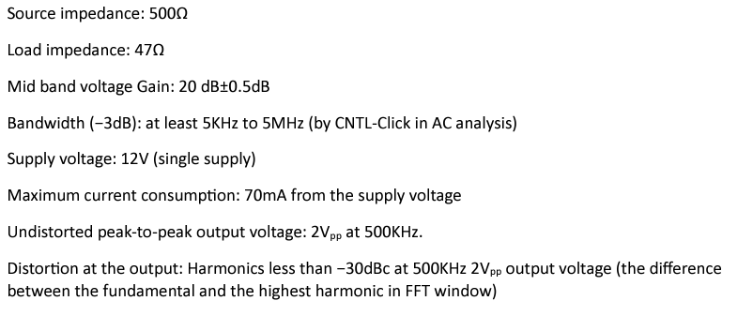

Fig. 1: Specifications

1. **Hardware Implementation:**

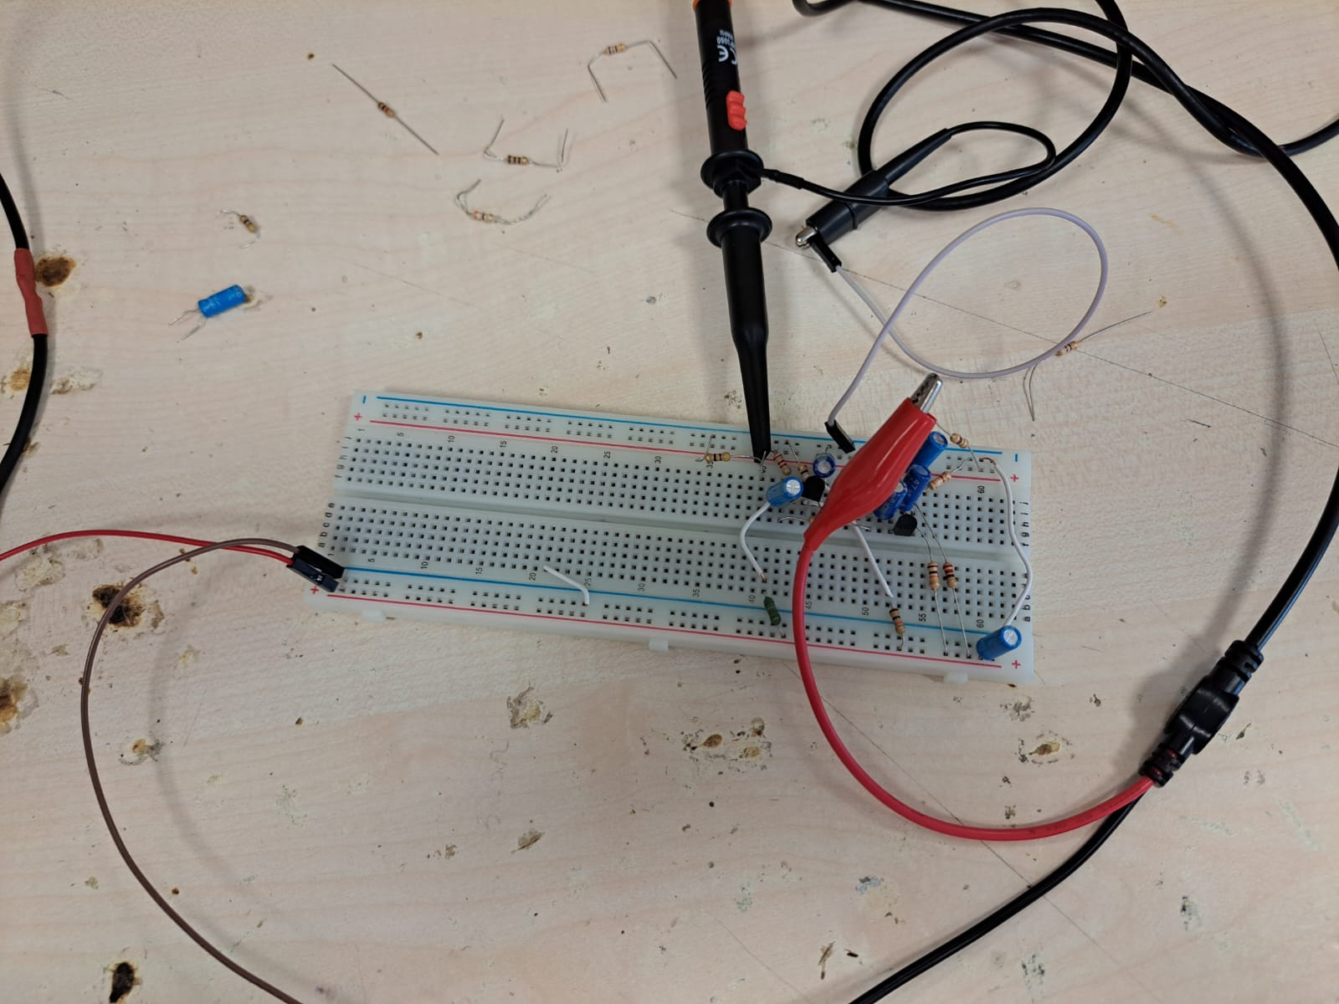

Fig. 2: Implemented circuit

I implemented the circuit whose design decisions are mentioned in preliminary report. In implementation, I used 470Ω series resistance to make source impedance as close to 500Ω. Other components are implemented with same components in the LTSpice.

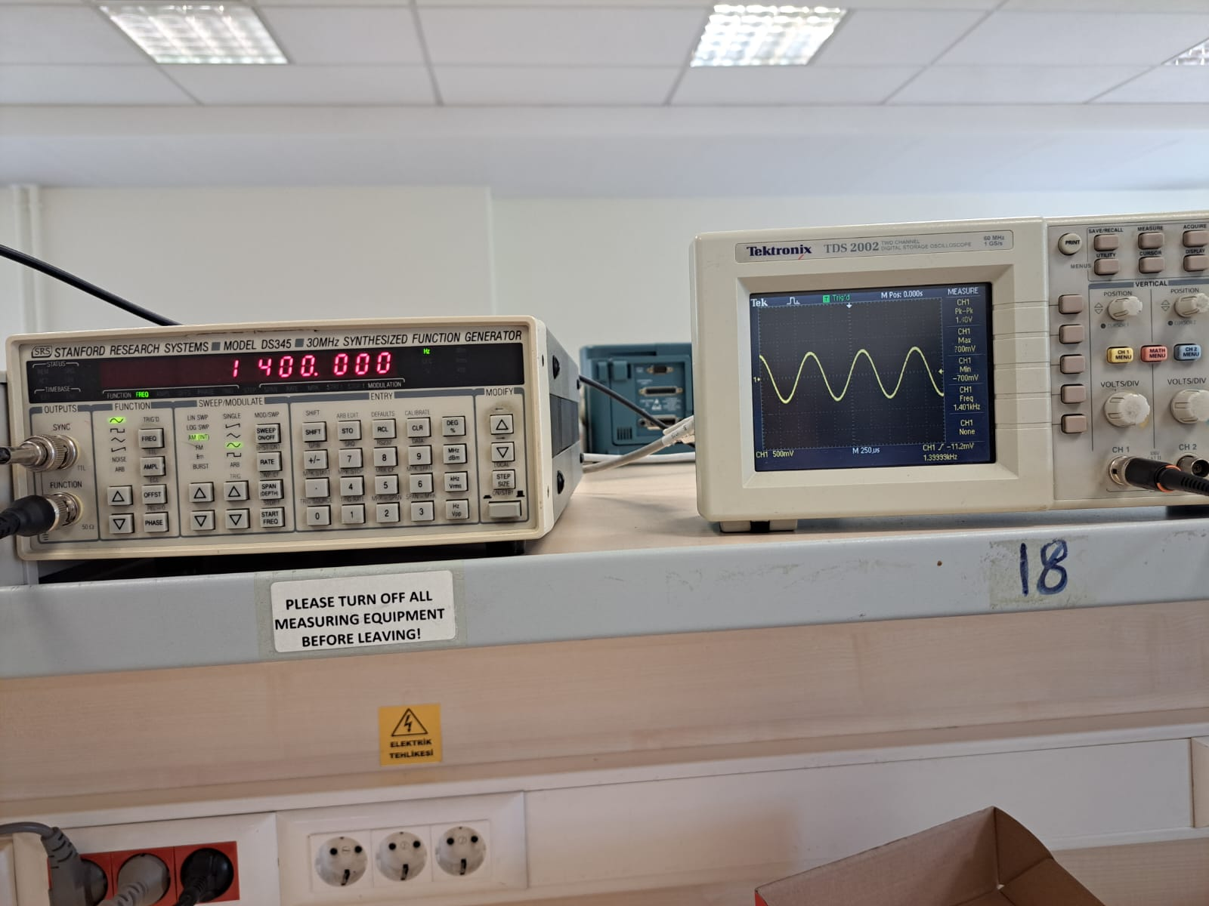

Fig. 3: Lower corner frequency

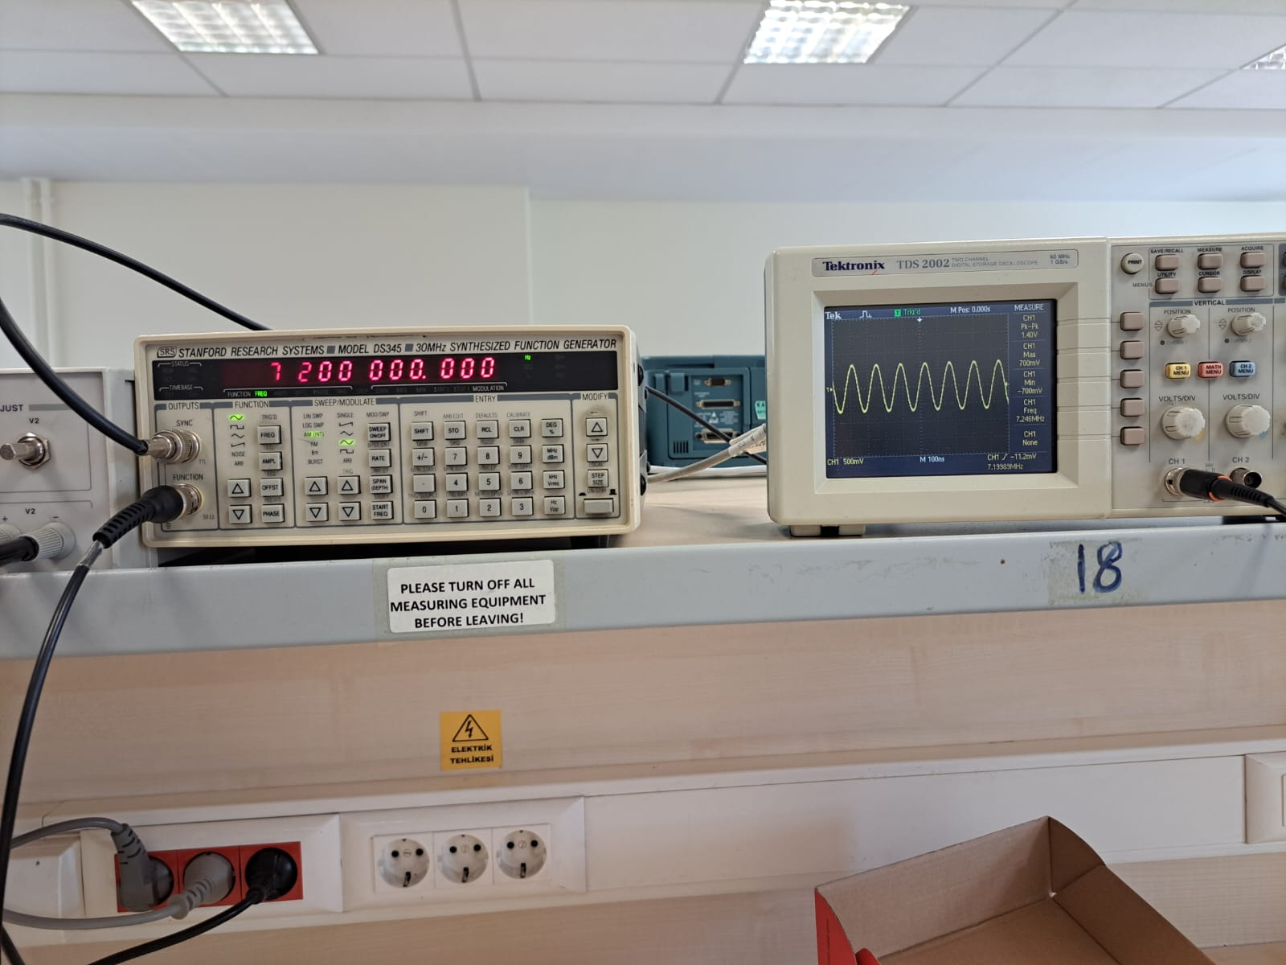

Fig. 4: Upper corner frequency

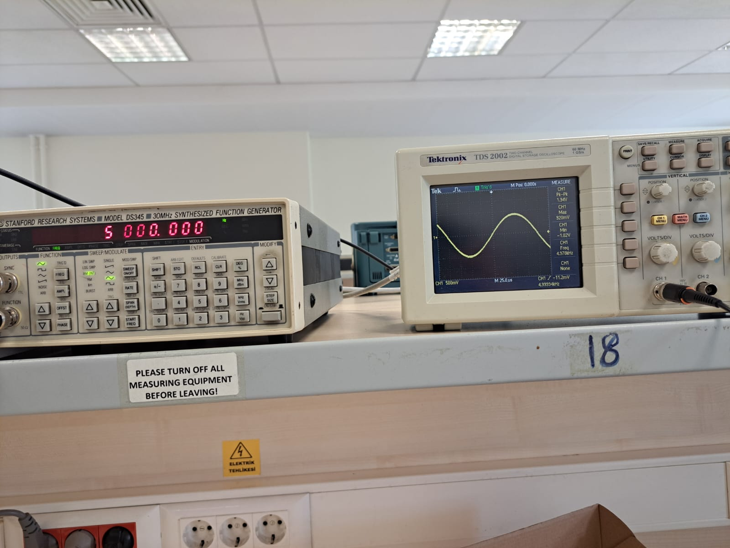

Fig. 4: Gain at 5kHz

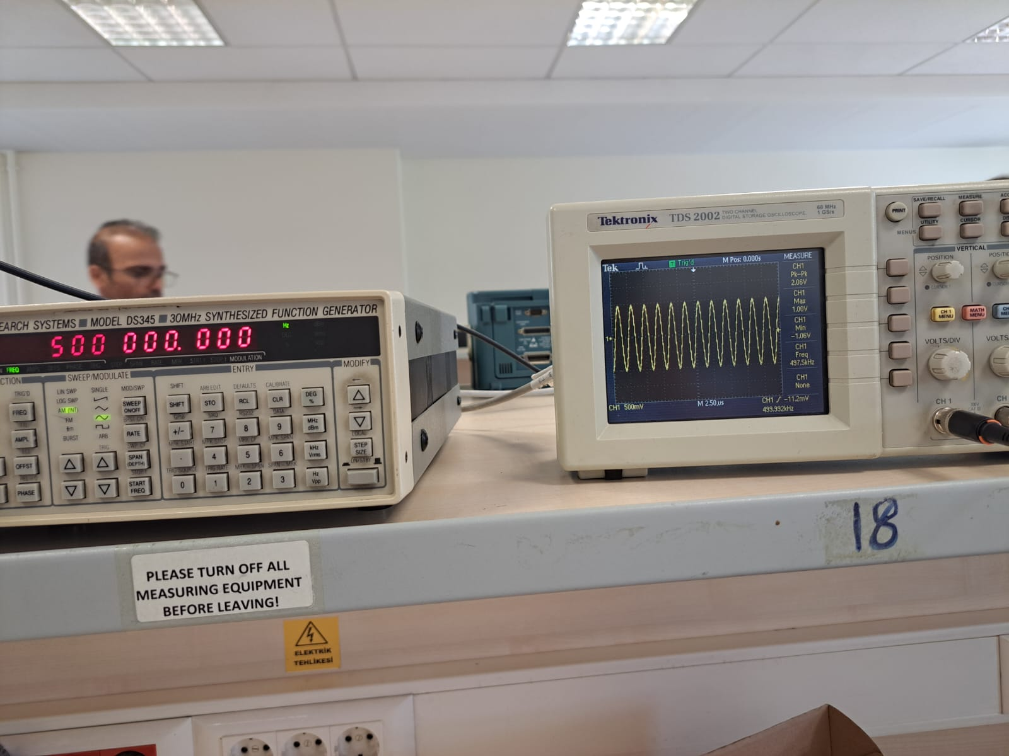

Fig. 5: Gain at 500kHz

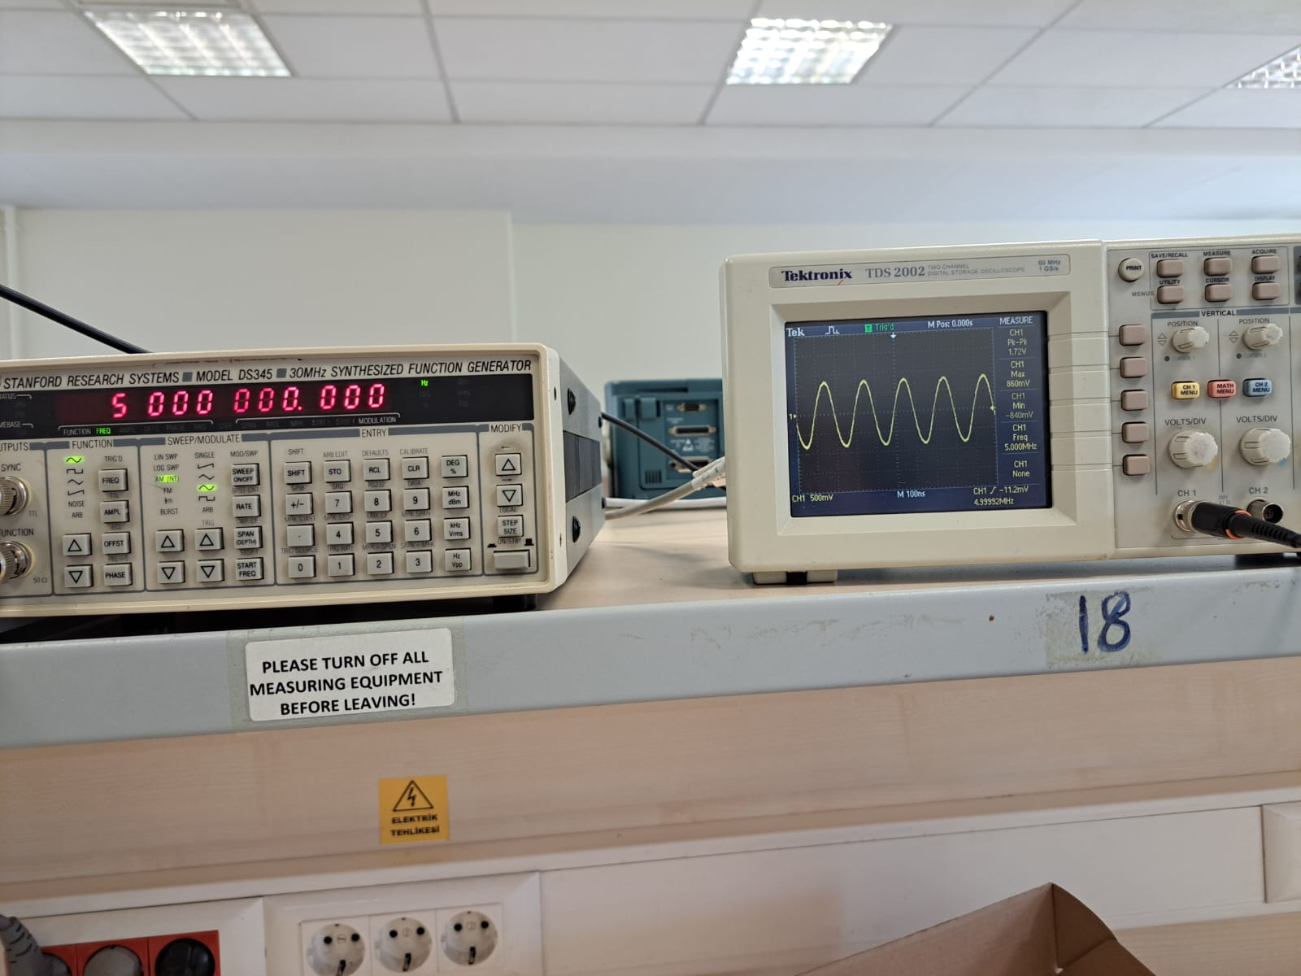

Fig. 6: Gain at 5MHz

As seen in Fig. 3 and 4, the amplifier’s band-with is between 1.4kHz and 7.2MHz which satisfies the band-with condition. Corresponding calculation is below:

As seen in the Fig. 5, at 500kHz is 2.06V. Hence, the voltage gain of the circuit is 20.26dB. As a result, gain specification is achieved as well.

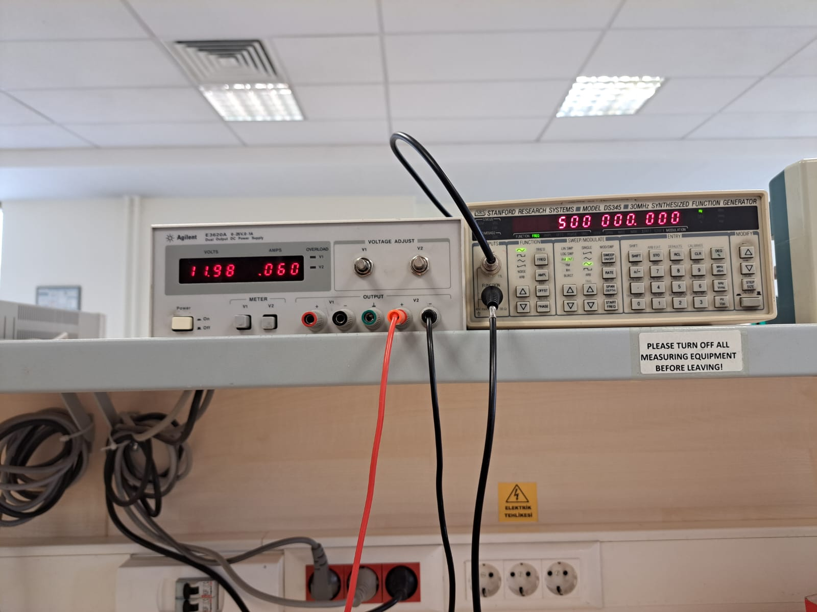

Fig. 7: Current consumption at 500kHz frequency

As seen in Fig. 5 and 7, maximum current consumption is 60 mA which is less than 70mA and which satisfies the corresponding specifications..

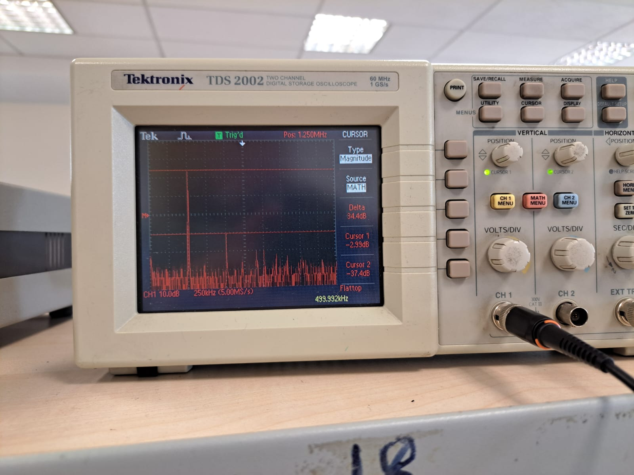

Fig. 8: FFT analysis

Fig. 8 shows that the difference between fundamental component of the output voltage and second highest harmonic is which meets the specification as well.

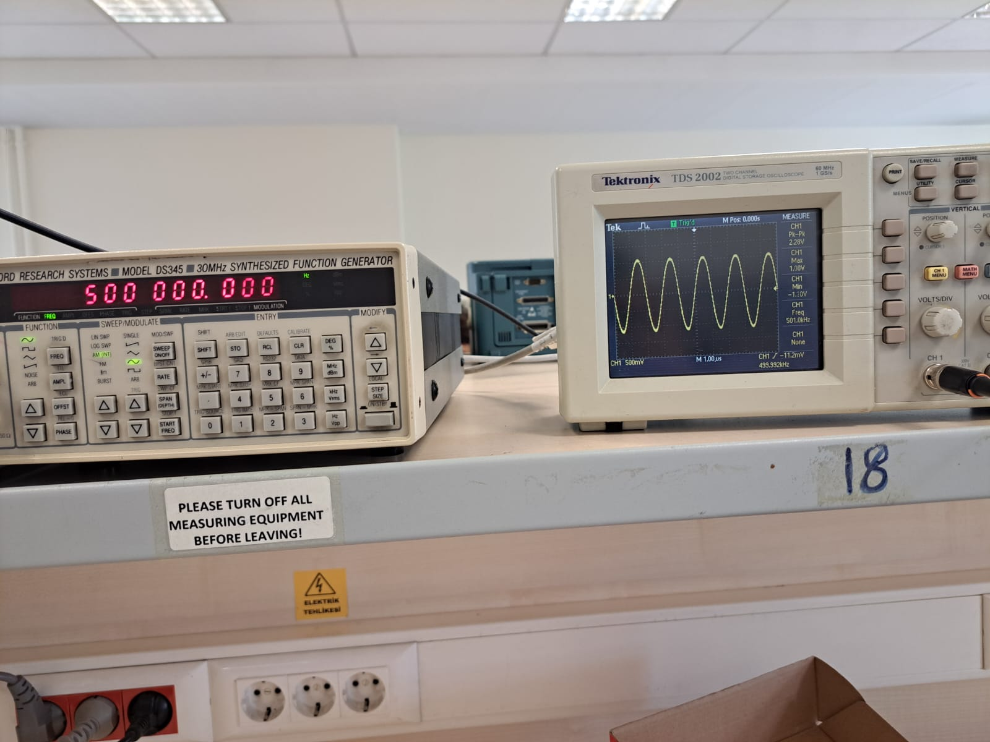

Fig. 9: Output Voltage with

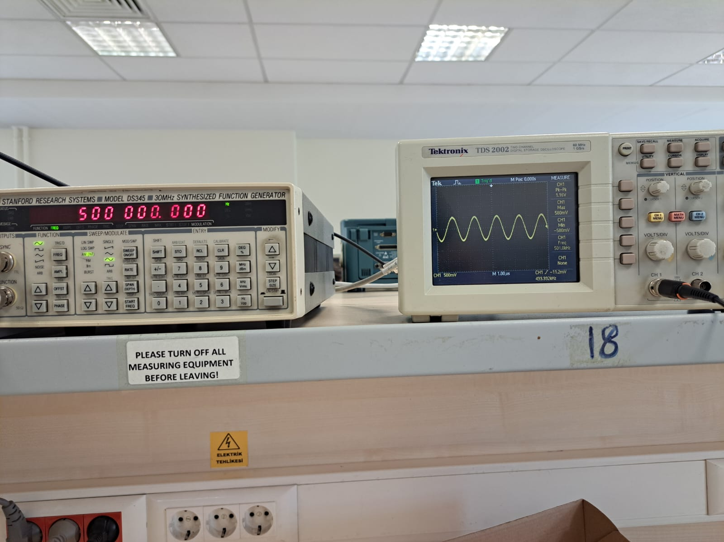

Fig. 10: Output Voltage with

As seen in Fig. 9 and 10, Output voltage is halved when = 2700Ω which implies this is the amount of as well.

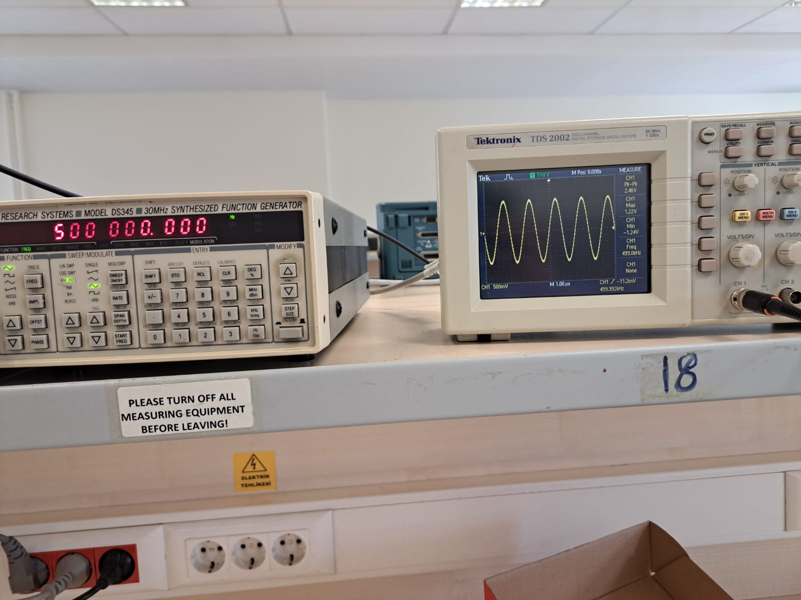

Fig. 11: Output Voltage with

As seen in Fig. 11, when is open. Hence below calculation gives the output impedance: