EE-313 Project Design Phase

Bilge Kaan Ateş

April 19, 2024

1. **Introduction:**

In this project, I designed a basic compass circuitry by using Hall Effect sensor which measure magnetic field of the Earth and gives $±0.5mV$ with an 3V offset voltage output voltage depending on the direction of south or north. I used recommended circuit given by Abdullah Hoca and with some trial and error designed the circuit shown in Fig. 1. I used 6V voltage supply because LTSpice doesn’t have 7806 voltage regulator component. In the LTSpice implementation part, I explained the satisfaction of the four criteria.

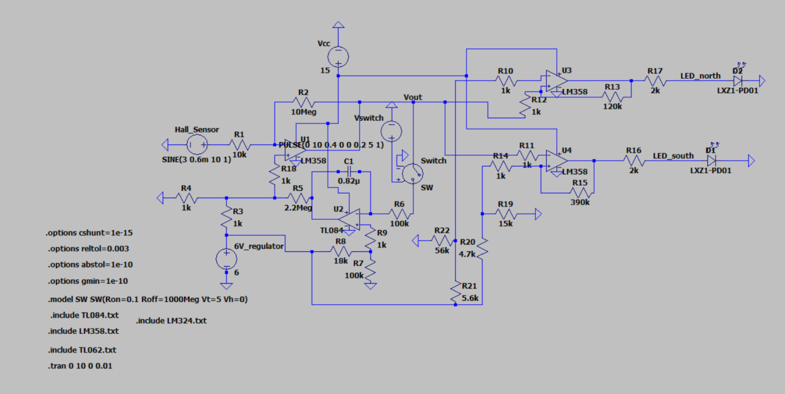

Fig. 1: Implemented Circuit

1. **LTspice Implementation:**
   1. **Implemented Circuit:**

**1-) At 15V supply, current consumption < 30mA:** In this calculation, I considered two different voltage supply as they will be one supply in my design. They are 6V voltage supply (Vref) which is used in place of 7806 and 15V voltage supply (Vcc). For simplicity purposed, I put them as different sources in the LTSpice implementation. Total current consumption of those sources can be seen in Fig. 4. Total current consumption doesn’t exceed 6.3 mA which is less than 30mA.

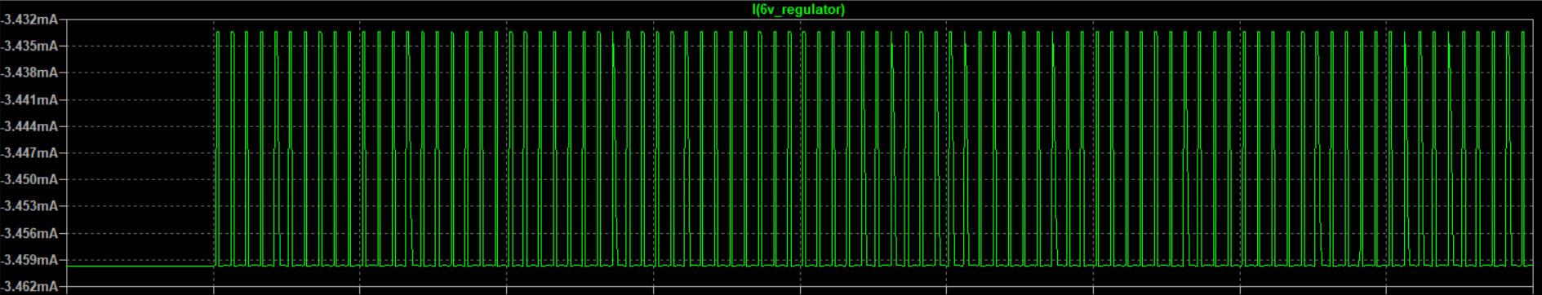

Fig. 2: Current consumption of 6V_regulator

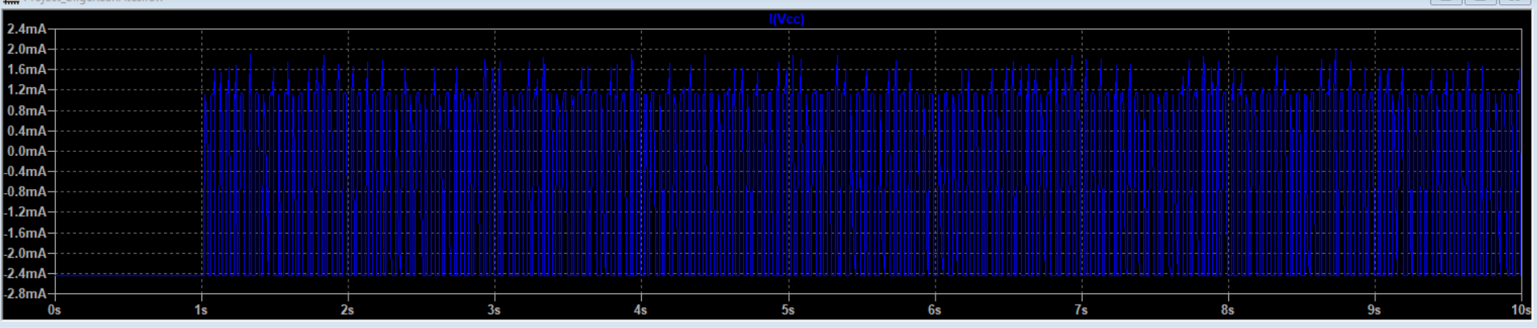

Fig. 3: Current consumption of Vcc

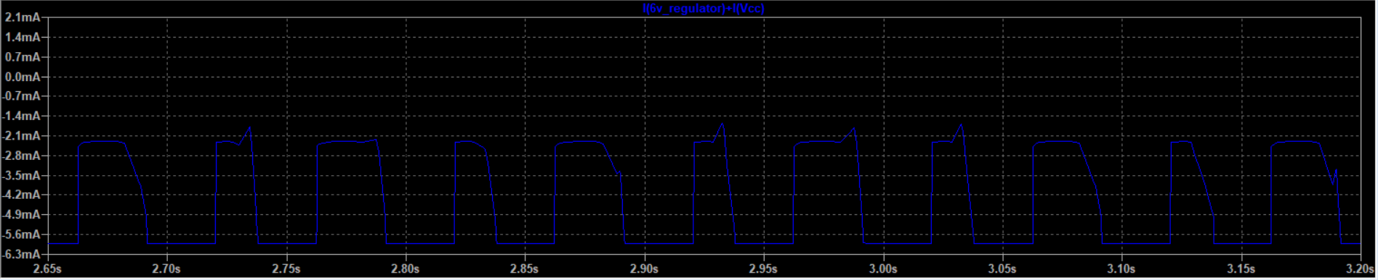

Fig. 4: Total current consumption of the circuit

**2-) Circuit behavior after auto-zero circuit (at least 3 miniutes operation after pulse):**

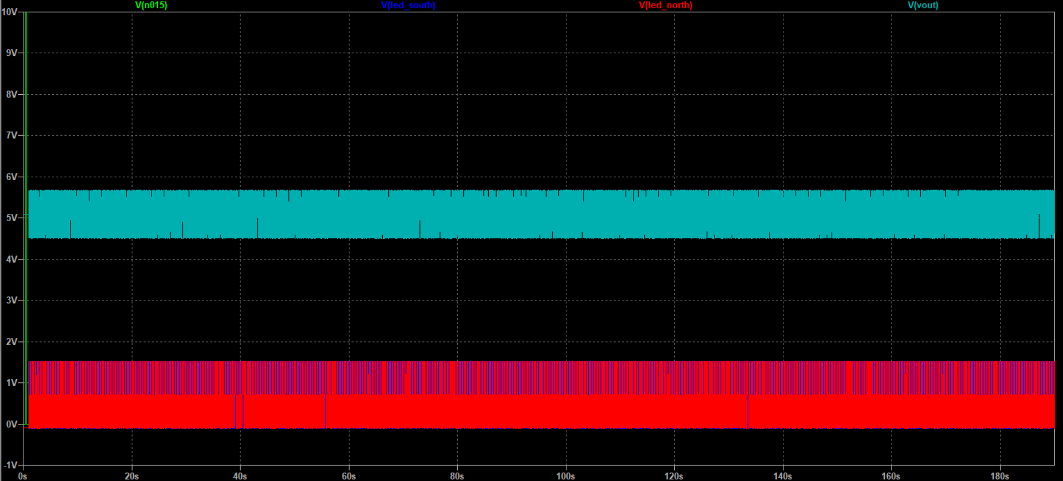

Fig. 5: Transient analysis of the circuit for 190s

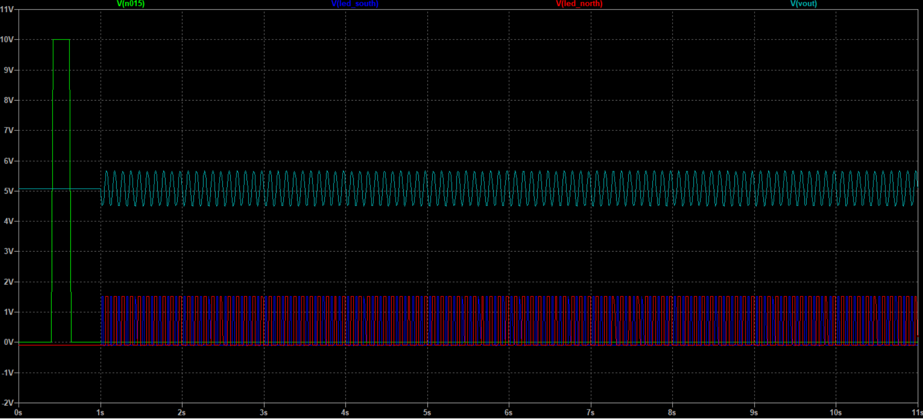

Fig. 6: First wave occurences

As shown in Fig. 5 and 6, circuit works for at least 180 second after the pulse is occurred at switch. Green voltage pulse starts the switch operation and charges the integrator circuit which will supply the necessary power and behaviour for the regular output voltage. Turquoise wave shows the output voltage and red/blue waves show the LED’s voltage due to change in the direction of Hall effect sensor. I used sine wave for the Hall effect representation of supply voltage to observe change of the direction. The integrator part of the circuit is expected to continue the duty for more than 30 minutes as it is used as a analog memory. Hence, second condition is satisfied as well.

**3-) Green or Red LED turn on condition at $±45°$ angle between north and south:**

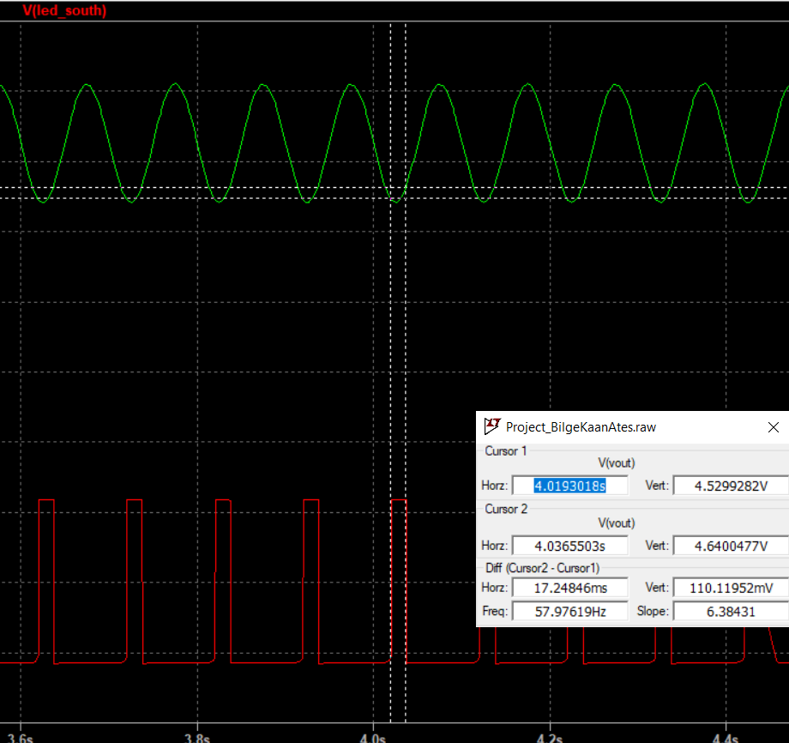

Fig. 7: South Led Turn on Voltage

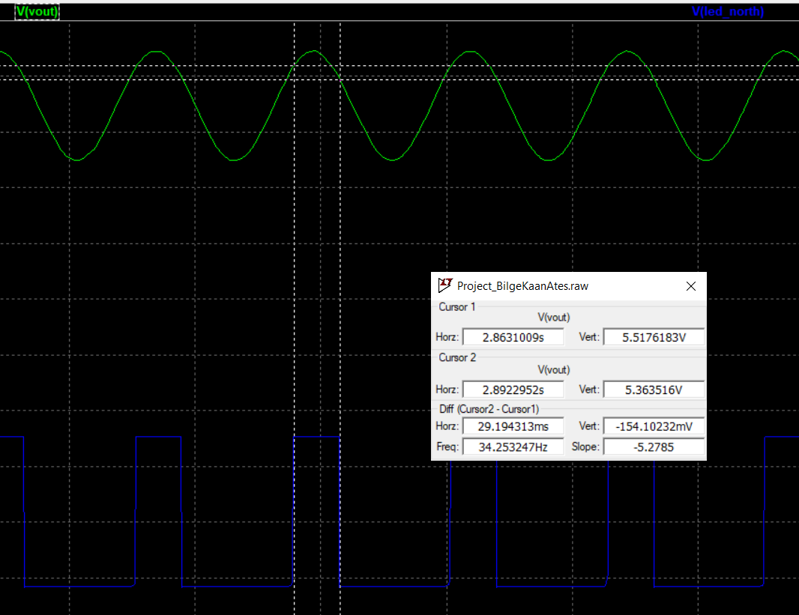

Fig. 8: North Led Turn on Voltage

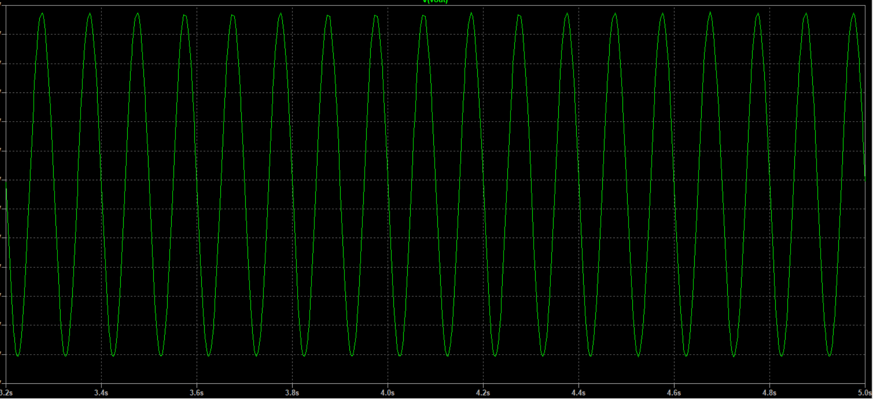

Fig. 9: $V_{out}$ graph

As seen in Fig. 9, output voltage ranges between 5.7V and 4.5V where it is DC offset is 5.1V. It is the amplified signal of the Hall effect output voltage. 5.7V indicates the circuitry is towards to the north and 4.5V indicates the circuit is towards to the south. I need north LED turn on when output voltage exceeds $5+0.5 x sin(45°)≅5.35V$ and south LED turn on when output voltage is below $5-0.5 x sin(45°)≅4.65V$. As seen in Fig. 7 and 8, lower threshold voltage (for south LED) is 4.64V and upper threshold voltage (for north LED) is 5.36V which are less than 45° angle range from the desired directions which satisfies the third condition.

**4-) LED Hysteresis:**

I used Comparator OPAMP’s to control the turn-on/off condition of the LED’s. I connect lower threshold voltage to the plus input of the south LED Comparator OPAMP and upper threshold voltage to the minus input of the north LED Comparator OPAMP. The other inputs are connected with the $V_{out}$. To avoid from flicker of the LED’s, I used positive feedback hysteresis with $R_{1}=1kΩ,R_{2}=120kΩ$ for this purposes. As seen in Fig. 7 and 8, north LED has 154mV hysteresis and south LED has 110mV hysteresis. Thus, fourth specification is satisfied as well. You can see Diptrace Schematic in the next page.

* 1. **Diptrace Schematic:**

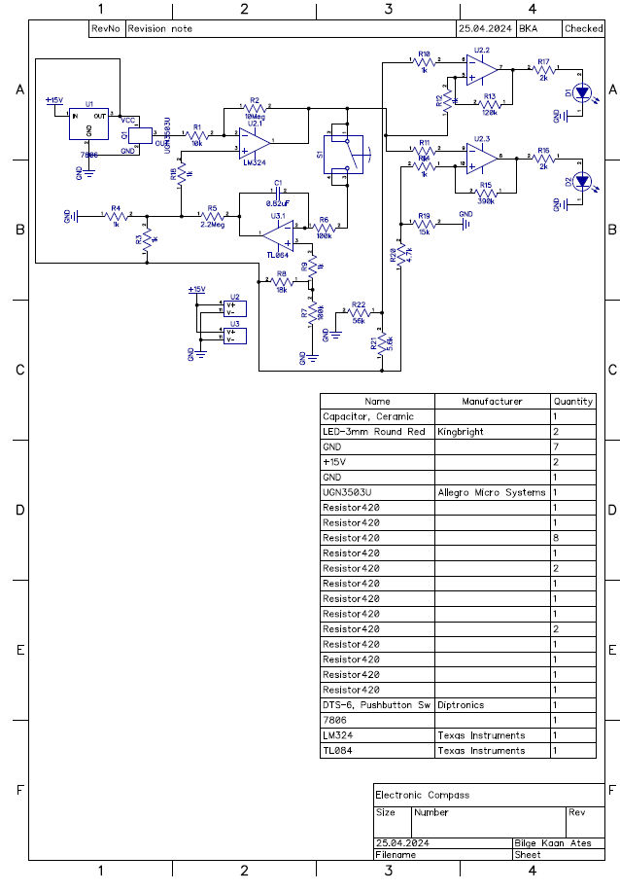

Fig. 10: Diptrace Schematic