EE-313 Project Experimental Implementation

Bilge Kaan Ateş

May 15, 2024

1. **Introduction:**

In this project, I designed a basic compass circuitry by using Hall Effect sensor which measure magnetic field of the Earth and gives with an 3V offset voltage output voltage depending on the direction of south or north. I used recommended circuit given by Abdullah Hoca and with some trial and error designed the circuit shown in Fig. 1. I used 6V voltage supply because LTSpice doesn’t have 7806 voltage regulator component. In the LTSpice implementation part, I explained the satisfaction of the four criteria.

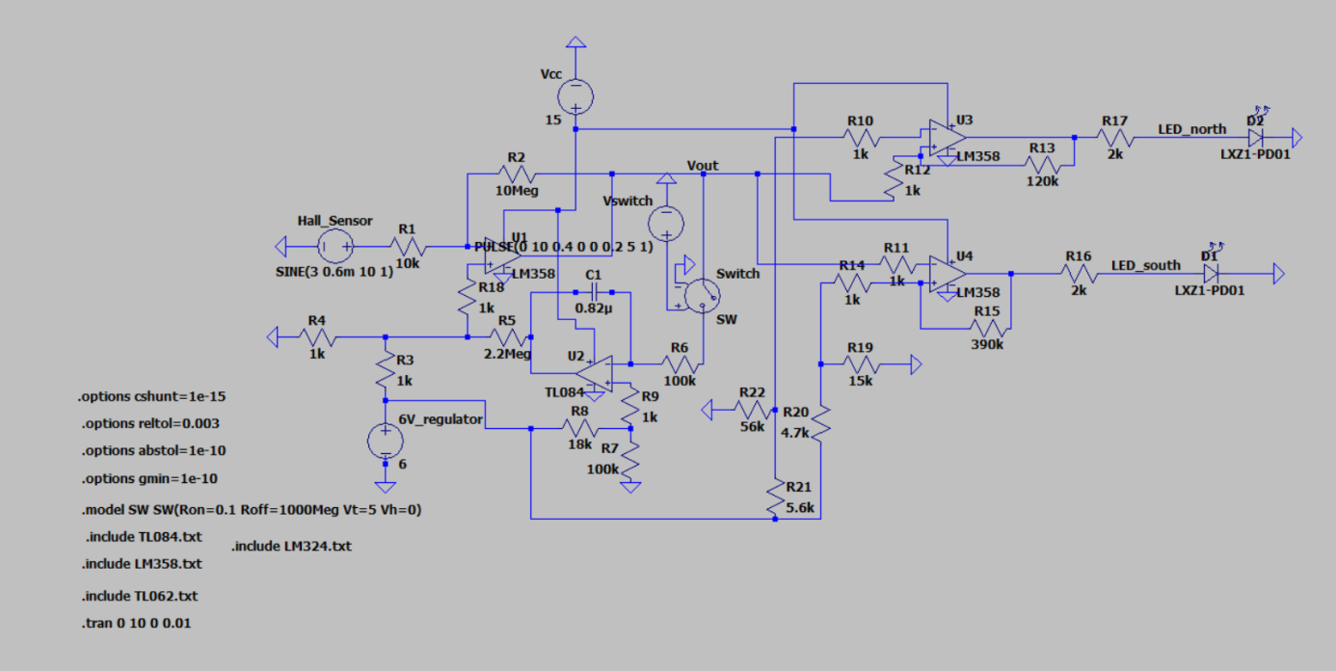

Fig. 1: Implemented Circuit

1. **PCB Design:**
   1. **Diptrace Schematic:**

I implemented my LTSpice design in Diptrace. I labeled the components and added their libraries that are provided. Hence, I was able to transfer the circuit in PCB design phase. Corresponding Diptrace Schematic can be seen in Fig. 2.

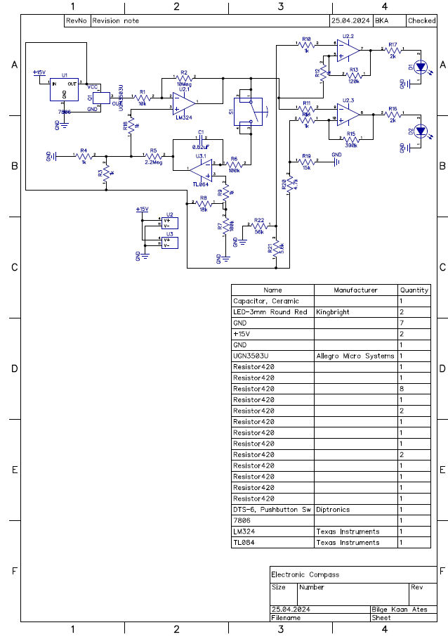

Fig. 2: Diptrace Schematic

* 1. **PCB Design**

I designed the PCB by importing the Diptrace file. All components and connections are transferred in this way. Then I put the components in a suitable way inside the PCB so that connections doesn’t intersect. As seen in Fig. 3, ‘UGN3503U’ component (Hall Effect Sensor) pads are too close (separations are closer then 20mil) according to the application, but in real life it doesn’t possess any problem as Abdullah Hoca said. Beside this, all electrical and design rules are verified.

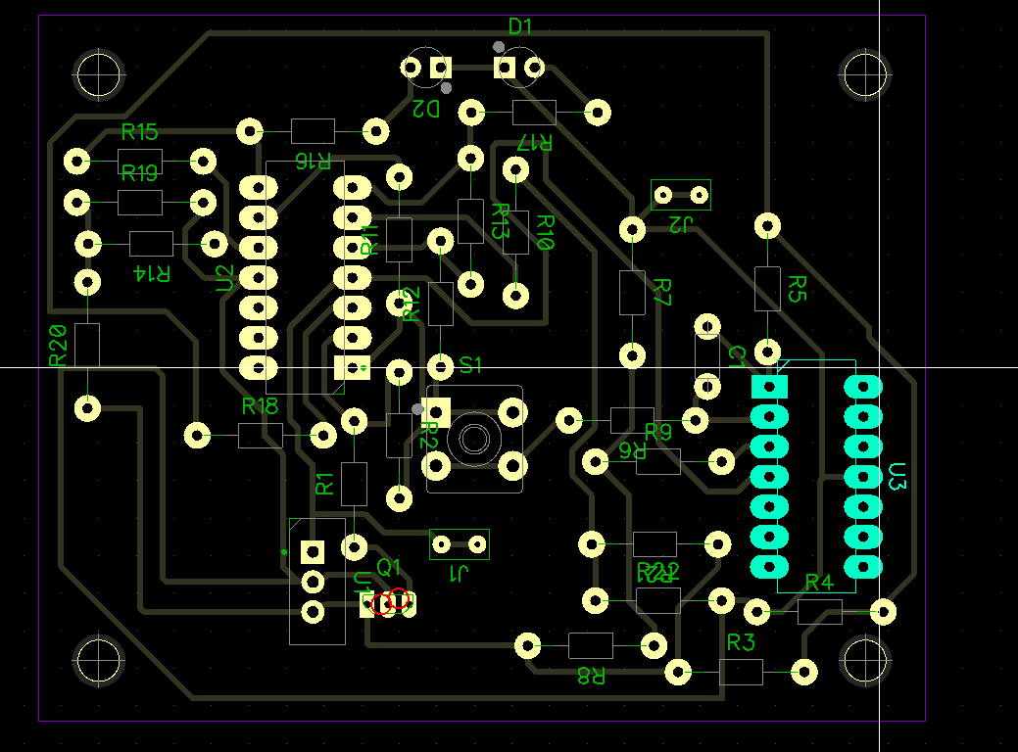

Fig. 3:PCB design of the circuit

After that, I checked my PCB design in OnlineGerberView. I upload Gerber files (Top silk, Board, Bottom) and DRL files into this website and obtained the figures shown in Fig. 4,5 and 6.

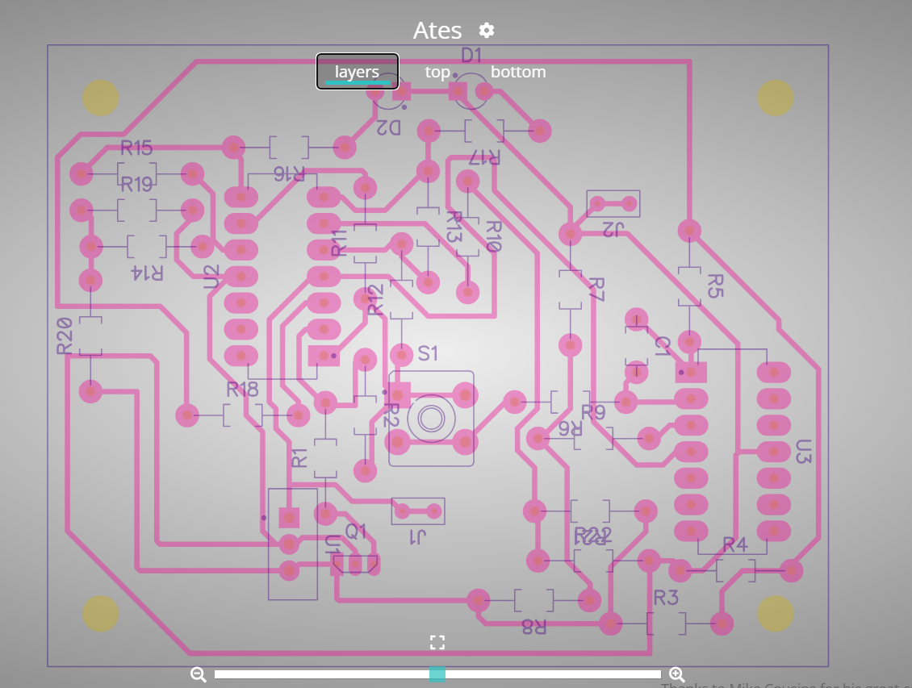

Fig. 4: Layer view of the PCB

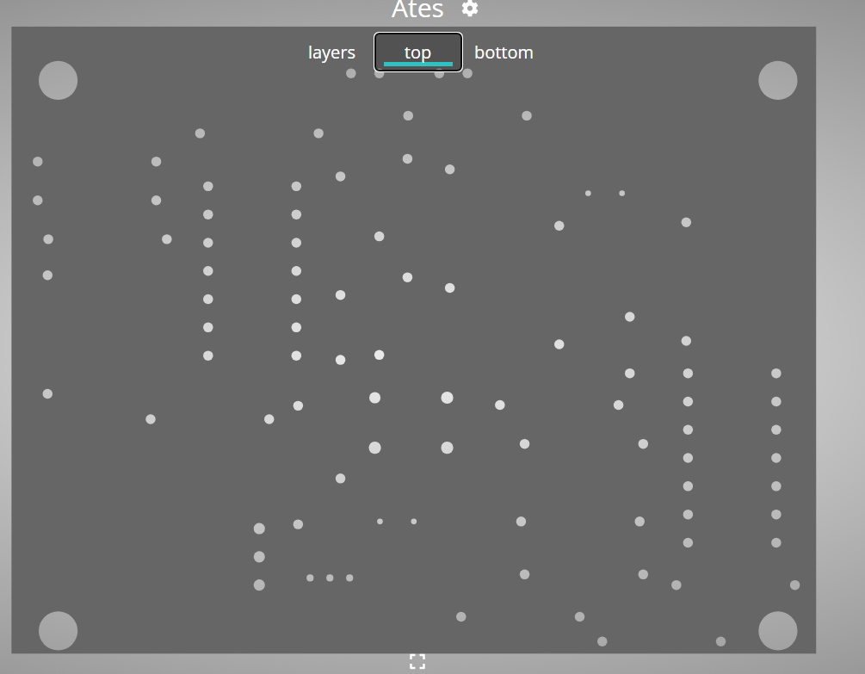

Fig. 5: Top view of the PCB

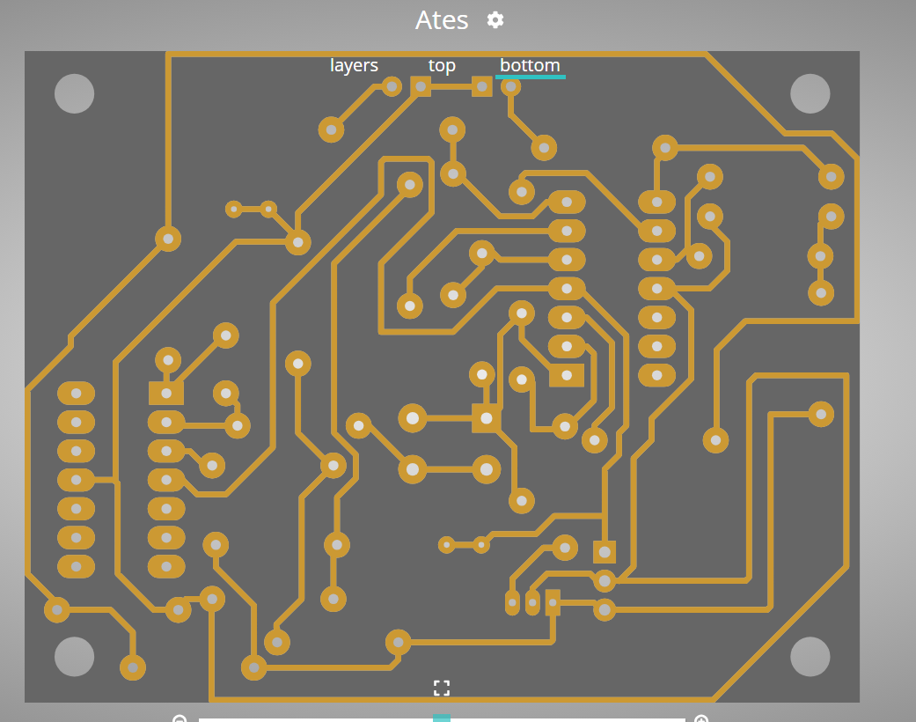

Fig. 6: Bottom view of the PCB

* 1. **Circuit Implementation**

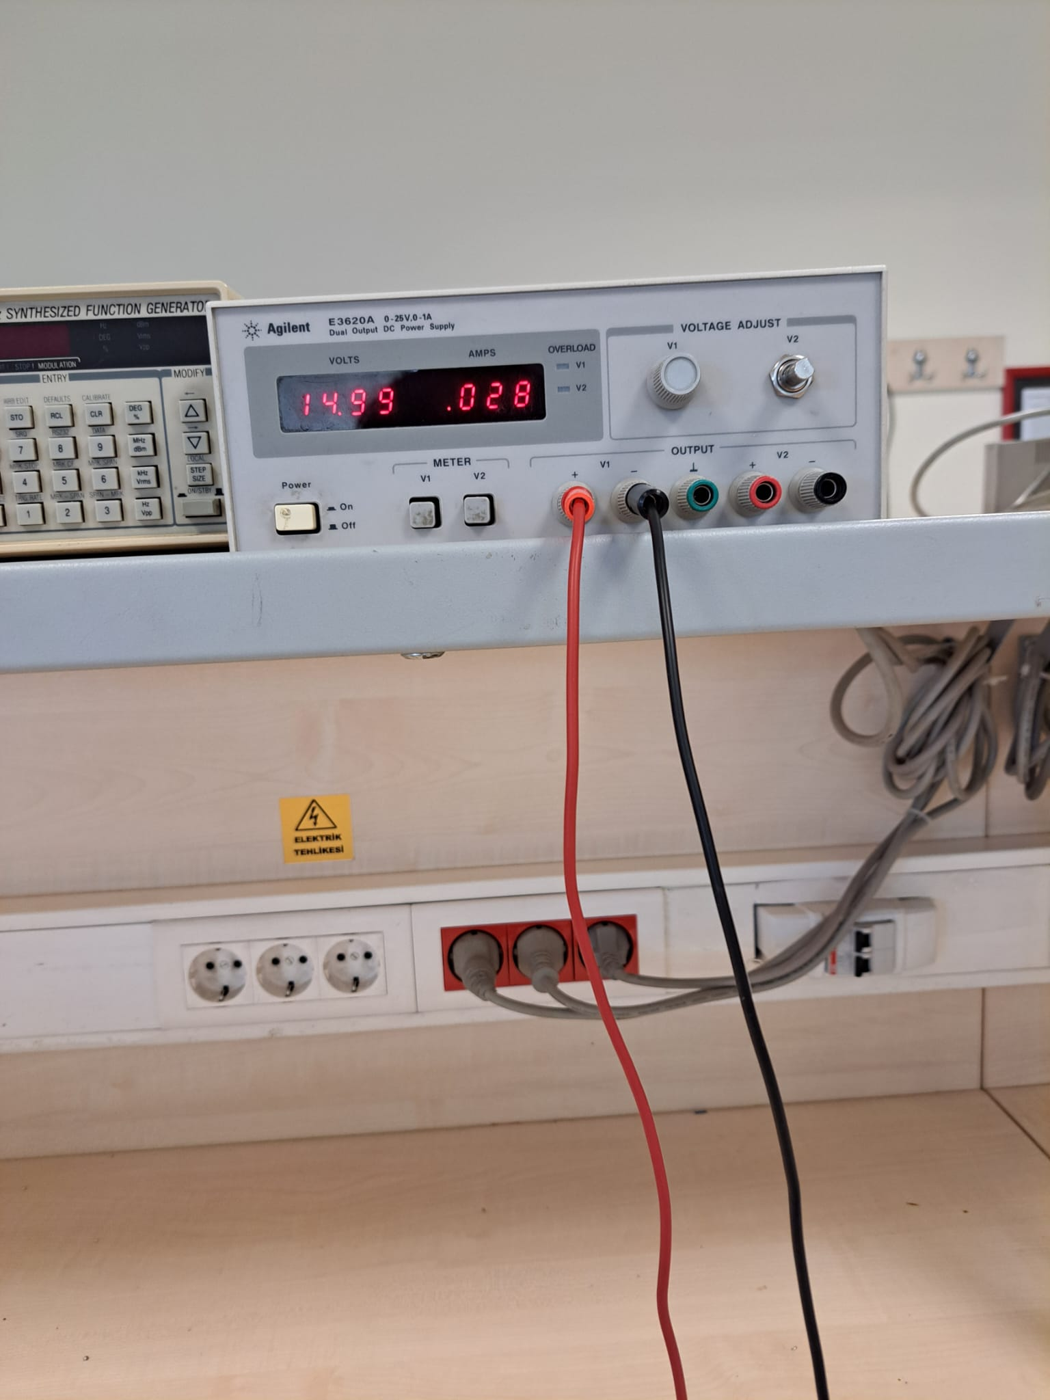

Fig. 7: Current consumption of the circuit while one of the Led is on

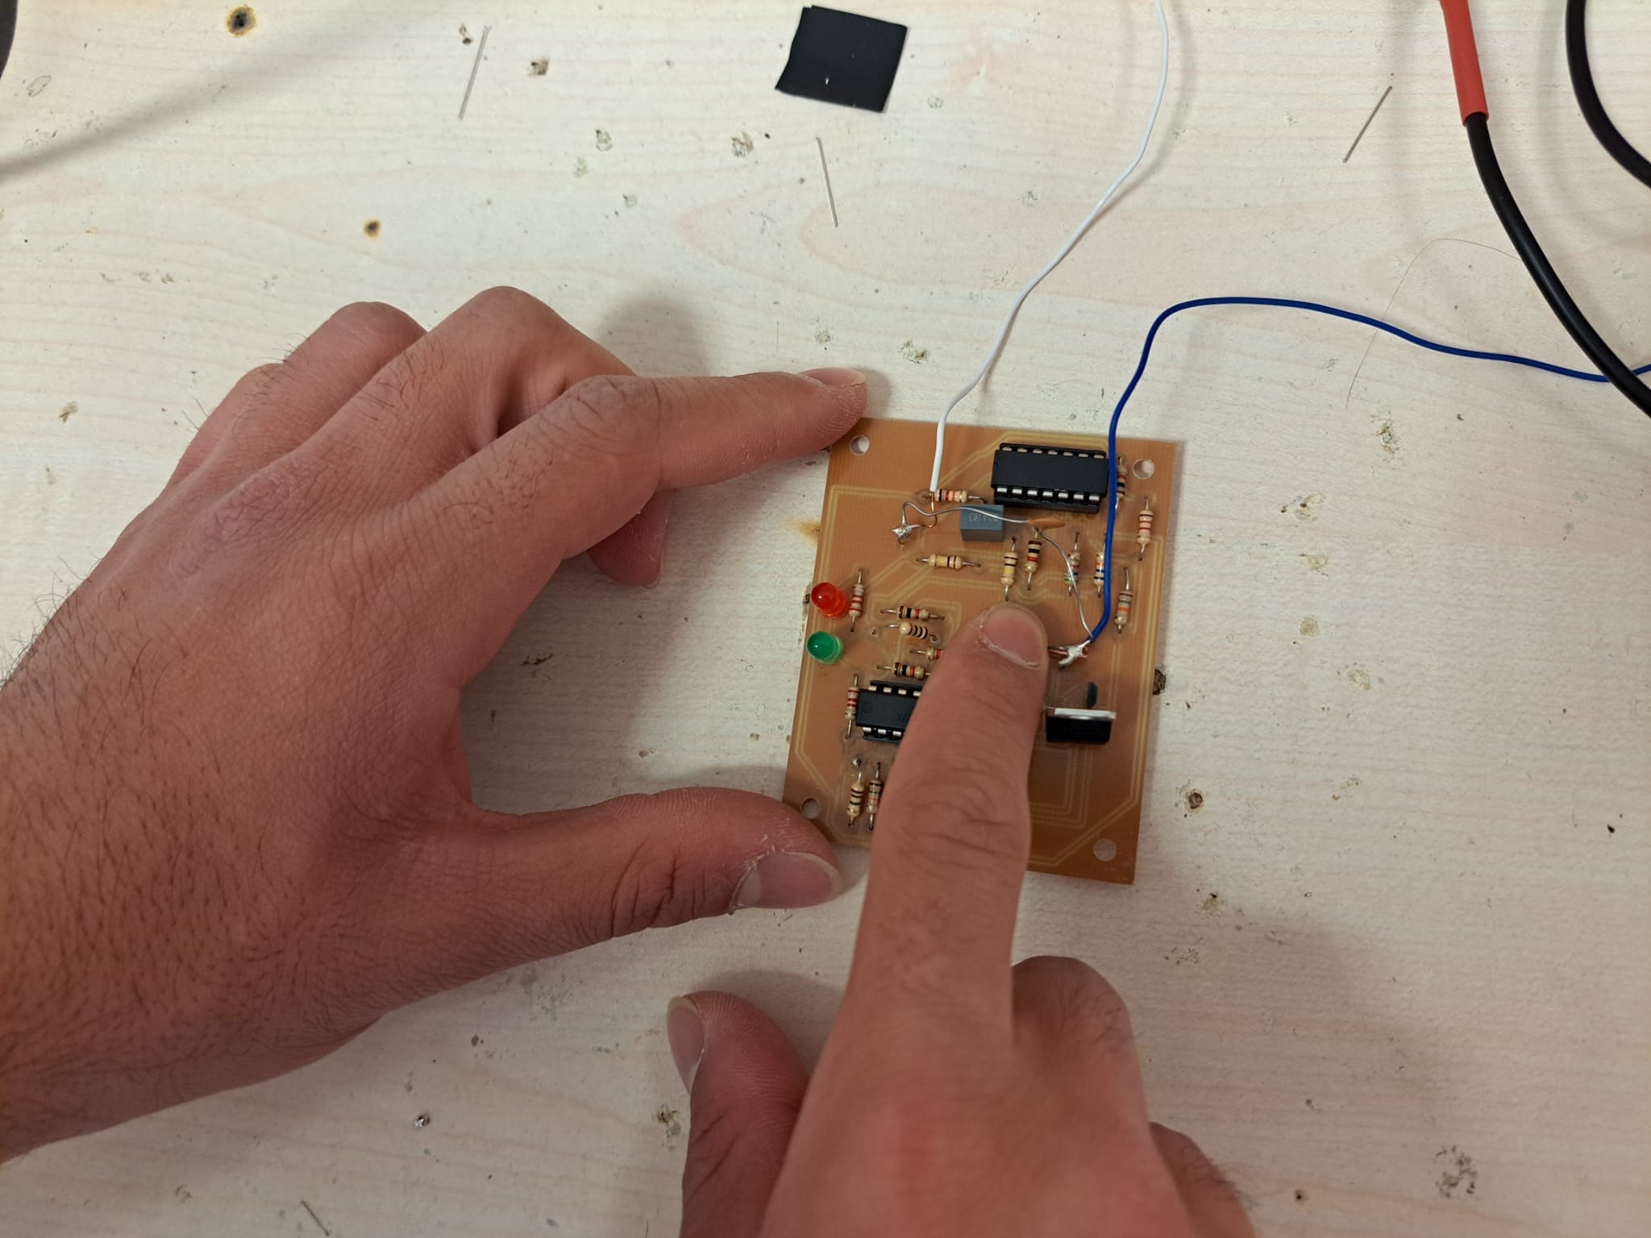

Fig. 8: Both LEDs off while auto-zero

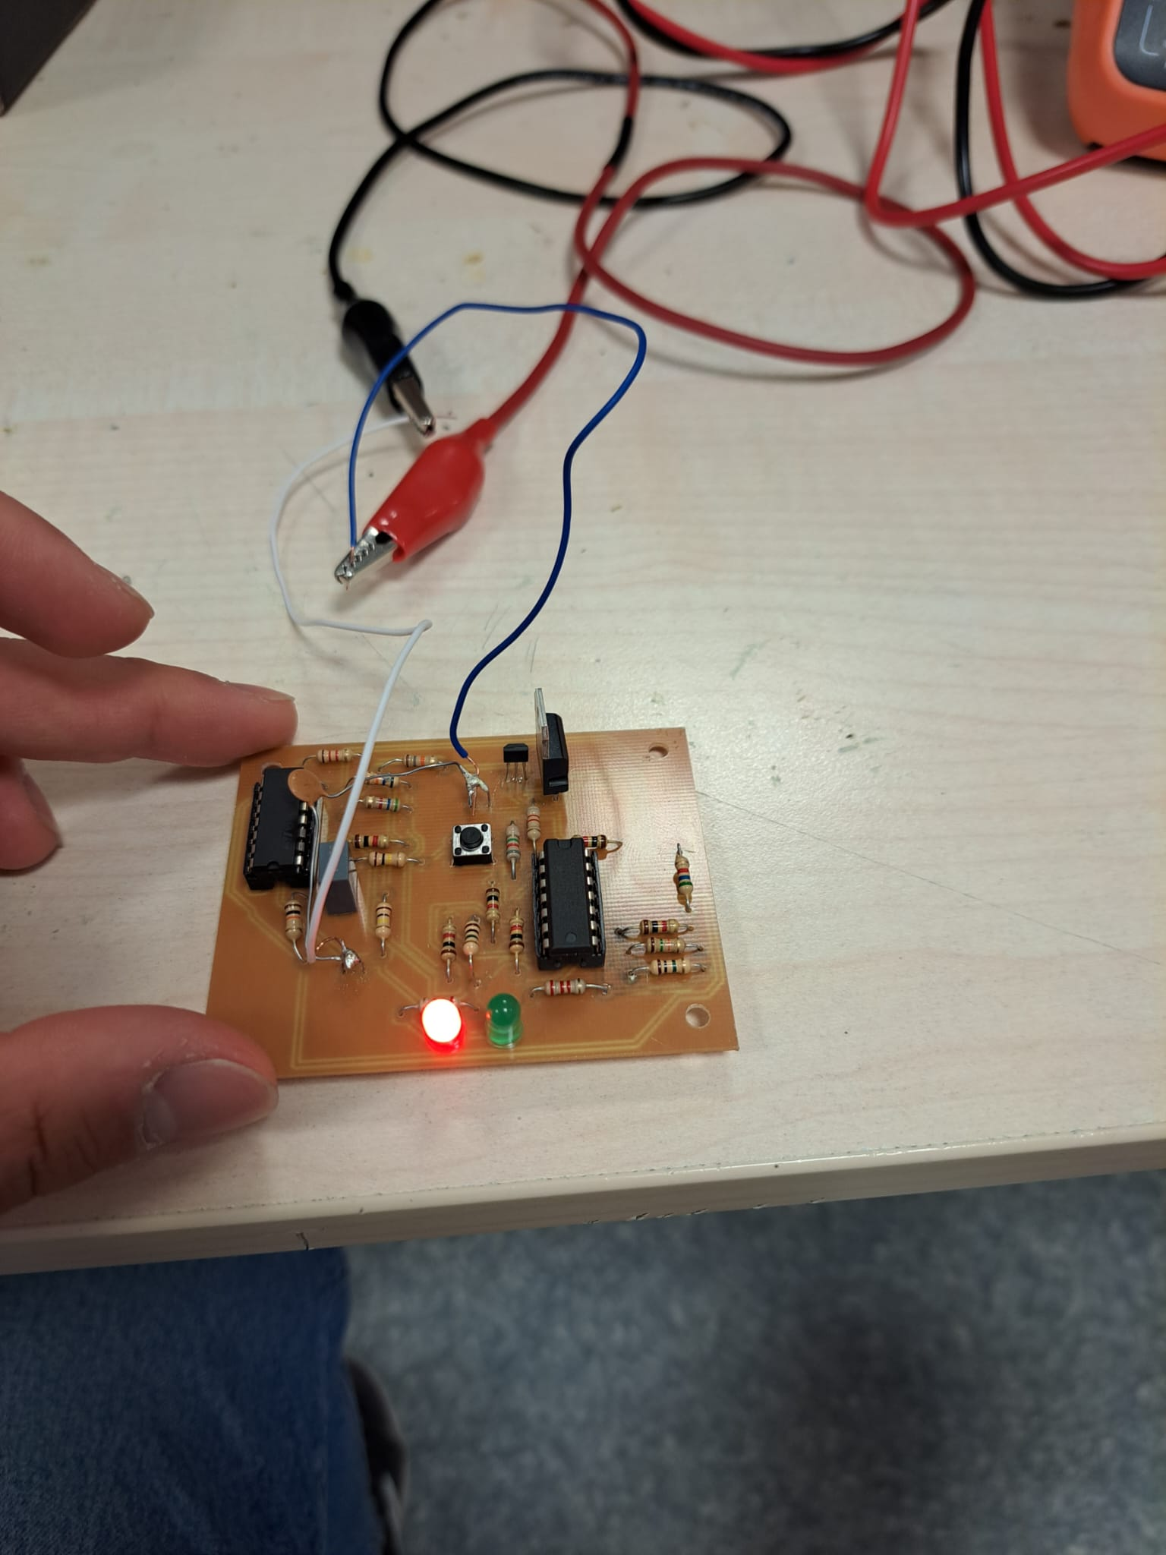

Fig. 9: Red LED (north) is on while the circuit is directed to the north

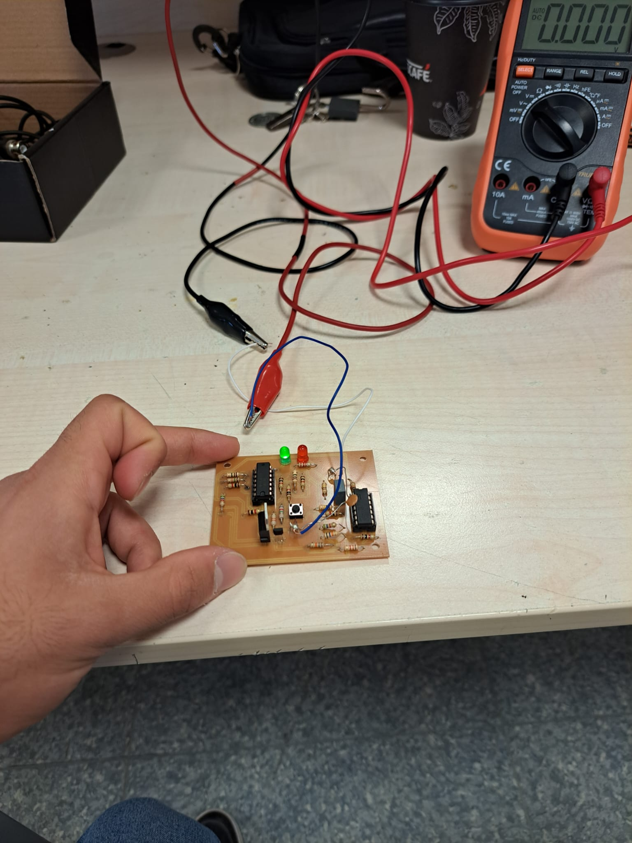

Fig. 10: Green LED (south) is on while the circuit is directed to the south

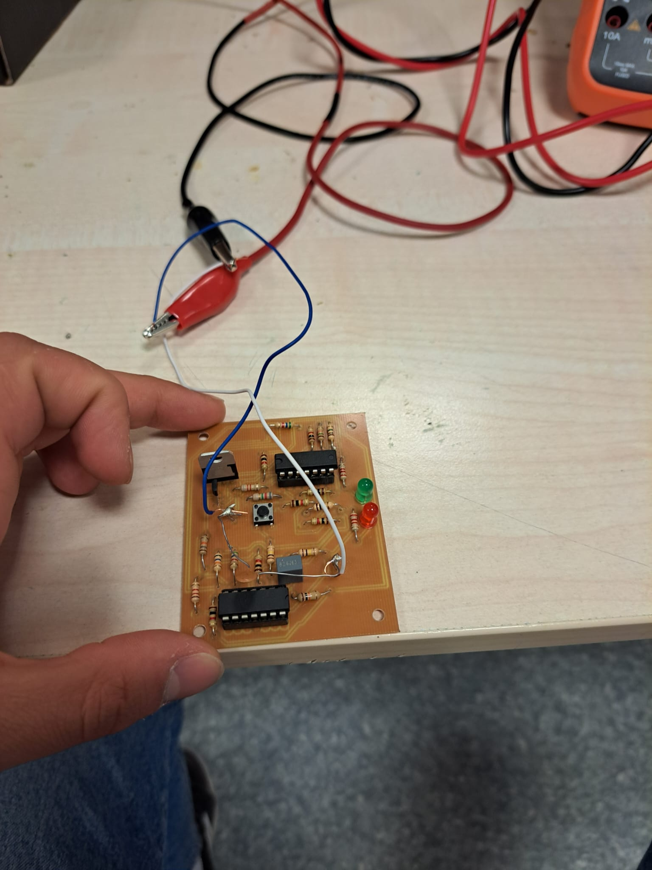

Fig. 11: Both LEDs are off while the circuit is directed to the west

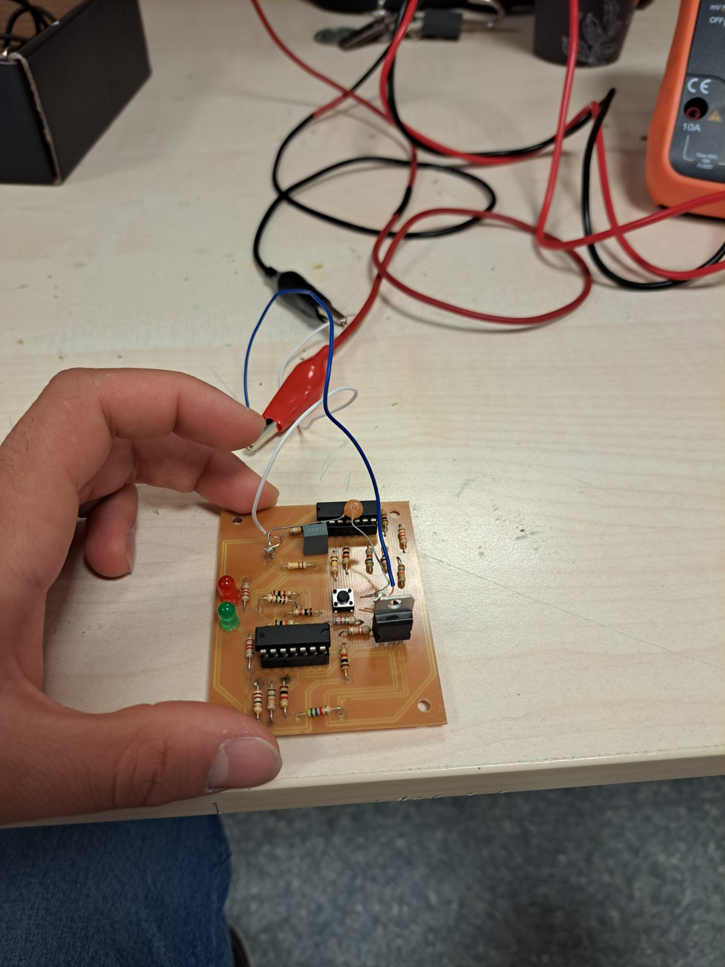

Fig. 12: Both LEDs are off while the circuit is directed to the east

As seen in Fig. 7, maximum current consumption is less than 30mA which satisfies the condition. Fig. 8 shows that auto-zero circuit. As seen in Fig. 9 and 10, LEDs work in correct direction. Since it is hard to show angles in photos, I didn’t upload photographs for those criteria. Fig. 11 and 12 shows both LEDs are off when the circuit is directed to the either west or east. After auto-zero, circuit works for at least 3 minutes which satisfies that condition as well.