CoreArena Software Review/Assessment:

Just so you know I’m not some 12yr old ranting about your plugin. I’m 45 and a lead software test engineer for a major defense contractor….(who like to build free MC servers for under privileged kids). I have a masters in explosives engineering, and have been in the VV&T (look it up) line of work for my whole career for the past 20+ years. I have been testing software for the past 9yrs and am responsible for validating multi-billion dollar defense networks when new software deliveries are made to our baselines. So please take this list of red-lines as constructive criticism, because I wouldn’t have spent my valuable time to send this to you if I didn’t think your work had the potential to move to the next level and be really really great.

Ok lets get started, there are some major design flaws with this plugin when you look at the big picture of what it is designed (or expected) to do. Often times GUIs make things easier, however in this case the mix of / commands with multilevel GUI pages makes arena setup overly complicated requiring too many mouse clicks and repeated /ma <cmd> entries to navigate up and down through menu levels in order to perform basic setup tasks.

- Spawner/Class/Upgrades/Rewards editing GUIs:
  - Allow shift-click to move items to/from inventory & setup areas (drag & drop is just agonizing)
    - Also your drag & drop for armor is a bit buggy, it usually requires several attempts to get the armor to stick into it’s slot.
  - Having to close out the editors repeatedly to move items into inventory such as equipment & eggs is exceedingly tedious. Ideally the user “should” be able to right-click an empty slot which opens a menu of available items (look at how SSDynamicShop works)
    - For spawner setup I’d suggest two pages, one with animal eggs, and one page with monster eggs.
    - For the Class/Upgrades/Rewards pages just open the full MC block/item catalog.

Spawner deletion is WAY to easy, you should not be able to left-click a spawner and instantly delete it after it has been configured. This leads to user frustration after a carefully configured a spawner is accidentally deleted it due to a bad mouse click. There should be a confirmation prompt for this action once a spawner is setup. (with a bypass “spawner delete confirmation” option in the config file, for Pro-users) (This is a major user input error risk that can be easily avoided)

The need for a damaged snapshot “seems” (to me) unnecessary. At a high-level all you are doing is reverting the arena from it’s end state (which will be different after every match) to it’s initial state (initial snapshot) while preserving a few special items/blocks. (look at how Marcely’s BedWars works, or any instanced mini-game plugin that resets the game world) (Your just doing this inside a box, inside a static world). I suspect in true engineer fashion your overcomplicating something that could be accomplished relatively simply.

….again I stress the need for real documentation because your making mixing setup instructions in your Spigot plugin Advertisement which I overlooked the 1st time. Example below:

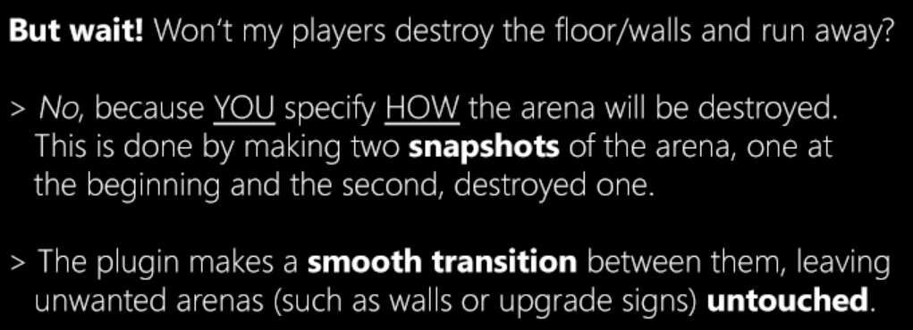

I didn’t catch the full implication of this until reading it a 2nd time. Basically, the end-user has to infer that they should delete the whole arena except for what they want to keep undestroyed. I think a simpler implementation of this functionality would be to allow everything in the defined arena region to be destroyed by default, and set a 1 block no-pass / no-destroy zone across all 6 surfaces of the defined arena region. You could also hard code the upgrade signs & the like to be non-breakable by default. (These settings could be adjustable in the config if the user wanted) This would potentially eliminate the entire tedious step of deleting massive areas of the arena just to produce the “damaged snapshot”.

The implementation of selecting only solid cubic blocks for lobby,mob,player spawn is just a very poor choice. This limits the end-users ability to customize the arena by setting exact x,y,z coords. (I wanted my lobby spawn to be in between 2 pillars that were 2 blocks apart so the spawn point should have been something like 25.5,60,32.999. (not 25.5,60,32.5)

Also connecting a spawner location to a “physical block” is very bizzare since you cannot define mob spawn points in mid-air without using barrier blocks. Which leads to problems with a scenario like this: …if you we’re trying to create an arena where the mobs rain down on the players, you would now have all these barrier blocks in the way. In addition you can’t use the same spawn point for multiple rounds, this is not conducive to arena design when trying to have bosses for multiple rounds spawn at the same spot in the middle of the arena.

Areas for improvement here would be:
- Allow ANY block type to be used as a spawner selection point. (Not just cubic “solid” blocks)
- Do not tie spawners to physical blocks in edit mode….what I mean by this is separate your block editing with your spawner point selection in two different edit modes.
  - By doing this you can delete blocks used as reference points without deleting the defined spawn point.

Mob spawners need to be numbered as they are placed, it’s nearly impossible to setup a 100 lvl area and keep track of which spawners have been used for which level with out actually checking each one and trying to keep track of ~120 spawners.

Learn some lessons from the MobArena folks:
- Their Wiki is one of the better ones I’ve seen. (Clear concise user guides and technical documentation is key to any good software product)
- They are also doing some things right that CoreArena is severely lacking when it comes to level design, control and setup.
- I’d suggest you separate your level definitions from the individual spawner configurations. The fact the CoreArena requires you to configure every little detail of every single spawner for each level can be a useful feature, but it’s just frustrating when that is the only way to define levels.
- Allow different level types to be defined
  - At least Normal & Boss level classes
- Allow Mob Spawners to be defined as a random spawn location for particular levels or level ranges.
- Define mobs per level in a separate GUI that utilize the random spawn points
- Add config settings to require all mobs to be cleared or not to be cleared prior to a Boss level
- Add config settings to require all mobs to be cleared or not to be cleared after a Boss level
- Implement spawner mob-production advancement per spawner or by the level definitions that utilize the random-spawn-points.
  - Allow user to define algebraically the mob multiplier advancement curve.

Note: I have a large colosseum with sand floor that was extremely difficult to setup mob spawner points with this plugin. I had to place sandstone everywhere so that I could set mob spawner locations. (OH and now the players know where all the mob spawn points are for each round….just great.)

Also you mentioned on your Spigot page the following misleading statement: (Obviously the end-user does not have “total control” based on the above comments.)

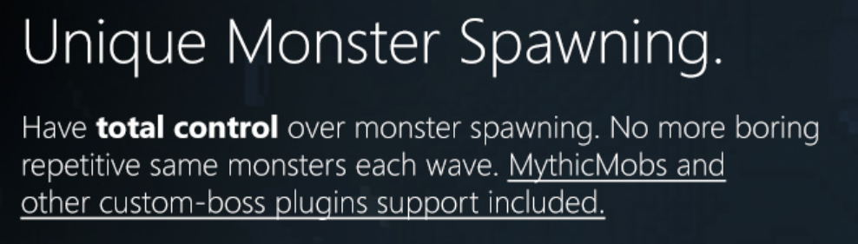

I was getting really tired at this point it was like 2am and I did’nt feel like testing any more. (Nothing below this point was thoroughly tested, so I might make some incorrect assumptions.)

CoreArena Data/File storage seems to behave strangely:
- Files don’t seem to update in real time when changes are made in game
- Running “/ma reload” doesn’t seem to work as expected
  - Manually editing files while game is running then executing “/ma reload” does not implement the changes made to the class file. (I think it might only load changes made to the config.yml. (I didn’t check the upgrades files))

Other thoughts comments:
- CoreArena doesn’t “seem” to remember (or blocks) player position data within the Arena. (When not running a match.) If Op & or Member players log out while in the arena zone they are kicked back to the server spawn upon login. (even when there is no match running) ….I guess this could be considered a safeguard feature to keep people out of the arena when their not supposed to be in there. I just found this annoying when trying to setup the arena and troubleshoot the crash issue I was experiencing.
- ….is there a way to change the really weird death sound effects?
  - Don’t force stuff like this on end-users w/o giving them a way to change it
- …ditto on the use of the currency term “nuggets” this is not the best choice for a currency name since nuggets can be slang for “turds”. (Yup that’s right, I said turds, no joke)
  - Allow users to change the CoreArena currency name

I never actually got to play in a functioning CoreArena due to the issue noted in Discord, which I am guessing is a issue between MMOCore and CoreArena. So for now I’ll be sticking with MobArena. I REALLY like some of the features you put into this plugin like the gravitaional (physics) force effects & the player leveling/upgrading. But given the crash problem and huge list of usability issues noted above I won’t be switching over to your plugin at this time. If I understand correctly you have been in school and probably been working on other projects like Punish Control. However, this plugin feels like it’s a very unfinished unpolished state to be considered a “premium plugin” it’s missing a lot of usability functionality, and seems a bit buggy, which make it difficult to setup and use compared to other products on the market.

Best of Luck, Tarlak333

