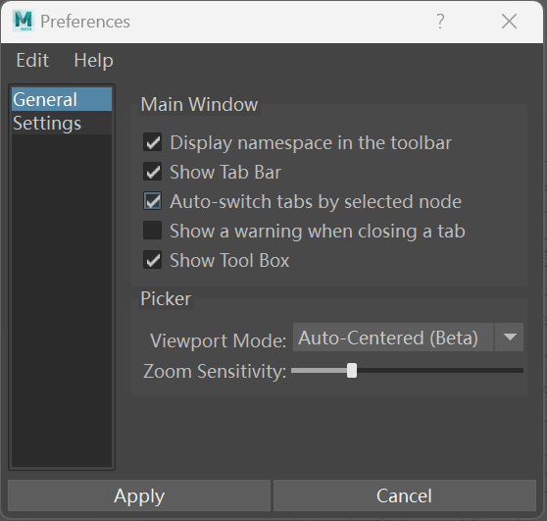

**Main Window Preferences**

**Display namespace in the toolbar**

Whether to display the Namespace in the toolbar. This is not fundamentally different from the "**Edit** -> **Change Namespace**" option, it simply provides a quicker way to select the Namespace.

**Show Tab Bar**

Whether to display the tab bar. (If you want the picker to feel more focused, you can try hiding it.)

**Auto-switch tabs by selected node**

Automatically switch to the corresponding picker based on the selected object (if the node has already been added to the picker’s internal buttons).

**Show a warning when closing a tab**

Whether to display a warning dialog when closing the picker.

**Show Tool Box**

Whether to display the tool box widget. (If you want the picker to feel more focused, you can try hiding it.)

**Picker Preferences**

**ViewPort Mode**

This option provides "**Auto-Centered**" and "**Fixed**" for selection.

The former automatically centers the view, while the latter fixes the view (similar to **AnimSchoolPicker** behavior).

**Zoom Sensitivity**

Scene zoom mouse sensitivity.

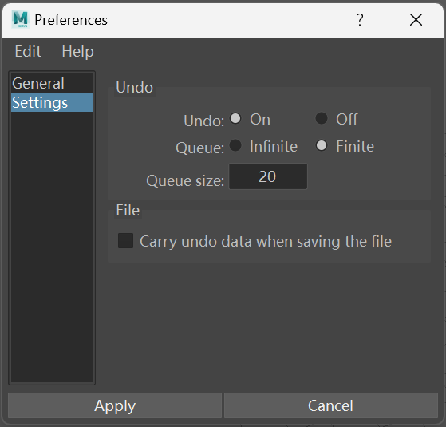

**Undo Preferences**

**Undo**

Whether to enable undo functionality. If you choose to disable undo, all undo data for the current Picker will be deleted.

**Queue**

Number of undo steps, either limited or unlimited.

**File Preferences**

**Carry undo data when saving the file**

Whether to carry undo data when saving the file. (This option is disabled by default, as enabling it will significantly increase the file size!)