**LEMBAR JAWABAN TUGAS**

Nama : Melani 212310049 / TI-21-PA1

Mata Kuliah : Lab PBO Praktikum 7

Dosen : Febri Damatraseta Fairuz, S.T, M.Kom / 3320190306

FormPage

**package** com.ibik.pbo.praktikum;

**import** java.awt.Font;

**import** java.awt.BorderLayout;

**import** java.awt.FlowLayout;

**import** java.awt.Dimension;

**import** javax.swing.BorderFactory;

**import** javax.swing.ButtonGroup;

**import** javax.swing.JButton;

**import** javax.swing.JFrame;

**import** javax.swing.JLabel;

**import** javax.swing.JMenu;

**import** javax.swing.JMenuBar;

**import** javax.swing.JMenuItem;

**import** javax.swing.JPanel;

**import** javax.swing.JRadioButton;

**import** javax.swing.JScrollPane;

**import** javax.swing.JTable;

**import** javax.swing.JTextField;

**import** javax.swing.WindowConstants;

**import** javax.swing.border.Border;

**public** **class** FormPage **extends** JFrame {

/**

*

*/

**private** **static** **final** **long** ***serialVersionUID*** = 1L;

FormPage() {

setVisible(**true**);

pack();

setLocationRelativeTo(**null**);

setSize(1000, 480);

setTitle("Form");

setDefaultCloseOperation(WindowConstants.***EXIT_ON_CLOSE***);

GenerateUI(**this**);

}

**public** **static** **void** main(String[] args) {

**new** FormPage();

}

**private** **void** GenerateUI(FormPage frame) {

// Menu

JMenuBar menuBar = **new** JMenuBar();

JMenu fileMenu = **new** JMenu("File");

JMenu editMenu = **new** JMenu("Edit");

JMenu helpMenu = **new** JMenu("Help");

menuBar.add(fileMenu);

menuBar.add(editMenu);

menuBar.add(helpMenu);

JMenuItem item1 = **new** JMenuItem("New");

JMenuItem item2 = **new** JMenuItem("Save");

JMenuItem item3 = **new** JMenuItem("Exit");

fileMenu.add(item1);

fileMenu.add(item2);

fileMenu.add(item3);

frame.setJMenuBar(menuBar);

// Main Panel

JPanel mainPanel = **new** JPanel();

mainPanel.setLayout(**new** BorderLayout());

frame.setContentPane(mainPanel);

// Header Title

JPanel headerPanel = **new** JPanel();

headerPanel.setLayout(**new** FlowLayout(FlowLayout.***CENTER***));

mainPanel.add(headerPanel, BorderLayout.***NORTH***);

JLabel headerTitle = **new** JLabel("FORM PENILAIAN MATAKULIAH PBO");

headerTitle.setFont(**new** Font("Arial", Font.***PLAIN***, 30));

headerPanel.add(headerTitle);

// Start of Form

Border lftPanelBorder = BorderFactory.*createTitledBorder*("Input Data Mahasiswa");

JPanel leftPanel = **new** JPanel();

leftPanel.setLayout(**null**);

leftPanel.setPreferredSize(**new** Dimension(480, 480));

mainPanel.add(leftPanel, BorderLayout.***WEST***);

// Start of Panel Content

// // Input NPM

JLabel npmLabel = **new** JLabel("NPM");

npmLabel.setBounds(22, 40, 80, 30);

leftPanel.add(npmLabel);

JTextField inputNPM = **new** JTextField();

inputNPM.setBounds(22, 80, 400, 30);

leftPanel.add(inputNPM);

// // Input Nama

JLabel namaLabel = **new** JLabel("Nama");

namaLabel.setBounds(22, 120, 80, 30);

leftPanel.add(namaLabel);

JTextField inputNama = **new** JTextField();

inputNama.setBounds(22, 160, 400, 30);

leftPanel.add(inputNama);

// // Input Nilai

JLabel gradeLabel = **new** JLabel("Nilai");

gradeLabel.setBounds(22, 200, 80, 30);

leftPanel.add(gradeLabel);

JRadioButton gradeA = **new** JRadioButton("A");

gradeA.setBounds(25, 240, 50, 30);

leftPanel.add(gradeA);

JRadioButton gradeB = **new** JRadioButton("B");

gradeB.setBounds(100, 240, 50, 30);

leftPanel.add(gradeB);

JRadioButton gradeC = **new** JRadioButton("C");

gradeC.setBounds(175, 240, 50, 30);

leftPanel.add(gradeC);

JRadioButton gradeD = **new** JRadioButton("D");

gradeD.setBounds(250, 240, 50, 30);

leftPanel.add(gradeD);

JRadioButton gradeE = **new** JRadioButton("E");

gradeE.setBounds(325, 240, 50, 30);

leftPanel.add(gradeE);

JRadioButton gradeF = **new** JRadioButton("F");

gradeF.setBounds(400, 240, 50, 30);

leftPanel.add(gradeF);

ButtonGroup bg = **new** ButtonGroup();

bg.add(gradeA);

bg.add(gradeB);

bg.add(gradeC);

bg.add(gradeD);

bg.add(gradeE);

bg.add(gradeF);

// // Button CRUD Data

JButton btnSave = **new** JButton("Save");

btnSave.setBounds(25, 280, 100, 30);

leftPanel.add(btnSave);

JButton btnDelete = **new** JButton("Delete");

btnDelete.setBounds(175, 280, 100, 30);

leftPanel.add(btnDelete);

JButton btnClear = **new** JButton("Clear");

btnClear.setBounds(325, 280, 100, 30);

leftPanel.add(btnClear);

// End of Panel Content

leftPanel.setBorder(lftPanelBorder);

// End of Form

// Table

Border rPanelBorder = BorderFactory.*createTitledBorder*("Data Mahasiswa");

JPanel rightPanel = **new** JPanel();

rightPanel.setLayout(**new** FlowLayout(FlowLayout.***CENTER***));

mainPanel.add(rightPanel, BorderLayout.***EAST***);

String data[][] = {

{ "212310004", "ani", "B" },

{ "212310002", "mel", "C" },

{ "212310003", "melani", "A" }

};

String column[] = {

"Student ID",

"Name",

"Grade"

};

JTable jt = **new** JTable(data, column);

jt.setBounds(22, 40, 480, 450);

JScrollPane sp = **new** JScrollPane(jt);

rightPanel.add(sp);

rightPanel.setBorder(rPanelBorder);

}

}

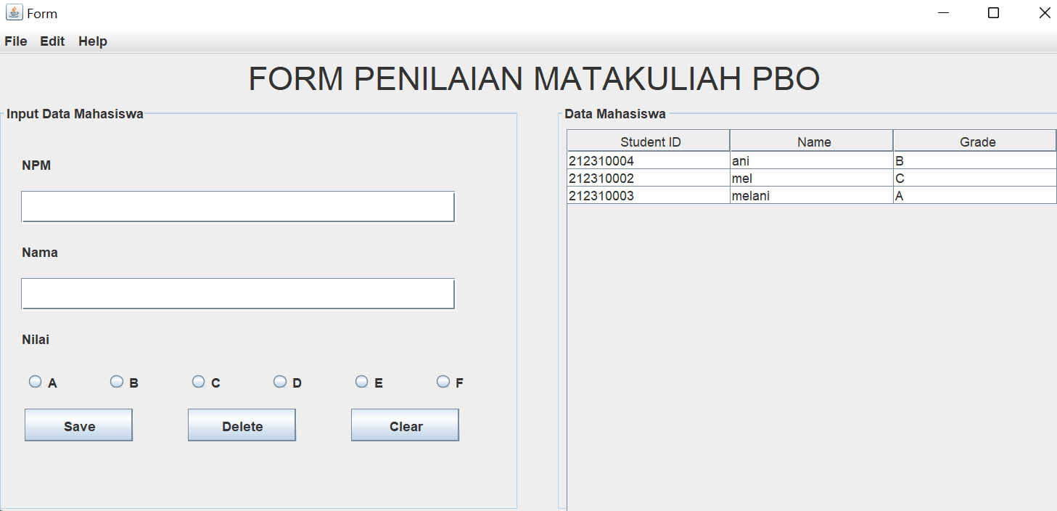

Login

**package** com.ibik.pbo.praktikum;

**import** java.awt.BorderLayout;

**import** java.awt.Color;

**import** javax.swing.JButton;

**import** javax.swing.JCheckBox;

**import** javax.swing.JFrame;

**import** javax.swing.JLabel;

**import** javax.swing.JOptionPane;

**import** javax.swing.JPanel;

**import** javax.swing.JPasswordField;

**import** javax.swing.JTextField;

**import** javax.swing.SwingConstants;

**import** javax.swing.WindowConstants;

**import** java.awt.event.ActionEvent;

**import** java.awt.event.ActionListener;

**public** **class** Login **extends** JFrame {

/**

*

*/

**private** **static** **final** **long** ***serialVersionUID*** = 1L;

Login() {

setVisible(**true**);

pack();

setLocationRelativeTo(**null**);

setSize(400, 400);

setTitle("Contoh Window Frame");

setDefaultCloseOperation(WindowConstants.***EXIT_ON_CLOSE***);

GenerateUI(**this**);

}

**public** **static** **void** main(String[] args) {

**new** Login();

}

**private** **void** GenerateUI(Login frame) {

JPanel mainPanel = **new** JPanel();

mainPanel.setLayout(**new** BorderLayout());

frame.setContentPane(mainPanel);

JPanel panel1 = **new** JPanel();

panel1.setLayout(**null**);

mainPanel.add(panel1, BorderLayout.***NORTH***);

JLabel lblEmail = **new** JLabel("Email");

lblEmail.setBounds(22, 23, 80, 16);

panel1.add((lblEmail));

**final** JTextField textEmail = **new** JTextField();

textEmail.setBounds(105, 18, 169, 30);

panel1.add(textEmail);

JLabel lblPassword = **new** JLabel("Password");

lblPassword.setBounds(22, 69, 61, 16);

panel1.add(lblPassword);

**final** JPasswordField textPassword = **new** JPasswordField();

textPassword.setBounds(105, 64, 169, 30);

panel1.add(textPassword);

JCheckBox chkRemember = **new** JCheckBox("Remember Account ?");

chkRemember.setBounds(105, 100, 169, 40);

panel1.add(chkRemember);

JButton btnRegister = **new** JButton("Register");

btnRegister.setBounds(105, 150, 83, 40);

btnRegister.addActionListener(**new** ActionListener() {

@Override

**public** **void** actionPerformed(ActionEvent e) {

Login regPage = **new** Login();

regPage.setVisible(**true**);

dispose();

}

});

panel1.add(btnRegister);

JButton btnLogin = **new** JButton("Login");

btnLogin.setBounds(205, 150, 83, 40);

btnLogin.addActionListener(**new** ActionListener() {

@Override

**public** **void** actionPerformed(ActionEvent e) {

String data[] = {

"212310004@student.ibik.ac.id",

"212310004",

"MuhamadAgus"

};

String inputedPass = **new** String(textPassword.getPassword());

**if** (textEmail.getText().isEmpty() || inputedPass.isEmpty()) {

JOptionPane.*showMessageDialog*(**null**, "Silakan mengisi data dengan benar", "Alert!",

JOptionPane.***ERROR_MESSAGE***);

} **else** {

**if** (!textEmail.getText().equals(data[0]) && !inputedPass.equals(data[1])) {

JOptionPane.*showMessageDialog*(**null**, "Data yang anda masukan salah!", "Alert!",

JOptionPane.***ERROR_MESSAGE***);

} **else** {

JOptionPane.*showMessageDialog*(**null**, "Selamat datang " + data[2], "Success!",

JOptionPane.***INFORMATION_MESSAGE***);

FormPage formPage = **new** FormPage();

formPage.setVisible(**true**);

dispose();

}

}

}

});

panel1.add(btnLogin);

JLabel lblCopyright = **new** JLabel("copyright IBIK @ 2022", SwingConstants.***CENTER***);

lblCopyright.setBackground(Color.***BLUE***);

lblCopyright.setSize(300, 50);

mainPanel.add(lblCopyright, BorderLayout.***SOUTH***);

frame.add(panel1);

}

}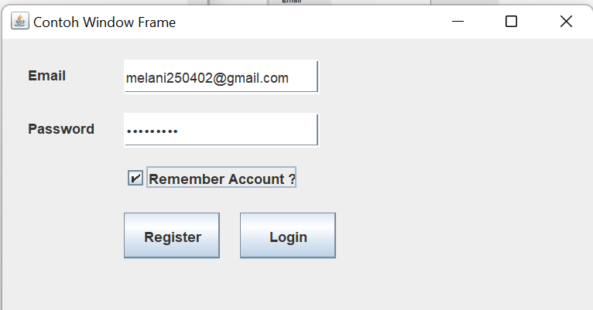

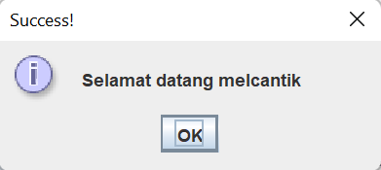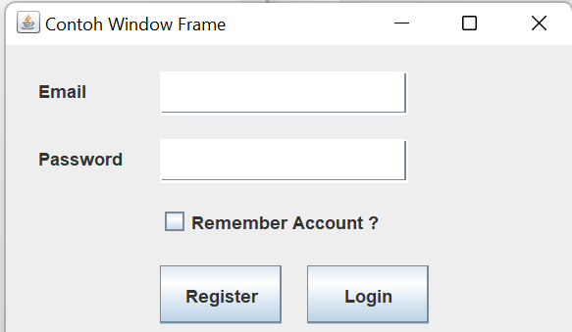

Register

**package** com.ibik.pbo.praktikum;

**import** java.awt.BorderLayout;

**import** javax.swing.ButtonGroup;

**import** javax.swing.JButton;

**import** javax.swing.JComboBox;

**import** javax.swing.JFrame;

**import** javax.swing.JLabel;

**import** javax.swing.JOptionPane;

**import** javax.swing.JPanel;

**import** javax.swing.JRadioButton;

**import** javax.swing.JTextField;

**import** javax.swing.WindowConstants;

**import** java.awt.event.ActionEvent;

**import** java.awt.event.ActionListener;

**import** java.util.ArrayList;

**public** **class** Register **extends** JFrame {

/**

*

*/

**private** **static** **final** **long** ***serialVersionUID*** = 1L;

Register() {

setVisible(**true**);

pack();

setLocationRelativeTo(**null**);

setSize(500, 500);

setTitle("Contoh Window Frame");

setDefaultCloseOperation(WindowConstants.***EXIT_ON_CLOSE***);

GenerateUI(**this**);

}

**public** **static** **void** main(String[] args) {

**new** Register();

}

**private** **void** GenerateUI(Register frame) {

JPanel mainPanel = **new** JPanel();

mainPanel.setLayout(**new** BorderLayout());

frame.setContentPane(mainPanel);

JPanel panel1 = **new** JPanel();

panel1.setLayout(**null**);

mainPanel.add(panel1, BorderLayout.***NORTH***);

JLabel lblFullName = **new** JLabel("Fullname");

lblFullName.setBounds(22, 23, 80, 16);

panel1.add(lblFullName);

**final** JTextField textFullName = **new** JTextField();

textFullName.setBounds(105, 18, 169, 30);

textFullName.setEditable(**true**);

panel1.add(textFullName);

JLabel lblEmail = **new** JLabel("Email");

lblEmail.setBounds(22, 69, 61, 16);

panel1.add(lblEmail);

**final** JTextField textEmail = **new** JTextField();

textEmail.setBounds(105, 64, 169, 30);

panel1.add(textEmail);

JLabel lblPhone = **new** JLabel("Phone");

lblPhone.setBounds(22, 109, 61, 16);

panel1.add(lblPhone);

**final** JTextField txtPhone = **new** JTextField();

txtPhone.setBounds(105, 104, 169, 30);

panel1.add(txtPhone);

JLabel lblGender = **new** JLabel("Gender");

lblGender.setBounds(22, 150, 61, 16);

panel1.add(lblGender);

**final** JRadioButton radioGender1 = **new** JRadioButton("Female");

radioGender1.setBounds(105, 145, 100, 30);

panel1.add(radioGender1);

**final** JRadioButton radioGender2 = **new** JRadioButton("Male");

radioGender2.setBounds(200, 145, 100, 30);

panel1.add(radioGender2);

ButtonGroup bg = **new** ButtonGroup();

bg.add(radioGender1);

bg.add(radioGender2);

JLabel lblCityzen = **new** JLabel("Citizenship");

lblCityzen.setBounds(22, 185, 100, 16);

panel1.add(lblCityzen);

String country[] = {

"Indonesia",

"India",

"Australia",

"U.S.A",

"England",

"New Zealand"

};

**final** JComboBox<String> selectCitizen = **new** JComboBox<>(country);

selectCitizen.setBounds(105, 180, 169, 30);

panel1.add(selectCitizen);

JButton btnSubmit = **new** JButton("Submit");

btnSubmit.setBounds(105, 250, 169, 40);

ActionListener actionSubmit = **new** ActionListener() {

**public** **void** actionPerformed(ActionEvent e) {

ArrayList<String> data = **new** ArrayList<String>();

**if** (!textFullName.getText().isEmpty()) {

data.add(textFullName.getText());

} **else** {

JOptionPane.*showMessageDialog*(**null**,

"Data tidak boleh kosong (Nama Kosong). Silakan periksa kembali isian anda.",

"Alert!", JOptionPane.***ERROR_MESSAGE***);

}

**if** (!textEmail.getText().isEmpty()) {

data.add(textEmail.getText());

} **else** {

JOptionPane.*showMessageDialog*(**null**,

"Data tidak boleh kosong (Email Kosong). Silakan periksa kembali isian anda.",

"Alert!", JOptionPane.***ERROR_MESSAGE***);

}

**if** (!txtPhone.getText().isEmpty()) {

data.add(txtPhone.getText());

} **else** {

JOptionPane.*showMessageDialog*(**null**,

"Data tidak boleh kosong (No. Telepon Kosong). Silakan periksa kembali isian anda.",

"Alert!", JOptionPane.***ERROR_MESSAGE***);

}

**if** (radioGender1.isSelected()) {

data.add(radioGender1.getText());

} **else** **if** (radioGender2.isSelected()) {

data.add(radioGender2.getText());

}

data.add(selectCitizen.getSelectedItem().toString());

String output = "";

output += "Name : " + data.get(0) + "\n";

output += "Email : " + data.get(1) + "\n";

output += "Phone : " + data.get(2) + "\n";

output += "Gender : " + data.get(3) + "\n";

output += "Citizenship : " + data.get(4) + "\n";

JOptionPane.*showMessageDialog*(**null**, output, "Test Submit", JOptionPane.***INFORMATION_MESSAGE***);

Login loginPage = **new** Login();

loginPage.setVisible(**true**);

dispose();

}

};

btnSubmit.addActionListener(actionSubmit);

panel1.add(btnSubmit);

frame.add(panel1);

}

}

