1 .Invoke \dist\mgrmgr.exe
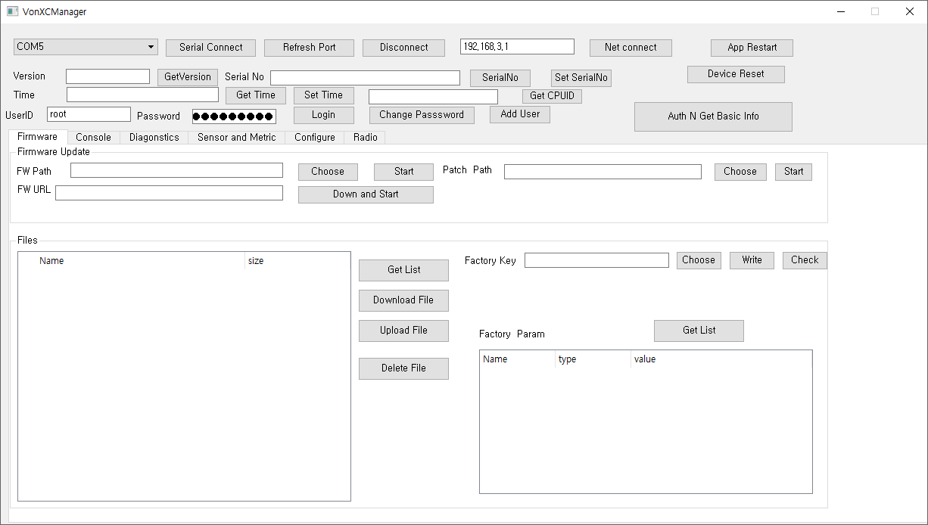

2. Connect USB
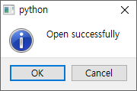

3. choose Confirgue Tab

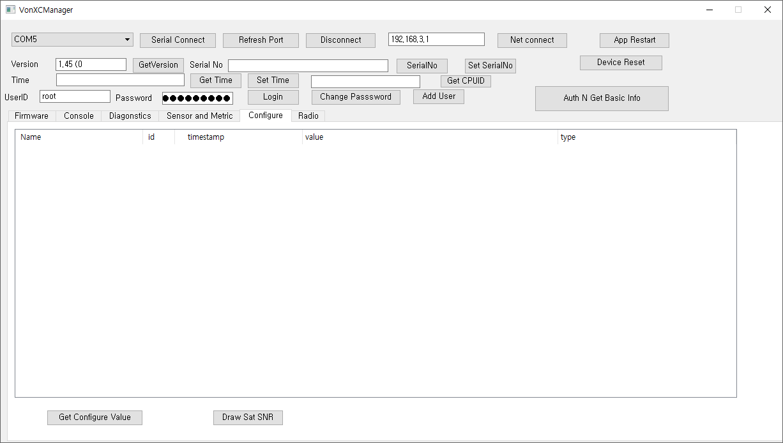

4. Click configure Value

4. Confirm configure value list & click ‘dconfigure_radio_apn’

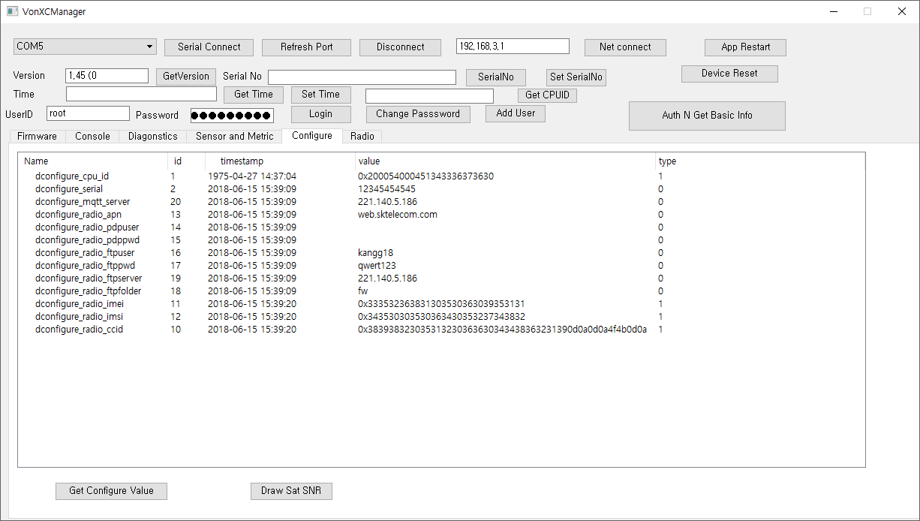
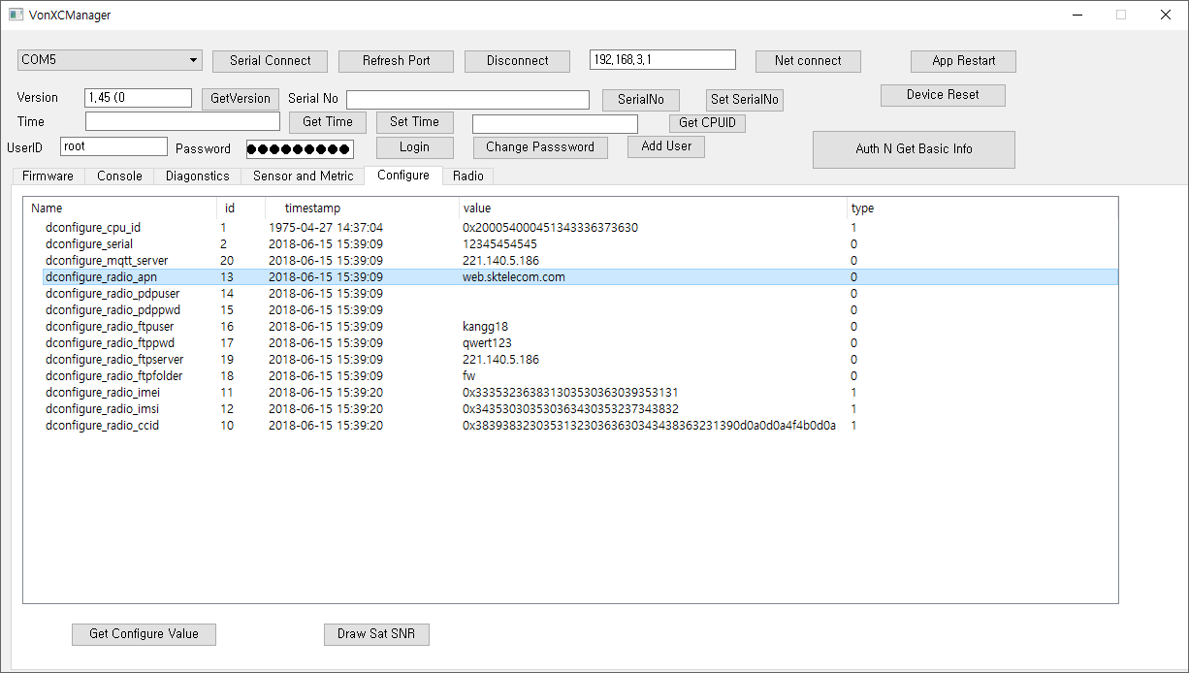

5. Edit APN in notepad(No Space) and Save

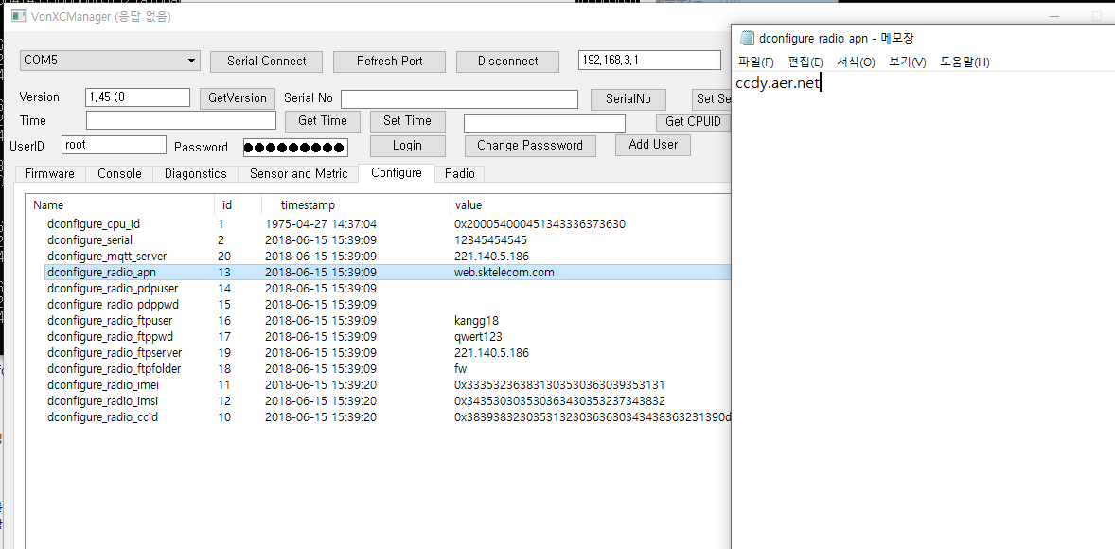

6. Click to configure Value , Confirm changed value
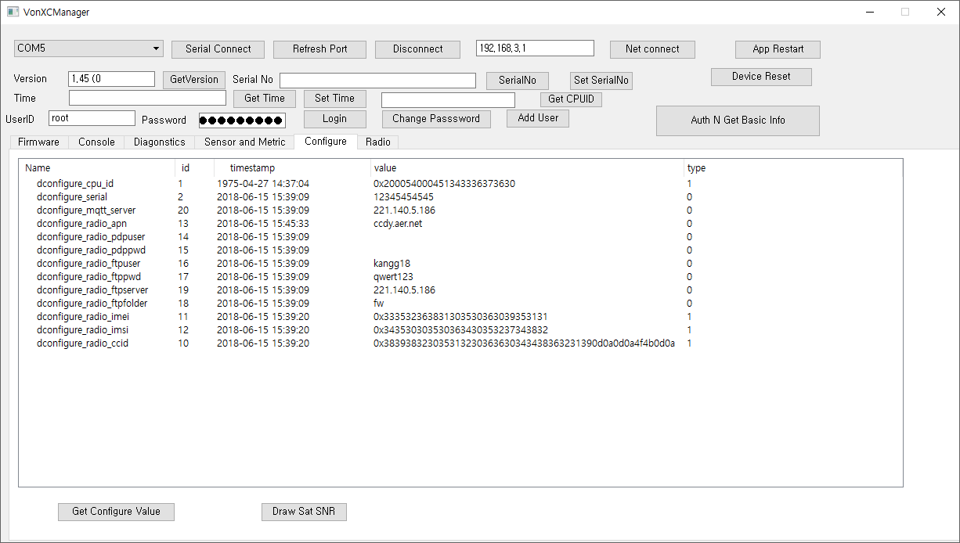

7. Click device restart

