1 .Invoke \dist\mgrmgr.exe
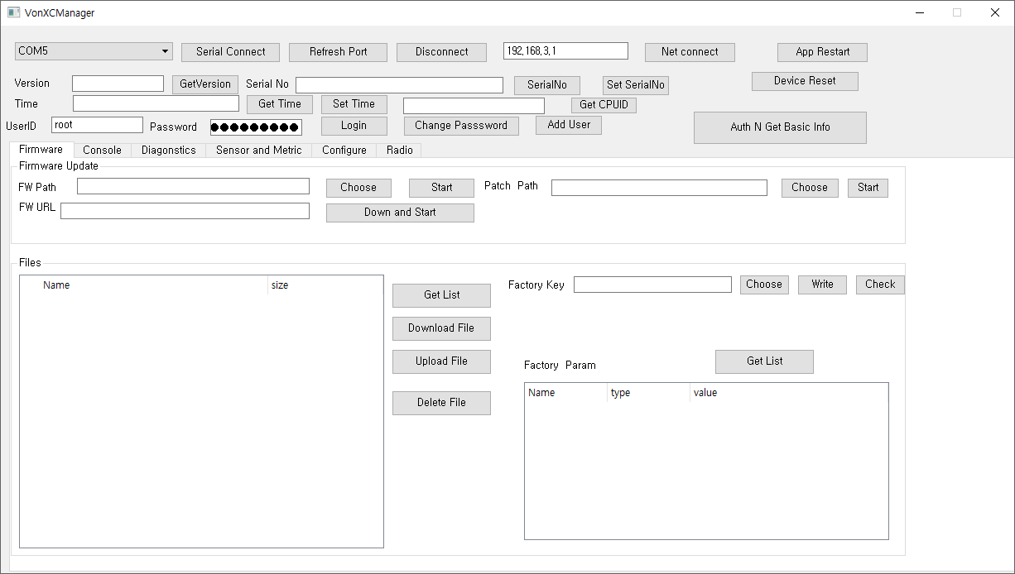

2. Connect USB
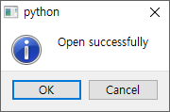

3. Choose Firmware - bin\{version}\vonxc.elf.binary

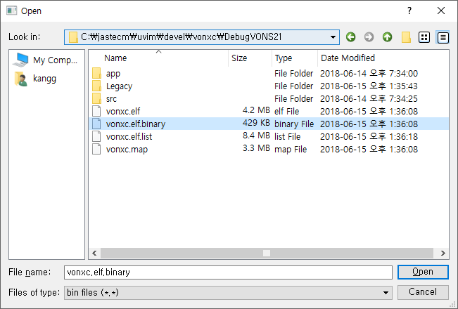

4. Click Start

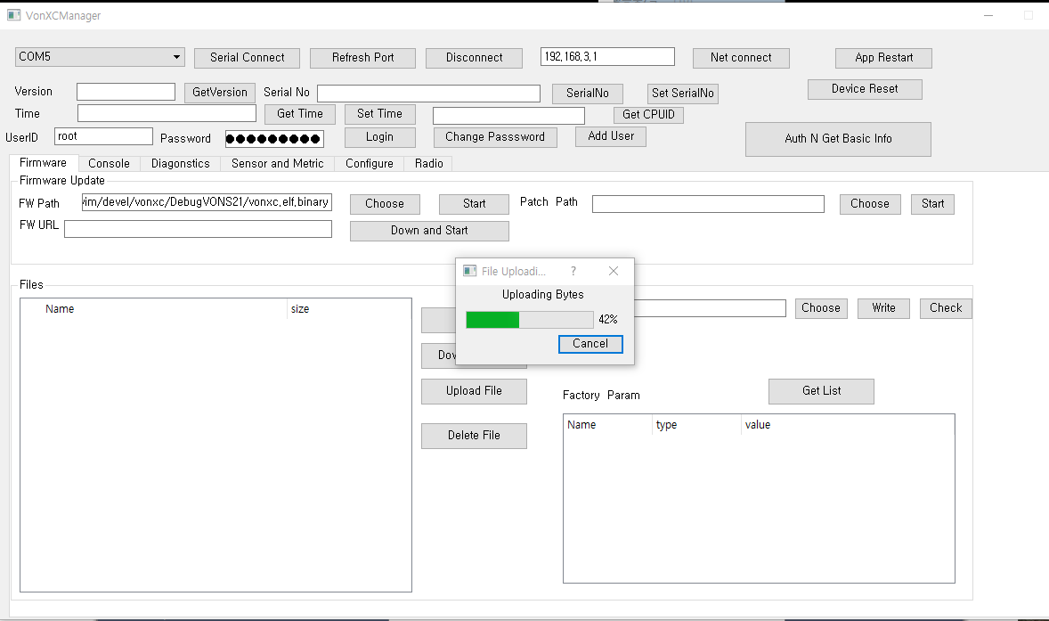

5. Reconfirm after reboot – wait 2 min

