1 .Invoke \dist\mgrmgr.exe
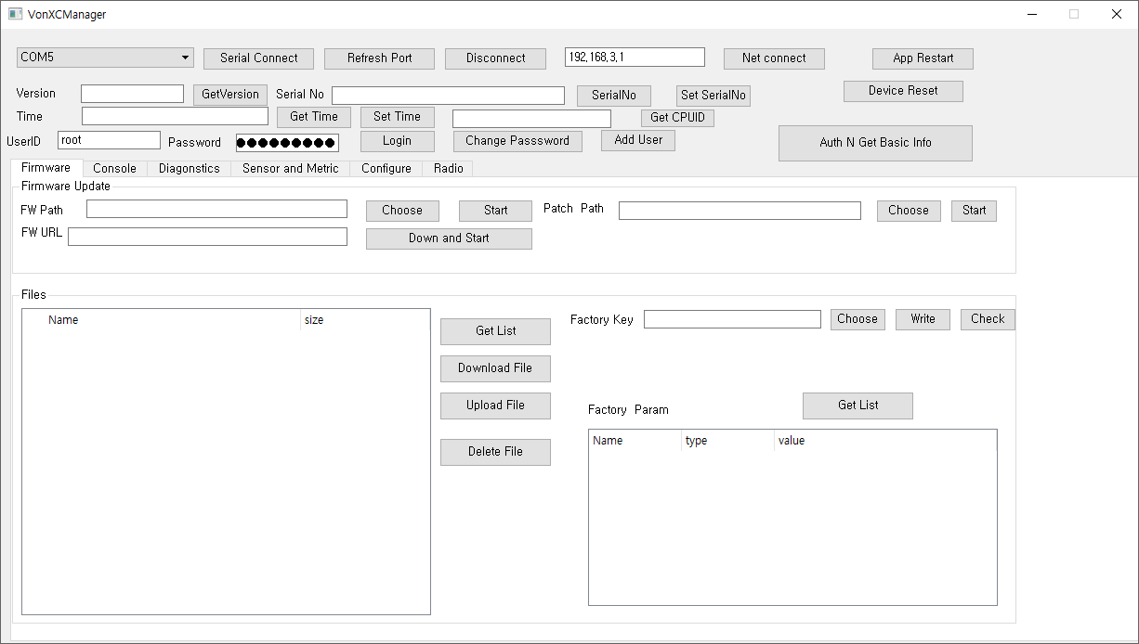

2. Connect USB
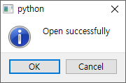

3. Choose Firmware Tab

4 Get List

5. Check File List confirm “ignsp.txt”
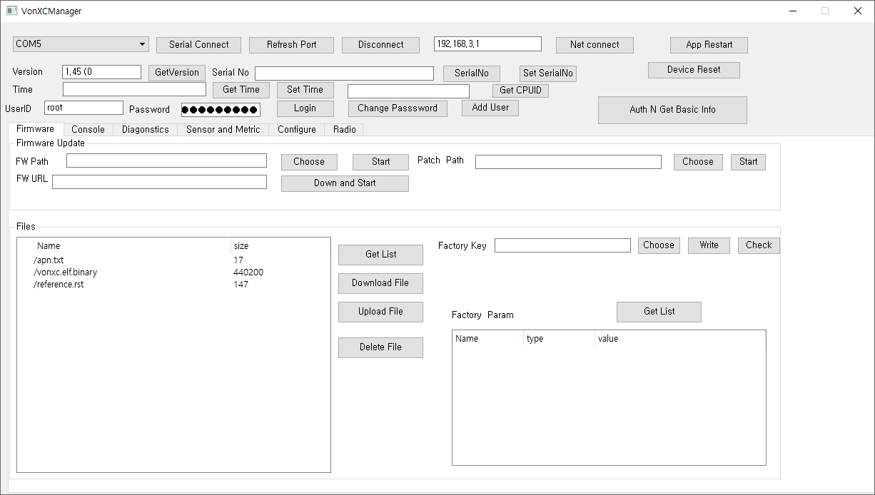

6. Choose upload file

4. Confirm “ignsp.txt” Click “ignsp.txt”
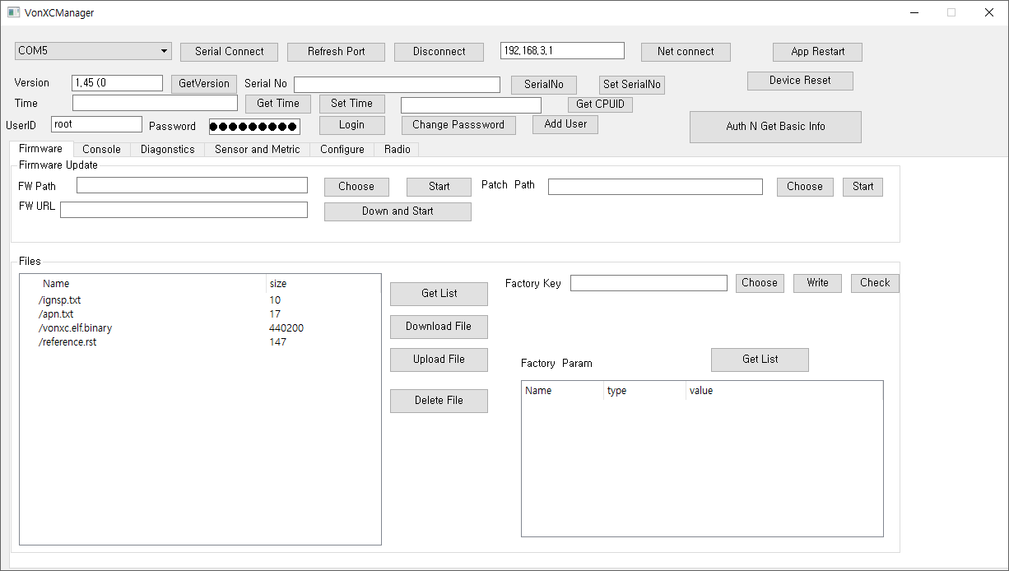

5. Reconfirm ignsp.txt

