1 .Radio : Connection Time
Metric_radio_ttfc – time to first connection , Registration time , value mili sec after boot
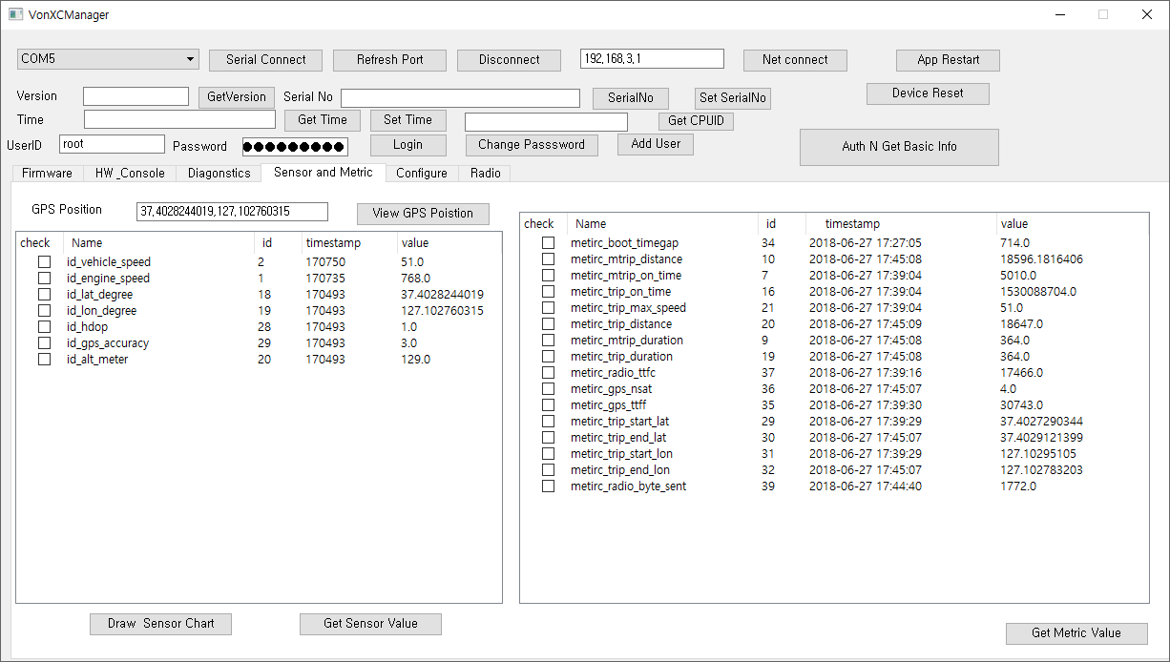

2 .GPS
Metric_gps_ttft– time to first fixation, mili sec after boot
Metric_gps_nsat– number of satellite
Id_hdop – horizontal dilution of precision
Id_gps_accuracy - Id_hdop * Telit module parameter (3m)
Click ‘Get Sensor Value’ In order to Get the current Value
Click ‘Get Metric Value’ In order to Get the current Value

2 .GPS Position Map
Connect to network in Laptop computer
Click the “View GPS Poistion”
Click ‘Get Sensor Value’
Confirm the order of Position(0,1,2,3…)
