1 .Invoke \dist\mgrmgr.exe
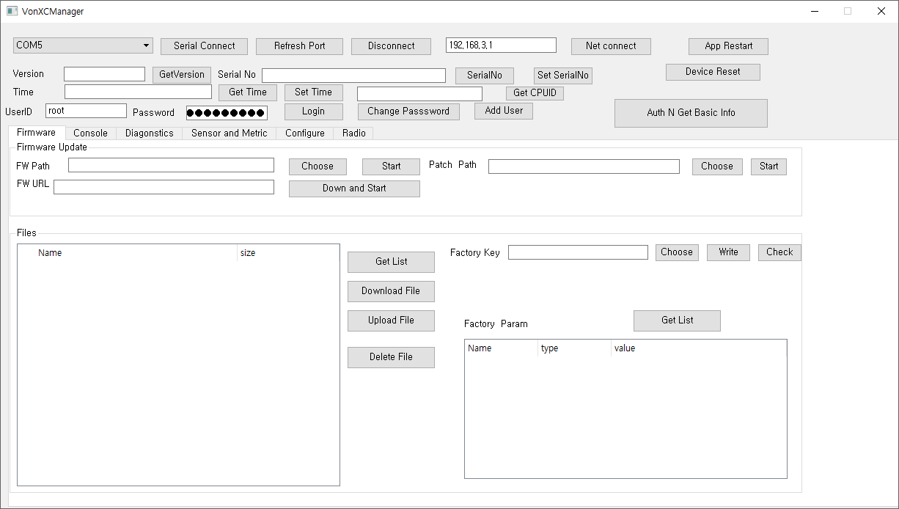

2. Connect USB
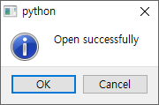

3. Choose Firmware Tab

4 Get List

5. Check File List confirm “ignsp.txt”
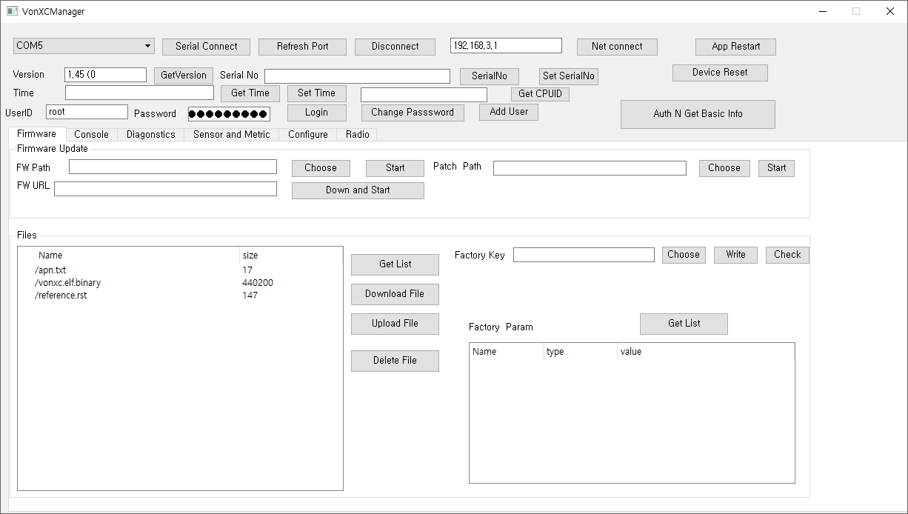

6. Confirm File List
In case of OBD-2
Bus.json
Ignsp.txt

In case of Maker
Igndiag.json
Messageset.json

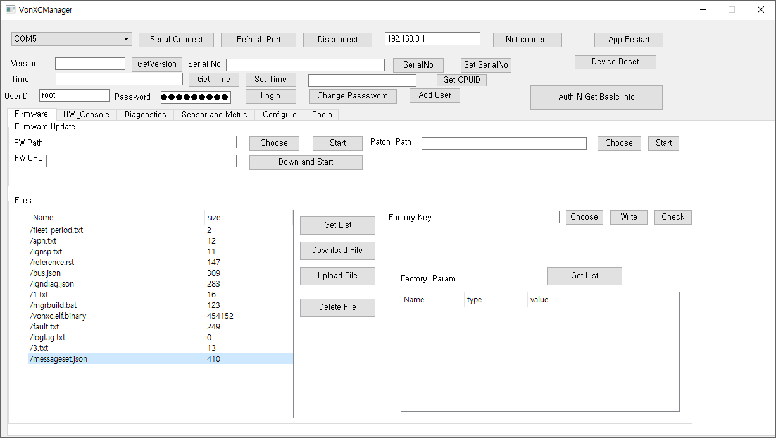

7. Confirm sensor tab
Id_vehcile_speed
Id_engine_speed

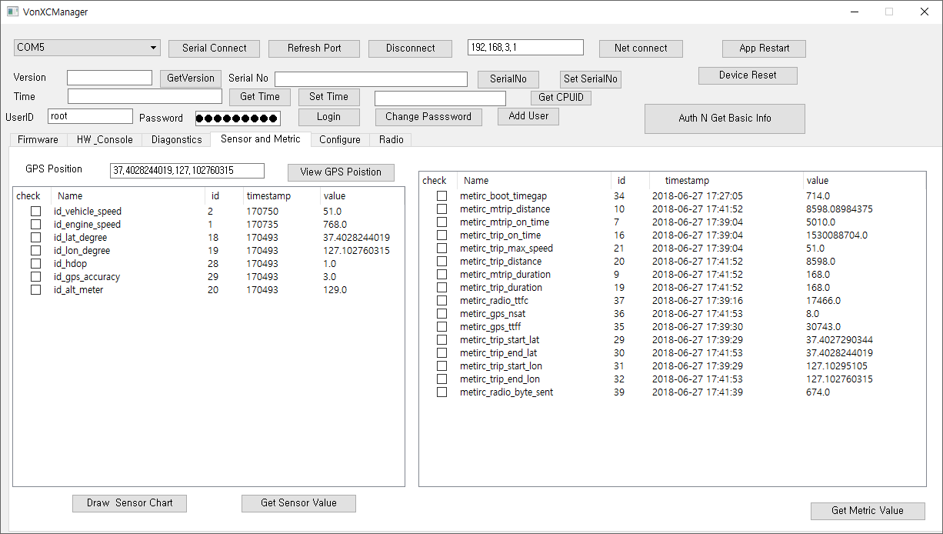

8. Confirm VIN in configure tab
