# Market Entry Strategy Report

## ShipBob × KR

## Executive

|  |  |  |  |
| --- | --- | --- | --- |
| Decision: | Coverage: 0% | TBD: 0% | Risk: |

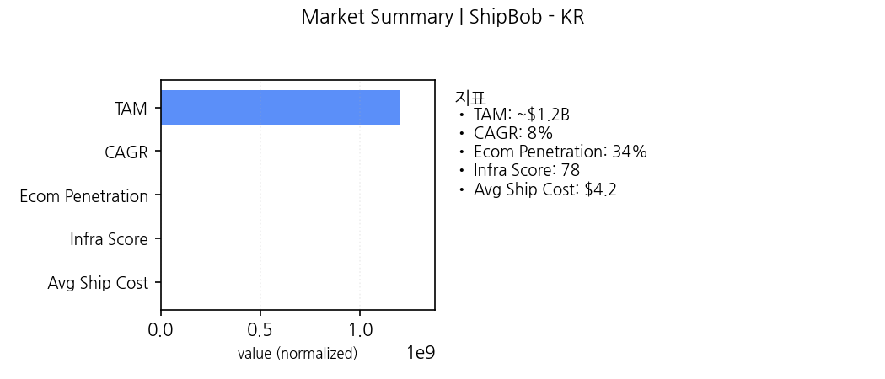

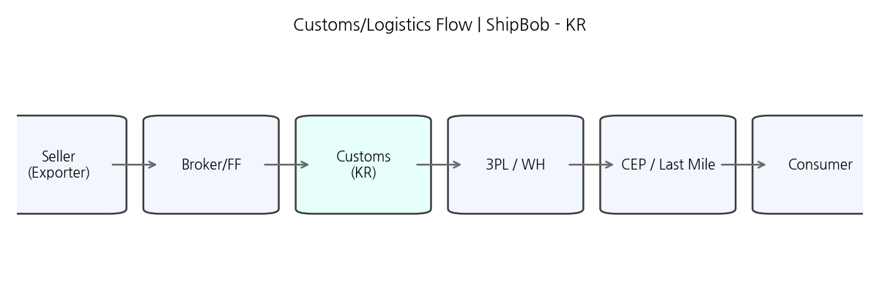

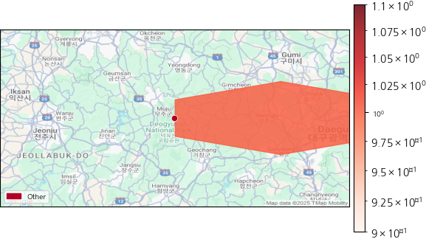

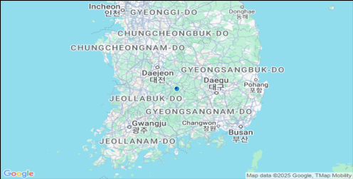

Market image: outputs/ShipBob_KR\01_market_summary_ShipBob_KR.png

Regulation image: outputs/ShipBob_KR\02_customs_flow_ShipBob_KR.png

Competition map: outputs/ShipBob_KR\map_ShipBob_KR.png

## Market

Why Now: 크로스보더 수요 증가와 물류 인프라 개선으로 진입 타이밍 양호

|  |  |
| --- | --- |
| Metric | Value |
| TAM | ~$1.2B |
| CAGR | 8% |
| Ecom Penetration | 34% |
| Infra Score | 78 |
| Avg Ship Cost | $4.2 |

## Regulation

Coverage: 60% · TBD: 30% · Risk: 높음

## Competition

* SE corridor
* Port-adjacent SMB
* Cross-border niche

## GTM

|  |  |  |  |
| --- | --- | --- | --- |
| Segment | Score | ICP | Offer |
| mid | 4.7 | 중견/성장 셀러 | 표준 풀필+가이드 킷 |
| high | 3.9 | 엔터프라이즈/대형 셀러 | 전담 풀필+SLA+규제패키지 |
| low | 3.9 | SMB/크로스보더 시범 | 셀프서비스+라이트 풀필 |

## Partners

* ABC Customs (Customs) · priority=High
* XYZ 3PL (3PL) · priority=Mid
* SI-One (SI) · priority=Mid

## Risks

* 규제 해석 지연 · prob=M · impact=H · mitigation=로펌 의견서 (trigger: coverage<0.8)
* SLA 미달 · prob=M · impact=M · mitigation=대체 3PL (trigger: OTD<95%)

## Decision Scorecard

|  |  |
| --- | --- |
| base | 70 |
| cov | 0.6 |
| tbd_ratio | 0.3 |
| competition_high | False |
| partners | 3 |
| final | 65 |

Evidence - Market

* (Gov Stats/https://example.gov, 2025-10-23)
* (Industry Report/https://example.org, 2025-10-23)

Evidence - Regulation

* (Gov Stats/https://example.gov, 2025-10-23)
* (Industry Report/https://example.org, 2025-10-23)

Evidence - Competition

* (Gov Stats/https://example.gov, 2025-10-23)
* (Industry Report/https://example.org, 2025-10-23)

Evidence - GTM

* (Gov Stats/https://example.gov, 2025-10-23)
* (Industry Report/https://example.org, 2025-10-23)

Evidence - Partners

* (Gov Stats/https://example.gov, 2025-10-23)
* (Industry Report/https://example.org, 2025-10-23)

Evidence - Risks

* (Gov Stats/https://example.gov, 2025-10-23)
* (Industry Report/https://example.org, 2025-10-23)

## ShipBob × JP

## Executive

|  |  |  |  |
| --- | --- | --- | --- |
| Decision: RECOMMEND | Coverage: 60% | TBD: 30% | Risk: 높음 |

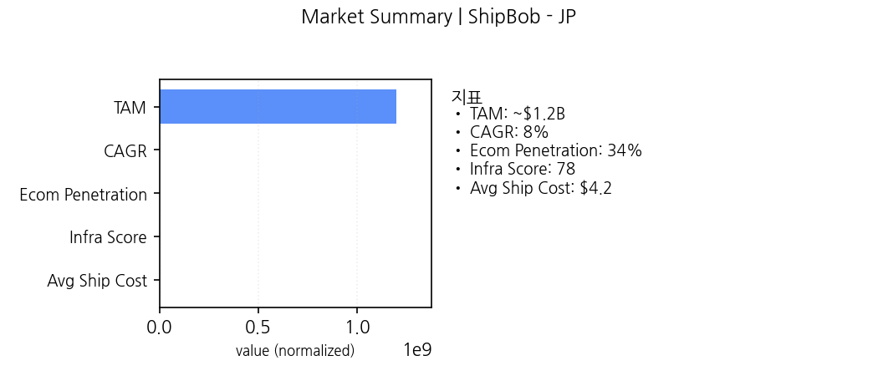

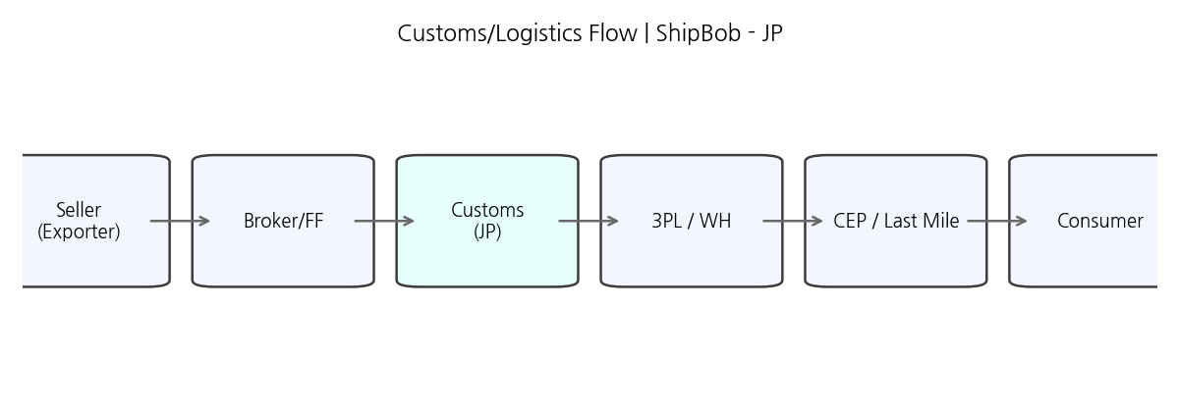

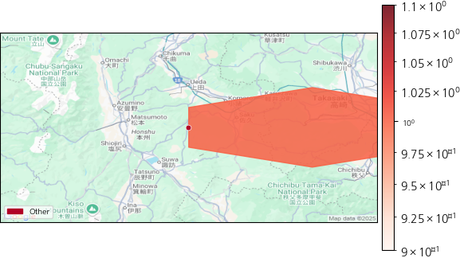

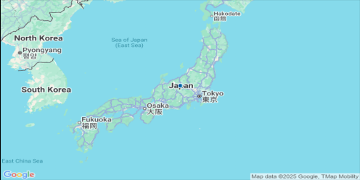

Market image: outputs/ShipBob_JP\01_market_summary_ShipBob_JP.png

Regulation image: outputs/ShipBob_JP\02_customs_flow_ShipBob_JP.png

Competition map: outputs/ShipBob_JP\map_ShipBob_JP.png

## Market

Why Now: 크로스보더 수요 증가와 물류 인프라 개선으로 진입 타이밍 양호

|  |  |
| --- | --- |
| Metric | Value |
| TAM | ~$1.2B |
| CAGR | 8% |
| Ecom Penetration | 34% |
| Infra Score | 78 |
| Avg Ship Cost | $4.2 |

## Regulation

Coverage: 60% · TBD: 30% · Risk: 높음

## Competition

* SE corridor
* Port-adjacent SMB
* Cross-border niche

## GTM

|  |  |  |  |
| --- | --- | --- | --- |
| Segment | Score | ICP | Offer |
| mid | 3.8 | 중견/성장 셀러 | 표준 풀필+가이드 킷 |
| high | 3.7 | 엔터프라이즈/대형 셀러 | 전담 풀필+SLA+규제패키지 |
| low | 3.5 | SMB/크로스보더 시범 | 셀프서비스+라이트 풀필 |

## Partners

* ABC Customs (Customs) · priority=High
* XYZ 3PL (3PL) · priority=Mid
* SI-One (SI) · priority=Mid

## Risks

* 규제 해석 지연 · prob=M · impact=H · mitigation=로펌 의견서 (trigger: coverage<0.8)
* SLA 미달 · prob=M · impact=M · mitigation=대체 3PL (trigger: OTD<95%)

## Decision Scorecard

|  |  |
| --- | --- |
| base | 70 |
| cov | 0.6 |
| tbd_ratio | 0.3 |
| competition_high | False |
| partners | 3 |
| final | 65 |

Evidence - Market

* (Gov Stats/https://example.gov, 2025-10-23)
* (Industry Report/https://example.org, 2025-10-23)

Evidence - Regulation

* (Gov Stats/https://example.gov, 2025-10-23)
* (Industry Report/https://example.org, 2025-10-23)

Evidence - Competition

* (Gov Stats/https://example.gov, 2025-10-23)
* (Industry Report/https://example.org, 2025-10-23)

Evidence - GTM

* (Gov Stats/https://example.gov, 2025-10-23)
* (Industry Report/https://example.org, 2025-10-23)

Evidence - Partners

* (Gov Stats/https://example.gov, 2025-10-23)
* (Industry Report/https://example.org, 2025-10-23)

Evidence - Risks

* (Gov Stats/https://example.gov, 2025-10-23)
* (Industry Report/https://example.org, 2025-10-23)

## Locus.sh × US

## Executive

|  |  |  |  |
| --- | --- | --- | --- |
| Decision: RECOMMEND | Coverage: 60% | TBD: 30% | Risk: 높음 |

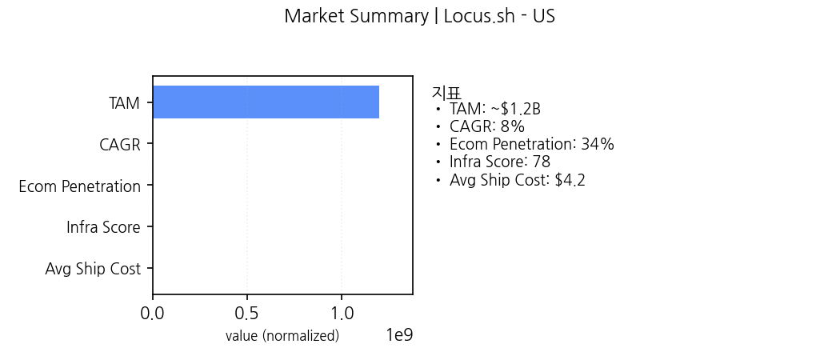

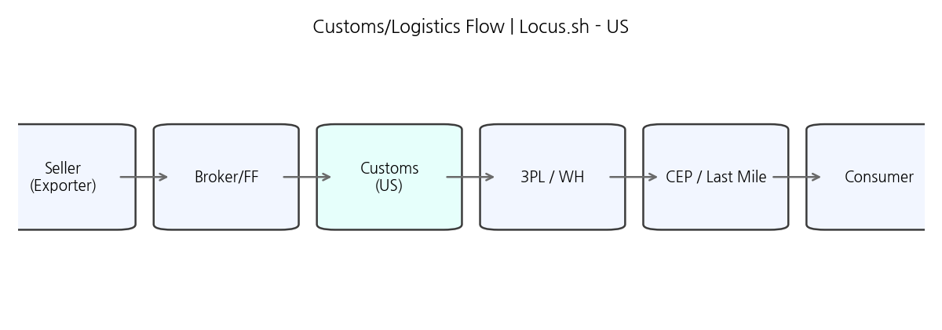

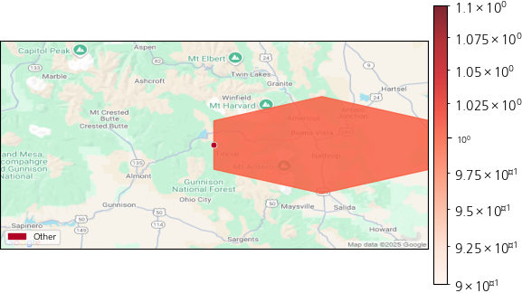

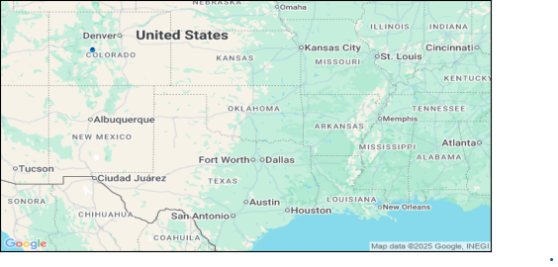

Market image: outputs/Locus.sh_US\01_market_summary_Locus.sh_US.png

Regulation image: outputs/Locus.sh_US\02_customs_flow_Locus.sh_US.png

Competition map: outputs/Locus.sh_US\map_Locus.sh_US.png

## Market

Why Now: 크로스보더 수요 증가와 물류 인프라 개선으로 진입 타이밍 양호

|  |  |
| --- | --- |
| Metric | Value |
| TAM | ~$1.2B |
| CAGR | 8% |
| Ecom Penetration | 34% |
| Infra Score | 78 |
| Avg Ship Cost | $4.2 |

## Regulation

Coverage: 60% · TBD: 30% · Risk: 높음

## Competition

* SE corridor
* Port-adjacent SMB
* Cross-border niche

## GTM

|  |  |  |  |
| --- | --- | --- | --- |
| Segment | Score | ICP | Offer |
| high | 4.1 | 엔터프라이즈/대형 셀러 | 전담 풀필+SLA+규제패키지 |
| mid | 4.0 | 중견/성장 셀러 | 표준 풀필+가이드 킷 |
| low | 3.9 | SMB/크로스보더 시범 | 셀프서비스+라이트 풀필 |

## Partners

* ABC Customs (Customs) · priority=High
* XYZ 3PL (3PL) · priority=Mid
* SI-One (SI) · priority=Mid

## Risks

* 규제 해석 지연 · prob=M · impact=H · mitigation=로펌 의견서 (trigger: coverage<0.8)
* SLA 미달 · prob=M · impact=M · mitigation=대체 3PL (trigger: OTD<95%)

## Decision Scorecard

|  |  |
| --- | --- |
| base | 70 |
| cov | 0.6 |
| tbd_ratio | 0.3 |
| competition_high | False |
| partners | 3 |
| final | 65 |

Evidence - Market

* (Gov Stats/https://example.gov, 2025-10-23)
* (Industry Report/https://example.org, 2025-10-23)

Evidence - Regulation

* (Gov Stats/https://example.gov, 2025-10-23)
* (Industry Report/https://example.org, 2025-10-23)

Evidence - Competition

* (Gov Stats/https://example.gov, 2025-10-23)
* (Industry Report/https://example.org, 2025-10-23)

Evidence - GTM

* (Gov Stats/https://example.gov, 2025-10-23)
* (Industry Report/https://example.org, 2025-10-23)

Evidence - Partners

* (Gov Stats/https://example.gov, 2025-10-23)
* (Industry Report/https://example.org, 2025-10-23)

Evidence - Risks

* (Gov Stats/https://example.gov, 2025-10-23)
* (Industry Report/https://example.org, 2025-10-23)

## Ninja Van × JP

## Executive

|  |  |  |  |
| --- | --- | --- | --- |
| Decision: RECOMMEND | Coverage: 60% | TBD: 30% | Risk: 높음 |

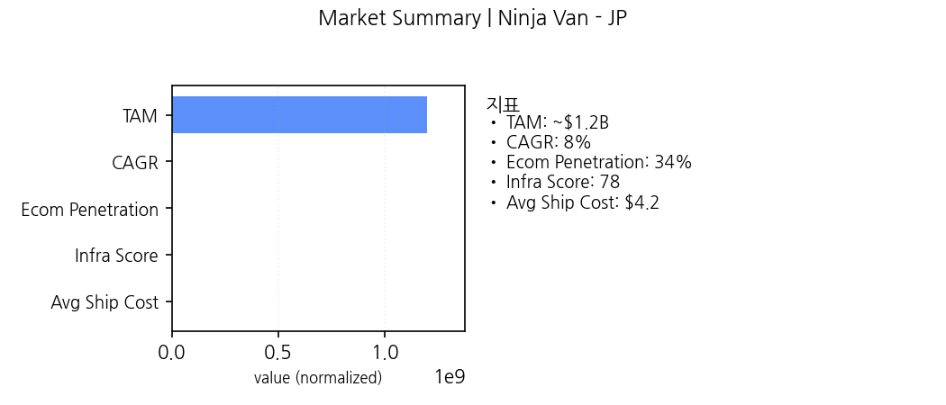

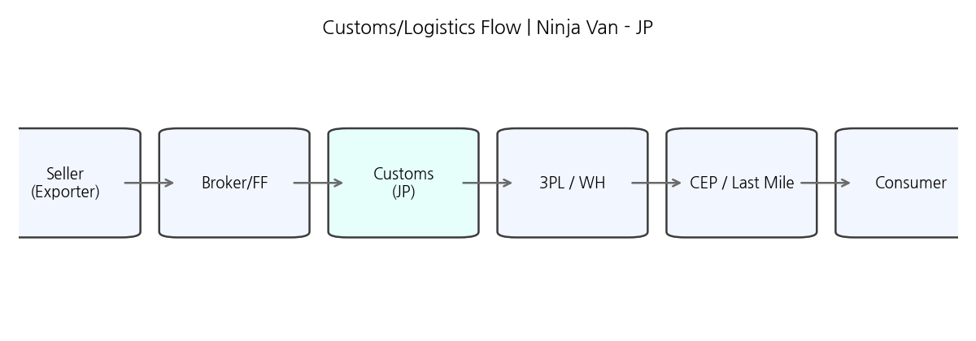





Market image: outputs/Ninja Van_JP\01_market_summary_Ninja Van_JP.png

Regulation image: outputs/Ninja Van_JP\02_customs_flow_Ninja Van_JP.png

Competition map: outputs/Ninja Van_JP\map_Ninja Van_JP.png

## Market

Why Now: 크로스보더 수요 증가와 물류 인프라 개선으로 진입 타이밍 양호

|  |  |
| --- | --- |
| Metric | Value |
| TAM | ~$1.2B |
| CAGR | 8% |
| Ecom Penetration | 34% |
| Infra Score | 78 |
| Avg Ship Cost | $4.2 |

## Regulation

Coverage: 60% · TBD: 30% · Risk: 높음

## Competition

* SE corridor
* Port-adjacent SMB
* Cross-border niche

## GTM

|  |  |  |  |
| --- | --- | --- | --- |
| Segment | Score | ICP | Offer |
| mid | 4.7 | 중견/성장 셀러 | 표준 풀필+가이드 킷 |
| high | 4.1 | 엔터프라이즈/대형 셀러 | 전담 풀필+SLA+규제패키지 |
| low | 3.9 | SMB/크로스보더 시범 | 셀프서비스+라이트 풀필 |

## Partners

* ABC Customs (Customs) · priority=High
* XYZ 3PL (3PL) · priority=Mid
* SI-One (SI) · priority=Mid

## Risks

* 규제 해석 지연 · prob=M · impact=H · mitigation=로펌 의견서 (trigger: coverage<0.8)
* SLA 미달 · prob=M · impact=M · mitigation=대체 3PL (trigger: OTD<95%)

## Decision Scorecard

|  |  |
| --- | --- |
| base | 70 |
| cov | 0.6 |
| tbd_ratio | 0.3 |
| competition_high | False |
| partners | 3 |
| final | 65 |

Evidence - Market

* (Gov Stats/https://example.gov, 2025-10-23)
* (Industry Report/https://example.org, 2025-10-23)

Evidence - Regulation

* (Gov Stats/https://example.gov, 2025-10-23)
* (Industry Report/https://example.org, 2025-10-23)

Evidence - Competition

* (Gov Stats/https://example.gov, 2025-10-23)
* (Industry Report/https://example.org, 2025-10-23)

Evidence - GTM

* (Gov Stats/https://example.gov, 2025-10-23)
* (Industry Report/https://example.org, 2025-10-23)

Evidence - Partners

* (Gov Stats/https://example.gov, 2025-10-23)
* (Industry Report/https://example.org, 2025-10-23)

Evidence - Risks

* (Gov Stats/https://example.gov, 2025-10-23)
* (Industry Report/https://example.org, 2025-10-23)