COVID-19 SNF Snap Shot

The Amazing SNF Analytics Team

# Summary

#### Skilled Nursing Facilities (SNFs) have had many COVID-19 cases and deaths, house people at high risk for compilations by virtue of their age and infirmity, may disproportionately employ disadvantaged populations at higher risk for spreading/acquiring COVID-19 in their communities, and are otherwise a focal area for COVID-19 control

#### Of the 1,204 SNFs, 591 had at least one COVID-19 case among residents as of DATE. As of DATE there were a total of 13,704 resident cases per the SNF123 Survey data (and 12962 per CalREDIE) and 8903 staff cases.

# Table for review and cleaning only

| **sizeSNF** | **nFacilties** | **nWithCases** | **percentWithCases** | **caseMax** | **censusMax** | **censusMin** | **allResidentCases** | **allResidents** | **Staff_Cases** |
| --- | --- | --- | --- | --- | --- | --- | --- | --- | --- |
| 1 >100 | 284 | 177 | 62.32394 | 125 | 740 | 101 | 5038 | 40795 | 3206 |
| 2 >75-100 | 321 | 178 | 55.45171 | 100 | 100 | 76 | 3976 | 27981 | 2690 |
| 3 >50-75 | 271 | 127 | 46.86347 | 204 | 75 | 51 | 3214 | 17158 | 1816 |
| 4 <50 | 328 | 109 | 33.23171 | 68 | 50 | 0 | 1476 | 11556 | 1191 |
| Total | 1204 | 591 | 197.87083 | 497 | 965 | 228 | 13704 | 97490 | 8903 |

# Race/Ethnicity and percent of SNFs with cases (these 3 tables will be combined into one…)

| **p_Black_Latino4a** | **Total** | **May 31** | **Jun 30** | **Sep 30** |
| --- | --- | --- | --- | --- |
| 1 >45% | 224 (100.0%) | 150 (67.0%) | 150 (67.0%) | 150 (67.0%) |
| 2 25-45% | 379 (100.0%) | 227 (59.9%) | 227 (59.9%) | 227 (59.9%) |
| 3 5-25% | 436 (100.0%) | 177 (40.6%) | 177 (40.6%) | 177 (40.6%) |
| 4 0-5% | 136 (100.0%) | 30 (22.1%) | 30 (22.1%) | 30 (22.1%) |
| Total | 1175 (100.0%) | 584 (49.7%) | 584 (49.7%) | 584 (49.7%) |

# (Chart) Association of Race/Ethnicity and with SNF Resident Covid-19 Cases

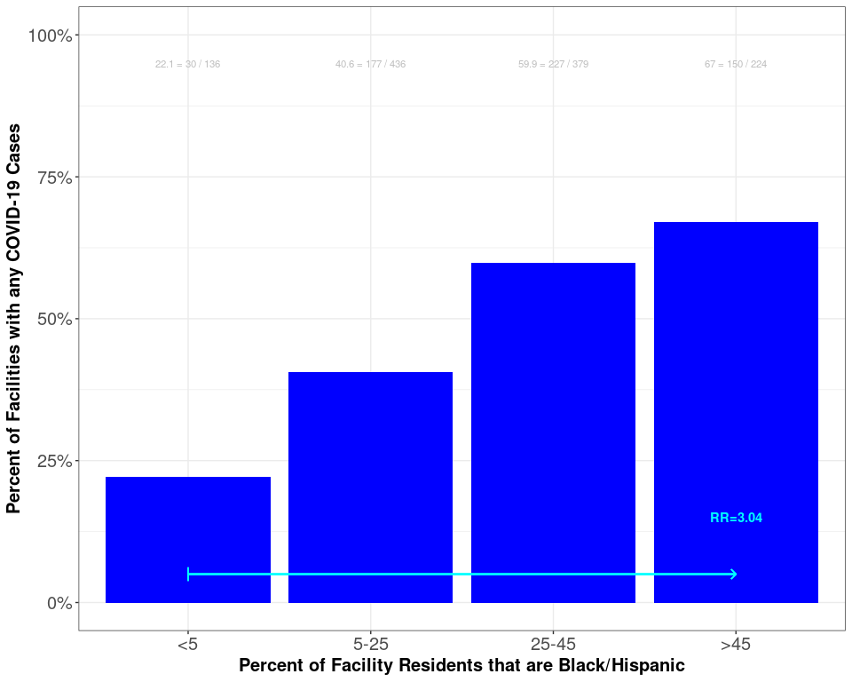

# (Chart) Association of Community Covid-19 Rates with Covid-19 Cases in SNFs

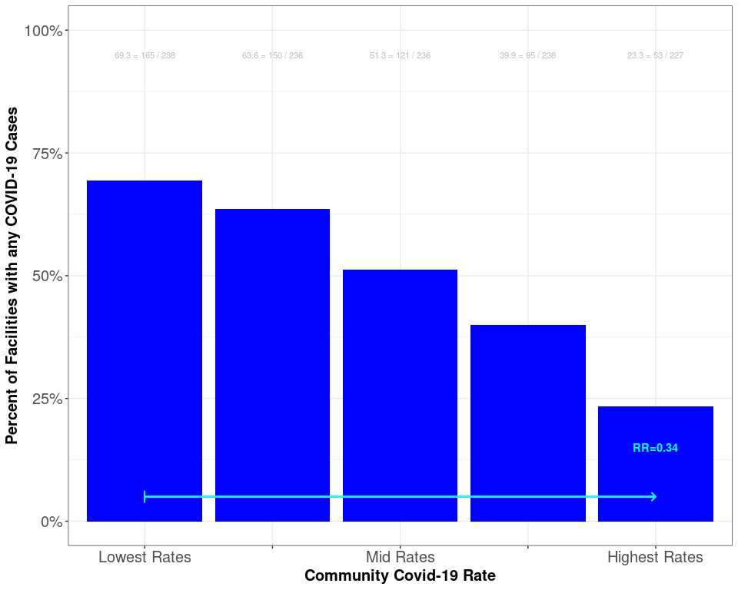

# Percent of SNFs with cases by DISTRICT and race/ethnicity

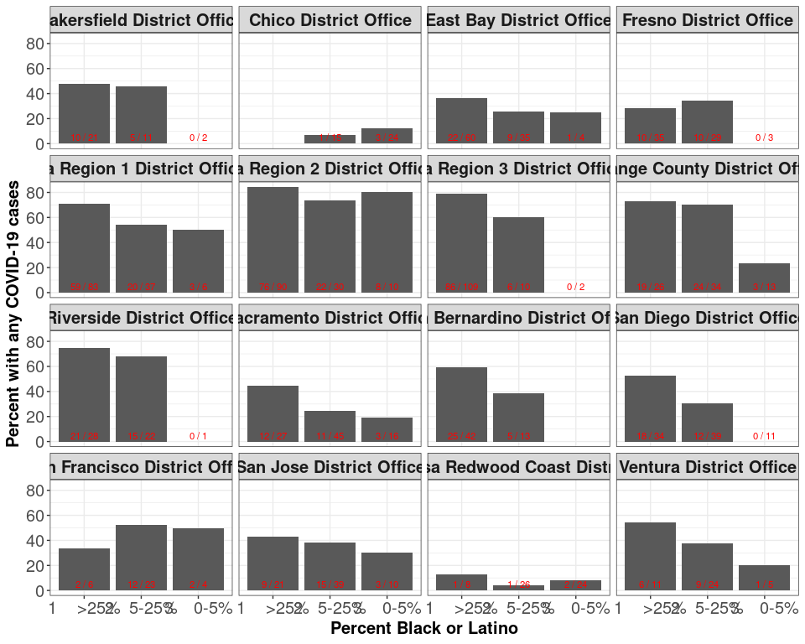

## Percentage of Race/Ethnic Groups:

* COVID-19 SNF Reident Cases (CalREDIE)
* SNF Residents (CMS/MDS)
* California Population 80-99 Years of Age (DOF)

| **Race/Ethnicity** | **CalREDIE SNF Cases** | **CMS/ MDS** | **Population 80-99 years of age** | **CalREDIE %** | **MDS %** | **Population %** |
| --- | --- | --- | --- | --- | --- | --- |
| American Indian or Alaska Native | 25 | 544 | 5,692 | 0.3 | 0.3 | 0.4 |
| Black | 1,067 | 18,395 | 74,717 | 12.4 | 10.8 | 4.8 |
| Asian | 1,152 | 17,486 | 261,896 | 13.4 | 10.2 | 17.0 |
| Latino | 2,475 | 30,541 | 301,795 | 28.8 | 17.9 | 19.5 |
| Native Hawaiian and other Pacific Islander | 35 | 884 | 3,609 | 0.4 | 0.5 | 0.2 |
| White | 3,389 | 101,121 | 884,046 | 39.4 | 59.2 | 57.2 |
| Multi-Race | 70 | 1,948 | 13,259 | 0.8 | 1.1 | 0.9 |
| Other | 390 | 0 | 0 | 4.5 | 0.0 | 0.0 |
| Total with Data | 8,603 | 170,919 | 1,545,014 | 100.0 | 100.0 | 100.0 |
| Unknown | 4,359 | 6,891 | 0 | 33.6 | 3.9 | 0.0 |
| Total | 12,962 | 177,810 | 1,545,014 | 100.0 | 100.0 | 100.0 |