Plant biodiversity and ecosystem services   
in an Asian developed city: land use and scale

**The draft for Dissertation Preliminary Review**

KANG Jiefeng

2022

A Thesis Presented to

Graduate School of Global Environmental Studies of

Kyoto University in

Candidacy for the Degree of Doctor of Philosophy

2022

# Acknowledgement

I am extremely grateful to my supervisor, Professor Shozo Shibata. I would not get a ticket to the field of urban biodiversity research without his support. His overall insight in this field gave me a big picture. When I came to the lab, I “knew nothing” just like John snow; when I am going to graduate, I am proud that now I “know something” about urban biodiversity research.

My sincere appreciation is also extended to Dr. Satoshi Hirabayashi for his encouragement and efficient feedback for our joint study. It has been a pleasure working with him.

I must also thank Associate Professor Katsue Fukamachi, Assistant Professor Ryo Nukina, and Assistant Professor Wen Liu, for their valuable comments on this study. The different viewpoint also reminds me of the limitation of my research and sparked me.

I also wish to thank the lab members of the Graduate School of Global Environmental Studies, and in Faculty/Graduate School of Agriculture, Kyoto University. For their support and help not only in academics but also in lab life. I would like to say a special thank you to the members of the “mini-seminar” in the lab of the Graduate School of Global Environmental Studies for that I enjoyed the discussions on urban ecology research.

I am grateful to my family and my girlfriend for their support in my life. They are never tired to remind me to take care of my health, which is the foundation of my academic research. And thank them for putting up with me being working for my study for hours on end (with just a few outcomes though).

I would like to acknowledge the Ministry of Education, Culture, Sports, Science and Technology (MEXT) for providing the scholarship for my Ph.D. study; and the Grant-in-Aid for Scientific Research (B) from the Japan Society for the Promotion of Science (18H02226) for the research funding.

Finally, I wish to say a special thank you to the great naturalist and writer, Edward O. Wilson. I have never had the honor to met him, but I have been inspired to chase my dream by his book since I was a master's student.

# Abstract

Urbanization provides both challenges and opportunities in biodiversity conservation. The demand for urban ecosystem services increases with the rapid growth of the urban population. Urban dwellers can benefit from within-urban biodiversity and local ecosystem services. However, the pattern of urban biodiversity across land use and scales, especially in Asian cities, remains unclear. The evaluation of urban ecosystem services across urban heterogeneity has also been less addressed. In this study, multi-scale analysis of urban plant diversity and ecosystem services was conducted with ground-based investigation and model. To collect data, woody plants in 174 sample quadrats in Kyoto City were investigated.

The results of urban biodiversity analysis show that, at the land use level, residential areas were found to have the highest total richness with moderate to low evenness, while commercial areas exhibited low total richness. At the quadrat level, Low-rise residential area had higher richness than most of the other land use types. Quadrat abundance and evenness were significantly different across land use types for trees but not for shrubs. Quadrat species composition was significantly different across land use types for shrubs, but not for trees.

The ecosystem services calculated include carbon storage and sequestration, air pollutants removal, and runoff reduction in the following part. Ecosystem services of different land use classes were compared at both quadrat and single-tree levels. No significant difference across land use for all the ecosystem services was found at the quadrat level. However, ecosystem services were different across land use at the single-tree level. With a species-specific analysis, it is revealed that the pattern of ecosystem services across land use varies with both the service tested and species.

The results of the study provide insights into urban biodiversity and ecosystem services design and management by identifying prior land use types for biodiversity improvement and highlighting the contribution of residential private yards. Furthermore, the results suggest that urban heterogeneity, scale, and multidimensionality should be considered when measuring urban biodiversity and ecosystem services.

Then a preliminary analysis was conducted to test the link between urban biodiversity and urban ecosystem services. The results show that both richness and abundance are positively correlated with urban ecosystem services. But the relationship is not robust when the samples are grouped by land use. Further development of biodiversity-ecosystem service link analysis tool is needed to fill the critical link for the evidence-based decision in urban planning.

**Table of Contents**

Acknowledgement i

Abstract ii

Chapter 1 General Introduction 1

1 Background 1

1.1 Urbanization 1

1.2 Impact of urbanization on biodiversity 1

1.3 Impact of urbanization on ecosystem services 2

2 Research gaps 3

2.1 Importance of urban biodiversity and urban ecosystem services 3

2.2 Research gaps 4

2.3 Thesis outline 4

Chapter 2 Data Collection and Preprocessing 6

1 Research area 6

2 Land use classification 7

3 Sampling and data collection 9

3.1 Plant data 9

3.2 Quadrat attribute data 10

Chapter 3 Urban plant biodiversity 12

1 Introduction 12

2 Data analysis 13

3 Results 15

3.1 City level results 15

3.2 Land use level results 17

3.3 Quadrat level results 20

3.4 Impact factors for quadrat biodiversity 22

4 Discussion 25

4.1 Urban exotic species proportions at city level 25

4.2 Measurements of urban plant diversity 26

4.3 Land use type, scale, and plant diversity 26

4.4 Urban gradient, land cover, and quadrat plant diversity 29

5 Conclusion 30

Chapter 4 Urban ecosystem services 32

1 Introduction 32

2 Methods 34

2.1 Data preperation 34

2.2 Evaluation of ecosystem services and monetary value 35

2.3 Data analysis 37

3 Results 37

4 Discussion 43

4.4. Ecosystem service evaluation in cities 46

5 Conclusions 46

Chapter 5 Link Biodiversity and Ecosystem Services 48

1 Introduction 48

2 Method 49

2.1 Data preperation 49

2.2 Data analysis 49

3 Results 50

3.1 Linear model results 50

3.2 Ecological Price equation results 52

4 Discussion 54

4.1 The impact of diversity on ecosystem function 54

4.2 Methodology to test BEF in cities 55

5 Conclusion 56

Chapter 6 Conclusions and Discussion 57

1 Urban biodiversity 57

2 Urban ecosystem services 57

3 BEF in urban ecosystems 58

Reference 59

Appendix 77

# General Introduction

## Background

### 1.1 Urbanization

* 参考McDonald et al. 2020：罗列了很多数据，且包括人口和面积数据
* Past decades have witnessed rapid urbanization worldwide. The urban population has been growing rapidly since 1950. Estimated with statistics data reported by national governments, the proportion of the urban population increased from 30% in 1950 (Population Division, United Nations, 2019) to 55% in 2019 (The World Bank Data, n.d.), and it is projected to be 68% in 2050 (Population Division, United Nations, 2019). Depending on the policy and social trends, the proportion is projected to be up to 92% by the end of this century.
* The increase of the urban population, together with economic development, resulted in the expansion of the urban area. The expansion of urban areas is even faster than that of the urban population. A meta-analysis shows that urban area increases twice as fast its population on average worldwide (Seto et al., 2011). The urban area is estimated as 0.35 million square kilometers in 1992 and increases to 0.74 million square kilometers in 2015 (McDonald et al., 2020), and it is projected to be 1.9 million square kilometers in 2030 (Güneralp and Seto, 2013; Seto et al., 2012a). Furthermore, most urban area expansion in the future is projected to be in areas of limited economic development (Seto et al., 2013). Though the expansion rate of the urban area depends on the definition of ‘urban area’ or ‘urban land use”, a consensus is that in recent years, the urban area expansion has been fast and will continue to be fast.
* Past decades have witnessed rapid urbanization worldwide. The urban population has been growing rapidly since 1950. Estimated with statistics data reported by national governments, the proportion of the urban population increased from 30% in 1950 (Population Division, United Nations, 2019) to 55% in 2019 (The World Bank Data, n.d.), and it is projected to be 68% in 2050 (Population Division, United Nations, 2019). Depending on the policy and social trends, the proportion is projected to be up to 92% by the end of this century.
* The increase of the urban population, together with economic development, resulted in the expansion of the urban area. The expansion of urban areas is even faster than that of the urban population. A meta-analysis shows that urban area increases twice as fast its population on average worldwide (Seto et al., 2011). The urban area is estimated as 0.35 million square kilometers in 1992 and increases to 0.74 million square kilometers in 2015 (McDonald et al., 2020), and it is projected to be 1.9 million square kilometers in 2030 (Güneralp and Seto, 2013; Seto et al., 2012a). Furthermore, most urban area expansion in the future is projected to be in areas of limited economic development (Seto et al., 2013). Though the expansion rate of the urban area depends on the definition of ‘urban area’ or ‘urban land use”, a consensus is that in recent years, the urban area expansion has been fast and will continue to be fast.

Past decades have witnessed rapid urbanization worldwide. The urban population has been growing rapidly since 1950. Estimated with statistics data reported by national governments, the proportion of the urban population increased from 30% in 1950 (Population Division, United Nations, 2019) to 55% in 2019 (The World Bank Data, n.d.), and it is projected to be 68% in 2050 (Population Division, United Nations, 2019). Depending on the policy and social trends, the proportion is projected to be up to 92% by the end of this century.

The increase of the urban population, together with economic development, resulted in the expansion of the urban area. The expansion of urban areas is even faster than that of the urban population. A meta-analysis shows that urban area increases twice as fast its population on average worldwide (Seto et al., 2011). The urban area is estimated as 0.35 million square kilometers in 1992 and increases to 0.74 million square kilometers in 2015 (McDonald et al., 2020), and it is projected to be 1.9 million square kilometers in 2030 (Güneralp and Seto, 2013; Seto et al., 2012a). Furthermore, most urban area expansion in the future is projected to be in areas of limited economic development (Seto et al., 2013). Though the expansion rate of the urban area depends on the definition of ‘urban area’ or ‘urban land use”, a consensus is that in recent years, the urban area expansion has been fast and will continue to be fast.

### 1.2 Impact of urbanization on biodiversity

Rapid urbanization has a significant environmental and ecological impact, one of which is biodiversity degradation (Elmqvist et al., 2013; Güneralp and Seto, 2013; Seto et al., 2012a). Urbanization causes species loss in two ways: indirect and direct.

* 间接影响：遥相关

The indirect impact is from urban metabolism, including resources used by urban areas and pollution generated. Resource consumption rises with urbanization, that urban area requires loads of imported energy, food, and material in its ‘upstream’ and result in pollution in its ‘downstream’. Urbanization changes climate by heat island effect and modifying precipitation pattern which together will have an impact on biodiversity (Seto et al., 2013). A case study is that Girgin et al. evaluated the impact of water heavy metal pollutants on insects Ankara stream, Turkey (Girgin et al., 2010). Urbanization also impacts the biodiversity of other areas (especially surrounding rural areas) by human migration. Community-scale research in Mexico suggests that the migration of population to a city may cause a decline of biodiversity in forest and agricultural land in the surrounding area due to the decrease of human management, though with a net gain of forest area (Robson and Berkes, 2011). The scale of the impact may vary, it could also be regional or global. The production of food for a city could be far away that it may cause degradation of biodiversity in the place of food source (Selinske et al., 2020).

* 直接影响：对本地生物多样性的影响

On the other way, direct impact generally occurs with habitat change due to urbanization. Urbanization causes land use change/habitat transform, that direct change of habitat extinct the original endemic species (McDonald et al., 2020). Furthermore, urbanization doesn’t occur randomly globally. Since urbanization prefers the location with higher biodiversity, it caused degradation to global biodiversity conservation (Seto et al., 2013). The problem could be even more serious since urbanization will be rapid in area with low economic development that has limited investment capability in biodiversity conservation and mitigation (Seto et al., 2013). However, on the other hand, urbanization not only causes biodiversity loss but also biodiversity gain. Possible reasons include the increase of heterogeneity, edge effect, human introduction of exotic species (Hope et al., 2003). Some taxon, like flora or birds, has been frequently proved to be of higher richness in urban areas than surrounding nature or rural areas (Knapp, 2010a).

### 1.3 Impact of urbanization on ecosystem services

Ecosystem service is defined as the service provided by ecosystems that are essential to human survival, livelihood, health, and well-being (Costanza et al., 2014). Urbanization decreases ecosystem service by land use change, habitat fragmentation, and pollution.

With rapid urbanization, land use shifts from nature or agriculture to urban land. The change of process and pattern of biogeochemical circulation ensues, and thus a decrease of ecosystem services. Furthermore, ecosystem service is affected by many other factors, for instance, land quality, water quality, biodiversity. For example, a study in Shenzhen city, China, finds that ecosystem services and ecosystem health of the city decreased with the expansion of construction land use (Peng et al., 2015). A study of Bengal, India shows that 25% of ecosystem service value has been decreased from 1990 to 2017 (Das and Das, 2019). A study at eco-region scale shows es decrease with expanding urban area in South China (Su et al., 2012).

* Concerning ES：定义-城市化和ES过程-例子-城市内部的ES

## Research gaps

### 2.1 Importance of urban biodiversity and urban ecosystem services

The expansion of cities not only affects “natural ecosystems”, the city itself is becoming a novel ecosystem with its pattern of biodiversity and ecosystem services, and unique characteristics of ecological process.

City is not only unique in its physical environment and socio-economic dimension, but also in its biological dimension. It is thus regarded as a novel ecosystem. Though urbanization degrades nature habitat, it also creates novel habitat, for example, parks, street trees, and there are nature habitats remnant in the urban area. It has been proved, surprisingly, that the biological diversity of some taxon (e.g., woody plant and birds) are even higher than the surrounding nature area (Knapp, 2010a; Pearse et al., 2018). The unique community assemblage in cities results in a complex and high heterogeneous biodiversity pattern. From a perspective of process, William et al. (2009) proposed a conceptual framework for the effect of urbanization on biodiversity based on the environmental filter model, taking both biodiversity loss and gain into consideration. In their framework, urbanization affects biodiversity with four filters: habitat transfer, habitat fragmentation, environmental pressure of urbanization, and resident preference. From a perspective of within-city urban biodiversity research, the biodiversity pattern is determined by both physical environment factors and socio-economic factors (Chamberlain et al., 2019; Chen et al., 2020; Hope et al., 2003; Kajihara et al., 2016). The effect of different factors varies by taxon and habitat types. The biophysical environment works more on spontaneous species while socio-economic factors are more on woody or cultivate species. Socio-economic character affects woody plants diversity more than birds (Kinzig et al., 2005). The luxury effect is one example of the impact of socio-economic factors, which states that wealthier neighbor generally has higher biodiversity, which has been found for many cities and taxon (Chamberlain et al., 2020; Clarke et al., 2013; Leong et al., 2018).

From the perspective of human well-being, with the growth of urban population and area, the city will become the place where people get in touch with nature in their daily life. While with luxury effect, there can be environmental justice problem arising from urban biodiversity pattern that some people have less opportunity to exposure to high biodiversity environment. Studying urban biodiversity is not only good for biological conservation, but also for human well beings and long-term nature conservation. However, compared to other ecosystems, the biodiversity research in cities is much less, and there lack a application of scientific research into practice.

Those new habitats, together with the biological community, also provide local ecosystem services that are essential to urban residents. Bolund and Hunhammar identified six important services for an urban area, including air filtering, micro-climate regulation, noise reduction, water regulation, waste treatment, and recreation and culture services (Bolund and Hunhammar, 1999). The “key services” might differ across different cities, determined by environmental and socio-economic characteristics. For instance, air pollutants removal could be secondary important in cities with good air quality but is critical for cities with serious air pollution situations and more vulnerable people (Gómez-Baggethun et al., 2013). The relation between demand and supply of ecosystem services also varies with scale. Locally generated ecosystem services are more closely related to the living quality of the resident and some of them is irreplaceable by other distant sources (for example, mitigation of heat island effect) (Gómez-Baggethun et al., 2013). Considering the numerous population size in cities, the social and economic value of ecosystem services within cities can be surprisingly high (Gómez-Baggethun and Barton, 2013). Besides, a global assessment highlighted how massive urbanization is impacting biodiversity and ecosystems around the world negatively (Elmqvist et al., 2013). Therefore, an improvement of urban ecosystem services could potentially benefit city residents and mitigate the loss of ecosystem services globally. Growth of demand for ecosystem services in cities would ensue the rapid urbanization.

* # need a framework??? How urban impact biod and es#
* 框架：大尺度：城市代谢的间接影响和城市化的直接影响，后者参考Williams et al. 2009

Since urbanization is threatening biodiversity and ecosystem services globally, urban biodiversity and ecosystem services improvement might mitigate the impact, and can satisfy the demand of residential, it is important to research urban biodiversity and ecosystem services.

### 2.2 Research gaps

Despite the importance of urban biodiversity and urban ecosystem services, the application of the concept and research into practice is still lacking. One of the reasons is the data availability, and among the factors studied, land use has been less addressed in previous research. While land use is the main pathway that humans modify cities. Therefore, an integration of land use and urban ecology can enhance the application of urban ecology research. The detailed research gaps are identified in the following chapters.

### 2.3 Thesis outline

#### 2.3.1 Research aims

The main objectives of this research are: (1) to study the urban biodiversity across land use; (2) to study ecosystem services across land use; (3) to link biodiversity and ecosystem services in urban ecosystem services.

#### 2.3.2 Research content

The thesis is organized into 5 chapters (Figure 1). Chapter 1 introduces the background and the impact of urbanization on nature, and why should we care about biodiversity and ecosystem services within urban ecosystems. I also introduced the general idea of research gaps and research objectives. Chapter 2 introduces data collection and how the data set was formed. Chapter 3 focuses on urban biodiversity, taking woody plants as the target taxa. Chapters 4 focuses on urban ecosystem services provided by an urban forest. And analyzed ecosystem services across land use. In the following chapter, I linked urban biodiversity and urban ecosystem services, to test if higher biodiversity also leads to higher ecosystem services in urban ecosystems.

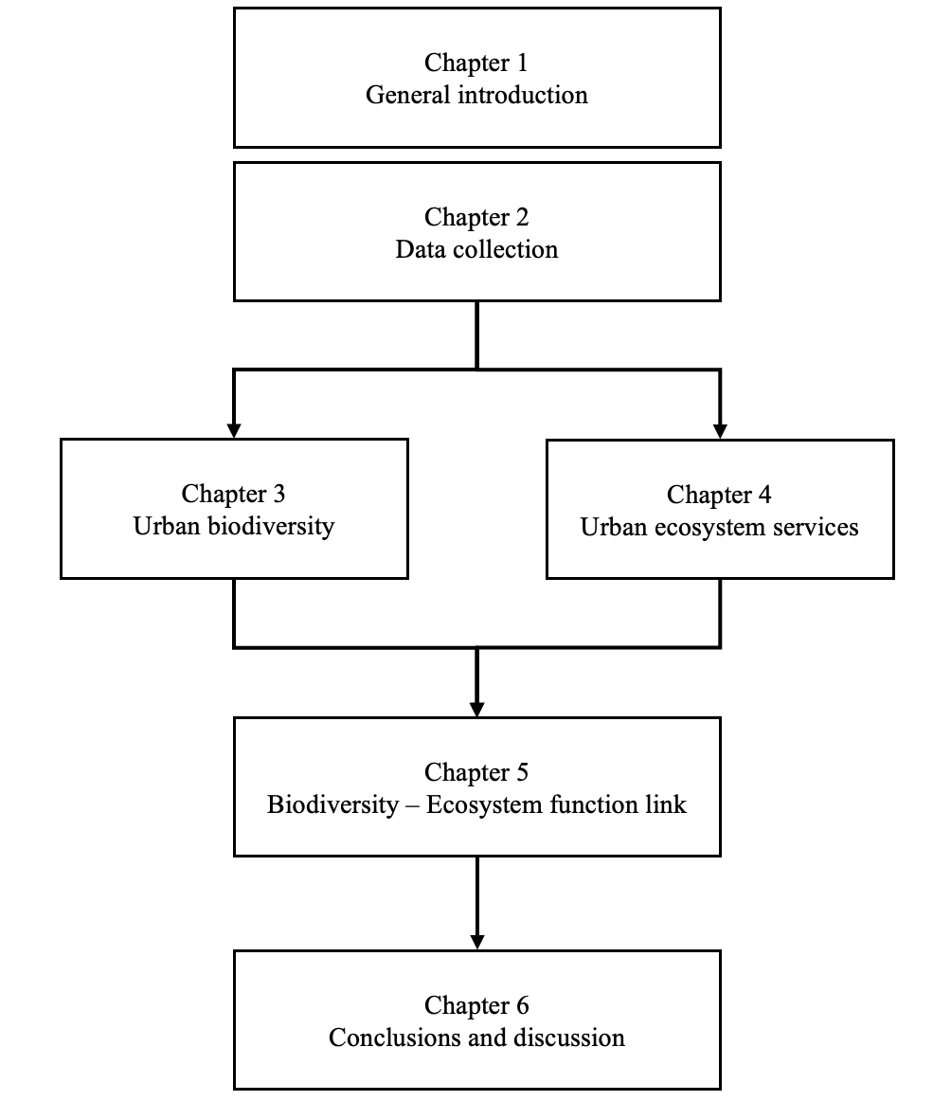

Figure 1. Research scheme for this thesis

# Data Collection and Preprocessing

## Research area

Kyoto City (35°19′16″N-34°52′30″N, 135°33′33″E-135°52′43″E), the capital of Kyoto Prefecture, is located in Kyoto Basin of Kansai Region, Honshu Island, Japan, with an area of 828 square kilometers. The city is dominated by a humid subtropical climate with hot, humid summers, and cold, dry winters. The annual high and low temperatures are 20.8°C and 11.7°C, respectively, with an average precipitation of 1,491 mm.

Kyoto had experienced rapid urbanization before 1980s, as with many cities in Japan; its population has remained stable since then. It is one of “Cities designated by government ordinance of Japan” with a population of 1.47 million (0.73 million households) in 2019. The population density is 1,773 people per square kilometer. The area of the built-up area of the city is 144 square kilometers (Kyoto City Statistics Portal, 2019).

As a planned capital, Kyoto city was founded when Emperor Kammu relocated the capital in 794. The Japanese borrowed the basic city layout from Chang’an, China in the Tang-dynasty, part of which is a grid spatial system dividing the city into blocks. The land use pattern of the city, however, mainly formed in modern times. During the infrastructure promotion at the end of the Meiji era (1868-1912), city center was constructed based on the traditional commercial area. The administration boundary expanded significantly in the Taisho era (1912-1926), and an expansion and construction of the industrial area and residential area was achieved based on the urban planning laws (Ueno, 2010). Kyoto city is now, overall, a mono-centric city. The city center is mainly used as a commercial area. The industrial area is mostly located in the west and south of the city. The residential area is in the surrounding area (**Figure 2**).

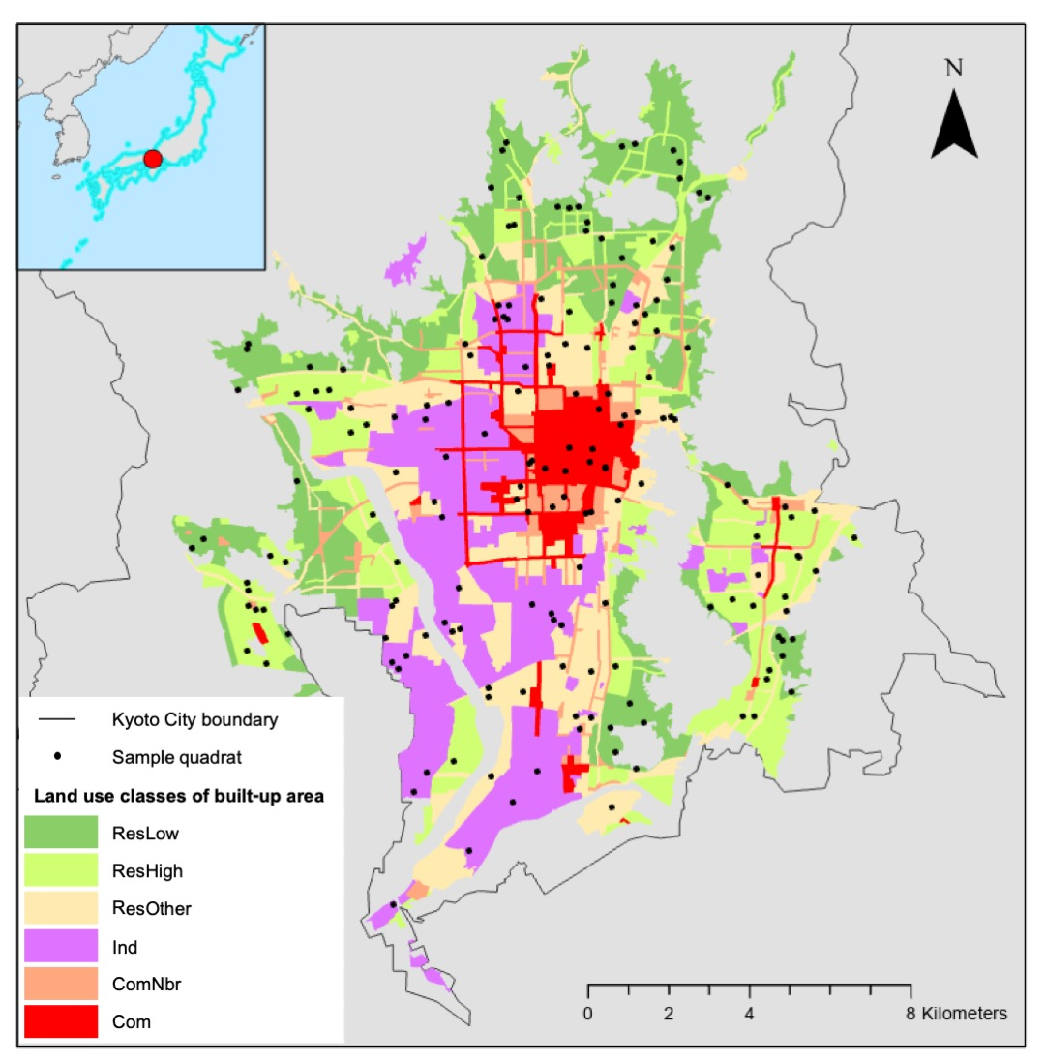

**Figure 2.** Land use of Kyoto City and distribution of quadrats. The map is based on WGS 1984. The abbreviations for land use: ResLow, low-rise residential area; ResHigh, mid- and high-rise residential area; ResOther, other residential area; Ind, industrial area; ComNbr, neighborhood commercial area; Com, commercial area.

## Land use classification

Urban planning system varies across countries due to different background of law, regulation, management and history; so does the concept “land use” (Briassoulis, 2019). In this study, “land use” emphasizes more on the potential usage of human activities. Japan's urban planning system set a framework for urban land use zoning, city infrastructure, and implementation of development projects under the City Planning Law of Japan (Ministry of Land, Infrastructure, Transport and Tourism, Government of Japan, 2021). “Land use zone” is the core and fundamental base of the system that categorizes land use of the built-up area into 3 main types (residential, commercial, and industrial use) or 12 sub-types (Table 1). For each land use, a series of rules on the use, height, density and other attributes of buildings are set (Akashi, 2007). These 12 sub-types of land use were aggregated into 6 types in this study: Com (Commercial) area, ComNbr (Neighborhood commercial) area, ResLow (Low-rise residential) area, ResHigh (Mid/high-rise residential) area, ResOther (Other residential) area, and Ind (Industrial) area (Table 1). Among commercial areas, Com area is predominated by commercial and business buildings such as banks, cinemas, restaurants and department stores, though residential building and small factories are also permitted; ComNbr area is mainly designated to provide daily shopping services for residents. Ind area is mainly intended for factories, though residential and shop buildings are also permitted. Among residential areas, ResLow is mainly designated for low rise residential buildings, and only small shops/offices and elementary/junior high school buildings are permitted other than residential buildings; ResHigh area is designated for medium to high rise residential buildings, hospitals, universities, and shops/offices with a floor area under 1,500 m2; ResOther area is designated as buffer zone for residential area, in which houses, shops, offices, and hotels with a floor area up to 3,000 m2 are permitted.

**Table 1.** Land classification in this study

|  |  |  |
| --- | --- | --- |
| **Land use types in this study** | **Land use sub-types** | **Number of investigated quadrats** |
| Com | Commercial area | 14 |
| ComNbr | Neighborhood commercial area | 10 |
| ResLow | Category I exclusively low-rise residential area  Category II exclusively low-rise residential area | 38 |
| ResHigh | Category I mid/high-rise oriented residential area  Category II mid/high-rise oriented residential area | 41 |
| ResOther | Category I residential area  Category II residential area  Quasi-residential area | 42 |
| Ind | Quasi-industrial area  Industrial area  Exclusively industrial area | 29 |

## Sampling and data collection

### 3.1 Plant data

In field research conducted between May and August 2019, plant data was collected in a potential sample size of 200 quadrats measuring 20 m × 20 m, including alternative quadrats considering some quadrats may be inaccessible. The number of quadrats in each land use type were determined with stratified sampling method based on areas of land use types (Nowak et al., 2008) and a total of 174 quadrats were actually accessed and investigated (**Figure 2**, Table 1).

For each quadrat, I took photos of the surrounding environment and the vegetation. All woody plants higher than 30 centimeters in the quadrats were investigated. Plants higher than 2 meters were recorded as trees and others as shrubs. Data collected for each tree or shrub included: (1) species: only refers to original species, thus cultivars, subspecies, or varieties was not considered; information of scientific names and taxon followed the online database of plant names, *The Plant List*, as per Royal Botanic Gardens, Kew, and the Missouri Botanical Garden (Kalwij, 2012); (2) size-related data for trees: height, diameter at breast height (DBH), crown size; (3) size-related data for shrubs: height and area for a shrub; (4) health status: canopy missing percentage, crown health condition, and crown light exposure; (5) growth status: planted or spontaneous; and (6) ownership: public or private. For the last attribute, “ownership”, since accessibility is emphasized in this research, some semi-public spaces like temple forest are classfied as “public” because they are generally accessible to the public.

Table 2. Category of urban green by ownership

|  |  |
| --- | --- |
| Ownership | Examples |
| Public | Temple forest and shrine forest, public garden, imperial palacae, street tree, rain garden, park, river bank |
| Private | Tradiational Japanese townhouse yard and other single-family house yard, green roof |

Species provenance was determined according to the Introduced Plant Species List of Kyoto Prefecture (Kyoto Prefecture Web Site), the Seed Plant Species Dataset of Kyoto Prefecture (Kyoto Prefecture Web Site), and the Introduced Species List of Japan published by the National Institute of Environmental Studies of Japan (National Institute of Environmental Studies of Japan). Native distribution information from the Missouri Botanical Garden database (Missouri Botanical Garden) and the Kew Science database (Kew Science) was also referenced for species not in the database. The details of species provenance is shown in Table A1.

After the data collection, we have a data set with several attributes of each tree. The data set will then be applied in the following chapters with different topics. The species, number of trees and area of shrubs, grown status, ownership, and provenance will be used in urban biodiversity ananlysis. The whole data set other than ownership and provenance will be applied into urban ecosystem services research.

### 3.2 Quadrat attribute data

The attribute data of accessed and investigated sampling quadrats were collected since they can act as impact factors for urban biodiversity and urban ecosystem services at the quadrat level. (1) The distance to the city center: The latitude and longitude of each quadrat were collected based on GoogleMap. Since Kyoto City is regarded as a monocentric city, I took Shijo-Kawaramachi station, located in the central business district, as the city center. Then *distm* function of geosphere package was applied to calculate the distance of each quadrat to the city center. (2) Land price: land price investigation point data of Kyoto Prefecture in 2019 was downloaded from the website of Ministry of Land, Infrastructure, Transport and Tourism (Ministry of Land, Infrastructure, Transport and Tourism, n.d.). The point data was then extended into a raster data covering the whole Kyoto City by Kriging interpolation in ArcGIS pro. Then the land price of the quadrats was equal to the land price of the corresponding pixel. (3) Population density: Ministry of Public Management, Home Affairs, Posts and Telecommunications of Japan published the demographic census data at neighborhood scale of 2010 then Nishizawa scaled the data into 100-meter resolution mainly according to building type and area (Nishizawa, 2016). The population density of each quadrat is based on the 100-meter demographic mesh data. (4) Onsite land cover: The detailed land cover was mapped for each quadrat during the investigation. A quadrat is divided into different land covers including residential, transportation, temple/shrine, multi-family residential, agriculture, commercial-neighbor, water/wetland, park, cemetery, vacant, commercial/industrial, institutional, and golf course. The proportion of each land cover in each quadrat was calculated.

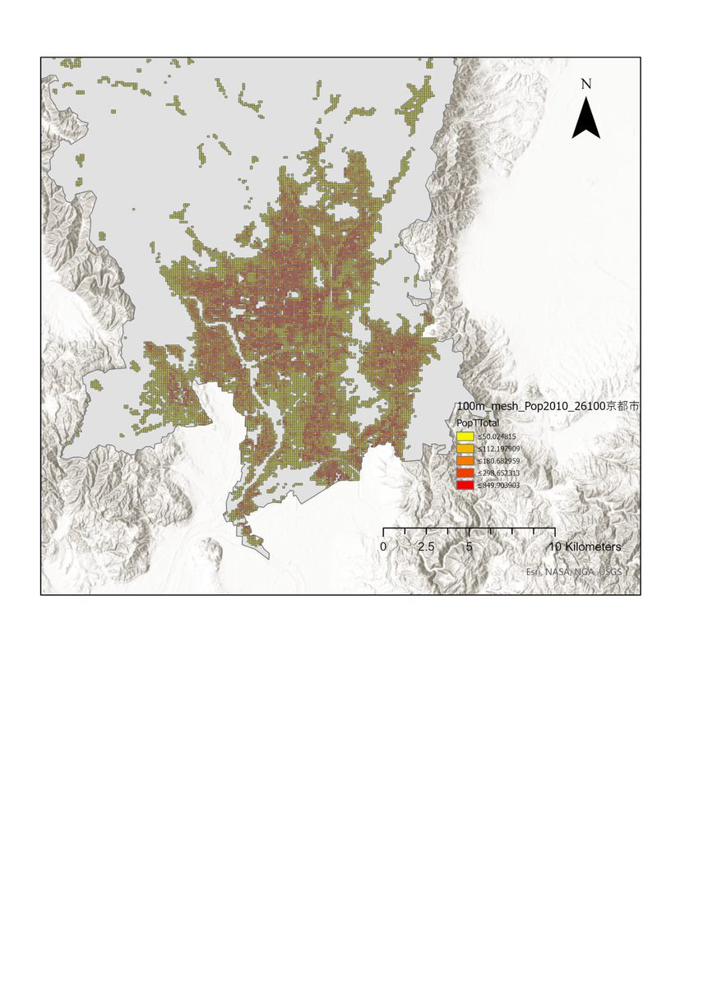

Figure 3. Population density of Kyoto City (unit: people per 1 ha)

# Urban plant biodiversity

## Introduction

Urbanization is occurring fast in area of previously highly productive ecosystems (Marc L. Imhoff et al., 2004) and adjacent to biodiversity hotspots (Seto et al., 2013), thus causing biodiversity decline due to habitat loss and fragmentation (Seto et al., 2012b). However, cities also provide new opportunities for biodiversity conservation. For instance, although the response of biodiversity to urbanization is unpredictable (McDonnell and Hahs, 2008a), many researchers have found higher richness or abundance in some taxa such as birds and flora in urban and suburban areas, partially due to a considerable number of introduced species and habitat heterogeneity (Allen and O’Connor, 2000; Dangulla et al., 2019; Hansen et al., 2005), and cities may even provide shelter to rare species (Ives et al., 2016). Among related taxa, plants are viewed as a template for biodiversity (Ackleh et al., 2010; Brearley et al., 2010; Brown and Freitas, 2002; Dearborn and Kark, 2010; MacGregor-Fors, 2008), and are directly modified by anthropic activity. It is therefore essential to understand the relationship between human activity and plant diversity in urban ecosystems. It has also been recognized in recent years that cities can play an important role in global biodiversity targets since urban residents have become more aware of biodiversity conservation needs and local authorities are more effective in managing surrounding biodiversity (Convention on Biological Diversity, 2010).

The past three decades have witnessed a significant growth of research interest in the urban plant diversity field. However, most such work has focused on European, Australian and Northern American cities, and less on cities in Central and Southern America, Africa and Asia (Ossola et al., 2018). Many urban plant diversity studies (Chimaimba et al., 2020; Raoufou et al., 2011; Wang et al., 2015, 2017) have also focused on rapidly urbanized areas rather than highly urbanized ones.

The dispersed green spaces, like private gardens, have been addressed less though they have been proven essential to urban biodiversity and ecosystem services (Camps-Calvet et al., 2016a). For urban biodiversity research in Japan, Tsuchiya and Saito (2018) reviewed 173 English- and Japanese-language articles published between 1975 and 2015, returning 71 articles on urban plants. Irecoded the 71 articles and found that a total of 37 of these focused on spermatophytes, but most of them focused on large green spaces like urban parks and forest remnants (e.g., Okamura et al. (1998)’s research of Nagoya’s urban parks).

Land use/land cover is driven by, and in turn, has impact on bio-physical and socio-economic factors; it is the results of, and constrains human activities (Briassoulis, 2019). However, the heterogeneity of urban plant diversity across land use/land cover has been less addressed. Since plantable space, greening goals, and human-related disturbances vary with land use/land cover (Bourne and Conway, 2014), land use/land cover has also been regarded as an urbanization gradient factor in relevant biodiversity research (Ortega-Álvarez et al., 2011; Porter et al., 2001a). However, most studies have focused on single land use/land cover types (Bourne and Conway, 2014) or have not distinguished between different land use/land cover types (residential areas, commercial areas, etc.) in urban built-up areas (Dangulla et al., 2019).

Urban-rural gradient has also been widely used for urban plant diversity research (McDonnell and Hahs, 2008b), while the results differ across different cities and taxa. For instance, research in Shanghai, China, indicates that the richness of woody plants, annual herbs, and perennial herbs show a different pattern with the increasing distance to the city center(Wang et al., 2020). And for woody plants, Wang et al. found that the richness decreases along the urban-rural gradient in Shanghai (Wang et al., 2020), while Aronson et al. found no significant difference of the richness along the urbanization gradient in New York (Aronson et al., 2015). While it is common that the diversity of native and exotic plants respond differently to the urbanization gradient. For instance, the richness of native species generally increases with the decrease of urbanization, while the richness of exotic species, by contraries, is usually higher in more urbanized areas(Aronson et al., 2015; Ranta and Viljanen, 2011a). A point of dispute is that there are multiple gradient in a city, and some of them may conflict with each other. Besides, the variation of urban gradient might change differently in different direction. Thus a multi-gradient analysis is required.

In this chapter, I applied investigation data of woody plants across Kyoto City to explore the urban biodiversity across land use at different scales. The data was then aggregated at three levels: city, land use, and quadrat. Analysis was conducted at these three levels to demonstrate the heterogeneity of urban plant diversity across land use and scales by comparing the richness, evenness, abundance, and species composition.

## Data analysis

The species, number of trees and area of shrubs, grown status, ownership, and provenance of the individual plant, and the onsite land cover proportion, and urban gradient variables of each quadrat were extracted from the data set described in Chapter 2. The data for each tree and shrub was then aggregated into city level, land use level, and quadrat level. All data analysis was conducted in *R (version 4.0.3)*. Difference was considered significant as *p* < 0.05 where statistical comparison was applied. The code for data analysis is accessible on GitHub (<https://github.com/kangjf1943/KUP>).

At city level, *iNEXT* function of *iNEXT* package was applied to estimate the total species for Kyoto City using a rarefaction and extrapolation method (Chao et al., 2014; Hsieh et al., 2020). To evaluate evenness of species distribution, rank abundance curves was plotted from calculation results of the *rankabundance* function of the *BiodiversityR* package for trees and shrubs respectively, in which species abundance was presented using proportional abundance, and species rank is standardized by dividing the total richness. An evenness index, , as proposed by Smith and Wilson (1996) in relation to the rank abundance curve, was also calculated.

Similarly, at land use level, total species was estimated, and rank abundance curves were plotted for each land use type. The results were compared across land use types directly. To quantify the difference of species composition, Bray-Curtis dissimilarity was calculated across land use in pairs. Furthermore, to explore preferred-species choice, the occupancy rate was used to test ubiquitous species of each land use type using , where is the number of quadrats with the presence of species in land use type and is the number of quadrats of land use type .

At quadrat level, though there are many alternative biodiversity metrics, I only use species richness and evenness for final analysis. I did a pretest of the correlation between a series of metrics and found that richness is a good surrogate though not correlated with evenness (Table A3). Richness was the number of species in the quadrat. Evenness was estimated with Pielou’s evenness index:

where is the quadrat’s proportional number of trees or the proportional area of shrubs of the constituent species , and *S* is the quadrat richness. As not all quadrat indexes follow normal distribution, Kruskal-Wallis rank sum test was applied to compare the richness, abundance, and evenness index of quadrats across land use types. For statistical group comparison where significant difference was detected, Dunn’s test was used for post hoc pairwise comparison with the *dunn.test* package (Alexis, 2017). The quadrat species composition discrepancy between different land use types was compared using the *anosim* function of *vegan* package. With this method, inter-quadrat species composition dissimilarity was determined from Bray-Curtis dissimilarity. To avoid bias, only the quadrats with > 1 tree or > 5 square meters shrubs were analyzed. Nonmetric multidimensional scaling (nMDS) analysis was used to visualize the quadrat species composition dissimilarity with the *metaMDS* function of the *vegan* package.

To examine the impact of urban gradient and onsite land cover, Pearson correlations were also performed to test the relationship s between the variables of quadrats with species richness, abundance, and evenness within all plant dataset, tree dataset, and shrub dataset. The function *cor.test* was applied for the analysis. Then multiple linear regression model was applied to test the association of the urban gradient variables and onsite land cover proportion variables with the biodiversity metrics. The *regsubset* function of *leap* package was applied to perform the analysis.

## Results

### 3.1 City level results

A total of 223 species of 157 genera and 77 families were recorded (Table A1). The most common plant family was Rosaceae (24 species), followed by Oleaceae (12 species), Cupressaceae (8 species), Ericaceae (7 species) and Leguminosae (7 species). Estimated total number of species for the whole city was 265 (Figure 4).

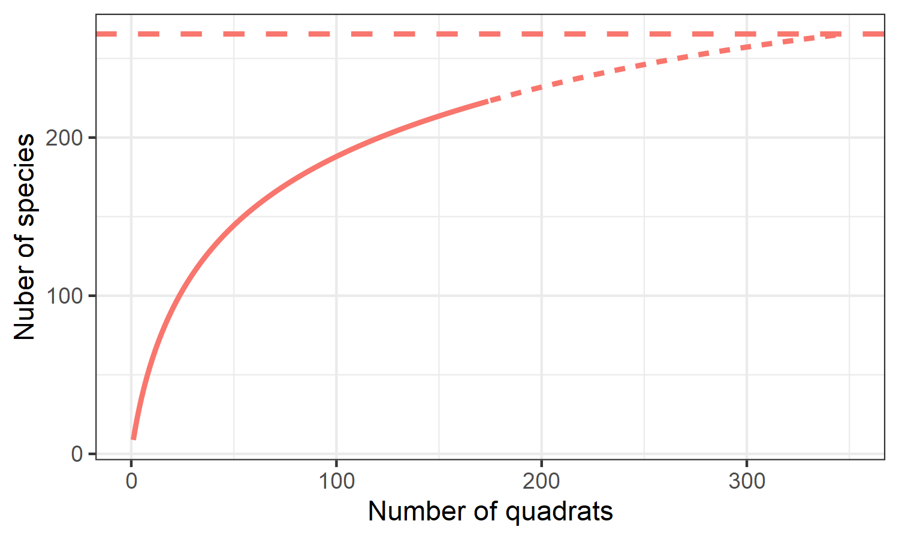

**Figure 4.** Sample-size-based rarefaction (solid line) and extrapolation (dotted line, up to double the investigated sample size) of number of species at city level; the dashed horizontal line represents estimated total number of species with the extrapolation.

From the perspective of abundance, 1,240 trees and 1,233 m2 of shrubs was recorded, with the most common families (in terms of individual numbers for trees and areas for shrubs) listed in Table 3. The most common species for trees were *Quercus glauca* Thunb. (8.71%), *Nandina domestica* Thunb. (7.58%), *Osmanthus fragrans* Lour.(6.05%), *Acer palmatum* Thunb. (4.35%) and *Ligustrum lucidum* W.T.Aiton (4.27%), all of which belong to the top 10 tree families. The most common species for shrubs were the *Rhododendron* *hirado* group (11.30%), *Nandina domestica* Thunb. (8.85%), *Rhododendron indicum* (L.) Sweet (8.21%), *Camellia sasanqua* Thunb. (4.18%) and *Photinia glabra* (Thunb.) Maxim. (3.62%), all of which belong to the top 10 shrub families. The distribution of the species was represented by rank abundance curves for trees and shrubs (Figure 5). The evenness of the trees (EQ = 0.16) was higher than that of the shrubs (EQ = 0.11).

**Table 3.** Top 10 families by abundance at city level. The abundance is represented by individual number for trees and area for shrubs.

|  |  |  |
| --- | --- | --- |
| **Family** | **Abundance\*** | **Proportion (%)** |
| **Tree** |  |  |
| Oleaceae | 191 | 15.40 |
| Fagaceae | 151 | 12.20 |
| Rosaceae | 98 | 7.90 |
| Berberidaceae | 95 | 7.66 |
| Cupressaceae | 74 | 5.96 |
| Sapindaceae | 67 | 5.40 |
| Theaceae | 66 | 5.32 |
| Pinaceae | 44 | 3.55 |
| Cornaceae | 39 | 3.14 |
| Lauraceae | 34 | 2.74 |
| **Shrub** |  |  |
| Ericaceae | 262.00 | 21.30 |
| Rosaceae | 157.00 | 12.70 |
| Berberidaceae | 128.00 | 10.40 |
| Theaceae | 88.10 | 7.16 |
| Oleaceae | 62.00 | 5.03 |
| Hydrangeaceae | 48.00 | 3.90 |
| Caprifoliaceae | 42.20 | 3.42 |
| Araliaceae | 28.80 | 2.34 |
| Garryaceae | 28.50 | 2.32 |
| Fagaceae | 26.40 | 2.14 |

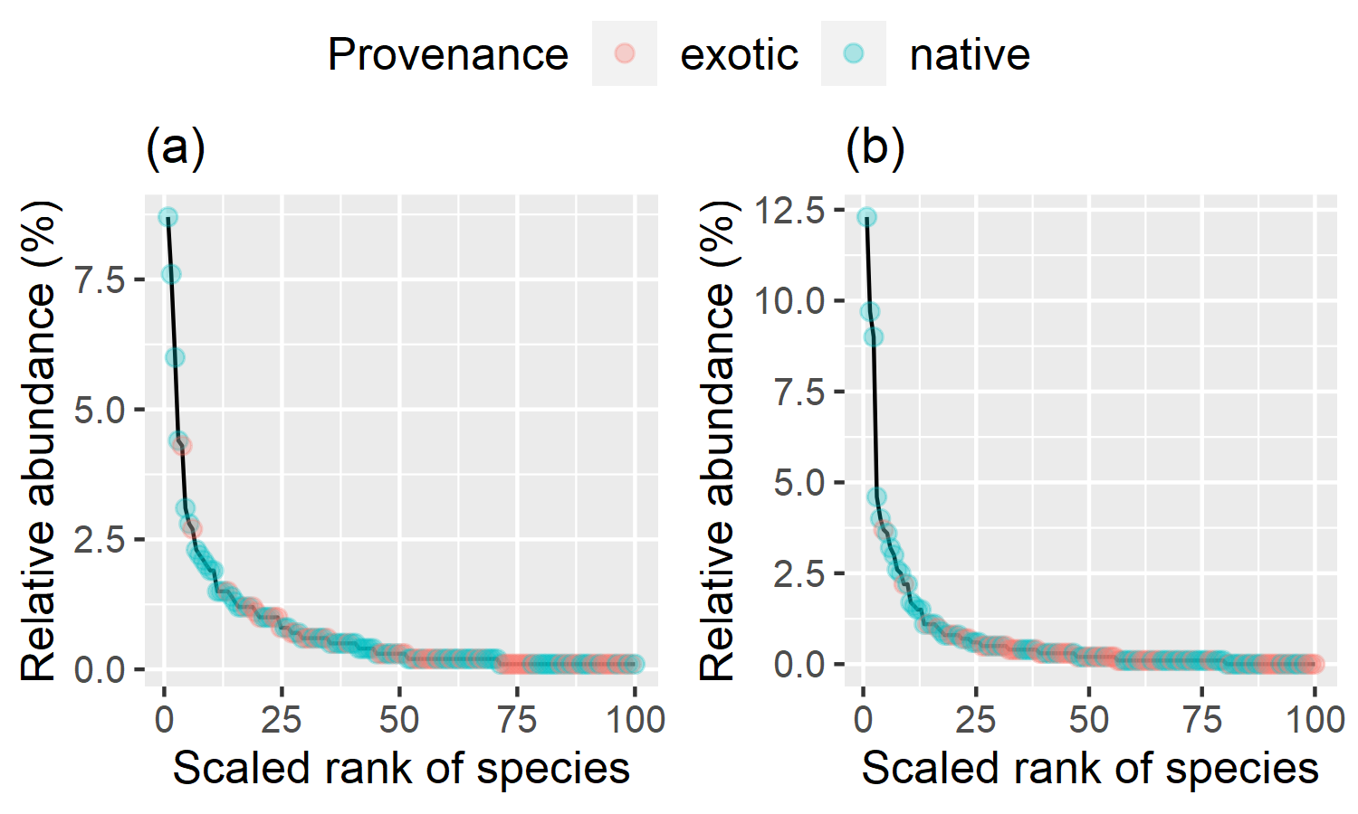

**Figure 5.** Rank abundance curves of (a) trees and (b) shrubs at city level, with the species rank being divided by observed richness

Regarding plant attributes, 93% of the 1,240 tree individuals and 89% of the 1,233 m2 of shrubs were planted rather than spontaneous. 72% of trees and 62% of shrubs were privately owned. In terms of provenance, 74% of tree individuals and 76% of shrubs belong to native species; though from the perspective of number of species, only 50% of the 223 species were native.

### 3.2 Land use level results

ResLow area had the highest estimated total richness, followed by ResOther area, ResHigh area, Ind area, Com area, and ComNbr area (Figure 6).

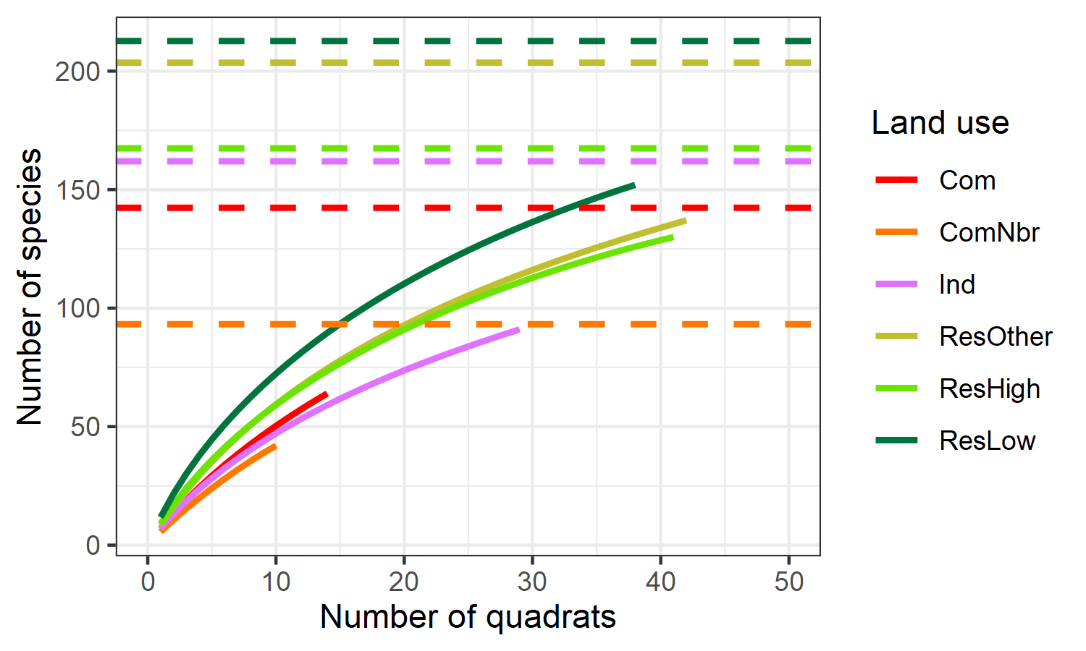

**Figure 6.** Sample-size-based rarefaction curves (solid lines) and estimated total number of species with extrapolation (dashed horizontal lines, up to 348 quadrats) for land use types

The steep trend of rank abundance curves (Figure 7) shows the variation of distribution in species abundance across land use types. Further EQ index calculation indicated that, for trees, Com area had the highest overall tree evenness (EQ = 0.31), followed by ResOther area (EQ = 0.25), Ind area (EQ = 0.24), ResHigh area (EQ = 0.21), ResLow area (EQ = 0.20), and ComNbr area (EQ = 0.19). In contrast, for shrubs, ComNbr area had the highest overall evenness (EQ = 0.15), followed by Industrial (EQ = 0.14), ResLow (EQ = 0.14), ResOther (EQ = 0.13), Commercial (EQ = 0.12), and ResHigh (EQ = 0.12) areas.

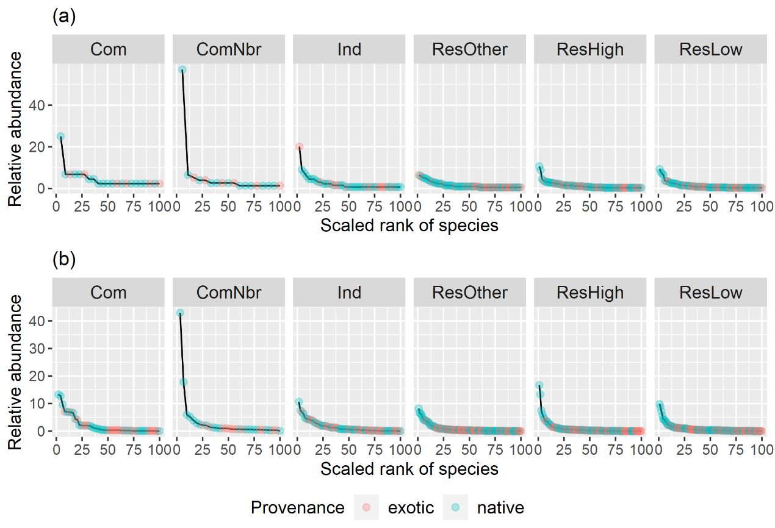

**Figure 7.** Rank abundance curves of (a) trees and (b) shrubs by land use types, with the species rank being divided by observed richness of the land use type

The results of pairwise Bray-Curtis dissimilarity (Table 4) suggested a high dissimilarity (> 0.8) between ResLow area and the other land use excepting for ResOther area, and between ResHigh area and Com area for trees; while a high dissimilarity (> 0.8) between ResHigh area and Com area, ComNbr area, and Ind area for shrubs. The top 10 ubiquitous species for each land use type are listed in Table 5 to demonstrate the details of species composition.

**Table 4.** Dissimilarity (Bray-Curtis index) of species composition between land use types at land use level

|  |  |  |  |  |  |  |
| --- | --- | --- | --- | --- | --- | --- |
|  | Com | ComNbr | Ind | ResOther | ResHigh | ResLow |
| **Trees** |  |  |  |  |  |  |
| Com | - |  |  |  |  |  |
| ComNbr | 0.52 | - |  |  |  |  |
| Ind | 0.54 | 0.50 | - |  |  |  |
| ResOther | 0.72 | 0.67 | 0.50 | - |  |  |
| ResHigh | 0.89 | 0.74 | 0.78 | 0.72 | - |  |
| ResLow | 0.89 | 0.83 | 0.84 | 0.74 | 0.82 | **-** |
| **Shrubs** |  |  |  |  |  |  |
| Com | - |  |  |  |  |  |
| ComNbr | 0.44 | - |  |  |  |  |
| Ind | 0.49 | 0.55 | - |  |  |  |
| ResOther | 0.66 | 0.67 | 0.60 | - |  |  |
| ResHigh | 0.82 | 0.85 | 0.80 | 0.72 | - |  |
| ResLow | 0.62 | 0.68 | 0.54 | 0.49 | 0.70 | - |

**Table 5.** Top 10 ubiquitous species for all the plants by occurency of number of quadrats

|  |  |  |
| --- | --- | --- |
| **Com** | **ComNbr** | **ResLow** |
| *Nandina domestica* | *Nandina domestica* | *Nandina domestica* |
| *Gardenia jasminoides* | *Osmanthus fragrans* | *Osmanthus fragrans* |
| *Mahonia japonica* | *Ginkgo biloba* | *Hydrangea macrophylla* |
| *Camellia japonica* | *Cornus florida* | *Acer palmatum* |
| *Quercus glauca* | *Hibiscus syriacus* | *Camellia japonica* |
| *Rhododendron indicum* | *Acer palmatum* | *Camellia sasanqua* |
| *Schefflera heptaphylla* | *Ternstroemia gymnanthera* | *Rhododendron indicum* |
| *Quercus myrsinifolia* | *Podocarpus macrophyllus* | *Rhododendron hirado group* |
| *Pieris japonica* | *Cornus kousa* | *Cornus kousa* |
| *Ginkgo biloba* | *Pyracantha coccinea* | *Celtis sinensis* |

(continuous table)

|  |  |  |
| --- | --- | --- |
| **ResHigh** | **ResOther** | **Ind** |
| *Nandina domestica* | *Nandina domestica* | *Nandina domestica* |
| *Hydrangea macrophylla* | *Ligustrum lucidum* | *Rhododendron indicum* |
| *Rhododendron indicum* | *Rhododendron indicum* | *Acer palmatum* |
| *Rhododendron hirado group* | *Camellia sasanqua* | *Hydrangea macrophylla* |
| *Osmanthus fragrans* | *Osmanthus fragrans* | *Rhododendron hirado group* |
| *Camellia sasanqua* | *Celtis sinensis* | *Cinnamomum camphora* |
| *Acer palmatum* | *Aphananthe aspera* | *Camellia japonica* |
| *Cinnamomum camphora* | *Camellia japonica* | *Celtis sinensis* |
| *Camellia japonica* | *Hydrangea macrophylla* | *Prunus x yedoensis* |
| *Zelkova serrata* | *Rhododendron hirado group* | *Rhaphiolepis indica* |

### 3.3 Quadrat level results

The results of quadrat richness comparison with Kruskal-Wallis rank sum test and post hoc Dunn’s test indicated that quadrats of ResLow area had higher number of species than those of the other land use excepting for ResHigh area (Figure 8). Quadrat abundance and evenness were compared across land use types for trees and shrubs respectively (Figure 9). Kruskal-Wallis rank sum test indicated significant difference in abundance and evenness for trees while no difference for shrubs. Post hoc pairwise comparison suggested a higher tree abundance for residential areas. For instance, ResLow area quadrats had higher tree abundance than the other land use types excepting for Mid/high residential area. A lower quadrat tree evenness was revealed for ResLow area and ResHigh area.

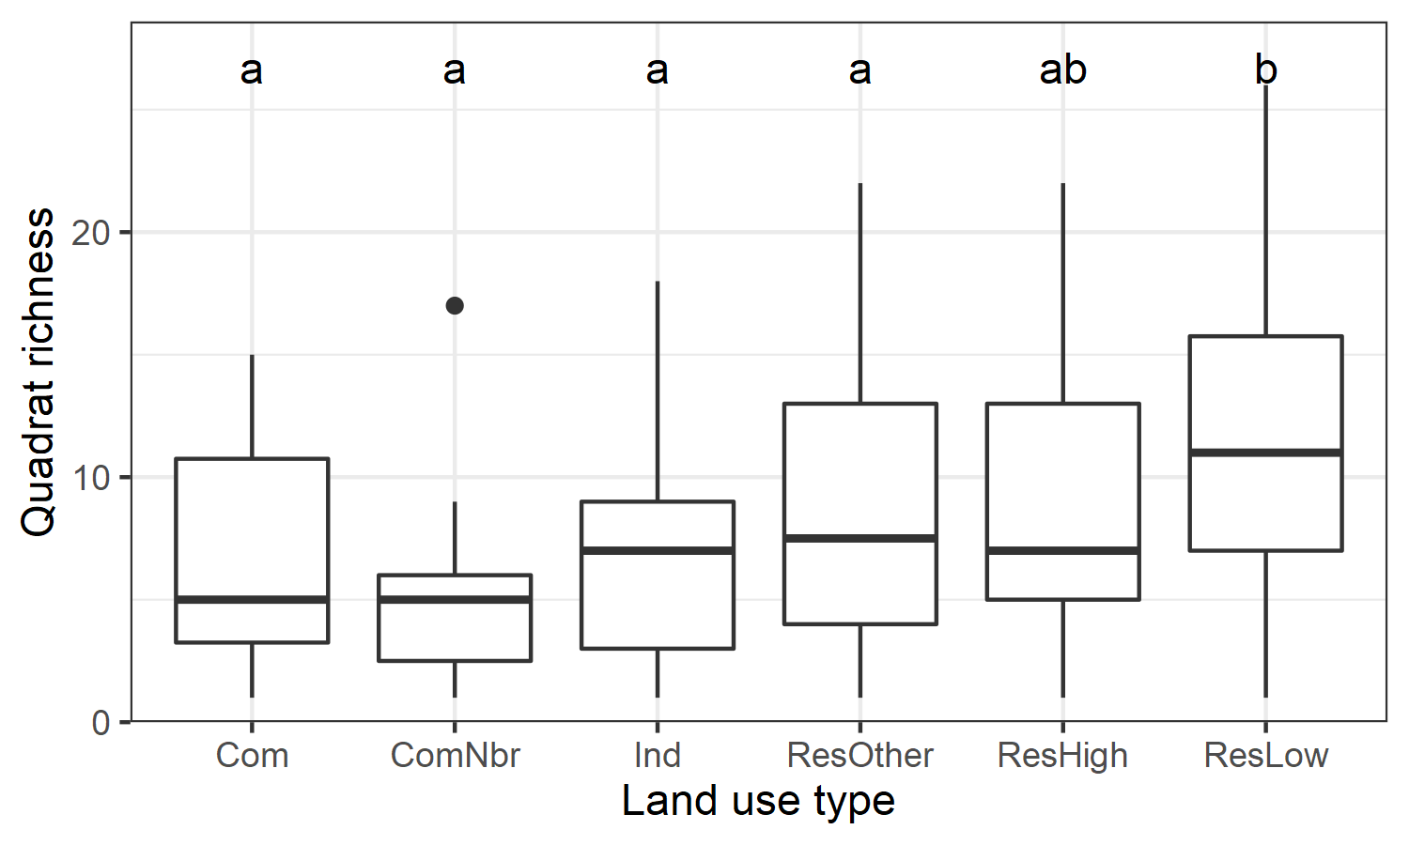

**Figure 8.** Comparison of quadrat richness across land use types

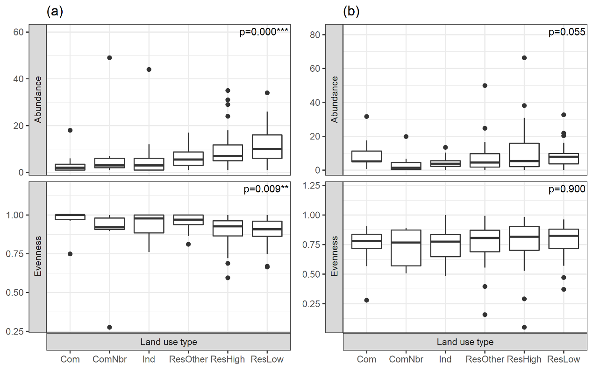

**Figure 9.** Comparison of quadrat abundance and evenness across land use types for (a) trees and (b) shrubs; shows the p-values of Kruskal-Wallis rank sum test

Species composition differed across land use types for shrubs (*R* = 0.059, *p* = 0.041) but not for trees (*R* = 0.021, *p* = 0.124) at quadrat level (Figure 10). Further post-hoc pairwise comparison results revealed that the difference for shrubs mainly resulted from the difference between Com quadrats and ResLow quadrats (*p* = 0.016) and the difference between ResLow quadrats and ResHigh quadrats (*p* = 0.041).

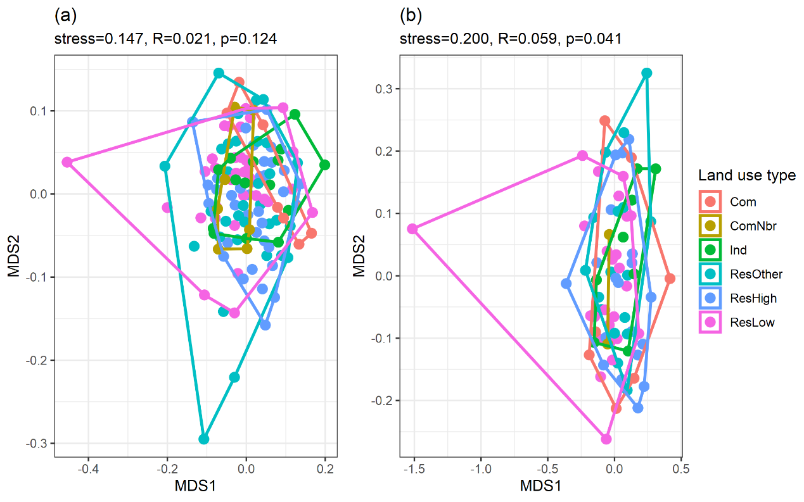

**Figure 10.** Comparisons of species composition of quadrats by land-use types for (a) trees and (b) shrubs

### 3.4 Impact factors for quadrat biodiversity

The results of Pearson correlation test (Table 6) showed that urban gradient factors (distance to city center, land price, population density) had higher impact on tree dataset compared to all plant dataset and shrub dataset. The correlation between the biodiversity metrics (richness, abundance, and evenness) and for all plants or shrubs was not significant, while land price had a negative association with tree richness and abundance, distance to city center had a positive correlation with tree abundance and a negative association with tree evenness. Regarding the variables related to land cover proportion, the proportion of residential was positively correlated with richness of shrub, but the proportion of multi-family residential area had a negative association, which might indicate the contribution of residential yard to biodiversity. It was not surprisingly that the percentage of transportation had a negative association to richness of all plant dataset, tree dataset, and shrub dataset. Besides, the percentage of transportation also had a negative correlation with tree abundance.

Table 6. The Pearson correlation between the variabes of quadrats and species richness, abundance, and evenness with test of all plant dataset, tree dataset, and shrub dataset.

|  |  |  |  |  |
| --- | --- | --- | --- | --- |
| Metrics | Explainary variable | All plant | Tree | Shrub |
| Richness | distance to city center | 0.07 | 0.15 | 0.02 |
|  | land price | -0.06 | -0.19* | -0.02 |
|  | population density | 0.01 | -0.10 | 0.06 |
|  | agriculture% | -0.11 | 0.03 | -0.07 |
|  | residential% | 0.16 | -0.01 | 0.29** |
|  | multi-family residential% | -0.28 | -0.13 | -0.34* |
|  | commercial/industrial% | -0.29 | -0.59 | -0.04 |
|  | institutional% | 0.01 | 0.15 | -0.09 |
|  | park% | -0.28 | -0.11 | -0.24 |
|  | transportation% | -0.31** | -0.25* | -0.30** |
| Abundance | distance to city center | - | 0.20* | 0.14 |
|  | land price | - | -0.18* | -0.04 |
|  | population density | - | -0.02 | -0.08 |
|  | agriculture% | - | -0.15 | -0.09 |
|  | residential% | - | -0.06 | -0.12 |
|  | multi-family residential% | - | -0.15 | -0.27 |
|  | commercial/industrial% | - | -0.37 | -0.40 |
|  | institutional% | - | 0.07 | 0.17 |
|  | park% | - | 0.23 | -0.03 |
|  | transportation% | - | -0.21* | 0.00 |
| Evenness | distance to city center | - | -0.18* | 0.09 |
|  | land price | - | 0.13 | -0.10 |
|  | population density | - | -0.08 | -0.09 |
|  | agriculture% | - | -0.04 | -0.34 |
|  | residential% | - | 0.07 | 0.03 |
|  | multi-family residential% | - | 0.13 | 0.23 |
|  | commercial/industrial% | - | 0.08 | 0.37 |
|  | institutional% | - | 0.37 | -0.16 |
|  | park% | - | -0.27 | 0.25 |
|  | transportation% | - | -0.02 | -0.14 |

The results of linear regression (Table 7) also showed that urban gradient to tree dataset compared with all plant dataset and shrub dataset, and the effect was only limited for tree richness. On contrast, the metrics of the dataset were more likely to be better predicted by land cover proportion. The impact of the proportion of residential and the proportion of multi-family residential area were similar as the results detected by Pearson correlation. The proportion of agriculture had a negative association with tree richness since it is dominated by herbage. The proportion of commercial and industrial area was negatively associated with the richness of all plants and trees, the abundance of trees, and evenness of trees and shrubs, a possible reason is the available space for plants in industrial area or commercial area is limited.

Table 7. Multiple regression analyses for urban gradient measures and onsite land cover proportion to biodiversity metrics of all plant dataset, tree dataset, and shrub dataset. Significance is indicated as: *p < 0.05, ** p < 0.01, *** p < 0.001.

|  |  |  |  |  |
| --- | --- | --- | --- | --- |
| Metrics | Explainary variable | All plant | Tree | Shrub |
| Richness | distance to city center | 0.00 | - | 0.00 |
|  | land price | - | 0.00** | - |
|  | population density | -0.01 | -0.01* | 0.00 |
|  | agriculture% | -6.48 | -4.88* | -2.95 |
|  | residential% | 3.70* | - | 4.27*** |
|  | multi-family residential% | -3.31 | -1.72 | -1.84 |
|  | commercial/industrial% | -6.80** | -5.01** | -3.14 |
|  | institutional% | -2.63 | -2.47 | -1.23 |
|  | park% | - | -0.78 | - |
|  | transportation% | -1.43 | -2.07* | -0.68 |
| R square of the model |  | 0.20 | 0.16 | 0.21 |
| Abundance | distance to city center | - | 0.00 | 0 .00 |
|  | land price | - | - | 0.00 |
|  | population density | - | 0.00 | -0.01 |
|  | agriculture% | - | -2.95 | -9.85 |
|  | residential% | - | 4.27*** | -3.94 |
|  | multi-family residential% | - | -1.84 | -3.42 |
|  | commercial/industrial% | - | -3.14 | -9.19* |
|  | institutional% | - | -1.23 | - |
|  | park% | - | - | 6.52 |
|  | transportation% | - | -0.68 | - |
| R square of the model |  | - | 0.21 | 0.14 |
| Evenness | distance to city center | - | 0.00 | - |
|  | land price | - | 0.00 | 0.00 |
|  | population density | - | -0.01 | 0.00 |
|  | agriculture% | - | -9.85 | -0.14 |
|  | residential% | - | -3.94 | 0.11* |
|  | multi-family residential% | - | -3.42 | 0.12 |
|  | commercial/industrial% | - | -9.19* | 0.17* |
|  | institutional% | - | - | -0.02 |
|  | park% | - | 6.52 | - |
|  | transportation% | - | - | 0.01 |
| R square of the model |  | - | 0.16 | 0.10 |

## Discussion

### 4.1 Urban exotic species proportions at city level

Despite a potentially high plant diversity, urban areas typically feature high concentrations of exotic species due to human introduction (Aronson et al., 2015). Icollected the percentage data for exotic species from other studies (Table 8). The percentage in our research for Kyoto City (50%) is nearly average among the cities. The percentage of exotic species varies among city contexts, possibly in relation to climate (Avolio et al., 2015a), history (Aronson et al., 2014) and development levels. For instance, in drier cities, trees of exotic species are often artificially cultivated as part of urban development efforts (Avolio et al., 2015a). Research on Danish temporal changes in species composition suggested a faster increase in the presence of exotic species than for native species in urban development (Nielsen et al., 2019). Proportion differences may also be attributable to research methodology relating to geographical extent, target land use types and criteria of plant provenance. For instance, previous studies have shown that exotic plant species richness and abundance increase with greater urban land use coverage (Aronson et al., 2015; Pennington et al., 2010). Regarding the impact of target land use types covered in the research, Chimaimba et al. (2020) found that the proportion of exotic species in residential areas, along roads and at institutions was much higher than in graveyards, afforestation hills, and parks in Zomba of Malawi.

**Table 8.** The proportion of exotic species for woody plants or trees in some cities

|  |  |  |  |
| --- | --- | --- | --- |
| Reference | Study area | Number of species recorded | Percentage of exotic species |
| Avolio et al. (2015a) | three southern California counties, US | 114 | 93% |
| Raoufou et al. (2011) | Lomé, Togo | 297 | 69% |
| Ortega-Álvarez et al. (2011) | Mexico City, Mexico | 89 | 66% |
| Guo et al. (2018) | Beijing, China | 148 | 57% |
| Ouyang et al. (2015) | Xi’an, China | 176 | 45% |
| Dangulla et al. (2019) | Zaria and Sokoto, Nigeria | 56 | 39% |
| Chimaimba et al. (2020) | Zomba, Malawi | 168 | 36% |
| Muthulingam and Thangavel (2012) | Chennai metropolitan city, India | 45 | 31% |
| Godefroid and Koedam (2007) | city of Brussels, Belgium | 702 | 23% |
| Zhao et al. (2013) | Chongming island, China | 42 | < 20% |
| This research | Kyoto city, Japan | 223 | 50% |

Although half the species recorded in the current research were exotic, the proportion was much lower regarding abundance (26% for trees and 24% for shrubs). The Malawi study conducted by Chimaimba et al. (2020) also suggested inconsistencies in exotic species percentage based on species number and abundance data. As ecosystem functionality may depend more on species dominance (Genung et al., 2020a), the proportion of exotic species by abundance should be emphasized in future research in case of possible overestimation of the importance of rare exotic species.

### 4.2 Measurements of urban plant diversity

Biodiversity is a complex concept with controversy in measurement despite acknowledged definitions. From the perspective of scale, while biodiversity indexes at quadrat level has been widely applied in gradient-based studies (e.g., Aronson et al., 2015; Brunzel et al., 2009; Hahs and McDonnell, 2007; Vakhlamova et al., 2014; Wang et al., 2020), indexes at aggregate level has been frequently used in discrete-variable-based research like the studies on biodiversity across land use types other than quadrat diversity (Bourne and Conway, 2014; Chimaimba et al., 2020; Guo et al., 2018; Liu et al., 2018; Yang et al., 2017). However, since biodiversity is scale-dependent, higher diversity at quadrat level does not necessarily represent higher diversity at aggregated level. Inconsistencies between quadrat richness and richness at aggregated level were found in previous research (Bourne and Conway, 2014; Ortega-Álvarez et al., 2011; Thompson et al., 2003). Thus the hierarchical framework of *alpha-*, *beta-* and *gamma-*biodiversity indexes should be applied (Tuomisto, 2010; Whittaker and Rh, 1977; Whittaker et al., 2001; Whittaker, Robert H., 1960) and scale should be emphasized to achieve a better comparability between research when calculating urban biodiversity.

For comparison of richness at aggregated level, most studies treated the sum of quadrat richness as a precise estimation of total richness at the scale of interest, which can be heavily biased since species number increases with sampling effort (e.g., sample quadrat area or the number of quadrats). It is not appropriate to compare richness without a calibration of sample size (e.g., Chimaimba et al. (2020) compared total richness of each land use measured with different number of quadrats). Here Isuggest the method based on species accumulation curves as a useful tool for a reliable total richness estimation to eliminate the bias caused by sample size (Chao et al., 2014; Willis, 2019).

### 4.3 Land use type, scale, and plant diversity

For comparison with other studies at quadrat level, average values of quadrat richness and abundance of this research were extracted and calculated for all woody plants and for trees across land use types (Table 9; results from other studies linearly converted with a 400 m2 base). It should be noted that since many of the studies didn’t indicate the distribution or statistical analysis results of quadrat richness or abundance, the comparison in this section only focuses on the average values. The mean quadrat richness for residential areas in Kyoto City (ResLow, 11.70; ResHigh, 9.05; ResOther, 8.52) is higher than that in Beijing (8.46, Guo et al., 2018) for woody plants; while that for trees in Kyoto City (ResLow, 5.77; ResHigh, 4.84; ResOther, 4.03) is lower than Mexico City (9.99, Ortega-Álvarez et al., 2011) and the Peel region of Canada (5.99, Bourne and Conway, 2014). Quadrat tree abundance for residential areas in this research (ResLow, 11.40; ResHigh, 9.68; ResOther, 6.41) is also lower than that of Mexico City (20.0, Ortega-Álvarez et al., 2011), but quadrat tree abundance of ResLow area and ResHigh quadrats are higher than that in the Peel region (9.0, Bourne and Conway, 2014).

**Table 9.** Comparison of quadrat richness and abundance across land use types in some cities. The area of sample quadrats differs across studies, so the richness and plant abundance has been linearly converted by a base of 400 m2 in this table.

|  |  |  |  |  |  |
| --- | --- | --- | --- | --- | --- |
| Reference | Study area | Biological group | Land use type | Richness | Abundance |
| Guo et al. (2018) | Beijing, China | woody plants | residential | 8.46 | - |
| community park | 7.95 | - |
| institutional | 7.38 | - |
| commercial | 6.01 | - |
| roadside | 5.96 | - |
| riverside | 5.21 | - |
| municipal park | 5.11 | - |
| woodlot | 2.53 | - |
| Ortega-Álvarez et al. (2011) | Mexico City, Mexico | trees | residential | 9.99 | 19.98 |
| residential-commercial | 8.97 | 3.63 |
| commercial | 6.58 | 5.40 |
| green area | 4.12 | 19.98 |
| Bourne and Conway (2014) | Peel region, Canada | trees | agriculture | 2.00 | 2.99 |
| commercial | 2.00 | 2.99 |
| golf | 5.99 | 38.91 |
| institutional | 4.99 | 11.97 |
| parkland | 4.99 | 20.95 |
| residential | 5.99 | 8.98 |
| transportation | 4.99 | 20.95 |
| vacant | 5.99 | 38.91 |
| Dangulla et al. (2019) | Zaria, Malawi | trees | built-up | - | 2.79 |
| farmland | - | 1.42 |
| green area | - | 5.48 |
| open space | - | 1.51 |
| wetland/water | - | 1.72 |
| Dangulla et al. (2019) | Sokoto, Malawi | trees | built-up | - | 1.93 |
| farmland | - | 0.64 |
| green area | - | 7.44 |
| open space | - | 0.52 |
| wetland/water | - | 2.57 |
| This research | Kyoto, Japan | trees | Com | 2.25 | 3.67 |
| ComNbr | 2.89 | 8.56 |
| Ind | 3.17 | 5.83 |
| ResOther | 4.03 | 6.41 |
| ResHigh | 4.84 | 9.68 |
| ResLow | 5.77 | 11.40 |
| This research | Kyoto, Japan | woody plants | Com | 6.93 | - |
| ComNbr | 5.60 | - |
| Ind | 7.00 | - |
| ResOther | 8.52 | - |
| ResHigh | 9.05 | - |
| ResLow | 11.70 | - |

Differences in environment, available space, greening goals and types of people making decisions (Bourne and Conway, 2014; Godefroid and Koedam, 2007) lead to different patterns of plant diversity across land use types and scale. In listed studies (Table 9, including this research), quadrat richness of residential areas are all higher than that of commercial areas (Bourne and Conway, 2014; Guo et al., 2018; Ortega-Álvarez et al., 2011). Furthermore, a similar pattern was found at land use level that the estimated total richness in residential areas is higher than that in industrial area and commercial areas in Kyoto City. The results are likely associated with the effects of space available for plants. Unlike residential areas, commercial areas are characterized by high-density commercial centers and offices, which lack green spaces and private gardens (Godefroid and Koedam, 2007). For industrial area, greening ratios for factory sites in Japan must exceed 10% legally (Ministry of Economy, Trade and Industry, Government of Japan, 2017), but planted species tend to be function-oriented as well as being easy to maintain. The results also emphasize the critical impact of residents’ preferences. Unlike city planners and factory owners who may choose plants from a limited number of species to achieve public greening goals, residents tend to select from a larger species pool for cultivation on their properties (Avolio et al., 2018). The results here also suggest that the dispersed green spaces like private gardens are essential for maintaining urban biodiversity (Goddard et al., 2010). Whereas, on the other hand, the demolition of traditional private garden due to the lifestyle change (Niino et al., 2021) might lead to a decrease in the urban plant diversity in Kyoto City.

Even within residential areas, diverse building types and residential conditions lead to differences in plant diversity (Bourne and Conway, 2014; Troy et al., 2007). Among three types of residential areas in Kyoto City, ResLow area has the highest estimated total richness at land use level and highest quadrat richness. The results are partially attributable to larger plantable areas and species turnover rates in ResLow area. In Japan’s cities, ResLow area generally features low-rise houses with yard, along with limited numbers of other buildings with lower greening rates such as recreational facilities, hotels and institutions. Residential buildings in ResHigh and ResOther area are generally high-rise structures such as multi-family apartments with no gardens.

Despite higher richness at both land use level and quadrat level, ResLow area exhibited moderate to low evenness. This finding is consistent with Bourne and Conway (2014), and might result from a mix of varied unique species in residential areas due to diverse choices among homeowners as opposed to relatively uniform greening in commercial and industrial areas. The outcomes further suggest that evenness should be applied as a supplement for richness in plant diversity research.

### 4.4 Urban gradient, land cover, and quadrat plant diversity

Urban gradient analysis has been widely applied in urban biodiversity research (Vakhlamova et al., 2014a). While many patterns of plant diversity along the urban gradient were found in previous research, the results could be determined by the target taxa, provenance, the metrics of urban gradient, and the scale of research. (1) Target taxa. The urban area has more woody plant species than the surrounding less developed areas like suburban and rural area in Shanghai (Wang et al., 2020), while a research in Kazakhstan focusing on spontaneous plants showed that the quadrat richness and shannon index are positively associated with the distance of the quadrat to city center (Vakhlamova et al., 2014b). In this study, I also found a positive but not significant correlation between the distance of quadrat to city center with richness, which is partially consistent with the results of woody plants research in Shanghai. (2) Provenance. A study of Tampere of Finland suggests that the richness of non-native species peaks at suburban area, while the richness of native species is higher in the suburban and the rural (Ranta and Viljanen, 2011b). (3) The surrogate metrics for urbanization. Though distance to city center has been widely used as the proxy of urban gradient, it is controvercial that it assumes a gradual change of urbanization along the physical transect, and it can conflict with other urban gradient metrics like population density or other socio-economic gradient. Theoretically, the distance metrics is more suitable for a monocentric city with a urban core area. Other than a single measure of urban gradient, complex metrics has also been applied. For instance, a combined urbanization index (Hahs and McDonnell, 2006) was applied in a Melbourn’s urban gradient research (Hahs and McDonnell, 2007b). Another study used Delphi method which is based on experts’ experience and knowledge to determine the urbanization gradient (Porter et al., 2001b). (4) Scale. The scales of urbanization might be limited in urban built-up area or extend to surround rural area or even natural area (e.g., forest). The presence of peak diversity value also varies with the scale.

It turns out that the distance of the quadrats to city center is not a good explanatory variable for biodiversity prediction in this study. Amon the test, only the association between tree abundance and the distance to city center was positive and significant revealed by Pearson correlation test. The result of higher diversity in the urban core is explained by the high demand for green space in urbanized areas (Wang et al., 2020), which is paradoxical with the high built-up density of urban core (Troy et al., 2007). And intermediate disturbance hypothesis was frequently applied to explain the so-called suburban peak pattern of plant diversity(Ortega-Álvarez et al., 2011; Wang et al., 2020). While the results from the studies and the hypothesis might not be applicable to predict our result for the following reason: (1) the Kyoto city is characterized with mixed function, which leads to a more evenly spatial distribution of anthropic disturbance, that the distance to the city center is not a good presenter of disturbance intensity; (2) the suburban peak pattern are usually found for spontaneous plants and herbs, while rarely for woody plants which are mainly planted (Ortega-Álvarez et al., 2011); (3) and the pattern is also related to boundary and scale (Aronson et al., 2015) – since our study is limited to Kyoto city built-up area, the extent of our study area might not include less developed rural area.

Land price is negatively correlated with tree richness and abundance, and population is negatively associated with tree abundance revealed by linear model in this study. The results of land price is contrast to luxury effect, which generally reveal the positive relationship between median income and biodiversity (Chamberlain et al., 2019). This result indicates the difference pattern of biodiversity along land price gradient and income gradient. According to the spatial data, land price is generally higher in city center, while the reason for that is more likely because of the commercial value of the land. In many cities, wealthier people tend to live in the surrounding aera even the suburban of cities because they can afford a bigger house and the commuting cost. The seemingly opposite results require further research with more comprehensive socio-economic dataset.

Compared to urban gradient variables, on site land cover proportion variables turn out to be better predictors for the biodiversity metrics. The positive impact of residential area and the negative impacts of the proportion of multi-family residential area, commercial and industrial area, and transportation area support the conclusion that private land has critical contribution to urban biodiversity. Among the habitat change, agriculture is another key factor driving biodiversity loss globally. In this study, agriculture area percentage has a negative impact on tree richness since it is dominated by herbages like crops and vegetables.

## Conclusion

In this study, I explored woody plant diversity across land use and scale in Kyoto City. At land use level, residential areas had higher total richness with moderate to low overall evenness, while commercial areas had relatively lower total richness. A high species composition dissimilarity was identified between residential areas and other land use types. At quadrat level, ResLow area had higher richness than the other land use excepting for ResHigh area. Quadrat abundance and evenness were different across land use types for trees but not for shrubs. Quadrat species composition was significantly different across land use types for shrubs, but not for trees. The test of relationship of urban gradient and onsite land cover with the quadrat biodiversity metrics reveals that onsite land cover proportion variables are better predictors for the metrics. Specifically, residential area percentage has a positive impact while multi-family residential area and trasportation percentage have a negative association with the metrics.

From the perspective of urban management practice, this research identified prior land use types for biodiversity improvement. For instance, the commercial areas are characterized with lower plant diversity but more visitors and higher population density. An improvement of plant diversity in these land use types can enhance the potential ecosystem services benefit due to a higher beneficiary population and higher accessibility of the plants in public space. The contribution of ResLow area for urban biodiversity conservation was also further proved.

The results also suggest that the mechanism underlying urban plant diversity requires further research, especially in regard to the heterogeneous impact of different land use types at various of scales.

# Urban ecosystem services

## Introduction

The world’s urban population is expected to increase from 55% in 2019 (The World Bank Data, n.d.) to 68% by 2050 (Population Division, United Nations, 2019), thus growth of demand for ecosystem services in cities would ensue. The relation between demand and supply of ecosystem services varies with scale. Locally generated ecosystem services are more closely related to the living quality of the resident, and some of them are irreplaceable by other distant sources of ecosystem services (for example, mitigation of heat island effect) (Gómez-Baggethun et al., 2013). Considering the numerous population size in cities, the social and economic value of ecosystem services within cities can be surprisingly high (Gómez-Baggethun and Barton, 2013). Besides, a global assessment highlighted how massive urbanization is impacting biodiversity and ecosystems around the world negatively (Elmqvist et al., 2013). Therefore, an improvement of urban ecosystem services could potentially benefit city residents and mitigate the loss of ecosystem services globally.

Yet despite the importance of urban ecosystem services evaluation (Gómez-Baggethun et al., 2013), most of the studies and the implementation of the research findings into land use policy, are in North America, Europe, and China (Haase et al., 2014; Ordóñez-Barona et al., 2019) (case studies see New York City (Kremer et al., 2016b) and Berlin (Larondelle and Lauf, 2016)). Besides, even though related evaluation tools like i-Tree have been widely applied in many cities around the world, urban ecosystem services research in Japan has been less addressed. A pilot study evaluated the ecosystem services of street trees in Kawasaki City in Japan using i-Tree (Hirabayashi et al., 2016). Other than that, only some case studies using a similar approach were found (Hirabayashi et al., 2019; Kawaguchi et al., 2021; Tan et al., 2021).

Ecosystem services are estimated with a variety of methods, including indicators and valuation. Indicators are used to quantify the state and change of the objects of interest. Some of the commonly used indicators are crop yield for food production, carbon storage and carbon sequestration for climate change mitigation, and runoff reduction for hydrological regulation. Regarding the valuation, two methods are applied to estimate ecosystem services' monetary value. One is the traditional economic method using firsthand data, including the stated preference method and revealed preference method. Though the empirical, field-based method can provide more accurate results (Zhao and Sander, 2018), it is time-consuming and limited on the scale. Therefore, the other method, value transfer (or ‘benefit transfer’) is widely used in ecosystem evaluation (Kremer et al., 2016a), for which the monetary value estimation of one location (the ‘reference ecosystem’) is transferred to another (the ‘target location’) (Costanza et al., 2017). The value transfer method is frequently applied in regional services estimation based on the area of land use/land cover types and per unit area ecosystem service value of each type. In these studies, cities are categorized as ‘urban area’ or ‘built-up area,’ and the ecosystem service of the category is estimated with a constant per unit area ecosystem service value. Particularly, the per unit area ecosystem service value for urban ecosystem from Costanza et al. (Costanza et al., 2014) has been widely applied (e.g. see (Arowolo et al., 2018; Yi et al., 2017)). Some other research modified the per unit area ecosystem service value based on the local context like scarcity value effect (Bryan et al., 2018). However, the land use/land cover-based value transfer method could cause uncertainty in urban ecosystem service estimation since it ignores the high heterogeneity in cities and rapid change of land use/land cover (Haase et al., 2014; Kremer et al., 2016a). To get a more specific per unit area ecosystem service value for urban ecosystems, within-city research and inter-city comparison research is needed.

Among the service providers in urban ecosystems (e.g., forest patches, waterways and lakes, parks, brownfields, urban agriculture (Haase, 2013; Haase et al., 2014; Kim et al., 2015)), urban forest is one of the foremost. As a crucial local ecosystem services provider in cities, urban forest functions in many services like carbon storage and sequestration, noise reduction, air quality improvement, energy conservation, and recreation (Bolund and Hunhammar, 1999; Gómez-Baggethun et al., 2013). However, the ecosystem services of urban forests might have been underestimated since many previous studies focused on remnant forests or street trees (e.g., (Szkop, 2016; Tang et al., 2016)), partially due to data availability. However, the dispersed green spaces such as private gardens have been less studied, despite the fact that their importance to urban ecosystem services has been proved (Camps-Calvet et al., 2016b; Haase, 2013; Kim et al., 2015).

To estimate the ecosystem services of urban forests more precisely, i-Tree Eco has been applied worldwide in more than one hundred countries. Developed by the United States Department of Agriculture, i-Tree Eco allows users to calculate several ecosystem services (carbon storage and sequestration, pollutants removal, runoff reduction, etc.) of each tree with field investigation data of tree species, size, and condition. Though i-Tree Eco enhances users to manage urban forest more accurately, even at a single-tree level, most research only presented the results of inferred total ecosystem services of the whole research area (e.g., see (Nowak et al., 2016)) or results by species (Kiss et al., 2015; Ning et al., 2016). One possible reason is being guided by the automatically generated report of the tool. These results, however, provide little information on the link between within-city heterogeneity and urban ecosystem services. Only a few research reported ecosystem services across land use/land cover within cities (Baro et al., 2014; Kim et al., 2015).

To address the gaps mentioned above, Iconducted an urban ecosystem services evaluation at a Japanese city, Kyoto. The study is partially aimed at enriching the data base of urban ecosystem services with detailed ground-based investigation data and i-Tree Eco tool. Another main objective of this article is to link urban heterogeneity and urban ecosystem services by comparing ecosystem services across land use. Iexpected that ecosystem services would differ across land use types.

In this study, a pre-stratified sampling method based on the area of land use classes was applied for field data collection, then i-Tree Eco tool was used to calculate the urban forest structure, tree compensatory value, and ecosystem services. The ecosystem services, including carbon storage and sequestration, air pollutants removal, and runoff reduction, were estimated for the entire study area and allocated to each tree, then further grouped by quadrat. Icompared ecosystem services at both quadrat level and single-tree level across land use classes. For a better understanding of the link between heterogeneity and ecosystem service, Ialso compared the results of Kyoto City with the studies of other cities.

## Methods

### 2.1 Data preperation

A subset of data with the following information of each tree was extracted from the data set formed in Chapter 2: (1) species; (2) size-related data for trees: height, diameter at breast height (DBH), crown size; (4) health status: canopy missing percentage, crown health condition, and crown light exposure. It should be noted that this chapter mainly focuses on efficiency of ecosystem services (per quadrat ecosystem services) across land use, thus a evaluation of ecosystem services for each individual plant is required. While i-Tree Eco, the tool applied for ecosystem service calculation here, can only produce the output of individual for trees while not for shrubs. Therefore, only the subset for tree was extracted for the analysis of this chapter from the complete data set. The number of trees in each land use is shown in **Table 10**.

**Table 10.** Sample quadrats by stratified sampling method in this research.

|  |  |  |  |  |
| --- | --- | --- | --- | --- |
| Land use class | Area (ha) | Proportion of area | Number of quadrats | Number of trees |
| ResLow | 3519 | 24% | 35 | 399 |
| ResHigh | 3027 | 21% | 38 | 368 |
| ResOther | 3113 | 21% | 34 | 218 |
| Ind | 3213 | 22% | 23 | 134 |
| ComNbr | 864 | 5% | 9 | 77 |
| Com | 1009 | 7% | 12 | 44 |

### 2.2 Evaluation of ecosystem services and monetary value

i-Tree model has been widely used to help managers and researchers to quantify urban forest structure, ecosystem services, and tree monetary value. I calculated three values of each tree: compensatory value, representing compensation for the loss of a tree (Council of Tree and Landscape Appraisers, 1992; David J. Nowak, 2002); monetary value of carbon storage, representing the cumulative result of net carbon sequestration for years; annual ecosystem services, including carbon sequestration, air pollutants removal, and runoff reduction. Though cultural service is one of the most critical components of ecosystem services in cities, i-Tree is not capable of calculating it for now. I will briefly introduce the method for structure and ecosystem services evaluation, and valuation of tree monetary value in the following sections; for more details refer to i-Tree method documentation (Nowak, 2020). To improve the accuracy of results, a modified i-Tree model with local parameters of Kyoto City was applied (see Table A4 for model details and parameters list). The basic operating steps are to input the data into i-Tree Eco software interface with a new program, and submit the program to i-Tree server, then the ouput will be sent to the user after the calculation is finished. However, generally, the output is a report with inferred ecosystem services of the whole research area in PDF format. I cooperated with an environmental modeller, Dr. Hirabayashi, in this study that the original output data of each tree from i-Tree Eco was available.

#### 2.2.1 Structure

Leaf area is estimated based on species, total height, crown base height, crown width, and percent crown missing. The method is a species-specific regression equation with a shading coefficient (percent light intensity intercepted by foliated tree crowns) for deciduous urban species, while a shading coefficient of 0.91 is applied for conifer trees (i-Tree, 2019). Leaf area index (LAI) is calculated with leaf area and adjusted with the overlap of tree crowns or light exposure. Leaf biomass is calculated based on leaf area with species-specific convert factor. Total biomass for each tree is calculated using species-specific allometric equations from the literature with DBH and total height (see (David John Nowak, 2002; Nowak, 1994) for the attributes and references of the equations).

#### 2.2.2 Carbon storage and carbon sequestration

Carbon storage is estimated based on biomass and carbon content. For evergreen and palm species, leaf biomass is added. Carbon sequestration is estimated based on the growth rate. The growth rates are estimated with the measurement of radial growth increments (Nowak, 1994), length of the growing season, and the growth adjustment factor of crown health and crown light exposure (i-Tree, 2019). For valuation of the ecosystem services, the social cost for carbon in Japan (10,600 Yen, which is about 96 US dollars per ton carbon) from the Japanese government document (Ministry of the Environment, Government of Japan, 2019) was applied.

#### 2.2.3 Air pollutants removal and health benefits

Air pollution removal is estimated using the percent tree cover and leaf area index. The pollutants estimated include nitrogen dioxide (), ozone (), particulate matter less than 2.5 µm (), and sulfur dioxide (). In the locations supported more sufficiently in i-Tree Eco (e.g., cities in the US and Canada), the tree data is merged with local pre-processed weather and air pollution concentration data for the evaluation of pollutants removal. However, in this case, since Kyoto City is not officially supported by default, Iinput the local weather data from local monitor stations manually. The value of air pollutant removal is assessed by the BenMAP method (Nowak et al., 2014) that estimates avoided costs for adverse health incidences based on the air quality improvement and medical records across the US.

#### 2.2.4 Runoff reduction

Runoff reduction in i-Tree Eco is estimated based on the difference between the runoff with current tree cover and that without trees [40]. In the simulation, rainfall interception of trees and runoff are calculated mainly by precipitation, leaf area index, and infiltration with a time step of an hour (Wang et al., 2008). One limitation of the model is that the water reaching pervious surface is assumed to be absorbed by the soil, while the water reaching the impervious surface is assumed to become urban surface runoff. Besides, though the impervious cover rate is estimated by JAXA satellite imagery, the number is assumed to be constant across the research area. To reflect the local economic benefit of the ecosystem service, Iused the stormwater control facilities cost estimation of Suita City of Japan (719 yen per , which is about 7 US dollars per ) (Kawaguchi et al., 2021) for the valuation.

#### 2.2.5 Compensatory value

The compensatory value of trees is estimated using the guideline of Council of Tree and Landscape Appraisers (Council of Tree and Landscape Appraisers, 1992) in i-Tree Eco (Nowak, 2020). The compensatory value of a tree is determined by replacement cost, DBH, and a location-specific per unit trunk area cost. For palm trees, the cost to clear trunk is also considered. The values of these parameters have been compiled for numerous states in the US; while for other countries, an average value of replacement cost and per unit trunk area cost is applied.

### 2.3 Data analysis

The collected and calculated data for each single tree was then added to get a quadrat dataset, including average DBH, average LAI, the total number of trees, and the total ecosystem services of each quadrat. Since the assumption of normality for the metrics is violated in this case, the non-parametric statistic method, Kruskal-Wallis rank sum test, was used to analyze the difference of DBH, LAI, the number of trees, and each ecosystem service among land use classes. For the statistical group comparison where a significant difference was detected, Dunn’s test was then applied for a post hoc pairwise comparison. Similarly, at the single-tree level, Kruskal-Wallis rank sum test and Dunn’s test were used to test the differences of DBH, LAI, and each ecosystem service across land use classes respectively.

Furthermore, a species-specific analysis was used to compare the single-tree ecosystem services across land use classes by species. To achieve a robust result, only widespread species presenting across a sequence of land use classes with at least 3 individuals for each land use class were analyzed. The target species include *Acer palmatum*, *Ginkgo biloba*, *Ligustrum lucidum*, *Nandina domestica*, *Osmanthus fragrans*, *Podocarpus macrophyllus*, *Prunus x blireana*, *Quercus x alvordiana*, and *Zelkova serrata*.

All the analysis was conducted in R (version 4.0.3), and the difference was considered significant at p < 0.05. The function was applied for Kruskal-Wallis rank sum test and function from package was used for the post hoc comparison.

## Results

#### 3.1. DBH and LAI

DBH is related to both age and species of trees. Trees with DBH 15 *cm* accounted for a large proportion across the land use classes (**Figure 11**). Ind zone had more trees with DBH > 15 cm than others, probably reflecting the low manage intensity of Ind zone and being constrained by both planting goals and limited space. ComNbr zone was characterized by a larger proportion of trees with DBH 15 cm than the others.

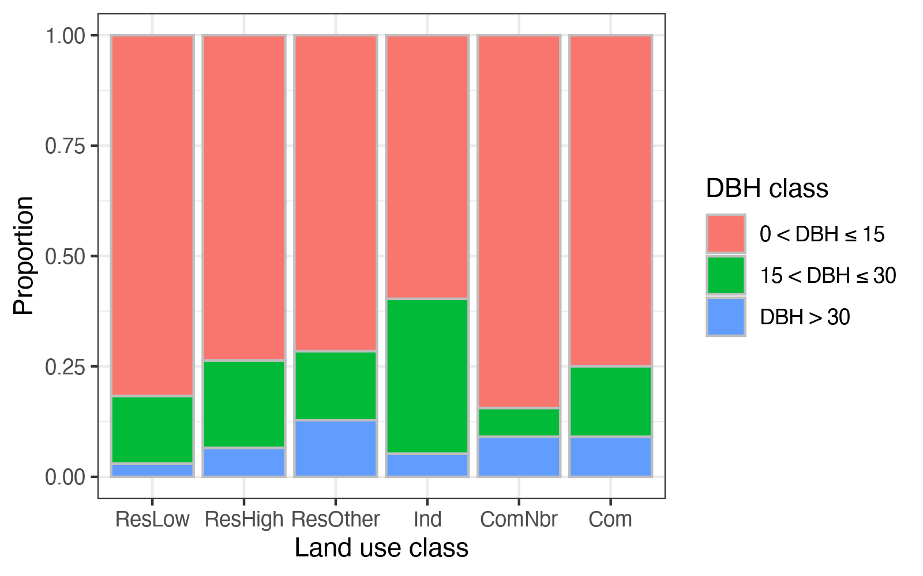

**Figure 11.** DBH (diameter at breast height) distribution across land use classes.

The LAI for most trees was under 6 (**Figure 12**). The proportion of LAI < 3 is higher in ComNbr zone, followed by Ind and Com, and residential areas. Among the residential areas, ResLow and ResHigh were chartered by a lower proportion of LAI <3 and a higher proportion of LAI > 6, which might result from the maintenance of the house owners.

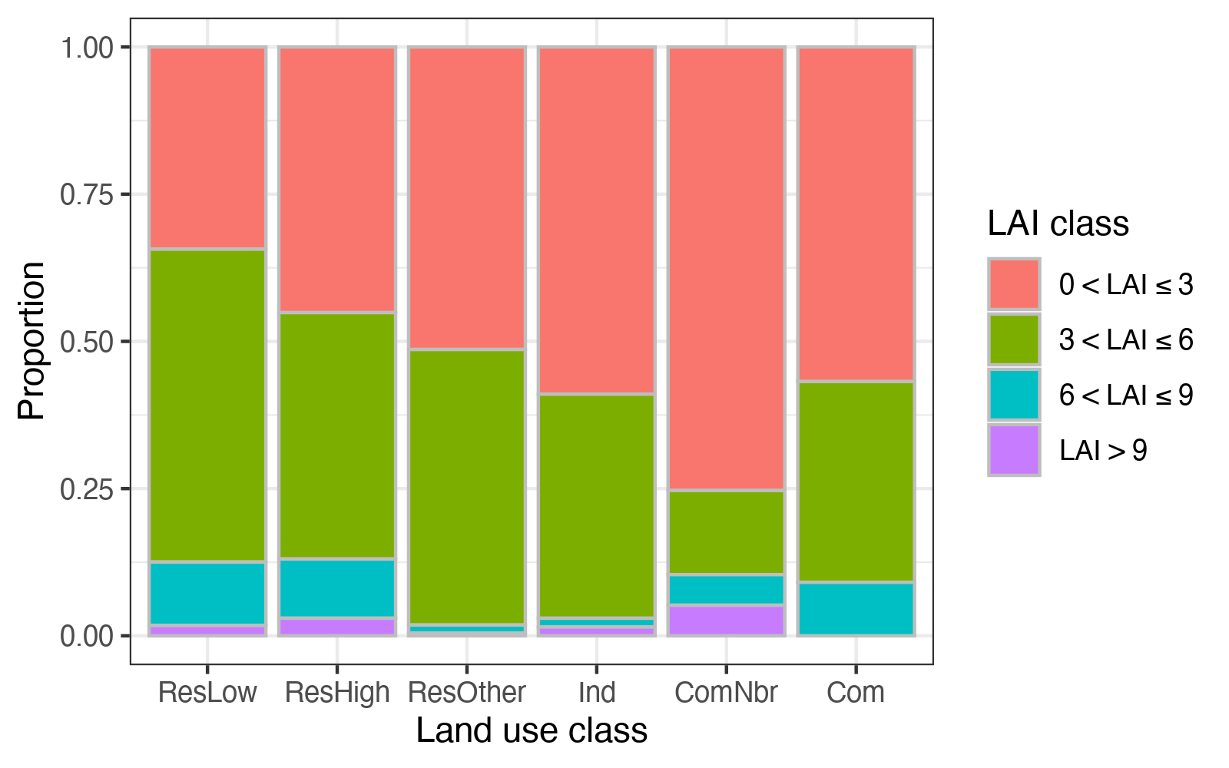

**Figure 12.** LAI (leave area index) distribution across land use classes.

#### 3.2. Total monetary value of trees

The sum, average number, and median of quadrat annual ecosystem service values, carbon storage value, and compensatory value were calculated (**Table 11**). The average annual ecosystem service value is 30% as much as the average carbon storage value, while the compensatory value of trees is 121 times of annual ecosystem services. Due to the data distribution, the differences became smaller if comparing by median values. The annual ecosystem service value median is 63% of carbon storage value median, though the compensatory value is still 110 times of annual ecosystem service value median.

**Table 11.** Valuation of ecosystem services and compensatory value (unit: US dollars).

|  |  |  |  |
| --- | --- | --- | --- |
| Item | Sum | Quadrat average | Quadrat median |
| Annual ecosystem services | 4,285 | 28 | 10 |
| Carbon storage | 14,339 | 95 | 16 |
| Compensatory value | 518,712 | 3,435 | 1128 |

Regarding the composition of quadrat annual ecosystem service values (**Figure 13**), removal value accounted for about half of the total value, followed by removal, carbon sequestration, and runoff reduction value. removal and removal values only account for a small fraction of the total annual ecosystem service value.

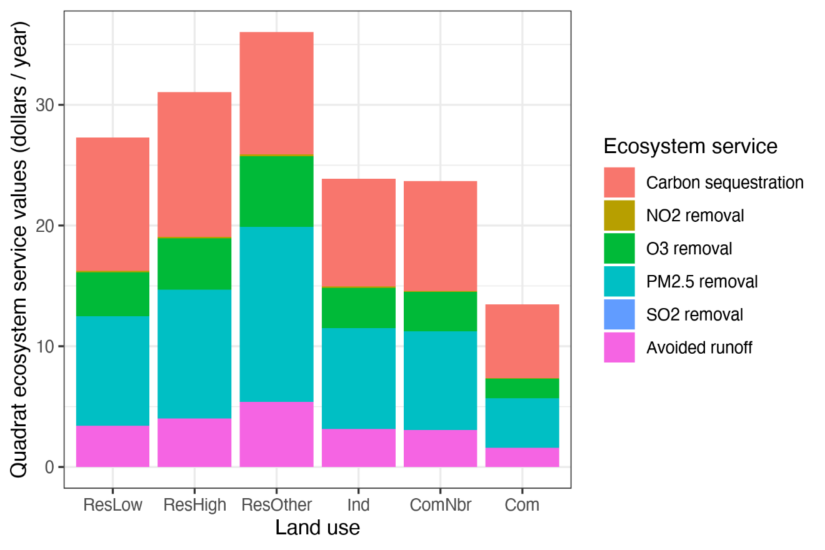

**Figure 13.** Average valuation of quadrat annual ecosystem services across land use classes.

But it should be noted that, though ecosystem services valuation is convenient for inter-ecosystem-services comparison, the monetary value varies with valuation method covering different aspects of total economic value; and it varies by local context like market value of the services. For example, in this case, the social cost for carbon in Japan is 10,600 Yen (about 96 US dollars) per ton (Ministry of the Environment, Government of Japan, 2019), while the monetary value for carbon is 188 US dollars per ton carbon for the US (Interagency Working Group on Social Cost of Greenhouse Gases, United States Government, 2016); the stormwater control facilities cost of Suita City, Japan is 719 yen (about 7 US dollars) per (Kawaguchi et al., 2021), while that estimation in the US is 2.36 US dollars per . The comparison of monetary value between ecosystem services should thus be cautious. Researchers should pay attention to indicators of ecosystem services as well, rather than focusing on valuation only.

#### 3.3. Quadrat ecosystem services across land use

No significant difference was found for quadrat ecosystem services across land use classes (**Table 12**).

Table 12. Chi-square statistics of comparison of ecosystem services across land use by Kruskal-Wallis rank sum test (the level of significance is denoted by asterisks: no asterisk, p ≥ 0.05; *, p < 0.05; **, p < 0.01; ***, p < 0.001).

|  |  |  |  |  |  |  |
| --- | --- | --- | --- | --- | --- | --- |
| Scale | Carbon sequestration | NO2 removal | O3 removal | PM2.5 removal | SO2 removal | Runoff reduction |
| Quadrat level | 7.68 | 9.53 | 9.04 | 8.00 | 9.34 | 7.97 |
| Single-tree level | 24.42*** | 55.68*** | 53.94*** | 51.98*** | 54.21*** | 51.68*** |

Table 13. Average values of ecosystem services of each land use at quadrat and single-tree level.

|  |  |  |  |  |  |  |  |
| --- | --- | --- | --- | --- | --- | --- | --- |
| **Scale** | **Land use** | **Carbon sequestration**  **(kg)** | **NO2 removal**  **(g)** | **O3 removal**  **(g)** | **PM2.5 removal**  **(g)** | **SO2 removal**  **(g)** | **Runoff reduction**  **(m3)** |
| Quadrat level | ResLow | 58.86 | 37.30 | 125.12 | 8.67 | 16.29 | 1.44 |
|  | ResHigh | 63.89 | 43.05 | 145.62 | 10.20 | 18.90 | 1.70 |
|  | ResOther | 53.87 | 64.47 | 208.21 | 13.69 | 27.42 | 2.28 |
|  | Ind | 47.56 | 33.43 | 113.61 | 8.01 | 14.73 | 1.33 |
|  | ComNbr | 48.53 | 33.80 | 112.92 | 7.78 | 14.72 | 1.30 |
|  | Com | 32.36 | 14.61 | 52.78 | 4.00 | 6.72 | 0.67 |
| Single-tree level | ResLow | 5.16 | 3.27 | 10.98 | 0.76 | 1.43 | 0.13 |
|  | ResHigh | 6.60 | 4.44 | 15.04 | 1.05 | 1.95 | 0.18 |
|  | ResOther | 8.40 | 10.05 | 32.47 | 2.13 | 4.28 | 0.35 |
|  | Ind | 8.16 | 5.74 | 19.50 | 1.37 | 2.53 | 0.23 |
|  | ComNbr | 5.67 | 3.95 | 13.20 | 0.91 | 1.72 | 0.15 |
|  | Com | 8.83 | 3.98 | 14.39 | 1.09 | 1.83 | 0.18 |

Table 14. Median values of ecosystem services of each land use at quadrat and single-tree level.

|  |  |  |  |  |  |  |  |
| --- | --- | --- | --- | --- | --- | --- | --- |
| **Scale** | **Land use** | **Carbon sequestration**  **(kg)** | **NO2 removal**  **(g)** | **O3 removal**  **(g)** | **PM2.5 removal**  **(g)** | **SO2 removal**  **(g)** | **Runoff reduction**  **(m3)** |
| Quadrat level | ResLow | 35.31 | 15.49 | 51.95 | 3.43 | 6.84 | 0.57 |
|  | ResHigh | 22.88 | 17.92 | 54.38 | 3.24 | 7.31 | 0.54 |
|  | ResOther | 20.83 | 12.76 | 40.77 | 2.54 | 5.39 | 0.42 |
|  | Ind | 11.36 | 7.76 | 29.84 | 2.14 | 3.73 | 0.36 |
|  | ComNbr | 19.66 | 6.00 | 19.61 | 1.31 | 2.57 | 0.22 |
|  | Com | 12.78 | 2.54 | 8.65 | 0.61 | 1.12 | 0.10 |
| Single-tree level | ResLow | 2.45 | 1.13 | 3.66 | 0.26 | 0.47 | 0.04 |
|  | ResHigh | 2.62 | 1.70 | 5.20 | 0.31 | 0.70 | 0.05 |
|  | ResOther | 2.73 | 1.51 | 4.76 | 0.31 | 0.64 | 0.05 |
|  | Ind | 4.31 | 1.85 | 5.99 | 0.38 | 0.78 | 0.06 |
|  | ComNbr | 2.23 | 0.24 | 0.91 | 0.07 | 0.11 | 0.01 |
|  | Com | 3.59 | 1.11 | 3.46 | 0.20 | 0.47 | 0.03 |

#### 3.4. Single-tree ecosystem services across land use

Different from quadrat ecosystem services, the differences for all ecosystem services at the single-tree level across land use classes (**Table 12**) were significant. Post hoc comparison indicates that the single-tree carbon sequestration in Com zone and Ind zone were higher than that in ResLow zone, and the carbon sequestration in Ind zone is higher than that in ComNbr zone. Trees in ComNbr zone had significantly lower air pollutants removal and runoff reduction than the other.

#### 3.5. Species-specific analysis

The results of the species-specific comparison (**Table 15**) indicate that ecosystem services across land use classes were significantly different for most of the species, but not for all the species. *Osmanthus fragrans* and *Podocarpus macrophyllus* showed no difference for carbon sequestration; *Acer palmatum*, *Prunus x blireana* and *Zelkova serrata* showed no difference in all of the ecosystem services across land use classes. A further post hoc pair-wise comparison suggested that the land use class with higher ecosystem services varied with species. For example, *Ginkgo biloba* showed higher ecosystem services in ComNbr; while *Ligustrum lucidum* showed higher ecosystem services in Ind zone; *Osmanthus fragrans* showed higher ecosystem services in ResOther.

**Table 15.** Chi-square statistics of species-specific comparison of ecosystem services across land use classes by Kruskal-Wallis rank sum test (the level of significance is denoted by asterisks: no asterisk, p ≥ 0.05; *, p < 0.05; **, p < 0.01; ***, p < 0.001).

|  |  |  |  |  |  |  |  |
| --- | --- | --- | --- | --- | --- | --- | --- |
| **Species** | **Distribution (> 3 Individuals per Land Use Class)** | **Carbon sequestration** | **NO2 Removal** | **O3 Removal** | **PM2.5 Removal** | **SO2 Removal** | **Runoff Reduction** |
| *Acer palmatum* Thunb. | Ind, ResOther, ResHigh, ResLow | 4.80 | 6.12 | 6.12 | 6.12 | 6.12 | 6.12 |
| *Ginkgo biloba* L., 1771 | Com, ComNbr, Ind, ResHigh | 9.86 * | 8.04 * | 8.04 * | 8.04 * | 8.04 * | 8.04 * |
| *Ligustrum lucidum* Ait. | Ind, ResOther, ResHigh, ResLow | 18.14 *** | 23.75 *** | 23.75 *** | 23.75 *** | 23.75 *** | 23.75 *** |
| *Nandina domestica* Thunb. | ComNbr, Ind, ResOther, ResHigh, ResLow | 14.38 ** | 23.92 *** | 23.92 *** | 23.92 *** | 23.92 *** | 23.92 *** |
| *Osmanthus fragrans* Lour. | Ind, ResOther, ResHigh, ResLow | 7.51 | 12.01 ** | 12.01 ** | 12.01 ** | 12.01 ** | 12.01 ** |
| *Podocarpus macrophyllus* (Thunb.) Sweet, 1818 | Com, ResOther, ResHigh, ResLow | 7.51 | 10.89 * | 10.89 * | 10.89 * | 10.89 * | 10.89 * |
| *Prunus x blireana* | Com, Ind, ResOther, ResHigh, ResLow | 0.78 | 3.49 | 3.49 | 3.49 | 3.49 | 3.49 |
| *Quercus x alvordiana* | Com, ComNbr, Ind, ResOther, ResHigh, ResLow | 54.36 *** | 72.05 *** | 72.05 *** | 72.05 *** | 72.05 *** | 72.05 *** |
| *Zelkova serrata* (Thunb.) Makino | Com, Ind, ResOther, ResHigh, ResLow | 7.19 | 5.53 | 5.53 | 5.53 | 5.53 | 5.53 |

## Discussion

#### 4.1 Ecosystem services across land use

Though not statistically significant, among the 6 land use classes in this research, residential zones have higher average and median quadrat carbon sequestration than the others (Table S2 and Table S3). A similar result was found in Roanoke of Virginia that per hectare carbon storage and annual carbon sequestration in the residential area is higher than that in the commercial area (Kim et al., 2015). A potential reason is that the quadrats of residential zones tend to have more trees or higher LAI than the other land use classes do. On the other hand, surprisingly, at single-tree level, Com and Ind zones have higher average carbon sequestration than ResHigh and ResLow zones, which is opposite to that at quadrat level. In this study, Ifound a significantly higher DBH, LAI, and number of trees at the quadrat level in residential zones than Com zone and Ind zone overall. Whereas, at the single-tree level, DBH is higher than in Com and Ind zones than ResLow zone (Table S4).

Different from carbon sequestration, air pollutants removal and runoff reduction represent more local ecosystem services. At the quadrat level, though not statistically significant, the average and median value of air pollutants removal are higher in residential zones, followed by Ind or ComNbr, and the minimum value is in Com zone (Table S2 and Table S3). However, due to a higher pollutants emission in Com zone and Ind zone, those results might suggest a mismatch of ecosystem services supply and demand. An improvement of air pollutants removal services in commercial and industrial areas can potentially benefit public health. Yet, it should also be noted that since the air pollutants data collected by the monitors distributed in the city was aggregated for the simulation, which leads to uncertainties of the results. The air pollutants removal services in commercial zones and Ind zone might be thus underestimated.

The species-specific analysis results suggest that the solution to promote urban ecosystem services should be species-specific rather than one-size-fits-all. For instance, as ubiquitous species, *Ligustrum lucidum* might be less managed thus has higher ecosystem services in Ind zone; on contrast, it has lower ecosystem services in ResLow zone possibly due to intense pruning considering residents’ aesthetics. A further species-specific study of the underlying causal relationship will enhance a more targeted urban plant management.

A limitation of the comparison should be addressed in which the concept of land use could vary among the research. Land use represents the actual practice and intended use of economic and cultural activities of a certain place, which is driven by both biophysical and socio-economic factors (Turner et al., 1995). Land use classification systems are distinguished regarding the scale and purpose of their development (Briassoulis, 2019). In our study, “land use” is a classification under City Planning Law of Japan that describes the potential use and limitation of building types of an area of land; while some other classification systems may emphasize more on actual use of the land.

#### 4.2. Impact of scale

An implicit assumption is that ecological processes remain consistent across different extents and grain (Uchida et al., 2021), while the convenient assumption usually fails because of the complexity of ecological systems, especially under the high heterogeneity of urban context (Pickett et al., 2017).

Ecological patterns vary across the scale, so is the urban ecosystem service pattern (Pickett et al., 2017; Uchida et al., 2021). Grain is one component of the scale concept (Wu and Li, 2006). Quadrat and single-tree levels represent two different levels of grain in our study. No significant difference was found among quadrat ecosystem services across land use classes, while variances were detected at the single-tree level for all ecosystem services (**Table 12**). These results support the theoretical conclusion that variance between sample quadrats generally decreases with the increasing of quadrat grain (Wiens, 1989). The results probably indicate that the variance of ecosystem services at the single-tree scale is “averaged” at the quadrat scale. Compared to single-tree level, the ecosystem services at quadrat level are affected by more factors including species, size, and the number of trees, which are further determined by the characteristics related to land use types such as available space and management intensity.

#### 4.3. Comparison of ecosystem services between cities

To compare our results with other studies, the mean value of carbon storage, carbon sequestration, and runoff reduction by land use classes on a per hectare-of-land basis were calculated (**Table 16**). Both carbon storage (11.51-17.41 ton carbon per hectare) and annual carbon sequestration (1.35-1.60 ton carbon per hectare) of residential zones in this study are lower than that in Roanoke, Virginia, the U.S. (37°16′N 79°56′W; 37.00 and 2.28 ton carbon per hectare), while those ecosystem services efficiency of the industrial zone of our study (9.95 and 1.19 ton carbon per hectare) is higher than that of Roanoke (7.31 and 0.48 ton carbon per hectare) (Kim et al., 2015). Besides, annual carbon sequestration of residential zones is higher in our research than that of a study for Barcelona, Spain (41°23′N 2°11′E; 0.35 and 1.33 ton carbon per hectare for high-density and low-density residential areas) (Baro et al., 2014). The runoff reduction ranges from 16.71 to 56.88 , which is similar to a study in green spaces of Luohe, China (33°34′N 114°00′E; 24.5-51.1 ) (Song et al., 2020).

**Table 16.** Ecosystem services efficiency in Kyoto City.

|  |  |  |  |
| --- | --- | --- | --- |
| Land use | Carbon storage (ton/ha) | Carbon sequestration (ton/ha/year) | Runoff reduction (m3/ha/year) |
| ResLow | 11.51 | 1.47 | 36.08 |
| ResHigh | 12.82 | 1.60 | 42.48 |
| ResOther | 17.41 | 1.35 | 56.88 |
| Ind | 9.95 | 1.19 | 33.35 |
| ComNbr | 12.45 | 1.21 | 32.38 |
| Com | 6.99 | 0.81 | 16.71 |

To compare the results of air pollutants removal with other research, Iconverted our results into grams per year per square meter tree cover (**Table 17**). The results in Kyoto City is comparable to those of a study in Strasbourg city, France (: 0.92 , 3.73 , 0.30 ) except for the result of removal (0.07 ) (Selmi et al., 2016).

**Table 17.** Average air purification efficiency of Kyoto City .

|  |  |  |  |  |
| --- | --- | --- | --- | --- |
| **Land use** | **NO2 removal** | **O3 removal** | **PM2.5 removal** | **SO2 removal** |
| ResLow | 1.01 | 3.21 | 0.21 | 0.42 |
| ResHigh | 1.10 | 3.53 | 0.23 | 0.47 |
| ResOther | 1.00 | 3.16 | 0.20 | 0.42 |
| Ind | 1.04 | 3.36 | 0.22 | 0.44 |
| ComNbr | 1.07 | 3.46 | 0.23 | 0.45 |
| Com | 0.71 | 2.35 | 0.16 | 0.31 |

It should be noted that the raw data distribution and sampling method may differ among these studies thus confounding the comparison of the results. For instance, the research in Luohe, China focuses on green space rather than random sample quadrats over the city (Song et al., 2020); and though also presents the results of quadrat ecosystem services in different land use, the study in Roanoke, Virginia mainly focuses on urban vacant (Kim et al., 2015). Furthermore, the quadrats with no woody plant are usually excluded for analysis, which also brings bias to the comparison of the results. The workbook of i-Tree Eco [35] has provided a solid base for standard workflow in field investigation, but the difference mentioned above still highlights the barrier in multi-city research. Besides, the results of air pollutants removal are strongly affected by local air quality. Under the same condition, air pollutants removal is higher in the area with higher air pollutants concentrations.

### 4.4. Ecosystem service evaluation in cities

In the prevalent land use/land cover-based methodology of ecosystem service evaluation, the per unit value of the urban area is usually considered constant (e.g. see (Arowolo et al., 2018; Yi et al., 2017)). Though no significant difference was detected for quadrat ecosystem services across land use classes in our research, it could be a result of the high heterogeneity of urban ecosystems rather than homogeneity. Land use is a rough classification under the context of law and policy in Japan. Within a certain land use type, there can be several onsite land cover classes, and quadrat ecosystem services of certain land use classes could be ‘averaged’ by this mixture. The relationship between land use or land cover and ecosystem services requires further research based on high-resolution geographic data and sampling at a different scale.

Another reason for further enrichment of the urban ecosystem services benchmark database is the heterogeneity between cities. As the comparison of our results with other studies in the previous section shows, per unit ecosystem services could vary across different cities. This comparison indicates that the local context must be considered when evaluating urban ecosystem services.

## Conclusions

The main purpose of this study is to demonstrate the link between heterogeneity of a city and urban ecosystem services, and the potential contribution of dispersed green to urban ecosystem services. This study captured the structure, ecosystem services, and monetary values of the urban forest in Kyoto City. For urban forest structure analysis, Ind zone has more mature trees with higher DBH than the other land use; residential zones have a higher proportion of trees with larger LAI. The comparison across land use classes shows that ecosystem services are different across land use at the single-tree level, though no significant difference was detected at the quadrat level. The results indicate that the comparison varies with scale. Though less addressed in previous research and not statistically significant, the residential zones have higher average and median ecosystem services values than the other land use. The result suggests a potentially important contribution of dispersed green space (like private yards) to urban ecosystem services. For a more comprehensive and precise evaluation of ecosystem services of urban forests, further research considering heterogeneity, scale effect, and varieties of green space type is needed.

The results also provided insight for practice. Iidentified a mismatch of air pollutants removal and emission across land use types that the air cleaning services of urban forests in commercial areas should be improved. Furthermore, a species-specific method can help in making urban planning aimed at increasing ecosystem services.

# Link Biodiversity and Ecosystem Services

## Introduction

With green infrastructure policy becoming prevalent over the world, it is believed that there is a positive link between biodiversity and ecosystem services (BES) or ecosystem function (BEF). Indeed, positive BEF link has been found in previous studies of experiments and non-urban context ecosystems. For instance, measuring biodiversity by functional or taxonomic metrics, positive BEF links were found in grasslands (Isbell et al., 2011; Lange et al., 2015) and forests (Verheyen et al., 2016). Theories have been proposed to explain the BEF relationship, e.g., sampling effect emphasizes the impact of identity of certain species on ecosystem services; niche complementarity theory states the utility of resource by diverse species (Tilman et al., 1997); and the positive interaction between species (Bertness and Leonard, 1997).

While BEF link in cities can be different comparing to previous studies of non-urban context, with the impact of human socio-economic factors (Schwarz et al., 2017). The reasons are mainly attributed to the influence factors on urban biodiversity. Firstly, urban ecosystem differs from “natural ecosystems”, in abiotic environment. It is a novel ecosystem with harsh environmental factors including higher temperature, less impervious surface, limited and fragmented habitat, and dominant by human. The novel system shapes the biological assemblage and process within it, even evolution (Johnson and Munshi-South, 2017). The community in cities are always characterized with less complex food web (Faeth et al., 2005). Short plants or individuals with more seeds tend to succeed. Or may have a higher proportion of wind-pollinated plants, plants with scleromorphic leaves or plants dispersed by animals (Knapp, 2010b). Second, the habitats in cities are limited by impervious area and plantable area, which directly influence biodiversity patterns (Figueroa et al., 2018). Furthermore, the top-down effect of urban planning determines the pattern of organism in a city with the impact of socio-economic factors (Hope et al., 2003). And residential preference also has an impact on the flora pattern in a bottom-up manners (Avolio et al., 2015b).

However, the evidence of positive BEF is unclear in cities despite a incresing attention on urban biodiversity and urban ecosystem services. Ziter reviewed 77 articles with 133 assessment on urban ecosystem services in 2016 and found that only 47 considered BEF link (Ziter, 2016). In most of the 47 assessments, BEF is reported non-correlative. And urban ecosystem services are considered as being more relevant to species composition, functional traits, or structures (24 assessments), rather than on the magnitude of a given biodiversity metric. Based on Ziter’s review (Ziter, 2016), Schwarz et al. reviewed 994 mentions of urban BEF in 317 studies. Only 24% of the mentions examine and BEF link empirically, among which only half (52%) demonstrated positive relationship (Schwarz et al., 2017). According to their counting-based study, the relationship between BEF varies with the metrics used and services.

In fact, even in non-urban context, where decades of experimental and observational research have been accumulated, it is confounding about the impact of different dimensions of biodiversity on ecosystem services. As a consequence, “there is still no predictive understanding of how species loss will impact ecosystem function in nature” (Cardinale et al., 2012). Studies have pointed out the role of species richness, the order of species loss, or/and dominant species(Genung et al., 2020b). Besides, other than species composition, habitat or trait diversity may also related to ecosystem function. In this chapter, I will made a primary analysis of BEF with the urban woody plants data set.

## Method

### 2.1 Data preperation

Among the 200 quadrats established in Kyoto City, 174 quadrats were accessible, and trees were recorded in 151 quadrats. In this study, the subset of trees was extracted from the complete data set fo analysis. The attributes of each tree in the subset including species, size, and health status. The biomassof each tree was calculated by i-Tree Eco, as stated in Chapter 4. The single-tree data was then grouped by quadrat ID. The richness and abundance (the number of trees) of each quadrat were calculated with R programming, as stated in Chapter 3. The total biomass of each quadrat was calculated as the sum of biomass of each tree in the quadrat.

### 2.2 Data analysis

Linear regression was the main method used to assess the effect of tree species richness and abundance on quadrat productivity, as well as their interact effect and the interaction with land use types. I also applied ecological Price equation to partition the effect of biodiversity into additive components. Considering the high variation of urban ecological pattern, the objection of the application of ecological Price equation is to test the applicablity of the methodology to BEF question under urban context.

For linear regression part, speice richness and abundance were used as the explainary variable respectively first with the full sample of the quadrats. Then the impact of richness on biomass was detected under different levels of abundance, in which the abundance was divided into 3 levels with 33% and 66% quantiles. The impact of abundance was also tested under 3 levels of richness. To test whether the BEF vary across land use, I test the impact of richness and abundance on biomass in grouped samples of different land use. The lm function of R was used for the linear regression analysis.

Ecological Price equation can divide the effects of richness, species identification and other context (e.g. abundance). Though it was for partioning the drivers of microevolutionary change at the very first (Price, 1972), it was developed for biodiversity – function analysis (Fox, 2006). With ecological Price equation, the change of function between a pair of sites can be divided into three additive parts: richness effect, which indicate that the higher function is simply resulted from more species; composition effect, which indicate that higher function site has species with higher function on average; and context dependence effect, which indicate that the contribution of species presenting at both site is higher in the higher function site. I used the priceTools package for the partition in R.

## Results

### 3.1 Linear model results

The results of single factor revealed a significant impact of richness and abundance on biomassrespectively (p < 0.05 and p < 0.001). The impacts were both positive, but the slope of abundance was higher than that of richness (Figure 14).

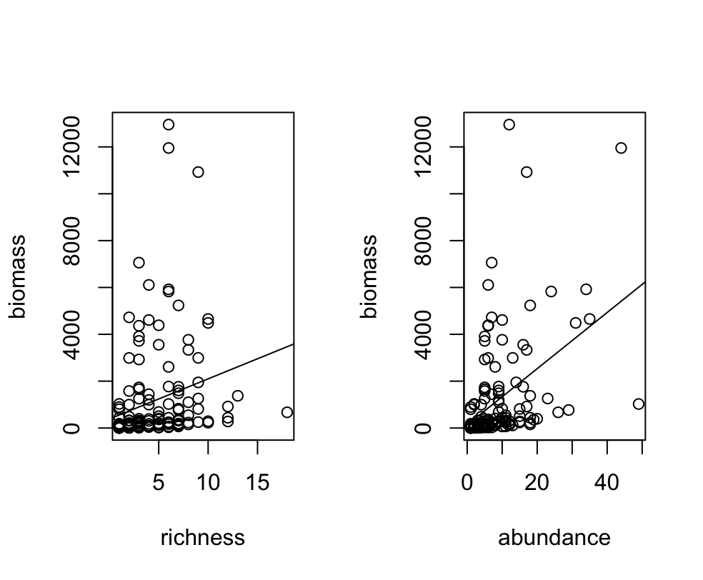

Figure 14. The impact of richness and abundance on biomass

No significant p value was detected under any level of abundance for the relationship between richness and biomass. While a positive relationship between abundance and biomasswere detected under higher richness (p = 0.001 under richness level 3, Figure 15).

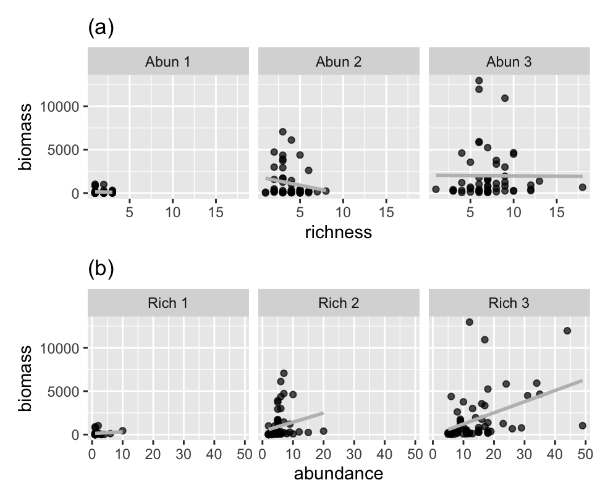

Figure 15. Linear regression of richness or abundance and biomasswith different levels of abundance or richness

The test of relationship between richness and biomass across land use (Table 18 and Figure 16) showed that significance was only detected for commercial area. Other than that, a marginal significance was detected for Other residential area. Regarding the impact of abundance, a positive impact showed in all the land use types other than Neighborhood commercial area.

Table 18. The p values for the impact of richness or abundance on biomass across land use

|  |  |  |
| --- | --- | --- |
| Land use | Richness | Abundance |
| Com | 0.001 | 0.000 |
| Com-neigh | 0.298 | 0.870 |
| Ind | 0.210 | 0.000 |
| R-high | 0.078 | 0.000 |
| R-low | 0.464 | 0.039 |
| R-other | 0.052 | 0.017 |

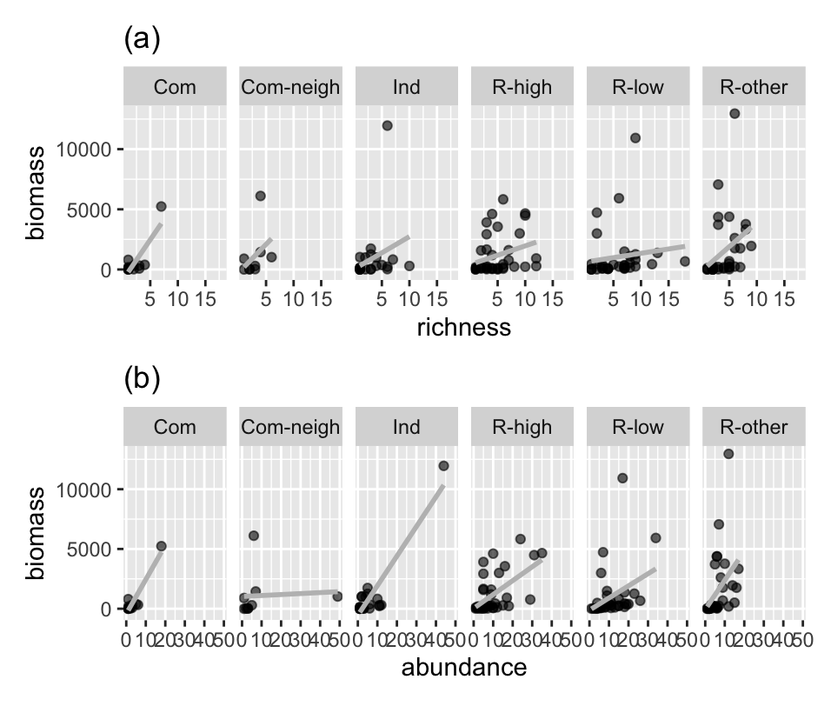

Figure 16. Linear regression of richness or abundance and biomasswith different land use

### 3.2 Ecological Price equation results

According to the results of ecological Price equation partition (Figure 17), for two randomly selected quadrats, biomass declined by 70-90% on average between higher- and lower-biomass quadrats. Furthermore, it is mainly the results of species richness effect, regarding the components contributing to the total effect. The effect values remained similar across land use types (Figure 18), which is partly attributable to high variation of urban quadrats. Since the data is collected by field investigation rather than experiment, it is affected by many other variables.

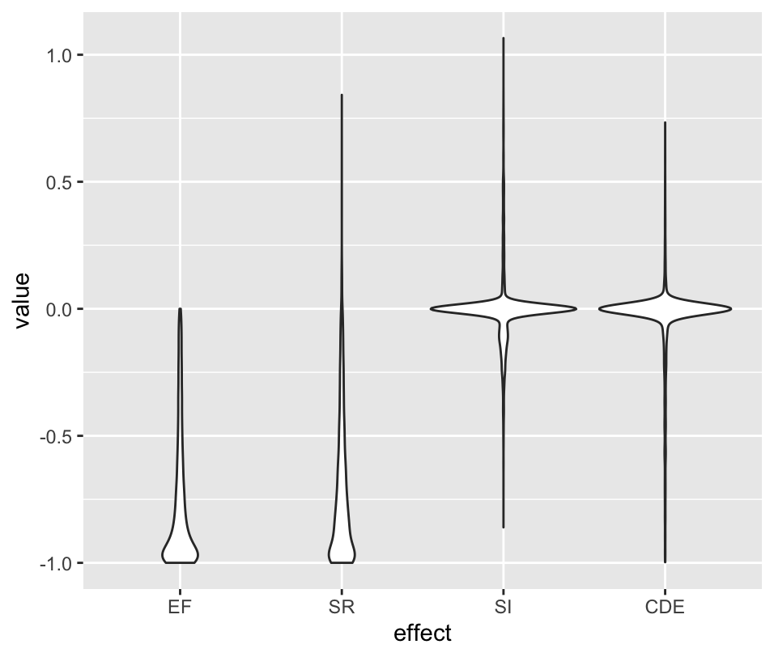

Figure 17. The change in biomass between sites (EF) is partitioned into additive effect attributable to change of species richness (SR), changes of species identification (SI), and changes in the per-capita biomass or abundance of common species (CDE).

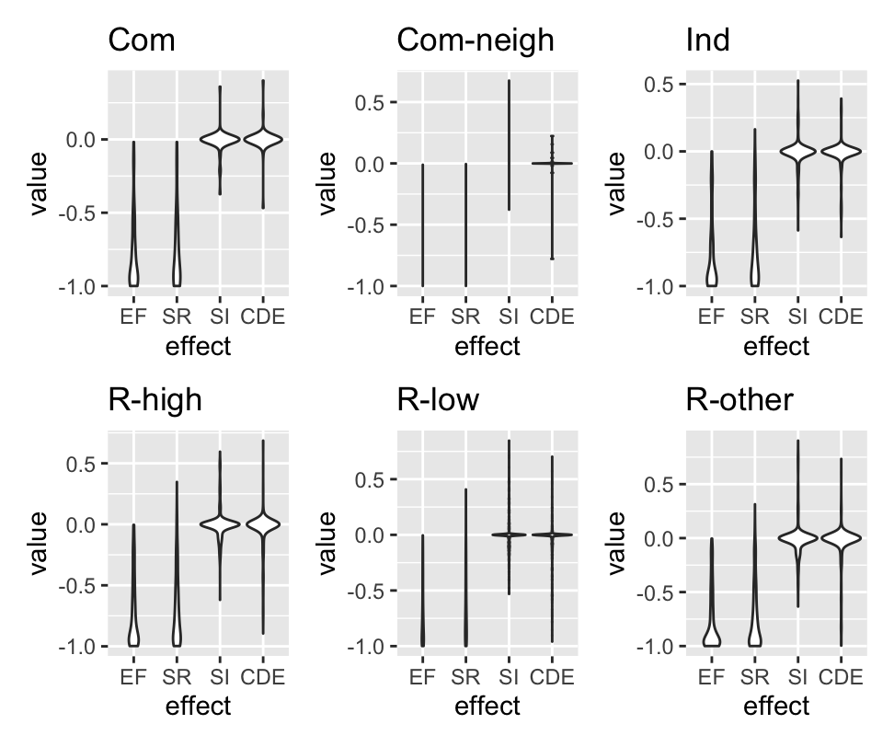

Figure 18. Results of Price equation partition across land use.

## Discussion

### 4.1 The impact of diversity on ecosystem function

Despite the high heterogeneity of urban context made the results confounding, it is cross-validated by the results of linear models that abundance may affect biomass more than richness does. The results of ecological Price equation should be treated with caution since the turnover of species between quadrats is generally high in the city. The conclusion is also consistent with some other research.

An explanation regarding the impact of abundance is more individual hypothesis (Yee and Juliano, 2007), which state that with the increase of abundance, the risk of species extinction decreases. Thus, abundance has a positive impact on richness and ecosystem functions. In the dataset of this research, I also found a correlation between abundance and richness. A critical relative factor is relative abundance and the identity of the species. Though I didn’t detect it successfully with ecological Price equation, it is generally referred as “context dependent effect” in the method. Most species with lower abundance tend to have lower function in our dataset (Figure 19). Thus, the effect of species loss between higher function quadrat and lower function quadrat depends on the turnover rate of the species. If the turnover rate of the higher-abundance species is also higher, than it will result into a larger change of function.

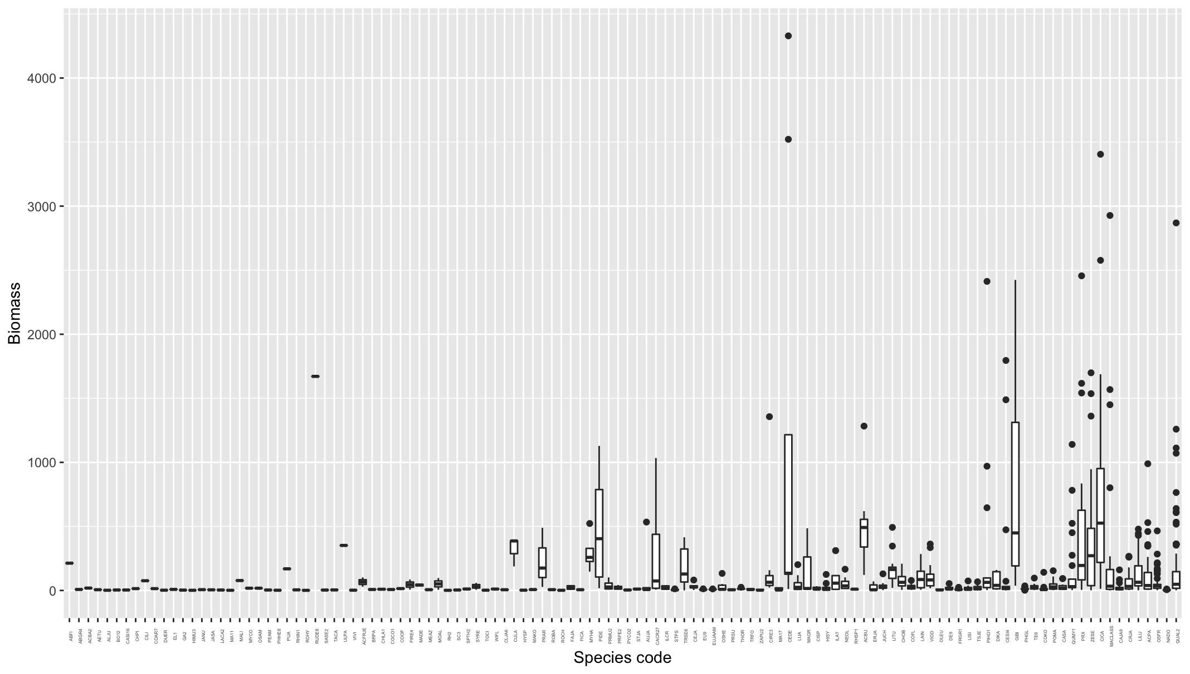

Figure 19. Biomass range of each species along abundance order

On the other hand, one explanation about the impact of richness is based on the theory of niche. Higher function quadrats may have higher richness that the plants make use of the niches by complementarity. That situation could be common under urban context as the resources like water and fertilizer) other than available space is generally sufficient.

### 4.2 Methodology to test BEF in cities

For BEF research in urban ecosystems, there is a paucity of empirical study with cause-effect relationship statistical analysis. In this sense, certain statistical method like structural equation modelling can be useful, since it can separate the effects of impact factors into different layers with a hierarchical hypothesis. For instance, though richness or other diversity metrics is one impact factor for ecosystem function, it is also affected by other factors of an urban site including available greening space, land use, and human management. Besides, there is also a lack of BEF experimental studies in cities. Schwarz et al. reviewed 337 articles with 228 tested BEF relationship on urban BEF research and found that only 30% are tested with experiments, and the proportion become even smaller for urban woody plants (Schwarz et al., 2017).

A major bottle neck of studying BEF in urban ecosystems is that researchers have lacked analytical tools. For nature ecosystems research, real-world differs from experiments in three ways: first, the community in experiments are generally with lower dominance; second, aggregate abundance in experiment is controlled; third, BEF varies with spatial scale and temporal scale while the scales for experiments are limited (Winfree et al., 2015). Considering that differences, it is difficult to separate the effect of different component of biodiversity (richness, composition, and abundance) on ecosystem functions. The analytical innovation, ecological Price equation, was developed to solve the problem with field investigation data (Fox, 2006). However, the applicability for that method to urban ecosystems is still debatable according to our test. Urban ecosystems differ from “natural ecosystems” and related experiments in many ways. First, similar to “natural ecosystems”, cities is characterized with high species turnover rate – it is even larger than natural ecosystems regarding woody plants, since the species richness of woody plants is generally higher than that in natural ecosystems (Pearse et al., 2018). Second, the community of some land use in cities (e.g., residential yard) is generally with lower dominance while some are not (e.g., industrial area). Third, since the available space in cities is limited, it is difficult to collect data systematically from quadrats with controlling the other factors.

Other than analysis method, there are also many other shortcomings of this preliminary research. One of which is that my research takes biomass as the surrogate metric for ecosystem functions. While different functions may vary. Besides, some research suggests that a lower richness and higher dominance may increase certain ecosystem function, but higher richness may increase multi-functions (Lundholm, 2015). Therefore, research limited in certain function can result into a guidance with bias for practice.

## Conclusion

The linear regression results indicate that both richness and abundance have positive impact on biomass. Though the two independent factors are correlated, to some degree, the results suggest a stronger impact of abundance than richness. The impact of richness was not detected for subgroup samples with different richness level; while the impact of abundance was detected at high richness samples. For the grouped samples of different land use, again, the impact of richness was not significant other than the Commercial area group; while the impact of abundance was detected in all the land use other than Neighborhood commercial area samples. The results of ecological Price equation are different with the results of linear regression that it attributed the effect of biomass change between quadrat to richness change. However, based on other evidence of the data analysis like turnover rate and the biomass of rare- and abundant-species, the results of ecological Price equation can be less reliable compared with that of linear regression. The tools for urban BEF analysis need further study.

# Conclusions and Discussion

A series of research were conducted for this thesis to understand the pattern and scale of urban biodiversity and urban ecosystem services, and their linkage. To this end, data on woody plants were collected with sampling quadrat across the built-up area of Kyoto City. The following objective were emphasized for this thesis: (1) What is the pattern of plant diversity across land use types in a city? And does the pattern vary with scale? (2) What is pattern of ecosystem services provided by urban forest across land use types in a city? Does the pattern vary with scale? (3) What is the linkage between biodiversity and ecosystem function / service under urban context? Then in the following chapters, I used ecological tools and data science to answer the questions.

## Urban biodiversity

In this study, I evaluated woody plant diversity across land use and scales in Kyoto City. At land use level, residential areas had higher total richness with moderate to low overall evenness, while commercial areas had relatively lower total richness. A high species composition dissimilarity was identified between residential areas and other land use types. At quadrat level, ResLow area had higher richness than the other land use excepting for ResHigh area. Quadrat abundance and evenness were different across land use types for trees but not for shrubs. Quadrat species composition was significantly different across land use types for shrubs, but not for trees. The research identified prior land use types for biodiversity improvement. For instance, the commercial areas are characterized with lower plant diversity but higher visitors. An improvement of plant diversity in these land use types can enhance the potential ecosystem services benefit due to a higher beneficiary population and higher accessibility of the plants in public space. The contribution of ResLow area for urban biodiversity conservation was also further proved.

## Urban ecosystem services

In this chapter, I focused on the pattern of ecosystem services across land use. The main objective is to demonstrate the link between heterogeneity of a city and urban ecosystem services, and the potential contribution of dispersed green to urban ecosystem services. This chapter captured the structure, ecosystem services, and monetary values of the urban forest in Kyoto City. The ecosystem services evaluated in this chapter includes carbon storage and sequestration, air pollutants removal, and runoff reduction. Here I would like to just focus on the ecosystem services part.

The pattern of ecosystem services was compared at both quadrat and single-tree level. The comparison shows that ecosystem services are different across land use at the single-tree level, though no significant difference was detected at the quadrat level. The results indicate that the comparison varies with scale. Though less addressed in previous research and not statistically significant, the residential zones have higher average and median ecosystem services values than the other land use. The result suggests a potentially important contribution of dispersed green space (like private yards) to urban ecosystem services. From a perspective of methodology of ecosystem services evaluation, for a more comprehensive and precise evaluation of ecosystem services of urban forests, further research considering heterogeneity, scale effect, and varieties of green space type is needed.

## BEF in urban ecosystems

The linear regression results indicate that both richness and abundance have positive impact on biomass. Though the two independent factors are correlated, to some degree, the results suggest a stronger impact of abundance than richness. The impact of richness was not detected for subgroup samples with different richness level; while the impact of abundance was detected at high richness samples. For the grouped samples of different land use, again, the impact of richness was not significant other than the Commercial area group; while the impact of abundance was detected in all the land use other than Neighborhood commercial area samples. The results of ecological Price equation were different with the results of linear regression that it attributed the effect of biomass change between quadrat to richness change. However, based on other evidence of the data analysis like turnover rate and the biomass of rare- and abundant-species, the results of ecological Price equation can be less reliable compared with that of linear regression. The tools for urban BEF analysis need further study.

# Reference

Ackleh, A.S., Carter, J., Cole, L., Nguyen, T., Monte, J., Pettit, C., 2010. Measuring and modeling the seasonal changes of an urban Green Treefrog (Hyla cinerea) population. Ecological Modelling 221, 281–289. https://doi.org/10.1016/j.ecolmodel.2009.10.012

Akashi, T., 2007. Urban land use planning system in Japan.

Alexis, D., 2017. dunn.test: Dunn’s Test of Multiple Comparisons Using Rank Sums. R package version 1.3.5.

Allen, A.P., O’Connor, R.J., 2000. Interactive effects of land use and other factors on regional bird distributions. Journal of Biogeography 27, 889–900. https://doi.org/10.1046/j.1365-2699.2000.00453.x

Aronson, M.F.J., A., L.S.F., H., N.C., Katti Madhusudan, Goddard Mark A., Lepczyk Christopher A., Warren Paige S., Williams Nicholas S. G., Cilliers Sarel, Clarkson Bruce, Dobbs Cynnamon, Dolan Rebecca, Hedblom Marcus, Klotz Stefan, Kooijmans Jip Louwe, Kühn Ingolf, MacGregor-Fors Ian, McDonnell Mark, Mörtberg Ulla, Pyšek Petr, Siebert Stefan, Sushinsky Jessica, Werner Peter, Winter Marten, 2014. A global analysis of the impacts of urbanization on bird and plant diversity reveals key anthropogenic drivers. Proceedings of the Royal Society B: Biological Sciences 281, 20133330. https://doi.org/10.1098/rspb.2013.3330

Aronson, M.F.J., Handel, S.N., La Puma, I.P., Clemants, S.E., 2015. Urbanization promotes non-native woody species and diverse plant assemblages in the New York metropolitan region. Urban Ecosyst 18, 31–45. https://doi.org/10.1007/s11252-014-0382-z

Arowolo, A.O., Deng, X., Olatunji, O.A., Obayelu, A.E., 2018. Assessing changes in the value of ecosystem services in response to land-use/land-cover dynamics in Nigeria. Science of The Total Environment 636, 597–609. https://doi.org/10.1016/j.scitotenv.2018.04.277

Avolio, M., Pataki, D.E., Gillespie, T., Jenerette, G.D., McCarthy, H.R., Pincetl, S., Weller-Clarke, L., 2015a. Tree diversity in southern California’s urban forest: the interacting roles of social and environmental variables. Frontiers in Ecology and Evolution 3, 73.

Avolio, M., Pataki, D.E., Gillespie, T., Jenerette, G.D., McCarthy, H.R., Pincetl, S., Weller-Clarke, L., 2015b. Tree diversity in southern California’s urban forest: the interacting roles of social and environmental variables. Frontiers in Ecology and Evolution 3, 73.

Avolio, M.L., Pataki, D.E., Trammell, T.L.E., Endter-Wada, J., 2018. Biodiverse cities: the nursery industry, homeowners, and neighborhood differences drive urban tree composition. Ecological Monographs 88, 259–276. https://doi.org/10.1002/ecm.1290

Baro, F., Chaparro, L., Gomez-Baggethun, E., Langemeyer, J., Nowak, D., Terradas, J., 2014. Contribution of Ecosystem Services to Air Quality and Climate Change Mitigation Policies: The Case of Urban Forests in Barcelona, Spain. AMBIO 43, 466–479. https://doi.org/10.1007/s13280-014-0507-x

Bertness, M.D., Leonard, G.H., 1997. The role of positive interactions in communities: lessons from intertidal habitats. Ecology 78, 1976–1989.

Bolund, P., Hunhammar, S., 1999. Ecosystem services in urban areas. Ecological economics 29, 293–301.

Bourne, K.S., Conway, T.M., 2014. The influence of land use type and municipal context on urban tree species diversity. Urban Ecosyst 17, 329–348. https://doi.org/10.1007/s11252-013-0317-0

Brearley, G., Bradley, A., Bell, S., McAlpine, C., 2010. Influence of contrasting urban edges on the abundance of arboreal mammals: A study of squirrel gliders (Petaurus norfolcensis) in southeast Queensland, Australia. Biological Conservation 143, 60–71. https://doi.org/10.1016/j.biocon.2009.09.003

Briassoulis, H., 2019. Analysis of land use change: theoretical and modeling approaches. Regional Research Institute, West Virginia University.

Brown, K.S., Freitas, A.V.L., 2002. Butterfly Communities of Urban Forest Fragments in Campinas, São Paulo, Brazil: Structure, Instability, Environmental Correlates, and Conservation. Journal of Insect Conservation 6, 217–231. https://doi.org/10.1023/A:1024462523826

Brunzel, S., Fischer, S.F., Schneider, J., Jetzkowitz, J., Brandl, R., 2009. Neo- and archaeophytes respond more strongly than natives to socio-economic mobility and disturbance patterns along an urban–rural gradient. Journal of Biogeography 36, 835–844. https://doi.org/10.1111/j.1365-2699.2008.02044.x

Bryan, B.A., Ye, Y., Zhang, J., Connor, J.D., 2018. Land-use change impacts on ecosystem services value: Incorporating the scarcity effects of supply and demand dynamics. Ecosystem Services 32, 144–157. https://doi.org/10.1016/j.ecoser.2018.07.002

Camps-Calvet, M., Langemeyer, J., Calvet-Mir, L., Gómez-Baggethun, E., 2016a. Ecosystem services provided by urban gardens in Barcelona, Spain: Insights for policy and planning. Environmental Science & Policy 62, 14–23. https://doi.org/10.1016/j.envsci.2016.01.007

Camps-Calvet, M., Langemeyer, J., Calvet-Mir, L., Gómez-Baggethun, E., 2016b. Ecosystem services provided by urban gardens in Barcelona, Spain: Insights for policy and planning. Environmental Science & Policy 62, 14–23. https://doi.org/10.1016/j.envsci.2016.01.007

Cardinale, B.J., Duffy, J.E., Gonzalez, A., Hooper, D.U., Perrings, C., Venail, P., Narwani, A., Mace, G.M., Tilman, D., Wardle, D.A., Kinzig, A.P., Daily, G.C., Loreau, M., Grace, J.B., Larigauderie, A., Srivastava, D.S., Naeem, S., 2012. Biodiversity loss and its impact on humanity. Nature 486, 59–67. https://doi.org/10.1038/nature11148

Chamberlain, D., Reynolds, C., Amar, A., Henry, D., Caprio, E., Batáry, P., 2020. Wealth, water and wildlife: Landscape aridity intensifies the urban luxury effect. Global Ecology and Biogeography 29, 1595–1605.

Chamberlain, D.E., Henry, D.A.W., Reynolds, C., Caprio, E., Amar, A., 2019. The relationship between wealth and biodiversity: A test of the Luxury Effect on bird species richness in the developing world. Global Change Biology 0. https://doi.org/10.1111/gcb.14682

Chao, A., Gotelli, N.J., Hsieh, T.C., Sander, E.L., Ma, K.H., Colwell, R.K., Ellison, A.M., 2014. Rarefaction and extrapolation with Hill numbers: a framework for sampling and estimation in species diversity studies. Ecological Monographs 84, 45–67. https://doi.org/10.1890/13-0133.1

Chen, C., Mao, L., Qiu, Y., Cui, J., Wang, Y., 2020. Walls offer potential to improve urban biodiversity. Scientific Reports 10, 9905. https://doi.org/10.1038/s41598-020-66527-3

Chimaimba, F.B., Kafumbata, D., Chanyenga, T., Chiotha, S., 2020. Urban tree species composition and diversity in Zomba city, Malawi: Does land use type matter? Urban Forestry & Urban Greening 54, 126781. https://doi.org/10.1016/j.ufug.2020.126781

Clarke, L.W., Jenerette, G.D., Davila, A., 2013. The luxury of vegetation and the legacy of tree biodiversity in Los Angeles, CA. Landscape and urban planning 116, 48–59.

Convention on Biological Diversity, 2010. COP 10 Decision X/22. Plan of action on Subnational Governments, Cities and Other Local Authorities for Biodiversity.

Costanza, R., De Groot, R., Braat, L., Kubiszewski, I., Fioramonti, L., Sutton, P., Farber, S., Grasso, M., 2017. Twenty years of ecosystem services: how far have we come and how far do we still need to go? Ecosystem services 28, 1–16.

Costanza, R., de Groot, R., Sutton, P., van der Ploeg, S., Anderson, S.J., Kubiszewski, I., Farber, S., Turner, R.K., 2014. Changes in the global value of ecosystem services. Global Environmental Change 26, 152–158. https://doi.org/10.1016/j.gloenvcha.2014.04.002

Council of Tree and Landscape Appraisers, 1992. Guide for plant appraisal.

Dangulla, M., Abd Manaf, L., Ramli, M.F., Yacob, M.R., 2019. Urban tree composition, diversity and structural characteristics in North-western Nigeria. Urban Forestry & Urban Greening 126512. https://doi.org/10.1016/j.ufug.2019.126512

Das, M., Das, A., 2019. Dynamics of Urbanization and its impact on Urban Ecosystem Services (UESs): A study of a medium size town of West Bengal, Eastern India. Journal of Urban Management 8, 420–434. https://doi.org/10.1016/j.jum.2019.03.002

Dearborn, D.C., Kark, S., 2010. Motivations for conserving urban biodiversity. Conservation biology 24, 432–440.

Earth System Research Laboratory, 2020. NOAA/ESRL Radiosonde Database [WWW Document]. URL https://ruc.noaa.gov/raobs/

Elmqvist, T., Fragkias, M., Goodness, J., Güneralp, B., Marcotullio, P.J., McDonald, R.I., Parnell, S., Schewenius, M., Sendstad, M., Seto, K.C., Wilkinson, C. (Eds.), 2013. Urbanization, Biodiversity and Ecosystem Services: Challenges and Opportunities. Springer Netherlands, Dordrecht. https://doi.org/10.1007/978-94-007-7088-1

Faeth, S.H., Warren, P.S., Shochat, E., Marussich, W.A., 2005. Trophic dynamics in urban communities. BioScience 55, 399–407.

Figueroa, J.A., Castro, S.A., Reyes, M., Teillier, S., 2018. Urban park area and age determine the richness of native and exotic plants in parks of a Latin American city: Santiago as a case study. Urban Ecosystems 21, 645–655. https://doi.org/10.1007/s11252-018-0743-0

Fox, J.W., 2006. Using the Price Equation to Partition the Effects of Biodiversity Loss on Ecosystem Function. Ecology 87, 2687–2696. https://doi.org/10.1890/0012-9658(2006)87[2687:UTPETP]2.0.CO;2

Genung, M.A., Fox, J., Winfree, R., 2020a. Species loss drives ecosystem function in experiments, but in nature the importance of species loss depends on dominance. Global Ecology and Biogeography n/a. https://doi.org/10.1111/geb.13137

Genung, M.A., Fox, J., Winfree, R., 2020b. Species loss drives ecosystem function in experiments, but in nature the importance of species loss depends on dominance. Global Ecology and Biogeography n/a. https://doi.org/10.1111/geb.13137

Girgin, S., Kazanci, N., Dügel, M., 2010. Relationship between aquatic insects and heavy metals in an urban stream using multivariate techniques. International Journal of Environmental Science & Technology 7, 653–664.

Goddard, M.A., Dougill, A.J., Benton, T.G., 2010. Scaling up from gardens: biodiversity conservation in urban environments. Trends in ecology & evolution 25, 90–8. https://doi.org/10.1016/j.tree.2009.07.016

Godefroid, S., Koedam, N., 2007. Urban plant species patterns are highly driven by density and function of built-up areas. Landscape Ecol 22, 1227–1239. https://doi.org/10.1007/s10980-007-9102-x

Gómez-Baggethun, E., Barton, D.N., 2013. Classifying and valuing ecosystem services for urban planning. Ecological Economics 86, 235–245.

Gómez-Baggethun, E., Gren, A., Barton, D.N., Langemeyer, J., McPhearson, T., O’farrell, P., Andersson, E., Hamstead, Z., Kremer, P., 2013. Urban ecosystem services, in: Urbanization, Biodiversity and Ecosystem Services: Challenges and Opportunities. Springer, Dordrecht, pp. 175–251.

Güneralp, B., Seto, K.C., 2013. Futures of global urban expansion: uncertainties and implications for biodiversity conservation. Environmental Research Letters 8, 014025.

Guo, P., Su, Y., Wan, W., Liu, W., Zhang, H., Sun, X., Ouyang, Z., Wang, X., 2018. Urban Plant Diversity in Relation to Land Use Types in Built-up Areas of Beijing. Chin. Geogr. Sci. 28, 100–110. https://doi.org/10.1007/s11769-018-0934-x

Haase, D., 2013. Shrinking cities, biodiversity and ecosystem services, in: Urbanization, Biodiversity and Ecosystem Services: Challenges and Opportunities. Springer, Dordrecht, pp. 253–274.

Haase, D., Larondelle, N., Andersson, E., Artmann, M., Borgström, S., Breuste, J., Gomez-Baggethun, E., Gren, A. ̊sa, Hamstead, Z., Hansen, R., 2014. A quantitative review of urban ecosystem service assessments: concepts, models, and implementation. Ambio 43, 413–433.

Hahs, A.K., McDonnell, M.J., 2007a. Composition of the plant community in remnant patches of grassy woodland along an urban–rural gradient in Melbourne, Australia. Urban Ecosyst 10, 355–377. https://doi.org/10.1007/s11252-007-0034-7

Hahs, A.K., McDonnell, M.J., 2007b. Composition of the plant community in remnant patches of grassy woodland along an urban–rural gradient in Melbourne, Australia. Urban Ecosyst 10, 355–377. https://doi.org/10.1007/s11252-007-0034-7

Hahs, A.K., McDonnell, M.J., 2006. Selecting independent measures to quantify Melbourne’s urban–rural gradient. Landscape and Urban Planning 78, 435–448. https://doi.org/10.1016/j.landurbplan.2005.12.005

Hansen, A.J., Knight, R.L., Marzluff, J.M., Powell, S., Brown, K., Gude, P.H., Jones, K., 2005. Effects of Exurban Development on Biodiversity: Patterns, Mechanisms, and Research Needs. Ecological Applications 15, 1893–1905. https://doi.org/10.1890/05-5221

Hirabayashi, S., Tan, X., Shozo, S., 2019. Customization of i-Tree Eco’s medical cost and building energy saving models for Japan (In Japanese). Journal of the Japanese Society of Revegetation Technology 45, 200–203. https://doi.org/10.7211/jjsrt.45.200

Hirabayashi, S., Tokue, Y., Ito, A., Ellis, A., Hoehn, R., Imamura, F., Morioka, C., 2016. Estimating ecosystem services and their monetary values provided by street trees in Kawasaki ward of Kawasaki city using i-Tree Eco. (In Japanese). Journal of the Japanese Society of Revegetation Technology 42, 44–49. https://doi.org/10.7211/jjsrt.42.44

Hope, D., Gries, C., Zhu, W., Fagan, W.F., Redman, C.L., Grimm, N.B., Nelson, A.L., Martin, C., Kinzig, A., 2003. Socioeconomics drive urban plant diversity. Proceedings of the national academy of sciences 100, 8788–8792.

Hsieh, T.C., Ma, H.W., Chao, A., 2020. 2020 iNEXT: iNterpolation and EXTrapolation for species diversity.

Interagency Working Group on Social Cost of Greenhouse Gases, United States Government, 2016. Technical Support Document: Technical Update of the Social Cost of Carbon for Regulatory Impact Analysis ­ Under Executive Order 12866.

Isbell, F., Calcagno, V., Hector, A., Connolly, J., Harpole, W.S., Reich, P.B., Scherer-Lorenzen, M., Schmid, B., Tilman, D., van Ruijven, J., Weigelt, A., Wilsey, B.J., Zavaleta, E.S., Loreau, M., 2011. High plant diversity is needed to maintain ecosystem services. Nature 477, 199–202. https://doi.org/10.1038/nature10282

i-Tree, 2019. UFORE methods [WWW Document]. URL https://www.itreetools.org/documents/53/UFORE%20Methods.pdf (accessed 9.16.20).

Ives, C.D., Lentini, P.E., Threlfall, C.G., Ikin, K., Shanahan, D.F., Garrard, G.E., Bekessy, S.A., Fuller, R.A., Mumaw, L., Rayner, L., Rowe, R., Valentine, L.E., Kendal, D., 2016. Cities are hotspots for threatened species: The importance of cities for threatened species. Global Ecology and Biogeography 25, 117–126. https://doi.org/10.1111/geb.12404

Japan Meteorological Agency (JMA)., 2021. Historical meteorological data [WWW Document]. URL https://www.data.jma.go.jp/obd/stats/etrn/index.php

JAXA, 2021. ALOS@EORC homepage [WWW Document]. URL https://www.eorc.jaxa.jp/ALOS/en/index_e.htm

Johnson, M.T., Munshi-South, J., 2017. Evolution of life in urban environments. Science 358.

Kajihara, K., Yamaura, Y., Soga, M., Furukawa, Y., Morimoto, J., Nakamura, F., 2016. Urban shade as a cryptic habitat: fern distribution in building gaps in Sapporo, northern Japan. Urban ecosystems 19, 523–534.

Kalwij, J.M., 2012. Review of ‘The Plant List, a working list of all plant species.’ Journal of Vegetation Science 23, 998–1002. https://doi.org/10.1111/j.1654-1103.2012.01407.x

Kawaguchi, M., Hirabayashi, S., Hirase, K., Kaga, H., Akazawa, H., 2021. Estimation of monetary value of street trees by i-Tree Eco using tree health surveys in Suita City, Osaka Prefecture. Landscape Research Japan Online 14, 1–12. https://doi.org/10.5632/jilaonline.14.1

Kew Science, n.d. Plants of the world online database [WWW Document]. URL http://www.plantsoftheworldonline.org/

Kim, G., Miller, P., Nowak, D., 2015. Assessing urban vacant land ecosystem services: Urban vacant land as green infrastructure in the City of Roanoke, Virginia. URBAN FORESTRY & URBAN GREENING 14, 519–526. https://doi.org/10.1016/j.ufug.2015.05.003

Kinzig, A.P., Warren, P., Martin, C., Hope, D., Katti, M., 2005. The Effects of Human Socioeconomic Status and Cultural Characteristics on Urban Patterns of Biodiversity. E&S 10, art23. https://doi.org/10.5751/ES-01264-100123

Kiss, M., Takacs, A., Pogacsas, R., Gulyas, A., 2015. The role of ecosystem services in climate and air quality in urban areas: Evaluating carbon sequestration and air pollution removal by street and park trees in Szeged (Hungary). MORAVIAN GEOGRAPHICAL REPORTS 23, 36–46. https://doi.org/10.1515/mgr-2015-0016

Knapp, S., 2010a. Plant Biodiversity in Urbanized Areas: Plant Functional Traits in Space and Time, Plant Rarity and Phylogenetic Diversity. Vieweg+Teubner Verlag. https://doi.org/10.1007/978-3-8348-9626-1

Knapp, S., 2010b. Urbanization Causes Shifts of Species’ Trait State Frequencies–a Large Scale Analysis, in: Plant Biodiversity in Urbanized Areas. Springer, pp. 13–29.

Kremer, P., Hamstead, Z., Haase, D., McPhearson, T., Frantzeskaki, N., Andersson, E., Kabisch, N., Larondelle, N., Rall, E.L., Voigt, A., 2016a. Key insights for the future of urban ecosystem services research. Ecology and Society 21. http://dx.doi.org/10.5751/ES-08445-210229

Kremer, P., Hamstead, Z.A., McPhearson, T., 2016b. The value of urban ecosystem services in New York City: A spatially explicit multicriteria analysis of landscape scale valuation scenarios. Environmental Science & Policy, Advancing urban environmental governance: Understanding theories, practices and processes shaping urban sustainability and resilience 62, 57–68. https://doi.org/10.1016/j.envsci.2016.04.012

Kyoto City Statistics Portal, 2019. Demographic statistics of Kyoto City [WWW Document]. URL https://www2.city.kyoto.lg.jp/sogo/toukei/Population/Suikei/ (accessed 11.10.19).

Kyoto Prefecture Web Site, n.d. Introduced Plant Species List of Kyoto Prefecture [WWW Document]. URL http://www.pref.kyoto.jp/gairai/databook.html

Kyoto Prefecture Web Site, n.d. Seed Plant Species Dataset of Kyoto Prefecture [WWW Document]. URL http://www.pref.kyoto.jp/kankyo/mokuroku/bio/flower.html

Lange, M., Eisenhauer, N., Sierra, C.A., Bessler, H., Engels, C., Griffiths, R.I., Mellado-Vázquez, P.G., Malik, A.A., Roy, J., Scheu, S., 2015. Plant diversity increases soil microbial activity and soil carbon storage. Nature communications 6, 1–8.

Larondelle, N., Lauf, S., 2016. Balancing demand and supply of multiple urban ecosystem services on different spatial scales. Ecosystem Services 22, 18–31. https://doi.org/10.1016/j.ecoser.2016.09.008

Leong, M., Dunn, R.R., Trautwein, M.D., 2018. Biodiversity and socioeconomics in the city: a review of the luxury effect. Biology letters 14, 20180082.

Liu, Q., Buyantuev, A., Wu, J., Niu, J., Yu, D., Zhang, Q., 2018. Intensive land-use drives regional-scale homogenization of plant communities. Science of the Total Environment 644, 806–814.

Lundholm, J.T., 2015. Green roof plant species diversity improves ecosystem multifunctionality. Journal of Applied Ecology 52, 726–734. https://doi.org/10.1111/1365-2664.12425

MacGregor-Fors, I., 2008. Relation between habitat attributes and bird richness in a western Mexico suburb. Landscape and Urban Planning 84, 92–98. https://doi.org/10.1016/j.landurbplan.2007.06.010

Marc L. Imhoff, Lahouari Bounoua, Ruth Defries, William T. Lawrence, David Stutzer, Compton J. Tucker, Taylor Ricketts, 2004. The consequences of urban land transformation on net primary productivity in the United States. Remote Sensing of Environment 89, 434–443.

McDonald, R.I., Mansur, A.V., Ascensão, F., Crossman, K., Elmqvist, T., Gonzalez, A., Güneralp, B., Haase, D., Hamann, M., Hillel, O., 2020. Research gaps in knowledge of the impact of urban growth on biodiversity. Nature Sustainability 3, 16–24.

McDonnell, M.J., Hahs, A.K., 2008a. The use of gradient analysis studies in advancing our understanding of the ecology of urbanizing landscapes: current status and future directions. Landscape Ecol 23, 1143–1155. https://doi.org/10.1007/s10980-008-9253-4

McDonnell, M.J., Hahs, A.K., 2008b. The use of gradient analysis studies in advancing our understanding of the ecology of urbanizing landscapes: current status and future directions. Landscape Ecol 23, 1143–1155. https://doi.org/10.1007/s10980-008-9253-4

Ministry of Economy, Trade and Industry, Government of Japan, 2017. Factory Location Act [WWW Document]. URL https://www.meti.go.jp/policy/local_economy/koujourittihou/index.html

Ministry of Land, Infrastructure, Transport and Tourism, n.d. Land price data set of Japan (in Japanse) [WWW Document]. URL https://nlftp.mlit.go.jp/ksj/gml/datalist/KsjTmplt-L02-v3_0.html#prefecture26

Ministry of Land, Infrastructure, Transport and Tourism, Government of Japan, 2021. Introduction of urban land use planning system in Japan [WWW Document]. URL https://www.mlit.go.jp/crd/city/plan/tochiriyou/index.html

Ministry of the Environment, Government of Japan, 2019. Manual for calculation and valuation of ecosystem services related to biodiversity conservation activities for enterprises (In Japanese).

Missouri Botanical Garden, n.d. Missouri Botanical Garden web site [WWW Document]. URL http://www.missouribotanicalgarden.org/

Miyazato, S., 2010. An estimation of value of a statistical life based on labor market data. Jpn. Econ. Res 63, 1–28.

Muthulingam, U., Thangavel, S., 2012. Density, diversity and richness of woody plants in urban green spaces: A case study in Chennai metropolitan city. Urban Forestry & Urban Greening 11, 450–459. https://doi.org/10.1016/j.ufug.2012.08.003

National Centers for Environmental Information, 2021. Climate data online [WWW Document]. URL https://www.ncdc.noaa.gov/cdo-web/

National Institute for Environmental Studies, 2021. Environment database [WWW Document]. URL http://www.nies.go.jp/igreen/

National Institute of Environmental Studies of Japan, n.d. Introduced Species List of Japan [WWW Document]. URL https://www.nies.go.jp/biodiversity/invasive/DB/etoc8_plants.html

Nielsen, T.F., Sand‐Jensen, K., Dornelas, M., Bruun, H.H., 2019. More is less: net gain in species richness, but biotic homogenization over 140 years. Ecology Letters 22, 1650–1657. https://doi.org/10.1111/ele.13361

Niino, A., Imanishi, J., Shibata, S., 2021. Changes in vegetation cover and connectivity of private gardens at traditional wooden townhouses in the ancient city of Kyoto. Landscape and Ecological Engineering 17, 157–163.

Ning, Z., Chambers, R., Abdollahi, K., 2016. Modeling air pollutant removal, carbon storage, and CO2 sequestration potential of urban forests in Scotlandville, Louisiana, USA. IFOREST-BIOGEOSCIENCES AND FORESTRY 9, 860–867. https://doi.org/10.3832/ifor1845-009

Nishizawa, A., 2016. Japan 100-meter demographic mesh data in 2010 download [WWW Document]. URL https://home.csis.u-tokyo.ac.jp/~nishizawa/teikyo/kani_100m_download.html#26

Nowak, D., Hoehn, R., Bodine, A., Greenfield, E., O’Neil-Dunne, J., 2016. Urban forest structure, ecosystem services and change in Syracuse, NY. URBAN ECOSYSTEMS 19, 1455–1477. https://doi.org/10.1007/s11252-013-0326-z

Nowak, D.J., 2020. Understanding i-Tree: summary of programs and methods.

Nowak, David J., 2002. Compensatory value of urban trees in the United States. Journal of Arboriculture 28, 194–199.

Nowak, David John, 2002. Brooklyn’s urban forest. USDA Forest Service, United State.

Nowak, D.J., 1994. Atmospheric carbon dioxide reduction by Chicago’s urban forest. US Department of Agriculture, Radnor.

Nowak, D.J., Hirabayashi, S., Bodine, A., Greenfield, E., 2014. Tree and forest effects on air quality and human health in the United States. Environmental pollution 193, 119–129.

Nowak, D.J., Walton, J.T., Stevens, J.C., Crane, D.E., Hoehn, R.E., 2008. Effect of plot and sample size on timing and precision of urban forest assessments. Arboriculture and Urban Forestry 34, 386–390.

OECD, 2021a. Health spending [WWW Document]. URL https://data.oecd.org/healthres/health-spending.htm

OECD, 2021b. Better life index [WWW Document]. URL https://www.oecdbetterlifeindex.org/topics/income/

Ordóñez-Barona, C., Devisscher, T., Dobbs, C., Aguilar, L.A.O., Baptista, M., Navarro, N.M., da Silva Filho, D.F., Escobedo, F.J., 2019. Trends in urban forestry research in latin america & the caribbean: a systematic literature review and synthesis. Urban Forestry & Urban Greening 126544. https://doi.org/10.1016/j.ufug.2019.126544

Ortega-Álvarez, R., Rodríguez-Correa, H.A., MacGregor-Fors, I., 2011. Trees and the City: Diversity and Composition along a Neotropical Gradient of Urbanization. International Journal of Ecology 2011, e704084. https://doi.org/10.1155/2011/704084

Ossola, A., Irlich, U.M., Niemelä, J., 2018. Bringing Urban Biodiversity Research into Practice, in: Urban Biodiversity. ROUTLEDGE in association with GSE Research, pp. 1–17.

Pearse, W.D., Cavender‐Bares, J., Hobbie, S.E., Avolio, M.L., Bettez, N., Chowdhury, R.R., Darling, L.E., Groffman, P.M., Grove, J.M., Hall, S.J., Heffernan, J.B., Learned, J., Neill, C., Nelson, K.C., Pataki, D.E., Ruddell, B.L., Steele, M.K., Trammell, T.L.E., 2018. Homogenization of plant diversity, composition, and structure in North American urban yards. Ecosphere 9, e02105. https://doi.org/10.1002/ecs2.2105

Peng, J., Liu, Y., Wu, J., Lv, H., Hu, X., 2015. Linking ecosystem services and landscape patterns to assess urban ecosystem health: A case study in Shenzhen City, China. Landscape and Urban Planning 143, 56–68. https://doi.org/10.1016/j.landurbplan.2015.06.007

Pennington, D.N., Hansel, J.R., Gorchov, D.L., 2010. Urbanization and riparian forest woody communities: diversity, composition, and structure within a metropolitan landscape. Biological Conservation 143, 182–194.

Pickett, S.T.A., Cadenasso, M.L., Rosi-Marshall, E.J., Belt, K.T., Groffman, P.M., Grove, J.M., Irwin, E.G., Kaushal, S.S., LaDeau, S.L., Nilon, C.H., 2017. Dynamic heterogeneity: a framework to promote ecological integration and hypothesis generation in urban systems. Urban Ecosystems 20, 1–14.

Population Division, United Nations, 2019. World Urbanization Prospects: The 2018 Revision.

Porter, E.E., Forschner, B.R., Blair, R.B., 2001a. Woody vegetation and canopy fragmentation along a forest-to-urban gradient. Urban Ecosystems 5, 131–151. https://doi.org/10.1023/A:1022391721622

Porter, E.E., Forschner, B.R., Blair, R.B., 2001b. Woody vegetation and canopy fragmentation along a forest-to-urban gradient. Urban Ecosystems 5, 131–151. https://doi.org/10.1023/A:1022391721622

Price, G.R., 1972. Extension of covariance selection mathematics. Annals of human genetics 35, 485–490.

Ranta, P., Viljanen, V., 2011a. Vascular plants along an urban-rural gradient in the city of Tampere, Finland. Urban Ecosyst 14, 361–376. https://doi.org/10.1007/s11252-011-0164-9

Ranta, P., Viljanen, V., 2011b. Vascular plants along an urban-rural gradient in the city of Tampere, Finland. Urban Ecosyst 14, 361–376. https://doi.org/10.1007/s11252-011-0164-9

Raoufou, R., Kouami, K., Koffi, A., 2011. Woody plant species used in urban forestry in West Africa: Case study in Lomé, capital town of Togo. JHF 3, 21–31. https://doi.org/10.5897/JHF.9000120

Robson, J.P., Berkes, F., 2011. Exploring some of the myths of land use change: Can rural to urban migration drive declines in biodiversity? Global Environmental Change, Symposium on Social Theory and the Environment in the New World (dis)Order 21, 844–854. https://doi.org/10.1016/j.gloenvcha.2011.04.009

Schwarz, N., Moretti, M., Bugalho, M.N., Davies, Z.G., Haase, D., Hack, J., Hof, A., Melero, Y., Pett, T.J., Knapp, S., 2017. Understanding biodiversity-ecosystem service relationships in urban areas: A comprehensive literature review. Ecosystem Services 27, 161–171. https://doi.org/10.1016/j.ecoser.2017.08.014

Selinske, M.J., Fidler, F., Gordon, A., Garrard, G.E., Kusmanoff, A.M., Bekessy, S.A., 2020. We have a steak in it: Eliciting interventions to reduce beef consumption and its impact on biodiversity. Conservation Letters 13, e12721. https://doi.org/10.1111/conl.12721

Selmi, W., Weber, C., Riviere, E., Blond, N., Mehdi, L., Nowak, D., 2016. Air pollution removal by trees in public green spaces in Strasbourg city, France. URBAN FORESTRY & URBAN GREENING 17, 192–201. https://doi.org/10.1016/j.ufug.2016.04.010

Seto, K.C., Fragkias, M., Güneralp, B., Reilly, M.K., 2011. A Meta-Analysis of Global Urban Land Expansion. PLOS ONE 6, e23777. https://doi.org/10.1371/journal.pone.0023777

Seto, K.C., Guneralp, B., Hutyra, L.R., 2012a. Global forecasts of urban expansion to 2030 and direct impacts on biodiversity and carbon pools. Proceedings of the National Academy of Sciences 109, 16083–16088. https://doi.org/10.1073/pnas.1211658109

Seto, K.C., Guneralp, B., Hutyra, L.R., 2012b. Global forecasts of urban expansion to 2030 and direct impacts on biodiversity and carbon pools. Proceedings of the National Academy of Sciences 109, 16083–16088. https://doi.org/10.1073/pnas.1211658109

Seto, K.C., Parnell, S., Elmqvist, T., 2013. A Global Outlook on Urbanization, in: Elmqvist, T., Fragkias, M., Goodness, J., Güneralp, B., Marcotullio, P.J., McDonald, R.I., Parnell, S., Schewenius, M., Sendstad, M., Seto, K.C., Wilkinson, C. (Eds.), Urbanization, Biodiversity and Ecosystem Services: Challenges and Opportunities: A Global Assessment. Springer Netherlands, Dordrecht, pp. 1–12. https://doi.org/10.1007/978-94-007-7088-1_1

Smith, B., Wilson, J.B., 1996. A Consumer’s Guide to Evenness Indices. Oikos 76, 70–82. https://doi.org/10.2307/3545749

Song, P., Kim, G., Mayer, A., He, R., Tian, G., 2020. Assessing the Ecosystem Services of Various Types of Urban Green Spaces Based on i-Tree Eco. Sustainability 12, 1630. https://doi.org/10.3390/su12041630

Su, S., Xiao, R., Jiang, Z., Zhang, Y., 2012. Characterizing landscape pattern and ecosystem service value changes for urbanization impacts at an eco-regional scale. Applied Geography 34, 295–305. https://doi.org/10.1016/j.apgeog.2011.12.001

Szkop, Z., 2016. An evaluation of the ecosystem services provided by urban trees: The role of Krasinski Gardens in air quality and human health in Warsaw (Poland). ENVIRONMENTAL & SOCIO-ECONOMIC STUDIES 4, 41–50. https://doi.org/10.1515/environ-2016-0023

Tan, X., Hirabayashi, S., Shibata, S., 2021. Estimation of Ecosystem Services Provided by Street Trees in Kyoto, Japan. Forests 12, 311. https://doi.org/10.3390/f12030311

Tang, Y., Chen, A., Zhao, S., 2016. Carbon Storage and Sequestration of Urban Street Trees in Beijing, China. Front. Ecol. Evol. 4. https://doi.org/10.3389/fevo.2016.00053

The World Bank Data, n.d. . Urban population (% of total population). URL https://data.worldbank.org/indicator/SP.URB.TOTL.IN.ZS (accessed 1.20.21).

Thompson, K., Austin, K.C., Smith, R.M., Warren, P.H., Angold, P.G., Gaston, K.J., 2003. Urban domestic gardens (I): Putting small-scale plant diversity in context. Journal of Vegetation Science 14, 71–78. https://doi.org/10.1111/j.1654-1103.2003.tb02129.x

Tilman, D., Lehman, C.L., Thomson, K.T., 1997. Plant diversity and ecosystem productivity: theoretical considerations. Proceedings of the national academy of sciences 94, 1857–1861.

Troy, A.R., Grove, J.M., O’Neil-Dunne, J.P.M., Pickett, S.T.A., Cadenasso, M.L., 2007. Predicting Opportunities for Greening and Patterns of Vegetation on Private Urban Lands. Environmental Management 40, 394–412. https://doi.org/10.1007/s00267-006-0112-2

Tuomisto, H., 2010. A diversity of beta diversities: straightening up a concept gone awry. Part 1. Defining beta diversity as a function of alpha and gamma diversity. Ecography 33, 2–22. https://doi.org/10.1111/j.1600-0587.2009.05880.x

Turner, B.L., Skole, D., Sanderson, S., Fischer, G., Fresco, L., Leemans, R., 1995. Land-use and land-cover change: science/research plan. IGBP.

Uchida, K., Blakey, R.V., Burger, J.R., Cooper, D.S., Niesner, C.A., Blumstein, D.T., 2021. Urban biodiversity and the importance of scale. Trends Ecol. Evol. doi 10.

Ueno, H., 2010. City planning and formation of Kyoto in modern age (In Japanese). Shisen 111, 30–44.

Vakhlamova, T., Rusterholz, H.-P., Kanibolotskaya, Y., Baur, B., 2014a. Changes in plant diversity along an urban–rural gradient in an expanding city in Kazakhstan, Western Siberia. Landscape and Urban Planning 132, 111–120.

Vakhlamova, T., Rusterholz, H.-P., Kanibolotskaya, Y., Baur, B., 2014b. Changes in plant diversity along an urban–rural gradient in an expanding city in Kazakhstan, Western Siberia. Landscape and Urban Planning 132, 111–120.

Verheyen, K., Vanhellemont, M., Auge, H., Baeten, L., Baraloto, C., Barsoum, N., Bilodeau-Gauthier, S., Bruelheide, H., Castagneyrol, B., Godbold, D., Haase, J., Hector, A., Jactel, H., Koricheva, J., Loreau, M., Mereu, S., Messier, C., Muys, B., Nolet, P., Paquette, A., Parker, J., Perring, M., Ponette, Q., Potvin, C., Reich, P., Smith, A., Weih, M., Scherer-Lorenzen, M., 2016. Contributions of a global network of tree diversity experiments to sustainable forest plantations. Ambio 45, 29–41. https://doi.org/10.1007/s13280-015-0685-1

Wang, H., Qureshi, S., Knapp, S., Friedman, C.R., Hubacek, K., 2015. A basic assessment of residential plant diversity and its ecosystem services and disservices in Beijing, China. Applied Geography 64, 121–131.

Wang, H.B., Qin, J., Bin, Z., Chen, J.K., Dong, L., Hu, Y.H., 2017. Spatiotemporal dynamics of plant diversity in response to farmers’ evolved settlements in Shanghai. Urban Forestry & Urban Greening 22, 64–73. https://doi.org/10.1016/j.ufug.2017.01.008

Wang, J., Endreny, T.A., Nowak, D.J., 2008. Mechanistic simulation of tree effects in an urban water balance model 1. JAWRA Journal of the American Water Resources Association 44, 75–85.

Wang, M., Li, J., Kuang, S., He, Y., Chen, G., Huang, Y., Song, C., Anderson, P., Łowicki, D., 2020. Plant Diversity Along the Urban–Rural Gradient and Its Relationship with Urbanization Degree in Shanghai, China. Forests 11, 171. https://doi.org/10.3390/f11020171

Whittaker, R.H., Rh, W., 1977. Evolution of species diversity in land communities.

Whittaker, R.J., Willis, K.J., Field, R., 2001. Scale and species richness: towards a general, hierarchical theory of species diversity. Journal of biogeography 28, 453–470.

Whittaker, Robert H., R.H., 1960. Vegetation of the Siskiyou Mountains. Oregon and Califonia.

Wiens, J.A., 1989. Spatial scaling in ecology. Functional Ecology 3: 385-397.

Williams, N.S.G., Schwartz, M.W., Vesk, P.A., McCarthy, M.A., Hahs, A.K., Clemants, S.E., Corlett, R.T., Duncan, R.P., Norton, B.A., Thompson, K., McDonnell, M.J., 2009. A conceptual framework for predicting the effects of urban environments on floras. Journal of Ecology 97, 4–9. https://doi.org/10.1111/j.1365-2745.2008.01460.x

Willis, A.D., 2019. Rarefaction, Alpha Diversity, and Statistics. Front. Microbiol. 0. https://doi.org/10.3389/fmicb.2019.02407

Winfree, R., W. Fox, J., Williams, N.M., Reilly, J.R., Cariveau, D.P., 2015. Abundance of common species, not species richness, drives delivery of a real-world ecosystem service. Ecology letters 18, 626–635.

Wu, J., Li, H., 2006. Concepts of scale and scaling, in: Scaling and Uncertainty Analysis in Ecology. Springer, pp. 3–15.

Yang, J., Yan, P., He, R., Song, X., 2017. Exploring land-use legacy effects on taxonomic and functional diversity of woody plants in a rapidly urbanizing landscape. Landscape and Urban Planning 162, 92–103.

Yee, D.A., Juliano, S.A., 2007. Abundance matters: a field experiment testing the more individuals hypothesis for richness–productivity relationships. Oecologia 153, 153–162.

Yi, H., Güneralp, B., Filippi, A.M., Kreuter, U.P., Güneralp, İ., 2017. Impacts of Land Change on Ecosystem Services in the San Antonio River Basin, Texas, from 1984 to 2010. Ecological Economics 135, 125–135. https://doi.org/10.1016/j.ecolecon.2016.11.019

Zhao, C., Sander, H.A., 2018. Assessing the sensitivity of urban ecosystem service maps to input spatial data resolution and method choice. Landscape and Urban Planning 175, 11–22. https://doi.org/10.1016/j.landurbplan.2018.03.007

Zhao, M., Escobedo, F.J., Wang, R., Zhou, Q., Lin, W., Gao, J., 2013. Woody Vegetation Composition and Structure in Peri-urban Chongming Island, China. Environmental Management 51, 999–1011. https://doi.org/10.1007/s00267-013-0025-9

Ziter, C., 2016. The biodiversity–ecosystem service relationship in urban areas: a quantitative review. Oikos 125, 761–768.

土屋一彬, 斎藤昌幸, 2018. 都市の生物多様性研究は何を目的や対象としてきたか?: 国内研究の動向分析. 保全生態学研究 23, 265–278.

欧阳子珞, 吉文丽, 杨梅, 2015. 西安城市绿地植物多样性分析. 西北林学院学报 30, 257-261+292.

穣岡村, 篤美佐藤, 進林, 1998. 名古屋市南部の都市公園・緑地の樹種の多様性に関する研究. ランドスケープ研究 62, 613–616. https://doi.org/10.5632/jila.62.613

# Appendix

Table A1 Family, genus, and provenance of all the species recorded in this study

|  |  |  |  |
| --- | --- | --- | --- |
| Species | Family | Genus | Provenance |
| *Justicia brandegeeana* | Acanthaceae | Justicia | native |
| *Viburnum odoratissimum* | Adoxaceae | Viburnum | exotic |
| *Viburnum plicatum* | Adoxaceae | Viburnum | exotic |
| *Cotinus coggygria* | Anacardiaceae | Cotinus | exotic |
| *Mandevilla sanderi* | Apocynaceae | Mandevilla | native |
| *Nerium oleander* | Apocynaceae | Nerium | native |
| *Trachelospermum asiaticum* | Apocynaceae | Trachelospermum | exotic |
| *Ilex latifolia* | Aquifoliaceae | Ilex | exotic |
| *Ilex crenata* | Aquifoliaceae | Ilex | exotic |
| *Ilex rotunda* | Aquifoliaceae | Ilex | exotic |
| *Dendropanax trifidus* | Araliaceae | Dendropanax | exotic |
| *Fatsia japonica* | Araliaceae | Fatsia | exotic |
| *Hedera canariensis* | Araliaceae | Hedera | native |
| *Hedera helix* | Araliaceae | Hedera | native |
| *Schefflera heptaphylla* | Araliaceae | Schefflera | exotic |
| *Chamaedorea elegans* | Arecaceae | Chamaedorea | native |
| *Dypsis lutescens* | Arecaceae | Dypsis | native |
| *Rhapis humilis* | Arecaceae | Rhapis | native |
| *Trachycarpus fortunei* | Arecaceae | Trachycarpus | native |
| *Cordyline fruticosa* | Asparagaceae | Cordyline | exotic |
| *Dracaena marginata* | Asparagaceae | Dracaena | native |
| *Dracaena cambodiana* | Asparagaceae | Dracaena | native |
| *Begonia grandis* | Begoniaceae | Begonia | native |
| *Mahonia fortunei* | Berberidaceae | Mahonia | native |
| *Mahonia eurybracteata* | Berberidaceae | Mahonia | native |
| *Mahonia japonica* | Berberidaceae | Mahonia | native |
| *Nandina domestica* | Berberidaceae | Nandina | exotic |
| *Buxus microphylla* | Buxaceae | Buxus | exotic |
| *Sarcococca ruscifolia* | Buxaceae | Sarcococca | native |
| *Schlumbergera truncata* | Cactaceae | Schlumbergera | native |
| *Chimonanthus praecox* | Calycanthaceae | Chimonanthus | native |
| *Aphananthe aspera* | Cannabaceae | Aphananthe | exotic |
| *Celtis sinensis* | Cannabaceae | Celtis | exotic |
| *Euonymus japonicus* | Celastraceae | Euonymus | exotic |
| *Euonymus alatus* | Celastraceae | Euonymus | exotic |
| *Cercidiphyllum japonicum* | Cercidiphyllaceae | Cercidiphyllum | exotic |
| *Sarcandra glabra* | Chloranthaceae | Sarcandra | exotic |
| *Dendranthema morifolium* | Compositae | Dendranthema | native |
| *Osteospermum ecklonis* | Compositae | Osteospermum | native |
| *Cornus kousa* | Cornaceae | Cornus | exotic |
| *Cornus officinalis* | Cornaceae | Cornus | exotic |
| *Cornus florida* | Cornaceae | Cornus | native |
| *Cornus hongkongensis* | Cornaceae | Cornus | native |
| *Crassula ovata* | Crassulaceae | Crassula | native |
| *Chamaecyparis obtusa* | Cupressaceae | Chamaecyparis | exotic |
| *Chamaecyparis pisifera* | Cupressaceae | Chamaecyparis | exotic |
| *Cryptomeria japonica* | Cupressaceae | Cryptomeria | exotic |
| *Cunninghamia lanceolata* | Cupressaceae | Cunninghamia | native |
| *Cupressus macrocarpa* | Cupressaceae | Cupressus | native |
| *Juniperus chinensis* | Cupressaceae | Juniperus | native |
| *Juniperus scopulorum* | Cupressaceae | Juniperus | native |
| *Platycladus orientalis* | Cupressaceae | Platycladus | native |
| *Cycas revoluta* | Cycadaceae | Cycas | exotic |
| *Cyrilla racemiflora* | Cyrillaceae | Cyrilla | native |
| *Daphniphyllum macropodum* | Daphniphyllaceae | Daphniphyllum | exotic |
| *Diospyros kaki* | Ebenaceae | Diospyros | exotic |
| *Elaeagnus macrophylla* | Elaeagnaceae | Elaeagnus | exotic |
| *Elaeagnus umbellata* | Elaeagnaceae | Elaeagnus | exotic |
| *Elaeagnus multiflora* | Elaeagnaceae | Elaeagnus | exotic |
| *Elaeagnus pungens* | Elaeagnaceae | Elaeagnus | exotic |
| *Enkianthus perulatus* | Ericaceae | Enkianthus | exotic |
| *Pieris japonica* | Ericaceae | Pieris | exotic |
| *Rhododendron hirado group* | Ericaceae | Rhododendron | exotic |
| *Rhododendron indicum* | Ericaceae | Rhododendron | exotic |
| *Rhododendron kurume group* | Ericaceae | Rhododendron | exotic |
| *Rhododendron spp.* | Ericaceae | Rhododendron | native |
| *Vaccinium oldhamii* | Ericaceae | Vaccinium | exotic |
| *Mallotus japonicus* | Euphorbiaceae | Mallotus | exotic |
| *Triadica sebifera* | Euphorbiaceae | Triadica | exotic |
| *Castanea crenata* | Fagaceae | Castanea | exotic |
| *Quercus myrsinifolia* | Fagaceae | Quercus | exotic |
| *Quercus glauca* | Fagaceae | Quercus | exotic |
| *Quercus salicina* | Fagaceae | Quercus | exotic |
| *Quercus phillyraeoides* | Fagaceae | Quercus | exotic |
| *Aucuba japonica* | Garryaceae | Aucuba | exotic |
| *Gelsemium sempervirens* | Gelsemiaceae | Gelsemium | native |
| *Ginkgo biloba* | Ginkgoaceae | Ginkgo | native |
| *Corylopsis pauciflora* | Hamamelidaceae | Corylopsis | exotic |
| *Distylium racemosum* | Hamamelidaceae | Distylium | exotic |
| *Loropetalum chinense* | Hamamelidaceae | Loropetalum | exotic |
| *Deutzia scabra* | Hydrangeaceae | Deutzia | exotic |
| *Hydrangea macrophylla* | Hydrangeaceae | Hydrangea | exotic |
| *Hydrangea quercifolia* | Hydrangeaceae | Hydrangea | native |
| *Hydrangea arborescens* | Hydrangeaceae | Hydrangea | native |
| *Hypericum calycinum* | Hypericaceae | Hypericum | native |
| *Hypericum monogynum* | Hypericaceae | Hypericum | native |
| *Hypericum patulum* | Hypericaceae | Hypericum | native |
| *Callicarpa japonica* | Lamiaceae | Callicarpa | exotic |
| *Callicarpa dichotoma* | Lamiaceae | Callicarpa | exotic |
| *Lavandula angustifolia* | Lamiaceae | Lavandula | native |
| *Lavandula dentata* | Lamiaceae | Lavandula | native |
| *Mentha canadensis* | Lamiaceae | Mentha | native |
| *Rosmarinus officinalis* | Lamiaceae | Rosmarinus | native |
| *Akebia quinata* | Lardizabalaceae | Akebia | exotic |
| *Cinnamomum camphora* | Lauraceae | Cinnamomum | native |
| *Laurus nobilis* | Lauraceae | Laurus | native |
| *Lindera lancea* | Lauraceae | Lindera | exotic |
| *Persea americana* | Lauraceae | Persea | native |
| *Acacia baileyana* | Leguminosae | Acacia | native |
| *Albizia julibrissin* | Leguminosae | Albizia | native |
| *Caragana sinica* | Leguminosae | Caragana | native |
| *Cercis chinensis* | Leguminosae | Cercis | native |
| *Lespedeza thunbergii* | Leguminosae | Lespedeza | native |
| *Styphnolobium japonicum* | Leguminosae | Styphnolobium | native |
| *Wisteria floribunda* | Leguminosae | Wisteria | exotic |
| *Lagerstroemia indica* | Lythraceae | Lagerstroemia | exotic |
| *Lagerstroemia subcostata* | Lythraceae | Lagerstroemia | exotic |
| *Punica granatum* | Lythraceae | Punica | native |
| *Liriodendron tulipifera* | Magnoliaceae | Liriodendron | native |
| *Magnolia kobus* | Magnoliaceae | Magnolia | exotic |
| *Magnolia liliiflora* | Magnoliaceae | Magnolia | exotic |
| *Magnolia grandiflora* | Magnoliaceae | Magnolia | native |
| *Magnolia denudata* | Magnoliaceae | Magnolia | native |
| *Abutilon megapotamicum* | Malvaceae | Abutilon | native |
| *Hibiscus syriacus* | Malvaceae | Hibiscus | native |
| *Hibiscus mutabilis* | Malvaceae | Hibiscus | native |
| *Paris polyphylla* | Melanthiaceae | Paris | native |
| *Tibouchina urvilleana* | Melastomataceae | Tibouchina | native |
| *Melia azedarach* | Meliaceae | Melia | exotic |
| *Toona sinensis* | Meliaceae | Toona | native |
| *Broussonetia papyrifera* | Moraceae | Broussonetia | exotic |
| *Ficus erecta* | Moraceae | Ficus | exotic |
| *Ficus microcarpa* | Moraceae | Ficus | exotic |
| *Ficus carica* | Moraceae | Ficus | native |
| *Morus alba* | Moraceae | Morus | native |
| *Myrica rubra* | Myricaceae | Myrica | exotic |
| *Callistemon citrinus* | Myrtaceae | Callistemon | native |
| *Eucalyptus cinerea* | Myrtaceae | Eucalyptus | native |
| *Eucalyptus globulus* | Myrtaceae | Eucalyptus | native |
| *Myrtus communis* | Myrtaceae | Myrtus | native |
| *Mirabilis jalapa* | Nyctaginaceae | Mirabilis | native |
| *Forsythia viridissima* | Oleaceae | Forsythia | native |
| *Fraxinus griffithii* | Oleaceae | Fraxinus | native |
| *Jasminum mesnyi* | Oleaceae | Jasminum | native |
| *Jasminum nudiflorum* | Oleaceae | Jasminum | native |
| *Ligustrum japonicum* | Oleaceae | Ligustrum | exotic |
| *Ligustrum lucidum* | Oleaceae | Ligustrum | native |
| *Ligustrum sinense* | Oleaceae | Ligustrum | native |
| *Olea europaea* | Oleaceae | Olea | native |
| *Osmanthus heterophyllus* | Oleaceae | Osmanthus | exotic |
| *Osmanthus fragrans* | Oleaceae | Osmanthus | exotic |
| *Syringa reticulata* | Oleaceae | Syringa | native |
| *Paeonia suffruticosa* | Paeoniaceae | Paeonia | native |
| *Paeonia lactiflora* | Paeoniaceae | Paeonia | native |
| *Cleyera japonica* | Pentaphylacaceae | Cleyera | exotic |
| *Eurya emarginata* | Pentaphylacaceae | Eurya | exotic |
| *Eurya japonica* | Pentaphylacaceae | Eurya | exotic |
| *Ternstroemia gymnanthera* | Pentaphylacaceae | Ternstroemia | exotic |
| *Phytolacca japonica* | Phytolaccaceae | Phytolacca | exotic |
| *Abies firma* | Pinaceae | Abies | exotic |
| *Cedrus deodara* | Pinaceae | Cedrus | native |
| *Picea glehnii* | Pinaceae | Picea | exotic |
| *Pinus densiflora* | Pinaceae | Pinus | exotic |
| *Pinus thunbergii* | Pinaceae | Pinus | exotic |
| *Tsuga sieboldii* | Pinaceae | Tsuga | exotic |
| *Pittosporum tobira* | Pittosporaceae | Pittosporum | exotic |
| *Ceratostigma plumbaginoides* | Plumbaginaceae | Ceratostigma | native |
| *Podocarpus macrophyllus* | Podocarpaceae | Podocarpus | exotic |
| *Muehlenbeckia axillaris* | Polygonaceae | Muehlenbeckia | native |
| *Reynoutria japonica* | Polygonaceae | Reynoutria | exotic |
| *Ardisia crenata* | Primulaceae | Ardisia | exotic |
| *Cerasus jamasakura* | Rosaceae | Cerasus | exotic |
| *Chaenomeles speciosa* | Rosaceae | Chaenomeles | native |
| *Chaenomeles sinensis* | Rosaceae | Chaenomeles | native |
| *Eriobotrya japonica* | Rosaceae | Eriobotrya | exotic |
| *Kerria japonica* | Rosaceae | Kerria | exotic |
| *Photinia glabra* | Rosaceae | Photinia | exotic |
| *Prunus spachiana* | Rosaceae | Prunus | exotic |
| *Prunus subhirtella* | Rosaceae | Prunus | exotic |
| *Prunus mume* | Rosaceae | Prunus | native |
| *Prunus armeniaca* | Rosaceae | Prunus | native |
| *Prunus persica* | Rosaceae | Prunus | native |
| *Pyracantha coccinea* | Rosaceae | Pyracantha | native |
| *Rhaphiolepis indica* | Rosaceae | Rhaphiolepis | native |
| *Rhodotypos scandens* | Rosaceae | Rhodotypos | exotic |
| *Rosa chinensis* | Rosaceae | Rosa | native |
| *Rosa banksiae* | Rosaceae | Rosa | native |
| *Rosa hybrida* | Rosaceae | Rosa | native |
| *Rubus trifidus* | Rosaceae | Rubus | exotic |
| *Rubus spectabilis* | Rosaceae | Rubus | native |
| *Sanguisorba officinalis* | Rosaceae | Sanguisorba | exotic |
| *Spiraea thunbergii* | Rosaceae | Spiraea | exotic |
| *Spiraea japonica* | Rosaceae | Spiraea | exotic |
| *Spiraea cantoniensis* | Rosaceae | Spiraea | native |
| *Gardenia jasminoides* | Rubiaceae | Gardenia | exotic |
| *Ixora chinensis* | Rubiaceae | Ixora | native |
| *Mussaenda pubescens* | Rubiaceae | Mussaenda | native |
| *Serissa japonica* | Rubiaceae | Serissa | native |
| *Citrus limon* | Rutaceae | Citrus | exotic |
| *Citrus junos* | Rutaceae | Citrus | native |
| *Citrus reticulata* | Rutaceae | Citrus | native |
| *Citrus japonica* | Rutaceae | Citrus | native |
| *Zanthoxylum bungeanum* | Rutaceae | Zanthoxylum | exotic |
| *Salix futura* | Salicaceae | Salix | exotic |
| *Salix babylonica* | Salicaceae | Salix | native |
| *Acer palmatum* | Sapindaceae | Acer | exotic |
| *Acer pictum* | Sapindaceae | Acer | exotic |
| *Acer japonicum* | Sapindaceae | Acer | exotic |
| *Acer buergerianum* | Sapindaceae | Acer | native |
| *Aesculus turbinata* | Sapindaceae | Aesculus | exotic |
| *Brucea javanica* | Simaroubaceae | Brucea | native |
| *Brunfelsia australis* | Solanaceae | Brunfelsia | native |
| *Styrax japonicus* | Styracaceae | Styrax | exotic |
| *Symplocos sumuntia* | Symplocaceae | Symplocos | exotic |
| *Taxus wallichiana* | Taxaceae | Taxus | native |
| *Camellia japonica* | Theaceae | Camellia | exotic |
| *Camellia sasanqua* | Theaceae | Camellia | exotic |
| *Camellia sinensis* | Theaceae | Camellia | exotic |
| *Camellia rusticana* | Theaceae | Camellia | exotic |
| *Stewartia pseudocamellia* | Theaceae | Stewartia | exotic |
| *Daphne odora* | Thymelaeaceae | Daphne | exotic |
| *Ulmus parvifolia* | Ulmaceae | Ulmus | exotic |
| *Zelkova serrata* | Ulmaceae | Zelkova | exotic |
| *Boehmeria nivea* | Urticaceae | Boehmeria | native |
| *Pilea cadierei* | Urticaceae | Pilea | native |
| *Duranta erecta* | Verbenaceae | Duranta | native |
| *Lantana camara* | Verbenaceae | Lantana | native |
| *Vitis vinifera* | Vitaceae | Vitis | native |
| *Prunus × yedoensis* | - | - | exotic |
| *Osmanthus × fortunei* | - | - | native |
| *Citrus × aurantium* | - | - | native |
| *Abelia × grandiflora* | - | - | native |
| *Pelargonium × hortorum* | - | - | native |

Table A2 Onsite land cover proportion of the sampling quadrats

|  |  |  |  |  |  |  |  |  |  |  |  |  |  |
| --- | --- | --- | --- | --- | --- | --- | --- | --- | --- | --- | --- | --- | --- |
| Plot_ID | residential | transportation | Temple  shrine | multi_family  residential | agriculture | Commercial  neighbor | Water  wetland | park | cemetery | vacant | Commercial  industrial | institutional | Golf  course |
| 6 | 39 | 61 | 0 | 0 | 0 | 0 | 0 | 0 | 0 | 0 | 0 | 0 | 0 |
| 15 | 20 | 3 | 76 | 0 | 0 | 0 | 0 | 0 | 0 | 0 | 0 | 0 | 0 |
| 17 | 0 | 4 | 0 | 96 | 0 | 0 | 0 | 0 | 0 | 0 | 0 | 0 | 0 |
| 18 | 1 | 95 | 0 | 4 | 0 | 0 | 0 | 0 | 0 | 0 | 0 | 0 | 0 |
| 21 | 42 | 17 | 0 | 0 | 41 | 0 | 0 | 0 | 0 | 0 | 0 | 0 | 0 |
| 22 | 56 | 44 | 0 | 0 | 0 | 0 | 0 | 0 | 0 | 0 | 0 | 0 | 0 |
| 24 | 30 | 28 | 0 | 0 | 0 | 31 | 11 | 0 | 0 | 0 | 0 | 0 | 0 |
| 25 | 80 | 0 | 0 | 20 | 0 | 0 | 0 | 0 | 0 | 0 | 0 | 0 | 0 |
| 36 | 0 | 92 | 0 | 0 | 0 | 0 | 0 | 7 | 0 | 0 | 0 | 0 | 0 |
| 43 | 0 | 50 | 0 | 0 | 20 | 0 | 0 | 0 | 26 | 5 | 0 | 0 | 0 |
| 45 | 75 | 25 | 0 | 0 | 0 | 0 | 0 | 0 | 0 | 0 | 0 | 0 | 0 |
| 46 | 79 | 5 | 0 | 16 | 0 | 0 | 0 | 0 | 0 | 0 | 0 | 0 | 0 |
| 47 | 0 | 0 | 0 | 0 | 0 | 0 | 0 | 100 | 0 | 0 | 0 | 0 | 0 |
| 48 | 0 | 12 | 0 | 0 | 0 | 0 | 0 | 88 | 0 | 0 | 0 | 0 | 0 |
| 50 | 31 | 0 | 0 | 0 | 0 | 0 | 0 | 0 | 0 | 0 | 69 | 0 | 0 |
| 53 | 0 | 36 | 0 | 0 | 0 | 0 | 0 | 0 | 0 | 64 | 0 | 0 | 0 |
| 54 | 6 | 75 | 0 | 0 | 0 | 0 | 0 | 0 | 0 | 0 | 0 | 19 | 0 |
| 55 | 0 | 0 | 0 | 36 | 0 | 0 | 0 | 0 | 0 | 35 | 0 | 29 | 0 |
| 58 | 100 | 0 | 0 | 0 | 0 | 0 | 0 | 0 | 0 | 0 | 0 | 0 | 0 |
| 60 | 49 | 23 | 0 | 28 | 0 | 0 | 0 | 0 | 0 | 0 | 0 | 0 | 0 |
| 63 | 43 | 50 | 0 | 0 | 0 | 0 | 0 | 7 | 0 | 0 | 0 | 0 | 0 |
| 66 | 0 | 0 | 0 | 0 | 0 | 0 | 5 | 95 | 0 | 0 | 0 | 0 | 0 |
| 67 | 4 | 96 | 0 | 0 | 0 | 0 | 0 | 0 | 0 | 0 | 0 | 0 | 0 |
| 68 | 75 | 25 | 0 | 0 | 0 | 0 | 0 | 0 | 0 | 0 | 0 | 0 | 0 |
| 71 | 89 | 11 | 0 | 0 | 0 | 0 | 0 | 0 | 0 | 0 | 0 | 0 | 0 |
| 74 | 42 | 49 | 0 | 0 | 0 | 0 | 0 | 9 | 0 | 0 | 0 | 0 | 0 |
| 75 | 100 | 0 | 0 | 0 | 0 | 0 | 0 | 0 | 0 | 0 | 0 | 0 | 0 |
| 76 | 64 | 0 | 0 | 0 | 0 | 0 | 30 | 5 | 0 | 0 | 0 | 0 | 0 |
| 78 | 40 | 23 | 0 | 0 | 34 | 0 | 0 | 0 | 0 | 3 | 0 | 0 | 0 |
| 81 | 0 | 3 | 0 | 0 | 0 | 0 | 0 | 97 | 0 | 0 | 0 | 0 | 0 |
| 83 | 77 | 23 | 0 | 0 | 0 | 0 | 0 | 0 | 0 | 0 | 0 | 0 | 0 |
| 84 | 73 | 27 | 0 | 0 | 0 | 0 | 0 | 0 | 0 | 0 | 0 | 0 | 0 |
| 86 | 33 | 29 | 0 | 26 | 0 | 0 | 0 | 0 | 0 | 12 | 0 | 0 | 0 |
| 89 | 79 | 21 | 0 | 0 | 0 | 0 | 0 | 0 | 0 | 0 | 0 | 0 | 0 |
| 92 | 83 | 17 | 0 | 0 | 0 | 0 | 0 | 0 | 0 | 0 | 0 | 0 | 0 |
| 93 | 0 | 20 | 0 | 0 | 0 | 0 | 0 | 0 | 0 | 0 | 0 | 80 | 0 |
| 94 | 100 | 0 | 0 | 0 | 0 | 0 | 0 | 0 | 0 | 0 | 0 | 0 | 0 |
| 96 | 72 | 28 | 0 | 0 | 0 | 0 | 0 | 0 | 0 | 0 | 0 | 0 | 0 |
| 97 | 74 | 26 | 0 | 0 | 0 | 0 | 0 | 0 | 0 | 0 | 0 | 0 | 0 |
| 98 | 0 | 7 | 0 | 93 | 0 | 0 | 0 | 0 | 0 | 0 | 0 | 0 | 0 |
| 100 | 0 | 0 | 0 | 0 | 0 | 0 | 0 | 100 | 0 | 0 | 0 | 0 | 0 |
| 102 | 71 | 29 | 0 | 0 | 0 | 0 | 0 | 0 | 0 | 0 | 0 | 0 | 0 |
| 103 | 100 | 0 | 0 | 0 | 0 | 0 | 0 | 0 | 0 | 0 | 0 | 0 | 0 |
| 105 | 46 | 0 | 0 | 0 | 55 | 0 | 0 | 0 | 0 | 0 | 0 | 0 | 0 |
| 109 | 61 | 40 | 0 | 0 | 0 | 0 | 0 | 0 | 0 | 0 | 0 | 0 | 0 |
| 110 | 69 | 5 | 0 | 0 | 26 | 0 | 0 | 0 | 0 | 0 | 0 | 0 | 0 |
| 111 | 73 | 27 | 0 | 0 | 0 | 0 | 0 | 0 | 0 | 0 | 0 | 0 | 0 |
| 112 | 84 | 16 | 0 | 0 | 0 | 0 | 0 | 0 | 0 | 0 | 0 | 0 | 0 |
| 115 | 71 | 29 | 0 | 0 | 0 | 0 | 0 | 0 | 0 | 0 | 0 | 0 | 0 |
| 118 | 71 | 29 | 0 | 0 | 0 | 0 | 0 | 0 | 0 | 0 | 0 | 0 | 0 |
| 119 | 95 | 5 | 0 | 0 | 0 | 0 | 0 | 0 | 0 | 0 | 0 | 0 | 0 |
| 121 | 100 | 0 | 0 | 0 | 0 | 0 | 0 | 0 | 0 | 0 | 0 | 0 | 0 |
| 122 | 100 | 0 | 0 | 0 | 0 | 0 | 0 | 0 | 0 | 0 | 0 | 0 | 0 |
| 125 | 18 | 0 | 0 | 0 | 82 | 0 | 0 | 0 | 0 | 0 | 0 | 0 | 0 |
| 127 | 20 | 34 | 0 | 46 | 0 | 0 | 0 | 0 | 0 | 0 | 0 | 0 | 0 |
| 128 | 0 | 0 | 0 | 0 | 0 | 0 | 0 | 100 | 0 | 0 | 0 | 0 | 0 |
| 129 | 0 | 12 | 0 | 76 | 0 | 0 | 0 | 12 | 0 | 0 | 0 | 0 | 0 |
| 131 | 11 | 46 | 0 | 26 | 0 | 0 | 0 | 0 | 0 | 0 | 0 | 17 | 0 |
| 133 | 0 | 26 | 0 | 0 | 0 | 0 | 0 | 60 | 0 | 0 | 0 | 14 | 0 |
| 135 | 84 | 16 | 0 | 0 | 0 | 0 | 0 | 0 | 0 | 0 | 0 | 0 | 0 |
| 136 | 0 | 0 | 0 | 0 | 0 | 0 | 0 | 0 | 0 | 0 | 0 | 100 | 0 |
| 137 | 36 | 0 | 0 | 0 | 64 | 0 | 0 | 0 | 0 | 0 | 0 | 0 | 0 |
| 138 | 82 | 18 | 0 | 0 | 0 | 0 | 0 | 0 | 0 | 0 | 0 | 0 | 0 |
| 139 | 0 | 62 | 0 | 17 | 0 | 0 | 0 | 0 | 0 | 0 | 0 | 21 | 0 |
| 141 | 24 | 33 | 0 | 0 | 0 | 0 | 0 | 0 | 0 | 0 | 0 | 0 | 44 |
| 142 | 76 | 24 | 0 | 0 | 0 | 0 | 0 | 0 | 0 | 0 | 0 | 0 | 0 |
| 143 | 81 | 19 | 0 | 0 | 0 | 0 | 0 | 0 | 0 | 0 | 0 | 0 | 0 |
| 144 | 0 | 0 | 0 | 100 | 0 | 0 | 0 | 0 | 0 | 0 | 0 | 0 | 0 |
| 146 | 26 | 0 | 0 | 0 | 0 | 0 | 0 | 0 | 0 | 48 | 0 | 26 | 0 |
| 147 | 84 | 16 | 0 | 0 | 0 | 0 | 0 | 0 | 0 | 0 | 0 | 0 | 0 |
| 150 | 12 | 50 | 0 | 20 | 0 | 0 | 0 | 18 | 0 | 0 | 0 | 0 | 0 |
| 152 | 94 | 6 | 0 | 0 | 0 | 0 | 0 | 0 | 0 | 0 | 0 | 0 | 0 |
| 153 | 26 | 0 | 0 | 23 | 51 | 0 | 0 | 0 | 0 | 0 | 0 | 0 | 0 |
| 155 | 72 | 28 | 0 | 0 | 0 | 0 | 0 | 0 | 0 | 0 | 0 | 0 | 0 |
| 156 | 43 | 0 | 0 | 0 | 12 | 45 | 0 | 0 | 0 | 0 | 0 | 0 | 0 |
| 157 | 0 | 33 | 0 | 67 | 0 | 0 | 0 | 0 | 0 | 0 | 0 | 0 | 0 |
| 158 | 0 | 81 | 0 | 0 | 0 | 0 | 0 | 0 | 0 | 0 | 0 | 19 | 0 |
| 159 | 32 | 0 | 0 | 0 | 0 | 0 | 0 | 0 | 0 | 0 | 68 | 0 | 0 |
| 161 | 31 | 0 | 0 | 69 | 0 | 0 | 0 | 0 | 0 | 0 | 0 | 0 | 0 |
| 163 | 0 | 0 | 0 | 0 | 0 | 0 | 0 | 0 | 0 | 0 | 0 | 100 | 0 |
| 164 | 0 | 0 | 0 | 0 | 0 | 0 | 43 | 56 | 0 | 0 | 0 | 0 | 0 |
| 165 | 65 | 15 | 0 | 20 | 0 | 0 | 0 | 0 | 0 | 0 | 0 | 0 | 0 |
| 167 | 0 | 17 | 0 | 0 | 0 | 0 | 0 | 83 | 0 | 0 | 0 | 0 | 0 |
| 171 | 38 | 0 | 0 | 62 | 0 | 0 | 0 | 0 | 0 | 0 | 0 | 0 | 0 |
| 172 | 0 | 0 | 0 | 0 | 0 | 0 | 0 | 0 | 0 | 0 | 0 | 100 | 0 |
| 175 | 25 | 6 | 0 | 0 | 0 | 0 | 0 | 0 | 0 | 0 | 68 | 0 | 0 |
| 176 | 79 | 21 | 0 | 0 | 0 | 0 | 0 | 0 | 0 | 0 | 0 | 0 | 0 |
| 177 | 0 | 7 | 0 | 93 | 0 | 0 | 0 | 0 | 0 | 0 | 0 | 0 | 0 |
| 183 | 100 | 0 | 0 | 0 | 0 | 0 | 0 | 0 | 0 | 0 | 0 | 0 | 0 |
| 185 | 73 | 27 | 0 | 0 | 0 | 0 | 0 | 0 | 0 | 0 | 0 | 0 | 0 |
| 186 | 72 | 0 | 27 | 0 | 0 | 0 | 0 | 0 | 0 | 0 | 0 | 0 | 0 |
| 187 | 69 | 31 | 0 | 0 | 0 | 0 | 0 | 0 | 0 | 0 | 0 | 0 | 0 |
| 188 | 54 | 14 | 0 | 0 | 32 | 0 | 0 | 0 | 0 | 0 | 0 | 0 | 0 |
| 189 | 100 | 0 | 0 | 0 | 0 | 0 | 0 | 0 | 0 | 0 | 0 | 0 | 0 |
| 193 | 97 | 0 | 0 | 0 | 3 | 0 | 0 | 0 | 0 | 0 | 0 | 0 | 0 |
| 195 | 100 | 0 | 0 | 0 | 0 | 0 | 0 | 0 | 0 | 0 | 0 | 0 | 0 |
| 196 | 0 | 0 | 0 | 100 | 0 | 0 | 0 | 0 | 0 | 0 | 0 | 0 | 0 |
| 198 | 79 | 21 | 0 | 0 | 0 | 0 | 0 | 0 | 0 | 0 | 0 | 0 | 0 |
| 201 | 3 | 0 | 0 | 0 | 0 | 0 | 78 | 18 | 0 | 0 | 0 | 0 | 0 |
| 202 | 81 | 18 | 0 | 0 | 0 | 0 | 0 | 0 | 0 | 0 | 0 | 0 | 0 |
| 203 | 0 | 10 | 0 | 0 | 0 | 0 | 0 | 90 | 0 | 0 | 0 | 0 | 0 |
| 204 | 0 | 15 | 0 | 0 | 0 | 0 | 0 | 85 | 0 | 0 | 0 | 0 | 0 |
| 206 | 60 | 40 | 0 | 0 | 0 | 0 | 0 | 0 | 0 | 0 | 0 | 0 | 0 |
| 208 | 0 | 31 | 62 | 0 | 0 | 0 | 0 | 0 | 0 | 0 | 6 | 0 | 0 |
| 210 | 83 | 17 | 0 | 0 | 0 | 0 | 0 | 0 | 0 | 0 | 0 | 0 | 0 |
| 213 | 79 | 21 | 0 | 0 | 0 | 0 | 0 | 0 | 0 | 0 | 0 | 0 | 0 |
| 214 | 0 | 0 | 0 | 38 | 0 | 0 | 0 | 0 | 0 | 0 | 62 | 0 | 0 |
| 217 | 86 | 14 | 0 | 0 | 0 | 0 | 0 | 0 | 0 | 0 | 0 | 0 | 0 |
| 218 | 0 | 20 | 0 | 0 | 0 | 0 | 0 | 0 | 0 | 0 | 79 | 0 | 0 |
| 219 | 0 | 0 | 0 | 0 | 0 | 0 | 0 | 100 | 0 | 0 | 0 | 0 | 0 |
| 230 | 19 | 0 | 0 | 0 | 0 | 0 | 0 | 0 | 0 | 0 | 81 | 0 | 0 |
| 234 | 58 | 38 | 0 | 0 | 0 | 0 | 0 | 0 | 0 | 0 | 0 | 0 | 0 |
| 237 | 33 | 43 | 0 | 0 | 0 | 24 | 0 | 0 | 0 | 0 | 0 | 0 | 0 |
| 240 | 0 | 0 | 0 | 0 | 55 | 0 | 0 | 0 | 0 | 0 | 45 | 0 | 0 |
| 244 | 5 | 0 | 0 | 95 | 0 | 0 | 0 | 0 | 0 | 0 | 0 | 0 | 0 |
| 245 | 0 | 35 | 0 | 0 | 33 | 0 | 24 | 0 | 0 | 0 | 8 | 0 | 0 |
| 259 | 22 | 61 | 0 | 0 | 0 | 17 | 0 | 0 | 0 | 0 | 0 | 0 | 0 |
| 260 | 0 | 100 | 0 | 0 | 0 | 0 | 0 | 0 | 0 | 0 | 0 | 0 | 0 |
| 261 | 0 | 0 | 0 | 100 | 0 | 0 | 0 | 0 | 0 | 0 | 0 | 0 | 0 |
| 264 | 0 | 0 | 100 | 0 | 0 | 0 | 0 | 0 | 0 | 0 | 0 | 0 | 0 |
| 268 | 0 | 62 | 0 | 38 | 0 | 0 | 0 | 0 | 0 | 0 | 0 | 0 | 0 |
| 269 | 7 | 27 | 0 | 55 | 0 | 12 | 0 | 0 | 0 | 0 | 0 | 0 | 0 |
| 270 | 86 | 14 | 0 | 0 | 0 | 0 | 0 | 0 | 0 | 0 | 0 | 0 | 0 |
| 274 | 54 | 23 | 4 | 18 | 0 | 0 | 0 | 0 | 0 | 0 | 0 | 0 | 0 |
| 279 | 0 | 0 | 0 | 26 | 0 | 74 | 0 | 0 | 0 | 0 | 0 | 0 | 0 |
| 281 | 78 | 3 | 0 | 20 | 0 | 0 | 0 | 0 | 0 | 0 | 0 | 0 | 0 |
| 284 | 0 | 57 | 0 | 0 | 0 | 0 | 0 | 0 | 0 | 0 | 42 | 0 | 0 |
| 285 | 12 | 26 | 0 | 29 | 0 | 0 | 0 | 0 | 0 | 0 | 0 | 33 | 0 |
| 293 | 100 | 0 | 0 | 0 | 0 | 0 | 0 | 0 | 0 | 0 | 0 | 0 | 0 |
| 297 | 0 | 0 | 0 | 0 | 0 | 46 | 54 | 0 | 0 | 0 | 0 | 0 | 0 |
| 298 | 0 | 0 | 100 | 0 | 0 | 0 | 0 | 0 | 0 | 0 | 0 | 0 | 0 |
| 299 | 0 | 89 | 0 | 0 | 0 | 0 | 0 | 0 | 0 | 0 | 0 | 11 | 0 |
| 300 | 0 | 100 | 0 | 0 | 0 | 0 | 0 | 0 | 0 | 0 | 0 | 0 | 0 |
| 301 | 100 | 0 | 0 | 0 | 0 | 0 | 0 | 0 | 0 | 0 | 0 | 0 | 0 |
| 303 | 0 | 0 | 0 | 0 | 0 | 0 | 0 | 0 | 0 | 0 | 0 | 100 | 0 |
| 304 | 100 | 0 | 0 | 0 | 0 | 0 | 0 | 0 | 0 | 0 | 0 | 0 | 0 |
| 305 | 0 | 68 | 0 | 0 | 0 | 0 | 0 | 0 | 0 | 0 | 0 | 32 | 0 |
| 307 | 0 | 42 | 3 | 0 | 0 | 0 | 0 | 0 | 0 | 0 | 0 | 54 | 0 |
| 311 | 0 | 0 | 100 | 0 | 0 | 0 | 0 | 0 | 0 | 0 | 0 | 0 | 0 |
| 313 | 0 | 24 | 0 | 0 | 0 | 0 | 0 | 0 | 0 | 0 | 76 | 0 | 0 |
| 318 | 50 | 0 | 0 | 50 | 0 | 0 | 0 | 0 | 0 | 0 | 0 | 0 | 0 |
| 321 | 0 | 26 | 0 | 0 | 0 | 0 | 15 | 0 | 0 | 0 | 0 | 59 | 0 |
| 326 | 7 | 0 | 0 | 45 | 0 | 0 | 0 | 0 | 0 | 41 | 0 | 0 | 0 |
| 327 | 100 | 0 | 0 | 0 | 0 | 0 | 0 | 0 | 0 | 0 | 0 | 0 | 0 |
| 329 | 0 | 93 | 0 | 6 | 0 | 0 | 0 | 0 | 0 | 0 | 0 | 0 | 0 |
| 331 | 75 | 0 | 0 | 0 | 25 | 0 | 0 | 0 | 0 | 0 | 0 | 0 | 0 |
| 332 | 81 | 19 | 0 | 0 | 0 | 0 | 0 | 0 | 0 | 0 | 0 | 0 | 0 |
| 334 | 0 | 27 | 0 | 13 | 0 | 0 | 0 | 60 | 0 | 0 | 0 | 0 | 0 |
| 338 | 87 | 13 | 0 | 0 | 0 | 0 | 0 | 0 | 0 | 0 | 0 | 0 | 0 |
| 341 | 68 | 0 | 0 | 0 | 0 | 0 | 0 | 0 | 0 | 32 | 0 | 0 | 0 |
| 343 | 60 | 24 | 0 | 0 | 0 | 16 | 0 | 0 | 0 | 0 | 0 | 0 | 0 |
| 7 | 65 | 35 | 0 | 0 | 0 | 0 | 0 | 0 | 0 | 0 | 0 | 0 | 0 |
| 16 | 11 | 0 | 0 | 89 | 0 | 0 | 0 | 0 | 0 | 0 | 0 | 0 | 0 |
| 37 | 0 | 0 | 0 | 0 | 0 | 0 | 0 | 100 | 0 | 0 | 0 | 0 | 0 |
| 57 | 0 | 44 | 0 | 0 | 0 | 0 | 5 | 0 | 0 | 0 | 51 | 0 | 0 |
| 65 | 39 | 0 | 0 | 0 | 61 | 0 | 0 | 0 | 0 | 0 | 0 | 0 | 0 |
| 73 | 100 | 0 | 0 | 0 | 0 | 0 | 0 | 0 | 0 | 0 | 0 | 0 | 0 |
| 130 | 100 | 0 | 0 | 0 | 0 | 0 | 0 | 0 | 0 | 0 | 0 | 0 | 0 |
| 149 | 100 | 0 | 0 | 0 | 0 | 0 | 0 | 0 | 0 | 0 | 0 | 0 | 0 |
| 179 | 28 | 5 | 0 | 68 | 0 | 0 | 0 | 0 | 0 | 0 | 0 | 0 | 0 |
| 191 | 64 | 36 | 0 | 0 | 0 | 0 | 0 | 0 | 0 | 0 | 0 | 0 | 0 |
| 199 | 9 | 34 | 0 | 89 | 0 | 0 | 0 | 0 | 0 | 0 | 0 | 0 | 0 |
| 209 | 0 | 60 | 0 | 40 | 0 | 0 | 0 | 0 | 0 | 0 | 0 | 0 | 0 |
| 221 | 0 | 33 | 0 | 0 | 0 | 0 | 0 | 0 | 0 | 0 | 67 | 0 | 0 |
| 225 | 0 | 0 | 0 | 0 | 0 | 0 | 0 | 0 | 0 | 0 | 100 | 0 | 0 |
| 239 | 0 | 70 | 0 | 0 | 0 | 0 | 0 | 0 | 0 | 0 | 30 | 0 | 0 |
| 255 | 0 | 55 | 0 | 0 | 0 | 0 | 0 | 0 | 0 | 0 | 45 | 0 | 0 |
| 276 | 82 | 18 | 0 | 0 | 0 | 0 | 0 | 0 | 0 | 0 | 0 | 0 | 0 |
| 283 | 0 | 35 | 0 | 65 | 0 | 0 | 0 | 0 | 0 | 0 | 0 | 0 | 0 |
| 286 | 0 | 0 | 0 | 0 | 0 | 0 | 0 | 0 | 0 | 0 | 100 | 0 | 0 |
| 309 | 85 | 15 | 0 | 0 | 0 | 0 | 0 | 0 | 0 | 0 | 0 | 0 | 0 |
| 317 | 100 | 0 | 0 | 0 | 0 | 0 | 0 | 0 | 0 | 0 | 0 | 0 | 0 |
| 349 | 0 | 25 | 0 | 75 | 0 | 0 | 0 | 0 | 0 | 0 | 0 | 0 | 0 |
| 350 | 0 | 47 | 0 | 4 | 0 | 0 | 0 | 0 | 0 | 0 | 50 | 0 | 0 |

Table A3 Pairwise product-moment correlations between measures of plant density and species diversity indexes in the plots

|  |  |  |  |  |
| --- | --- | --- | --- | --- |
|  | Richness | Shannon index | Simpson index | Evenness |
| **Trees** |  |  |  |  |
| Number of trees | 0.68*** | 0.53*** | 0.42*** | -0.63*** |
| Richness |  | 0.91*** | 0.77*** | - |
| Shannon index |  |  | 0.95*** | 0.23* |
| Simpson index |  |  |  | 0.44*** |
| **Shrubs** |  |  |  |  |
| Area of shrubs | 0.44*** | 0.32*** | 0.27** | -0.15* |
| Richness |  | 0.89*** | 0.74*** | - |
| Shannon index |  |  | 0.96*** | 0.49*** |
| Simpson index |  |  |  | 0.68*** |

p<0.001: ***, p<0.01: **, p<0.05: *

Table A4 Main parameters of i-Tree Eco input for this research (superscript: “a”, customized in this study; “b”, replaced with local parameter value via i-Tree Database).

|  |  |  |  |  |
| --- | --- | --- | --- | --- |
| Ecosystem service | Parameter | Value/ID/Monitor | Data Year | Reference |
| Carbon Storage/  Sequestration | Social cost of carbon a | 96 US$/ton carbon | 2019 | Japan Ministry of the Environment, 2019 (Ministry of the Environment, Government of Japan, 2019) |
| Air Pollutant Removal | Leaf-on date b | April 4th | 1981–2010 | Japan Meteorological Agency, 2021 (Japan Meteorological Agency (JMA)., 2021) |
|  | Leaf-off date b | November 18th | 1981–2010 | Japan Meteorological Agency, 2021 (Japan Meteorological Agency (JMA)., 2021) |
|  | Upper air monitor ID a | 47778: Shionomisaki | 2015 | Earth System Research Laboratory, 2020 (Earth System Research Laboratory, 2020) |
|  | Solar radiation monitor ID a | 26104060: Mibu | 2015 | National Institute for Environmental Studies, 2021 (National Institute for Environmental Studies, 2021) |
|  | Net radiation monitor ID a | 28204150: Hamakoushien | 2015 | National Institute for Environmental Studies, 2021 (National Institute for Environmental Studies, 2021) |
|  | Precipitation monitor ID b | 28214010: Yoriaihiroba | 2015 | National Institute for Environmental Studies, 2021 (National Institute for Environmental Studies, 2021) |
|  | CO concentration monitor ID b | 26104510: Jihaioomiya | 2010–2015 | National Institute for Environmental Studies, 2021 (National Institute for Environmental Studies, 2021) |
|  | 26107510: Jihaiminami | 2010–2015 | National Institute for Environmental Studies, 2021 (National Institute for Environmental Studies, 2021) |
|  | NO2 concentration monitor ID b | 26101010: Kita | 2010–2015 | National Institute for Environmental Studies, 2021 (National Institute for Environmental Studies, 2021) |
| 26102510: Jihaikamigyou | 2010–2015 | National Institute for Environmental Studies, 2021 (National Institute for Environmental Studies, 2021) |
| 26103010: Sakyou | 2010–2015 | National Institute for Environmental Studies, 2021 (National Institute for Environmental Studies, 2021) |
| 26104010: Kyoutoshiyakusho | 2010–2015 | National Institute for Environmental Studies, 2021 (National Institute for Environmental Studies, 2021) |
| 26104060: Mibu | 2010–2015 | National Institute for Environmental Studies, 2021 (National Institute for Environmental Studies, 2021) |
| 26104510: Jihaioomiya | 2010–2015 | National Institute for Environmental Studies, 2021 (National Institute for Environmental Studies, 2021) |
| 26107510: Jihaiminami | 2010–2015 | National Institute for Environmental Studies, 2021 (National Institute for Environmental Studies, 2021) |
|  | O3 concentration monitor ID b | 26101010: Kita | 2010–2015 | National Institute for Environmental Studies, 2021 (National Institute for Environmental Studies, 2021) |
| 26103010: Sakyou | 2010–2015 | National Institute for Environmental Studies, 2021 (National Institute for Environmental Studies, 2021) |
| 26104010: Kyoutoshiyakusho | 2010–2015 | National Institute for Environmental Studies, 2021 (National Institute for Environmental Studies, 2021) |
| 26104060: Mibu | 2010–2015 | National Institute for Environmental Studies, 2021 (National Institute for Environmental Studies, 2021) |
|  | PM2.5 concentration monitor ID b | 26102510: Jihaikamigyou | 2010–2015 | National Institute for Environmental Studies, 2021 (National Institute for Environmental Studies, 2021) |
| 26104010: Kyoutoshiyakusho | 2010–2015 | National Institute for Environmental Studies, 2021 (National Institute for Environmental Studies, 2021) |
| 26104060: Mibu | 2010–2015 | National Institute for Environmental Studies, 2021 (National Institute for Environmental Studies, 2021) |
| 26104510: Jihaioomiya | 2010–2015 | National Institute for Environmental Studies, 2021 (National Institute for Environmental Studies, 2021) |
| 26107510: Jihaiminami | 2010–2015 | National Institute for Environmental Studies, 2021 (National Institute for Environmental Studies, 2021) |
|  | SO2 concentration monitor ID b | 26104060: Mibu | 2010–2015 | National Institute for Environmental Studies, 2021 (National Institute for Environmental Studies, 2021) |
| Human health effects | Population b | 1,474,735 | 2016 | Kyoto City Statistics Portal, 2019 (Kyoto City Statistics Portal, 2019) |
|  | Medical expense a | 46% of the US | 2018 | OECD, 2021 (OECD, 2021a) |
|  | Household income a | 65% of the US | - | OECD, 2021 (OECD, 2021b) |
|  | Value of a statistical life a | 3,909,090.91 US$ | 1991–2007 | Miyazato, 2010 (Miyazato, 2010) |
| Avoided runoff | Surface weather b | 477590: Kyoto | 2015 | National Centers for Environmental Information, 2021 (National Centers for Environmental Information, 2021) |
|  | Precipitation b | 28214010: Yoriaihiroba | 2015 | National Institute for Environmental Studies, 2021 (National Institute for Environmental Studies, 2021) |
|  | Impervious cover a | 80.57% | 2014–2016 | JAXA, 2021 (JAXA, 2021) |
|  | Stormwater control cost a | 7 US$/m3 | 2007 | Kawaguchi, et al., 2021 (Kawaguchi et al., 2021) |

Table A5 Chi-square statistics of comparison of structure metrics across land use classes by Kruskal-Wallis rank sum test (the level of significance is denoted by asterisks: no asterisk, p ≥ 0.05; *, p < 0.05; **, p < 0.01; ***, p < 0.001).

|  |  |  |  |
| --- | --- | --- | --- |
| **Scale** | **DBH** | **LAI** | **Number of trees** |
| Quadrat level | 11.99* | 32.74*** | 30.20*** |
| Single-tree level | 19.20** | 47.66*** | - |